Title

Subtitle

Revision (yyyymmdd)

EnforcereferentialIntegrity is Not Turned On

MySQL database Query Example

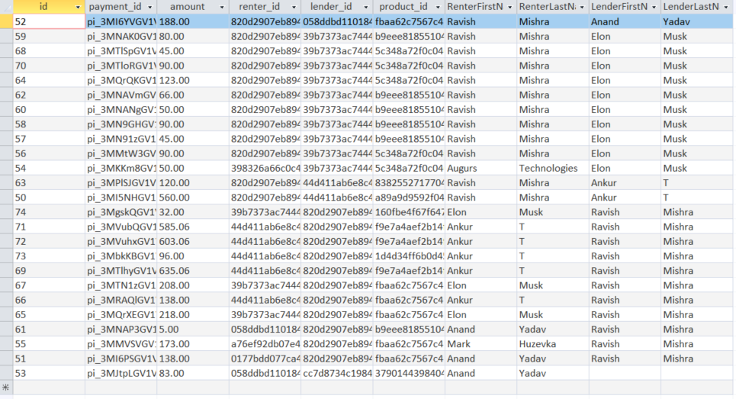

As you can see in the data above, for the product_orderdetails table, id=53 there is no Lender. There is a lender_id, but somehow no associated lender in the tbl_AccountRegistration table. This would be a serious issue in real life.

SELECT products_orderdetails.id, products_orderdetails.payment_id, products_orderdetails.amount, products_orderdetails.renter_id, products_orderdetails.lender_id, products_orderdetails.product_id, tbl_AccountRegistration.Name_First AS RenterFirstName, tbl_AccountRegistration.Name_Last AS RenterLastName, tbl_AccountRegistration_1.Name_First AS LenderFirstName, tbl_AccountRegistration_1.Name_Last AS LenderLastName

FROM (products_orderdetails LEFT JOIN tbl_AccountRegistration ON products_orderdetails.renter_id = tbl_AccountRegistration.account_id) LEFT JOIN tbl_AccountRegistration AS tbl_AccountRegistration_1 ON products_orderdetails.lender_id = tbl_AccountRegistration_1.account_id;

If “enforce referential Integrity” was enabled, then this event could not happen even accidentally by a program or person.

Note that “Cascade Update Related Fields” should also be enabled, although this will likely never happen.

“Cascade Delete Related Fields” should NOT be enabled since address may be used in another table like an old financial receipt which must be kept here in Canada for a minimum of 7 years. Below is an example of these settings in MSaccess.

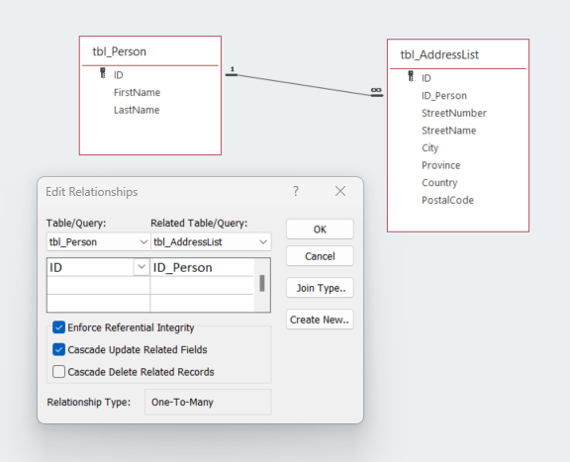

Example of two linked tables. The parent table is tbl_Person. The child table is tble_AddressList. In this example, if there is an address that is linked to the person, then the person cannot be deleted until the address for the person is deleted first. This ensures the “Integrity” of the database in that addresses will always have a person associated with them.

I do not profess to be an expert in MySQL, but decided to look up the concept and it definitely exists in that database. It is just not being used yet in the current NDR database.

These are set in MySQL when creating the table. Looking this up on google, it would appear that for this example, the following statement should be added to the create table command for tbl_Address:

ALTER TABLE tbl_Address ADD FOREIGN KEY (ID_Person) REFERENCES tbl_Person(ID);

[Referential Integrity Constraints in MySQL - Dot Net Tutorials](https://dotnettutorials.net/lesson/referential-integrity-constraints-in-mysql/#:~:text=What%20are%20Referential%20Integrity%20Constraints%20in%20MySQL%3F%20The,point.%20What%20are%20the%20Actions%20Performed%20by%20MySQL%3F)

**I am only given partial access to the NDR database at this point and I would like to see everything. Please give me an additional, login with complete Administrative privileges so I can see everything.**

Thanks.

Mark