**Order Details Table (Transaction Table)**

All the transactions manage in Order Details Table

Order Details Table Field List:

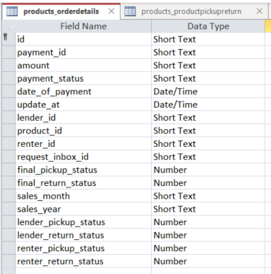

**Payment_id:-** Store Payment ID when Payment is successful

Is this the id that comes from Stripe? Or from another table? What is this used for or linked to?**Amount :-** Amount ofthe product pay by renter How is this one entry auditable? For instance, if the payment is made, and then part of it is reimbursed, is this number changed by the application?Nowhere is it listed on how canceled orders are related to our refund and Cancelation policy and how they get reimbursed depending who canceled the request. Is this “amount” stored as a proposal somewhere else as well? We need to keep track of the amount that is reimbursed, paid to NDR according to policy. How is this done if not in a ledger?

**Reference:** [Refund and Cancelation Process](https://nextdoorrental.ca/refund-and-cancelation-process/)

**Payment_status:-** When the payment is successful the payment status becomes true

What about the status of transaction when the Renter has requested, and Lender accepts, but Renter hasn’t paid for the Transaction yet. We are missing a list of statuses / steps to even get to the Payment Status becoming true.

The Renter Request is only Valid for 72 hours after being sent OR 2 hours prior to Product Pick up. Otherwise the request is deleted. There is nowhere in the database to track requested products. Please see Table posted below from original scope of work from 2022-05.

These status ID’s are needed in order to accurately control and monitor the transaction from start to finish with all of the possible outcomes.

For a list of required status ID’s with complete descriptions, please see page 8, 9 and 10 of the original scope (included below for your reference). If you can produce these status numbers from a query looking at various tables, then please provide that query.

| The following lists the typical interactions between the forms and tables for a transaction | | | |
| --- | --- | --- | --- |
| ID | Description | Forms | Tables Updated |
| 0 | Available | ***frm_001_000_000 Explore*** User selects a product from the Lender Product List using the selected filter. The selected filter is built by the user in ***frm_001_001_000 Explore_Filters***. | None, only a selection is made based on the filters. |
|  |  | ***frm_001_001_000 Explore_Filters***. Filter information is stored in these tables. Unlimited number of filters can be created and used by the user. When a filter is chosen a set of queries is built to satisfy the filter requirements. | tbl_Explore  tbl_ExploreDatesWanted  tbl_Explore_SortOrder  tbl_ExploreCategory |
| 1 | Renter Selected Product, but not sent request to Lender yet | ***frm_005_001_A00 Product Detail***  This form is used to view more details about the product. Pushing the “Request Product” button brings up the “Create a transaction for One Product” form |  |
|  |  | ***frm_003_010_000 Renter Product Request***. This form allows the user to build a proposal. Based on what the user selects, the proposal is created and stored in tbl_Transaction. A transaction record is a contiguous set of dates (delineated by an inclusive “from” and a “to” date) so the proposal may have many transactions. These are like line items on an invoice. The application minimizes the number transactions based on a variety of parameters. When the user is ready to submit the proposal, the user selects the continue button which calls up ***frm_003_100_000 Renter Request Confirmation***. |  |
| 2 | Renter Request Sent to Lender | ***frm_003_100_000 Renter Request Confirmation***. This form allows the user to view all the transactions in one form with the total price. This like a typical invoice. Once the user presses the “Confirm” button, the transaction id number is updated to 2. This confirmation also sends a message to the tbl_Messages where the lender can reply. The message is linked to the unique transaction id. | tbl_Transaction  tbl_Messages |
| 3 | Renter and Lender are Messaging regarding (negotiating) the transaction | Messaging can occur any time between a lender and renter, but only if it has been started from explore form. |  |
| 4 | Lender has accepted request from Renter | ***frm_003_000_100_Request Inbox***.  This form contains all of the requests from renters. The Lender can respond to the request from buttons on the form. They can then reject, comment or accept the request. Comment brings up messages with that person to negotiate. The lender cannot change the offer or make counter offers, only the renter can change the offer. The lender can negotiate over the messaging system as required.  ***frm_003_300_000 Lender Request Confirmation*** is pulled up if the lender wishes. | tbl_Transaction  tbl_Messages |
|  |  | ***frm_003_300_000 Lender Request Confirmation***.  This form permits the lender to select and agree to all of the terms proposed by the renter. Once the Lender has agreed to the terms, the “Confirm” button becomes active and the Lender can push this button. There could be a accept all or just another confirm, acknowledging that they agree, upon designers recommendation. Pushing this button changes the transaction id number to 4. |  |
| 5 | I-Rent has requested Payment from Credit Card Registered for Item | ***frm_Simulation***.  This form is not seen by the user. The “btnFinInternal” program stored in it is activated every time the user logs in and moves from screen to screen. This program checks for ID=4, and completes the credit card payment which is PCI compliant, sends messages to the lender and the renter, and moves the ID to 5. We would expect the developer to recommend a online credit card solution or develop the PCI compliant application or develop the automatic interface to this online credit card company. We want all financial transactions made by the applications to integrate in real time with Quickbooks online. | tbl_Message  tbl_transactions |
| 6 | I-Rent has received Payment from Credit Card Registered for Item | ***frm_Simulaton***.  This form is not seen by the user. The “btnFinInternal” program stored in it is activated every time the user logs in and moves from screen to screen. This program checks for ID=5, messages the Lender and Renter that payment has been  received, and moves the ID to 6.  This program checks for ID=6, and completes the financial ledger entries if they have not already been completed. Note that if the lender is a business, then different entries are made in the financial ledger. The program also checks to see if pickup and drop off reminders have been requested, if it is time to send them, and if they have been sent already, otherwise it sends the reminder messages as needed.  If the lender is not a business, then NDR has received payment and rewards points are allocated to the renter. | tbl_Message  tbl_Transaction  tbl_LedgerFinancial  tbl_LedgerRewards |
|  |  | ***frm_003_000_300 Product Pickup***.  This form is accessed by both the lender and the renter and shows the products that need to be picked up. When a lender selects the product, either ***frm_003_400_000 Renter Pick-Up Confirmation*** is activated or ***frm_003_410_000 Lender Pick-Up Confirmation*** is activated. |  |
| 7 | Renter has confirmed that product has been picked up | ***frm_003_400_000 Renter Pick-Up Confirmation*** moves the transaction ID is changed from 6 to 7 or from 8 to 9. | tbl_Transaction |
| 8 | Lender has confirmed that product has been picked up | ***frm_003_410_000 Lender Pick-Up Confirmation*** moves the transaction from 6 to 8 or from 7 to 9. | tbl_Transaction |
| 9 | Both Renter and Lender have confirmed that product has been picked up | ***frm_003_000_400 Product Return*** display all of the product that need to be returned for the renter or lender that is logged in. Selecting one of them brings up ***frm_003_000_410 Product Return Details***. If a lender selects, then ***frm_003_410_000 Lender Pick-up Confirmation*** is activated. If a renter selects, then ***frm_003_400_000 Renter Confirmation*** is activated.  The possession ID on the product is changed to the renter. |  |
| 10 | Renter has confirmed that the product has been returned | ***frm_003_400_000 Renter Confirmation*** moves the transaction ID from 9 to 10 or 11 to 12 and the possession ID for the product is changed to the lender.. | tbl_Transaction |
| 11 | Lender has confirmed that the product has been returned | ***frm_003_410_000 Lender Pick-up Confirmation*** moves the transaction ID from 9 to 11 or 10 to 12 and the possession ID for the product is changed to the lender.. | tbl_Transaction |
| 12 | Both Renter and Lender have confirmed that product has been returned | ***frm_Simulaton***.  This form is not seen by the user. The “btnFinInternal” program stored in it is activated every time the user logs in and moves from screen to screen. This program checks for ID=12, and makes the dual entry ledger entries to account for the transaction finishing. It also makes the payment to the lender, and sends a message to the lender that payment has been made. It then moves the transaction ID from 12 to 13. | tbl_Message  tbl_Transaction  tbl_LedgerFinancial  tbl_LedgerRewards (To be implemented by developer) |
| 13 | I-Rent has made payment to Lender | Transaction is complete. |  |

**Date_of_payment:-** date of payment

**Why does this not include the time as well in this same field?**

**Lender_pickup_status:-** After the Payment is done, when the lender update the pickup confirm the pickup status of the lender becomes true

Ok, so how is this different then the Lender_pickup_status in table (see below snippet). Are you storing the same information in different tables? I hope not.

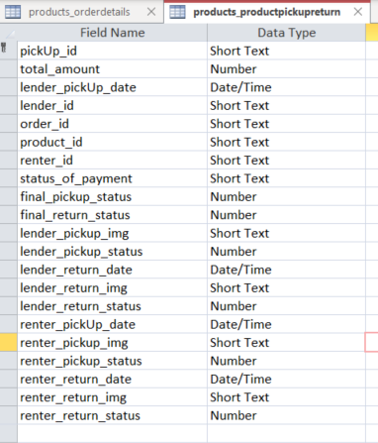

**Renter_pickup_status:-** Renter side pending after lender pickup status updated when renter will update pickup confirm then **final pickup status** will be true. And same product return working when renter update product return **renter_return_status** will be true and pending will be show lender side when lender update product return the **lender_return_status** and **final_return_status** will be true

**Final_return_status & Final_pickup_status:-** ReturnFinal status and Pickup Final Status will be update when pick up and return confirm both side

**Note:-** All the transactions manage in Order Details Table if you want to calculate transactions between two date try Query:

Thanks for the query examples. Please do not spend further time with queries as we are quite familiar with these. The database structure, including the inherent referential integrity of relationships between tables is our primary concern. Right now, the structure, relationships and integrity de not seem stable. To rely on programming to ensure database integrity is not wise so we hope you are not doing that.

**SQL Query**: [SELECT](http://54.89.50.153/phpmyadmin/url.php?url=https://dev.mysql.com/doc/refman/8.0/en/select.html) [SUM](http://54.89.50.153/phpmyadmin/url.php?url=https://dev.mysql.com/doc/refman/8.0/en/aggregate-functions.html%23function_sum)(amount) FROM `products_orderdetails` WHERE date_of_payment BETWEEN "2022-12-23" [AND](http://54.89.50.153/phpmyadmin/url.php?url=https://dev.mysql.com/doc/refman/8.0/en/logical-operators.html%23operator_and) "2022-12-28";

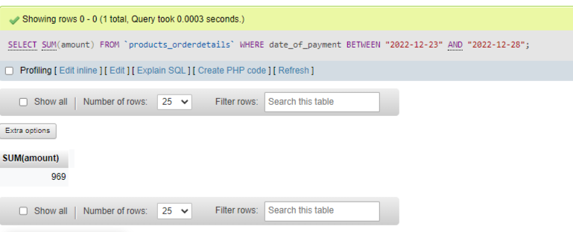

**Total number of transactions per month:-**

**Query:** [SELECT](http://54.89.50.153/phpmyadmin/url.php?url=https://dev.mysql.com/doc/refman/8.0/en/select.html) [COUNT](http://54.89.50.153/phpmyadmin/url.php?url=https://dev.mysql.com/doc/refman/8.0/en/aggregate-functions.html%23function_count)(amount) FROM `products_orderdetails` WHERE date_of_payment BETWEEN "2023-01-01" [AND](http://54.89.50.153/phpmyadmin/url.php?url=https://dev.mysql.com/doc/refman/8.0/en/logical-operators.html%23operator_and) "2023-01-30"

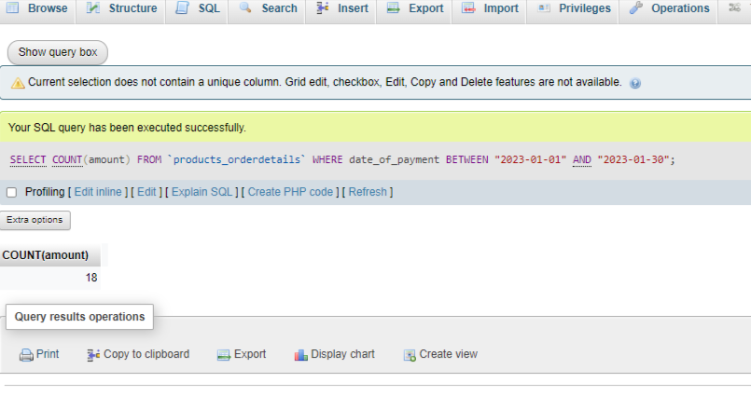

**If you want to track request accept reject lender side track in Request inbox Table:-**

[SELECT](http://54.89.50.153/phpmyadmin/url.php?url=https://dev.mysql.com/doc/refman/8.0/en/select.html) [COUNT](http://54.89.50.153/phpmyadmin/url.php?url=https://dev.mysql.com/doc/refman/8.0/en/aggregate-functions.html%23function_count)(request_status) FROM `products_requestinbox` WHERE request_status = "Accepted";

