1. **Explain what Recovery Point Objective (RPO)/ Recovery Time Objective (RTO) is**

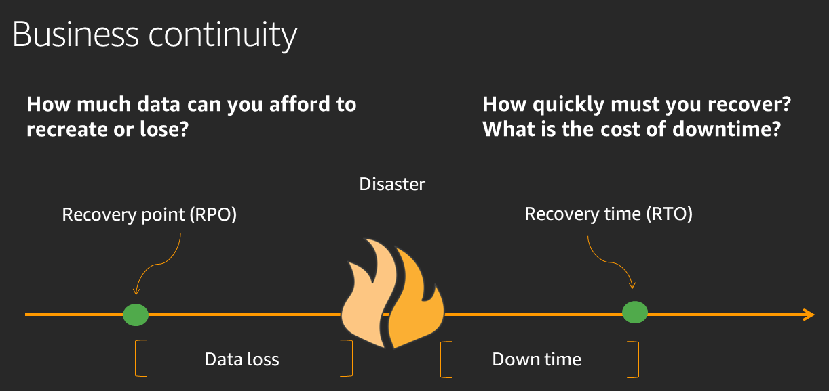

|  |  |
| --- | --- |
| Recovery Point Objective (RPO) | is the **maximum acceptable amount of data loss** after an unplanned data-loss incident, expressed as an amount of time. |
| Recovery Time Objective (RTO) | **is the amount of downtime a business can tolerate**. In a high-frequency transaction environment, seconds of being offline can represent thousands of dollars in lost revenue, while other systems (such as HR databases) can be down for hours without adversely impacting the business |

1. **What is a 3-tier architecture in AWS?** three-tier architecture is the most popular implementation of a multi-tier architecture and consists of a single presentation tier, logic tier, and data tier.

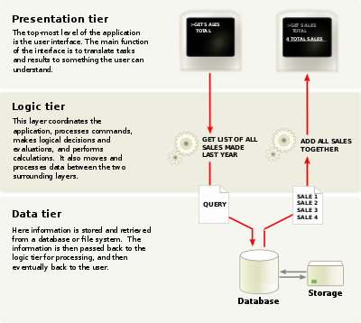

1. **What is vertical/horizontal scaling ?**

With vertical scaling (a.k.a. “scaling up”), you're adding more power to

your existing machine. In horizontal scaling (a.k.a. “scaling out”), you get

the additional resources into your system by adding more machines to

your network, sharing the processing and memory workload across multiple

devices.

1. **What is paravirtualization ?**

paravirtualization is an enhancement of virtualization technology in which a guest OS is modified prior to installation inside a virtual machine (VM) in order to allow all guest OSes within the system to share resources and successfully collaborate, rather than attempt to emulate an entire hardware environment.

|  |  |
| --- | --- |
| **Representational state transfer (REST)** | Representational state transfer (REST) is basically a set of rules for communication  between a client and Web server.  **There are a few constraints on the definition of REST**:   1. Client-Server Architecture 2. Statelessness: 3. Layered system: (be it proxy or load balancers)   Difference between SOAP and REST, Use Cases - Jelvix   1. **REST Client:** code or an app that can access these REST 2. **REST Service**: the server. There are many popular libraries that make creation of 3. these **servers a breeze, like [ExpressJS](https://expressjs.com/)for NodeJS and**[**Django**](https://www.djangoproject.com/)**for Python.** 4. **REST API**: this defines the endpoint and methods allowed to access/submit data to 5. the server. 6. Method: Earlier, I wrote that you can either request data or modify it 7. Diagram     Description automatically generated |
| RAID |   **RAID (Redundant Array of Inexpensive Drives)** is actually a visualization technology  to store data, it combines different physical drives of different locations and  combines it into a single logical unit, so the performance can be improved. And also,  data can be mirrored on one or more disk in the same array, preventing data loss.  How does RAID storage works?   * RAID 0 * RAID 1 * RAID 5 * RAID 10 (also known as RAID 1+0)   In all the diagrams mentioned below:   * A, B, C, D, E and F – represents blocks * p1, p2, and p3 – represents parity   A parity check is the process that ensures accurate data transmission between  nodes during communication RAID LEVEL 0 Graphical user interface  Description automatically generated Following are the key points to remember for RAID level 0.   * Minimum 2 disks. * Excellent performance ( as blocks are striped ). * No redundancy ( no mirror, no parity ). * Don’t use this for any critical system.  RAID LEVEL 1 Graphical user interface  Description automatically generated  Following are the key points to remember for RAID level 1.   * Minimum 2 disks. * Good performance ( no striping. no parity ). * Excellent redundancy ( as blocks are mirrored ).  RAID LEVEL 5 A picture containing text  Description automatically generated Following are the key points to remember for RAID level 5.   * Minimum 3 disks. * Good performance ( as blocks are striped ). * Good redundancy ( distributed parity ). * Best cost effective option providing both performance and redundancy.   Use this for DB that is heavily read oriented. Write operations will be slow.  disk striping) is the process of dividing a body of data into blocks and spreading the data  blocks across multiple storage devices RAID LEVEL 10 A picture containing text, electronics  Description automatically generated  Following are the key points to remember for RAID level 10.  Minimum 4 disks.  This is also called as “stripe of mirrors”  Excellent redundancy ( as blocks are mirrored )  Excellent performance ( as blocks are striped )  If you can afford the dollar, this is the BEST option for any mission critical applications (especially databases). |
| VLAN | VLAN is a logical grouping of networking devices. When we create VLAN, we  break large broadcast domain in smaller broadcast domains. Consider  VLAN as a subnet. Same as two different subnets cannot communicate with  each other without router, different VLANs also requires router to communicate  The benefit of this is that it lets you segment your network into smaller pieces for  security or performance reasons. It also lets you trunk these networks over a single  link (whether copper or optical fiber) to another switch or a server. Otherwise, creating  these separate networks on an unmanaged switch infrastructure would require a switch  or network interface for each physical network.  VLANs are created by adding 32 bytes of data (a “tag”) to the header portion of the  ethernet frame. This allows the device to identify which VLAN a particular frame is  associated with. VLANs are identified numerically from 1 to 4096 (the last 12 bits of  the VLAN tag).    Trunk links are required to pass VLAN information between switches. A port on a Cisco  switch is either an access port or a trunk port.  Access ports – This switch ports belongs to carry the traffic of only one vlan. By default, it will carry the  traffic of native vlan (VLAN 1)  Trunk ports –  Switch port that can carry more than one VLAN traffic from one switch to another switch |
| **Ip subnet** | EmbeddedGeeKs - Network / IP Classes      How to make a Class C Network Subnet with Binary |
| **DNS cache poisoning** | Domain Name Server (DNS) spoofing (a.k.a. DNS cache poisoning) is an  attack in which altered DNS records are used to redirect online traffic to a  fraudulent website that resembles its intended destination.  What Is DNS Spoofing? - KeyCDN Support |
| How https works | Complete Guide to SOCKS Proxy - How to Securely Bypass Blocks, Safe  Torrenting, Free Proxy List, Anonymous Proxies, Access Restricted Content  SSL/TLS Client Authentication – Know How it Works  1>When you enter the URL www.Google.com, Google’s server gives its public key and  Digital certificate (which was signed by GeoTrust) to the Browser.  2) Now browser has to verify the authenticity of the certificate i.e. it’s actually signed  From GeoTrust or not. As browsers come with a pre-installed list of public keys from  all the major CA’s, it picks the public key of the GeoTrust and tries to decrypt the digital  signature of the certificate which was encrypted by the private key of GeoTrust.  3) If it’s able to decrypt the signature (which means it’s a trustworthy website) then it  proceeds to the next step else it stops and shows a red cross before the URL.  As I mentioned, Google sends its public key when you enter www.Google.com . Any  data encrypted with this public key can only be decrypted by Google’s private key which  Google doesn’t share with anyone.  2) After validating the certificate, browser creates a new key let’s call it Session Key  ( symmetric key) and make 2 copies of it. These keys can encrypt as well as decrypt the  data.  3) The browser then encrypts (1 copy of session key + other request data) with the  Google's public key . Then it sends it back to the Google server.  4) Google’s server decrypts the encrypted data using its private key and gets the session  key , and other request data. Now, see, server and browser both have got the same copies  of session key of the browser. No one else has this key, therefore, only server and  browser can encrypt and decrypt the data. This key will now be used for both to decrypt  and to encrypt the data.  5) If the user closes the website and opens again, a new session key would be created. |
| How switch works | A switch kicks off with an empty table that maps MAC address to the outgoing  switch port. When a switch receives a packet at the first time, it adds the  source MAC along with the port at which it received the packet to the switch  table. As it doesn’t have an entry for the destination MAC yet, it broadcasts  that packet to all the devices connected in local network. Once the destined device  responds, switch receives this packet and update the switch table.  This is how switch updates its table and uses it to route packets to  corresponding switch port. |
| How dns works | Network Basics for Hackers: Domain Name Service (DNS) and BIND. How it Works  and How it Breaks  Understanding How DNS Works - the Domain Name System |
| Index sql | What is meant by index in SQL?  An index contains keys built from one or more columns in the table or view.  that enables SQL Server to find the row or rows associated with the key values quickly and  efficiently.  Different RDBMS may offer different indexing options. The basic index is a b-tree index.  Other index types may include bitmap and hash indexes, along with specialized indexes to  support various types of clustering or partitioning, such as block indexes and partition indexes |

**What is AWS? Amazon Cloud (Web) Services Tutorial**

**What is Cloud Computing?**

Cloud computing is a term referred to storing and accessing data over the internet. It doesn’t store any data on the hard disk of your personal computer. In cloud computing, you can access data from a remote server.

**What is AWS?**

The full form of AWS is Amazon Web Services. It is a platform that offers flexible, reliable, scalable, easy-to-use and, cost-effective cloud computing solutions.

AWS is a comprehensive, easy to use computing platform offered Amazon. The platform is developed with a combination of infrastructure as a service (IaaS), platform as a service (PaaS) and packaged software as a service (SaaS) offering.

**History of AWS**

* 2002- AWS services launched
* 2006- Launched its cloud products
* 2012- Holds first customer event
* 2015- Reveals revenues achieved of $4.6 billion
* 2016- Surpassed $10 billon revenue target
* 2016- Release snowball and snowmobile
* 2019- Offers nearly 100 cloud services
* 2021- AWS comprises over 200 products and services

**Important AWS Services**

Amazon Web Services offers a wide range of different business purpose global cloud-based products. The products include storage, databases, analytics, networking, mobile, development tools, enterprise applications, with a pay-as-you-go pricing model.

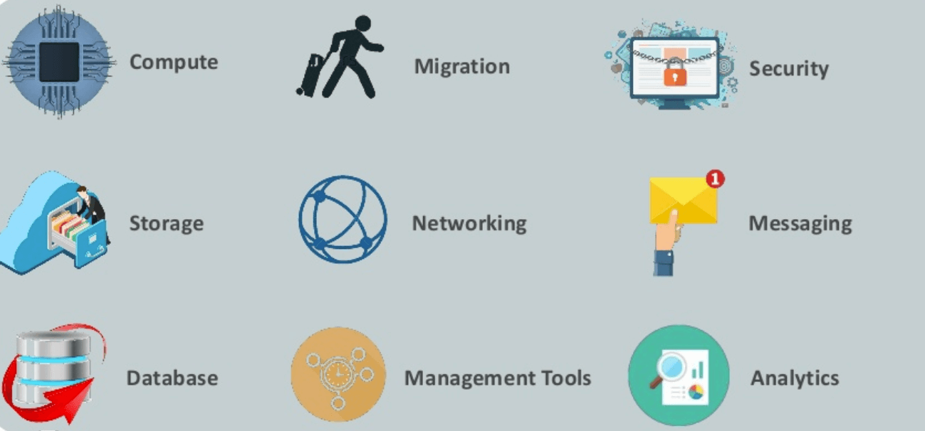Important AWS Services

**Here, are essential AWS services.**

**AWS Compute Services**

Here, are Cloud Compute Services offered by Amazon:

12.3M

117

Top 10 Behavioral Interview Questions and Answers

1. **EC2(Elastic Compute Cloud)-** EC2 is a virtual machine in the cloud on which you have OS level control. You can run this cloud server whenever you want.
2. **LightSail-** This cloud computing tool automatically deploys and manages the computer, storage, and networking capabilities required to run your applications. Amazon Lightsail is a service that allows you to deploy preconfigured virtual machines and its service(s) by point-and-click.
3. **Elastic Beanstalk-** AWS Elastic Beanstalk is an easy-to-use service for deploying and scaling web applications and services developed with Java, .NET, PHP, Node.js, Python, Ruby, Go, and Docker on familiar servers such as Apache, Nginx, Passenger, and IIS. You can simply upload your code and Elastic Beanstalk automatically handles the deployment, from capacity provisioning, load balancing, auto-scaling to application health monitoring.
4. **EKS (Elastic Container Service for Kubernetes)-** The tool allows you toKubernetes on Amazon cloud environment without installation.
5. **AWS Lambda-** ThisAWS service allows you to run functions in the cloud. The tool is a big cost saver for you as you to pay only when your functions execute. AWS Lambda is a serverless computer service that executes your code in response to events and automatically manages the underlying computing resources for you. You can use AWS Lambda to expand other AWS services with custom logic, or create your own back-end services that operate at AWS scale, performance and security.**serverless background task**

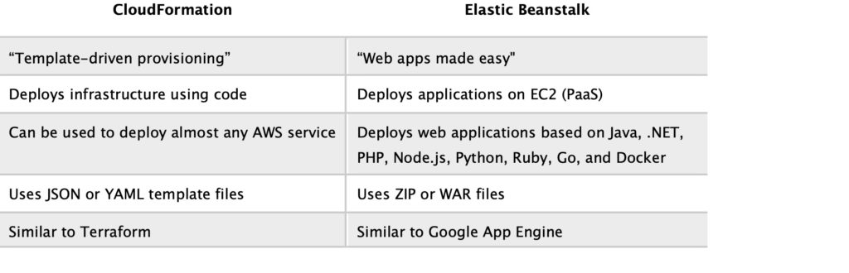

**Migration**

Migration services used to transfer data physically between your datacenter and AWS.

1. **DMS (Database Migration Service)**– DMS service can be used to migrate on-site databases to AWS. It helps you to migrate from one type of database to another — for example, Oracle to MySQL.
2. **SMS (Server Migration Service)**– SMS migration services allows you to migrate on-site servers to AWS easily and quickly.
3. **Snowball**— Snowball is a small application which allows you to transfer terabytes of data inside and outside of AWS environment.

**Storage**

1. **Amazon Glacier-** It is an extremely low-cost storage service. It offers secure and fast storage for data archiving and backup.

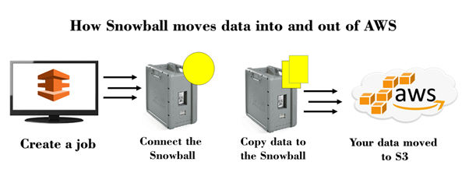

1. **Amazon Elastic Block Store (EBS)-** It provides block-level storage to use with Amazon EC2 instances. Amazon Elastic Block Store volumes are network-attached and remain independent from the life of an instance.

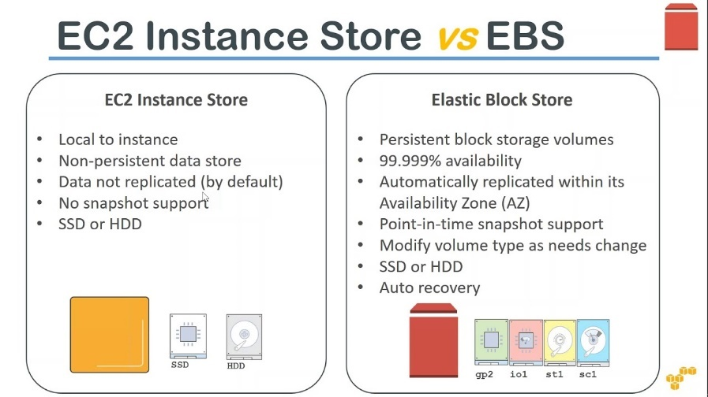

1. **AWS Storage Gateway-** This AWS service is connecting on-premises software applications with cloud-based storage. It offers secure integration between the company’s on-premises and AWS’s storage infrastructure.

**Security Services**

1. **IAM (Identity and Access Management)**— IAM is a secure cloud security service which helps you to manage users, assign policies, form groups to manage multiple users.
2. **Inspector**— It is an agent that you can install on your virtual machines, which reports any security vulnerabilities.
3. **Certificate Manager**— The service offers free SSL certificates for your domains that are managed by Route53.
4. **WAF (Web Application Firewall)**— WAF security service offers application-level protectionand allows you to block SQL injection and helps you to block cross-site scripting attacks.
5. **Cloud Directory**— This service allows you to create flexible, cloud-native directories for managinghierarchies of data along multiple dimensions.
6. **KMS (Key Management Service)**— It is a managed service. This security service helps you to create and control the encryption keyswhich allows you to encrypt your data.
7. **Organizations**— You can create groups ofAWS accounts using this service to manages security and automation settings.
8. **Shield**— Shield is managedDDoS (Distributed Denial of Service protection service). It offers safeguards against web applications running on AWS.
9. **Macie**— It offers a data visibility security service which helps classify and protect your sensitive critical content.
10. **GuardDuty**— It offers threat detectionto protect your AWS accounts and workloads.

**Database Services**

1. **Amazon RDS-**ThisDatabase AWS service is easy to set up, operate, and scale a relational database in the cloud.
2. **Amazon DynamoDB-** It is a fast, fully managed NoSQL database service. It is a simple service which allow cost-effective storage and retrieval of data. It also allows you to serve any level of request traffic.
3. **Amazon ElastiCache-** It is a web service which makes it easy to deploy, operate, and scale an in-memory cache in the cloud.
4. **Neptune-**It is a fast, reliable and scalable **graph database** service.
5. **Amazon RedShift-** It is Amazon’s data warehousing solution which you can use to perform complex OLAP queries.

**Analytics**

1. **Athena**— This analytics service allows permSQL queries on your S3 bucket to find files.
2. **CloudSearch**— You should use this AWS service to create a fully managed search engine for your website.
3. **ElasticSearch**— It is similar to CloudSearch. However, it offers more features like application monitoring.
4. **Kinesis**— This AWS analytics service helps you to stream and analyzing real-time data at massive scale.
5. **QuickSight**— It is a business analytics tool. It helps you to create visualizations in a dashboard for data in Amazon Web Services. For example, S3, DynamoDB, etc.
6. **EMR (Elastic Map Reduce)**— This AWS analytics service mainly used for big data processing like Spark, Splunk, Hadoop, etc.
7. **Data Pipeline**— Allows you to move data from one place to another. For example from DynamoDB to S3.

**Management Services**

1. **CloudWatch**— Cloud watch helps you to monitor AWS environments like EC2, RDS instances, and CPU utilization. It also triggers alarms depends on various metrics.
2. **CloudFormation**— It is a way of turning infrastructure into the cloud. You can use templates for providing a whole production environment in minutes.
3. **CloudTrail**— It offers an easy method of auditing AWS resources. It helps you to log all changes.
4. **OpsWorks**— The service allows you to automated Chef/Puppet deployments on AWS environment.
5. **Config**— This AWS service monitors your environment. The tool sends alerts about changes when you break certain defined configurations.
6. **Service Catalog**— This service helps large enterprises to authorize which services user will be used and which won’t.
7. **AWS Auto Scaling**— The service allows you to automatically scale your resources up and down based on given CloudWatch metrics.
8. **Systems Manager**— This AWS service allows you to group your resources. It allows you to identify issues and act on them.
9. **Managed Services**— It offers management of your AWS infrastructure which allows you to focus on your applications.

**Internet of Things**

1. **IoT Core**— It is a managed cloud AWS service. The service allows connected devices?like cars, light bulbs, sensor grids, to securely interact with cloud applications and other devices.
2. **IoT Device Management**— It allows you to manage your IoT devices at any scale.
3. **IoT Analytics**— This AWS IOT service is helpful to perform analysis on data collected by your IoT devices.
4. **Amazon FreeRTOS**— This real-time operating system for microcontrollers helps you to connect IoT devices in the local server or into the cloud.

**Application Services**

1. **Step Functions**— It is a way of visualizing what’s going inside your application and what different microservices it is using.
2. **SWF (Simple Workflow Service)**— The service helps you to coordinate both automated tasks and human-led tasks.
3. **SNS (Simple Notification Service)**— You can use this service to send you notifications in the form of email and SMS based on given AWS services.
4. **SQS (Simple Queue Service)**— Use this AWS service to decouple your applications. It is a pull-based service.
5. **Elastic Transcoder**— This AWS service tool helps you to changes a video’s format and resolution to support various devices like tablets, smartphones, and laptops of different resolutions.

**Deployment and Management**

1. **AWS CloudTrail:**The services records AWS API calls and send backlog files to you.
2. **Amazon CloudWatch:** The tools monitor AWS resources like Amazon EC2 and Amazon RDS DB Instances. It also allows you to monitor custom metrics created by user’s applications and services.
3. **AWS CloudHSM:**This AWS service helps you meet corporate, regulatory, and contractual, compliance requirements for maintaining data security by using the Hardware Security Module(HSM) appliances inside the AWS environment.

**Developer Tools**

1. **CodeStar**— Codestar is a cloud-based service for creating, managing, and working with various software development projects on AWS.
2. **CodeCommit**— It is AWS’s version control servicewhich allows you tostore your code and other assets privately in the cloud.
3. **CodeBuild**— This Amazon developer service help you to automates the process of building and compilingyour code.
4. **CodeDeploy**— It is a way of deploying your code in EC2 instances automatically.
5. **CodePipeline**— It helps you create a deployment pipeline like testing, building, testing, authentication, deployment on development and production environments.
6. **Cloud9**— It is an Integrated Development Environment for writing, running, and debugging code in the cloud.

**Mobile Services**

1. **Mobile Hub**— Allows you to add, configure and design features for mobile apps.
2. **Cognito**— Allows users to signup using his or her social identity.
3. **Device Farm**— Device farm helps you to improve the quality of apps by quickly testing hundreds of mobile devices.
4. **AWS AppSync**— It is a fully managed GraphQL service that offers real-time data synchronization and offline programming features.

**Business Productivity**

1. **Alexa for Business**— It empowers your organization with voice, using Alexa. It will help you to Allows you to build custom voice skills for your organization.
2. **Chime**— Can be used for online meeting and video conferencing.
3. **WorkDocs**— Helps to store documents in the cloud
4. **WorkMail**— Allows you to send and receive business emails.

**Desktop & App Streaming**

1. **WorkSpaces**— Workspace is a VDI(Virtual Desktop Infrastructure). It allows you to use remote desktops in the cloud.
2. **AppStream—** A way ofstreaming desktop applicationsto your users in the web browser. For example, using MS Word in Google Chrome.

**Artificial Intelligence**

1. **Lex**— Lex tool helps you to build chatbots**quickly.**
2. **Polly**— It is AWS’s text-to-speech service allows you to create audio versions of your notes.
3. **Rekognition**— It is AWS’s face recognition service. This AWS service helps you to recognize faces and object in images and videos.
4. **SageMaker**— Sagemaker allows you to build, train, and deploy machine learning models at any scale.
5. **Transcribe**— It is AWS’s speech-to-text service that offers high-quality and affordable transcriptions.
6. **Translate**— It is a very similar tool to Google Translate which allows you to translate text in one language to another.

**AR & VR (Augmented Reality & Virtual Reality)**

1. **Sumerian**— Sumerian is a set of tool for offering high-quality virtual reality (VR) experiences on the web. The service allows you to create interactive 3D scenes and publish it as a website for users to access.

**Customer Engagement**

1. **Amazon Connect**— Amazon Connect allows you to create your customer care centerin the cloud.
2. **Pinpoint**— Pinpoint helps you to understand your users and engage with them.
3. **SES (Simple Email Service)**— Helps you to send bulkemails to your customers at a relatively cost-effective price.

**Game Development**

1. **GameLift**– It is a service which is managed by AWS. You can use this service to host dedicated game servers. It allows you to scale seamlessly without taking your game offline.

**Applications of AWS services**

Amazon Web services are widely used for various computing purposes like:

* Web site hosting
* Application hosting/SaaS hosting
* Media Sharing (Image/ Video)
* Mobile and Social Applications
* Content delivery and Media Distribution
* Storage, backup, and disaster recovery
* Development and test environments
* Academic Computing
* Search Engines
* Social Networking

**Companies using AWS**

* Instagram
* Netflix
* Twitch
* LinkedIn
* Facebook
* Turner Broadcasting: $10 million
* Zoopla
* Smugmug
* Pinterest
* Dropbox

**Advantages of AWS**

Following are the pros of using AWS services:

* AWS allows organizations to use the already familiar programming models, operating systems, databases, and architectures.
* It is a cost-effective service that allows you to pay only for what you use, without any up-front or long-term commitments.
* You will not require to spend money on running and maintaining data centers.
* Offers fast deployments
* You can easily add or remove capacity.
* You are allowed cloud access quickly with limitless capacity.
* Total Cost of Ownership is very low compared to any private/dedicated servers.
* Offers Centralized Billing and management
* Offers Hybrid Capabilities
* Allows you to deploy your application in multiple regions around the world with just a few clicks

**Disadvantages of AWS**

* If you need more immediate or intensive assistance, you’ll have to opt for paid support packages.
* Amazon Web Services may have some common cloud computing issues when you move to a cloud. For example, downtime, limited control, and backup protection.
* AWS sets default limits on resources which differ from region to region. These resources consist of images, volumes, and snapshots.
* Hardware-level changes happen to your application which may not offer the best performance and usage of your applications.

**Best practices of AWS**

* You need to design for failure, but nothing will fail.
* It’s important to decouple all your components before using AWS services.
* You need to keep dynamic data closer to compute and static data closer to the user.
* It’s important to know security and performance tradeoffs.
* Pay for computing capacity by the hourly payment method.
* Make a habit of a one-time payment for each instance you want to reserve and to receive a significant discount on the hourly charge.

**1) Explain what AWS is?**

AWS stands for Amazon Web Service; it is a collection of remote computing services also known as a cloud computing platform.  This new realm of cloud computing is also known as IaaS or Infrastructure as a Service.

**2) Mention what the key components of AWS are?**

The key components of AWS are

* **Route 53:**A DNS web service
* **Simple E-mail Service:**It allows sending e-mail using RESTFUL [API](https://career.guru99.com/top-20-questions-on-api-testing/) call or via regular SMTP
* **Identity and Access Management:**It provides enhanced security and identity management for your AWS account
* **Simple Storage Device or (S3):**It is a storage device and the most widely used AWS service
* **Elastic Compute Cloud (EC2):**It provides on-demand computing resources for hosting applications. It is handy in case of unpredictable workloads
* **Elastic Block Store (EBS):**It offers persistent storage volumes that attach to EC2 to allow you to persist data past the lifespan of a single Amazon EC2 instance
* **CloudWatch:**To monitor AWS resources, It allows administrators to view and collect keys. Also, one can set a notification alarm in case of trouble.

### ****3) Explain what S3 is?****

S3 stands for Simple Storage Service. You can use the S3 interface to store and retrieve any amount of data, at any time and from anywhere on the web.  For S3, the payment model is “pay as you go.”

### ****4) What is AMI?****

AMI stands for Amazon Machine Image.  It’s a template that provides the information (an [operating system](https://career.guru99.com/top-50-operating-system-interview-questions/), an application server, and applications) required to launch an instance, which is a copy of the AMI running as a virtual server in the cloud.  You can launch instances from as many different AMIs as you need.

### ****) How can you send a request to Amazon S3?****

Amazon S3 is a REST service, and you can send a request by using the REST API or the AWS SDK wrapper libraries that wrap the underlying Amazon S3 REST API.

### ****16) What are key-pairs in AWS?****

Key-pairs are secure login information for your virtual machines. To connect to the instances, you can use key-pairs which contain a public-key and private-key.

|  |  |
| --- | --- |
|  | AWS stands for Amazon Web Service; it is a collection of remote computing services also known as a cloud computing platform.  This new realm of cloud computing is also known as IaaS or Infrastructure as a Service. |
|  | AWS Regions are the actual geographic places in which the AWS data centers are located. AWS Regions can either be states such as Ohio, Oregon, Northern Virginia, cities like Mumbai, London, São Paulo, or countries such as Canada and Singapore. An AWS Region has at least one Availability Zone and this number can go up to 6 in some of them. Availability Zones are the actual AWS data centers that are located in these regions. AZs can have either a single or culmination of closely situated data centers. AZs within a region are within a distance of 100 km or 60 miles from each other.  edge location is the area where the contents will be cached. So, when a user is trying to access any content, the content will automatically be searched in the edge location. AWS Edge locations are services that redundantly cache data and images. |
|  | AWS Identity and Access Management (IAM) enables you to securely control access to AWS services and resources for your users. Using IAM, you can create and manage AWS users and groups, and use permissions to allow and deny their access to AWS resources  Rather AWS Identity and Access Management (IAM) roles provide a way to access AWS by relying on temporary security credentials. Each role has a set of permissions for making AWS service requests, and a role is not associated with a specific user or group. |
|  | **Route 53**:A DNS web service. The buffer is used to make the system more robust to manage traffic or load by synchronizing different components. |
|  | AMI is Amazon Machine Image. |
|  | S3 is Simple Storage Service.S3 is a REST service & by using the REST API or the AWS SDK wrapper libraries |
|  | VPC is Virtual Private Cloud. It enables customization of your networking configuration. This network is isolated from another network in the cloud. It allows you to have your IP address range, internet gateways, subnet and security groups. With private and public subnets in VPC, database servers should ideally launch into private subnets. No, currently Amazon VPC does not provide support for broadcast or multicast. we can establish a peering connection to a VPC in a different region. You can have 200 subnets per VPC. |
|  | **security group is just like a firewall**, it controls the traffic in and out of your instance.  In AWS terms, the inbound and outbound traffic. |
|  | Snowball is a data transport option. Source appliances are used to move a large amount of data in & out of AWS. It enables one to transfer a massive amount of data from one place to another. It makes networking cost effective. |
|  | With the help of Amazon CloudWatch, one can monitor the application status of various AWS services and custom events. State Changes in Amazon EC2, Auto-scaling Lifecycle events, Scheduled events, AWS API calls & Console Sign-in events, all these can be monitored with the help of Amazon CloudWatch. |
|  | Key-pairs are secure login information for your virtual machines. To connect to the instances, you can use key-pairs which contain a public-key and private-key. |
|  |  |
|  | Redshift is a big [data warehouse](https://career.guru99.com/top-50-datawarehousing-questions-answers/) product. It is a fast and powerful, fully managed data ware house service in the cloud |
|  | A large section of IP Addresses divided into chunks is known as subnets. |
|  | Simple Queue Service is also known as SQS. It is distributed queuing service which acts as a mediator for two controllers. |
|  | AWS Lambda is a serverless compute service that runs your code in response to events and automatically manages the underlying compute resources for you. These events may include changes in state or an update, such as a user placing an item in a shopping cart on an ecommerce website.  Fargate is a serverless container platform for running Docker containers. The advantages are cost effectiveness and lower operational overhead as instead of having to spin up, manage and pay for a cluster of servers to run your containers you can just deploy the containers on Fargate and pay just for the resources the container uses when they’re running and don’t have to hire people to manage a server cluster. |
|  | CloudTrail is a specially designed tool for logging and tracking API calls. It helps to [audit](https://career.guru99.com/top-10-internal-audit-interview-questions/) all S3 bucket accesses. |
|  | Amazon Elastic cache is a web service which makes it easy to deploy, scale and store data in the cloud. |
|  | We can’t be able to connect EBS volume to multiple instances.  However, you can connect various EBS Volumes to a single instance. |
|  | Sharding and partitioning are both about breaking up a large data set into smaller subsets. The difference is that sharding implies the data is spread across multiple computers while partitioning does not. Partitioning is about grouping subsets of data within a single database instance |
|  | AWS enables you to easily deploy your system in multiple regions around the world with just a moment's notice. |
|  |  |
|  |  |
|  |  |
|  |  |
|  |  |
|  |  |
|  |  |