2nd- second idea-

Problem that I believe company is facing –
“Does this data change the model’s internal belief in a useful way?”

predicting external context usefulness via internal signals.”
-“Did reasoning align with retrieved evidence?”

RAG hallucination detection is an active research area.
Even with correct retrieved data, RAG still hallucinates
Cause: imbalance between internal knowledge vs external context.

Graph-based hallucination detection (HaluGNN) combines attention + hidden states
Mechanistic methods (ReDeEP) analyze internal components (FFN vs attention)
Attention-based scoring methods (AggTruth) already detect hallucination in real-time

Even after cleaning, enterprise data is NOT actually clean in the RAG sense.
Your idea combines:
- attention graphs (Φ)
- similarity graphs (χ)
- layer dynamics

A document can be:
- factually correct ✅
- but still bad for RAG ❌
Example:
- Legal policy (correct but vague)
- Old documentation (correct but outdated)
- Long paragraphs with no structure
👉 LLM struggles to use it → leads to hallucination
Even after cleaning:
- Version A says: “Policy X = 30 days”
- Version B says: “Policy X = 60 days”
Both are “correct” at some point.
👉 Retrieval might return both → model gets confused → hallucination
Even with perfect data:
- embedding similarity is approximate
- wrong chunk can still be retrieved
👉 So:
The problem is not just data quality, but retrieval + usage
Even with perfect RAG:
- model may ignore context
- model may hallucinate anyway
- model may over-rely on one chunk
👉 This is well documented in RAG literature
Research consensus
- RAG reduces hallucination but does not eliminate it
- “Garbage in → garbage out” is too simple
👉 Even good data can produce bad outputs
Industry reality (very important)
Companies struggle with:
1. Retrieval noise
- Top-k often includes irrelevant chunks
2. Context overload
- Too many tokens → worse answers
3. Cost explosion
- More data → more tokens → more $$$

👉 So the real problem is:
Not “should we store data?”
but “which data should we retrieve and use at runtime?”

Detect harmful data before storing

At query time, decide whether the retrieved RAG context will HELP or HURT before generating the answer
👉 This is a runtime problem, not just storage problem
Retrieval always introduces noise
Even with perfect DB:
Query → Top-5 chunks → some irrelevant
👉 You need to filter or score them

🎯 Reason 2: More context ≠ better
Research shows:
- too many documents → worse performance
👉 Need to decide:
- use this chunk?
- drop it?
Your friend said:
“Main problem is token generation, not storage”
Correct.

But:
Bad RAG → longer prompts → more tokens → more cost
👉 If you filter useless chunks:
- fewer tokens
- cheaper inference

Reason 4: Safety / hallucination
Even clean data can:
- mislead model
- conflict with query
👉 Need dynamic validation

🧠 6. The real problem statement (this is what you should focus on)
Given retrieved documents, can we predict whether using them will improve or degrade the model’s answer?

Use case 1: Dynamic RAG filtering
Retrieve → Score → Keep best → Drop harmful

🔥 Use case 2: Adaptive retrieval
If RAG looks bad → re-retrieve

🔥 Use case 3: Early stopping
If RAG not useful → skip context → save tokens

A mechanism to evaluate whether the CURRENT RAG context is helpful—before generation
dicting the usefulness of retrieved context in RAG systems before generation to improve accuracy and reduce token cost.”

Predict RAG usefulness BEFORE answering, using internal cluster behavior.
This can become a real product
“Early-stage hallucination prediction in RAG using internal token dynamics and retrieval alignment”

A company could integrate your system as:
"Geometry-Aware RAG: Detecting Retrieval Quality from Internal Token States" ⭐ VERY PRACTICAL
The claim:
"RAG system quality can be predicted from token similarity patterns in the model's intermediate layers, without evaluating the generated output. This enables real-time quality monitoring and selective re-retrieval."
Why this is good:
- Direct application to Anthropic's Claude (RAG-heavy)
- Practical value (saves compute, improves output)
- Connects to your original RQ2 (RAG influence)
- Clear eval metrics (AUC, NDCG, latency saved)
- Strong hiring signal for reliability-focused teams
How to execute:
- Get real RAG data (1-2 weeks)
  - Use open-domain QA: Natural Questions, TriviaQA
  - For each query: relevant document, irrelevant document, no document
- Hypothesis: Token connectivity Φ and χ at layer 3-8 differ depending on retrieval quality
- Experiment:
For each (query, retrieved_doc, model):
a) Prepend doc to query (length-controlled!)
b) Extract hidden states at each layer
c) Compute connectivity metrics
d) Compare: good retrieval vs. bad retrieval
e) Train a classifier: Φ(layer) → quality
- Results:
  - "Connectivity at layer 5 predicts retrieval quality with 82% AUC"
  - "This works for GPT-2, Qwen, Mistral (not just one model)"
  - "Real-time overhead: <1ms per query"
- Application:
  - "Can be deployed in Anthropic/OpenAI RAG systems immediately"
  - "Enables dynamic re-retrieval when confidence is low"
- Publication: NeurIPS 2026 Applications track, or Anthropic blog (they publish internally)
- Hiring narrative: "I built a practical system for detecting retrieval quality in LLM applications using interpretability. This directly improves production RAG systems at scale.

RAG Safety Layer
(or “Cluster-Guard”)
Before passing retrieved context to the LLM:
- Analyze token clusters →
- Score RAG →
- Pass only “safe/high-value” context to LLM
This can be sold as:
- API
- SDK
- LLM middleware
- Enterprise RAG safety tool
Companies already pay for this kind of safety layer (e.g., guardrails), but NOTHING exists for RAG quality prediction.
Define a RAG Quality Score like:
$$\text{RQS}=α(L_{\text{no_rag}}^{*}-L_{\text{rag}}^{*})-β⋅\text{Instability}+γ⋅\text{GCC_final}$$
We measure it in two steps.
First -----
we define cluster-based metrics from the token graphs, like the percolation layer (when the giant component appears), fragmentation, and stability across layers. That gives us a cluster signature for each run.
Second-----
we label RAG as helpful, neutral, or harmful by comparing answer quality with and without RAG. Then we either define an analytic score, or train a small classifier that maps the cluster signature to these labels. This way, we can predict RAG usefulness before generation, using only the internal cluster dynamics.
per-layer connectivity graphs + percolation + cluster stability
as a method for evaluating whether RAG is “helpful / neutral / harmful.
Physics concepts (percolation)
LLM internal geometry
Graph-based modeling
RAG dynamics
Are there any risks? (Honest answer)
YES — but manageable.
Here are the real risks:
RISK 1 — Some professors may ask:
Is percolation just a visualization or does it give real predictive power?”
You can solve this:
Train your RAG quality classifier.

RISK 2 — You need multiple models
(good: GPT-2, Qwen1.5B, Mistral2.7B)
If you're careful, CPU models are enough.
RISK 3 — You must produce good evaluation
So your results must show:
- correlation between percolation shift and RAG usefulness
- cluster instability predicts hallucinations
- different models behave differently
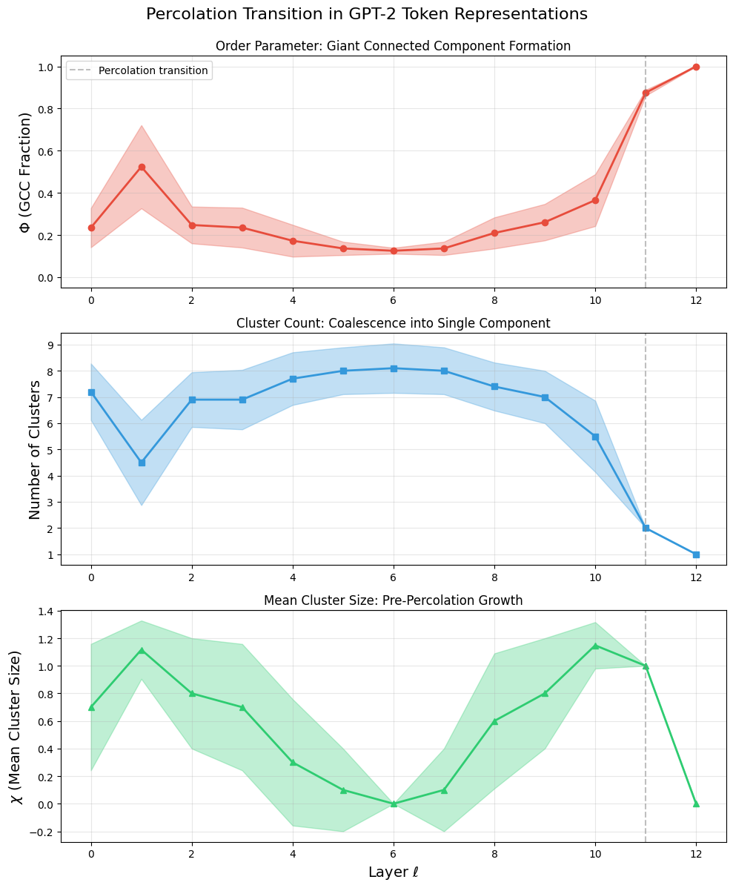

giant connected component
Φ and #clusters reflect the final stage of understanding, which is similar for both RAG and No-RAG.
χ captures the intermediate complexity of the reasoning process.
lthough the final percolation point is similar in both cases, the internal fragmentation is much higher with RAG. The GCC eventually forms, but χ shows that many medium-sized clusters survive longer, meaning the model’s internal semantic landscape is more complex under RAG.”
Φ (GCC Fraction)
tends to rise sharply around layer 11 in BOTH No-RAG and RAG.
Clusters
gradually decreases at deeper layers in BOTH No-RAG and RAG.
This happens because:
GPT-2 naturally forms a unified global representation near layer 11.
RAG does not change that fundamental behavior — the model still must “understand” the whole sentence at the end.

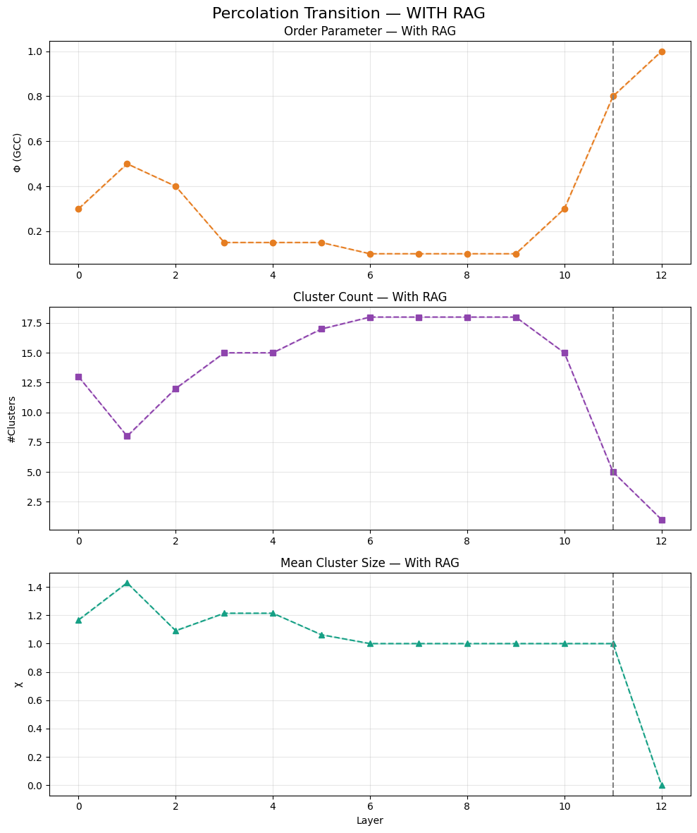
It means the LLM absorbs RAG knowledge gradually not immediately

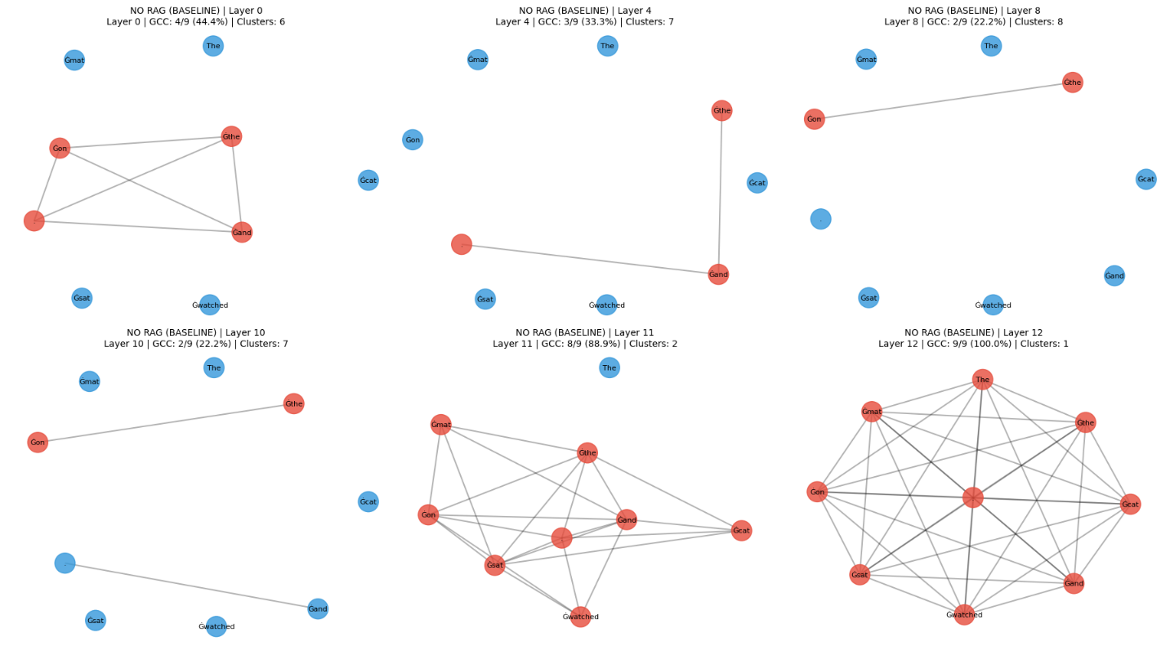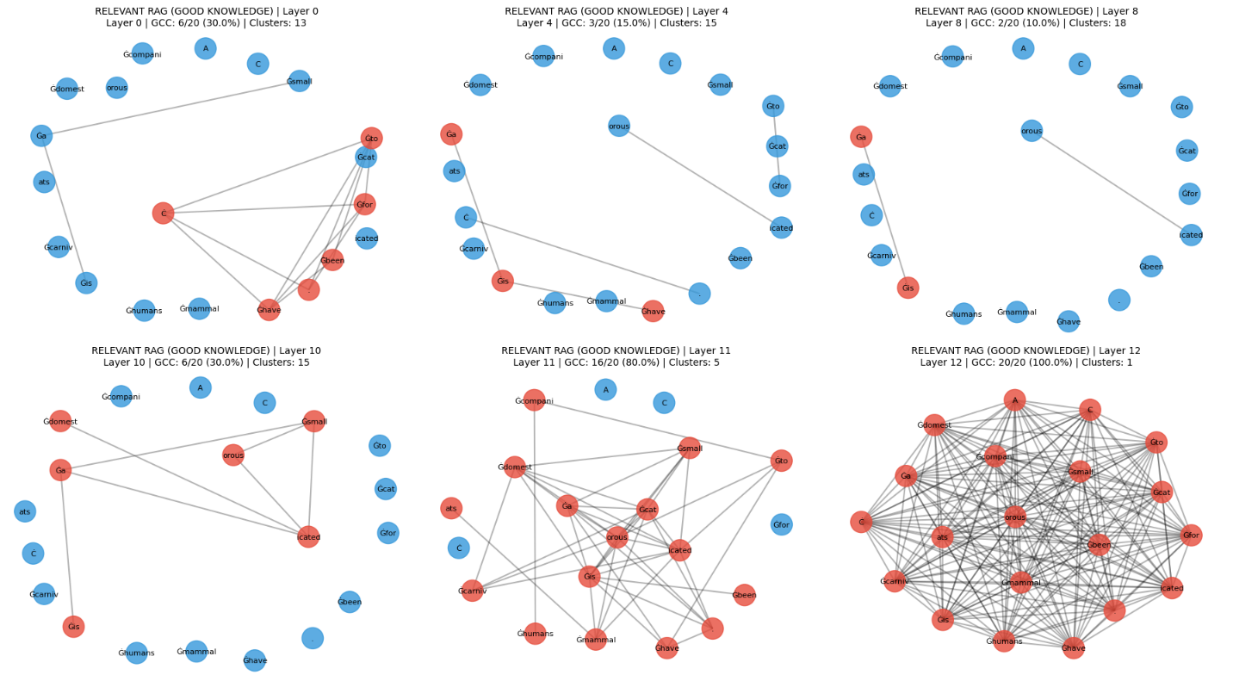

“Predict RAG groundedness using layer-wise token alignment dynamics, enabling early detection and adaptive retrieval before full generation
✅ You can predict RAG quality using intermediate-layer signals (including token similarity / representation patterns)
However, it is strong enough for early-warning systems + selective re-retrieval, which is exactly where your idea becomes powerful

“detect harmful RAG and save memory”
A RAG chunk is harmful if it:
- ❌ Increases hallucination
  - Misleading / outdated / incorrect info
- ❌ Conflicts with better evidence
  - Causes model confusion
- ❌ Adds no value (redundant/noisy)
  - Wastes tokens → increases cost
- ❌ Dominates attention incorrectly
  - Model attends to irrelevant chunk
Can we identify and filter harmful or low-utility RAG documents using internal model signals before or during generation?”
Find signals that correlate with:
- hallucination
- poor grounding
- useless retrieval
From your .ipynb, modify forward pass to capture:
(A) Token–Context Similarity
- Embedding similarity between:
  - generated tokens
  - retrieved chunks
👉 Hypothesis:
- Good RAG → high alignment
- Bad RAG → weak or inconsistent alignment
Attention Patterns
- How much attention tokens give to:
  - retrieved context vs prompt
👉 Key signal:
- If attention ignores context → hallucination risk
- RAGTruth
- HaluEval
- Natural Questions (with gold answers)

🏷️ Define labels:
Instead of binary:
0 = harmful
1 = neutral
2 = useful
Or:
Hallucinated vs Grounded

⚠️ Important:
Label at document level, not just output level.
👉 This is your novelty:
“Which retrieved chunk caused the hallucination?”

🤖 4. Phase 3 — Build the Detection Model
Now convert signals → prediction.

🧠 Model options:
Start simple:
- Logistic Regression (baseline)
- Then:
- Small MLP / XGBoost

📌 Input features:
[similarity_score,
attention_score,
layer_stability,
retrieval_contribution]

🎯 Output:
P(harmful | chunk, query)

🧪 Key experiment:
Compare:
Model | Signals Used
A | similarity only
B | attention only
C | layer dynamics only
D | ALL combined
Break it into 3 mathematically grounded components:

🧩 (A) Alignment Score (semantic grounding)
$$A(d_{i})=\frac{1}{T}\sum_{t=1}^{T}{\underset{x∈d_{i}}{max⁡}}cos⁡(h_{t},h_{x})$$
Where:
- $h_{t}$= hidden state of generated token
- $h_{x}$= embedding of token in document
- Measures how much generation aligns with the document
(B) Attention Contribution Score
$$C(d_{i})=\frac{1}{T}\sum_{t=1}^{T}{\sum_{x∈d_{i}}{α_{t,x}}}$$
Where:
- $α_{t,x}$= attention weight

Meaning:
- Measures how much the model uses the document

🧩 (C) Stability Score (hallucination signal)
$$S=\frac{1}{T}\sum_{t=1}^{T}{∥}h_{t}^{\left(L\right)}-h_{t}^{\left(L − 1\right)}∥$$

Meaning:
- Large fluctuations → unstable → hallucination risk
- 🧮 5. Final Harmfulness Score
- Now combine:
- $\hat{U}(d_{i})=w_{1}A(d_{i})+w_{2}C(d_{i})-w_{3}S$

- Classification:
- Score > +τ → Useful
Score between [-τ, +τ] → Neutral
Score < -τ → Harmful

7. Even better: Information-theoretic version
If you want something more “NeurIPS-level”:

KL divergence impact:
$$H(d_{i})=D_{KL}(P(⋅∣q,D) ∥ P(⋅∣q,D∖d_{i}))$$

Meaning:
- How much the document changes the model’s belief

👉 If change is:
- helpful → useful
- misleading → harmful

We define the utility of a retrieved document as its marginal contribution to the model’s predictive distribution, and approximate it using internal alignment, attention, and stability signals.

- Your scoring function:
- $\hat{U}(d_{i})=w_{1}A(d_{i})+w_{2}C(d_{i})-w_{3}S$

Your claim:
- Predicts harmful RAG without output evaluation
- Enables filtering and cost reduction

How can we automatically identify which subset of enterprise data is worth storing/indexing for RAG—before spending money on embedding, storage, and retrieval?
That’s a data valuation problem for RAG, not just hallucination detection

“Estimate the expected utility of a document for future queries before indexing it.”

. What makes data “valuable” for RAG?
A document is valuable if it:
✅ (A) Is relevant to real queries
✅ (B) Contains unique information (not redundant)
✅ (C) Improves answer quality when used
✅ (D) Is easy for LLMs to use (clear, structured, factual)

How to actually compute each term
This is the core of your system.

🧩 (A) Relevance Score $R(d)$
You don’t know future queries → approximate them.

Method:
- Sample queries:
  - From logs (best)
  - Or generate using LLM:
“Generate 10 realistic questions answerable from this document”
- Compute:
$$R(d)=\frac{1}{∣Q∣}\sum_{q∈Q}{cos⁡(\text{embed}(q),\text{embed}(d))}$$

👉 Meaning:
- If document is never relevant → don’t store it

🧩 (B) Utility Score $U(d)$(MOST IMPORTANT)
This is your earlier idea, adapted.

Approximate:
$$U(d)=E_{q∼Q}\left[log⁡P(y^{*}∣q,d)\right]$$
But since ground truth is hard:

Practical proxy:
$$U(d)=\text{Answerability}(d)$$

How to compute:
Prompt LLM:
“Given this document, how well can you answer questions from it? Score 1–5.”
Or:
- Generate Q&A pairs
- Check consistency

👉 Insight:
- Some data is relevant but not usable → low utility

🧩 (C) Clarity Score $C(d)$
LLMs prefer:
- structured
- factual
- non-ambiguous

Compute using:
- Perplexity (lower = clearer)
- Readability metrics
- LLM scoring:
$$C(d)=-\text{Perplexity}(d)$$

🧩 (D) Noise / Redundancy $N(d)$
This is where you save money.

Redundancy:
$$N_{\text{redundancy}}(d)=\underset{d^{'}∈D}{max⁡}cos⁡(\text{embed}(d),\text{embed}(d^{'}))$$

Noise:
- low information density
- boilerplate text

👉 Combine:
$$N(d)=\text{redundancy}+\text{noise score}$$

💡 5. Final decision rule
if V(d) > threshold → STORE
else → DISCARD or COMPRESS

💰 6. Why this saves money (your core goal)
Without filtering:
- embed everything ❌
- store everything ❌
- retrieve noisy data ❌

With your system:
- store only top 10–20% ✅
- reduce vector DB size ✅
- faster retrieval ✅
- better accuracy ✅

🚀 7. Scalable pipeline (industry-ready)
Raw enterprise data
↓
Chunking
↓
Compute V(d) for each chunk
↓
Top-K selection OR threshold filtering
↓
Embed only selected chunks
↓
Store in vector DB

🧠 8. Advanced (this is your “research edge”)

🔥 Add internal LLM signals (your original idea)
Instead of only embeddings:
- run small forward pass
- compute:
  - alignment
  - attention entropy

👉 Add to utility:
$$U(d)=f(\text{alignment},\text{attention},\text{answerability})$$

🔥 Even stronger: Data Shapley (research-level)
Estimate:
$$ϕ(d)=\text{marginal contribution of document}$$

But:
- expensive
- approximate with sampling

⚠️ 9. Hard truths (important)

❌ You cannot perfectly know usefulness beforehand
Because:
- usefulness depends on future queries

👉 So your system is:
probabilistic estimation, not exact truth

❌ LLM bias problem (you mentioned this)
Yes:
- LLM may ignore data
- or hallucinate anyway

👉 Solution:
- evaluate data quality, not model output alone

🏁 10. Clean final formulation (use this in your research)

Problem:
Given large enterprise data, select a subset that maximizes RAG performance while minimizing storage and compute cost.

Solution:
Define a document value function:
$$V(d)=λ_{1}R(d)+λ_{2}U(d)+λ_{3}C(d)-λ_{4}N(d)$$

Contribution:
- Pre-index filtering method
- Reduces storage by X%
- Maintains or improves answer quality

The right abstraction (think like a researcher)
Inside the model, at each layer:
h_t^l = representation of token t at layer l
RAG effectiveness =
How much RAG tokens influence the evolution of these representations

Define the problem mathematically:
You need a function: $Q_{\text{RAG}}=f(\text{influence},\text{alignment},\text{stability})$
Where:
Term | Meaning
Influence | Does RAG affect the model?
Alignment | Is RAG consistent with query?
Stability | Does it stabilize or confuse reasoning?
Influence Score (MOST IMPORTANT)
Does the model actually use RAG?
Compute via attention: $I=\frac{1}{T}\sum_{t=1}^{T}{\sum_{x∈\text{RAG}}{α_{t,x}}}$
Better (stronger, more causal):
Gradient-based:
$$I=\frac{1}{T}\sum_{t=1}^{T}{∥\frac{∂log⁡P(y_{t})}{∂h_{x}}∥}$$
👉 Interpretation:
- Low influence → RAG ignored (neutral)
- High influence → RAG matters (good or bad)

(B) Alignment Score
Is RAG semantically consistent with query + generation?
$$A=\frac{1}{T}\sum_{t=1}^{T}{\underset{x∈\text{RAG}}{max⁡}}cos⁡(h_{t},h_{x})$$
👉 Interpretation:
- High alignment → grounded
- Low alignment → hallucination risk
(C) Stability Score (your “percolation intuition”)
Does RAG stabilize or destabilize internal representations?
$$S=\frac{1}{T}\sum_{t=1}^{T}{∥}h_{t}^{l}-h_{t}^{l-1}∥$$
👉 Interpretation:
- Stable → coherent reasoning
- Large jumps → confusion / hallucination

Add graph theory (your key idea)
Now convert these into graph features.
(A) Attention Graph Φ
Nodes: tokens
Edges: attention weights
Metrics:
- Cross-attention ratio
- Attention entropy
- Connectivity
(B) Similarity Graph χ
Edges:
$$cos⁡(h_{i},h_{j})$$
Metrics:
- Cluster coherence
- Graph modularity
- Fragmentation
🔥 (C) Your “percolation” idea (make it real)
Define:
$$P=\text{size of largest connected component}$$
Now compare:
$$ΔP=P_{\text{with RAG}}-P_{\text{without RAG}}$$
👉 Interpretation:
- Positive ΔP → RAG integrates well
- Negative ΔP → fragmentation → harmful

CRITICAL FIX (this solves your biggest issue)
You should do:
Forward pass WITH RAG
Forward pass WITHOUT RAG
Then compute:
$$ΔQ=Q_{\text{with RAG}}-Q_{\text{without RAG}}$$

This removes:
- query difficulty bias
- model bias
- complexity confusion
- Final RAG Score (clean formulation)
- $Q_{\text{RAG}}=w_{1}⋅ΔI+w_{2}⋅ΔA-w_{3}⋅ΔS+w_{4}⋅ΔP$
- Q > +τ → Helpful
- Q ≈ 0 → Neutral
- Q < -τ → Harmful
Physics intuition-
RAG as an external force
- Query = initial state
- RAG = perturbation
- Model = dynamical system
Good RAG:
- reduces entropy
- guides trajectory
Bad RAG:
- increases entropy
- creates instability
measure:
$$Δ\text{Entropy}+Δ\text{Energy (representation change)}$$
How to train a model (practical path):
For each query:
(query, docs, answer, label)
Step 2: Extract features
[ΔI, ΔA, ΔS, ΔP, entropy, modularity]
Step 3: Train classifier
- Logistic regression (start)
- Then MLP / XGBoost
Step 4: Evaluate
- Accuracy of predicting:
  - helpful / harmful / neutral

Address your biggest concern in Project-

Solution:
Control experiments:

(1) Same query, different RAG
Fix query
Change retrieved docs
👉 If score changes → RAG effect is real

(2) Shuffle RAG
Replace with random docs
👉 Should degrade score

(3) Gold vs bad RAG
- Compare with known good sources

- Δ (with vs without RAG) signals
- Influence + alignment + stability combination
- Graph metrics as features

⚠ What will NOT work alone:
- attention alone
- similarity alone
- percolation as visualization only

🔥 What makes your work strong:
- combining signals
- proving causality via Δ
- showing improvement in real RAG system

RAG quality = how the retrieved context changes the model’s internal representation trajectory
Suggestion what I got from other people -
Use Δ (with vs without RAG)
This is your strongest idea:
Signal_with_RAG − Signal_without_RAG
Very few papers fully exploit this
3. Combine signals (not just graphs)
You need:
- attention
- similarity
- gradient / influence
- layer dynamics
1. The core idea in simple words
Right now your idea is:
“Look at patterns inside the model and decide if RAG is good or bad.”

❌ The problem with that (very important)
Those patterns might just reflect:
- how hard the question is
- how complex the text is
NOT whether RAG is helping.

✅ The fix (Δ idea)
Instead of looking at one case, compare two worlds:
World 1: Model WITHOUT RAG
World 2: Model WITH RAG

Then compute:
Δ (Delta) = Signal_with_RAG − Signal_without_RAG

🎯 Intuition
Ask:
“What changed because of RAG?”

Example:
Case | Meaning
No change | RAG useless
Improvement | RAG helpful
Worse signal | RAG harmful

👉 This isolates the true effect of RAG, not noise.

🔬 2. How this fits into your project

Your current idea:
- Build graphs (attention Φ, similarity χ)
- Look at patterns
- Predict helpful / harmful

Updated (correct version):
For each query:

Step 1: Run model WITHOUT RAG
Input: Query only
Extract:
- attention patterns
- similarity graph
- hidden states
Call this:
G_base

Step 2: Run model WITH RAG
Input: Query + retrieved docs
Extract same signals
Call this:
G_rag

Step 3: Compute difference
ΔG = G_rag − G_base

👉 This Δ is your actual feature

🧩 3. What signals you should combine
You mentioned graphs—but graphs alone are not enough.
You need 4 types of signals:

(1) Attention (Are we using RAG?)
Simple idea:
How much attention goes to RAG tokens?
- Low → ignored
- High → used

(2) Similarity (Does RAG match the reasoning?)
Are generated tokens similar to RAG tokens?
- High → grounded
- Low → hallucination risk

(3) Gradient / Influence (VERY IMPORTANT)
Simple meaning:
“Which tokens actually affect the model’s decision?”

- High influence from RAG → strong effect
- Low influence → irrelevant

👉 This is more “causal” than attention

(4) Layer dynamics (your original intuition)
How stable are representations across layers?
- Smooth → confident reasoning
- Chaotic → confusion

🧮 4. Final combined feature (simple version)
Instead of using raw signals:
ΔAttention
ΔSimilarity
ΔInfluence
ΔStability

Then combine:
RAG Score = w1*ΔAttention
+ w2*ΔSimilarity
+ w3*ΔInfluence
- w4*ΔInstability

Output:
Score > 0 → Helpful
Score ≈ 0 → Neutral
Score < 0 → Harmful

⚠️ 5. Why this improves your project (important)

Without Δ:
You risk:
- detecting question difficulty
- detecting token complexity
- meaningless patterns
👉 High chance of failure

With Δ:
You measure:
Only what RAG changed

👉 This directly answers your research question.

📊 6. Will this increase success probability?
Honest answer:

Without Δ:
👉 ~40–50% chance of meaningful result
(many papers fail here)

With Δ:
👉 ~70–80% chance of solid result

If you ALSO combine signals:
👉 ~80–85% chance

⚠️ 7. But still not perfect (important reality)
Even with Δ:
- model might ignore RAG
- signals can still be noisy
- generalization is hard

👉 So:
This doesn’t guarantee success—but removes the biggest failure mode

🧠 8. Why combining signals matters

❌ If you use only ONE signal:
- attention → misleading
- similarity → misleading
- graphs → incomplete

✅ If you combine:
You get:
Signal | Role
Attention | usage
Similarity | correctness
Influence | causality
Stability | reasoning quality

👉 Together = much stronger

🏁 9. Final takeaway (simple)

Your improved project becomes:
“Measure how RAG changes the model’s internal behavior, not just what the behavior looks like.”

The two upgrades you MUST do:

🔥 1. Use Δ (with vs without RAG)
→ removes fake signals

🔥 2. Combine multiple signals
→ makes prediction reliable

🚀 Final honest advice
If you do:
- only graphs → risky project
- graphs + Δ → good project
- graphs + Δ + multi-signals

Simple way to implement:
- Did internal signals change?”
Add this:
“Did reasoning align with retrieved evidence?”

For generated tokens:
- check if they are supported by RAG spans
- or drift away

Intuition:
Good RAG:
model → stays close to retrieved info
Bad RAG:
model → deviates or mixes sources
👉 This gives you semantic grounding, not just internal behavior.

“Companies clean data, so why worry?”

Reality:
Even with perfect data, failures come from:
- wrong chunk retrieved
- incomplete context
- multi-hop reasoning gaps
- query ambiguity

👉 So your system’s real value is:
detecting retrieval mismatch, not dirty data

If you frame it like this → much stronger story.
Simplify early (this will save you weeks)
Right now you have:
- attention
- similarity
- influence
- stability
- grounding
- retrieval
- uncertainty

Don’t start with all of them.
Start with ONLY:
ΔAttention
ΔSimilarity
Grounding

Why?
- faster iteration
- easier debugging
- clearer signal

👉 Then add others only if needed.

⚡ 6. The one experiment that will make or break your paper
If you do nothing else, do THIS well:

“Pre-generation prediction test”
Step 1: compute RAG score
Step 2: predict helpful / harmful
Step 3: THEN generate answer
Step 4: compare with actual outcome

👉 If this works well → your idea is validated
👉 If this fails → everything else doesn’t matter

🧠 7. Think like a reviewer (important shift)
A strong reviewer will ask:

Q1:
Why not just evaluate after generation?
Your answer must be:
👉 “We prevent bad outputs before they happen”

Q2:
Are your signals causal or just correlated?
👉 That’s why your Δ + intervention test is critical

Q3:
Does this generalize?
👉 You must test on:
- at least 2 models
- at least 2 datasets

🚨 8. Where you should be careful (honest warning)

⚠️ Over-engineering
Too many signals → noisy → weak results
👉 Keep it minimal first

⚠️ Interpretability trap
Graphs look impressive but don’t always predict anything
👉 Prediction > visualization

⚠️ Weak baselines
If you don’t compare against:
- simple similarity metrics
- retrieval score
👉 your work won’t stand out

Biggest risk in this Project-
Your core assumption:
“graph pattern → predicts RAG quality”
But reality:
- patterns often reflect:
  - token complexity
  - prompt difficulty
  - language structure
NOT necessarily RAG usefulness
Generalization problem:
Many papers fail here:
- works on one model
- fails on another
Even strong methods require:
- tuning
- retraining

NEXT PART IF THIS PROJECT SUCCESS:
Add causal intervention (THIS IS KEY)
Not just detect → change system
Example:
If RAG predicted harmful → remove it → show improvement
👉 This turns:
- correlation → causation

Project from research to PHD level and thought
What your project is really trying to become
Right now it’s:
“Analyze internal signals to predict RAG quality”
To succeed, it must become:
“A real-time decision system that decides whether to trust, ignore, or modify RAG before generation.”

🔥 2. The missing pieces you MUST add
These are not optional. Without them, the project stays academic.

✅ (A) Turn score → decision (critical)
Right now you compute:
RAG Score
That’s not enough.

You need:
if score < T1 → IGNORE RAG
if T1 ≤ score ≤ T2 → PARTIAL USE
if score > T2 → TRUST RAG

👉 This makes your system usable in:
- chatbots
- enterprise AI
- agents

✅ (B) Add grounding verification (huge gap)
Your current signals = internal behavior
But missing:
“Is the RAG factually aligned with the query?”

Add:
Grounding Score = similarity(query ↔ RAG)
+ entailment(query → RAG)

👉 Why?
Even if model “uses” RAG, it might be:
- irrelevant
- misleading
- outdated

✅ (C) Introduce causal testing (not just correlation)
This is where most papers fail.

Add intervention:
Remove top-k RAG tokens → recompute output
Measure:
Δ_output_quality

👉 If removing RAG changes output → it mattered
👉 If not → RAG useless

This turns your work into causal research, not correlation.

✅ (D) Add retrieval quality dimension (industry reality)
Your friend’s question was valid:
“Why would companies store bad data?”
They don’t—but problems still happen:

Real-world issues:
- wrong chunk retrieved
- partial context
- embedding mismatch
- stale info
- multi-hop reasoning failure

So add:
Retrieval Score =
coverage(query concepts in RAG)
+ diversity
+ redundancy penalty

👉 This separates:
Problem | Source
Bad RAG | retrieval
Ignored RAG | model
Hallucination | generation

✅ (E) Add uncertainty estimation (VERY powerful)
Instead of only score:
Confidence = variance of signals across layers

👉 If unstable → model is unsure → high hallucination risk

🧮 3. Your final improved formulation
Now your system becomes:

Step 1: Compute Δ signals
ΔAttention
ΔSimilarity
ΔInfluence
ΔStability

Step 2: Add external signals
GroundingScore
RetrievalScore
Uncertainty

Step 3: Combine
RAG Score =
w1*ΔAttention
+ w2*ΔSimilarity
+ w3*ΔInfluence
- w4*Instability
+ w5*Grounding
+ w6*Retrieval
- w7*Uncertainty

Step 4: Decision layer
Reject / Use / Modify RAG

🧪 4. What you should REMOVE (important)

❌ Remove: pure percolation focus
Why?
- It’s descriptive, not predictive
- reviewers will question it

👉 Keep it only as visualization, not core method

❌ Remove: single-layer analysis
Too noisy. Use:
layer range (e.g., 5–11 aggregated)

❌ Avoid: over-theoretical physics analogies
They look impressive but:
- hard to validate
- weak empirically

👉 Use only if they produce measurable metrics

🧪 5. Experiments you MUST run
If you don’t do these, project won’t be accepted seriously.

Experiment 1: Predict before generation
- Input → compute score
- Predict: helpful / harmful
- Then generate → check correctness
👉 Measure:
Accuracy of prediction

Experiment 2: Intervention test
- Remove RAG
- Compare output
👉 proves causality

Experiment 3: Bad retrieval stress test
Inject:
- irrelevant docs
- conflicting info
👉 Check if your system detects harm

Experiment 4: Generalization
Test on:
- different models
- different datasets

👉 This is what makes it “top-tier”

📚 6. Related research direction (honest view)
Your idea sits between:
- mechanistic interpretability (Anthropic-style work)
- RAG evaluation (Meta, DeepMind, Stanford work)
- hallucination detection

Closest areas (you should align with):
- attribution methods (Integrated Gradients, attention flow)
- RAG evaluation frameworks (RAGAS, TruLens)
- probing internal representations

👉 BUT your Δ idea + pre-generation prediction is still relatively underexplored → good opportunity

⚠️ 7. Biggest risks (be real)

Risk 1:
You’re measuring complexity, not RAG impact
✔ fixed by Δ

Risk 2:
Signals don’t generalize across models
✔ test multiple LLMs

Risk 3:
Too many signals → noisy system
✔ use simple model (logistic regression / small MLP)

🏁 8. Final evaluation (honest, no bias)

If you keep original idea:
👉 5/10
(interpretable but weak impact)

If you apply everything above:
👉 8.5 / 10

If you ALSO show:
- real-time decision system
- strong experiments
- causal validation
👉 9 / 10 (PhD-level work)

🚀 Final thought (most important)
Right now your project becomes powerful only if it answers:
“Can we prevent bad answers BEFORE they happen?”

If yes → high impact
If no → just analysis paper
Add ONE of these:

🔥 Option A (most practical)
Adaptive RAG system
- your score decides:
  - which docs to use
  - whether to use RAG at all
👉 immediate real-world value

🔥 Option B (more research-heavy)
Causal analysis of internal signals
- show removing RAG changes reasoning
- prove signal importance

🔥 Option C (most novel)
Early-exit mechanism
- stop generation if harmful RAG detected

Project Phases: is given by AI tool ( open ai) ; to flow to make sure successful completion.
PHASE 1 — Problem Setup & Dataset (FOUNDATION)
🎯 Objective
Create a controlled environment where “RAG helpful vs harmful” is measurable.

✅ Tasks
1. Build evaluation dataset (must-have)
For each query:
- Query
- Ground truth answer
- Retrieved documents (RAG)

2. Create 3 RAG conditions
(A) Good RAG → relevant, correct
(B) Bad RAG → irrelevant or misleading
(C) No RAG → baseline

3. Generate outputs
For each query:
Output_base = LLM(query)
Output_rag = LLM(query + RAG)

4. Define true label (ground truth)
RAG_effect =
+1 → improves answer
0 → no change
-1 → makes it worse
Use:
- exact match / F1 / semantic similarity

✅ Phase 1 Checklist
- Dataset has ≥ 500–1000 samples
- Includes good + bad retrieval
- You can clearly label helpful vs harmful

❌ Kill condition
If you cannot reliably label RAG effect, stop.
Everything else depends on this.

🧠 PHASE 2 — Signal Extraction (CORE ENGINE)
🎯 Objective
Extract internal signals from model.

✅ Signals to extract

(1) Attention (Φ)
Attention_to_RAG = avg attention(query → RAG tokens)

(2) Similarity (χ)
Similarity = cosine(hidden(query tokens), hidden(RAG tokens))

(3) Influence (most important)
Approximate using:
- gradient-based attribution OR
- attention rollout
Influence_RAG = contribution of RAG tokens to prediction

(4) Stability (layer dynamics)
Stability = variance(hidden states across layers 5–11)

✅ Store for BOTH cases
Signals_base (no RAG)
Signals_rag (with RAG)

❌ What to SKIP
- Percolation as main metric ❌
- Fancy physics analogies ❌
(keep only if they improve prediction)

✅ Phase 2 Checklist
- Signals extracted for each layer
- Stored cleanly (per query)
- Works for multiple inputs

🔥 PHASE 3 — Δ (DELTA) COMPUTATION (CRITICAL)
🎯 Objective
Isolate true RAG effect

✅ Compute:
ΔAttention = Attn_rag − Attn_base
ΔSimilarity = Sim_rag − Sim_base
ΔInfluence = Infl_rag − Infl_base
ΔStability = Stab_rag − Stab_base

👉 This is your actual feature set

✅ Phase 3 Checklist
- Δ computed for all signals
- Distribution looks different for good vs bad RAG

❌ Kill condition
If Δ does NOT separate helpful vs harmful cases →
your idea is failing → rethink signals.

🧩 PHASE 4 — Add External Signals (REAL-WORLD FIX)
🎯 Objective
Avoid “internal-only bias”

✅ Add:

(1) Grounding score
Grounding = similarity(query ↔ RAG)

(2) Retrieval quality
Coverage = % of query concepts in RAG
Redundancy penalty

(3) Uncertainty
Uncertainty = variance across layers / tokens

✅ Phase 4 Checklist
- External signals computed
- Improves separability

🧮 PHASE 5 — Build RAG Score
🎯 Objective
Combine everything into one score

✅ Model (keep simple first)
RAG_score =
w1*ΔAttention
+ w2*ΔSimilarity
+ w3*ΔInfluence
- w4*ΔInstability
+ w5*Grounding
+ w6*Retrieval
- w7*Uncertainty

Use:
- Logistic Regression (start)
- then small MLP

Output:
Helpful / Neutral / Harmful

✅ Phase 5 Checklist
- Model trains successfully
- Accuracy > baseline (important)

❌ Kill condition
If model performs ~random →
signals are not useful → revisit Phase 2

⚡ PHASE 6 — Decision System (WHAT MAKES IT VALUABLE)
🎯 Objective
Turn prediction into action

✅ Policy:
if score < T1 → ignore RAG
if T1 ≤ score ≤ T2 → partial use
if score > T2 → trust RAG

✅ Optional (advanced)
- Re-rank retrieved docs
- Drop harmful chunks

✅ Phase 6 Checklist
- System changes model behavior
- Output quality improves

🧪 PHASE 7 — Experiments (THIS DECIDES SUCCESS)

✅ Experiment 1 — Prediction Accuracy
Predict BEFORE generation
Compare with actual outcome
Metric:
- Accuracy / F1

✅ Experiment 2 — Causal Test
Remove RAG → check output change

✅ Experiment 3 — Adversarial RAG
Inject:
- wrong docs
- conflicting info
Check:
- does system detect harm?

✅ Experiment 4 — Generalization
Test on:
- different datasets
- different LLMs

✅ Phase 7 Checklist
- Works across models
- Detects bad RAG reliably
- Improves final answers

📊 FINAL SUCCESS METRICS (VERY IMPORTANT)

Your project is successful ONLY if:

✅ 1. Prediction Quality
Accuracy ≥ 70% (good)
Accuracy ≥ 80% (strong)

✅ 2. Improvement in output
With system > Without system

✅ 3. Harm detection
Detect ≥ 75% harmful RAG cases

✅ 4. Generalization
Works on:
- ≥ 2 models
- ≥ 2 datasets

🧠 FINAL PROJECT STRUCTURE

Pipeline:
Query
→ Retrieve RAG
→ Compute signals (with + without RAG)
→ Compute Δ
→ Compute RAG score
→ Decision (use / ignore / modify)
→ Generate answer

Final real advice (this matters most)
If I were doing this project seriously, I would:

Week 1–2:
- build dataset
- implement ΔAttention + ΔSimilarity
- run prediction test

Week 3:
- validate signal works
Only then:
- add complexity

