AI & TECH JOB MARKET ANALYSIS

A Project submitted to Madurai Kamaraj University in partial Fulfillment of the requirement for the award of the Degree of

MASTER OF COMPUTER APPLICATIONS

Submitted by
VISHALI K (2025MCA58)

Under the guidance of,
Mrs. S. SELVARANI, M.C.A., M.Phil., SET
Department of MCA


FATIMA COLLEGE(AUTONOMOUS)
Re-Accredited With ‘A++’Grade by NAAC(Cycle-IV)
Mary Land,Madurai-625018,TamilNadu

NOVEMBER-2026
DEPARTMENT OF MCA

FATIMA COLLEGE(AUTONOMOUS)
MADURAI-625018
BONAFIDE CERTIFICATE

This is to certify that the project entitled “AI & TECH JOB MARKET ANALYSIS” is a bonafide record of the project work done by VISHALI K (2025MCA58).This is submitted in partial fulfilment for the award of the degree of Master of Computer Applications in Fatima College, Madurai during the academic year 2026-2027.

Submitted for Viva-Voce examination held on

Internal Examiner Head of the Department

External Examiner

DECLARATION

I hereby declare that the project work entitled “AI & TECH JOB MARKET ANALYSIS” submitted to Fatima College (Autonomous) in partial fulfillment for the award of the Degree of Master of Computer Application is a record of an original work done under the guidance of Mrs. S. SELVARANI, M.C.A., M.Phil., SET, and that the project has not previously formed the basis for the award for any other degree, Diploma, Associate ship, Fellowship or other.

Place:Madurai Signature of the Candidate
Date:

ACKNOWLEDGEMENT

First and foremost, I express my deepest gratitude to the Almighty for providing me with the strength, wisdom, and perseverance to successfully complete my mini project. It is through divine guidance and blessings that I was able to overcome challenges and achieve this important academic milestone.
I would like to extend my heartfelt thanks to Dr. R. Smeeta Mary, M.C.A., M.Phil. Ph.D., Head of the Department of MCA, for her unwavering support, encouragement, and constant motivation throughout my academic journey. Her leadership and inspiration have played a key role in my development and in the completion of this project.
I am sincerely thankful to [Guide Name, Qualification], my project guide, for continuous guidance, valuable suggestions, and constructive feedback. The technical expertise and moral support received were crucial in the successful completion of my project work and the overall learning process.
My gratitude also extends to all the faculty members and staff of the department for their valuable support and encouragement throughout the duration of the program. Their helpful suggestions, academic advice, and moral support provided the foundation for a fruitful learning experience.
I express my sincere thanks to Fatima College (Autonomous) for providing the academic environment and resources that made it possible to carry out the project titled “AI & Tech Job Market Analysis”. The hands-on exposure to Python, SQL, Power BI and web development has been extremely beneficial in shaping my practical understanding and technical skills.
I am also thankful to my teammates and peers who shared knowledge, ideas, and extended their cooperation during the project. Working in a collaborative environment taught me the importance of teamwork, time management, and effective communication in achieving shared goals.
I owe special thanks to my family and friends for their constant encouragement, emotional support, and faith in my abilities. Their belief in me served as a great source of motivation and strength throughout the project journey.
In conclusion, I would like to express my profound gratitude to all those who contributed, directly or indirectly, to the successful completion of my project. This experience has been an important stepping stone in my professional career, and I am truly grateful for the learning and growth it has brought me.

TABLE OF CONTENTS

S.NO | CONTENTS |  | Pg.no
1 | Synopsis |  | 1
2 | Problem Specification |  | 2
3 | Language and Tools Used |  | 3
4 | System Requirements Specification |  | 4
 | 4.1 | Requirement Analysis
 | 4.2 | System Analysis
5 | System Design |  | 5
 | 5.1 | Modular Description
 | 5.2 | System Flow Diagram
6 | Coding |  | 7
7 | Testing |  | 8
 | 7.1 | Testing Objectives
 | 7.2 | Unit Testing
 | 7.3 | Integration Testing
 | 7.4 | System Testing
8 | Data Flow Diagram |  | 9
9 | Sample Output |  | 10
10 | Project Conclusion |  | 13
11 | References |  | 14

1.Synopsis

The AI & Tech Job Market Analysis project studies 12,140 data, AI and technology job postings from the Indian market to find the most demanded skills, the best cities and the salary patterns. The raw postings are cleaned, stored, queried with SQL, charted and presented in a Power BI dashboard. The findings are also delivered to students through a website called Career Finder.
The main objective of this project is to turn scattered job postings into clear, usable guidance. It helps students and job seekers see which skills employers ask for, where the openings are, what pay to expect, and how their own skills compare with real openings.
The project is built using Python (pandas and matplotlib) for cleaning and analysis, SQLite with SQL for storage and querying, Power BI for the dashboard, and HTML, CSS and JavaScript for the Career Finder website.
Key Modules:
- Data Cleaning and Analysis Module:
Python scripts and notebooks clean Dataset 1 and Dataset 2, create the jobs and job_skills tables, and produce 12 charts and the key findings.
- SQL Analysis Module:
Eighteen SQL queries on the SQLite database answer questions on skills, cities, salary and experience. Their results are saved as Q01 to Q18 CSV files.
- Power BI Dashboard Module:
The jobs and job_skills tables are loaded into Power BI to build interactive dashboard pages.
- Career Finder Website Module:
A website where users log in, take skill tests, explore booming careers and see jobs, internships and companies ranked by how well they match their skills.
Technologies Used:
- Data Processing: Python (pandas, matplotlib, openpyxl), Jupyter Notebook
- Database: SQLite and SQL
- Dashboard: Microsoft Power BI
- Website: HTML, CSS and JavaScript
2.Problem Specification

Job seekers in the data, AI and technology field face a large and fast-changing market. Thousands of postings are published on job portals, but they are unstructured and spread across many listings, so it is hard to know which skills are really in demand, which cities offer the most openings and what salary to expect.
The raw data also has quality problems. Postings contain missing values, repeated entries, inconsistent job titles and skills written in different ways. Only a small share of postings disclose salary (8.2% in this data), so conclusions must be drawn carefully from limited information.
This project addresses these problems by cleaning 12,140 postings with Python, storing them in two linked tables (jobs and job_skills), analysing them with SQL queries, and presenting the results as charts, a Power BI dashboard and the Career Finder website. Students can also take short skill tests and see openings that match their level.
Overall, the system gives a clear, data-based view of the Indian tech job market. It helps learners choose which skills to study, supports career decisions and shows how raw job data can be converted into useful guidance.
3.Languages and Tools Used

Python: is used for data cleaning and analysis. The pandas library handles the cleaning and the tables, matplotlib draws the 12 charts, and openpyxl reads the original Excel files. The cleaning script (clean_dataset1.py) and the analysis script (analysis.py) are written in Python.
Jupyter Notebook: is used to clean and inspect the two datasets step by step in Dataset1_cleaned.ipynb and Dataset2_cleaned.ipynb.
SQLite and SQL: SQLite is a lightweight database stored in a single file (jobs.db). It holds the jobs and job_skills tables, and SQL queries are used to group, filter and count the data. The 18 analysis queries are kept in analysis_queries.sql.
Microsoft Power BI: is used to build the interactive dashboard from the two cleaned tables, using measures and page layouts described in the dashboard guide.
HTML, CSS and JavaScript: are used to build the Career Finder website as a single self-contained file. HTML gives the structure, CSS the design, and JavaScript the login, skill tests, matching and filtering logic, with the data embedded in the page.
Data Files: Dataset1.xlsx and Dataset2.xlsx are the original scraped files. The cleaned data is stored as CSV files and in the SQLite database.
4. System Requirement Specification

A System Requirement Specification (SRS) defines what the system must do and the quality it must offer. It describes the needs of the AI & Tech Job Market Analysis system and the Career Finder website.
4.1 Requirement Analysis
Functional Requirements:
- The system should clean Dataset 1 and Dataset 2 and save the cleaned data as CSV files and in a SQLite database.
- The system should run SQL queries to find top skills, cities, salary patterns and experience levels.
- The system should produce charts and a Power BI dashboard from the cleaned tables.
- Users should be able to create an account, log in and log out of the website.
- Users should be able to take skill tests in SQL, Python, Statistics, Machine Learning and Power BI & Excel and get a level.
- The website should show careers, jobs, internships and companies ranked by how well they match the user's skills.
Non-Functional Requirements:
- The website should be simple to use and run in a normal web browser without a server.
- The cleaned data must be accurate and consistent so that the results are reliable.
- Accounts are stored only in the browser, so the login is a demo and not secure authentication.
- The limits of the data, such as a single snapshot of postings and few postings with salary, should be stated clearly.
4.2 System Analysis
The system analysis phase studies how data moves through the system. The main users are students and job seekers who use the website, and the analyst who prepares the data and the dashboard.
The raw Excel files are cleaned in Python and saved as CSV files and a SQLite database. SQL queries summarise the data, matplotlib and Power BI present it, and the website uses the same data, embedded in the page, to match users with careers, jobs, internships and companies. Keeping cleaning, storage, analysis and presentation separate makes the system easy to maintain.
5. System Design

The System Design phase turns the analysis into a clear structure of modules and data flow. The data model has two linked tables: jobs (one row per posting) and job_skills (one row per posting and skill), joined on Job_ID.
5.1 Modular Description
1. Data Cleaning Module
Python scripts and notebooks clean the two datasets and write the cleaned CSV files and the SQLite database.
2. SQL Analysis Module
Eighteen SQL queries analyse skills, cities, salary and experience, and their results are saved as CSV files.
3. Visualization Module
The analysis script draws 12 charts and writes the key findings.
4. Power BI Dashboard Module
The cleaned tables are loaded into Power BI to build dashboard pages.
5. Career Finder Website Module
The website provides login, skill tests, booming careers, and jobs, internships and companies matched to the user's skills.
5.2 System Flow Diagram
The System Flow Diagram shows how the data moves from the raw files to the final results.

6.CODING

6.1.Sample coding
Project code files:
clean_dataset1.py: cleans Dataset 1 and writes the CSV file and SQLite database.
analysis.py: exploratory data analysis and the 12 charts.
Dataset1_cleaned.ipynb and Dataset2_cleaned.ipynb: notebooks that clean the two datasets.
analysis_queries.sql: the 18 SQL analysis queries.
index.html: the Career Finder website.
Commands to run the project:
pip install -r requirements.txt
cd python
python clean_dataset1.py
cd ..
sqlite3 Data/cleaned/jobs.db < SQL/analysis_queries.sql
python python/analysis.py
Sample code from the website (index.html):
const bit=i=>1<<i;
const pop=x=>{let n=0;while(x){x&=x-1;n++}return n};
const mt=(m,U)=>Math.round(pop(m&U)/pop(m)*100);
const lvOf=p=>p<=4?0:p<=8?1:2;
Each skill is stored as one bit, so the skills of a job and the skills of a user can be compared with a single bitwise operation. The function mt gives the match percentage between a job and the user's skills, and lvOf converts a test score into a Beginner, Intermediate or Advanced level.
7.TESTING

7.1 Testing Objectives
The objectives of testing are to check that the cleaned data is correct, that the SQL queries return the expected results, and that the Career Finder website works correctly for the user, so that the final output is reliable.
7.2 Unit Testing
Unit testing checks each part separately: the cleaning steps in the Python script, each SQL query, and each website function such as the skill match calculation and the level calculation.
7.3 Integration Testing
Integration testing checks that the parts work together: the cleaned files load into SQLite and Power BI, the query results agree with the charts, and the website pages share the same data and the logged-in user's skills.
7.4 System Testing
System testing checks the complete project from the raw datasets to the dashboard and the website, including account creation, login, skill tests, and the jobs, internships and companies pages.
8.DATA FLOW DIAGRAM

The Data Flow Diagram shows how job postings flow through the cleaning, analysis and presentation processes and the data stores they use.
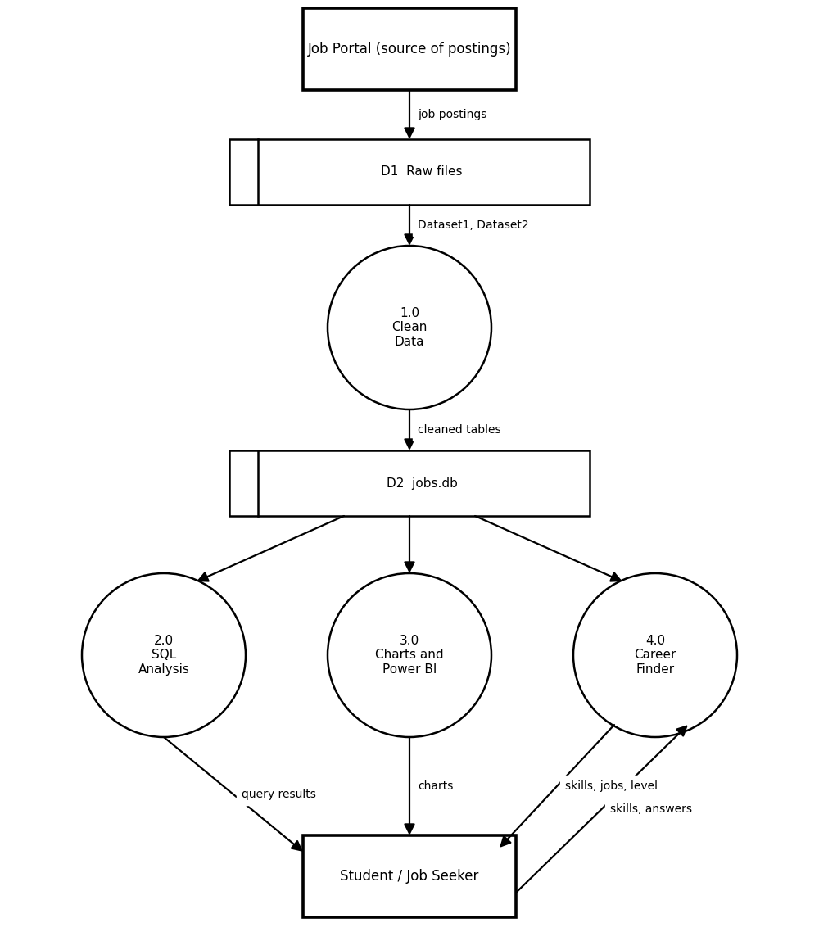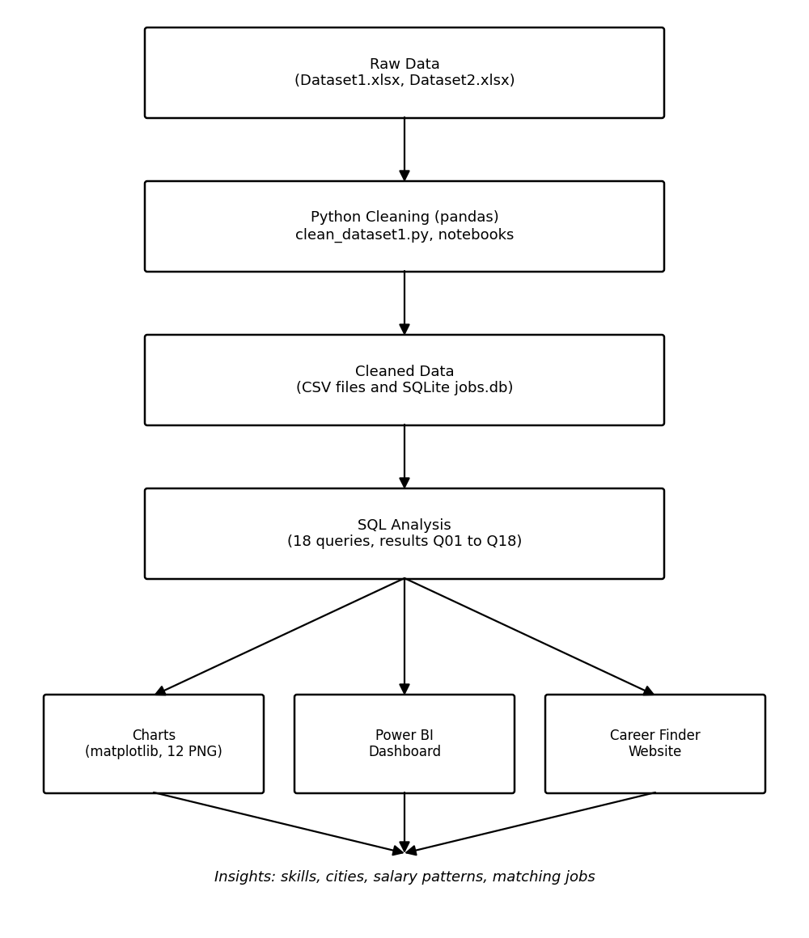
9.SAMPLE OUTPUT

Login and Create Account Page
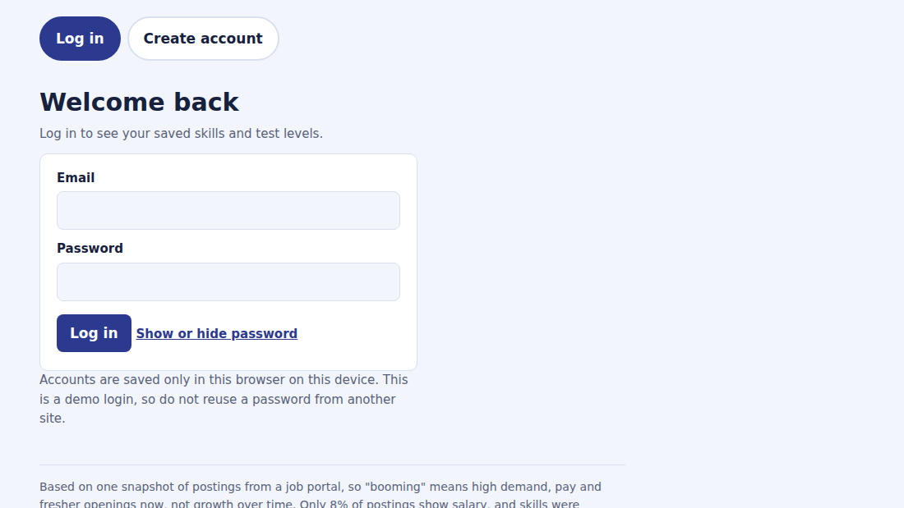
Booming Careers Page
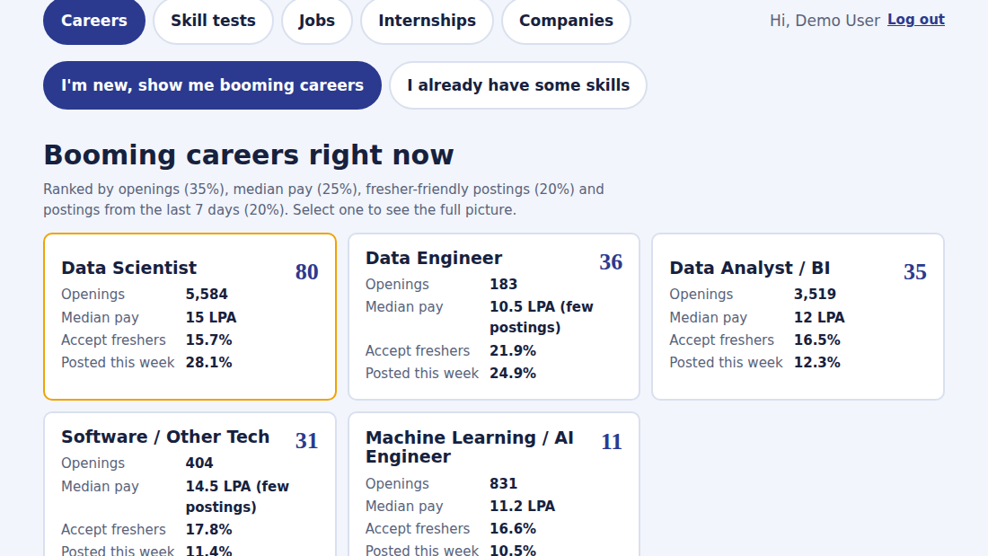
Skill Tests Page
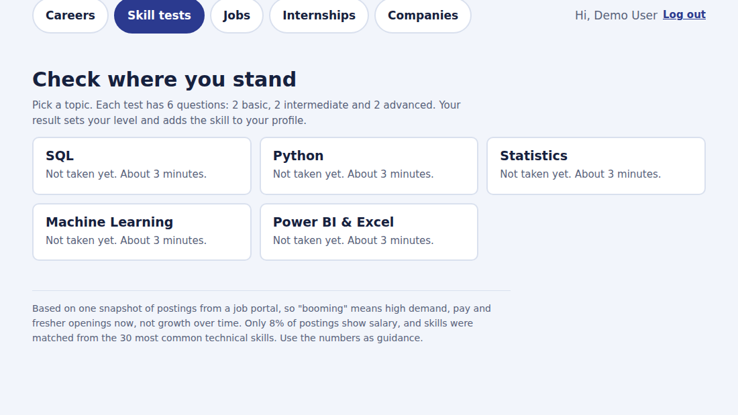
Jobs Page
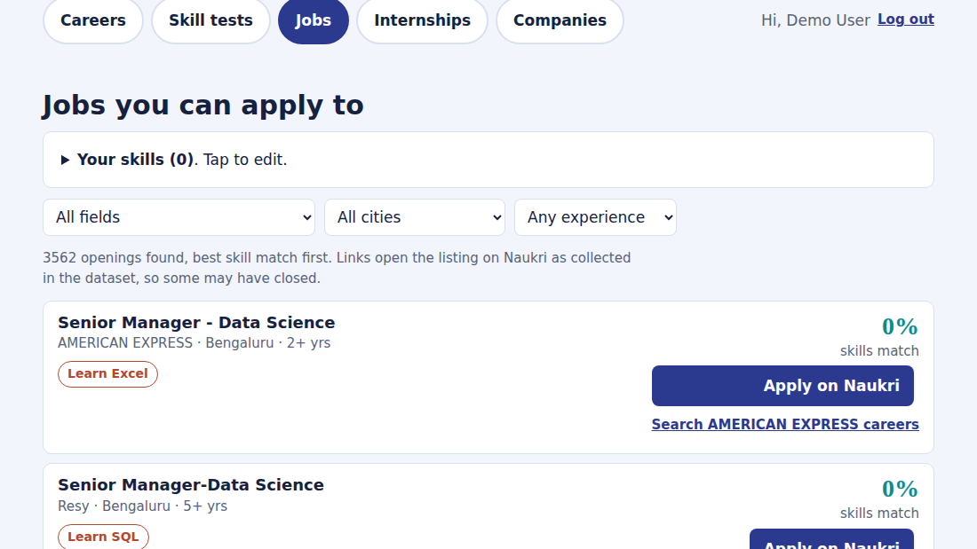
Internships Page
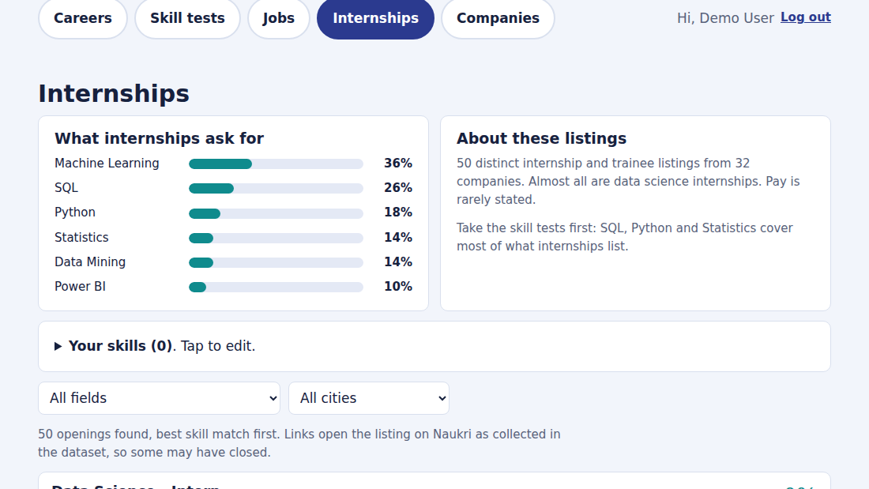
Companies Page
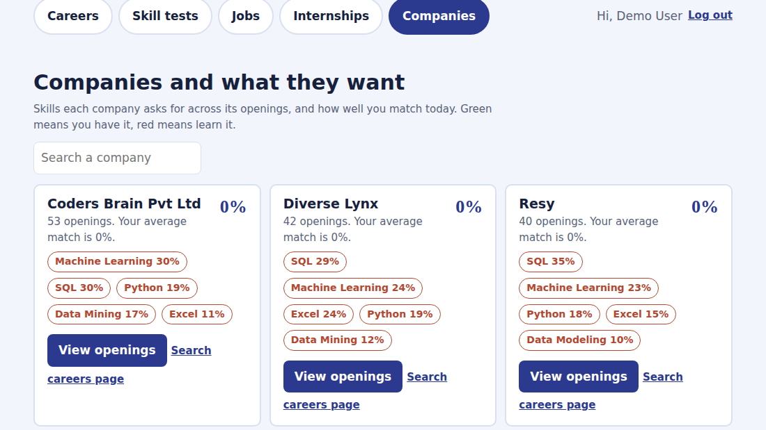
10.PROJECT CONCLUSION

The AI & Tech Job Market Analysis project shows how raw job postings can be turned into useful guidance. By cleaning 12,140 postings with Python, analysing them with SQL and presenting them through charts, a Power BI dashboard and the Career Finder website, the project makes the demand for skills, cities and salary easy to understand.
The main findings are that Machine Learning (28.1%), SQL (24.6%) and Python (13.1%) are the most requested technical skills. Bengaluru has 22.3% of all openings, and Gurugram has the highest median salary (20.2 LPA). The median disclosed salary is 12.5 LPA, although only 8.2% of postings disclose pay, and Power BI is requested about twice as often as Tableau.
The results are based on one snapshot of postings, so they should be used as guidance. In the future the project can be extended with newer postings to show change over time, more skills, and secure authentication for the website.
11.REFERENCES

• pandas Documentation – https://pandas.pydata.org/docs/
• Matplotlib Documentation – https://matplotlib.org/stable/
• SQLite Documentation – https://www.sqlite.org/docs.html
• Microsoft Power BI Documentation – https://learn.microsoft.com/power-bi/
• MDN Web Docs (HTML, CSS and JavaScript) – https://developer.mozilla.org/

