Subscriber Churn Prediction Using Machine Learning: A Cross-Platform Comparison on Three Independent Streaming Datasets
Vishali K
Department of Computer Applications (MCA), Fatima College, Madurai, India
vishali67891@gmail.com

ABSTRACT
Subscriber churn is among the most consequential commercial risks for subscription streaming services, yet a model validated on a single dataset can give a misleading picture of what works. This study applies one identical machine-learning pipeline to three independent streaming-subscriber datasets comprising 6,963 subscribers in total and compares three classifiers: Logistic Regression, Random Forest and Gradient Boosting. A cross-file identifier check showed that one of four supplied files duplicated another, and the duplicate was excluded before analysis. Churn prevalence differed sharply across the remaining platforms (50.3%, 17.6% and 53.9%), and so did model performance. Gradient Boosting reached an F1-score of 0.991 (AUC 0.999) on Platform A, a result better read as a warning about synthetic data than as a real-world ceiling. On Platform B, models reached 81–83% accuracy yet recalled as little as 7.1% of departing customers, because a classifier that predicts that nobody leaves already scores 82.4%. On Platform C, F1-scores were confined to 0.602–0.638 and the best AUC was 0.59. The spread in performance between datasets was far larger than the spread between algorithms. One signal was stable: a viewing-intensity variable ranked among the top three predictors on every platform. On this basis the paper proposes a three-tier, closed-loop retention framework that converts churn risk into graded interventions. All datasets are synthetic or of unconfirmed provenance, so the findings concern methodology rather than any named service.
Keywords: churn prediction; streaming services; machine learning; class imbalance; feature importance; gradient boosting

1. INTRODUCTION
Subscription streaming services earn revenue from sustained customer relationships rather than one-off purchases, so every cancellation removes a stream of future income. Retaining an existing subscriber is widely regarded as cheaper than acquiring a replacement, which has made churn prediction, the task of identifying subscribers likely to cancel before they do so, a central application of machine learning in the subscription economy.
Most churn studies report results on a single dataset. A model that scores well on one dataset says little about whether the same approach would work on another, because churn prevalence, available features and data quality vary from platform to platform. High headline accuracy can also be misleading when churners are a minority, since a model can score well simply by predicting that everyone stays (Saito & Rehmsmeier, 2015).
This paper takes a cross-platform view. One identical pipeline is applied to three independent streaming datasets, and the results are examined for what changes and what stays constant. The study addresses four questions. First, how much does predictive performance vary when the pipeline is held fixed and only the dataset changes? Second, which of three common classifiers performs best, and does the ranking hold on every platform? Third, which customer signals consistently predict churn? Fourth, how can a churn score be turned into a practical retention action?
The main findings are that the dataset matters more than the algorithm, that accuracy alone is not evidence of a useful churn model, and that viewing intensity is the most reliable signal. The remainder of the paper is organised as follows. Section 2 gives background, Section 3 describes the data and method, Section 4 reports the results, Section 5 discusses them, Section 6 proposes a retention framework, Section 7 sets out limitations, and Section 8 concludes.

2. BACKGROUND
Churn prediction is commonly framed as binary classification. Each subscriber is labelled as having churned or been retained, and a model learns to predict that label from usage, billing, support and demographic attributes. Three model families are widely used for this kind of tabular problem. Logistic Regression models the log-odds of churn as a linear function of the features and serves as an interpretable baseline (Hosmer et al., 2013). Random Forest averages many decision trees trained on resampled data and random feature subsets, which reduces variance and captures non-linear interactions (Breiman, 2001). Gradient Boosting builds trees sequentially, with each new tree correcting the errors of the ensemble so far (Friedman, 2001).
Evaluation needs particular care when classes are imbalanced. Accuracy is the share of all predictions that are correct, so on a dataset in which 17.6% of subscribers churn, a model that never predicts churn is 82.4% accurate while identifying no one at risk. Recall, the share of true churners that the model catches, and the F1-score, the harmonic mean of precision and recall, expose this failure. The area under the ROC curve (AUC) summarises how well a model ranks churners above non-churners across all decision thresholds. Where positives are rare, precision-recall measures are generally more informative than ROC-based ones (Saito & Rehmsmeier, 2015). Class weighting, threshold tuning and oversampling methods such as SMOTE (Chawla et al., 2002) are common remedies for imbalance.

3. DATA AND METHODOLOGY

3.1 Data Acquisition and Provenance Screening
Four data files were received for the study. Two of them were named in a way that suggested they were independent datasets. Before any modelling, subscriber identifiers were cross-joined across the files. All 5,000 identifiers in the two suspect files matched (5,000 of 5,000), and both files carried an identical churn rate of 50.3%, so they were treated as the same dataset. The file labelled as the cleaned version turned out to be the messier of the two, a reminder that file names cannot substitute for verification. The duplicate was excluded, which reduced the comparison from four platforms to three.

3.2 The Three Platform Datasets
Table 1 summarises the retained datasets, referred to throughout as Platforms A, B and C. Platform A (netflix_customer_churn.csv) holds 5,000 records and records watch hours, login recency, subscription plan and payment method. Platform B (Subscription_Service_Churn.csv) holds 963 records with billing, viewing duration, support-ticket and rating information. Platform C (netflix_large_user_data.xlsx) holds 1,000 records with satisfaction, engagement rate, income and promotion usage. The platforms differ in size, churn prevalence and feature set, which is precisely the variation the study sets out to examine.
Table 1. Characteristics of the three platform datasets.
Platform | Records | Churn rate | Representative feature groups
A | 5,000 | 50.3% | Watch hours, login recency, plan type, payment method
B | 963 | 17.6% | Billing, viewing duration, support tickets, ratings
C | 1,000 | 53.9% | Satisfaction, engagement rate, income, promotion usage

3.3 Modelling and Evaluation Protocol
The same pipeline was applied to every platform. Three classifiers (Logistic Regression, Random Forest and Gradient Boosting) were trained on each dataset and evaluated on a held-out test set that was not used during training. Feature engineering was kept identical across platforms by design. This limits how far any dataset can be tuned to its own quirks, but it protects the like-for-like comparison, so that differences in results can be attributed to the data rather than to bespoke preprocessing.
Performance was measured primarily with the F1-score and AUC, with accuracy and recall reported where they reveal how a model fails. Accuracy is reported alongside recall for Platform B because the two diverge sharply there. Feature importance scores were used to identify the variables that drive predictions on each platform, and these were then compared across platforms.

4. RESULTS

4.1 Overall Model Performance
Churn prevalence before modelling was 50.3% on Platform A, 17.6% on Platform B and 53.9% on Platform C. Figure 1 shows the F1-score of each model on each platform’s test set.
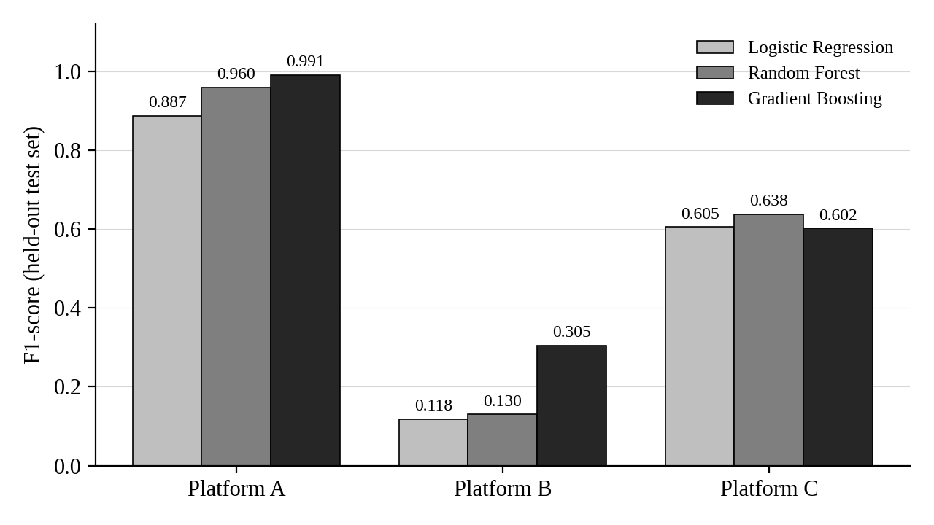
Figure 1. F1-score of Logistic Regression, Random Forest and Gradient Boosting on the held-out test set of each platform.
Gradient Boosting achieved the highest F1-score on Platform A (0.991, against 0.960 for Random Forest and 0.887 for Logistic Regression) and on Platform B (0.305, against 0.130 and 0.118). On Platform C the three models were within 0.036 of one another, with F1-scores of 0.602 for Gradient Boosting, 0.605 for Logistic Regression and 0.638 for Random Forest, close enough that their ranking should be treated with caution on 1,000 records. Gradient Boosting is therefore the strongest model on two platforms and competitive on the third, but this ranking is a secondary result.
The more important result is the vertical distance between platforms. The best F1-score on each platform ranged from 0.305 (Platform B) to 0.991 (Platform A), a gap of 0.686. By contrast, the largest gap between models within any single platform was 0.187 (Platform B), and on Platform C it was only 0.036. In this study, the choice of dataset moved performance far more than the choice of algorithm.

4.2 Platform-Level Findings
Table 2 summarises the headline result on each platform, and the paragraphs that follow interpret them.
Table 2. Headline results and interpretation by platform.
Platform | Best F1-score | Other headline metric | Reading
A | 0.991 (Gradient Boosting) | AUC 0.999 | Near-perfect, consistent with a dataset built to contain a clean, learnable relationship
B | 0.305 (Gradient Boosting) | Recall as low as 7.1%; accuracy 81–83% | High accuracy driven by the majority class; minority churners largely missed
C | 0.638 (Random Forest) | Best AUC 0.59 | Rich features but weak signal

Platform A. Gradient Boosting reached an F1-score of 99.1% and an AUC of 0.999. Scores this close to perfect are a warning rather than a success. Engagement variables account for over 60% of total feature importance (average daily watch time alone contributes 0.420 and total watch hours 0.210), and an AUC of 0.999 is consistent with a dataset generated to contain a clean, learnable relationship between engagement and churn. The result should not be presented as a ceiling that a deployed model could reach on real subscribers.
Platform B. Models on Platform B attained accuracy of 81–83%, which appears acceptable, but recall was as low as 7.1%. With 17.6% of subscribers churning, a model that predicts that nobody leaves scores 82.4% accuracy, so these accuracy figures are roughly what the trivial baseline achieves. Logistic Regression and Random Forest flagged fewer than one in twelve departing customers. Gradient Boosting performed better (F1 = 0.305) but remained weak. The dataset has 963 rows, of which about 170 are churners, a minority class too small for stable estimates. A retention team cannot use a model that hides nearly all of the customers it needs to find, and accuracy alone rewards exactly this behaviour.
Platform C. Platform C has a rich feature set, including satisfaction, engagement rate, income and promotion usage, yet the signal was weak: the best AUC was 0.59 and F1 did not exceed 0.64. Daily watch time led the importance ranking (0.125), but monthly income (0.120) and age (0.115) followed immediately behind. Self-reported satisfaction and engagement rank below these basic demographic variables. Having many features available is not the same as having relevant ones.

4.3 Churn Drivers
Figure 2 shows the five most important features on each platform. A viewing-intensity variable was among the top three predictors on every platform. Average daily watch time and total watch hours ranked first and second on Platform A, average viewing duration ranked second on Platform B, and daily watch time ranked first on Platform C. Account tenure and login recency were also strong wherever they were recorded: account age was the top predictor on Platform B (0.125) and days since last login ranked third on Platform A (0.180).
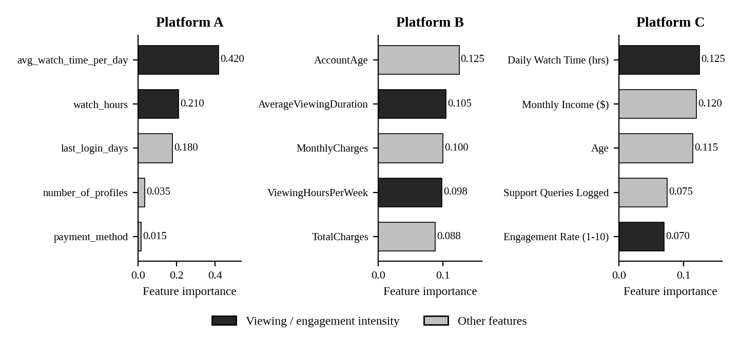
Figure 2. Top five feature importances on each platform. Dark bars mark viewing and engagement intensity variables.
Two groups of variables were consistently weak. Demographics, with the exception of age on Platform C, and content preference, such as genre and content type, ranked low on every platform where they were tested. The practical reading is that if a retention system can monitor only one thing, it should monitor how much subscribers are actually watching.

5. DISCUSSION

5.1 The Dataset Outranks the Algorithm
Because the pipeline was identical across platforms, the large differences in Figure 1 can be traced to the data. Class balance, feature relevance and provenance set the ceiling on performance before any model is trained. Platform B was limited by class imbalance and a small minority class, Platform C by features that carried little signal about churn, and Platform A by an apparently engineered relationship between engagement and churn. For practitioners, this suggests that effort spent on data quality and on understanding what a dataset can support will usually repay more than effort spent comparing algorithms. It also means that a model benchmarked on one dataset should not be assumed to transfer to another. Since the datasets here are synthetic or of unconfirmed origin, some of the between-dataset differences may also reflect how the data were generated.

5.2 Accuracy Is Not Evidence
An accuracy of 83% with a recall of 7.1% describes a model that has learned to say that nobody leaves. It is the practical consequence of evaluating on accuracy when churn is the minority outcome. Reports of churn models should therefore state the majority-class baseline, give recall and F1 for the churn class, and include AUC. On this evidence, the Platform B accuracy figures say nothing in the model’s favour, and the F1-scores in Figure 1 are the more honest summary.

5.3 Engagement Is the Signal
Viewing intensity is the one signal that survived across all three datasets, despite their different sizes, churn rates and feature sets. Tenure and login recency add predictive value where they are recorded. These findings describe association rather than cause: a decline in viewing may be a symptom of disengagement rather than its origin, and the study does not test whether raising viewing would reduce churn. Even so, a measure that is cheap to collect, available on most platforms and predictive in every dataset tested is a sensible first input to a retention system.

6. PROPOSED RETENTION FRAMEWORK
The findings suggest that churn modelling should end in an action rather than a score. The proposed framework converts each subscriber’s predicted churn risk into one of three response tiers, shown in Table 3.
Table 3. Risk tiers and corresponding retention actions.
Risk tier | Response | Typical interventions
Low | Standard engagement | Regular release updates and standard promotional newsletters
Moderate | Automated nudges | Push notifications, personalised content recommendations and email reminders
High | Personalised action | Direct phone outreach, custom support and targeted win-back discount offers

The framework is a closed loop: the outcome of every intervention is written back as a training label, so the model learns from what actually retained or lost each customer. Two layers follow from the findings of this study. The feature layer prioritises the strongest signals identified in Section 4.3, namely viewing intensity together with account tenure and login recency where they are recorded. The model layer addresses the imbalance failure observed on Platform B, using methods such as class weighting, SMOTE (Chawla et al., 2002) and decision-threshold tuning, and is judged on F1 and AUC rather than accuracy. Tier boundaries would be set on the model’s predicted churn probability and calibrated to the capacity of the retention team, since high-touch interventions such as phone outreach are costly and can be offered to only a limited number of subscribers.

7. LIMITATIONS
Several limitations bound these conclusions. First, all three datasets are synthetic or of unconfirmed provenance, and none represents a verified, named streaming service, so absolute performance figures should not be transferred to real services. Second, the 963 rows of Platform B contain roughly 170 churned customers, too few for stable minority-class estimates. Third, the discovery of a duplicate file reduced the comparison from four platforms to three, narrowing the evidence base. Fourth, feature engineering was kept identical across platforms by design, to protect the like-for-like comparison; platform-specific tuning that might raise individual scores was therefore deliberately not attempted.

8. CONCLUSION AND FUTURE WORK
This study compared Logistic Regression, Random Forest and Gradient Boosting on three streaming-subscriber datasets totalling 6,963 subscribers, using one identical pipeline. Three conclusions follow. First, engagement is the signal: viewing intensity ranked among the top three predictors on every platform, with tenure and login recency following wherever they were recorded. Second, the dataset outranks the algorithm: Gradient Boosting was the strongest model on two platforms and competitive on the third, but the spread between datasets was far larger than the spread between models. Third, accuracy is not evidence: 83% accuracy alongside 7.1% recall is a model that has learned to say that nobody leaves, and churn models should be reported with F1 and AUC. The paper also proposes a three-tier, closed-loop retention framework that links churn risk to graded actions.
Four directions would strengthen this work. The first is verified data from real, named streaming platforms. The second is systematic treatment of class imbalance through class weighting, SMOTE and threshold tuning. The third is richer features, in particular sequence and trend features derived from raw playback. The fourth is live validation, testing the framework against real churn outcomes.

REFERENCES
Breiman, L. (2001). Random forests. Machine Learning, 45(1), 5–32.
Chawla, N. V., Bowyer, K. W., Hall, L. O., & Kegelmeyer, W. P. (2002). SMOTE: Synthetic minority over-sampling technique. Journal of Artificial Intelligence Research, 16, 321–357.
Friedman, J. H. (2001). Greedy function approximation: A gradient boosting machine. The Annals of Statistics, 29(5), 1189–1232.
Hosmer, D. W., Lemeshow, S., & Sturdivant, R. X. (2013). Applied logistic regression (3rd ed.). John Wiley & Sons.
Saito, T., & Rehmsmeier, M. (2015). The precision-recall plot is more informative than the ROC plot when evaluating binary classifiers on imbalanced datasets. PLOS ONE, 10(3), e0118432.

