Wi-Fi Password Security Auditor
Technical Documentation
This document describes the design, functionality, scoring logic, and usage of the Wi-Fi Password Security Auditor, a browser-based tool that evaluates the security posture of a Wi-Fi network configuration.

Table of Contents
- 1. Overview
- 2. Key Features
- 3. Application Architecture
- 4. User Interface Walkthrough
- 5. How the Audit Works
- 6. Scoring System
- 7. Security Concepts Reference
- 8. Element Reference
- 9. Customization Guide
- 10. Privacy & Data Handling
- 11. Known Limitations
- 12. Future Enhancements
- 13. Conclusion

1. Overview
The Wi-Fi Password Security Auditor is a single-page, client-side web application that allows a user to evaluate the overall security of a Wi-Fi network configuration. Unlike a basic password checker, this tool audits four combined factors of network security:
- The strength of the Wi-Fi password itself
- Whether the password is a commonly used weak password
- Whether the password is related to the network name (SSID)
- The wireless security protocol and WPS configuration of the router
The application produces a single security score out of 100, a color-coded rating (Strong / Moderate / Weak), a detailed pass/fail/warning checklist, and a list of actionable recommendations.
The tool is built entirely with HTML, CSS, and JavaScript, with no external libraries, backend server, or network requests — all evaluation happens locally in the user's browser.

2. Key Features
- Real-time, on-demand Wi-Fi security audit triggered by a single button
- Composite 0–100 security score combining password strength and router configuration
- Color-coded results: 🟢 Strong, 🟡 Moderate, 🔴 Weak
- Detailed checklist with pass, fail, and warning states for each factor
- Dynamic, context-aware recommendations based on detected weaknesses
- Common weak-password detection against a built-in blocklist
- SSID-in-password detection to flag predictable passwords
- Security protocol evaluation (WPA3, WPA2, Mixed, WPA, WEP, Open)
- WPS (Wi-Fi Protected Setup) status check
- Show/Hide toggle for the password field
- No data transmission — all logic runs client-side in the browser

3. Application Architecture
The application is delivered as a single self-contained HTML file with inline CSS and JavaScript. This design keeps the tool portable and easy to distribute or embed.
Layer | Technology | Responsibility
Structure | HTML5 | Form inputs (SSID, password, security mode, WPS) and results layout
Styling | CSS3 (embedded in <style>) | Card-based layout, color-coded checks, responsive progress bar
Logic | Vanilla JavaScript (embedded in <script>) | Input handling, scoring algorithm, DOM rendering of results

Because everything is contained in one file, the tool has no build step and no dependency installation — it can be opened directly in any modern browser.

4. User Interface Walkthrough

4.1 Input Section
The form collects four pieces of information before an audit can run:
Field | Element ID | Type | Purpose
Wi-Fi Network Name | #ssid | Text input | Used to check whether the password contains the SSID
Wi-Fi Password | #password | Password input | The password being audited
Wi-Fi Security Mode | #security | Dropdown | The encryption protocol in use on the router
WPS Status | #wps | Dropdown | Whether WPS (a known attack vector) is enabled

4.2 Show/Hide Password Toggle
The #showPassword button toggles the password input's type attribute between "password" and "text", switching the button label between "Show" and "Hide" accordingly. This lets users visually verify what they typed without permanently exposing the field.

4.3 Audit Button
Clicking "🔍 Audit Wi-Fi Security" runs the auditWiFi() function, which performs the full evaluation and reveals the results panel (#result), previously hidden via CSS (display: none).

4.4 Results Panel
Once an audit completes, three components are displayed:
- Score Card — a large numeric score (0–100), a color-coded label, and an animated progress bar
- Security Checks — a list of individual pass/fail/warning items, each with a colored left border
- Recommendations — a dynamically generated bulleted list of suggested improvements

4.5 Privacy Notice
A footer note reassures the user that the password is evaluated locally and is not uploaded, reinforcing the client-side nature of the tool.

5. How the Audit Works
The auditWiFi() function runs seven independent checks each time the audit button is clicked. Each check appends an entry to a checks array (rendered in the checklist) and, where relevant, a suggestion to a recommendations array. Every check also adjusts a running score variable.

5.1 Password Length
Condition | Points | Result
16+ characters | +20 | Pass — "Password length is 16 characters or longer."
12–15 characters | +15 | Warning — recommends 16+ characters
Under 12 characters | +0 | Fail — recommends increasing length

5.2 Character Variety
Four independent regex checks each contribute up to +10 points if present:
Character Type | Regex | Points if Present
Uppercase letters | /[A-Z]/ | +10
Lowercase letters | /[a-z]/ | +10
Numbers | /[0-9]/ | +10
Special characters | /[^A-Za-z0-9]/ | +10

Each missing character type produces a warning (not a hard fail), since character variety alone does not guarantee — or invalidate — a strong password.

5.3 Common Password Detection
The password (converted to lowercase) is checked against a built-in blocklist of known weak passwords, including entries such as "password", "12345678", "qwerty123", and "iloveyou".
Outcome | Points | Result
Password matches blocklist | -30 | Fail — flagged as a commonly used weak password
Password not in blocklist | +10 | Pass — not found in the basic weak-password list

5.4 SSID Relation Check
If an SSID is provided, the tool checks whether the password contains the network name (case-insensitive).
Outcome | Points | Result
Password contains the SSID | -15 | Fail — recommends avoiding the SSID in the password
Password does not contain the SSID | +5 | Pass — SSID not found in password

5.5 Security Protocol Evaluation
The selected Wi-Fi security mode contributes the largest single point swing in the audit, since the encryption protocol determines the baseline security of all traffic on the network:
Security Mode | Points | Result
WPA3 | +20 | Pass — strongest currently available protocol
WPA2 | +17 | Pass — recommends upgrading to WPA3 if supported
WPA2/WPA3 Mixed | +15 | Pass — compatible transitional mode
WPA | +5 | Fail — outdated, recommends upgrading the router
WEP | -20 | Fail — obsolete and insecure, recommends replacement
Open (no encryption) | -25 | Fail — recommends enabling WPA2 or WPA3

5.6 WPS Status Check
WPS Status | Points | Result
Disabled | +5 | Pass — WPS is disabled
Enabled | +0 | Warning — recommends disabling WPS if not needed

WPS is flagged because its PIN-based pairing method is a well-documented weak point that can allow attackers to bypass an otherwise strong password.

5.7 Score Clamping
score = Math.max(0, Math.min(100, score));
Because some checks subtract points (weak password, SSID match, weak protocols), the raw total could theoretically fall below 0 or, in rare combinations, exceed 100. The final score is clamped to the 0–100 range before being displayed.

6. Scoring System
After all seven checks run and the score is clamped, it is mapped to one of three overall ratings:
Score Range | Rating | Label | Bar / Text Color
80–100 | Strong | 🟢 Strong Wi-Fi Security | Green (#16a34a)
60–79 | Moderate | 🟡 Moderate Wi-Fi Security | Amber (#f59e0b / #d97706)
0–59 | Weak | 🔴 Weak Wi-Fi Security | Red (#dc2626)

The progress bar's width is set directly to the numeric score percentage (score + "%"), and its background color matches the rating tier, giving an immediate visual read of network security alongside the numeric score.

7. Security Concepts Reference
For users unfamiliar with wireless security terminology, the following reference explains the protocols and settings evaluated by the tool.

7.1 Wi-Fi Security Protocols
Protocol | Status | Notes
WPA3 | Current standard | Strongest available consumer encryption; resistant to offline dictionary attacks
WPA2 | Widely supported | Secure when configured correctly; still acceptable but being phased out in favor of WPA3
WPA2/WPA3 Mixed | Transitional | Allows both WPA2 and WPA3 devices to connect; a reasonable compromise for mixed device environments
WPA | Outdated | Superseded by WPA2; vulnerable to known attacks
WEP | Obsolete | Can be cracked in minutes with widely available tools; should never be used
Open Network | Insecure | No encryption at all; all traffic is visible to anyone within range

7.2 WPS (Wi-Fi Protected Setup)
WPS is a router feature designed to simplify device pairing, typically via an 8-digit PIN or a physical button. The PIN method has a well-known design flaw that allows attackers to brute-force it in a matter of hours, potentially exposing the Wi-Fi password even if it is otherwise strong. Disabling WPS removes this attack surface entirely.

8. Element Reference
Element ID | Description
#ssid | Text input for the Wi-Fi network name
#password | Password input being audited
#showPassword | Toggles password visibility between masked and plain text
#security | Dropdown selecting the router's Wi-Fi security protocol
#wps | Dropdown selecting whether WPS is enabled or disabled
#result | Container for the results panel, hidden until an audit runs
#score | Displays the numeric score out of 100
#scoreLabel | Displays the color-coded overall rating text
#scoreBar | Progress bar reflecting the score visually
#checks | Container populated with individual pass/fail/warning check entries
#recommendations | Container populated with the dynamically generated recommendation list

9. Customization Guide

9.1 Adjusting Point Values
All scoring weights are defined inline within auditWiFi() in the <script> block. For example, to make length more heavily weighted:
if (password.length >= 16) { score += 20; ... } // increase 20 to weight length more heavily

9.2 Expanding the Common Password Blocklist
Add more entries to the commonPasswords array to catch additional weak passwords relevant to your context:
const commonPasswords = [
"password", "password123", "12345678", "qwerty123",
"yourNewEntryHere"
];

9.3 Adding a New Security Check
New checks can be added by following the existing pattern: run a condition, adjust score, and push an entry into checks (and recommendations, if applicable). For example, checking password entropy or requiring a minimum number of unique characters.

9.4 Changing Score Thresholds
The 80 / 60 cutoffs for Strong / Moderate / Weak can be adjusted in the score-display logic:
if (score >= 80) { ... } else if (score >= 60) { ... } else { ... }

10. Privacy & Data Handling
- All form inputs (SSID, password, security mode, WPS status) are processed entirely within the browser's JavaScript engine.
- No network requests, cookies, local storage, or external APIs are used — nothing is saved or transmitted.
- Refreshing or closing the page discards all entered data immediately.
- The in-app privacy notice explicitly informs users that their password stays local to the browser session.
This client-side-only design makes the tool safe to use for auditing real network passwords, since no third party (including the tool's author) ever receives the entered data.

11. Known Limitations
- The common-password blocklist is small and illustrative; it does not reflect real-world breach databases (e.g. Have I Been Pwned or rockyou.txt).
- Scoring is rule-based and additive rather than based on true password entropy calculations, so unusual edge cases may be scored inconsistently (e.g. a very long but low-entropy repeated string).
- The tool cannot verify router-side settings directly (security mode and WPS status are self-reported by the user via dropdowns, not detected automatically).
- No accessibility (ARIA) labels are currently implemented for screen reader users.
- The negative-scoring checks (common password, SSID match, weak protocols) can combine to produce a low score even when individual character-variety checks pass, which is intentional but may surprise first-time users.

12. Future Enhancements
- Integrate a real breach-password database (e.g. via k-anonymity API lookups) for stronger common-password detection
- Replace additive scoring with an entropy-based or zxcvbn-style strength model
- Auto-detect router security settings where browser/network APIs allow
- Add ARIA live regions and labels for full accessibility support
- Add a printable/exportable audit report (PDF)
- Support auditing multiple saved networks in one session

Output images:
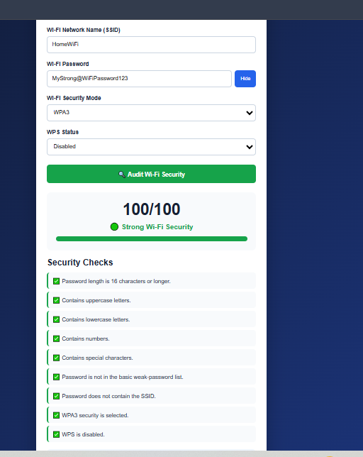

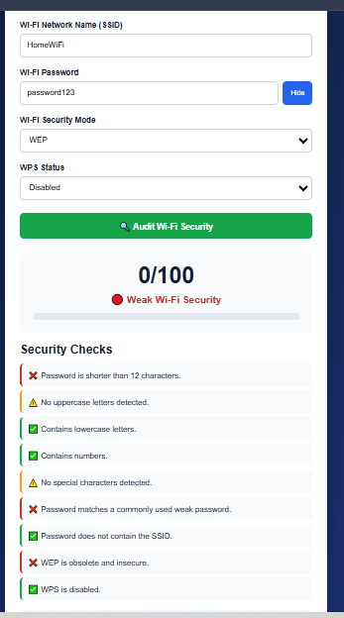

13. Conclusion
The Wi-Fi Password Security Auditor extends the concept of a simple password strength checker into a more complete network security assessment tool. By combining password quality, common-password detection, SSID-relation analysis, encryption protocol strength, and WPS configuration into a single composite score, it gives users a realistic, holistic view of their Wi-Fi network's exposure rather than judging the password in isolation.
Its entirely client-side architecture is a deliberate and meaningful design choice: because no data ever leaves the browser, users can safely audit their real, in-use network credentials without introducing new privacy or security risk — a critical property for a tool whose entire purpose is handling sensitive credentials.
That said, the tool is best understood as an educational and awareness-building aid rather than a certified security assessment. Its rule-based scoring, small weak-password blocklist, and self-reported router settings mean it should be used to guide better habits and configuration choices, not as a substitute for professional network security auditing or automated penetration testing.
With a larger breach-password dataset, entropy-based scoring, and improved accessibility, this tool could evolve into a more robust, production-ready security awareness utility while keeping the simplicity and privacy-first design that make it approachable today.

