**EXCEPTIONS**

* Try block (**put exceptions**)
* Catch block (**Handling an exception**)
* We **shouldn’t keep any statement between try () and catch () block**.
* Try block must be followed with catch and finally.
* Exceptions: Mistake or wrong code.

The ‘**throwable class**’ is the **super class** of all Java exceptions and errors.

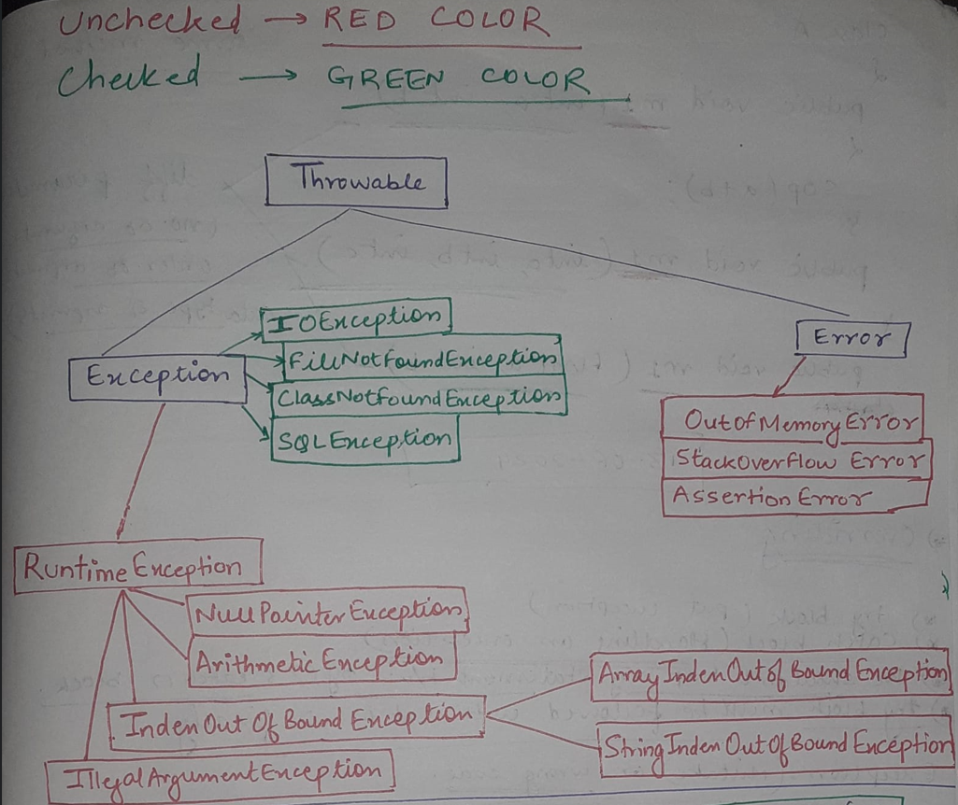

**Checked Exceptions (compile-time)**: During compilation if we get any exception that is checked exception.

**Unchecked Exception (run-time)**: During running of the program if we get any exception that is unchecked exception.

**FINALLY BLOCK:**

* Finally block purpose: It is a **mandatory block**. It will be executed all the time if we get exception or not.
* The purpose of ‘finally’ block is to do **resource cleanup**.
* finally, should be always come after try and catch block.

try () {

} catch {

} finally {

}

**THROW:**

* Comes inside a method.
* For custom exceptions or our own exceptions.
* Followed with an object.
* One exception at a time.

**THROWS:**

* Followed with class.
* Followed with method signature.
* Any number of exceptions at a time.