EXPRIMENT-2
A SIMPLE FLIGHT RESERVATION SYSTEM
Aim:
To create a simple cloud-based Flight Reservation System using a cloud service provider to demonstrate the Software as a Service (SaaS) model.
Procedure:
- Log in to the cloud platform (e.g., Zoho Creator).
- Create a new application named Flight Reservation System.
- Design a form to store flight details such as Flight Number, Airline, Source, Destination, Date, Time, Fare, and Available Seats.
- Create a passenger registration form with details such as Passenger Name, Age, Gender, Phone Number, and Email.
- Create a booking form to record flight reservations, travel date, seat selection, and payment status.
- Generate reports to display available flights, booked tickets, and passenger booking history.
- Save and deploy the application on the cloud platform.
- Test the application by adding sample flight and passenger details and verify that the booking information is stored and accessed online.
2.1 PASSENGER DETAILS
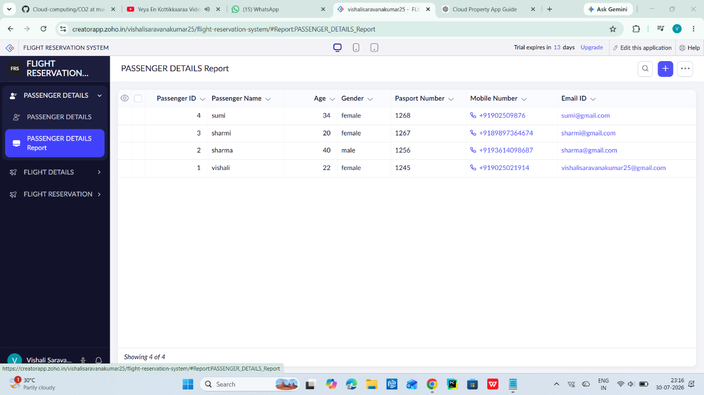
2.2 FLIGHT DETAILS
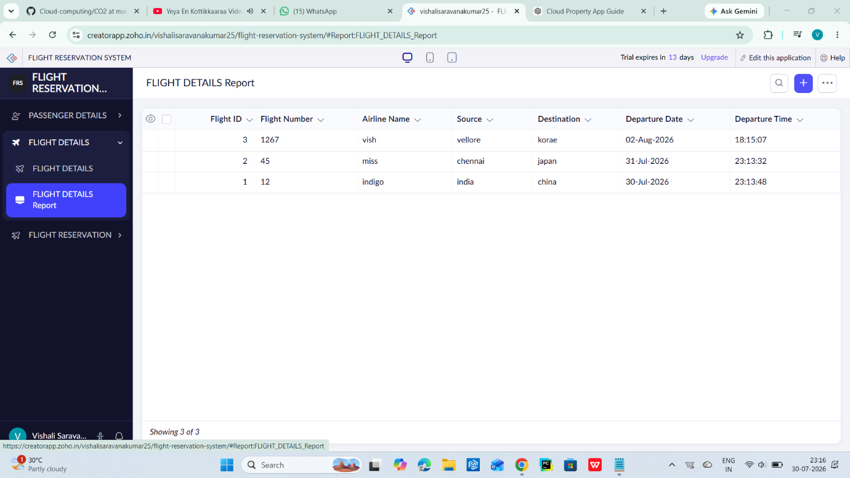
2.3 FLIGHT RESERVATION
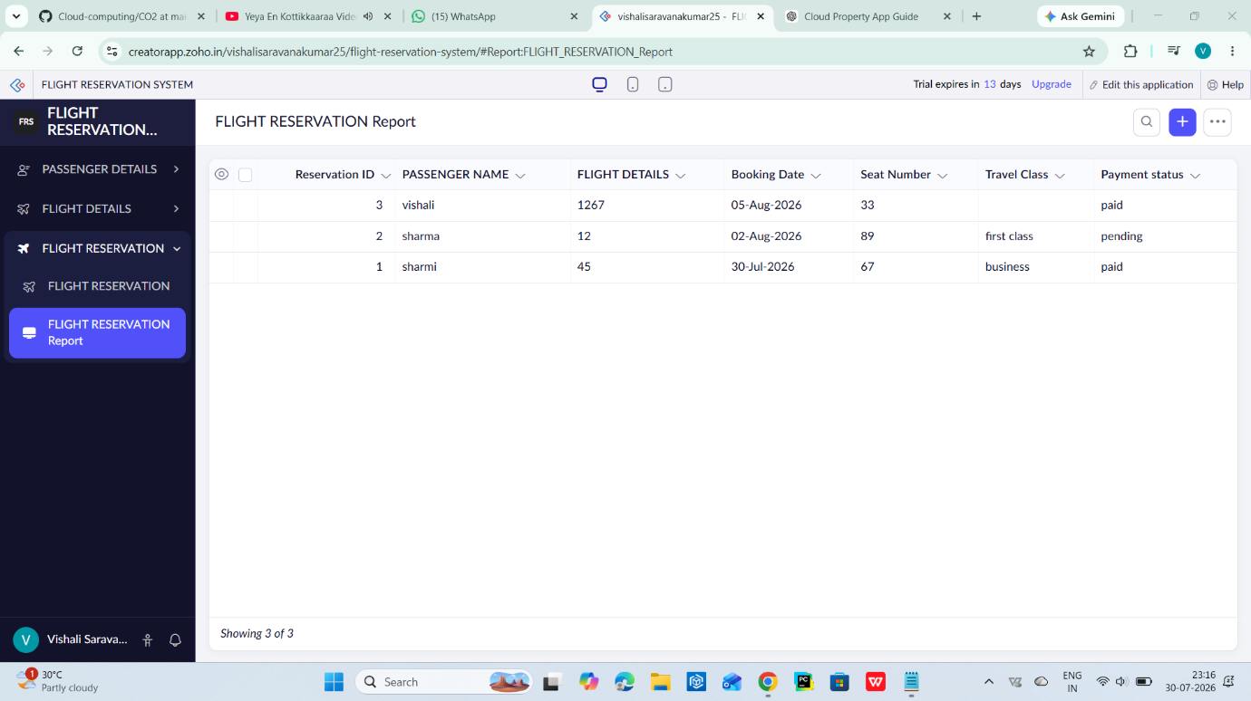
Result:
A cloud-based Flight Reservation System was successfully created and deployed. The application enables users to search flights, book tickets, and manage reservation details online, demonstrating the Software as a Service (SaaS) model in cloud computing.

