EXPRIMENT -24
A APPLICATION FOR STUDENTS ATTENDENCE SYSTEM
Aim:
To create a simple cloud-based Student Attendance System using a cloud service provider to demonstrate the Software as a Service (SaaS) model.
Procedure:
- Log in to the cloud platform (e.g., Zoho Creator).
- Create a new application named Student Attendance System.
- Design a form to store student details such as student ID, name, department, year, and section.
- Create an attendance form with fields for date, subject, student name, and attendance status (Present/Absent).
- Generate reports to view daily, weekly, and monthly attendance records.
- Save and deploy the application on the cloud platform.
- Test the application by adding sample student records and marking attendance.
- Verify that the attendance data is stored securely and can be accessed online.
24.1 STUDENT DETAILS
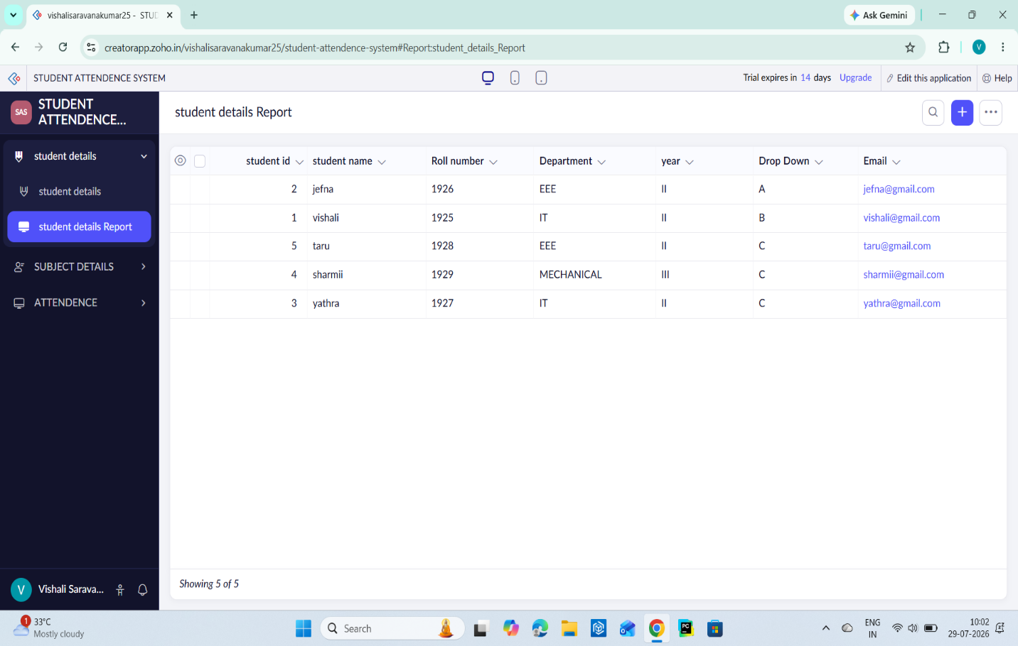

24.2 SUBJECT DETAILS
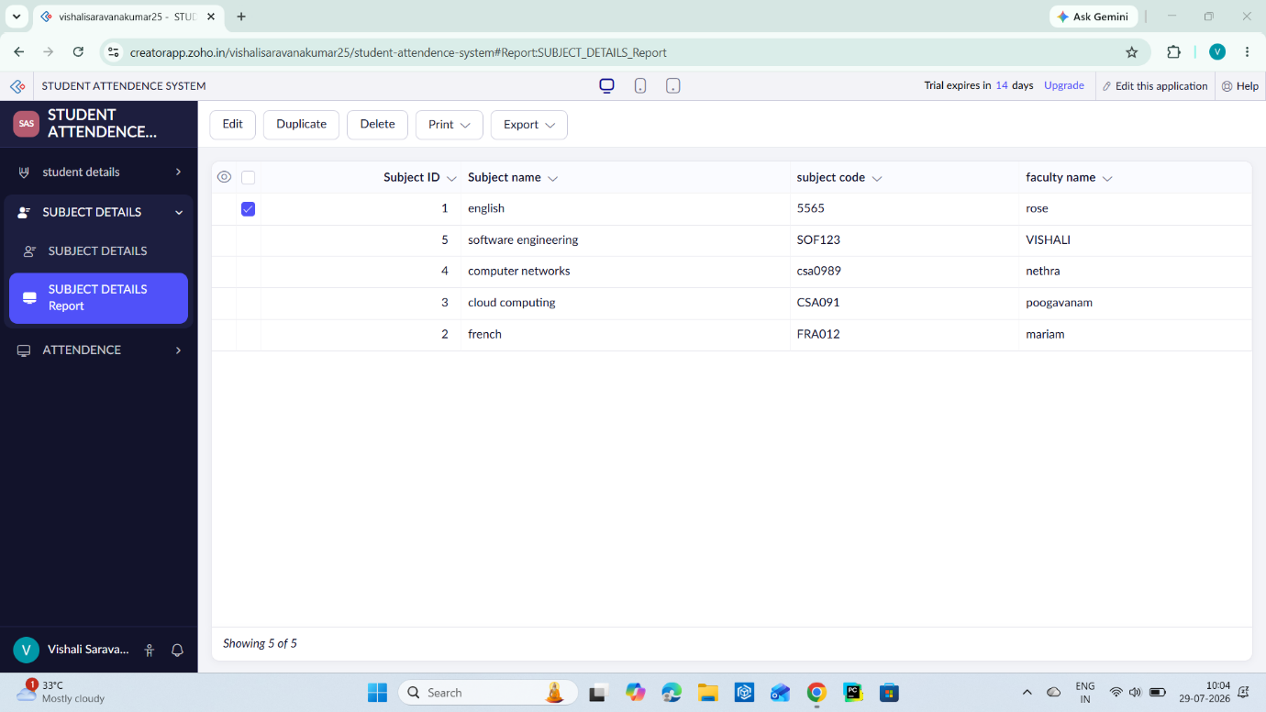
24.3 ATTENDENCE DETAILS
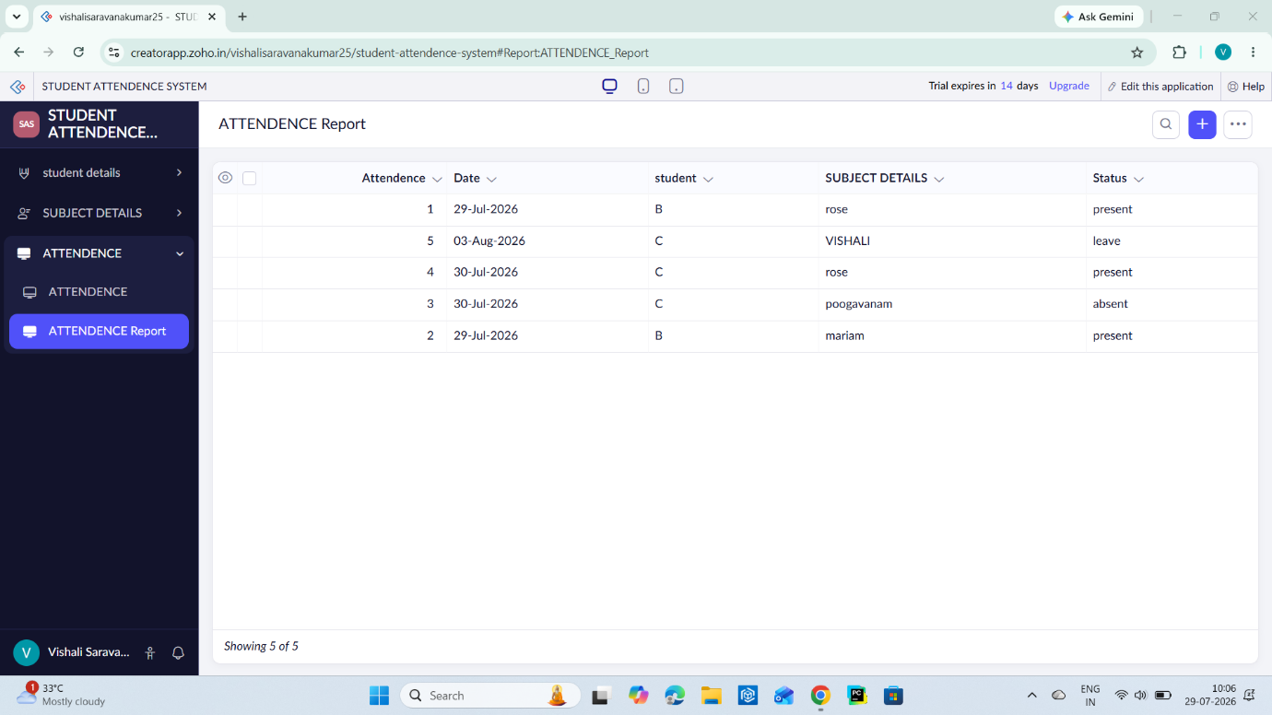
Result:
A cloud-based Student Attendance System was successfully created and deployed. The application allows users to manage student information and attendance records online, demonstrating the Software as a Service (SaaS) model in cloud computing.

