EXPRIMENT :3
A SIMPLE CLOUD SOFTWARE APPLICATION FOR PROPERTY BUYING & RENTAL
PROCESS
AIM:
To create a simple cloud-based Property Buying and Rental application using a cloud service provider to demonstrate the Software as a Service (SaaS) model.
PROCEDURE:
- Log in to the cloud platform (e.g., Zoho Creator).
- Create a new application named Property Buying & Rental.
- Design a form to store property details such as property name, location, type, price/rent, owner name, and contact number.
- Create another form to store customer details such as name, phone number, email, and property preference.
- Add fields to record property booking or rental requests.
- Configure reports to display available properties and customer requests.
- Save the application and deploy it on the cloud.
- Test the application by adding sample property and customer records and verify that the data is stored and accessed through the cloud.
3.1 PROPERTY DETAILS
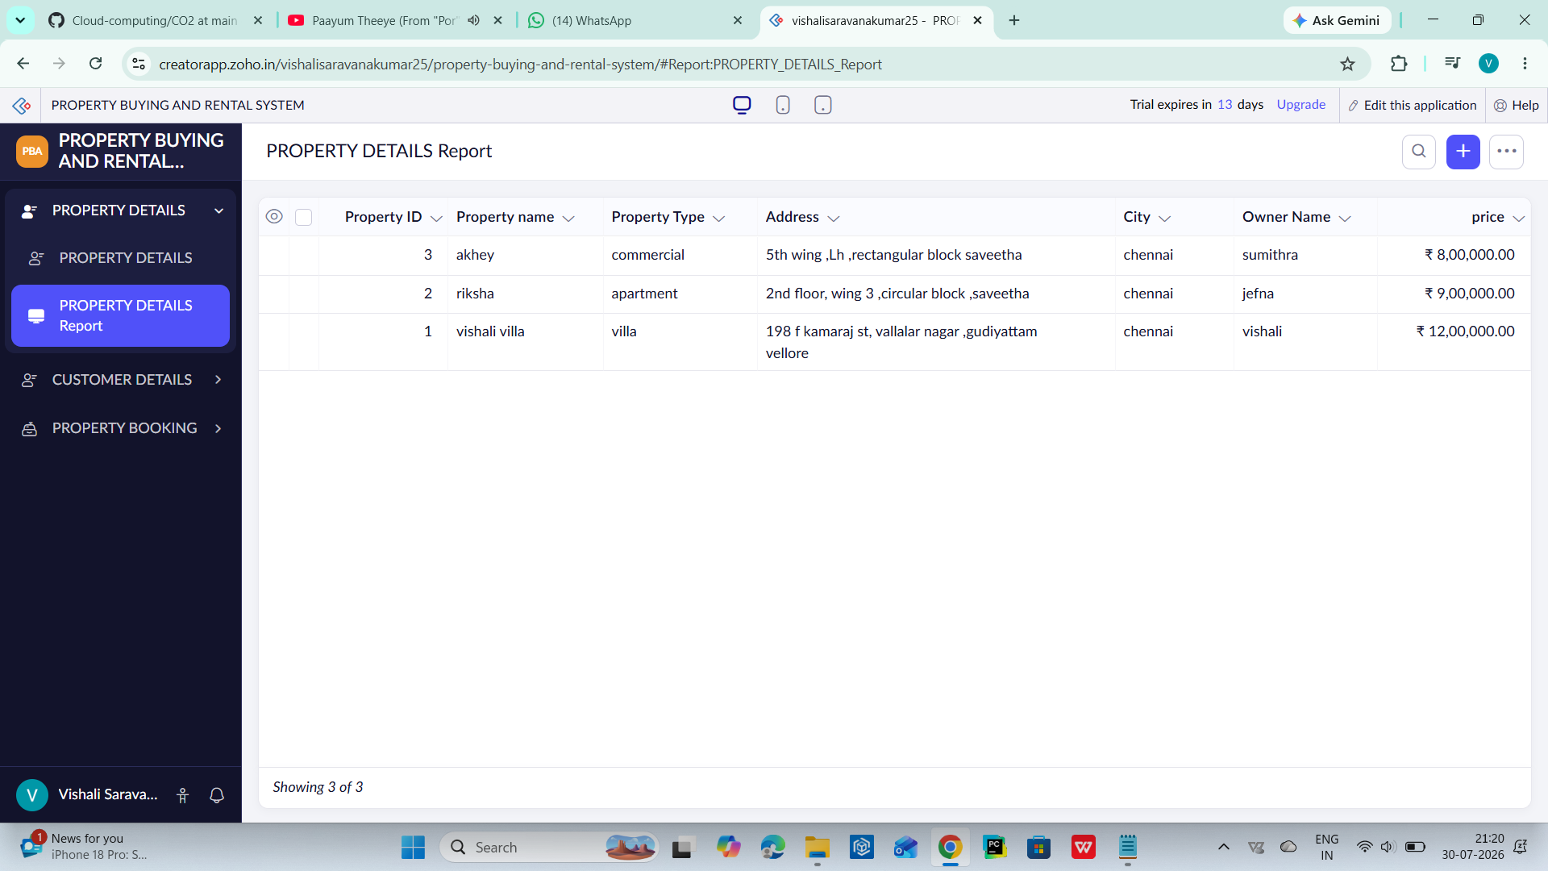

3.2 CUSTOMER DETAILS
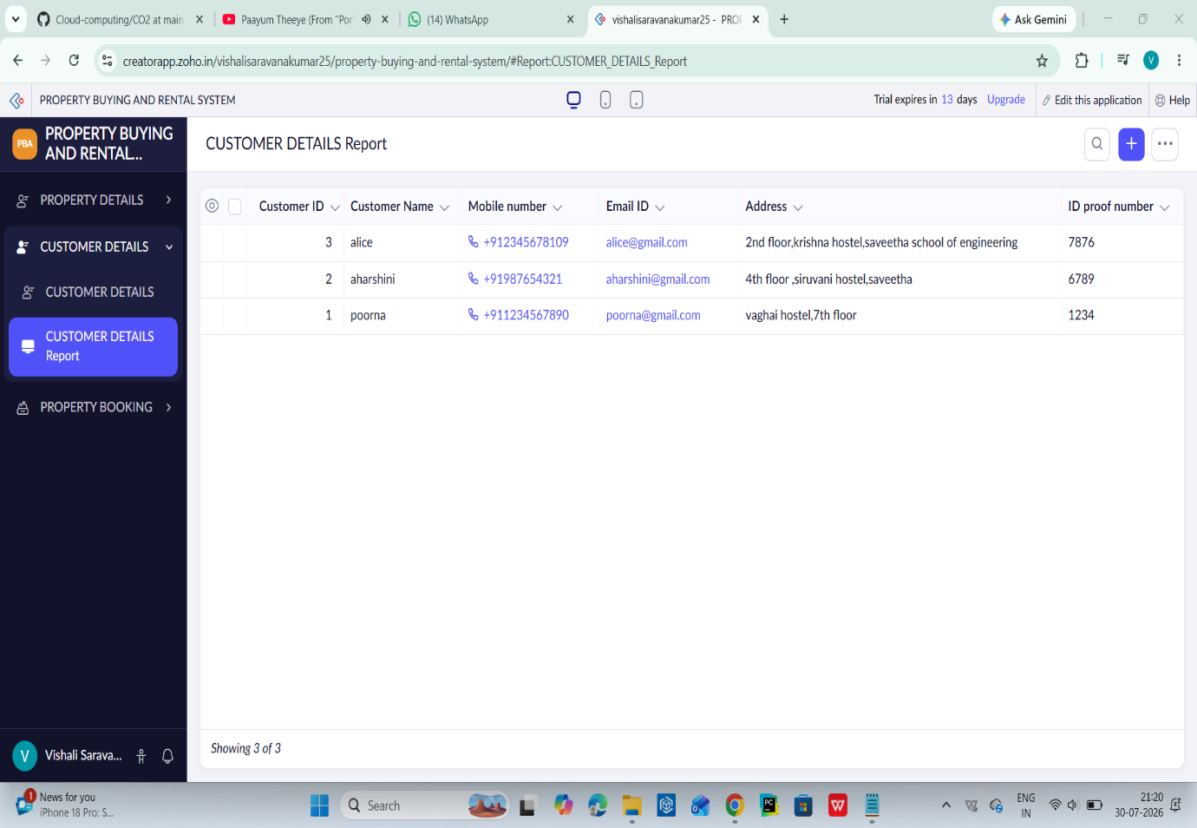

3.3 PROPERTY BOOKING
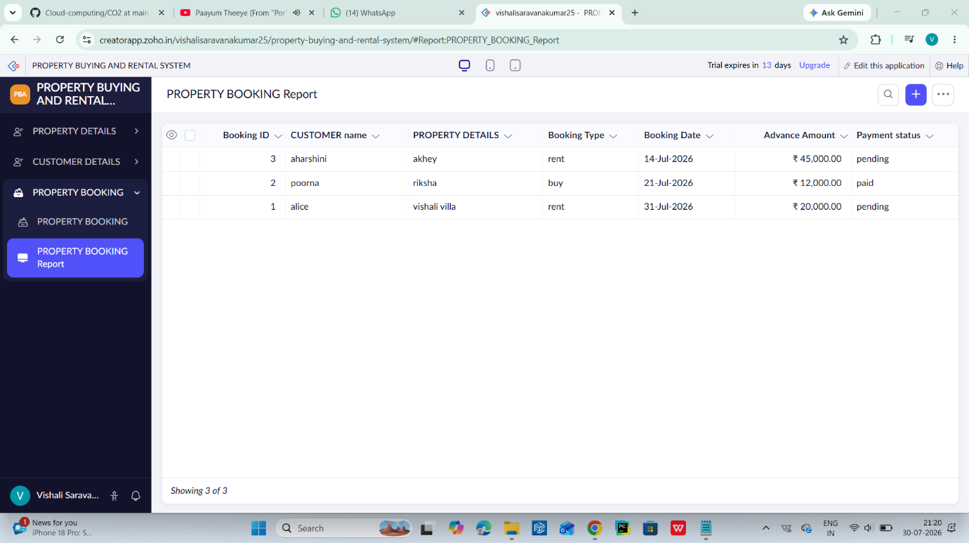
Result:
A cloud-based Property Buying & Rental application was successfully created and deployed. The application allows users to store, manage, and access property and customer information online, demonstrating the SaaS model of cloud computing.

