EXPRIMENT -5
A APPLICATION FOR LIBARARY BOOK RESERVATION SYSTEM FOR SIMATS LIBRARY
Aim:
To create a simple cloud-based Library Book Reservation System for the SIMATS Library using a cloud service provider to demonstrate the Software as a Service (SaaS) model.
Procedure:
- Log in to the cloud platform (e.g., Zoho Creator).
- Create a new application named SIMATS Library Book Reservation System.
- Design a form to store book details such as Book ID, Title, Author, Category, Availability, and Shelf Number.
- Create a student registration form with details such as Student ID, Name, Department, Year, and Contact Number.
- Create a reservation form to allow students to reserve available books by selecting the book and reservation date.
- Generate reports to display available books, reserved books, and reservation history.
- Save and deploy the application on the cloud platform.
- Test the application by adding sample books, student records, and reservation details to verify that the data is stored and accessed online.
5.1 STUDENT DETAILS
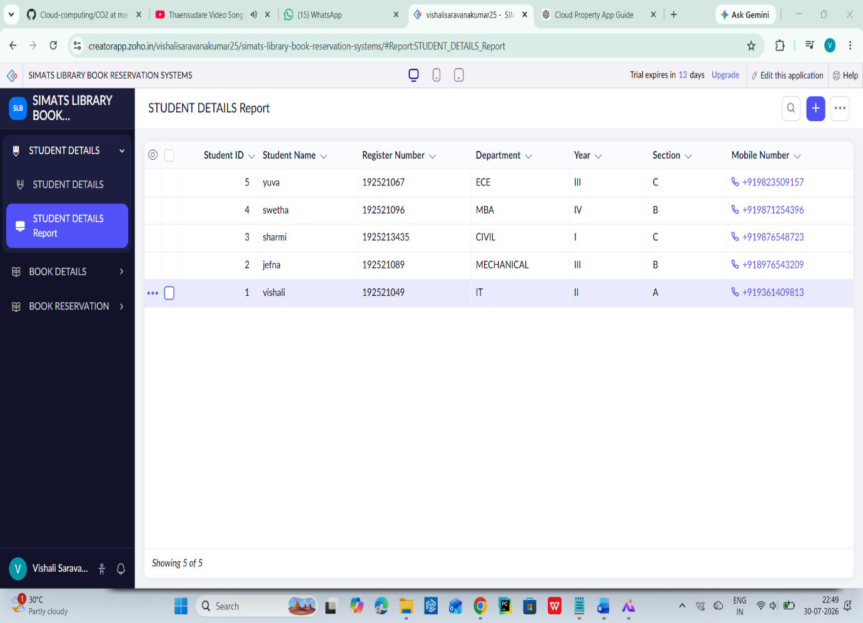
5.2 BOOK DETAILS
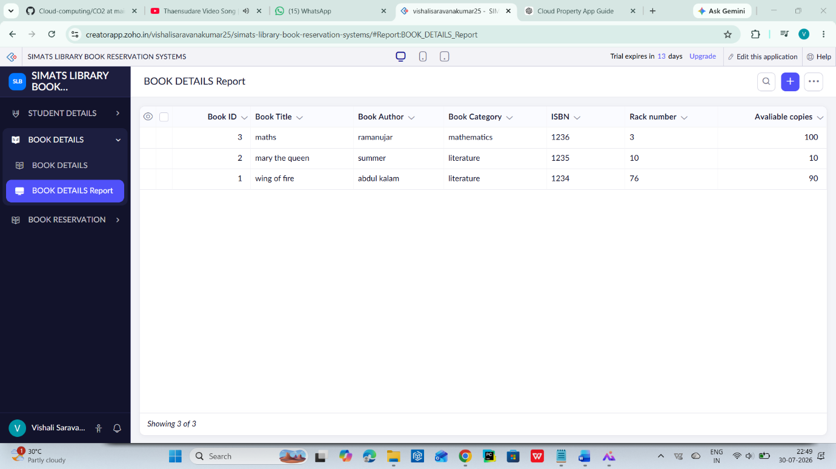\
5.3 BOOK RESERVATION
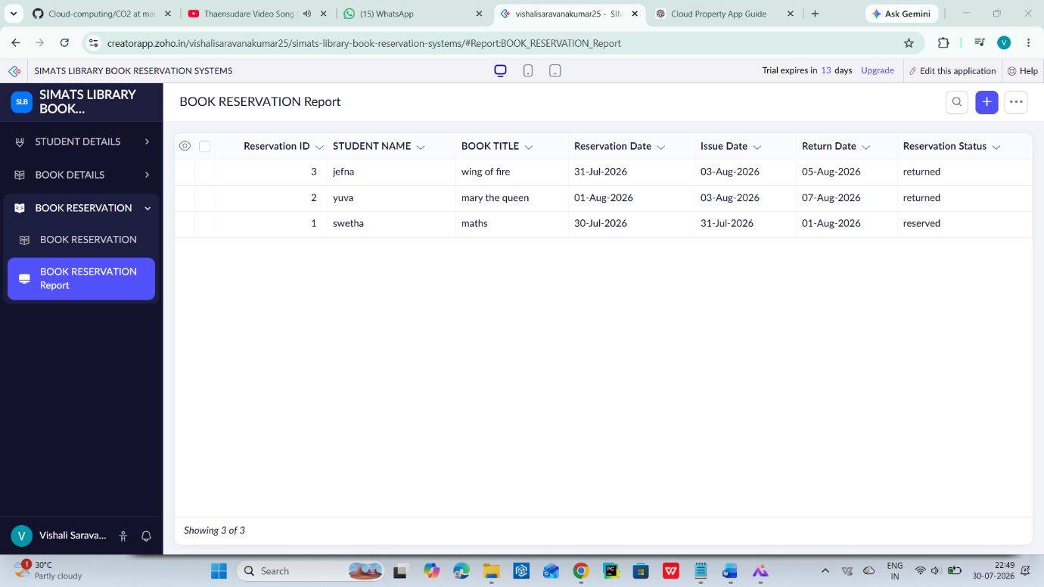
Result:
A cloud-based Library Book Reservation System for the SIMATS Library was successfully created and deployed. The application enables students to reserve books online and allows library staff to manage book availability and reservation records efficiently, demonstrating the Software as a Service (SaaS) model in cloud computing.

