JavaScript Programs



**Submitted to : Submitted by :**

**Mr. Kuldeep Singh Sidhu Name- Vishali**

**Class- 2CE-2**

**Roll No. 11601071**

**COMPUTER SCIENCE AND ENGINEERING**

**PUNJABI UNIVERSITY, PATIALA**

**APRIL 2018**

**CONTENTS**

1)Find the reverse of number 1

2)Find the factorial of number 3

3)Find the sum of first n natural numbers 4

4)Find the sum of numbers from n to m 6

5)Program to check even Number 8

6)Program to check larger no. between 2 numbers 10

7)Find the sum of square of digits of a number 11

8)Find the square of sum of the digits. 13

9)Program to check prime no. 15

10)Program to check whether the entered character is vowel or consonant. 16

# 1)Find the reverse of number.

<html>

<style>

form{

padding:10px;

margin:10px;

}

fieldset{

padding:20px;

color:blue;

}

</style>

<body>

<script type="text/javascript">

function rev()

{

var a,no,b,temp=0;

no=Number(document.getElementById("input").value);

b=no;

while(no>0)

{

a=no%10;

no=parseInt(no/10);

temp=temp*10+a;

}

abc.btn2.value=temp;

}

</script>

<form name="abc">

<fieldset style="margin-right:650px;">

<h1> Find the Reverse of a Number</h1>

Enter any Number: <br>

<br>

<input id="input" style="font-size:50px; height:60;width:500;color:blue;">

<br><br>

Reverse of Number: <br>

<br>

<input type="text" name="btn2" style="font-size:50px;

height:60;width:500;color:blue;">

<br><br>

<input type="button" name="btn3" value="Check" onclick="rev()" style="font-

size:50px; height:80; width:500; color:red;">

</fieldset>

</form>

</body>

</html>

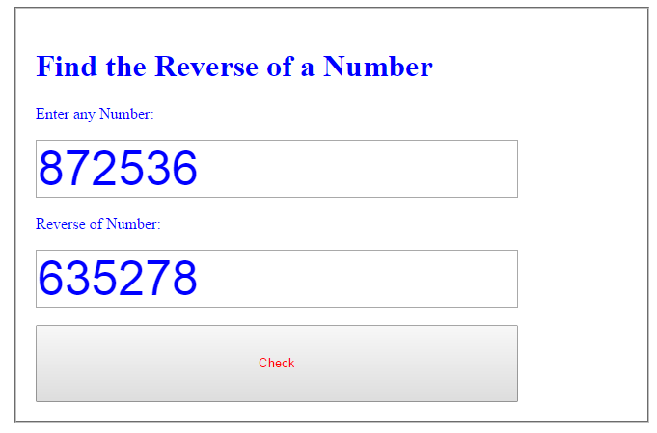

# 2)Find the factorial of number

<html>

<style>

form{

padding:10px;

margin:10px;

}

fieldset{

padding:20px;

color:black;

}

</style>

<body>

<script type="text/javascript">

function fact(n)

{

var m=1;

while(n)

{

m=m*n;

n--;

}

alert("Factorial of given number :"+" "+ m);

}

</script>

<fieldset style="margin-right:650px;">

<h1> Find Factorial of the Number</h1>

<form name="frm1">

Enter any number :<br>

<br>

<input type="text" name="fact1" style="font-size:20px; height:30;

width:200;color:blue;"><br><br>

<input type="submit" value="Calculate Factorial" onclick="fact

(frm1.fact1.value)" style="font-size:20px; height:35; width:185; color:red;">

</fieldset>

</form>

</body>

</html>

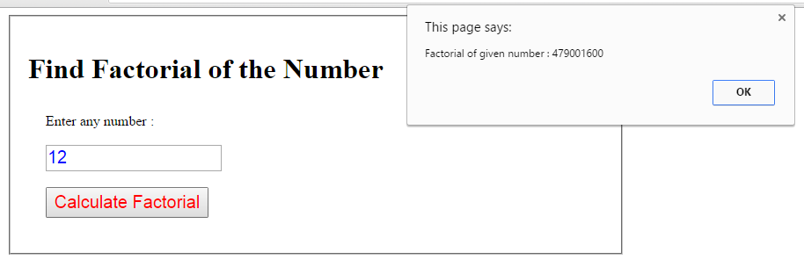

# 3)Find the sum of first n natural numbers

<html>

<style>

form{

padding:10px;

margin:10px;

}

fieldset{

padding:20px;

color;green;

}

</style>

<body>

<script type="text/javascript">

function f1()

{

var c=parseInt(abc.btn1.value);

if(!c)

{

alert("Enter value")

}

else

{

var sum=(c*(c+1))/2

abc.btn2.value=sum;

}

}

</script>

<form name="abc">

<fieldset style="margin-right:650px;">

<h1> Find the Sum of First n Natural Numbers </h1>

Enter Any Value: <br/>

<input type="text" name="btn1" style="font-size:50px;height:60;width:500;

color:red;">

<br/> <br/>

Sum of First n Natural Numbers: <br/>

<input type="text" name="btn2" style="font-size:50px;height:60;width:500;

color:blue;">

<br/> <br/>

<input type="button" name="btn3" value="check" onclick="f1()" style="font-

size:50px;height:80; width:500; color:red;" >

</fieldset>

</form>

</body>

</html>

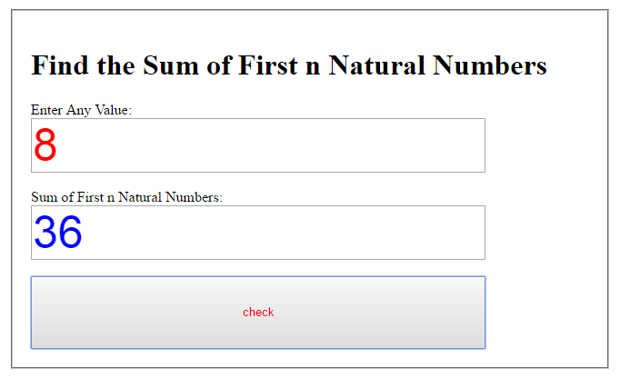

# 4)Find the sum of numbers from n to m

<html>

<style>

form{

padding:10px;

margin:10px;

}

fieldset{

padding:20px;

color;green;

}

</style>

<body>

<script type="text/javascript">

function f1()

{

var n=parseInt(abc.btn1.value);

var m=parseInt(abc.btn4.value);

if(n>m)

{ alert("plz enter m greater than n") }

else

{

var sum=0,i;

for(i=n;i<=m;i++)

{ sum+=i;

}

abc.btn2.value=sum;

}

}

</script>

<form name="abc">

<fieldset style="margin-right:650px;">

<h1> Find the Sum of numbers from n to m </h1>

Enter the Value of n: <br/>

<input type="text" name="btn1" style="font-size:50px;height:60;width:500;

color:red;">

<br/> <br/>

Enter the Value of m: <br/>

<input type="text" name="btn4" style="font-size:50px;height:60;width:500;

color:red;">

<br/> <br/>

Sum of Numbers from n to m(including both): <br/>

<input type="text" name="btn2" style="font-size:50px;height:100;width:500;

color:blue;">

<br/> <br/>

<input type="button" name="btn3" value="calculate" onclick="f1()"

style="font-size:50px;height:80; width:500; color:red;" >

</fieldset>

</form>

</body>

</html>

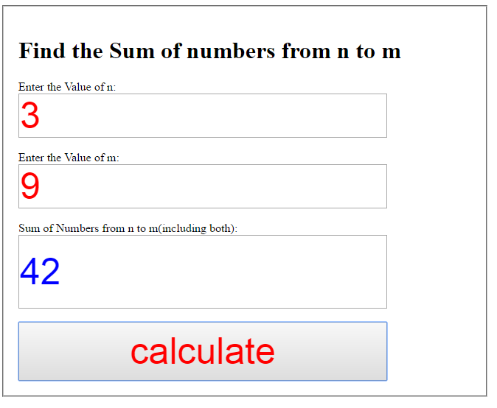

# 5)Program to check even Number

<html>

<style>

form{

padding:10px;

margin:10px;

}

fieldset{

padding:20px;

color;green;

}

</style>

<body>

<script type="text/javascript">

function f1()

{

var c=parseInt(abc.btn1.value);

if(!c)

{

alert("Enter any number other than 0")

}

else

{

if(c%2==0)

abc.btn2.value="even";

else

abc.btn2.value="odd";

}

}

</script>

<form name="abc">

<fieldset style="margin-right:650px;">

<h1> Find whether the no. is Even or Odd </h1>

Enter Any Value: <br/>

<input type="text" name="btn1" style="font-size:50px;height:60;width:500;

color:red;">

<br/> <br/>

No. is Even or Odd: <br/>

<input type="text" name="btn2" style="font-size:50px;height:60;width:500;

color:blue;">

<br/> <br/>

<input type="button" name="btn3" value="check" onclick="f1()" style="font-

size:50px;height:80; width:500; color:red;" >

</fieldset>

</form>

</body>

</html>

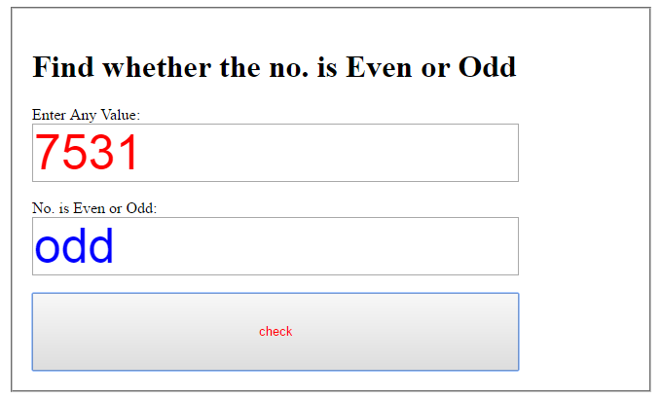

# 6)Program to check larger no. between 2 numbers

<html>

<style>

form{

padding:10px;

margin:10px;

}

fieldset{

padding:20px;

color;green;

}

</style>

<body>

<script type="text/javascript">

function f1()

{

var c=parseInt(abc.btn1.value);

var d=parseInt(abc.btn2.value);

if(c>=d)

abc.btn3.value=c;

else

abc.btn3.value=d;

}

</script>

<form name="abc">

<fieldset style="margin-right:650px;">

<h1> Find the Greater of 2 Numbers </h1>

Enter First No: <br/>

<input type="text" name="btn1" style="font-size:50px;height:60;width:500; color:red;">

<br/> <br/>

Enter second No: <br/>

<input type="text" name="btn2" style="font-size:50px;height:60;width:500; color:blue;">

<br/> <br/>

Greater Number is: <br/>

<input type="text" name="btn3" style="font-size:50px;height:60;width:500; color:blue;">

<br/> <br/>

<input type="button" name="btn4" value="check" onclick="f1()" style="font-size:50px;height:80; width:500; color:red;" >

</fieldset>

</form>

</body>

</html>

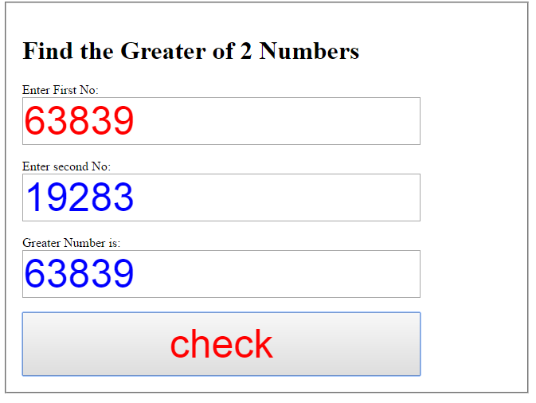

# 7)Find the sum of square of digits of a number

<html>

<style>

form{

padding:10px;

margin:10px;

}

fieldset{

padding:20px;

color;green;

}

</style>

<body>

<script type="text/javascript">

function f1()

{

var a= parseInt(abc.btn1.value);

var i,sum=0;

if(!a)

{

alert("enter number");

}

else

{

while(a!=0)

{ i=parseInt(a%10)

sum=parseInt(sum)+parseInt(i*i);

a=parseInt(a/10);

}

}

abc.btn2.value = sum;

}

</script>

<form name="abc">

<fieldset style="margin-right:650px;">

<h1> Find the sum of square of digits of a No.</h1>

Enter Any Number: <br/>

<input type="text" name="btn1" style="font-size:50px;height:60;width:500;

color:red;">

<br/> <br/>

Sum of square of digits of No.: <br/>

<input type="text" name="btn2" style="font-size:50px;height:60;width:500;

color:blue;">

<br/> <br/>

<input type="button" name="btn3" value="calculate" onclick="f1()"

style="font-size:50px;height:80; width:500; color:red;" >

</fieldset>

</form>

</body>

</html>

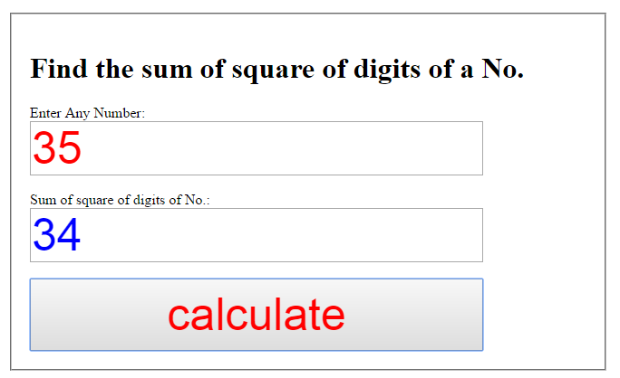

# 8)Find the square of sum of the digits.

<html>

<style>

form{

padding:10px;

margin:10px;

}

fieldset{

padding:20px;

color;green;

}

</style>

<body>

<script type="text/javascript">

function f1()

{

var a= parseInt(abc.btn1.value);

var i,sum=0;

if(!a)

{

alert("enter number");

}

else

{

while(a!=0)

{ i=parseInt(a%10);

sum=sum+i;

a=parseInt(a/10)

}

sum=parseInt(sum*sum)

}

abc.btn2.value = sum;

}

</script>

<form name="abc">

<fieldset style="margin-right:650px;">

<h1> Find the square of sum of digits of a No.</h1>

Enter Any Number: <br/>

<input type="text" name="btn1" style="font-size:50px;height:60;width:500;

color:red;">

<br/> <br/>

Square of sum of digits of No.: <br/>

<input type="text" name="btn2" style="font-size:50px;height:60;width:500;

color:blue;">

<br/> <br/>

<input type="button" name="btn3" value="calculate" onclick="f1()"

style="font-size:50px;height:80; width:500; color:red;" >

</fieldset>

</form>

</body>

</html>

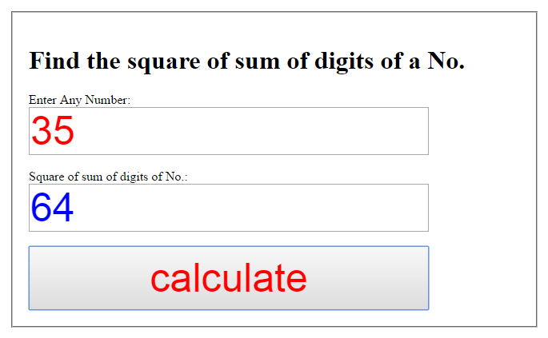

# 9)Program to check prime no.

<html>

<style>

form{

padding:10px;

margin:10px;

}

fieldset{

padding:20px;

color;green;

}

</style>

<body>

<script type="text/javascript">

function f1()

{

var c=parseInt(abc.btn1.value);

if(!c)

alert("Enter any number other than 0")

else

{

var i=2;

while(i<=c-1)

{ if(c%i==0)

{ abc.btn2.value="Not a prime no.";

break;

}

i++;

}

if(c==i)

abc.btn2.value="prime no.";

}

}

</script>

<form name="abc">

<fieldset style="margin-right:650px;">

<h1> To Find whether the no. is prime or not </h1>

Enter Any Value: <br/>

<input type="text" name="btn1" style="font-size:50px;height:60;width:500; color:red;">

<br/> <br/>

No. is Prime or Not: <br/>

<input type="text" name="btn2" style="font-size:50px;height:60;width:500; color:blue;">

<br/> <br/>

<input type="button" name="btn3" value="check" onclick="f1()" style="font-size:50px;height:80; width:500; color:red;" >

</fieldset>

</form>

</body>

</html>

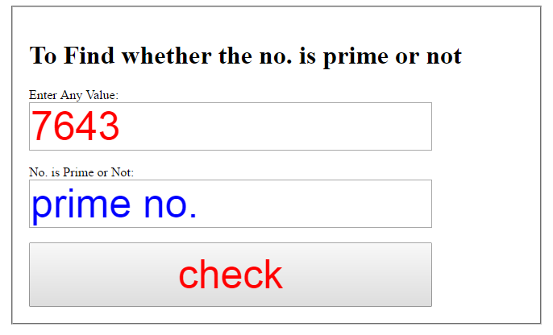

# 10)Program to check whether the entered character is vowel or consonant.

<html>

<style>

form{

padding:10px;

margin:10px;

}

fieldset{

padding:20px;

color;green;

}

</style>

<body>

<script type="text/javascript">

function f1()

{

var n=abc.btn1.value;

if(n=='a'||n=='e'||n=='i'||n=='o'||n=='u'||n=='A'||n=='E'||n=='I'||

n=='O'||n=='U')

{ abc.btn2.value="Vowel"; }

else

{ abc.btn2.value="Consonant";

}

}

</script>

<form name="abc">

<fieldset style="margin-right:650px;">

<h1> Find whether the entered alphabet is Vowel or Consonant </h1>

Enter Any Alphabet: <br/>

<input type="text" name="btn1" style="font-size:50px;height:60;width:500;

color:red;">

<br/> <br/>

No. is Vowel or Consonant: <br/>

<input type="text" name="btn2" style="font-size:50px;height:60;width:500;

color:blue;">

<br/> <br/>

<input type="button" name="btn3" value="check" onclick="f1()" style="font-

size:50px;height:80; width:500; color:red;" >

</fieldset>

</form>

</body>

</html>

