SMART PUBLIC RESTROOMS

phase 02: INNOVATION

COURSE NAME: INTERNET OF THINGS

GROUP:07

PROJECT NUMBER : 08

TITLE:SMART PUBLIC RESTROOMS

PHASE 2:DESIGN AND INNOVATION

YEAR : lll

DEPARTMENT : ELECTRONICS AND COMMUNICATIONS ENGINEERING

PROJECT SUBMITTED TO : IBM (SkillUp Online)

TEAM MEMBER

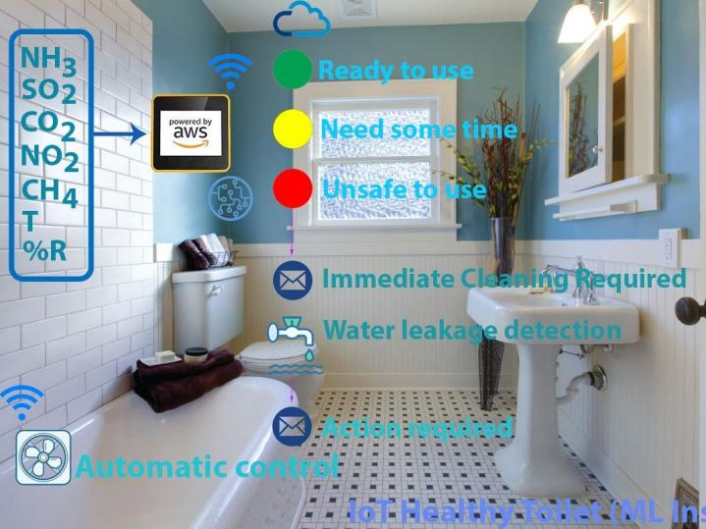

DESIGN OF SMART PUBLIC RESTROOMS:  
 In an existing system, they concentration on organizing sewages from the railway system. They are trying to taking all the medical tests through the usage of toilets. They are concentrated on reducing water wastage on toilets, by the implementation of automatic flusher. They are not focussed on providing clean and hygienic toilets.The medical test can have chance to produce fault results.

1. **Automated Entry and Exit Systems:**
   * Install motion sensors or RFID readers at restroom entrances and exits to automate access control.
   * Users can gain access by scanning a QR code on their smartphones or using RFID car
2. **Occupancy Monitoring:**
   * Use ultrasonic sensors or cameras to monitor restroom occupancy and display real-time availability information on digital signage outside the restroom.
   * Integrate with mobile apps or websites to allow users to check restroom availability remotely.
3. **Smart Cleaning Schedule:**
   * Implement occupancy-based cleaning schedules. If the restroom is frequently used, it triggers cleaning more often.
   * Sensors can detect when a stall or sink area needs cleaning, reducing waste and ensuring cleanliness.
4. **Air Quality Monitoring:**
   * Deploy air quality sensors to monitor humidity, temperature, and air freshness.
   * Automatically adjust ventilation and air purification systems based on sensor data to ensure a comfortable environment.
5. **Security and Privacy:**
   * Ensure that data collected by IoT devices is encrypted and securely stored.
   * Implement privacy measures to protect user identities and personal information.
6. **Maintenance and Remote Monitoring:**
   * Use IoT devices to monitor the health of restroom equipment and receive alerts for maintenance needs.
   * Schedule routine maintenance based on usage patterns and sensor data.
7. **Analytics and Reporting:**
   * Collect and analyze data from IoT devices to identify trends, usage patterns, and areas for improvement.
   * Generate reports to aid in decision-making and resource allocation.
8. **Emergency Alerts:**
   * Integrate emergency buttons or pull cords for immediate assistance.
   * In the event of an emergency, send alerts to security personnel or emergency services.
9. **Sustainability Measures:**
   * Use renewable energy sources like solar panels to power the restroom.
   * Implement water recycling systems to reduce water consumption.
10. **Public Wi-Fi and Charging Stations:**
    * Offer public Wi-Fi and charging stations to enhance user experience and encourage longer visits.
11. **Regular Maintenance and Upgrades:**
    * Implement a regular maintenance and upgrade plan to keep the IoT devices and systems up-to-date and secure.

COMPONENTS REQUIRED FOR SMART PUBLIC RESTROOMS:

**HARDWARE REQUIREMENTS:**

                                       • Microcontroller

                                       • Power supply

                                       • LCD display

                                       • Buzzer

                                       • Infrared sensor

                                       • Sonicsensor

• Gassensor

                                       • RFID

                                       • GSMmodem

**SOFTWARE REQUIREMENTS**

Embedded C

ARCHITECTURE OF THE PROPOSED SYSTEM:

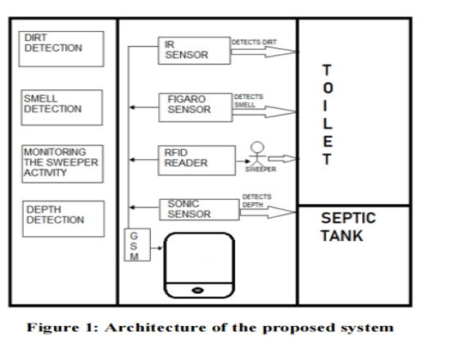

INNOVATION ON SMART PUBLIC RESTROOMS:

The indoor settings of heavily contaminated toilets are linked to an increased risk of diseasetransmission. Improved ventilation efficiency can enhance interior air quality (IAQ)[1]. The aspects of pollutant transmission in a public toilet model were analysed using computational fluid dynamics software, which was subsequently confirmed using experimental data using tracer gas. This research looked at typical pollutant diffusion characteristics, such as ammonia and hydrogen sulphide, as well as the relationship between the number of air changes per hour, pollutant concentrations, and personal exposure in public restrooms using ventilation systems:

The researchers' treatment method recycles water from hand washing and toilet flushing. It is capable or recycling enough safe and attractive hand washing and toilet flush water for household or public use in real-world applications. They demonstrated that the system could recycle enough water for safe and pleasant handwashing and toilet flushing in a real world scenario for household or public usage. Advancements are certainly being made in the modern world, our country's cleanliness is being jeopardised.

A Mobile Flush Toilet have been suggested. In an emergency, finding a good toilet can be challenging. Damage to essential infrastructure makes it difficult for shelters to clean toilets. As a result, the purpose of this study is to develop a mobile flush toilet that is self-contained in terms of power, water, and drainage. In flood-affected regions, the field test was conducted successfully. Before a disaster, placing this mobile toilet near public buildings that are used as emergency shelters helps improve access to a proper toilet.Furthermore, in underdeveloped nations with little infrastructure, this toilet design might be used.

In the proposed "Smart Toilet" system , IoT, fragrance sensor, IR sensor, sound sensor, and RFID sensor are all employed. The smart toilet will open and close the toilet seat for you, while an infrared sensor detects dirt on the toilet seat and informs you. The cleanliness of the toilet will be enhanced by keeping an eye on the sweeper's operations in order to keep the toilet clean and save water. One of the reasons is that the user is too lazy to wipe the toilet after each use. The upshot of this careless behaviour is filthy bathrooms. Furthermore, many public restrooms lack flushing facilities. Even though some of them have flush toilets, they are not utilised owing to a lack of awareness and laziness. The other factor is the sweeper's lack of comprehension of his or her obligation for toilet cleaning. The word "smart" alone is enough to pique people's interest and urge them to use the smart toilet. It also allows for the efficient administration of public bathrooms, with a high degree of hygiene maintained to the public's satisfaction.

Innovation To solve the problem:

There are numerous smart restroom devices this article could cover. For the sake of space, this list of restroom tech advancements consists of six of the most predominant smart restroom innovations to date.

**1. Smart Toilets**

According to real estate experts, smart toilets are the [most desired devices](https://www.realtor.com/research/smart-home-tech-2020/) when it comes to restroom renovations. Top features include:

* Automatic lid
* Seat warmers
* Dual-flush, touchless flush actuators
* Night lights
* Speakers for music
* And more

Smart toilets tend to be more compact, with improved design elements that make them space-saving while remaining comfortable. This feature makes the toilets easier to clean and keep clean. Although, self-cleaning is another feature of a smart toilet.

**2. Occupancy Monitoring**

These smart monitors let people know what stalls are available by using lights as indicators, activated when the user locks the stall. Patrons also receive alerts outside of the restroom on a touchscreen to let them know their place in line. That way, no one is waiting in a germ-filled or crowded bathroom.

These devices can also track supplies to ensure stalls remain stocked with essential restroom products. It also digitizes cleaning schedules and sanitation documentation.

**3. Touchless Fixtures and Digital Faucets**

Touchless fixtures allow users to go to the restroom without touching these contaminated surfaces. Public [restroom surfaces contain pathogens](https://www.powerofpositivity.com/public-bathrooms-avoiding-germs/) that cause illnesses and diseases, such as (but not limited to):

* E. coli
* Legionella
* Shigella
* Norovirus
* Salmonella

Automatic toilets, touchless faucets, and hands-free soap and paper towel dispensers, among others, reduce these risks and promote public health.

Sensor technology isn't the only advance in faucets that make them [Fixtures of the Future](https://www.homesandgardens.com/news/bathroom-trends-203661). You can find [faucets that are fully programmable](https://www.chicagofaucets.com/products/commercial-faucets/touchless), allowing you to control water temperature, usage, flow rates, and even metering functions.

**4. Smart Mirrors**

The restroom of the future includes mirrors that can broadcast the weather, daily news, and traffic updates.

While most smart technologies for [commercial restrooms inspire residential applications](https://learn.geberitnorthamerica.com/blog/7-subtle-residential-restroom-advances-inspired-by-commercial-restroom-tech) (think hands-free faucets), some began as residential fixtures and made their way to commercial building installations.

Brands began by manufacturing smart mirrors for residential applications. However, it is one of the advances in restroom technologies that originated for home use and has evolved into a commercial restroom tech device.

**5. Water Reclamation Devices**

Water recyclers can save potable water that would typically go down the drain and enter the public water system. Instead, these recyclers collect the water and reuse it for non-potable purposes, like irrigation or cooling systems.

These systems are better known as [Fit-For-Purpose Treatment](https://www.epa.gov/waterreuse/basic-information-about-water-reuse) when used in public water systems. The image below shows how water reuse works.

[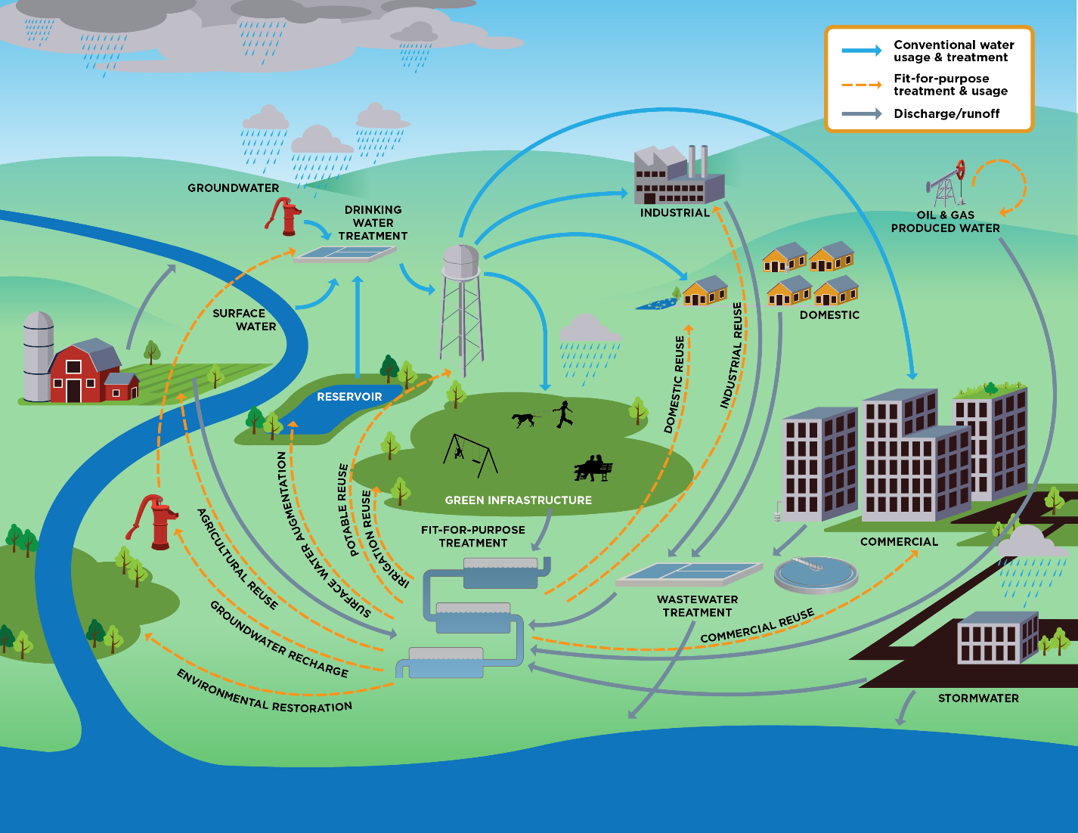](https://www.epa.gov/waterreuse/basic-information-about-water-reuse)

These devices are good for the environment because they reduce overall water usage. They are also a cost-effective investment. While these systems are not cheap, they generally pay for themselves in just a few short years, thanks to the water (and money) it saves.

**6. Smart Water Monitors**

These water monitors help save water (and money), and you can have the controls integrated with a voice assistant, like Siri or Alexa. These devices detect leaks, provide usage details, and determine when the restroom gets the most traffic.

These insights allow you to program temperature and water flow and even provide data on utility bill estimates based on usage. You will receive these notifications through either SMS text messages, emails, or push notifications to your smart device.

Smart water monitors can also identify hidden flaws in your water management system, like poor sealants, pressure fluctuations, line backups, frozen pipes, etc. These systems can even send alerts and recommendations for maintaining your building's plumbing, pipes, and fixtures.