What is Subnetting=>

Dividing large network into multiple small network is known as subneting.

Classes of IP address =>

* Class A start from 1-126
* Default subnet mask is – 255.0.0.0
* Default CIDR value is – 8
* CIDR stands for Classless inter domain routing it is the total number of network bits.
* In A class network ip address is 8 bit and host ip is 24 bit so CIDR value is 8.
* So like that class B and Class D also in diagram.

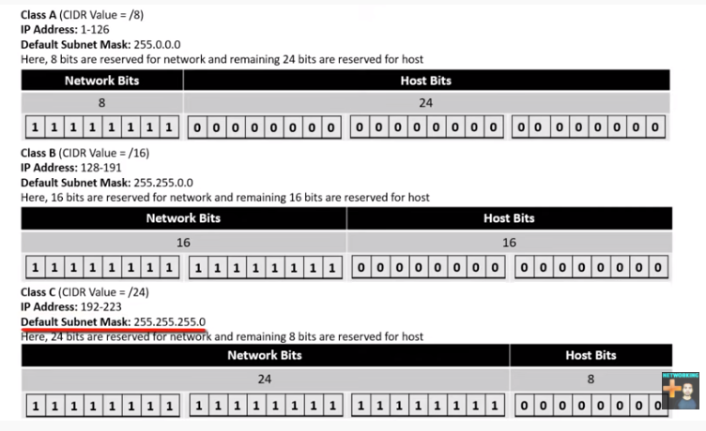

Example =>

Calculate subnet mask?

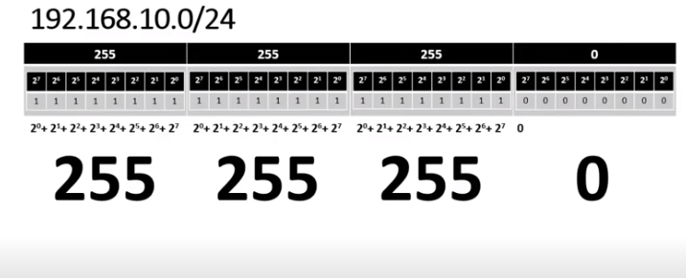

* In above diagram ip address is start from 192 so it is an C class .
* And CIDR value is 24.
* In binary 1 indicate network bit and 0 indicate host bit
* In ip address 4 blocks of 8 bit
* Bits on each block are count from right to left and it is 2^0 to 2^7 and addition of it is 255 calculate it for each block as shown in diagram .
* So default subnet mask of class C is 255.255.255.0 and why we written 0 here because subnet mask calculated from network bit only and network bit of class C is 24 bit .

Example 2 =>

Calculate subnet mask?

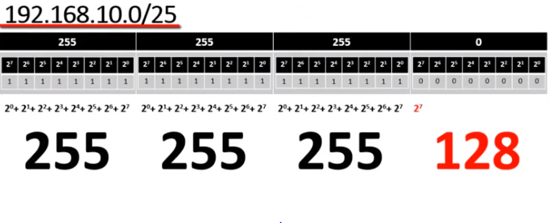

* In above diagram ip address is start from 192 so it is an C class .
* And CIDR value is 25.
* But default CIDR value of class c is 24 in that condition we take 1 bit from host bit as shown in diagram
* So subnet mask is 255.255.255.128 because it is a last bit of 4 block means 2^7=128
* Like that we calculate the subnet mask

Calculate Number of Networks , number of ip address in each network, and Number of Host in each Network ON above ip address and CIDR value ==🡺

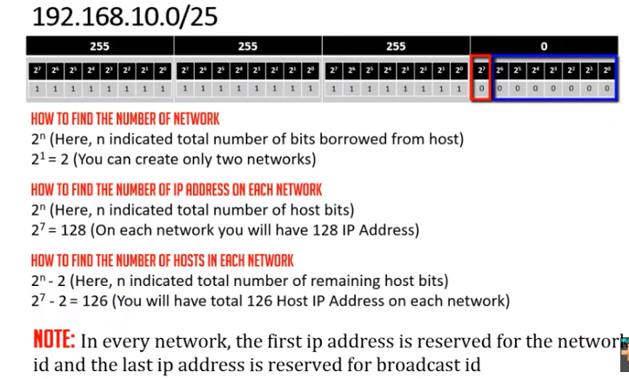

* + - * So above diagram shown number of networks =2
      * Total number of ip address =128
      * Number of hosts = 126 ,number of host means that number of ip address we can assign to devices in network.
    - So network 1 ip address start from 192.168.10.0 to 192.168.10.127
    - And network 2 ip address start from 192.168.10.128 to 192.168.10.255
    - But first ip address is reserved for network id and last ip address are reserved for broadcast id so middle all ip used as hosts ip address and we can assign it to devices in network.
    - And this shown in below diagram.

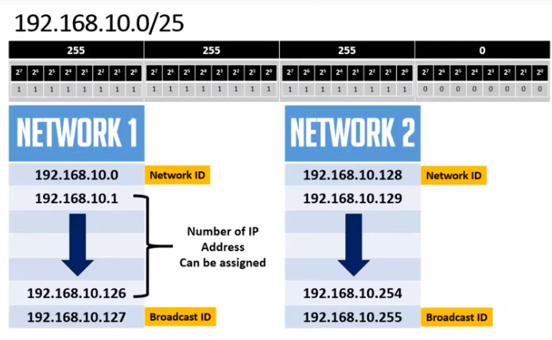

Exampe 3=>

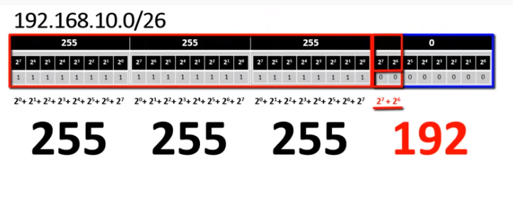

Subnet mask is = 255.255.255.192

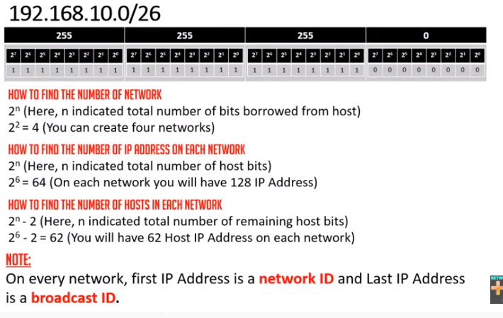

* + - So above diagram shown number of networks =2
    - Total number of ip address =128
    - Number of hosts = 126

And there description is Below

