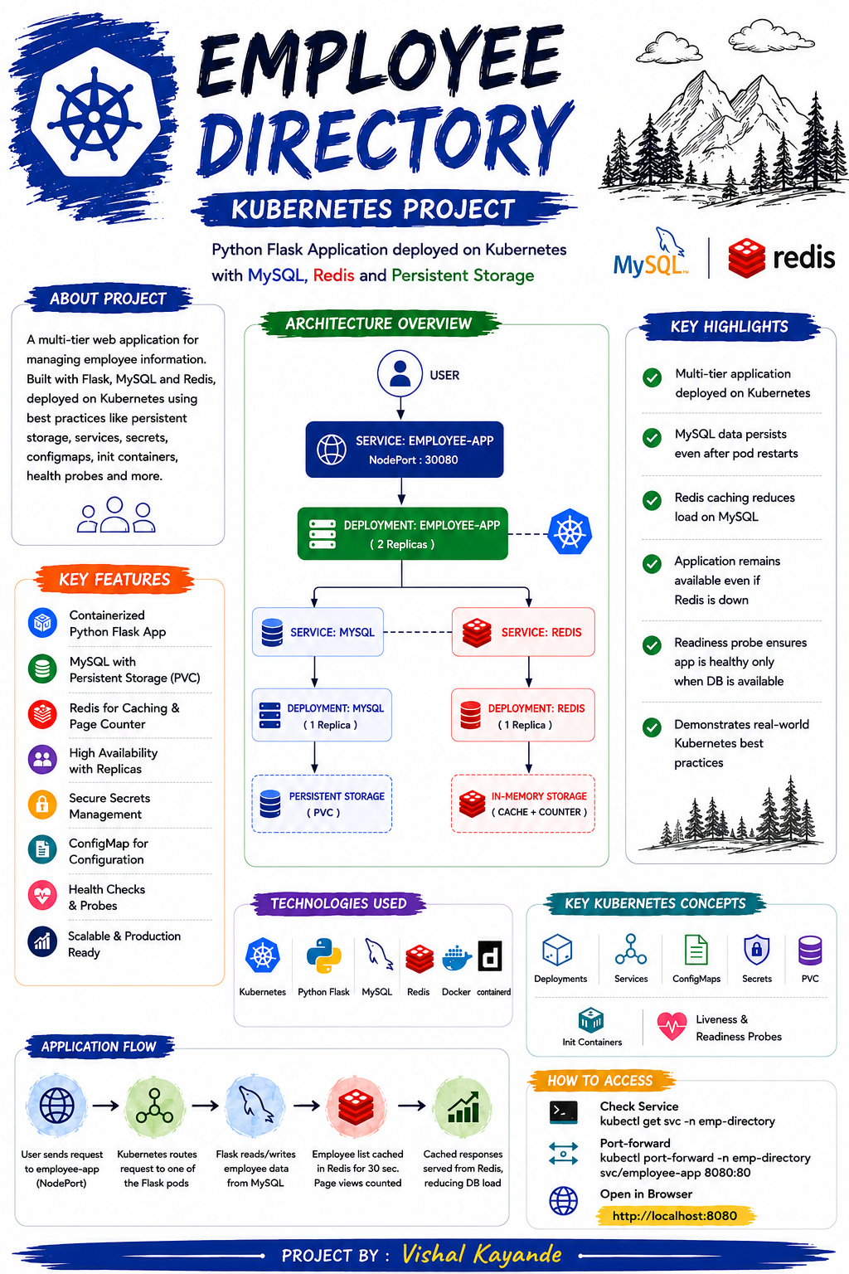

Project Overview
This project focuses on deploying a scalable, cloud-native web application using Kubernetes orchestration. The core objective is to manage an employee directory by integrating a Python Flask frontend, a persistent MySQL database, and a Redis caching layer. By utilizing Kubernetes-native resources, this deployment establishes a highly available infrastructure that effectively handles configuration management, stateful data storage, and automated health monitoring.
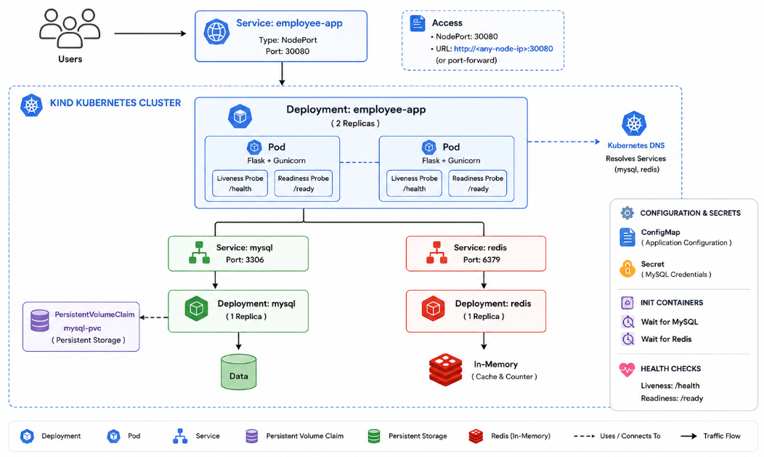

Architectural Summary
The system relies on a three-tier design to separate concerns and optimize performance:
- Application Tier: A Python Flask container serving RESTful requests, scaled across multiple replicas to ensure high availability.
- Data Tier: A MySQL instance utilizing a Persistent Volume Claim (PVC) to guarantee that employee records are retained independently of pod lifecycles.
- Caching Tier: An in-memory Redis instance tasked with caching data and tracking page visits to reduce the query load on the primary database.


Core Technologies
- Infrastructure & Orchestration: Kubernetes, Containerd
- Application Stack: Python Flask, Docker
- Data & State Management: MySQL, Redis

Execution & Implementation Steps
Step 1: Cluster Health Verification:
Step 2: Source Code Acquisition:
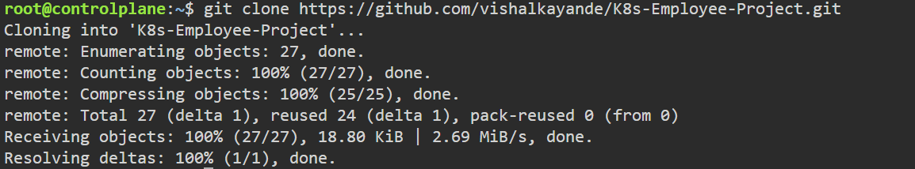
Step 3: Workspace Navigation:
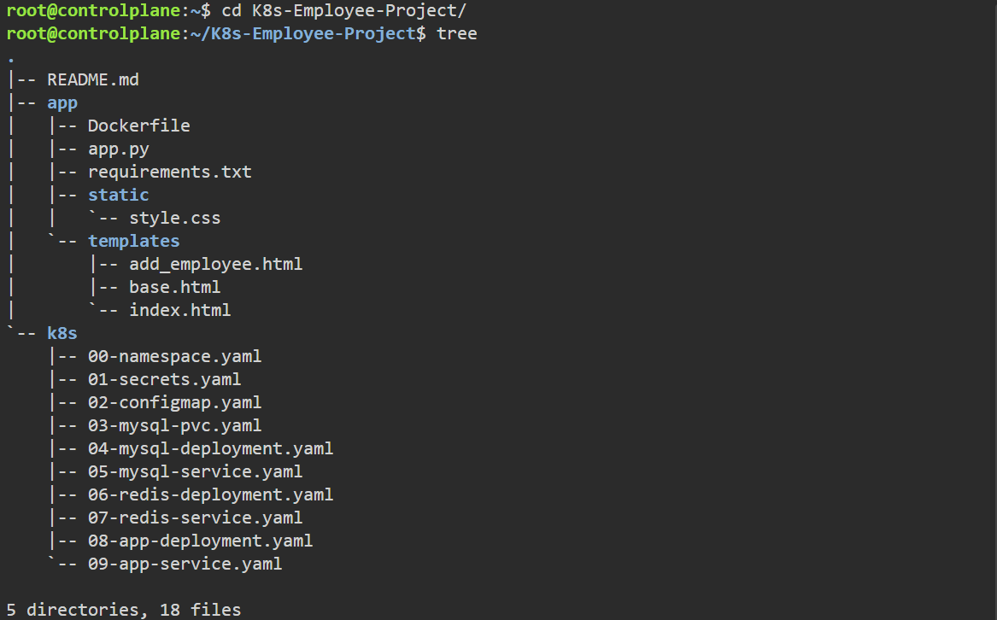

Step 4: Application Containerization:
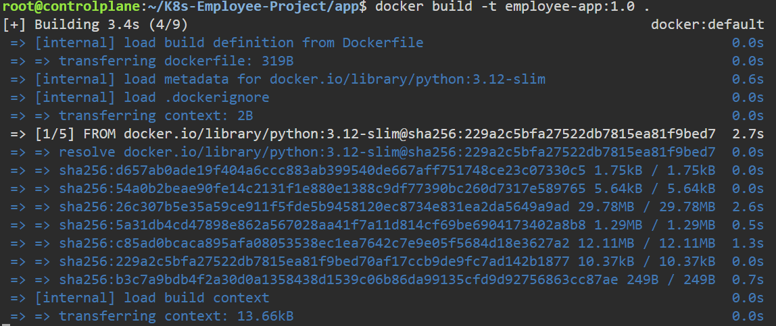
Step 5: Export the compiled Docker image:
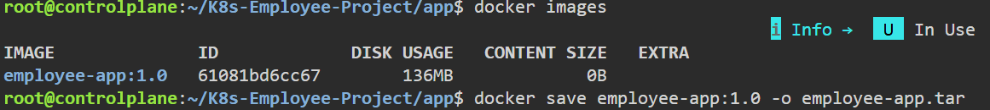
Step 6: Import the image into Containerd:
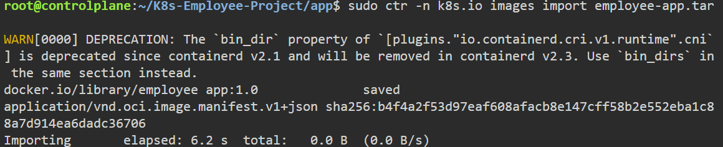
Step 7: Imported Image Verification:
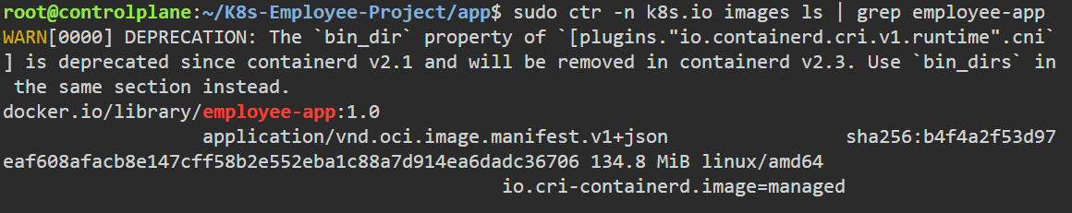


Step 8: Deploy the Kubernetes Resources:
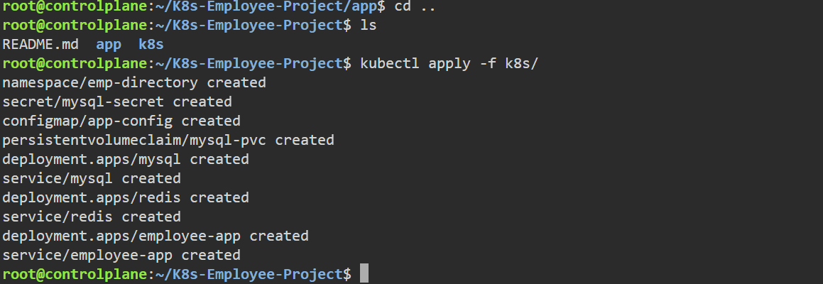
Step 9: Deployment Validation:
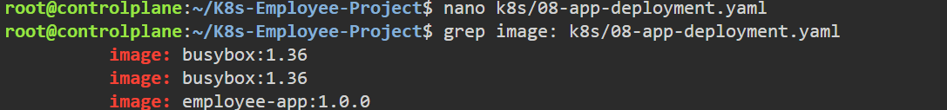
Step 10: Check Network Services:
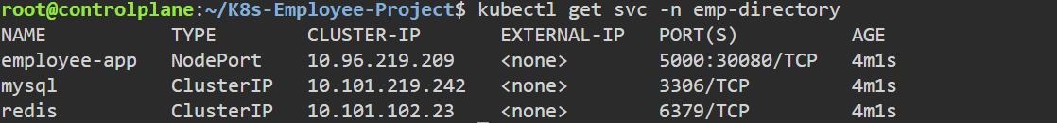
Step 11: Deployed Resources Verification:
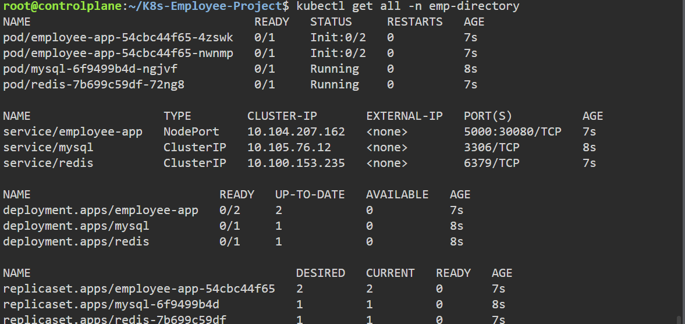


Step 12: Persistant Storage Verification:
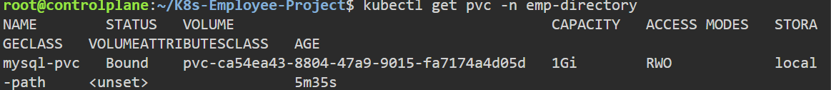
Step 13: Verify Configuration & Pod Status:
Step 14: Application Access:

Project Conclusion
The successful deployment of Employee Directory application demonstrates the practical implementation of Kubernetes for managing containerized applications in a production-like environment.
This project strengthened practical knowledge of Kubernetes, resource management, and cloud-native application deployment while reinforcing key DevOps practices such as Infrastructure as Code (IaC), containerization, configuration management, and persistent storage. Overall, the project serves as a solid foundation for building and managing scalable applications using Kubernetes in real-world environments.

