**Setup of DVWA**

Ref: <https://medium.datadriveninvestor.com/setup-install-dvwa-into-your-linux-distribution-d76dc3b80357> or https://nooblinux.com/how-to-install-dvwa/

sudo service nginx stop

sudo apt remove nginx

sudo apt install apache2 git

cd /var/[*www/html/*](http://www/html/)

sudo git clone [*https://github.com/ethicalhack3r/DVWA.git*](https://github.com/ethicalhack3r/DVWA.git)

sudo chmod -R 777 /var/[*www/html/DVWA/*](http://www/html/DVWA/)

*sudo mv DVWA dvwa*

*# Go to localhost/dvwa will give some error about config*

*# sudo wget https://dev.mysql.com/get/mysql-apt-config_0.8.15-1_all.deb*

*# sudo dpkg -i mysql-apt-config_0.8.15-1_all.deb*

*sudo apt-get update*

sudo apt-get install mariadb-server

sudo service mysql start

mysql -u root -p

sudo mysql_secure_installation

mysql -u root -p

CREATE DATABASE dvwadb;

CREATE USER ‘dvwausr’@’27.0.0.1’ IDENTIFIED BY ‘dvwa@123’;

GRANT ALL PRIVILEGES ON dvwadb.* TO ‘dvwausr’@’localhost’ IDENTIFIED BY ‘dvwa@123’;

FLUSH PRIVILEGES

mysql -u dvwausr -p

sudo apt install php

sudo service apache2 restart

cd /var/[*www/html*](http://www/html)

sudo vim info.php

Inside this file, copy paste the following:

<?php phpinfo(); ?>

# Then go to [*http://127.0.0.1/info.php*](http://127.0.0.1/info.php)

sudo apt install php-mysql

==========================================

sudo apt add-apt-repository ‘[*http://ftp.de.debian.org/debian*](http://ftp.de.debian.org/debian) sid main’

sudo apt update

sudo apt install php5-gd

sudo vim /var/[*www/html/dvwa/config/config.inc.php.dist*](http://www/html/dvwa/config/config.inc.php.dist)

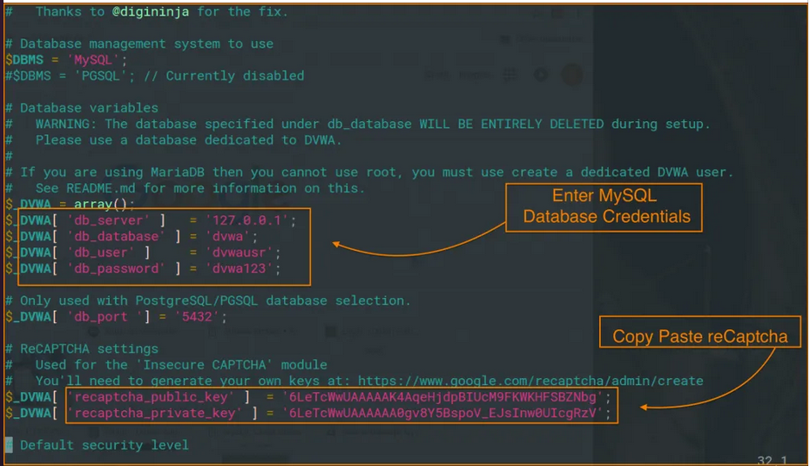Generate the captcha

sudo vim /etc/php/8.2/apache2/php.ini

* Enable Allow_url_fopen
* Enable Allow_url_include

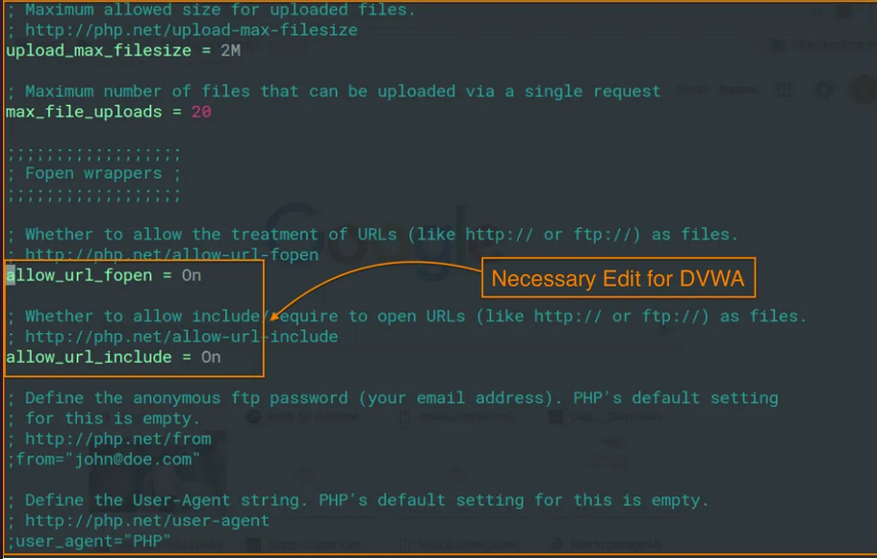

sudo service mysql restart

sudo service apache2 restart

cp /var/www/html/dvwa/config/config.inc.php.dist /var/www/html/dvwa/config/config.inc.php

Visist this URL

http://127.0.0.1/dvwa/setup.php

All other instruction are available at http://127.0.0.1/dvwa/instructions.php

**Run DVWA app**

sudo /opt/lampp/lampp stop

sudo service mysql restart

sudo service apache2 restart

Default Login user is admin:password

Reset the database for the first time and then re-login

All good to go

Download **XAMPP** and install it with all the things ignored

Ignore if there is any error and restart all the services

http://localhost/dashboard/faq.html

Manage of XAMPP

sudo /opt/lampp/lampp start

Check http://localhost/dashboard/faq.html

sudo /opt/lampp/lampp stop

Don’t do this (Will the XAMPP after the boot sequence)

sudo ln -s /opt/lampp/lampp /etc/init.d/lampp  
 sudo update-rc.d lampp start 80 2 3 4 5 . stop 30 0 1 6 .