CHAPTER 1
INTRODUCTION

It can be really helpful for people who are responsible for this part of multiplex shopping mall. It can swiftly create small database of employees,screens,billing transactions and reports.

The focus of this project is to design and implement a cheap and affordable management for use in a multiplex mall. This becomes very advantageous since all to work is automatically carried out by system rather than manual checking, which help to evaluate each employees and customers coming into the multiplex mall. The beginning page provide a well interface to select the from 2 type of entries Easy & Hard.

The use of JSP along with HTML, JAVASCRIPT help us to design perfect user interface along with the validations required at particular instance. Java Server Pages is server side scripting language.

The use of the computer based solution is better suited for this purpose due to the number of iterations needed to adequately satisfy the various variables. This project will be able to generate timetables for several levels of study, and a visual representation of the timetable can be viewed and simplified by filtering some properties such as level,
days of the week or hours.

CHAPTER 2
SCOPE
The software has been developed in such a way that it can accept modifications and further changes. The software is very user friendly and future any changes can be done easily. Software restructuring is carried out.
Software restructuring modifies source code in an effort to make it amenable to future changes. In general, restructuring does not modify the overall program architecture. It tends to focus on the design details of individual modules and on local data structure defined within modules.

Project Justification:

The system is an easy to use and error free system.

Future Scope:

Every system should allow scope for further development or enhancement. The system can be adapted for any further development. The system is so flexible to allow any modification need for the further functioning of programs.
Since the objectives may be brought broad in future, the system can be easily modified accordingly, as the system has been modularized. The future expansion can be done in a concise manner in order to improve the efficiently of the system.

CHAPTER 3
REQUIREMENTS:

Hardware Requirements

Hardware | Minimum Requirement
Processor | PIII/PIV – 500 MHz to 5 GHz and Onward
RAM | 256 MB and Onwards
Disk | More than 30 GB
Monitor | 15”/17” inch with true life resolution
Keyboard | Standard Keyboard with 104 Buttons or Keys
Mouse | Optical Mouse for faster use

Software Requirements
Software | Minimum Requirement
Operating System | Windows 2000/Windows XP/Windows Vista/Windows 7
Database | Mysql
Integrated Development Environment | ECLIPSE, ADODBE DREAMWEAVER
SERVER | APACHE

CHAPTER 4
CODE
INDEX PAGE:
<!DOCTYPE HTML PUBLIC "-//W3C//DTD HTML 4.01 Frameset//EN" "http://www.w3.org/TR/html4/frameset.dtd">
<!--NewPage-->
<HTML>
<HEAD>
<!-- Generated by javadoc on Wed Mar 07 13:18:12 IST 2012-->
<TITLE>
Generated Documentation (Untitled)
</TITLE>
<SCRIPT type="text/javascript">
targetPage = "" + window.location.search;
if (targetPage != "" && targetPage != "undefined")
targetPage = targetPage.substring(1);
if (targetPage.indexOf(":") != -1)
targetPage = "undefined";
function loadFrames() {
if (targetPage != "" && targetPage != "undefined")
top.classFrame.location = top.targetPage;
}
</SCRIPT>
<NOSCRIPT>
</NOSCRIPT>
</HEAD>
<FRAMESET cols="20%,80%" title="" onLoad="top.loadFrames()">
<FRAMESET rows="30%,70%" title="" onLoad="top.loadFrames()">
<FRAME src="overview-frame.html" name="packageListFrame" title="All Packages">
<FRAME src="allclasses-frame.html" name="packageFrame" title="All classes and interfaces (except non-static nested types)">
</FRAMESET>
<FRAME src="overview-summary.html" name="classFrame" title="Package, class and interface descriptions" scrolling="yes">
<NOFRAMES>
<H2>
Frame Alert</H2>

<P>
This document is designed to be viewed using the frames feature. If you see this message, you are using a non-frame-capable web client.
<BR>
Link to<A HREF="overview-summary.html">Non-frame version.</A>
</NOFRAMES>
</FRAMESET>
</HTML>

Login page:
import java.awt.SystemTray.*;
import javax.swing.table.*;
import java.sql.*;
import javax.swing.*;
import javax.swing.event.*;
import java.util.*;
import java.io.*;
import java.lang.*;

public class Login extends javax.swing.JFrame implements ActionListener
{
Connection con;
Statement st;
ResultSet rs;
PreparedStatement ps;
Container c;

JLabel name;
boolean flag = true;
JFrame fm;
JTextField t1;
JTextField t2;
JPanel jPanel1 = new JPanel();
JPanel jPanel2 = new JPanel();
JPanel jPanel3 = new JPanel();
JLabel l4 = new JLabel("", new ImageIcon("images/theater.jpg"), JLabel.CENTER);
/** Creates new form Login */
public Login()
{
super("MultiPlex Login Window");
initComponents();

Data Flow Diagram:

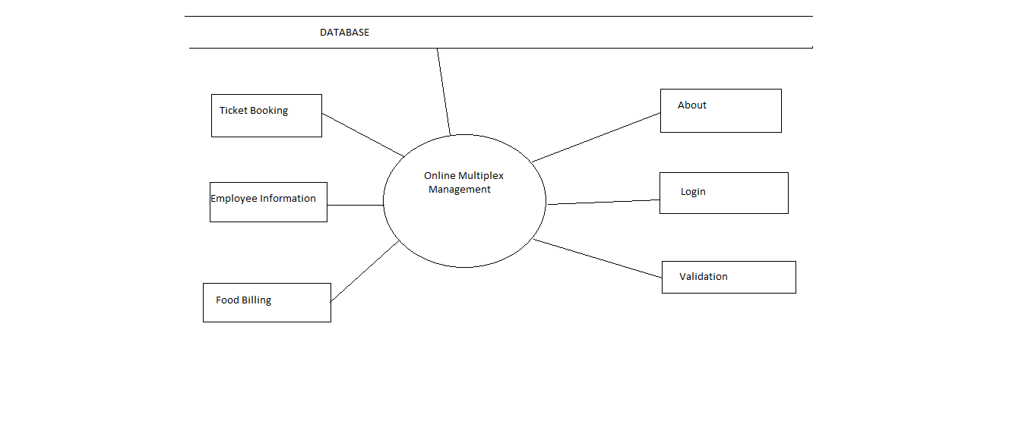

E-R Diagram:
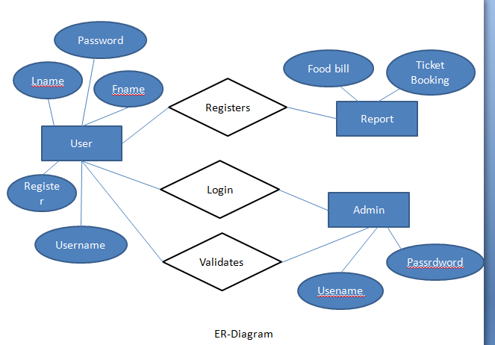

CHAPTER 5
GRAPHICAL USER INTERFACE:
LOGIN PAGE:

TICKET BOOKING:
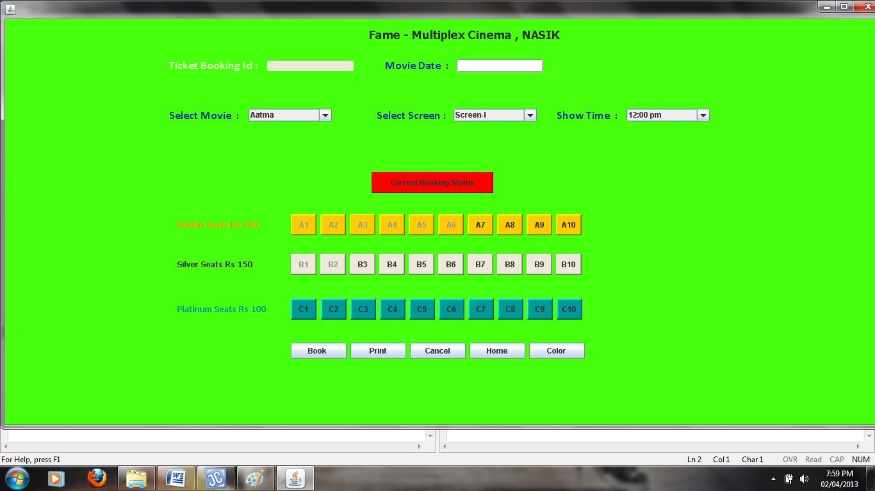
Billing:
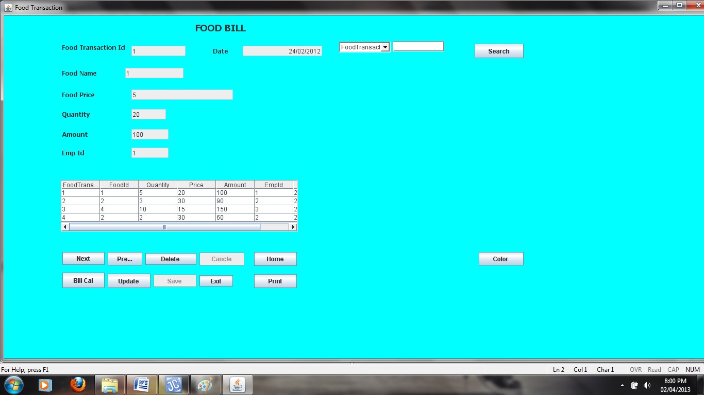

CHAPTER 6
CAPABILITIES AND OBJECTIVES
6.1 CAPABILITIES

Database Capabilities:
The system is well designed database to store all the information which will be entered in as the input & to retrieve the timely data.

Processing Capabilities:
The system is having queries to process all the data present in the database and keeping in view the various constraints like partition of exams in two different parts as easy & hard exams. It has processing capability that to separate the solved, unsolved question from each other while user clicks on submit.

Search Panel:
The system is an easy to use to search panel to search according his need on the question stored in the database. The system gives the response to the user quires in the proper format and errors messages shown properly to tell user about his mistakes and to guide him/her for proper use of the system.

6.2 PROJECT OBJECTIVES
- To Provide A Fast, Accurate And Error Free System To Generate Environment for online ticket booking.

- To Provide with an ease of selecting level of booking as easy and hard depending on the user need.

- To display the accurate seats of the theater at accurate place.so employee can use it in proper & fully manner.

- Automate The Availability And Automate Whole System.

CHAPTER 7
ASSUMPTION AND LIMITATION

7.1 ASSUMPTION

- The response time of the system accepted whatever it may be.
- The system is used only for windows operating system.
- The system is always connect to internet
- The system is use by people knowing somewhat of user.
- The user has the capability to navigate through the provided interface
- Network never fails during execution test.

7.2 LIMITATIONS OF THE SYSTEM

Online Multiplex System is created for the use of only ‘for institutional use not for commercial use’.
All the basic requirements of a system such as billing in two different levels,feedback sytem,providing the short but enough information for user to navigate through the entire site .
The main limitation with project is that it is design to book for ticket of movie.

CHAPTER 8
CONCLUSION

The Multiplex Exam System designed in JSP with Mysql as backend is complete online application that can be use to booking movie tickets and billing in an efficient manner. Rather than having booking carried out on paper, & then to verify it manually.

Depending on the need of user with an effective feedback system to provide user to fired his query or entire his/her comment regarding the project.

The main concept is the automatic calculation of the bill of appears customer along with the numbers. It also display how many customers entered into theater. And another thing that drag our attention is the user interface which is attractive & user friendly.

