### SAVITRIBAI PHULE

### PUNE UNIVERSITY

### A PROJECT REPORT ON

**CROPTHESIS**

SUBMITTED TOWARDS THE

PARTIAL FULFILLMENT OF THE REQUIREMENTS OF

**THIRD YEAR ENGINEERING**

**(Computer Engineering)**

**BY**

**1.Prathamesh Giri**

**2.Vishal kajale**

**3.Chetan Daulani**

**4.Hrithik Sangahvi**

**Under The Guidance of**

Prof. Namrata D.Ghuse



**DEPARTMENT OF COMPUTER ENGINEERING**

**Sandip Foundations**

**Sandip Institute of Technology and Research Centre Mahiravani,Trimbak Road, Nashik,(M.S.), India**



**Sandip Foundations**

**Sandip Institute of Technology and Research Centre**

**DEPARTMENT OF COMPUTER ENGINEERING**

**CERTIFICATE**

This is to certify that the Project Entitled

**CROPTHESIS**

Submitted by

**1.Prathamesh Giri**

**2.Vishal kajale**

**3.Chetan Daulani**

**4.Hrithik Sangahvi**

is a bonafide work carried out by Students under the supervision of Prof. Namrata D. Ghuse and it is submitted towards the partial fulfillment of the requirement of Bachelor of Engineering (Computer Engineering).

Prof. Namrata D. Ghuse Prof. A.D.Potgantwar

Internal Guide H.O.D

Dept. of Computer Engg. Dept. of Computer Engg.

Dr.S.T.Gandhe

Principal

Sandip Institute of Technology and Research Centre

Signature of Internal Signature of External Examiner Examiner

### 

### PROJECT APPROVAL SHEET

**CROPTHESIS**

Is successfully completed by

**1.Prathamesh Giri**

**2.Vishal kajale**

**3.Chetan Daulani**

**4.Hrithik Sangahvi**

at

DEPARTMENT OF COMPUTER ENGINEERING

**Sandip Institute of Technology and Research** **Centre**

**SAVITRIBAI PHULE PUNE UNIVERSITY,PUNE ACADEMIC YEAR 2019-2020**

Prof. Namrata D. Ghuse Prof.(Dr)A.D.Potgantwar

Internal Guide H.O.D

Dept. of Computer Engg. Dept. of Computer Engg.

# Table of Contents

Contents:

1. Introduction…………………………………………………….……….…..……03
2. Problem Definition………………………………………………….…..….…….05
3. Working Methodology and Code Snippets.……………………….…..…………07
4. Motivation………………………………………………………….….…………10
5. Design / Proposed System……………………………………………..…………11
6. Requirements………………………………………………………….………….12
7. Applications………………………………………………………………………14
8. Result…………………………………………………………………………..…15
9. Conclusion and Future Scope……………………………………………….……15

10. References…………….………………………………………………………….15

**Introduction to Crop prediction**

**What is Crop Prediction**

Crop yields are critically dependent on weather. A growing empirical literature models this relationship in order to project climate change impacts on the sector. We describe an approach to yield modeling that uses a semiparametric variant of a deep neural network, which can simultaneously account for complex nonlinear relationships in high-dimensional datasets, as well as known parametric structure and unobserved cross-sectional heterogeneity.

Using data on corn yield from the US Midwest, we show that this approach outperforms both classical statistical methods and fully-nonparametric neural networks in predicting yields of years withheld during model training. Using scenarios from a suite of climate models, we show large negative impacts of climate change on corn yield, but less severe than impacts projected using classical statistical methods. In particular, our approach is less pessimistic in the warmest regions and the warmest scenarios.

**WHY CROP PREDICTION IS SO IMPORTANT?**

**• The environment**

• Better flows and access

**• Socio economic aspect**

• Increased wealth

• Increased income

• Increased employment

• Economic growth

**• Health and nutrition**

• Reduced diseases

• Reduce morbidity

**USING PYTHON FOR CROP ANALYSIS**

**MATPLOTLIB**

Matplotlib is a plotting library for the Python programming language and its numerical mathematics extension NumPy.

Matplotlib is a library for making 2D plots of arrays in Python.

It provides an object-oriented API for embedding plots into applications using general-purpose GUI toolkits like wxPython, Qt, or GTK+.

The Matplotlib code is conceptually divided into three parts: the pylab interface is the set of functions provided by Matplotlib.

The Matplotlib frontend or Matplotlib API is the set of classes that do the heavy lifting, creating and managing figures, text, lines, plots and so on.

This is an abstract interface that knows nothing about output. The backends are device dependent drawing devices, aka renderers, that transform the frontend representation to hardcopy or a display device

## PILLOW

Pillow is a Python Imaging Library (PIL), which adds support for opening, manipulating, and saving images. The current version identifies and reads a large number of formats. Write support is intentionally restricted to the most commonly used interchange and presentation formats.

The program reads a JPG image and displays it in an external application.

**from PIL import Image**

**PYTHON GUI – TKINTER**

Python offers multiple options for developing GUI (Graphical User Interface). Out of all the GUI methods, tkinter is most commonly used method. It is a standard Python interface to the Tk GUI toolkit shipped with Python. Python with tkinter outputs the fastest and easiest way to create the GUI applications. Creating a GUI using tkinter is an easy task.  
**To create a tkinter:**

1. Importing the module – tkinter
2. Create the main window (container)
3. Add any number of widgets to the main window
4. Apply the event Trigger on the widgets.

Importing tkinter is same as importing any other module in the python code. Note that the name of the module in Python 2.x is ‘Tkinter’ and in Python 3.x is ‘tkinter’.

**import tkinter**

There are two main methods used you the user need to remember while creating the Python application with GUI.

1. **Tk(screenName=None,  baseName=None,  className=’Tk’,  useTk=1):** To create a main window, tkinter offers a method ‘Tk(screenName=None,  baseName=None,  className=’Tk’,  useTk=1)’. To change the name of the window, you can change the className to the desired one. The basic code used to create the main window of the application is:

**m=tkinter.Tk() where m is the name of the main window object**

1. **mainloop():** There is a method known by the name mainloop() is used when you are ready for the application to run. mainloop() is an infinite loop used to run the application, wait for an event to occur and process the event till the window is not closed.

m.mainloop()

[1]

**NUMPY**

**Numpy** | Mathematical **Function**. **NumPy** contains a large number of various mathematical operations. **NumPy** provides standard trigonometric **functions**, **functions** for arithmetic operations, handling complex numbers, etc. **NumPy** has standard trigonometric **functions** which return trigonometric ratios for a given angle in radians.

**PROBLEM STATEMENT**

Agriculture is the main occupation of the majority of population. The farmers of the district rely heavily on agriculture for earning their livelihood. The development of agriculture depends on various aspects such as type of soil, relief, vegetation, climatic conditions, attitudes of different social groups of farmers to agriculture, use of irrigation, HYV seeds, fertilizer, pesticides and insecticides, use of mechanical tools and implements, as well as proper scientific rotation of crops by which production be enhanced. The impact of these aspects of agriculture varies in different areas of the district. There are distinct variations in the magnitude of these concepts both over space and time. To have real understanding of the nature of agricultural development, scientific investigation and evaluation of different aspects of development become highly necessary.

**WORKING METHODLOGY**

There are many factors which influence the **yield** of **crop** like rainfall, temperature humidity, soil, etc. **Crop prediction helps farmers** in selecting proper **crop** for plantation to maximize their earning. This will be the purpose of our script.

* To take the input data such as whether conditions in past year/month, rainfull period, temperature etc.

* Analyze the data to find the best period for cultivation and the whether conditions in upcoming future and production prediction from past available data.

* 3. To input the large datasets of past years to find out the accurate results of crop prediction.

.

**MOTIVATION**

1.To help the farmer for getting ROI(Return On Investment).

2.Accurate hypothesis for the crop yielding.

3.Collection of more valid details of soil,latitude and suitable crop can greatly accelerate the efficiency of Work.

4.To encourage the farmer for accomplishing self development.

**“A FARMER IS A MAGICIAN WHO PRODUCES MONEY FROM THE MUD*”***

**DESIGN { PROPOSED SYSTEM }**

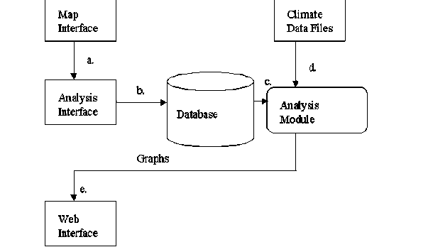

**System Requirements, Libraries & Languages used**

* **Linux Operating System. (Ubuntu Preferred)\***
* **Python 3.0 or above.**
* **Pyplot.**
* **Tkinter.**
* **Matplotlib.**

**RESULTS**

**GUI**

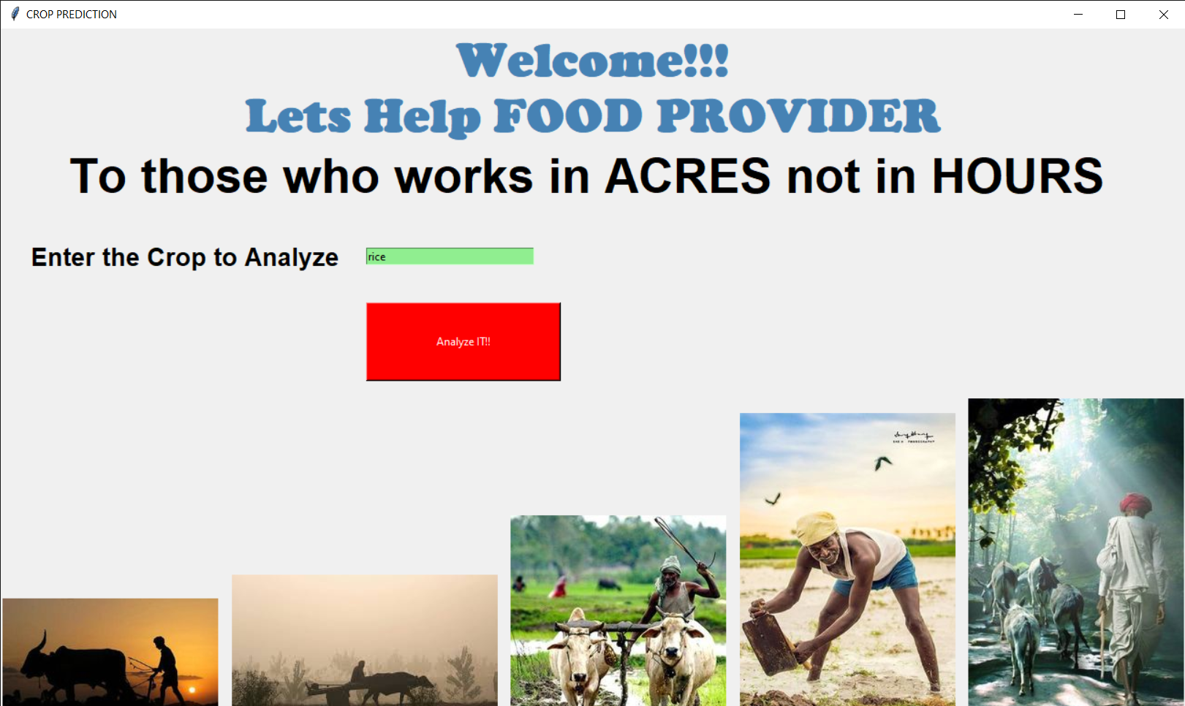

**OUTPUTS:-**

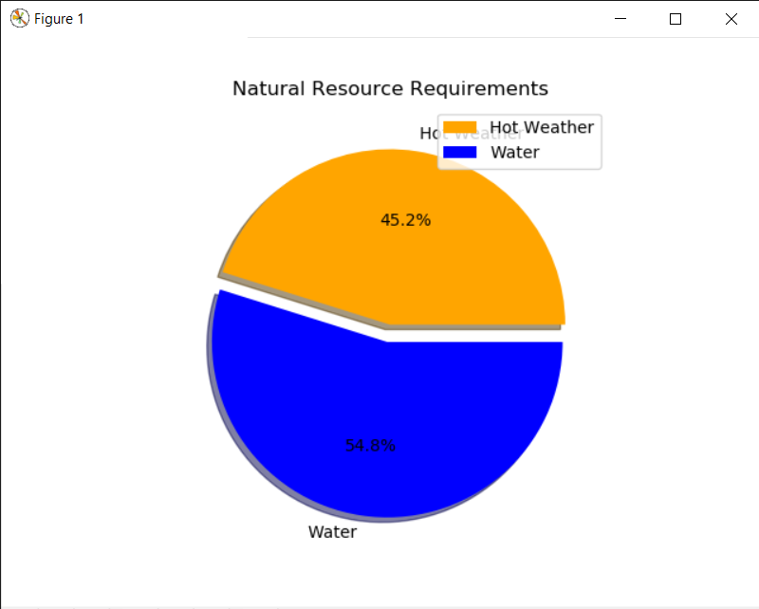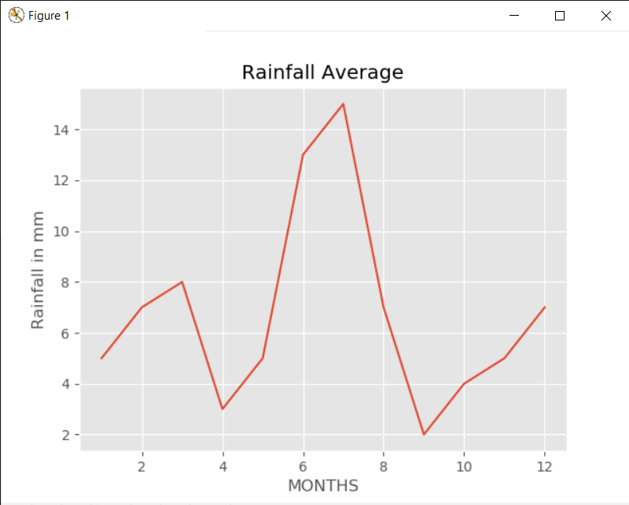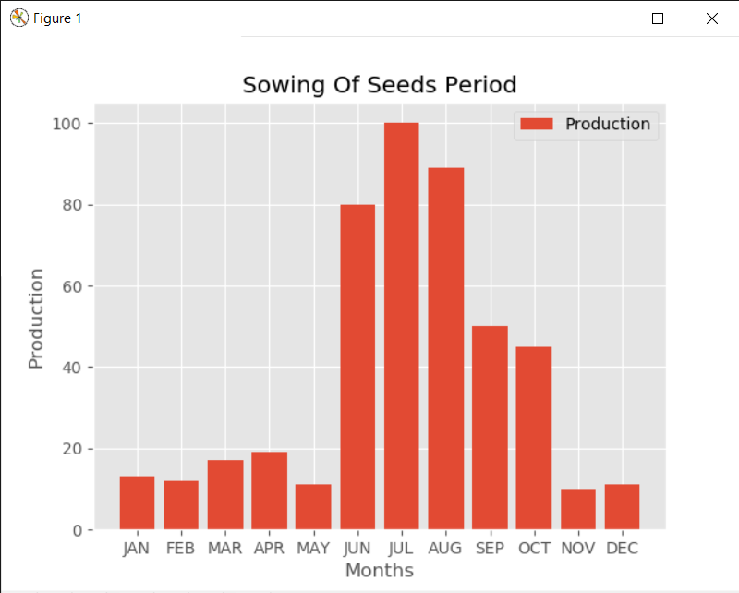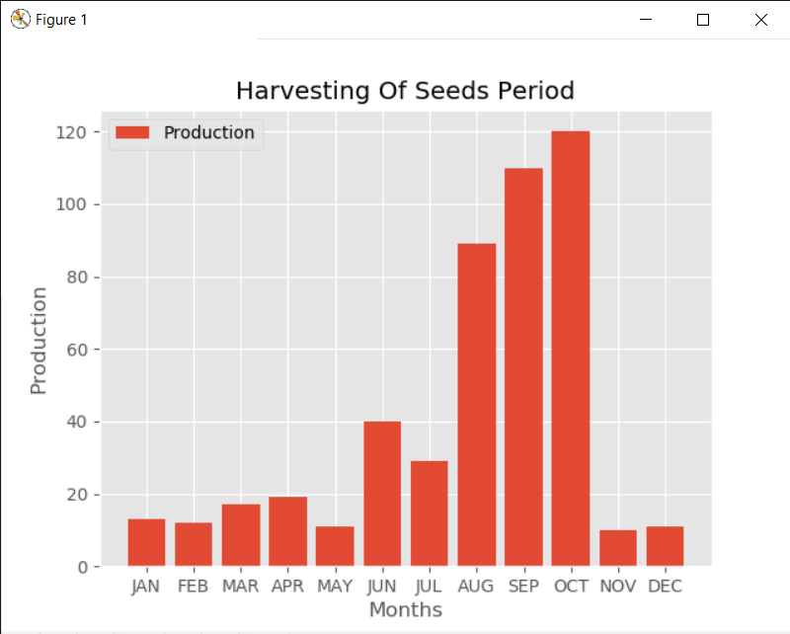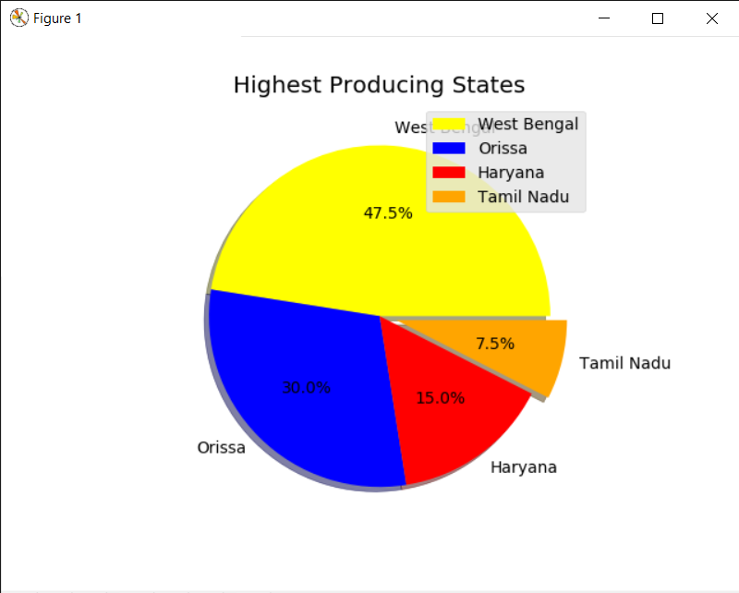

**APPLICATIONS**

* It helps to know the time good time for cultivation of crop
* It helps to know the demand and growth of agricultural industry and to find out the how much production is required.
* It also help in production of disease free crop and high yield with the least usage of resources
* It reduces the burden of farmer

**CONCLUSION**

➢ We conclude that, Crop yield prediction is still remaining as a challenging issue for farmers. The aim of this research is to propose and implement a rule based system to predict the crop yield production from the collection of past data.

             

**FUTURE WORK**

1.More Accurate Predictions will be Provided.

2.AI(Artificial Intelligence) And ML(Machine Learning) will be used for Better Hypothesis.

3. More Modules will be Imported For The DataSets.

4. The system can be extended to the mobile application to help the farmers by

uploading the image of agriculture area.

5. The system builds up an Image Classifier Model, using SSSE and

SVM, which acts as an image classifier builder

**REFERENCES**

* <https://en.m.wikipedia.org/wiki/Climate_change_and_agriculture>a is t

[www.fao.org/soils-portal/soil-survey/soil-maps-and-databases/harmonized-world](http://www.fao.org/soils-portal/soil-survey/soil-maps-and-databases/harmonized-world-soil-database-v12/en/)

* Attonaty JM, Chatelin MH, Garcia F, Ndiaye N. Using extended machine learning and simulation technics to design crop management strategies. First European Information Technology in Agriculture, Copenhagen. 1997; 1–500

**THANK**

**YOU!!!**

1.