Postgres Pre-Installation:
Download postgres package source code from server (9.3.0v)
Extract it.
Open terminal where you extract postgres tarball.
Then
./config –prefix=<path to install postgres(/home/vishal/Vishal/Sem6/SPC/)>
Then make.
Then install.
This will install postgres on prefix location.
Then make data directory in –prefix path
mkdir data
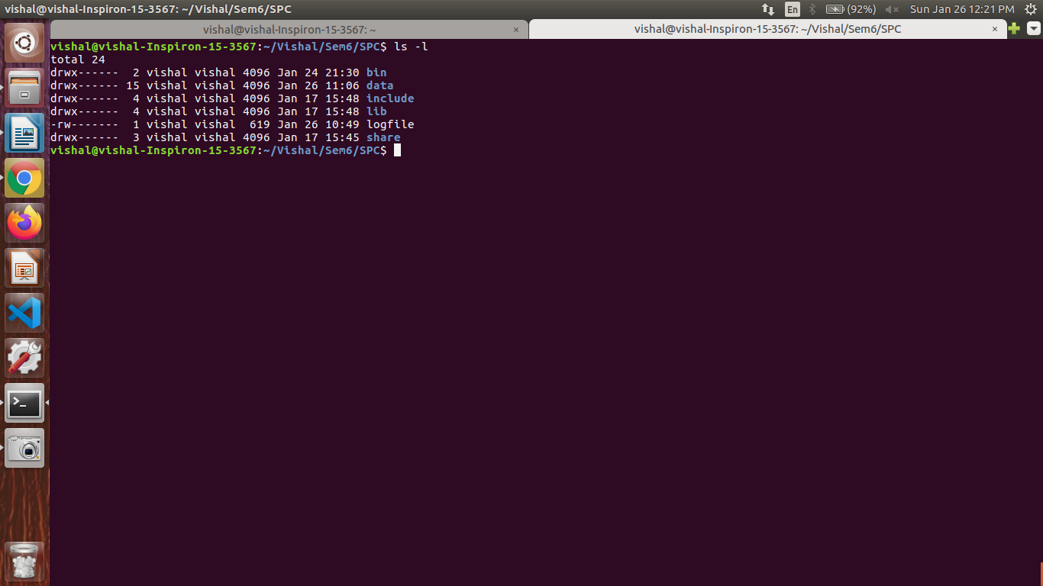
~/postgres/bin/initdb -D ~/postgres/data/
/home/vishal/Vishal/Sem6/SPC/bin/postgres -D /home/vishal/Vishal/Sem6/SPC/data/
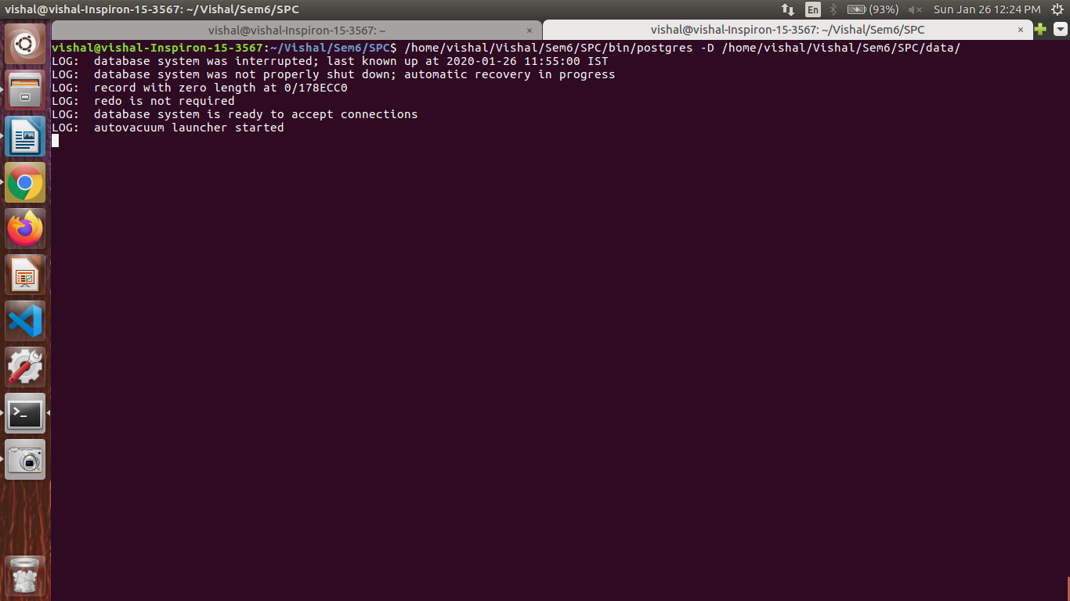
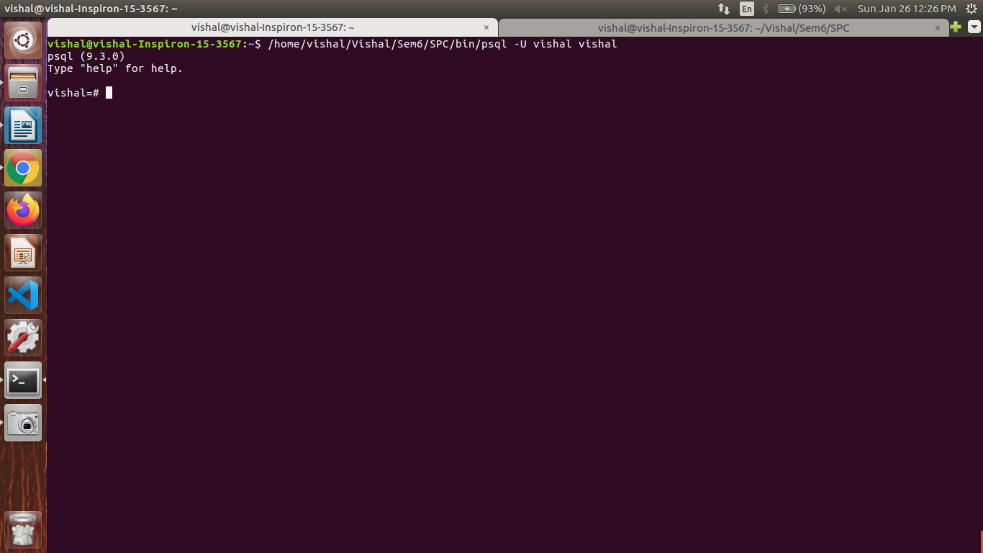
/home/vishal/Vishal/Sem6/SPC/bin/psql -U vishal vishal
Manual Postgres start:
1)/home/vishal/Vishal/Sem6/SPC/bin/pg_ctl -D /home/vishal/Vishal/Sem6/SPC/data/ -l logfile start
2)/home/vishal/Vishal/Sem6/SPC/bin/postgres -D /home/vishal/Vishal/Sem6/SPC/data/
3)/home/vishal/Vishal/Sem6/SPC/bin/psql -U vishal vishal
Autostart Postgres:
[ Till now process gets run if we run command 1 &3 manually; but not autostarting]
then create postgresql-service file in /etc/init.d/.
copy content to the file
#!/bin/bash
## EDIT FROM HERE
# Installation prefix
prefix=/home/vishal/Vishal/Sem6/SPC

# Data directory
PGDATA="/home/vishal/Vishal/Sem6/SPC/data"

# Who to run the postmaster as, usually "postgres". (NOT "root")
PGUSER=vishal
# Where to keep a log file
PGLOG="$PGDATA/serverlog"

# It's often a good idea to protect the postmaster from being killed by the
# OOM killer (which will tend to preferentially kill the postmaster because
# of the way it accounts for shared memory). To do that, uncomment these
# three lines:
#PG_OOM_ADJUST_FILE=/proc/self/oom_score_adj
#PG_MASTER_OOM_SCORE_ADJ=-1000
#PG_CHILD_OOM_SCORE_ADJ=0
# Older Linux kernels may not have /proc/self/oom_score_adj, but instead
# /proc/self/oom_adj, which works similarly except for having a different
# range of scores. For such a system, uncomment these three lines instead:
#PG_OOM_ADJUST_FILE=/proc/self/oom_adj
#PG_MASTER_OOM_SCORE_ADJ=-17
#PG_CHILD_OOM_SCORE_ADJ=0

## STOP EDITING HERE

# The path that is to be used for the script
PATH=/usr/local/sbin:/usr/local/bin:/sbin:/bin:/usr/sbin:/usr/bin

# What to use to control the postmaster
PGCTL="$prefix/bin/pg_ctl"

set -e

# Only start if we can find pg_ctl
test -x $PGCTL ||
{
echo "$PGCTL not found"
if [ "$1" = "stop" ]
then exit 0
else exit 5
fi
}

# If we want to tell child processes to adjust their OOM scores, set up the
# necessary environment variables. Can't just export them through the "su".
if [ -e "$PG_OOM_ADJUST_FILE" -a -n "$PG_CHILD_OOM_SCORE_ADJ" ]
then
DAEMON_ENV="PG_OOM_ADJUST_FILE=$PG_OOM_ADJUST_FILE PG_OOM_ADJUST_VALUE=$PG_CHILD_OOM_SCORE_ADJ"
fi

# Parse command line parameters.
case $1 in
start)
echo -n "Starting PostgreSQL: "
test -e "$PG_OOM_ADJUST_FILE" && echo "$PG_MASTER_OOM_SCORE_ADJ" > "$PG_OOM_ADJUST_FILE"
su - $PGUSER -c "$DAEMON_ENV $PGCTL start -w -D '$PGDATA' &" >>$PGLOG 2>&1
echo "ok"
;;
stop)
echo -n "Stopping PostgreSQL: "
su - $PGUSER -c "$PGCTL stop -D '$PGDATA' -s -m fast"
echo "ok"
;;
restart)
echo -n "Restarting PostgreSQL: "
su - $PGUSER -c "$PGCTL stop -D '$PGDATA' -s -m fast -w"
test -e "$PG_OOM_ADJUST_FILE" && echo "$PG_MASTER_OOM_SCORE_ADJ" > "$PG_OOM_ADJUST_FILE"
su - $PGUSER -c "$DAEMON_ENV $PGCTL start -w -D '$PGDATA' &" >>$PGLOG 2>&1
echo "ok"
;;
reload)
echo -n "Reload PostgreSQL: "
su - $PGUSER -c "$PGCTL reload -D '$PGDATA' -s"
echo "ok"
;;
status)
su - $PGUSER -c "$PGCTL status -D '$PGDATA'"
;;
*)
# Print help
echo "Usage: $0 {start|stop|restart|reload|status}" 1>&2
exit 1
;;
esac
exit

Then change path of prefix, pgdata and pguser in postgres_service accordingly.
Then sudo update-rc.d postgresql-service defaults.
Then in ~/.bashrc file add line at end:
alias psql="/home/vishal/Vishal/Sem6/SPC/bin/psql"
Then source ~/.bashrc
Then sudo service postgresql-service restart or restart machine.
After restarting check process get started or not using ps-ejH.
Then try to start postgres by psql -U vishal vishal.
Adding database or new users.
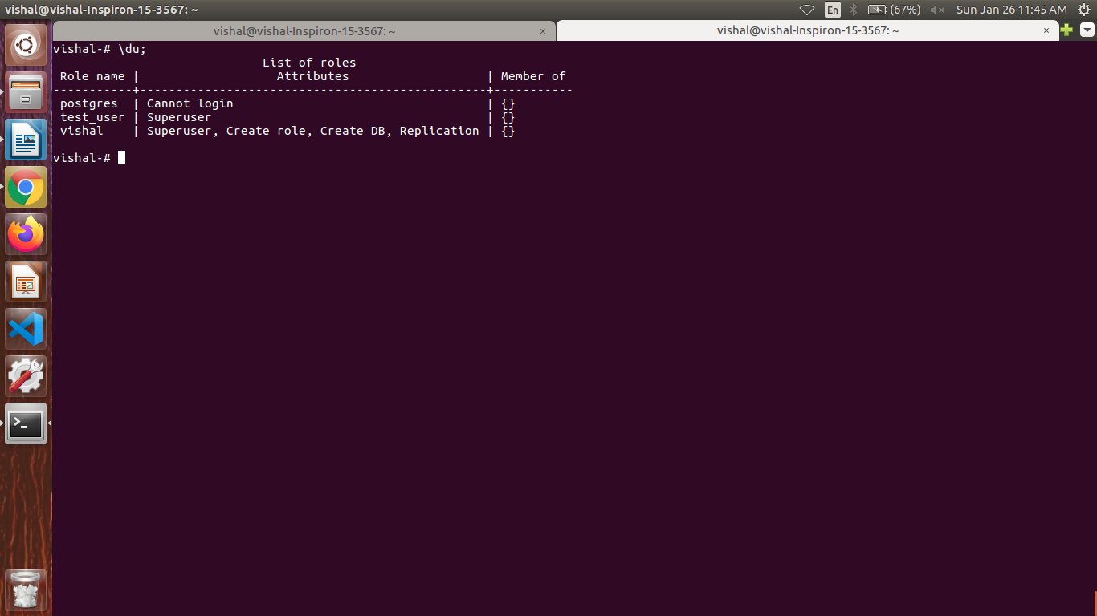
Start psql -U vishal vishal
Then inside psql prompt
\du
create role user1
create role user1 superuser;
grant ALL ON DATABASE postgres TO user1;

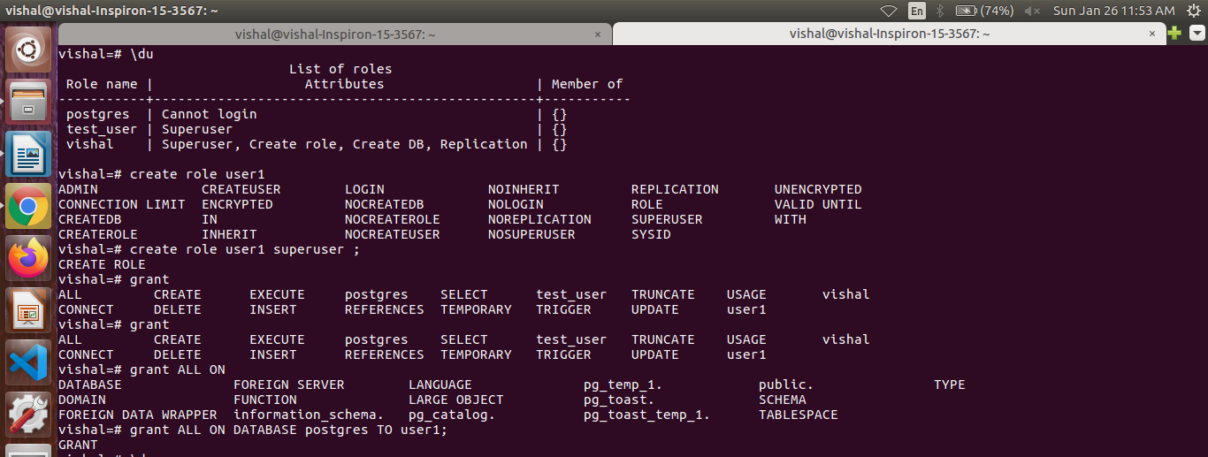
Then try this commands
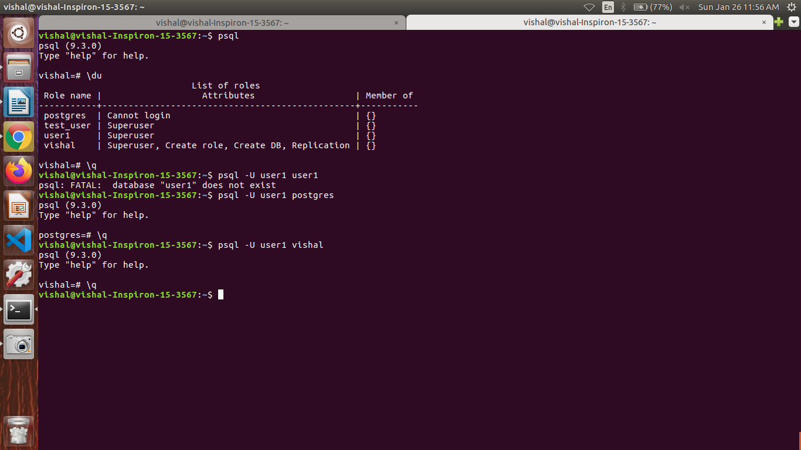
Boom!!!!

