Roll No.:17134
Name: Vishal Kokane
Project Partner:None
Project Title: Banking management system
------------------------------------------------------------------------------------------

This project is related to managing banking services like to serve customer, manage his banking activities like transactions, loan facilities, logins, card services, balances and so on.

- Project Scheduling an planning:
To organize and complete your projects in a timely, quality, financially responsible manner we need to schedule our project. It plays crucial role in ensuring project success. To keep project on track set realistic time frames, assign resources and manage to decrease errors. This makes customer satisfaction. We can achieve our goals and priorities in time

- Scheduling and planning
Planning is needed to identify desired goals reduce risk, avoid missed deadlines, and deliver the product, result. In planning we divide the projects into small tasks assemble a team of people and determine the shedule over which the work is to be completed. In this we create smaller goals within larger project, making sure it will achievable in timeframe

- Identifying tasks:
task is accomplish by a set deadline, it is single part of work to be done within time limit
when we plan a project some ajor tasks come in picture, we divide them into smaller subtask that which will make the whole working system after completion.

- Project tasks
1)Requirement gathering and validation.
2)Design screens
3)Design database
4)Coding
5)User documentation
6)Testing
7)Final Documentation
8)Installation

- project scheduling and tracking:
For project scheduling we use tools like Gantt chart, Critical path method, program evaluation and Review Technique i.e(PERT)

Project schedule table:
No. | Activity | Expected completion time(days) | Dependency
1 | Requirement gathering and validation | 10 | -
2 | Design screens | 10 | 1
3 | Design database | 5 | 2,1
4 | Coding | 20-25 | 2,3
5 | documentation | 5 | 4
6 | Testing | 10 | 5
7 | Final User documentation | 7 | 6
8 | Installation | 1 | 5,7

Work distribution:
1)Requirement gathering
2)Screen design
3)coding
4)database design
5)testing
6)documentation
7)final product

Techniques of project management:

1)Gantt chart:
Gantt chart is a visual view of task schedule over time. This is use for planning project and is useful way of showing what work is scheduled to be done on specific day. They also help to view start and end date of tasks.

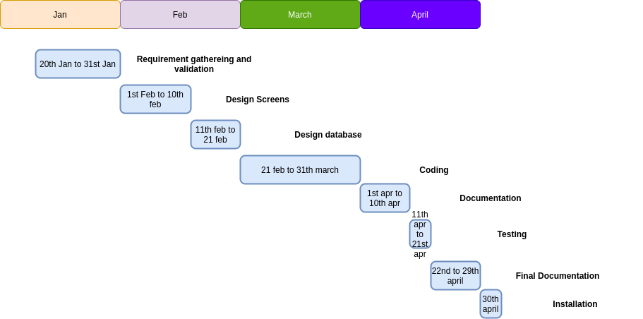

2)PERT Chart:
This is a tool use to calculate the amount of time require to finish a project.
Using information from project schedule table the diagram as follows
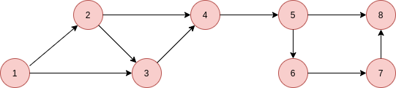

b)Pert chart earliest expected time.
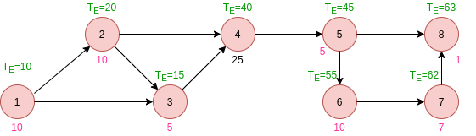

3) Critical path Method
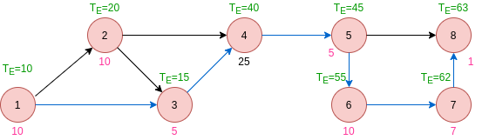
Critical pert path shown using blue arrow.
1-->3-->4-->5-->6-->7-->8

