Roll Number:17134
Name: Vishal Kokane
Assignment 2:Docker
Git URL:https://github.com/vishalkokane264/pucsd2020-devops
-----------------------------------------------------------------------------------------
This assignment is of building REST api using CRUD operations.
I’ve used nodejs +mysql in base docker image of ubuntu.

Project Directory structure:
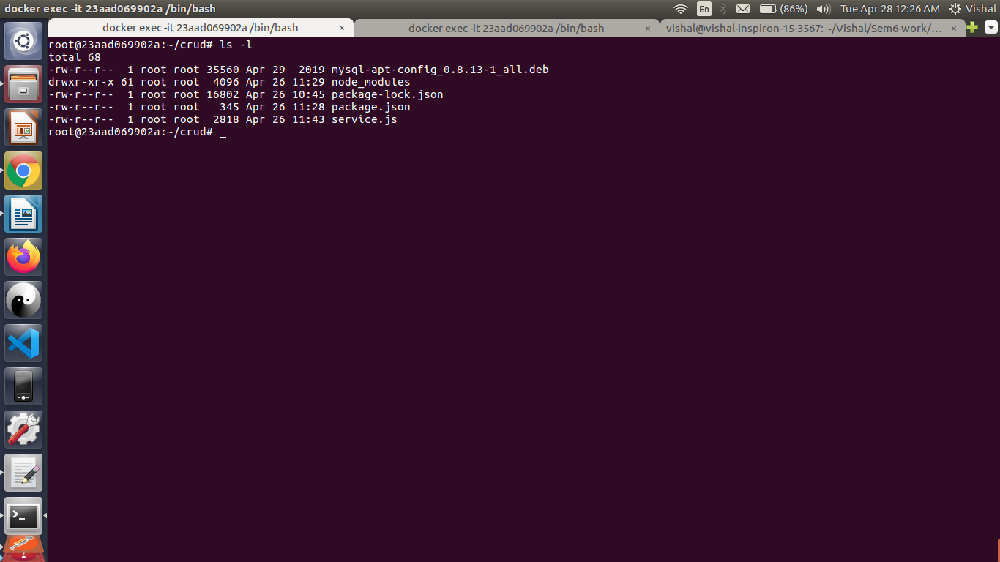
Api Documentation:
Method | URL | Description
GET by id | http://localhost:46150/user/:id | Get user by user id
Get (all) | http://localhostL46150/user | Get all users
POST | http://localhost:46150/user | Add user in database
PUT | http://localhost:46150/user | Update username using userid
DELETE(id) | http://localhost:46150/user/id | Delete user using userid

Flow diagram
CRUD REST API
Get
POST
PUT
DELETE
All
By id
By id
database
Docker image
PORT:8080
PORT:46150
Postman http://localhost:46150/user/1
Method=get

dockerfile:

FROM debian:latest

RUN cd
RUN apt-get update && apt-get install -y wget
RUN wget https://dev.mysql.com/get/mysql-apt-config_0.8.13-1_all.deb
RUN dpkg -i mysql-apt-config_0.8.13-1_all.deb
RUN apt-get update
RUN apt-get install -y mysql-server && apt-get install -y nodejs && apt-get install -y npm

COPY nodejs/ /root/crud

RUN cd /root/crud
RUN npm install

RUN /etc/init.d/mysql stop

RUN mysqld_safe --skip-grant-tables &

RUN mysql < database.sql

EXPOSE 8080

CMD ["node","service.js"]

------------------------------------------------------------------------------------------

Snapshot:
Running Docker file
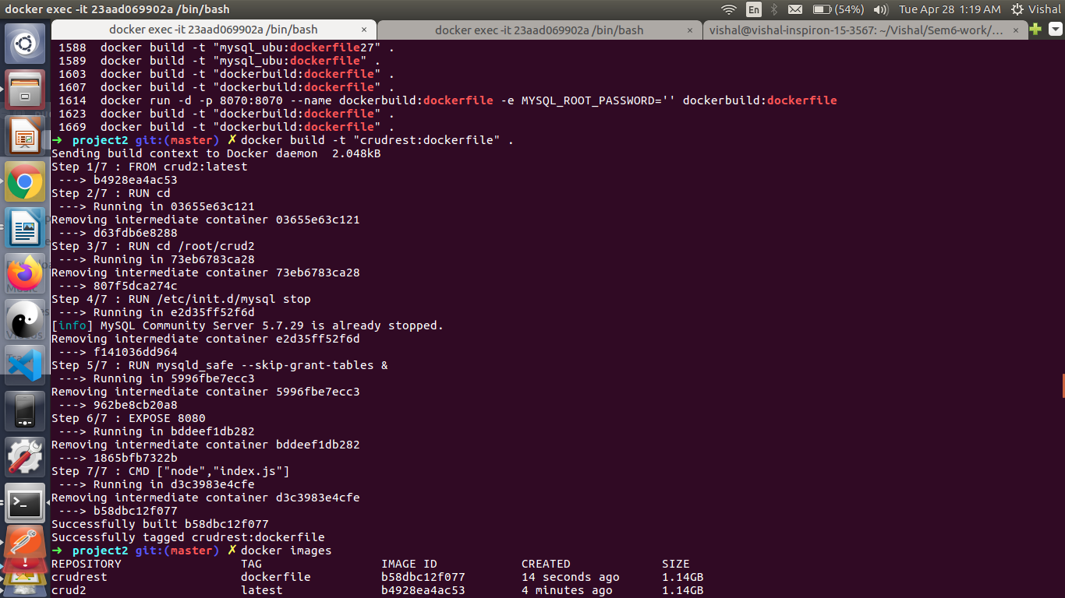
1)Docker images && container running
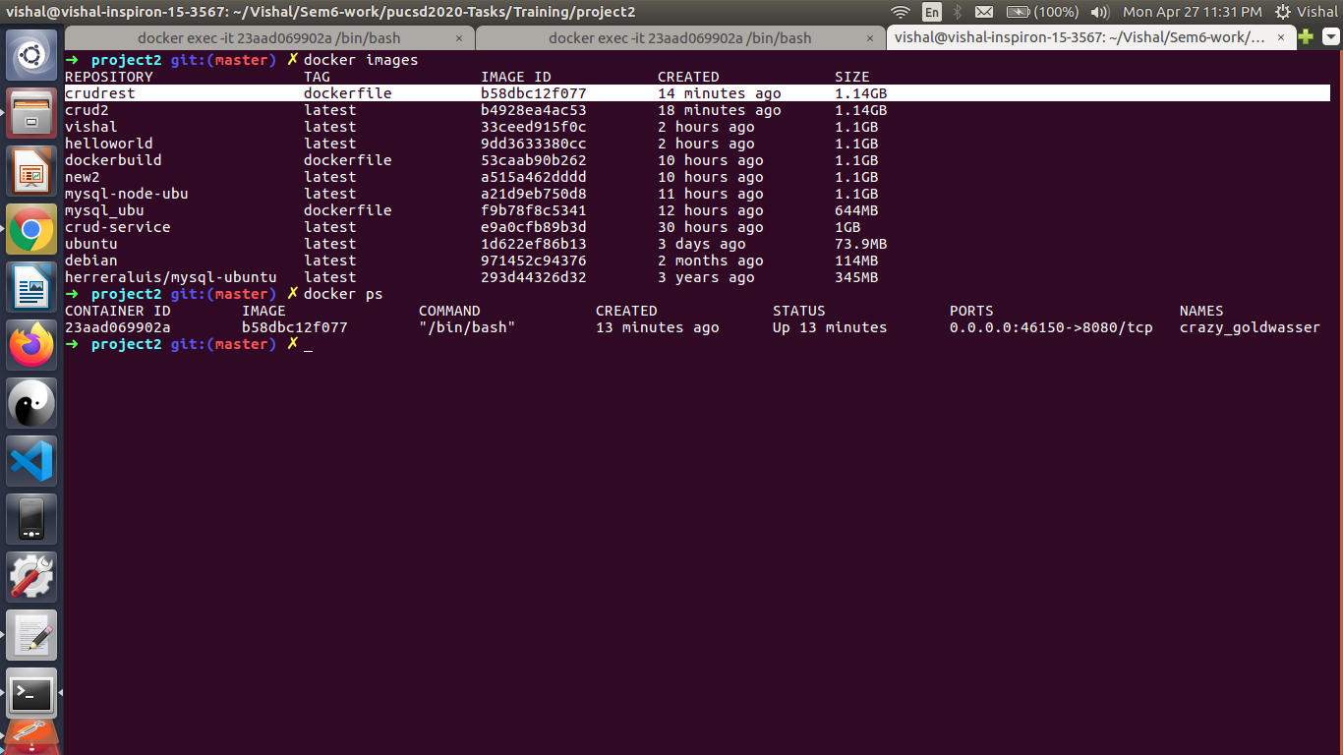

2)Nodejs service running on port 8080
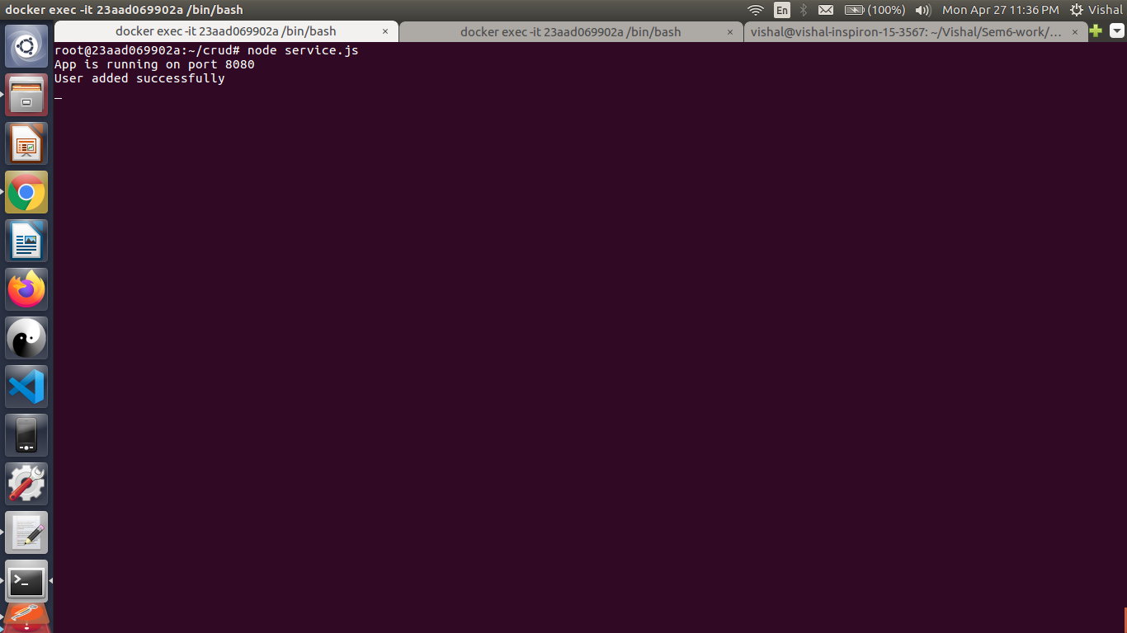

3)Another same container running for checking mysql data
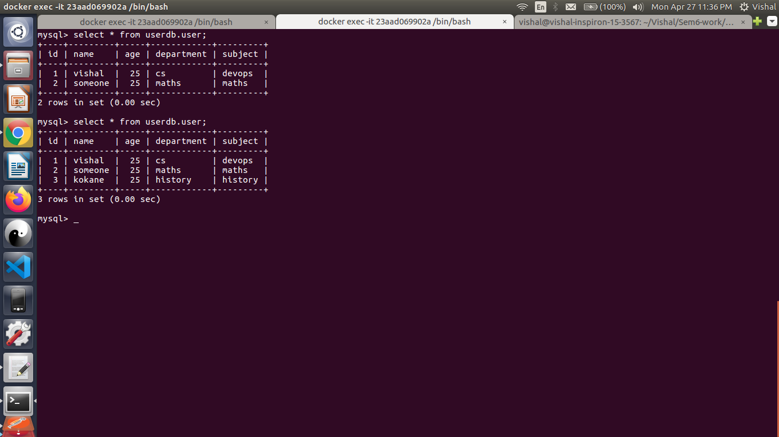

4)Validating service using CURL get request
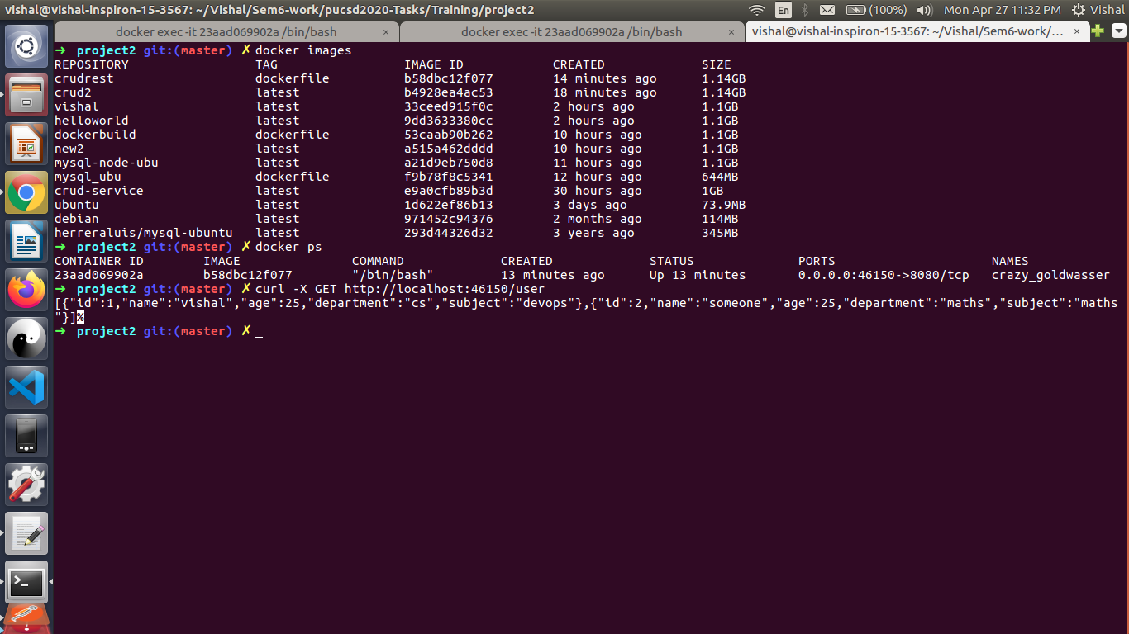

5)Postman POST method:
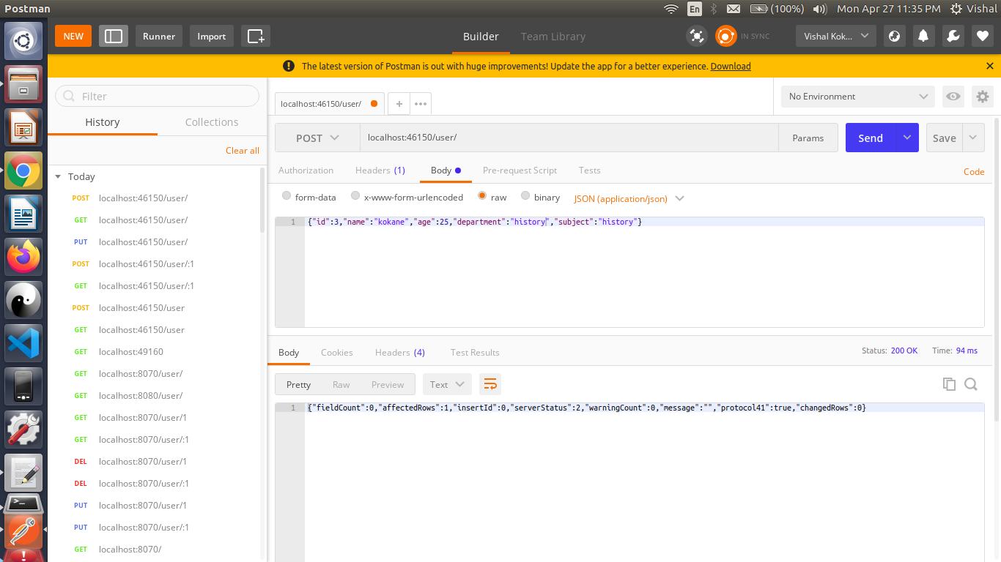

5.1) User added Successfully
5.2)Mysql result of POST

6)Postman delete data with user id =1
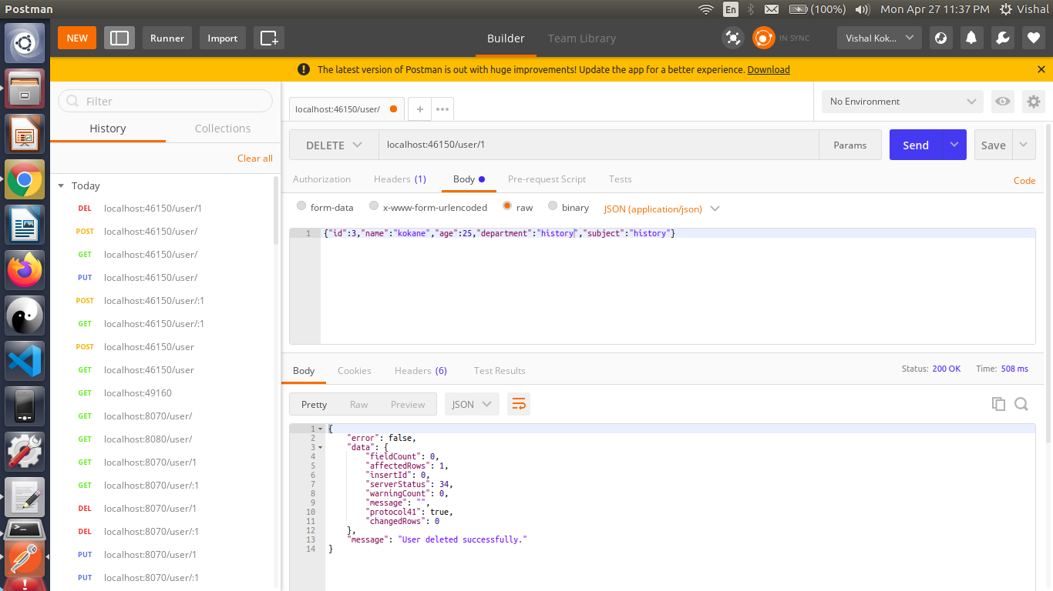

6.2)Mysql status
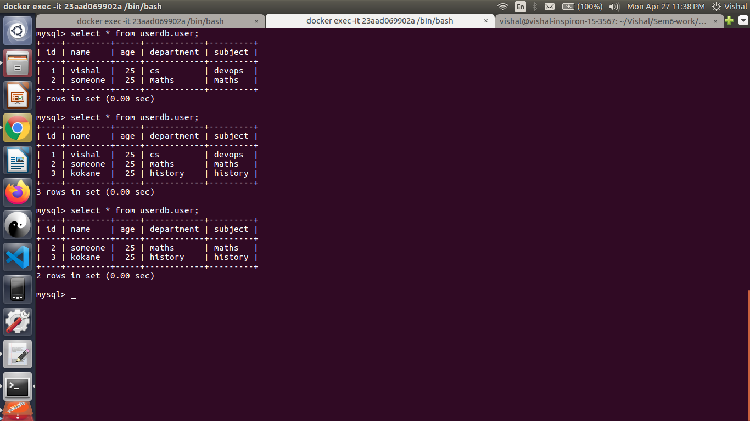

7)Postman PUT :update user name using userid

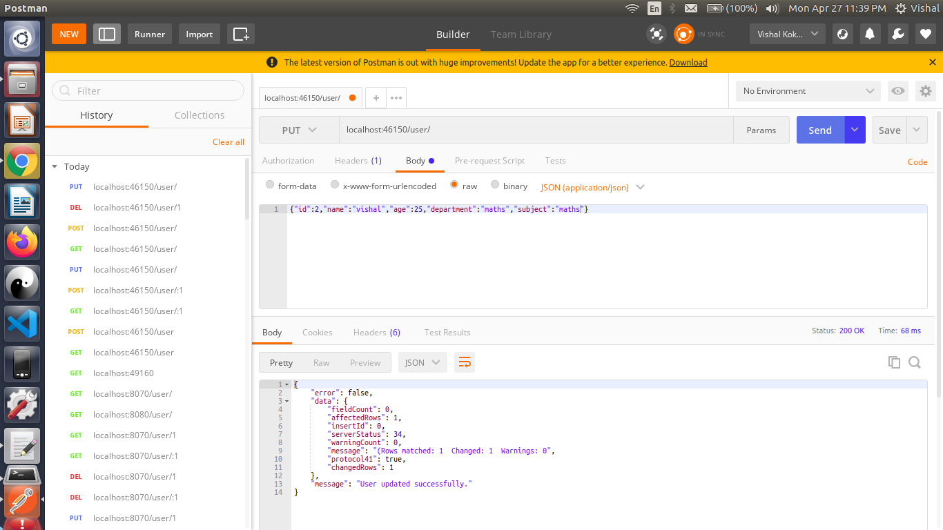

7.2)Mysql update status
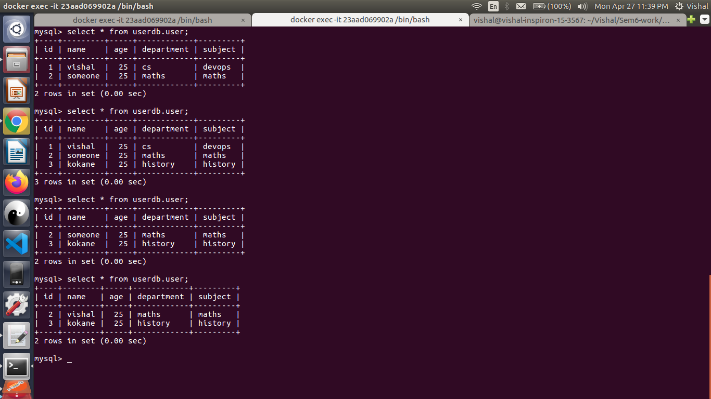

8)Postman get all records
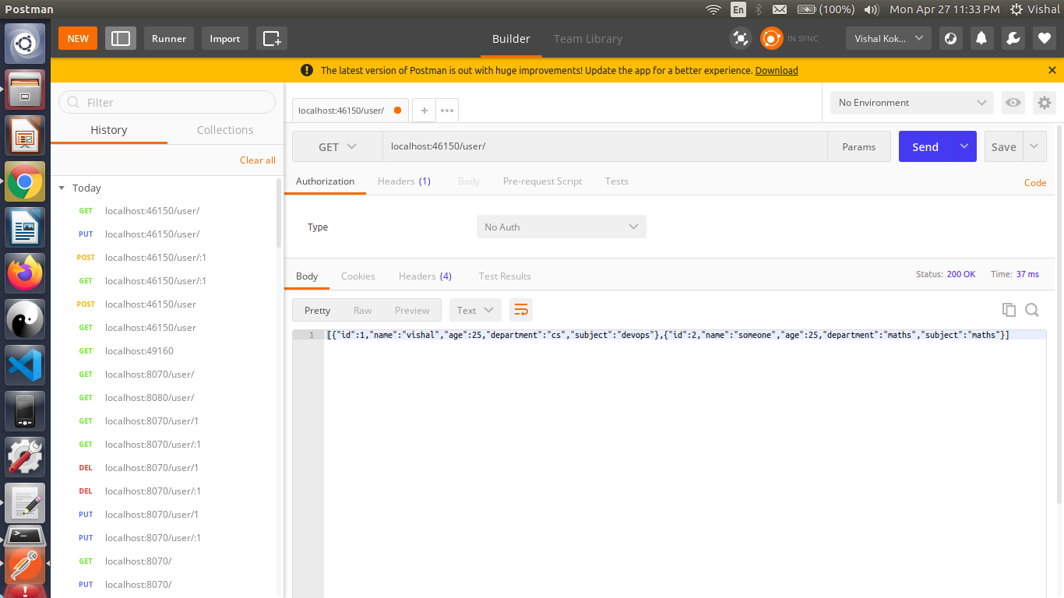

9)Postman delete fail record not exist
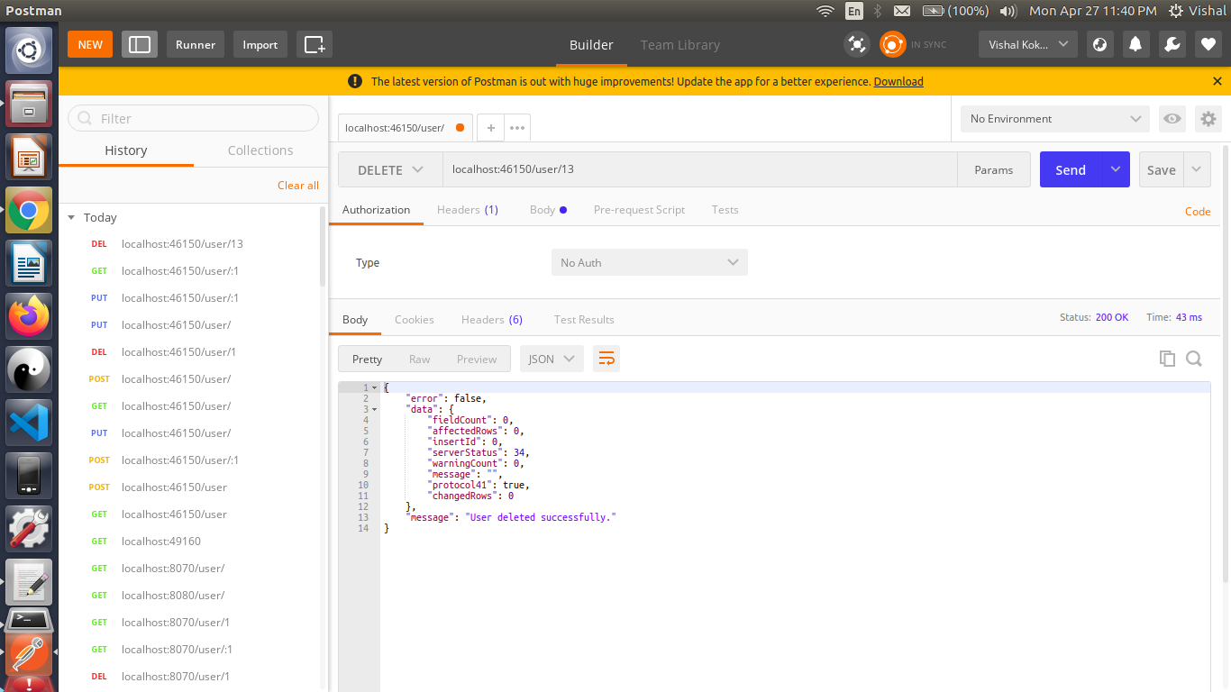

10)Postman delete Success
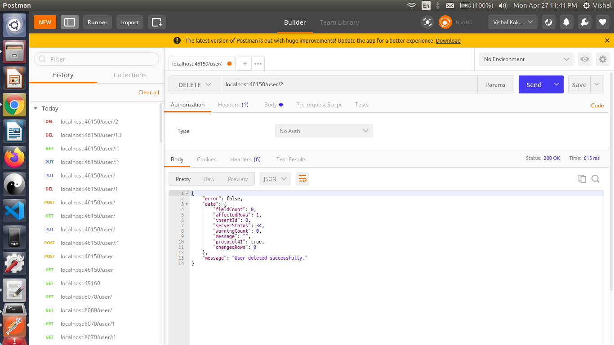

11)Postman Get by id
