**CURRICULUM-VITAE**

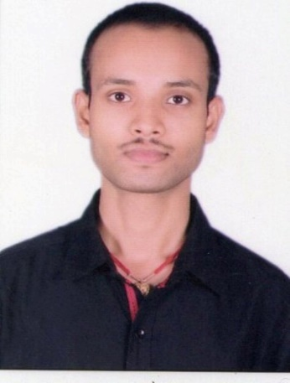

**Vishal Kumar Chaurasia**

**Address:-**

House no-11A, Barai Tola, Tetaria Bazar  
East Champaran, Motihari, Bihar, 845436   
Mobile No: 7982910853, 9555073702

Email ID: [vishalkrchsia@gmail.com](mailto:vishalkrchsia@gmail.com)

**Career Objective:**

To be a part of an organization where I can fully utilize my skills and make a significant contribution to the success of the employer and at the same time my individual growth.

**Professional Qualification:**

B.Tech in Computer Science engineering from Skyline Institute of Engineering & Technology, Greater Noida (UP) affiliated from Dr. A.P.J Abdul Kalam Technical University, Lucknow with 70.00% marks aggregate in 2016.

**Academic Qualification:**

|  |  |  |  |
| --- | --- | --- | --- |
| **Year of** | **Name of Examination** | **Board** | **Percentage** |
| **Passing** |  |  |  |
|  |  |  |  |
| 2009 | 10th | B.S.E.B | 69.00% |
| 2012 | 12th | B.S.E.B | 68.00% |



**Software Skills:**

* Basic C Programming
* Java
* Database Management System
* Manual testing
* Automation Testing



**Certification:**

* SQL
* Manual Testing

**Project**

I have completed my project on Online Skill Test.

* **Online Skill Test: -** This project is my main project. It is based on java programming language. In this project we use eclipse ide, Oracle 10g, Tomcat Server and jdk1.8. In this project we use HTML, JSP, SQL and Java Programming Language.

**Strength:**

* Dedication towards the work
* Helpful Nature
* Positive attitude
* Honesty
* Sincerity

**Hobbies:**

* Listening Music
* Playing Chess
* Playing Badminton



**Personal Profile:**

|  |  |  |
| --- | --- | --- |
| Name | : | Vishal Kumar Chaurasia |
| Father’s Name | : | Viresh Kumar Prasad |
| Date of Birth | : | 12th December, 1993 |
| Language Known | : | Hindi & English |
| Gender | : | Male |
| Nationality | : | Indian |
|  |  |  |
| **Achievements:** |  |  |
|  |  |  |

Actively participated in various activities like GK Quiz, Technical Quiz and debugging in the college competitions.

**Declaration:**

I, hereby declare that all the above mentioned information is true and correct to the best of my knowledge.

Date: ___________ (VISHAL KUMAR CHAURASIA)

Place: ___________