RIDE
(FUTURE SKILLING INITIATIVE)
PROGRAM
LEARNING GUIDE FOR ANALYTICS COMPETENCY

Contents
1. About this Document ................................................................................................................. 3
2. Who should use this Document ................................................................................................. 3
3. Introductory Note ...................................................................................................................... 4
4. Overall Program Details ............................................................................................................ 5
5. Step wise Program Plan ............................................................................................................. 6
6. Skill Identification and Participation ....................................................................................... 7
7. Learning Facilitation ...............................................................................................................10
8. Communities of Practice and Practice Environments: .........................................................12
9. Career Path and Learning Journeys ......................................................................................16
10. Participant Interaction Plan ...................................................................................................19
11. Learning Tracker .....................................................................................................................20
12. FAQs..........................................................................................................................................23
13. Glossary ....................................................................................................................................24
14. Annexures .................................................................................................................................25

About this Document
This is a detailed learning guide for the associates who have been selected to participate in the RIDE Wave 2 training program

Who should use this Document
The document is for internal use only. It should be used by associates undergoing training under the RIDE Program, training owners and faculty

Introductory Note

Welcome to the RIDE Programme!

Dear Colleagues,

To help us accelerate deployment and enhance the skills of associates on Future Skills, we have designed a high-quality skilling campaign called RIDE. The campaign started from the 17th of April, 2018. Each of the phases of the RIDE program is for a period of 6-8 weeks.
Under this initiative, associates have an opportunity to acquire future skills, practice them, get assessed and certified through an external platform. This will be followed by subsequent deployment in projects.
The RIDE, TLS, Competency, SBU, RMG teams will be working with you closely towards this competence building and deployment initiative over a period of 2 months.
Please remember that this is a program for YOU & it’s our sincere request to you to give it your 100%.
Participation in the program is mandatory for every associate who has been selected for the program.
You will continuously receive communication from the Competency team, RIDE team and SBUs.
Best regards for RIDE.

Wish you a happy learning experience,

RIDE Team

Overall Program Details

- Each associate will be communicated the Wave 2 skill identified for him/her by the RIDE team
- The programs are offered in blended mode with focus on self -learning through MOOCs platforms and internal content supported with faculty connect sessions on WebEx
- Training owners have been assigned for every competency
- WebEx sessions by Faculty will be conducted on a weekly basis, on Tuesdays and Thursdays, from 3 pm to 4 pm (IST) and on Saturdays from 11 am to 12 pm (IST)
- Participants are expected to spend 12 hours every week to keep pace with the program including 5 hours of hands-on practice on Saturdays

- End course external certifications will be reimbursed for the associates as per the standard company external training and certification policy (refer BMS)

Step wise Program Plan

S.no | Key Step | Timeline
1 | On being selected for RIDE, attend the opening connect sessions and clearly note the role you have been selected for | Week 1
2 | Download the learning guide and go through it with specific emphasis on training owner, faculty, career path and learning path | Week 1
3 | Identify the foundation skill for your role and complete the assessment. Contact your training owner for more details | Week 1
4 | In case you are unable to complete the assessment, please use the learning links provided. Assessments must be completed within 7 days of the start date | Week 2
5 | Register yourself on all the learning portals (using Tech M ID only) specified for your role as per the learning path. Registration guidelines for specific portals are given in the Learning Guide | Week 2
6 | Undergo training in your own time as per the sequence provided in the learning path. 12 hours of work per week is expected of you. Keep your training owner informed about your progress | Week 2- Week 6
7 | Attend connect sessions as per the schedule. Attendance is mandatory. Reach out to your training owners in case of any assistance. You can also use the CoP to do the same | Week 1- Week 7
8 | Stay in touch with your training owner and attend quizzes, assignments and SME connect sessions scheduled for you. Attendance is mandatory for these sessions | Week 1- Week 7
9 | You are strongly advised to utilize the training lab facilities for hands on practice on Saturdays. Contact your training owner for more details | Week 3- Week 8
10 | RMG-RH will be connecting you to Wave 2 opportunities. Stay on the lookout for such opportunities. Updates will be provided to you regularly via connect sessions/ CoPs and through RMG | Week 7- Week 8
11 | Get certified in the core skill for your role at the end of program. Refer to the certification and reimbursement policy available on BMS | Week 7- Week 8
12 | Get Ready for Deployment in the Role | Week 8

Skill Identification and Participation

This learning guide consisting of internal content (including recorded sessions on MyTube), MOOCs reference, external content, MyBeatPlus Communities of Practice (COP) links, and information on Training Owners/Faculty has been prepared for RIDE participants as mentioned in the previous section.
The subsequent sections contain details related to the following Modules:

Competency | Skill | Cluster | RSC | Basic Skill
Analytics | Big Data and Analytics Overview, Artificial Intelligence Overview, Machine Learning Algorithms, Introduction to Data Science | Basics | Data Scientist | Mathematics & Statistics, Any programming language, SQL
Analytics | Python, Scikit, R, RapidMiner, MLbase, Mahout | Data Analysis Tools | Data Scientist | Mathematics & Statistics, Any programming language, SQL

Competency | Skill | Cluster | Role | Basic/Other Skills Required | Internal Courses | EDX | PluralSight | Udemy | Others
Analytics | Big Data and Analytics Overview | Basics | Big Data Engineer/Developer | Mathematics & Statistics, Any programming language, SQL |  |  | Big Data: The Big Picture
Analytics | MongoDB | Data Storage and Management Tools | Big Data Engineer/Developer
Analytics | R | Data Processing/Analysis Tools | Big Data Engineer/Developer |  | R-Language :  Day 2,
Analytics | Big Data and Analytics Overview, Predictive Analytics Overview, Statistics Fundamentals | Analytics Basics | Predictive Analytics Developer | Mathematics & Statistics, Any programming language, SQL |  |  | Big Data: The Big Picture |  | Practical Predictive Analytics: Models and Methods
Analytics | R,SAS,SPSS | Data Analysis Tools | Predictive Analytics Developer | Mathematics & Statistics, Any programming language, SQL |  | Programming in R for Data Science
Analytics | Tableau, PowerBI | Data Visualization Tools | Predictive Analytics Developer | Mathematics & Statistics, Any programming language, SQL | Tableau | Data Visualization for All
 |  |  |  |  | Day 01
 |  |  |  |  | Day 02
 |  |  |  |  | Day 03
Analytics | Big Data and Analytics Overview, Artificial Intelligence Overview, Machine Learning Algorithms, Introduction to Data Science | Basics | Data Scientist | Mathematics & Statistics, Any programming language, SQL |  | Principles of Machine Learning | Big Data: The Big Picture |  | Machine Learning with Scikit Learn
 |  |  |  |  |  | Introduction to Artificial Intelligence (AI) | Big Data: The Big Picture |  | Machine Learning with Scikit Learn
Analytics | Python, Scikit, R, RapidMiner, MLbase, Mahout | Data Analysis Tools | Data Scientist | Mathematics & Statistics, Any programming language, SQL | R-Language :  Day 2, | Python for Data Science |  |  | Introduction to MLbase

Learning Facilitation

Below is the list of Training Owners/Faculty for the program
Competency | Skill | Faculty | Faculty Email
Analytics | Big Data and Analytics Overview | Vijay Arjunwadkar | VA0039456@TechMahindra.com
Analytics | MongoDB | Ramakanth Mallem | Ramakanth.Mallem@TechMahindra.com
Analytics | Big Data and Analytics Overview, Predictive Analytics Overview, Statistics Fundamentals | Vijay Arjunwadkar | VA0039456@TechMahindra.com
Analytics | R,SAS,SPSS | Vijay Arjunwadkar | VA0039456@TechMahindra.com
Analytics | Tableau, PowerBI | Sreenivas Ram | Sreenivas.V@TechMahindra.com
Analytics | Big Data and Analytics Overview, Artificial Intelligence Overview, Machine Learning Algorithms, Introduction to Data Science | Vijay Arjunwadkar | VA0039456@TechMahindra.com
Analytics |  | Prakash Goteti | Prakash.Lns@TechMahindra.com
Analytics | Python, Scikit, R, RapidMiner, MLbase, Mahout | Prakash Goteti  Prabhala Rama  Vijay Arjunwadkar | Prakash.Lns@TechMahindra.com  Prabhala.Kumar@TechMahindra.com  VA0039456@TechMahindra.com

SBU to be handled | LC Name | Email ID | Contact Details
SBU D-CROW | Amol Joshi | jamol@TechMahindra.com | 9823852755
SBU DACME | Parag Pimputkar | paragpi@TechMahindra.com | 9049800804
SBU D-ASV, VBU BFSI | Ritu Manuja | Manuja.Ritu@TechMahindra.com | 9822119596
SBU D-BT | Sanjana Sane | sssanjana@TechMahindra.com | 9820831824
SBU D-NS | Sandhya Bordia | bordias@TechMahindra.com | 9820618170
CBU CES, CBU EOF, CBU P2P BE | Sindhu Rajendra | SR0041556@TechMahindra.com | 9884863939
VBU HLS, SBU D-APJ | Bhargav G | GB00361810@TechMahindra.com | 9652191999
SBU D-IND, SBU D-SAEV | Dhanalaxmi Arla | Dhanalaxmi.Arla@TechMahindra.com | 9866755338
CBU IMS, SBU D-IES, VBU IOT | Leelavani Sastry | Leelavani.Sastry@TechMahindra.com | 9845455733
CBU P&PENG, SBU D-WC | Nagaraj Vaidya | nagarajv@TechMahindra.com | 9980790460
SBU D-EMEA | Sandhya Bordia | bordias@TechMahindra.com | 9820618170
CBU ESRM, CBU PACES, CIO, SBU_TIM, M_CTO, QWAY | Parkha Kaul | pk0031953@TechMahindra.com | 8860491919

Communities of Practice and Practice Environments:

Internal Communities of Practice:
S.no | COP URL | Name of Owner
1 | Analytics_RIDE_WAVEII | Sreenivas Ram

External Communities of Practice:
S.no | COP URL | Name of Owner

The associates may sign up for any of the forums mentioned below for free and practice their programming skills
- https://www.hackerrank.com
- https://jsfiddle.net/
- https://coderbyte.com
- http://dabblet.com

The associates may sign up for any of the forums mentioned below to meet a community of programmers and coders, discuss coding challenges and problems, and learn new technologies
- Github (https://github.com/ )
- Stack overflow (https://stackoverflow.com)
- W3 Schools (https://www.w3schools.com)
- Bit Bucket (https://bitbucket.org )
- Source Forge (https://sourceforge.net )
- Experts Exchange(https://www.experts-exchange.com )
- Dev.To (https://dev.to )

Below is the list of Skill wise practice platforms and Case Study Assignments for practice:
Competency | Skill | Role | Practice | Platform | Case Study / Assignments
Analytics | MongoDB | Big Data Engineer/  Developer | MongoDB |  | Mongo DB
Analytics | R | Big Data Engineer/  Developer | Coding Ground for R |  | Assignments in R
Analytics | R | Big Data Engineer/  Developer | R- Compiler
Analytics | R,SAS,SPSS | Predictive Analytics Developer | Coding Ground for R |  | Assignments in R
Analytics | R,SAS,SPSS | Predictive Analytics Developer | R- Compiler
Analytics | Tableau, PowerBI | Predictive Analytics Developer | Tableau Online |  | Assignments in Tableau
Analytics | Big Data and Analytics Overview, Artificial Intelligence Overview, Machine Learning Algorithms, Introduction to Data Science | Data Scientist | Cloud X Lab
Analytics | Python, Scikit, R, RapidMiner, MLbase, Mahout | Data Scientist | R-Language |  | Assignments in R
Analytics | Python, Scikit, R, RapidMiner, MLbase, Mahout | Data Scientist | or |  | Assignments in R
Analytics | Python, Scikit, R, RapidMiner, MLbase, Mahout | Data Scientist | R-Language |  | Assignments in R
Analytics | Python, Scikit, R, RapidMiner, MLbase, Mahout | Data Scientist | Python-2 compiler |  | Assignments in R
Analytics | Python, Scikit, R, RapidMiner, MLbase, Mahout | Data Scientist | or |  | Assignments in R
Analytics | Python, Scikit, R, RapidMiner, MLbase, Mahout | Data Scientist | Python-2 Compiler |  | Assignments in R
Analytics | Python, Scikit, R, RapidMiner, MLbase, Mahout | Data Scientist | or |  | Assignments in R
Analytics | Python, Scikit, R, RapidMiner, MLbase, Mahout | Data Scientist | Python-3 Compiler |  | Assignments in R

Internal Assessments & External certifications

The assessment/ assessments platform to be used for this program have been listed below and have also been mentioned in Section 6.
Role | Cluster | Foundation Skill | Foundation Skill Assessment Link
Big Data Engineer / Developer | Programming Language  SQL | SS0772 SQL Part 1 Introduction  SS0773 SQL Part2 Operators  SS0774 SQL Part3 Aggregation  SS0775 SQL Part4 Sub-Queries | LP01078 SQL_Level 1
Predictive Analytics Developer | Programming Language  SQL | SS0772 SQL Part 1 Introduction  SS0773 SQL Part2 Operators  SS0774 SQL Part3 Aggregation  SS0775 SQL Part4 Sub-Queries | LP01078 SQL_Level 1
Big Data Scientist | Programming Language  SQL | SS0772 SQL Part 1 Introduction  SS0773 SQL Part2 Operators  SS0774 SQL Part3 Aggregation  SS0775 SQL Part4 Sub-Queries | LP01078 SQL_Level 1

Competency | Skill | Cluster | RSC | Internal Assessment | External Assessment /  Certification
Analytics | Big Data and Analytics Overview | Basics | Big Data Engineer/  Developer | LP01802 BigData and Analytics Overview
Analytics | MongoDB | Data Storage and Management Tools | Big Data Engineer/  Developer | LP01757 MongoDB Overview
Analytics | R | Data Processing/Analysis Tools | Big Data Engineer/  Developer | LP01970 R Overview
Analytics | Big Data and Analytics Overview, Predictive Analytics Overview, Statistics Fundamentals | Basics | Predictive Analytics Developer | LP01802 BigData and Analytics Overview | EDX certification: Programming in R for Data Science (USD $99) EDX certification: Predictive Analytics ($50 USD)
Analytics | Tableau, PowerBI | Data Visualization Tools | Predictive Analytics Developer | LP01589 Tableau Level1
Analytics | Big Data and Analytics Overview, Artificial Intelligence Overview, Machine Learning Algorithms, Introduction to Data Science | Basics | Data Scientist | LP01802 BigData and Analytics Overview | EDX Certification: Programming with Python for Data Science
Analytics | Python, Scikit, R, RapidMiner, MLbase, Mahout | Data Analysis Tools | Data Scientist | LP01745 Machine Learning Overview

Career Path and Learning Journeys

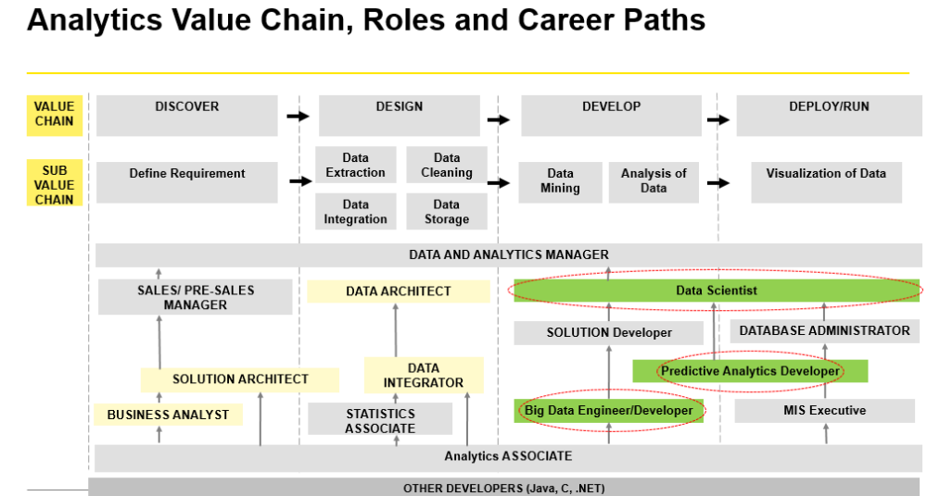
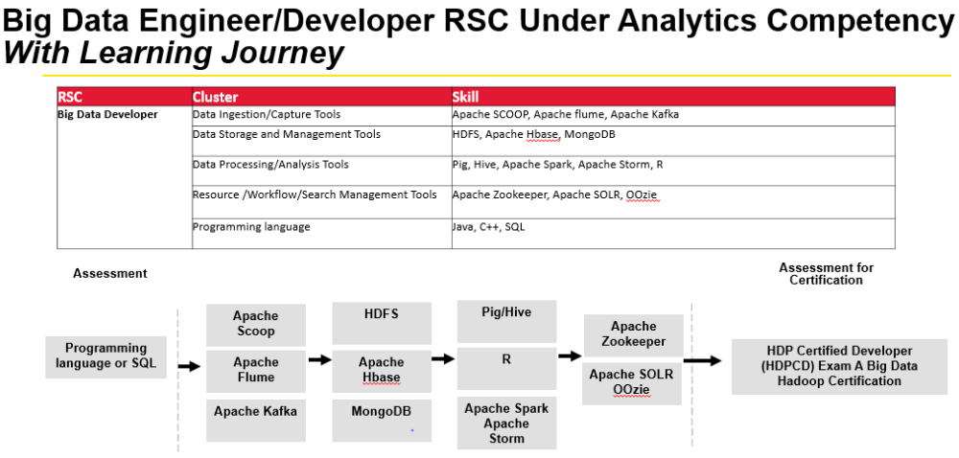
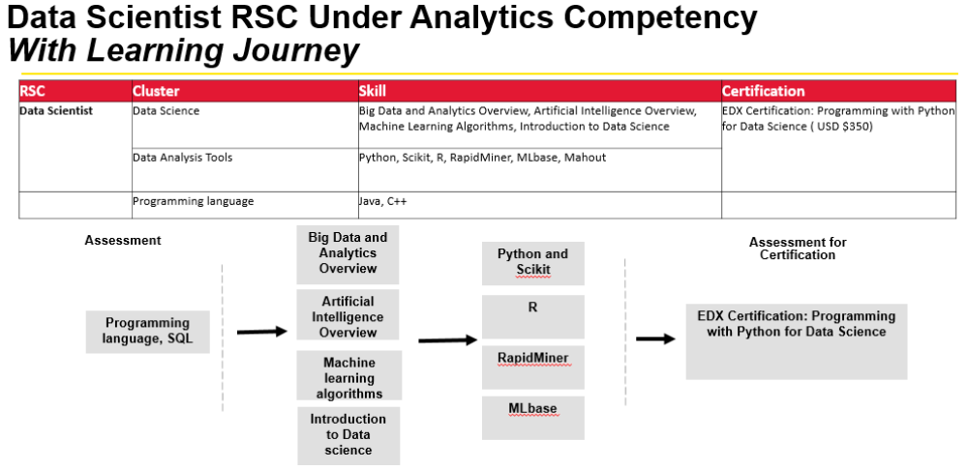
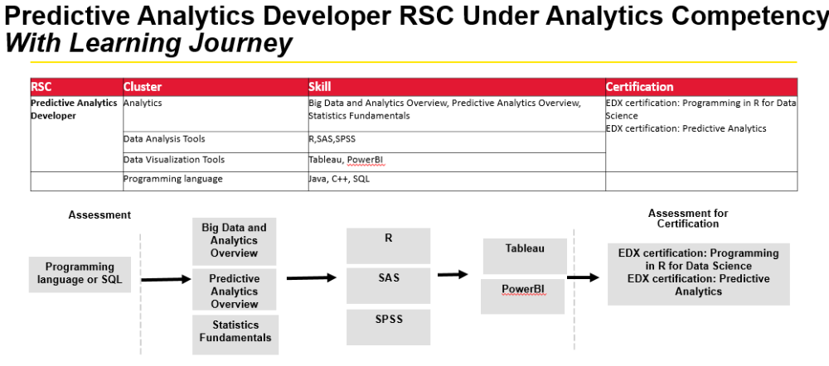

Participant Interaction Plan

- SME Connect Sessions will start from 24th April 2018
- Every Tuesday and Thursday from 3:00 PM to 4 PM (IST), SME and Faculty Connect Sessions will be held to discuss progress, queries, case studies, and latest market trends
- Every Saturday Faculty connect sessions will be held between 11:00 AM to 12:00 PM (IST) to resolve the issues, discuss Q&A and way further. Faculty will resolve further queries during the hands-on practice, if any on the community forum.

BIGDATA Developer: Learning Plan |  |  |  | Effort in hrs
Milestone# | Due-Date | Description | Modules/Topics |  | Preparation time | Practice time
 | 9-May-18 | Foundation | SQL |  | 5 | 5
1 | 18-May-18 | LP01078 SQL_level1 Course progress -5%
 |  | Big Data and Analytics Basics | Big Data and Analytics Overview |  | 10 | 0
2 | 23-May-18 | LP01802 BigData and Analytics Overview Course progress -20%
 |  | Data Ingestion/Capture Tools | Apache Sqoop, Apache Flume |  | 7 | 8
 |  | Data Ingestion/Capture Tools | Apache Kafka |  | 8 | 9
3 | 7-Jun-18 | Big Data- Data Ingestions tools (Quest Assessment) Course progress -40%
 |  | Data Storage and Management Tools | HDFS, Apache Hbase |  | 10 | 13
 |  | Data Storage and Management Tools | MongoDB |  | 8 | 12
4 | 27-Jun-18 | Big Data- Data storage tools (Quest Assessment) Course progress -60%
 |  | Data Processing/Analysis Tools | Apache HIVE, Apache PIG |  | 10 | 15
 |  | Data Processing/Analysis Tools | Apache SPARK, Apache STORM, R |  | 20 | 30
 |  | Resource /Workflow/Search Management Tools | Apache Zookeeper, Apache SOLR, Oozie |  | 10 | 10
5 | 27-Jul-18 | Big Data- Data processing tools (Quest Assessment) Course progress -100%
 | 7-Aug-18 | HDP Certified Developer (HDPCD) Exam A Big Data Hadoop Certification ()

Predictive Analytics Developer: Learning Plan |  |  |  | Effort in hrs
Milestone# | Due-Date | Description | Modules/Topics |  | Preparation time | Practice time
 | 9-May-18 | Foundation | Mathematics & Statistics, Any programming language + SQL |  | 5 | 5
1 | 18-May-18 | Exam - LP01078 SQL_Level 1 Course progress -5%
 |  | Statistics Knowledge | Statistics Fundamentals |  | 10 | 0
2 | 23-May-18 | Predictive Analytics: Statistics Foundation (Quest Assessment) Course progress -20%
 |  | Analytics Basics | Big Data and Analytics Overview, Predictive Analytics Overview |  | 12 | 0
3 | 7-Jun-18 | Predictive Analytics: Basics (Quest Assessment) Course progress -40%
 |  | Data Analysis Tools | SPSS |  | 4 | 6
 |  | Data Analysis Tools | R,SAS |  | 10 | 20
4 | 27-Jun-18 | Predictive Analytics: Analytics using R, SAS (Quest Assessment) Course progress -70%
 |  | Data Processing/Analysis Tools | Data Visualization Tools |  | 10 | 15
5 | 12-Jul-18 | LP01589 Tableau Level1 Course progress -100%
 | 23-Jul-18 | Coursera certification: Predictive Analytics + EDX certification:Programming in R for Data Science

Data Scientist : Learning Plan |  |  |  | Effort in hrs
Milestone# | Due-Date | Description | Modules/Topics |  | Preparation time | Practice time
 | 9-May-18 | Foundation | Mathematics & Statistics, Any programming language + SQL |  | 5 | 5
1 | 18-May-18 | Exam - LP01078 SQL_Level 1 Course progress -5%
 |  | Big Data and AI Basics | Big Data and Analytics Overview |  | 10 | 0
 |  |  | Artificial Intelligence Overview |  | 8 | 4
2 | 23-May-18 | Data Scientist: Foundation exam (Quest Assessment) Course progress -20%
 |  | Basics of Data Science | Machine Learning Algorithms |  | 8 | 10
 |  | Basics of Data Science | Introduction to Data Science |  | 6 | 6
3 | 6-Jun-18 | Data Scientist: Machine Learning (Quest Assessment) Course progress -40%
 |  | Data Analysis Tools | Python |  | 35 | 45
 |  | Data Analysis Tools | Scikit |  | 2 | 5
4 | 27-Jun-18 | Data Scientist: Data Analysis tools part1 (Quest Assessment) Course progress -70%
 |  | Data Analysis Tools | R, RapidMiner |  | 15 | 20
 |  | Data Analysis Tools | MLbase, Mahout |  | 17 | 25
5 | 16-Aug-18 | Data Scientist: Data Analysis tools part2 (Quest Assessment) Course progress -100%
 | 24-Aug-18 | EDX Certification: Python for Data Science

FAQs

1. What is the objective of the RIDE program?

Answer: The objective of RIDE program is to equip associates with necessaryskills needed for role-readiness of Wave 2 competencies for future. The program aims to provide learning, certification, and deployment opportunities for associates in future technologies in the organization
2. What is the duration of the RIDE program?

Answer: Two Months from the start date
3. Who all are eligible for the program?

Answer: Participation in this program is by invitation only. All the associates selected for this program need to be mandatorily part of the program
4. How has a skill been identified for associates?

Answer: Skills have been identified based on the requirements in various competencies within the organization and the current skill set possessed by the associate
5. Is participation in the program optional?

Answer: Participation in the program is mandatory. Any exemption requires SBU Head approval on mail along with reasons for the same communicated to Training Owner/ SBU Learning Consultant
6. How will one be deployed after undergoing training in the program?

Answer: During deployment, preference will first be given in the same SBU.
7. How will training be offered during the course of this program?

Answer: Programs will be offered in blended mode with focus on self -learning through MOOCS, supported with weekday and weekend faculty connect sessions through WebEx and communities of practice (COP). Participant are expected to leverage Saturday for practice sessions (at least 5 hours)
8. Where can associates find more information about RIDE?

Answer: The associates can get in touch with their respective Training Owner or Learning Consultant in case any other information regarding RIDE program is required
S.no | Term | Description
1 | RIDE | Future Skilling Initiative With Digital Enhancement
2 | TLS | Technical Learning Services
3 | SBU | Strategic Business Unit
4 | MOOC | Massive Open Online Course
5 | COP | Communities of Practice
6 | SPOC | Single point of contact
7 | F2F | Face to Face

Glossary

