**EXPERIMENT NO: -15**

**AIM: -** To implement matrix chain multiplication.

**FLOW CHART: -**

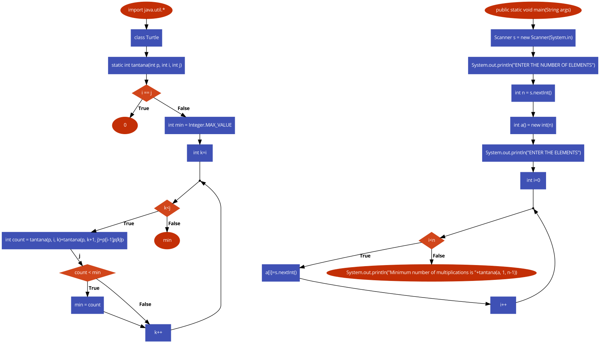

**CODE:-**

import java.util.*;

class Turtle

{

static int tantana(int p[], int i, int j)

{

if (i == j)

return 0;

int min = Integer.MAX_VALUE;

for (int k=i; k<j; k++)

{

int count = tantana(p, i, k)+tantana(p, k+1, j)+p[i-1]*p[k]*p[j];

if (count < min)

min = count;

}

return min;

}

public static void main(String args[])

{

Scanner s = new Scanner(System.in);

System.out.println("ENTER THE NUMBER OF ELEMENTS");

int n = s.nextInt();

int a[] = new int[n];

System.out.println("ENTER THE ELEMENTS");

for(int i=0;i<n;i++)

{

a[i]=s.nextInt();

}

System.out.println("Minimum number of multiplications is "+tantana(a, 1, n-1));

}

}

**OUTPUT:-**

