**EXPERIMENT 3**

**AIM:** Repairing straight through cable and cross-hover cable.

**REQUIREMENTS:** RJ-45, cable, clipping, measurement.

**PROCEDURE TO REPAIR STRIGHT THROUGH CABLE**

**STEP: 1**

Using a Crimping Tool, trim the end of the cable you're terminating, to ensure that the ends of the conducting wires are even

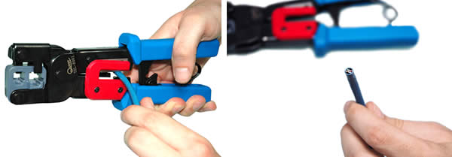

**STEP: 2**

Being careful not to damage the inner conducting wires, strip off approximately 1 inch of the cable's jacket, using a modular crimping tool or a UTP cable stripper.

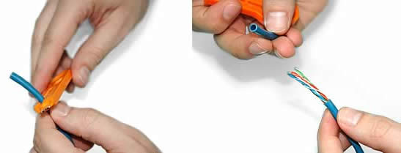

**STEP: 3**

Separate the 4 twisted wire pairs from each other, and then unwind each pair, so that you end up with 8 individual wires. Flatten the wires out as much as possible, since they'll need to be very straight for proper insertion into the connector.

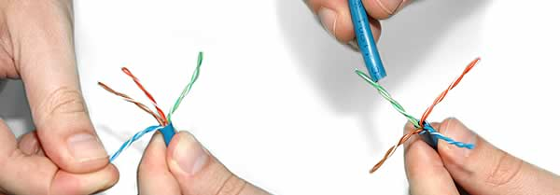

**STEP: 4**

Holding the cable with the wire ends facing away from you. Moving from left to right, arrange the wires in a flat, side-by-side ribbon formation, placing them in the following order: white/orange, solid orange, white/green, solid blue ,white/blue, solid green, white/brown, solid brown.

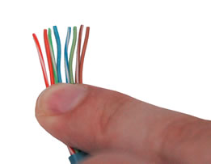

**STEP: 5**

Holding the RJ45 connector so that its pins are facing away from you and the plug-clip side is facing down , carefully insert the flattened, arranged wires into the connector, pushing through until the wire ends emerge from the pins. For strength of connection, also push as much of the cable jacket as possible into the connector.

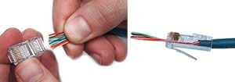

**STEP: 6**

Check to make sure that the wire ends coming out of the connector's pin side are in the correct order; if not, remove them from the connector, rearrange into proper formation, and re-insert. Remember, once the connector is crimped onto the cable, it's permanent. If you realize that a mistake has been made in wire order after termination, you'll have to cut the connector off and start all over again!

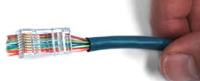

**STEP: 7**

Insert the prepared connector/cable assembly into the RJ45 slot in your crimping tool. Firmly squeeze the crimper's handles together until you can't go any further. Release the handles and repeat this step to ensure a proper crimp.

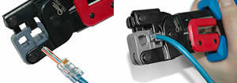

**STEP: 8**

If your crimper doesn't automatically trim the wire ends upon termination, carefully cut wire ends to make them as flush with the connector's surface as possible. The closer the wire ends are trimmed, the better your final plug-in connection will be.

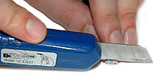

**STEP: 9**

After the first termination is complete, repeat process on the opposite end of your cable

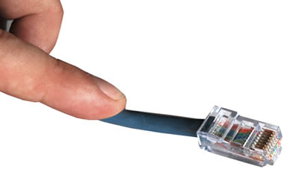

**PROCEDURE TO REPAIR CROSS-HOVER CABLE**

**STEP: 1**

 Start by stripping off about 2 inches of the plastic jacket off the end of the cable. Be very careful at this point, as to not nick or cut into the wires, which are inside. Doing so could alter the characteristics of your cable, or even worse render is useless. Check the wires, one more time for nicks or cuts. If there are any, just whack the whole end off, and start over.

**STEP: 2**

Spread the wires apart, but be sure to hold onto the base of the jacket with your other hand. You do not want the wires to become untwisted down inside the jacket. Category 5 cable must only have 1/2 of an inch of 'untwisted' wire at the end; otherwise it will be 'out of spec'. At this point, you obviously have ALOT more than 1/2 of an inch of un-twisted wire, but don't worry - well take care of that soon enough.

**STEP: 3**

 Up to this point, things have been pretty easy. Things will get a little bit tricky here, but don't worry, we'll get through this together. We are at a point in this article where a decision needs to be made. You need to decide which end of the cable you are making at this point in time. If you are making your cable from scratch like I am doing while writing this article, you have 2 end jacks, which must be installed on your cable. If you are using a pre-made cable, with one of the ends whacked off, you only have one end to install - the crossed over end. Below are two diagrams, which show how you need to arrange the cables for each type of cable end. Decide at this point which end you are making and examine the associated picture below.

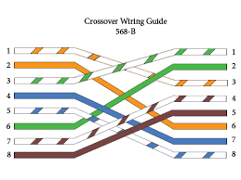

Begin to untwist the twisted exposed wires on your cable. Use caution so that you do not untwist them down inside the jacket. Once you have all the wires untwisted begin to arrange them in the proper order based on the pictures above. This stage can be a pain in the ass, especially some of the middle wires. Once you get all the wired arranged in the proper order, make sure your wire cutters are within reach then grasp them right at the point where they enter the jacket. Make sure you keep them in the proper order! Grab your cutters now. Line them up along your prepared wires about 1/2 inch above the jacket. Be sure at this point that you are both 1/2 inch above the jacket, and that your cutters are aligned straight across the wires. You want to make a clean cut here - also make sure you don't let go of that jacket / wires!

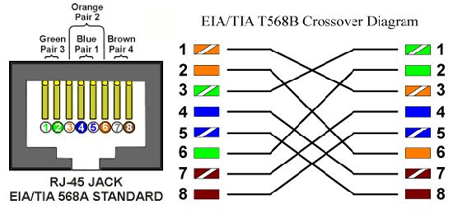

**STEP: 4**

Don't worry. From this point forward things get a lot easier. Grab your jack, and begin to slide the wires into the jack. Once you get to the point where the jacket begins to enter the jack things might get a little tough, but just have some patience and hold onto those wires. It will fit in there just fine. Once it is in as far as it will go the wires should extend almost to the front of the jack, and about 3/8 of an inch of the jacket will be inside the jack. Like the pictures below.

**STEP: 5**

Grab those crimpers - because not all crimpers are exactly the same your pictures may not match exactly what you see below. Be sure to keep a good grip on that jack and the cable. Insert the jack into the crimper. It should only go in one way, so you don't have a whole lot to worry about inserting it. Begin to compress those crimpers. You will more than likely hear a clicking sound. Keep squeezing. If you try to let go to early, nothing will happen. They will not release. Keep going until they stop clicking / stop moving all together. At this point, you should be able to let go of the jack, and the crimpers. The crimpers should release now leaving you with a crimped jack. If the crimpers do not release, you probably are a wimp and didn't press hard enough. Go ask your mom to help you at this point. She can probably finish what you started.

**STEP: 6**

It's time to examine what we have done. If you look at the end of the jack (distal), you should see that the copper connectors should not be pressed down into the wires. Toward the back of the jack (where the jacket meets the jack) it should be crimped securely holding the jacket / cable in the jack. If something has gone wrong, don't worry, its not the end of the world. Grab those cutters, and just whack the whole jack off and start back at step 1 (a pain in the ass I know, but its better to have a cable that works, than to spend hours trouble shooting your PC trying to figure out why you can't see the other machine). If everything is cool, all you have to do now is make the other end of the cable (unless you are using a pre-fab cable and have whacked one of the ends off), so go back to step one, and make the other end now.

.