**EXPERIMENT-4**

**Aim:** (a)How to Share Folders with Specific People in Windows

# (b)[How to Use Remote Desktop in Windows](http://www.wikihow.com/Use-Remote-Desktop-in-Windows-7)

**Procedure:**

**(a)How to Share Folders with Specific People in Windows:-**

1. If you want to share a folder with a specific user, right click or press and hold on it. Then, from the right-click menu, select 'Share with *->* Advanced sharing'.

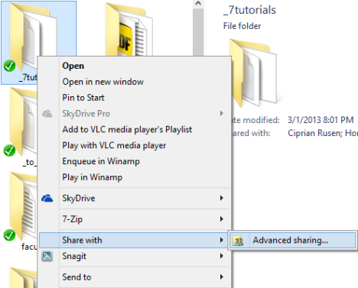.

1. Click or tap 'Advanced Sharing'.
2. First, check the 'Share this folder' box. If you want to use a different share name from the default one, type the preferred name in the 'Share name' text box.Then, you need to set the permissions for the folder you are sharing. Click or tap Permissions.

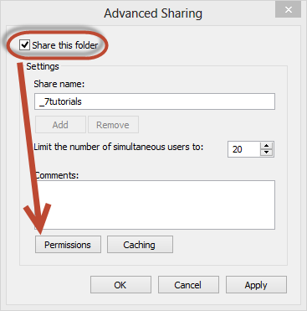

1. In the Permissions window you will see the users or groups that have permissions to access the folder you are sharing. By default, any folder is shared with the user Everyone. On the bottom you have the permissions given to the selected user or group.

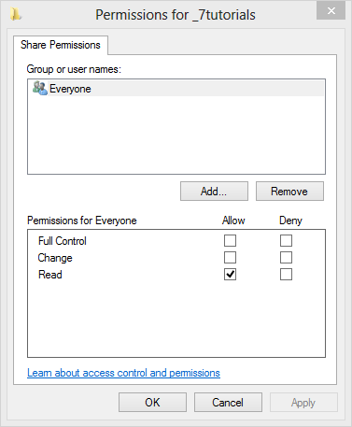

1. Before modifying the permissions assigned to each user or group, let’s add another user account that will receive access to the folder. Click or tap Add.
2. The Select Users or Groups window opens. In the text-box on the bottom, type the name of the user or group you want to give permissions to. If you are not sure which users/groups are registered on your PC, click or tap Advanced. If you know the exact user name or user group, click or tap Check Names to verify yourself, then OK and skip the next step.

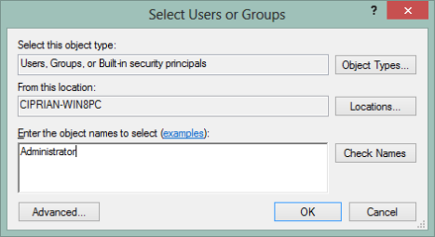

1. Clicking or tapping Advanced, extends the Select Users or Groups window with new options and buttons.
2. Click or tap 'Find Now' and Windows shows a list with all user accounts and user groups registered on your PC. Select the one you want to share with and click or tap OK to get back to the previous window.

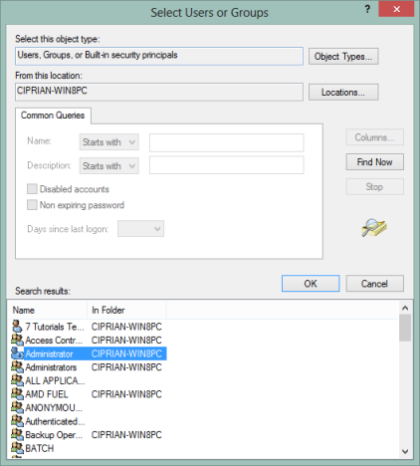.

1. There, click or tap OK one more time.Now it is time to pick the access you want to give to each user or group. Select each user or group and check the permissions level you wish to assign:

* **Full Control** - this is self-explanatory. When assigned, users or groups who have access to the shared folder can do anything with it: view it, modify it, delete it, etc.
* **Change -** users or groups can change the contents of the shared folder but cannot delete its content.
* **Read -** users or groups can only view the existing content without being able to perform any changes to it.

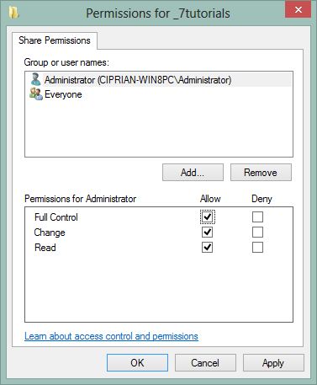

1. To remove a user or group, select it and click or tap Remove.
2. When done setting things up, click or tap OK. Then, click or tap Close in the Properties window.
3. The folder is shared with the user accounts or groups you selected, using the permissions you have set.

# (b)[How to Use Remote Desktop in Windows](http://www.wikihow.com/Use-Remote-Desktop-in-Windows-7) :-

1. On the Windows computer connecting to the target, open the Start menu and type “Remote Desktop” in the search box. When "Remote Desktop Connection" appears in the search results, click on it.

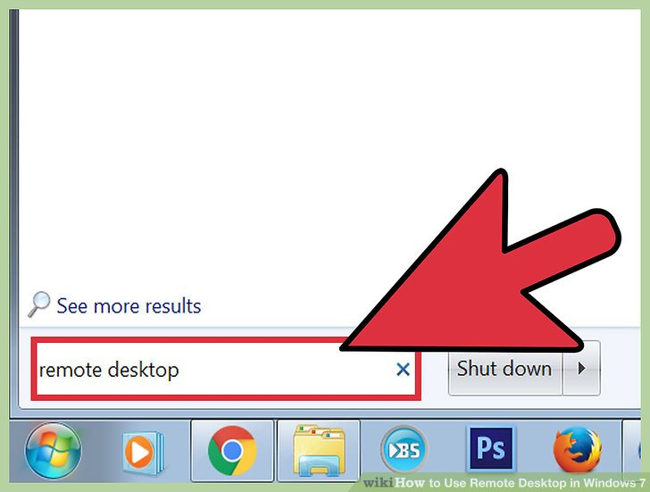

1. Enter the IP address of the target computer. This is the IPv4 address you previously collected from the other system. Press “Connect.”

[[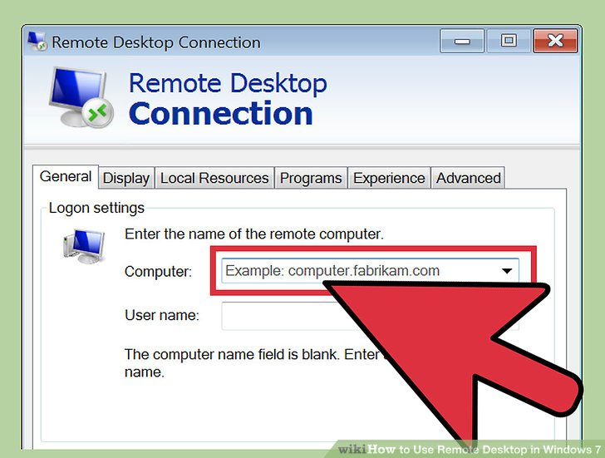](http://www.wikihow.com/Use-Remote-Desktop-in-Windows-7#/Image:Use-Remote-Desktop-in-Windows-7-Step-15.jpg)](http://www.wikihow.com/Use-Remote-Desktop-in-Windows-7" \l "/Image:Use-Remote-Desktop-in-Windows-7-Step-15.jpg)

1. Enter your login credentials. Enter the username and password of the account you configured in the target computer’s Remote Desktop settings. Click “OK.

[[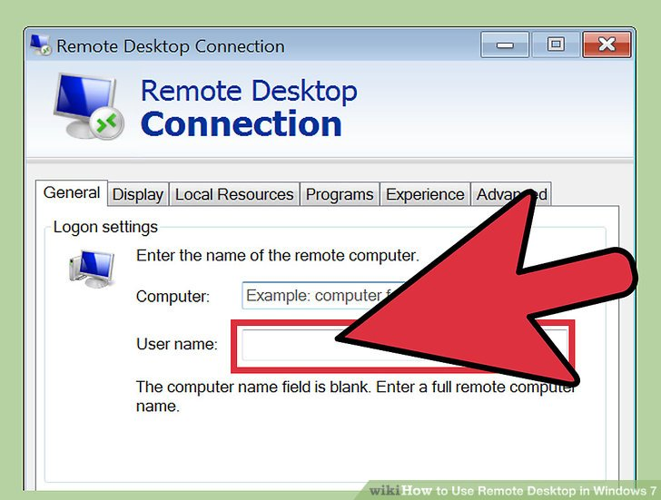](http://www.wikihow.com/Use-Remote-Desktop-in-Windows-7#/Image:Use-Remote-Desktop-in-Windows-7-Step-16.jpg)](http://www.wikihow.com/Use-Remote-Desktop-in-Windows-7" \l "/Image:Use-Remote-Desktop-in-Windows-7-Step-16.jpg)

1. Control the target computer remotely. You are now logged in to the target computer from your Windows 7 workstation

[[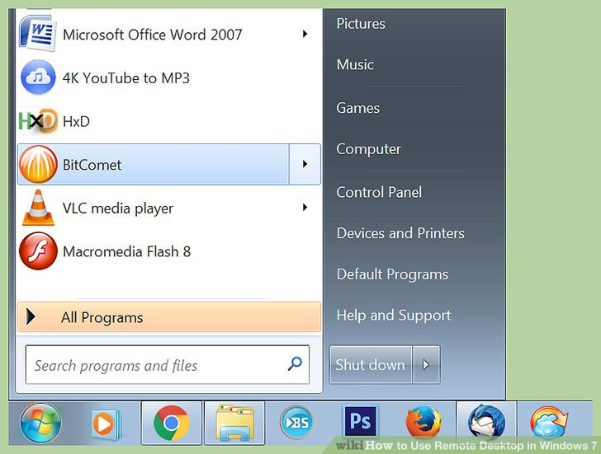](http://www.wikihow.com/Use-Remote-Desktop-in-Windows-7#/Image:Use-Remote-Desktop-in-Windows-7-Step-17.jpg)](http://www.wikihow.com/Use-Remote-Desktop-in-Windows-7" \l "/Image:Use-Remote-Desktop-in-Windows-7-Step-17.jpg)