**Experiment 1**

**AIM: 1**Familiarization with computer hardware components

1. **MOTHER BOARD :**

A motherboard (sometimes alternatively known as the mainboard, system board, baseboard, planar board or logic board, or colloquially, a mobo) is the main printed circuit board (PCB) found in general purpose microcomputers and other expandable systems. It holds and allows communication between many of the crucial electronic components of a system, such as the central processing unit (CPU) and memory, and provides connectors for other peripherals. Unlike a backplane, a motherboard usually contains significant sub-systems such as the central processor, the chipset's input/output and memory controllers, interface connectors, and other components integrated for general purpose use.

1. **MEMORY UNIT :**

Primary storage, or memory, means the space on your hard drive that is briefly used for working space. This usually occurs in a chip. Memory consists of four types of memory chips RAM, ROM, CMOS and flash. RAM stand for random access memory and ROM stand for read only memory.these are also called primary memory of a computer.

* 1. **RAM:**

Random access memory or RAM is a form of data storage used in computers. Taken in the form of integrated circuits which represents primary or temporary storage, it allows data which is stored to be accessed in any order, which is why it's called random. Making it random instead of sequential greatly increases the speed the computer can operate since time is not wasted going to the place where needed data is stored (Volatile is a descriptive word for RAM which is short term memory; when the computer loses power the temporary storage will be lost . In order to prevent data from being lost, it must be saved to a hard disk or permanent storage area called ROM (Read Only Memory)

* 1. **ROM:**

ROM (Read Only Memory)refers to a read only memory chip that cannot be written on or erased by the computer user without special equipment. While using ROM contents are not lost when power to the computer is no longer available.Since it does not need power, and cannot be rewritten the only things put on ROM are starting (booting) instructions.

1. **HARD DISK:**

A hard disk drive (HDD), hard disk, hard drive or fixed disk[[b]](https://en.wikipedia.org/wiki/Hard_disk_drive#cite_note-3) is a [data storage device](https://en.wikipedia.org/wiki/Data_storage_device) that uses [magnetic storage](https://en.wikipedia.org/wiki/Magnetic_media) to store and retrieve [digital](https://en.wikipedia.org/wiki/Digital_data) information using one or more rigid rapidly rotating disks ([platters](https://en.wikipedia.org/wiki/Hard_disk_platter)) coated with magnetic material. The platters are paired with [magnetic heads](https://en.wikipedia.org/wiki/Disk_read-and-write_head), usually arranged on a moving [actuator](https://en.wikipedia.org/wiki/Actuator) arm, which read and write data to the platter surfaces.[[2]](https://en.wikipedia.org/wiki/Hard_disk_drive#cite_note-ostep-4) Data is accessed in a [random-access](https://en.wikipedia.org/wiki/Random-access)manner, meaning that individual [blocks](https://en.wikipedia.org/wiki/Block_%28data_storage%29) of data can be stored or retrieved in any order and not only [sequentially](https://en.wikipedia.org/wiki/Sequential_access). HDDs are a type of [non-volatile storage](https://en.wikipedia.org/wiki/Non-volatile_storage), retaining stored data even when powered off.

1. **OPTICAL DISK**

In [computing](https://en.wikipedia.org/wiki/Computing) and [optical disc recording technologies](https://en.wikipedia.org/wiki/Optical_disc_recording_technologies), an optical disc (OD) is a flat, usually circular disc which encodes binary data ([bits](https://en.wikipedia.org/wiki/Bit)) in the form of [pits](https://en.wikipedia.org/wiki/Compact_disk#Physical_details) (binary value of 0 or off, due to lack of reflection when read) and lands (binary value of 1 or on, due to a reflection when read) on a special material (often [aluminium](https://en.wikipedia.org/wiki/Aluminium)[[1]](https://en.wikipedia.org/wiki/Optical_disc#cite_note-1) ) on one of its flat surfaces. The encoding material sits atop a thicker substrate (usually [polycarbonate](https://en.wikipedia.org/wiki/Polycarbonate)) which makes up the bulk of the disc and forms a dust defocusing layer. The encoding pattern follows a continuous, spiral path covering the entire disc surface and extending from the innermost track to the outermost track.

1. **SMPU**

A switch-mode power supply (switching-mode power supply or SMPS) is an electronic power supply that uses a switching regulator in order to control the conversion of electrical power in a highly efficient manner. This higher efficiency (thus lower heat dissipation) is the chief advantage of a switched-mode power supply.

1. **PCI SLOT:**

It is a parallel bus, synchronous to a single bus clock. Attached devices can take either the form of an integrated circuit fitted onto the motherboard itself (called a planar device in the PCI specification) or an expansion card that fits into a slot.

1. **NORTH BRIDGE :**

Northbridge is an Intel chipset that communicates with the computer processor and controls interaction with memory, the Peripheral Component Interconnect (PCI) bus, Level 2 cache, and all Accelerated Graphics Port (AGP) activities. Northbridge communicates with the processor using the frontside bus (FSB).

1. **SOUTH BRIDGE:**

The southbridge is one of the two chips in the core logic chipset on a personal computer (PC) motherboard, the other being the northbridge. The southbridge typically implements the slower capabilities of the motherboard in a northbridge/southbridge chipset computer architecture.

1. **CMOS BATTERY:**

Alternatively referred to as a Real-Time Clock (RTC), Non-Volatile RAM (NVRAM) or CMOS RAM, CMOS is short for Complementary Metal-Oxide Semiconductor. CMOS is an on-board, battery powered semiconductor chip inside computers that stores information

1. **NETWORK INTERFACE:**

A network interface is the point of interconnection between a computer and a private or public network. A network interface is generally a network interface card (NIC), but does not have to have a physical form. Instead, the network interface can be implemented in software.

2. NETWORK HARDWARE COMPONENT

1. **HUB:**

A [hub](https://en.wikipedia.org/wiki/Wheel#Hub) is the central part of a wheel that connects the axle to the wheel itself. Many expressions use the term for a literal or figurative central structure connecting to a periphery.

1. **SWITCH:**

A network switch (also called switching hub, bridging hub, officially MAC bridge[[1]](https://en.wikipedia.org/wiki/Network_switch#cite_note-1)) is a [computer networking device](https://en.wikipedia.org/wiki/Computer_networking_device) that connects devices together on a [computer network](https://en.wikipedia.org/wiki/Computer_network) by using [packet switching](https://en.wikipedia.org/wiki/Packet_switching) to receive, process, and forward data to the destination device. Unlike less advanced [network hubs](https://en.wikipedia.org/wiki/Network_hub), a network switch forwards data only to the devices that need to receive it, rather than broadcasting the same data out of each of its ports.

1. **ROUTER:**

A router[[a]](https://en.wikipedia.org/wiki/Router_%28computing%29#cite_note-2) is a [networking device](https://en.wikipedia.org/wiki/Networking_device) that forwards [data packets](https://en.wikipedia.org/wiki/Data_packet) between [computer networks](https://en.wikipedia.org/wiki/Computer_network). Routers perform the traffic directing functions on the [Internet](https://en.wikipedia.org/wiki/Internet). A data packet is typically [forwarded](https://en.wikipedia.org/wiki/Packet_forwarding) from one router to another router through the networks that constitute the [internetwork](https://en.wikipedia.org/wiki/Internetworking) until it reaches its destination [node](https://en.wikipedia.org/wiki/Node_%28networking%29).

1. **MODEM:**

A modem (modulator-demodulator) is a [network hardware](https://en.wikipedia.org/wiki/Network_hardware) device that [modulates](https://en.wikipedia.org/wiki/Modulation#Digital_modulation_methods) one or more [carrier wave](https://en.wikipedia.org/wiki/Carrier_wave) signals to encode [digital information](https://en.wikipedia.org/wiki/Digital_information) for transmission and [demodulates](https://en.wikipedia.org/wiki/Demodulation) signals to decode the transmitted information. The goal is to produce a [signal](https://en.wikipedia.org/wiki/Signal_%28electronics%29) that can be transmitted easily and decoded to reproduce the original digital data. Modems can be used with any means of transmitting analog signals, from [light emitting diodes](https://en.wikipedia.org/wiki/Light_emitting_diode) to [radio](https://en.wikipedia.org/wiki/Radio). A common type of modem is one that turns the [digital data](https://en.wikipedia.org/wiki/Digital_data) of a [computer](https://en.wikipedia.org/wiki/Computer) into modulated [electrical signal](https://en.wikipedia.org/wiki/Electrical_signal) for transmission over [telephone lines](https://en.wikipedia.org/wiki/Telephone_line) and demodulated by another modem at the receiver side to recover the digital data.

1. **REPEATER :**

A repeater is an electronic device that receives a [signal](https://en.wikipedia.org/wiki/Signal_%28information_theory%29) and retransmits it. Repeaters are used to extend transmissions so that the signal can cover longer distances or be received on the other side of an obstruction.Some types of repeaters broadcast an identical signal, but alter its method of transmission, for example, on another frequency or [baud rate](https://en.wikipedia.org/wiki/Baud_rate).

1. **BRIDGE:**

A network bridge is a computer networking device that creates a single aggregate network from multiple communication networks or network segments. This function is called network bridging. ... In the OSI model, bridging is performed in the first two layers, below the network layer .

1. **GATEWAY :**

A gateway is a node (router) in a computer network, a key stopping point for data on its way to or from other networks. ... In a workplace, the gateway is the computer that routes traffic from a workstation to the outside network that is serving up the Web pages.

**EXPERIMENT 2**

**AIM:** How to install different types of operating system

**PROCEDURE:**

A clean install is intended for users who want to freshly install Windows on their computer (by deleting all of the data on the hard disk and then installing Windows) or computers that do not have an operating system yet.

[[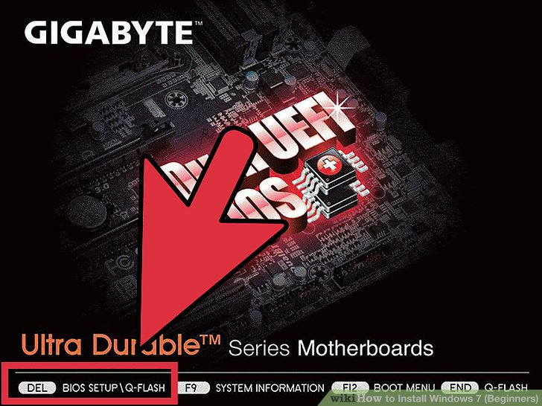](http://www.wikihow.com/Install-Windows-7-(Beginners)#/Image:Install-Windows-7-(Beginners)-Step-1.jpg)](http://www.wikihow.com/Install-Windows-7-(Beginners)" \l "/Image:Install-Windows-7-(Beginners)-Step-1.jpg)

1. **Enter your computer's BIOS.**

Turn off the computer that you want to install Windows on then turn it back on. When the BIOS screen appears or you are prompted to do so, press Del, Esc, F2, F10, or F9 (depending on your computer’s motherboard) to enter the system BIOS. The key to enter the BIOS is usually shown on the screen.

[[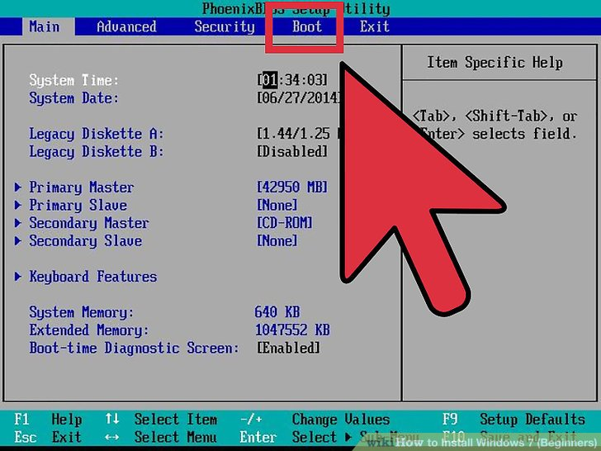](http://www.wikihow.com/Install-Windows-7-(Beginners)#/Image:Install-Windows-7-(Beginners)-Step-2.jpg)](http://www.wikihow.com/Install-Windows-7-(Beginners)" \l "/Image:Install-Windows-7-(Beginners)-Step-2.jpg)

1. **Find your BIOS's boot options menu.** The boot options menu of your BIOS may vary in location or name from the illustration, but you may eventually find it if you search around.

If you can't find the boot options menu, search the name of your BIOS (most likely located in the BIOS menu) online for help.

[[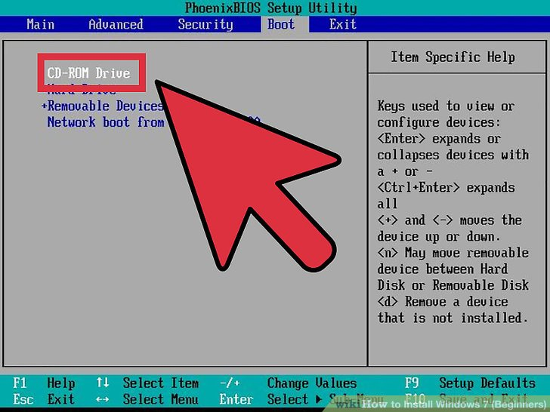](http://www.wikihow.com/Install-Windows-7-(Beginners)#/Image:Install-Windows-7-(Beginners)-Step-3.jpg)](http://www.wikihow.com/Install-Windows-7-(Beginners)" \l "/Image:Install-Windows-7-(Beginners)-Step-3.jpg)

1. Select the CD-ROM drive as the first boot device of your computer.

Although this method may vary among computers, the boot options menu is typically a menu of movable device names where you should set your CD-ROM drive as the first boot device. It can also be a list of devices that you can set the order of their boot on. Consult a manual or the internet for help if you're stuck.

[[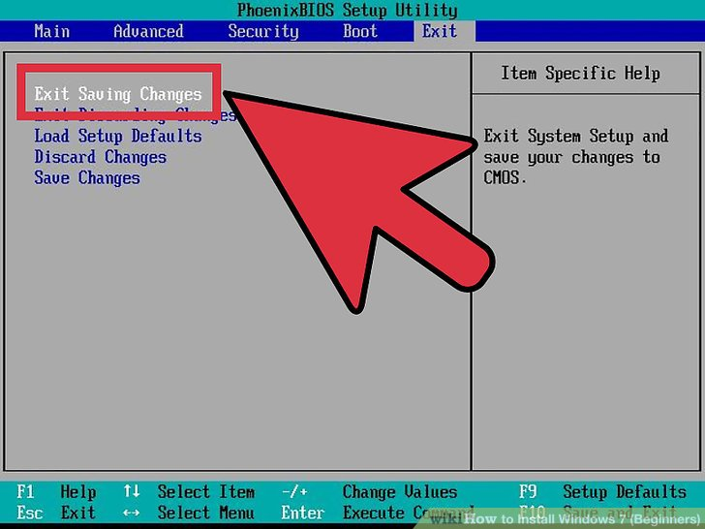](http://www.wikihow.com/Install-Windows-7-(Beginners)#/Image:Install-Windows-7-(Beginners)-Step-4.jpg)](http://www.wikihow.com/Install-Windows-7-(Beginners)" \l "/Image:Install-Windows-7-(Beginners)-Step-4.jpg)

1. Save the changes of the settings. Press the button indicated on the screen or select the save option from the BIOS menu to save your configuration.

[[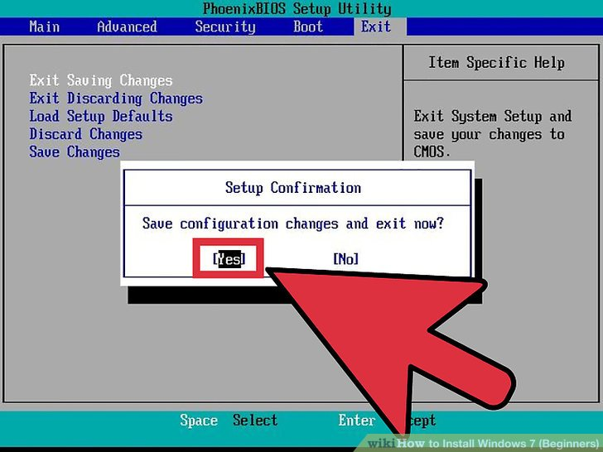](http://www.wikihow.com/Install-Windows-7-(Beginners)#/Image:Install-Windows-7-(Beginners)-Step-5.jpg)](http://www.wikihow.com/Install-Windows-7-(Beginners)" \l "/Image:Install-Windows-7-(Beginners)-Step-5.jpg)

1. Shut off your computer. Either turn off the computer by choosing the shut-down option in your current operating system, or hold the power button until the computer powers off.

[[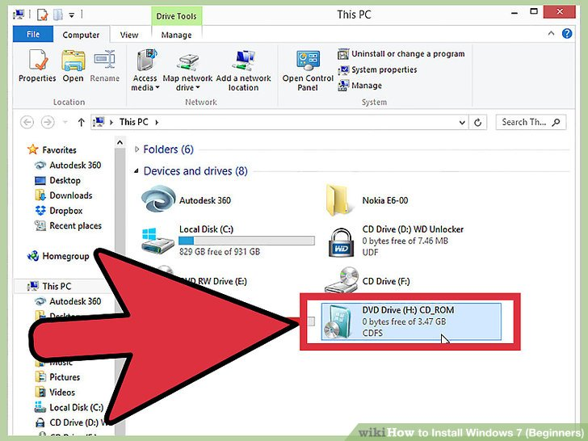](http://www.wikihow.com/Install-Windows-7-(Beginners)#/Image:Install-Windows-7-(Beginners)-Step-6.jpg)](http://www.wikihow.com/Install-Windows-7-(Beginners)" \l "/Image:Install-Windows-7-(Beginners)-Step-6.jpg)

1. Power on the PC and the insert the Windows 7 disc into your CD/DVD drive.

[[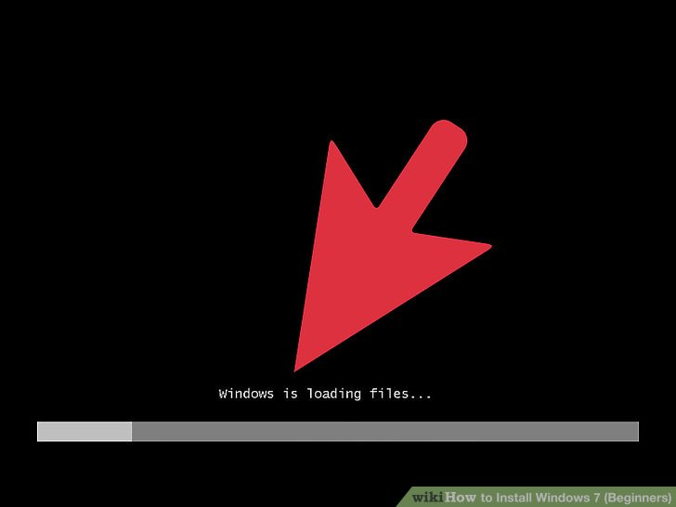](http://www.wikihow.com/Install-Windows-7-(Beginners)#/Image:Install-Windows-7-(Beginners)-Step-7.jpg)](http://www.wikihow.com/Install-Windows-7-(Beginners)" \l "/Image:Install-Windows-7-(Beginners)-Step-7.jpg)

1. Start your computer from the disc. After you have placed the disc into the disc drive, start your computer. When the computer starts, press a key if you are asked if you would like to boot from the disc by pressing any key. After you choose to start from the disc, Windows Setup will begin loading.

If you are not asked to boot from the disc, you may have done something wrong. Retry the previous steps to solve the problem.

[[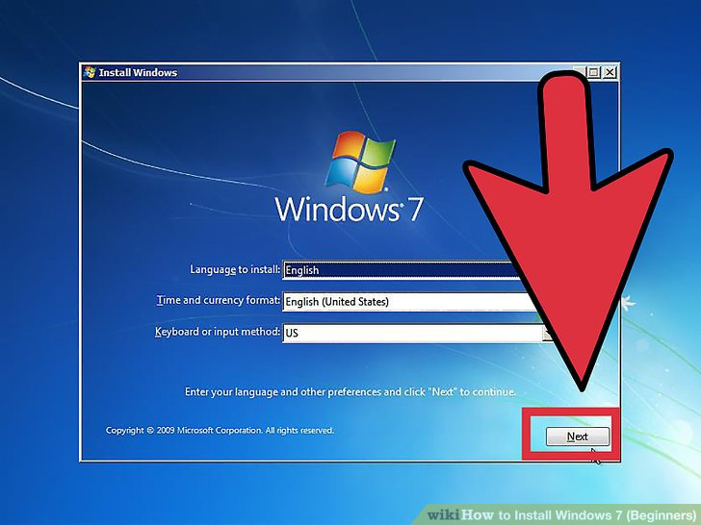](http://www.wikihow.com/Install-Windows-7-(Beginners)#/Image:Install-Windows-7-(Beginners)-Step-8.jpg)](http://www.wikihow.com/Install-Windows-7-(Beginners)" \l "/Image:Install-Windows-7-(Beginners)-Step-8.jpg)

1. Choose your Windows Setup options. Once Windows Setup loads, you'll be presented with a window. Select your preferred language, keyboard type, and time/currency format, then click Next.

[[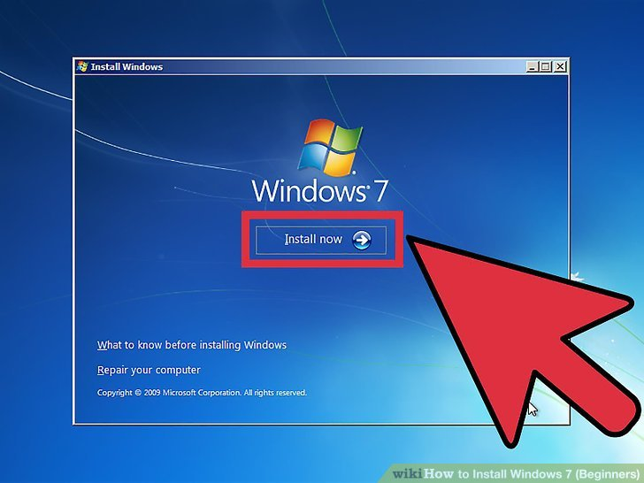](http://www.wikihow.com/Install-Windows-7-(Beginners)#/Image:Install-Windows-7-(Beginners)-Step-9.jpg)](http://www.wikihow.com/Install-Windows-7-(Beginners)" \l "/Image:Install-Windows-7-(Beginners)-Step-9.jpg)

1. Click the Install Now button.

[[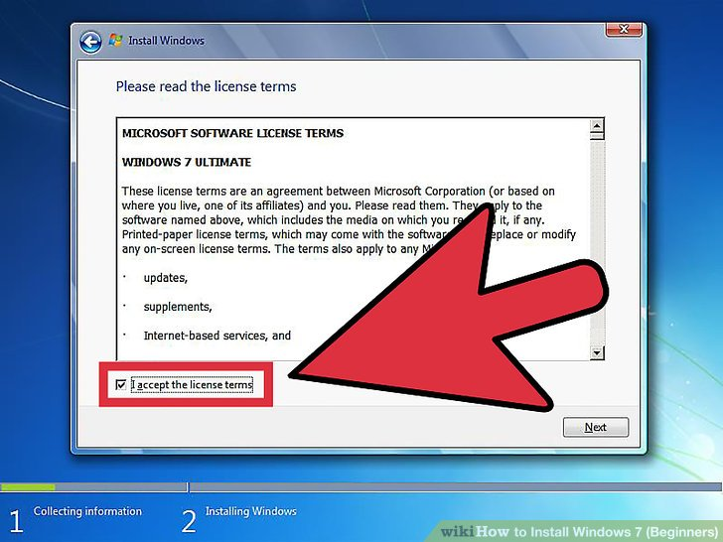](http://www.wikihow.com/Install-Windows-7-(Beginners)#/Image:Install-Windows-7-(Beginners)-Step-10.jpg)](http://www.wikihow.com/Install-Windows-7-(Beginners)" \l "/Image:Install-Windows-7-(Beginners)-Step-10.jpg)

1. Accept the License Terms. Read over the Microsoft Software License Terms, check I accept the license terms, and click Next.

[[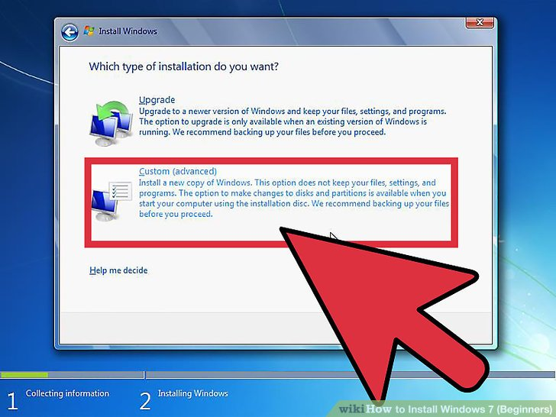](http://www.wikihow.com/Install-Windows-7-(Beginners)#/Image:Install-Windows-7-(Beginners)-Step-11.jpg)](http://www.wikihow.com/Install-Windows-7-(Beginners)" \l "/Image:Install-Windows-7-(Beginners)-Step-11.jpg)

1. Select the Custom installation.

[[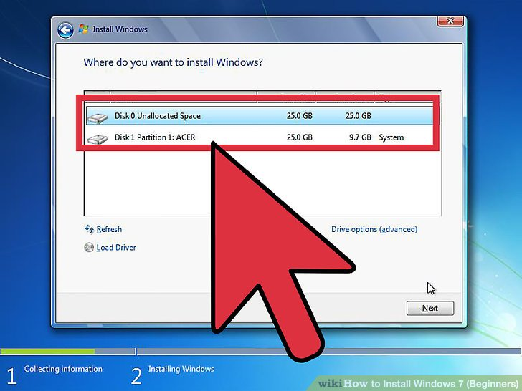](http://www.wikihow.com/Install-Windows-7-(Beginners)#/Image:Install-Windows-7-(Beginners)-Step-12.jpg)](http://www.wikihow.com/Install-Windows-7-(Beginners)" \l "/Image:Install-Windows-7-(Beginners)-Step-12.jpg)

1. Decide on which hard drive and partition you want to install Windows on. A hard drive is a physical part of your computer that stores data, and partitions "divide" hard drives into separate parts.

If the hard drive has data on it, delete the data off of it, or format it.

Select the hard drive from the list of hard drives.

Click Drive options (advanced).

Click Format from Drive options.

If your computer doesn't have any partitions yet, create one to install Windows on it.

Select the hard drive from the list of hard drives.

Click Drive options (advanced).

Select New from Drive options.

Select the size, and click OK.

[[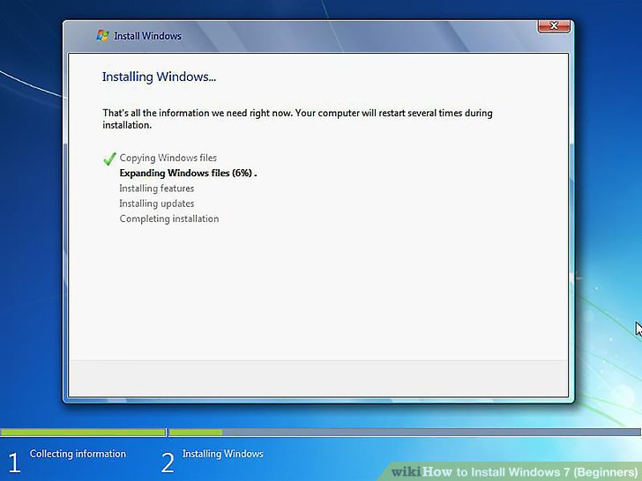](http://www.wikihow.com/Install-Windows-7-(Beginners)#/Image:Install-Windows-7-(Beginners)-Step-13.jpg)](http://www.wikihow.com/Install-Windows-7-(Beginners)" \l "/Image:Install-Windows-7-(Beginners)-Step-13.jpg)

1. Install Windows on your preferred hard drive and partition. Once you've decided on where to install Windows, select it and click Next. Windows will begin installing.

**EXPERIMENT 3**

**AIM:** Repairing straight through cable and cross-hover cable.

**REQUIREMENTS:** RJ-45, cable, clipping, measurement.

**PROCEDURE TO REPAIR STRIGHT THROUGH CABLE**

**STEP: 1**

Using a Crimping Tool, trim the end of the cable you're terminating, to ensure that the ends of the conducting wires are even

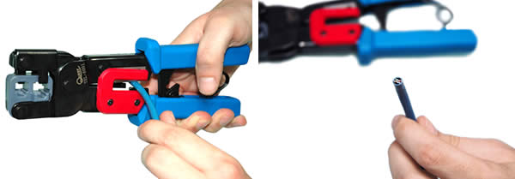

**STEP: 2**

Being careful not to damage the inner conducting wires, strip off approximately 1 inch of the cable's jacket, using a modular crimping tool or a UTP cable stripper.

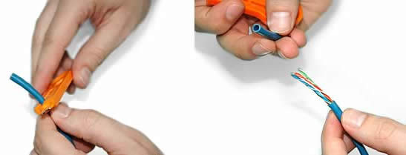

**STEP: 3**

Separate the 4 twisted wire pairs from each other, and then unwind each pair, so that you end up with 8 individual wires. Flatten the wires out as much as possible, since they'll need to be very straight for proper insertion into the connector.

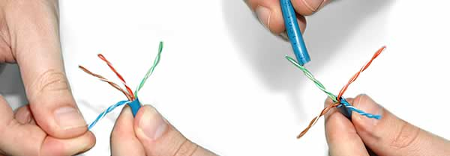

**STEP: 4**

Holding the cable with the wire ends facing away from you. Moving from left to right, arrange the wires in a flat, side-by-side ribbon formation, placing them in the following order: white/orange, solid orange, white/green, solid blue ,white/blue, solid green, white/brown, solid brown.

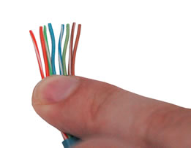

**STEP: 5**

Holding the RJ45 connector so that its pins are facing away from you and the plug-clip side is facing down , carefully insert the flattened, arranged wires into the connector, pushing through until the wire ends emerge from the pins. For strength of connection, also push as much of the cable jacket as possible into the connector.

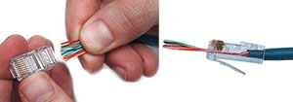

**STEP: 6**

Check to make sure that the wire ends coming out of the connector's pin side are in the correct order; if not, remove them from the connector, rearrange into proper formation, and re-insert. Remember, once the connector is crimped onto the cable, it's permanent. If you realize that a mistake has been made in wire order after termination, you'll have to cut the connector off and start all over again!

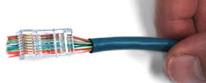

**STEP: 7**

Insert the prepared connector/cable assembly into the RJ45 slot in your crimping tool. Firmly squeeze the crimper's handles together until you can't go any further. Release the handles and repeat this step to ensure a proper crimp.

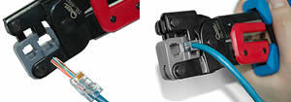

**STEP: 8**

If your crimper doesn't automatically trim the wire ends upon termination, carefully cut wire ends to make them as flush with the connector's surface as possible. The closer the wire ends are trimmed, the better your final plug-in connection will be.

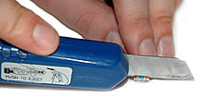

**STEP: 9**

After the first termination is complete, repeat process on the opposite end of your cable

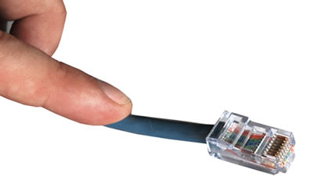

**PROCEDURE TO REPAIR CROSS-HOVER CABLE**

**STEP: 1**

 Start by stripping off about 2 inches of the plastic jacket off the end of the cable. Be very careful at this point, as to not nick or cut into the wires, which are inside. Doing so could alter the characteristics of your cable, or even worse render is useless. Check the wires, one more time for nicks or cuts. If there are any, just whack the whole end off, and start over.

**STEP: 2**

Spread the wires apart, but be sure to hold onto the base of the jacket with your other hand. You do not want the wires to become untwisted down inside the jacket. Category 5 cable must only have 1/2 of an inch of 'untwisted' wire at the end; otherwise it will be 'out of spec'. At this point, you obviously have ALOT more than 1/2 of an inch of un-twisted wire, but don't worry - well take care of that soon enough.

**STEP: 3**

 Up to this point, things have been pretty easy. Things will get a little bit tricky here, but don't worry, we'll get through this together. We are at a point in this article where a decision needs to be made. You need to decide which end of the cable you are making at this point in time. If you are making your cable from scratch like I am doing while writing this article, you have 2 end jacks, which must be installed on your cable. If you are using a pre-made cable, with one of the ends whacked off, you only have one end to install - the crossed over end. Below are two diagrams, which show how you need to arrange the cables for each type of cable end. Decide at this point which end you are making and examine the associated picture below.

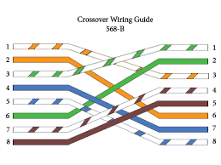

Begin to untwist the twisted exposed wires on your cable. Use caution so that you do not untwist them down inside the jacket. Once you have all the wires untwisted begin to arrange them in the proper order based on the pictures above. This stage can be a pain in the ass, especially some of the middle wires. Once you get all the wired arranged in the proper order, make sure your wire cutters are within reach then grasp them right at the point where they enter the jacket. Make sure you keep them in the proper order! Grab your cutters now. Line them up along your prepared wires about 1/2 inch above the jacket. Be sure at this point that you are both 1/2 inch above the jacket, and that your cutters are aligned straight across the wires. You want to make a clean cut here - also make sure you don't let go of that jacket / wires!

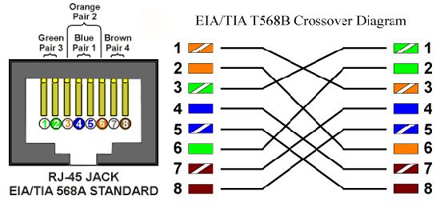

**STEP: 4**

Don't worry. From this point forward things get a lot easier. Grab your jack, and begin to slide the wires into the jack. Once you get to the point where the jacket begins to enter the jack things might get a little tough, but just have some patience and hold onto those wires. It will fit in there just fine. Once it is in as far as it will go the wires should extend almost to the front of the jack, and about 3/8 of an inch of the jacket will be inside the jack. Like the pictures below.

**STEP: 5**

Grab those crimpers - because not all crimpers are exactly the same your pictures may not match exactly what you see below. Be sure to keep a good grip on that jack and the cable. Insert the jack into the crimper. It should only go in one way, so you don't have a whole lot to worry about inserting it. Begin to compress those crimpers. You will more than likely hear a clicking sound. Keep squeezing. If you try to let go to early, nothing will happen. They will not release. Keep going until they stop clicking / stop moving all together. At this point, you should be able to let go of the jack, and the crimpers. The crimpers should release now leaving you with a crimped jack. If the crimpers do not release, you probably are a wimp and didn't press hard enough. Go ask your mom to help you at this point. She can probably finish what you started.

**STEP: 6**

It's time to examine what we have done. If you look at the end of the jack (distal), you should see that the copper connectors should not be pressed down into the wires. Toward the back of the jack (where the jacket meets the jack) it should be crimped securely holding the jacket / cable in the jack. If something has gone wrong, don't worry, its not the end of the world. Grab those cutters, and just whack the whole jack off and start back at step 1 (a pain in the ass I know, but its better to have a cable that works, than to spend hours trouble shooting your PC trying to figure out why you can't see the other machine). If everything is cool, all you have to do now is make the other end of the cable (unless you are using a pre-fab cable and have whacked one of the ends off), so go back to step one, and make the other end now.

**EXPERIMENT-4**

**Aim:** (a)How to Share Folders with Specific People in Windows

# (b)[How to Use Remote Desktop in Windows](http://www.wikihow.com/Use-Remote-Desktop-in-Windows-7)

**Procedure:**

**(a)How to Share Folders with Specific People in Windows:-**

1. If you want to share a folder with a specific user, right click or press and hold on it. Then, from the right-click menu, select 'Share with *->* Advanced sharing'.

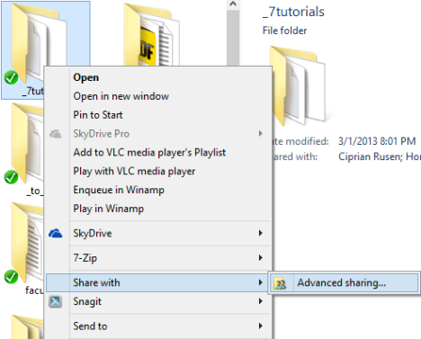.

1. Click or tap 'Advanced Sharing'.
2. First, check the 'Share this folder' box. If you want to use a different share name from the default one, type the preferred name in the 'Share name' text box.Then, you need to set the permissions for the folder you are sharing. Click or tap Permissions.

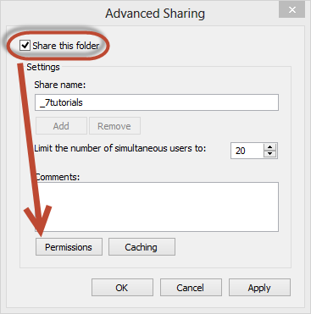

1. In the Permissions window you will see the users or groups that have permissions to access the folder you are sharing. By default, any folder is shared with the user Everyone. On the bottom you have the permissions given to the selected user or group.

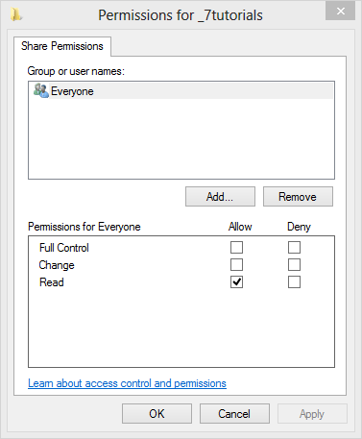

1. Before modifying the permissions assigned to each user or group, let’s add another user account that will receive access to the folder. Click or tap Add.
2. The Select Users or Groups window opens. In the text-box on the bottom, type the name of the user or group you want to give permissions to. If you are not sure which users/groups are registered on your PC, click or tap Advanced. If you know the exact user name or user group, click or tap Check Names to verify yourself, then OK and skip the next step.

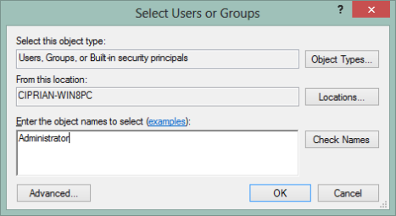

1. Clicking or tapping Advanced, extends the Select Users or Groups window with new options and buttons.
2. Click or tap 'Find Now' and Windows shows a list with all user accounts and user groups registered on your PC. Select the one you want to share with and click or tap OK to get back to the previous window.

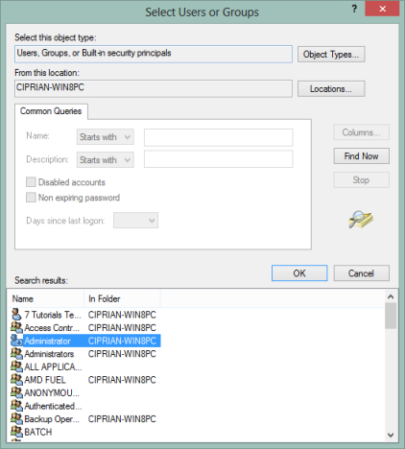.

1. There, click or tap OK one more time.Now it is time to pick the access you want to give to each user or group. Select each user or group and check the permissions level you wish to assign:

* **Full Control** - this is self-explanatory. When assigned, users or groups who have access to the shared folder can do anything with it: view it, modify it, delete it, etc.
* **Change -** users or groups can change the contents of the shared folder but cannot delete its content.
* **Read -** users or groups can only view the existing content without being able to perform any changes to it.

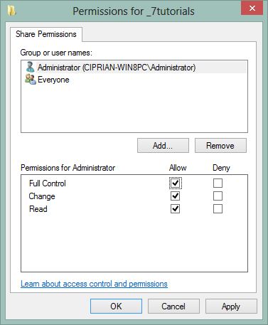

1. To remove a user or group, select it and click or tap Remove.
2. When done setting things up, click or tap OK. Then, click or tap Close in the Properties window.
3. The folder is shared with the user accounts or groups you selected, using the permissions you have set.

# (b)[How to Use Remote Desktop in Windows](http://www.wikihow.com/Use-Remote-Desktop-in-Windows-7) :-

1. On the Windows computer connecting to the target, open the Start menu and type “Remote Desktop” in the search box. When "Remote Desktop Connection" appears in the search results, click on it.

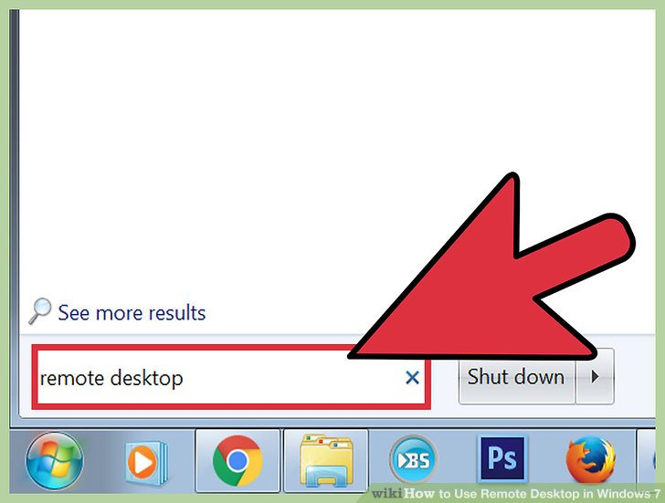

1. Enter the IP address of the target computer. This is the IPv4 address you previously collected from the other system. Press “Connect.”

[[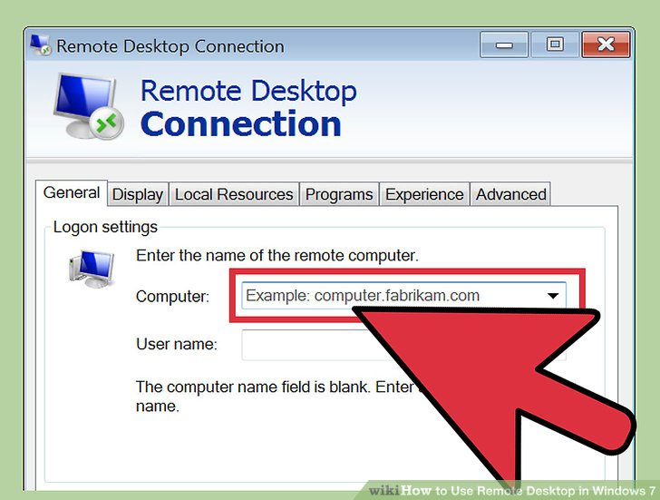](http://www.wikihow.com/Use-Remote-Desktop-in-Windows-7#/Image:Use-Remote-Desktop-in-Windows-7-Step-15.jpg)](http://www.wikihow.com/Use-Remote-Desktop-in-Windows-7" \l "/Image:Use-Remote-Desktop-in-Windows-7-Step-15.jpg)

1. Enter your login credentials. Enter the username and password of the account you configured in the target computer’s Remote Desktop settings. Click “OK.

[[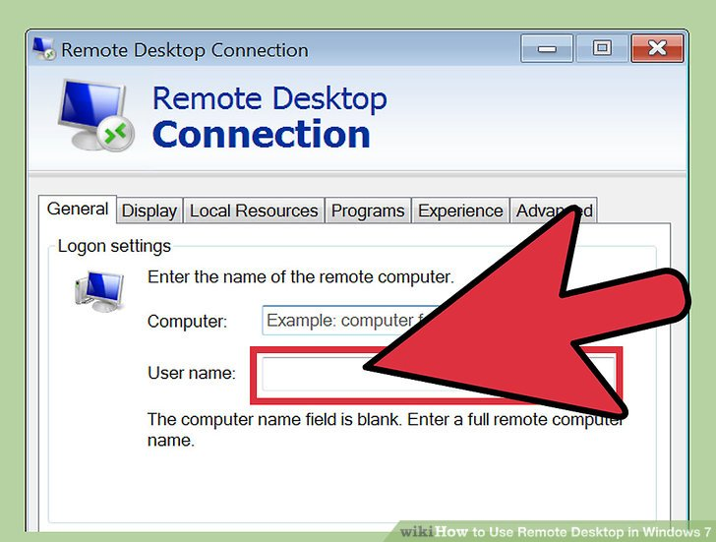](http://www.wikihow.com/Use-Remote-Desktop-in-Windows-7#/Image:Use-Remote-Desktop-in-Windows-7-Step-16.jpg)](http://www.wikihow.com/Use-Remote-Desktop-in-Windows-7" \l "/Image:Use-Remote-Desktop-in-Windows-7-Step-16.jpg)

1. Control the target computer remotely. You are now logged in to the target computer from your Windows 7 workstation

[[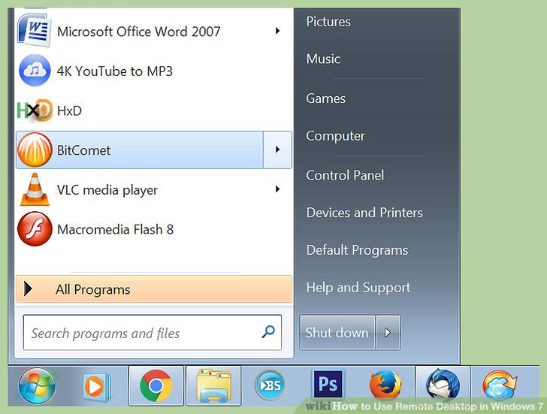](http://www.wikihow.com/Use-Remote-Desktop-in-Windows-7#/Image:Use-Remote-Desktop-in-Windows-7-Step-17.jpg)](http://www.wikihow.com/Use-Remote-Desktop-in-Windows-7" \l "/Image:Use-Remote-Desktop-in-Windows-7-Step-17.jpg)

.