**EXPERIMENT-2**

**AIM- Design data flow digram ,dataDictionary,Er diagram and structure chat for given project.**

**DATA FLOW DIAGRAM:**

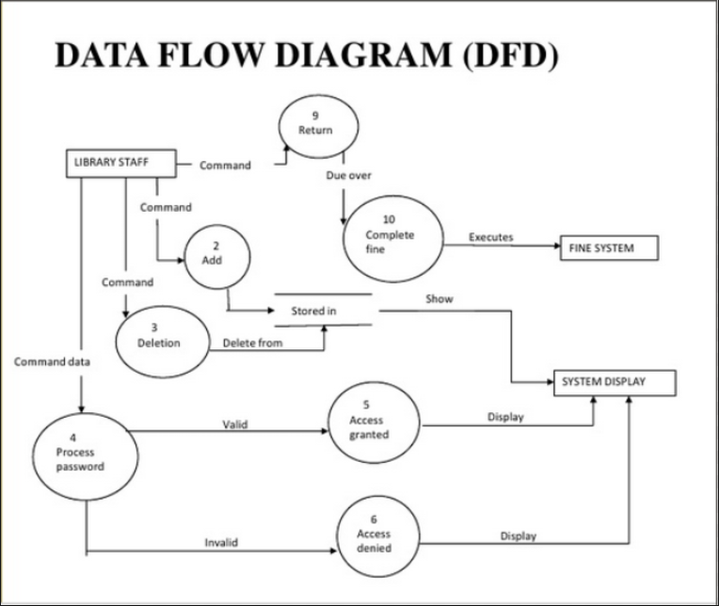

**DATA DICTIONARY :**

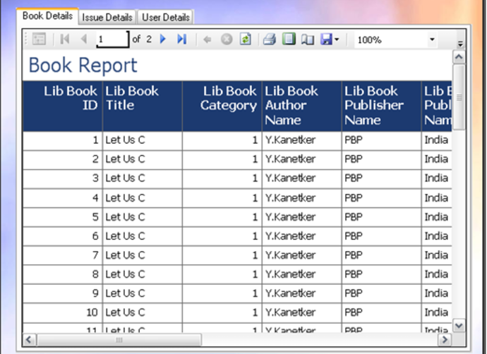

**ER DIGRAM :**

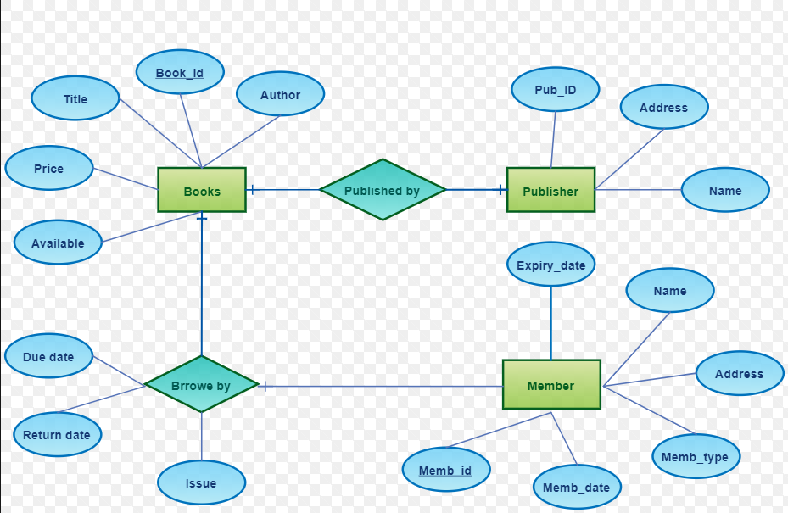

**STRUCTURE CHAT :**

