**EXPERIMENT-1**

**AIM**-Draft a project plan for any of the project student submitted in the previous class.

**What is software Engineering**

Software engineering is an engineering branch associated with development of software product using well-defined scientific principles, methods and procedures. The outcome of software engineering is an efficient and reliable software product.

Software project management has wider scope than software engineering process as it involves communication, pre and post delivery support etc.

This tutorial should provide you basic understanding of software product, software design and development process, software project management and design complexities etc. At the end of the tutorial you should be equipped with well understanding of software engineering concepts.

Softwareis more than just a program code. A program is an executable code, which serves some computational purpose. Software is considered to be collection of executable programming code, associated libraries and documentations. Software, when made for a specific requirement is called software product**.**

Engineering on the other hand, is all about developing products, using well-defined, scientific principles and methods.

**Introduction of project**

Library management system

**2.5 Requirement**

**Software Configuration:-**

This software package is developed using php&html as front end. MYSQL Server as the back end to store the database.

Operating System: Any

Language: PHP

Database: MYSQL SERVER (back end)

**Hardware Configuration:-**

Processor: Pentium(R)Dual-core CPU

Hard Disk: 40GB

RAM: 256 MB or more

**Data Requirement**

The inputs consist of the query to the database and the output consists of the solutions for the query. The output also includes the user receiving the details of their accounts. In this project the inputs will be the queries as fired by the users like create an account, selecting books and putting into account. Now the output will be visible when the user requests the server to get details of their account in the form of time, date and which books are currently in the account.  **External Interface Requirement**

**GUI**

The software provides good graphical interface for the user and the administrator can operate on the system, performing the required task such as create, update, viewing the details of the book.

* It allows user to view quick reports like Book Issued/Returned in between particular time.
* It provides stock verification and search facility based on different criteria.
* The user interface must be customizable by the administrator
* All the modules provided with the software must fit into this graphical user interface and accomplish to the standard defined
* The design should be simple and all the different interfaces should follow a standard template
* The user interface should be able to interact with the user management module and a part of the interface must be dedicated to the login/logout module

Login Interface:-

In case the user is not yet registered, he can enter the details and register to create his account. Once his account is created he can ‘Login’ which asks the user to type his username and password. If the user entered either his username or password incorrectly then an error message appears.

Search:-

The member or librarian can enter the type of book he is looking for and the title he is interested in,then he can search for the required book by entering the book name.

Categories View:-

Categories view shows the categories of books available and provides ability to the librarian to add/edit or delete category from the list.

Librarian’s Control Panel:-

This control panel will allow librarian to add/remove users; add, edit, or remove a resource. And manage lending options.

**System Features**

The users of the system should be provided the surety that their account is secure. This is possible by providing:-

* User authentication and validation of members using their unique member ID
* Proper monitoring by the administrator which includes updating account status, showing a popup if the member attempts to issue number of books that exceed the limit provided by the library policy, assigning fine to members who skip the date of return
* Proper accountability which includes not allowing a member to see other member’s account. Only administrator will see and manage all member accounts

**Other Non-functional Requirements**

**Performance Requirement**

The proposed system that we are going to develop will be used as the Chief performance system within the different campuses of the university which interacts with the university staff and students. Therefore, it is expected that the database would perform functionally all the requirements that are specified by the university.

* The performance of the system should be fast and accurate
* Library Management System shall handle expected and non-expected errors in ways that prevent loss in information and long downtime period. Thus it should have inbuilt error testing to identify invalid username/password
* The system should be able to handle large amount of data. Thus it should accommodate high number of books and users without any fault

**Safety Requirement**

The database may get crashed at any certain time due to virus or operating system failure. Therefore, it is required to take the database backup so that the database is not lost. Proper UPS/inverter facility should be there in case of power supply failure.

**Security Requirement**

* System will use secured database
* Normal users can just read information but they cannot edit or modify anything except their personal and some other information.
* System will have different types of users and every user has access constraints
* Proper user authentication should be provided
* No one should be able to hack users’ password
* There should be separate accounts for admin and members such that no member can access the database and only admin has the rights to update the database.

**Requirement attributes**

* There may be multiple admins creating the project, all of them will have the right to create changes to the system. But the members or other users cannot do changes
* The project should be open source
* The Quality of the database is maintained in such a way so that it can be very user friendly to all the users of the database
* The user be able to easily download and install the system

**User Requirement**

The users of the system are members and Librarian of the university who act as administrator to maintain the system. The members are assumed to have basic knowledge of the computers and internet browsing. The administrators of the system should have more knowledge of the internals of the system and is able to rectify the small problems that may arise due to disk crashes, power failures and other catastrophes to maintain the system. The proper user interface, user manual, online help and the guide to install and maintain the system must be sufficient to educate the users on how to use the system without any problems.

The admin provides certain facilities to the users in the form of:-

* Backup and Recovery
* Forgot Password
* Data migration i.e. whenever user registers for the first time then the data is stored in the server
* Data replication i.e. if the data is lost in one branch, it is still stored with the server
* Auto Recovery i.e. frequently auto saving the information
* Maintaining files i.e. File Organization
* The server must be maintained regularly and it has to be updated from time to time

**Other Requirements**

**Data and Category Requirement**

There are different categories of users namely teaching staff, Librarian, Admin, students etc. Depending upon the category of user the access rights are decided.It means if the user is an administrator then he can be able to modify the data,delete, append etc. All other users except the Librarian only have the rights to retrieve the information about database. Similarly there will be different categories of books available. According to the categories of books their relevant data should be displayed. The categories and the data related to each category should be coded in the particular format.

**Data Flow Diagram.**

Entity Relationship Diagram of Library Management System

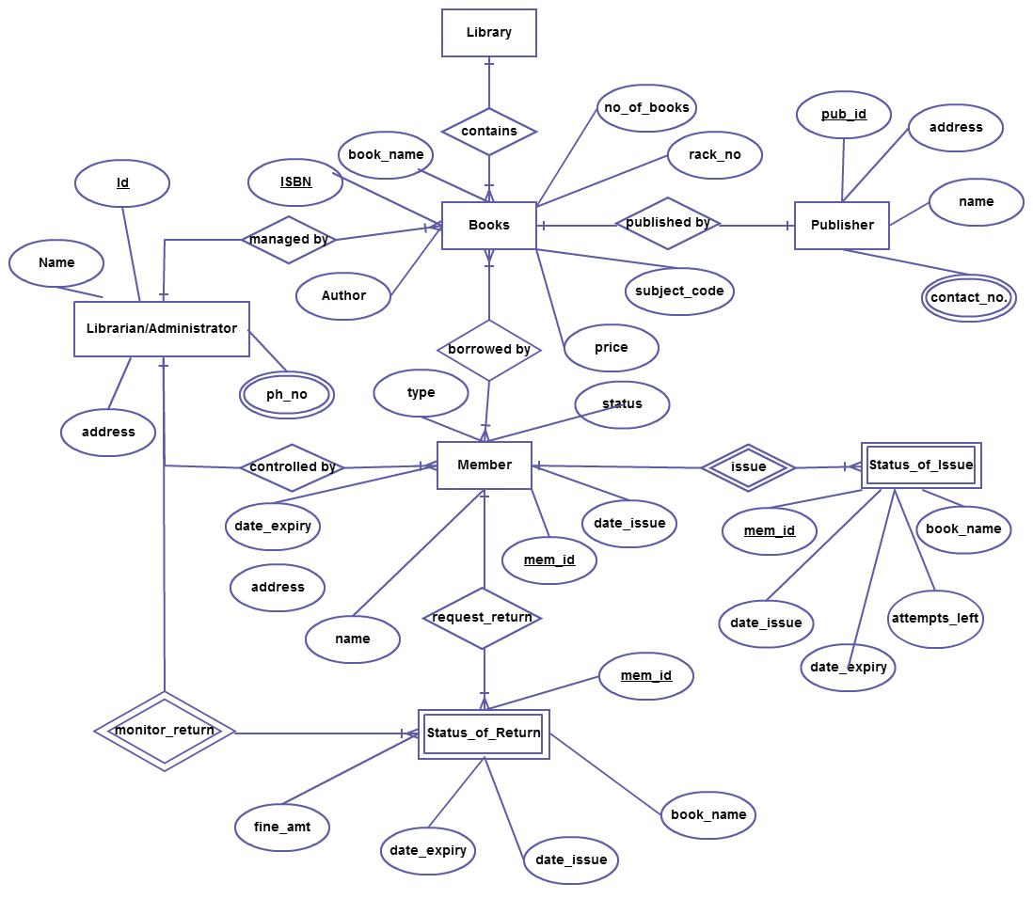

The Online Library System provides online real time information about the books available in the Library and the user information. The main purpose of this project is to reduce the manual work. This software is capable of managing Book Issues, Returns, Calculating/Managing Fine, Generating various Reports for Record-Keeping according to end user requirements. The Librarian will act as the administrator to control members and manage books. The member’s status of issue/return is maintained in the library database. The member’s details can be fetched by the librarian from the database as and when required. The valid members are also allowed to view their account information.

**EXPERIMENT-2**

**AIM- Design data flow digram ,dataDictionary,Er diagram and structure chat for given project.**

**DATA FLOW DIAGRAM:**

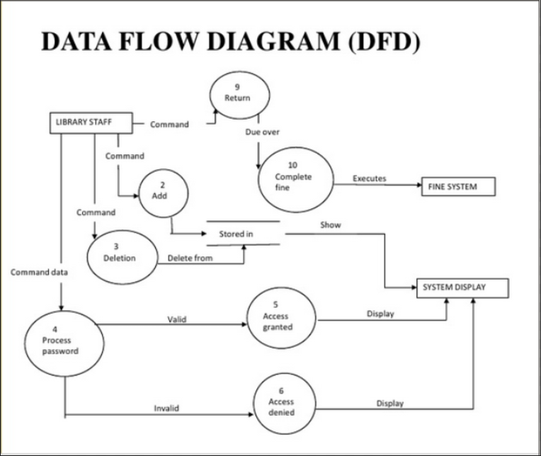

**DATA DICTIONARY :**

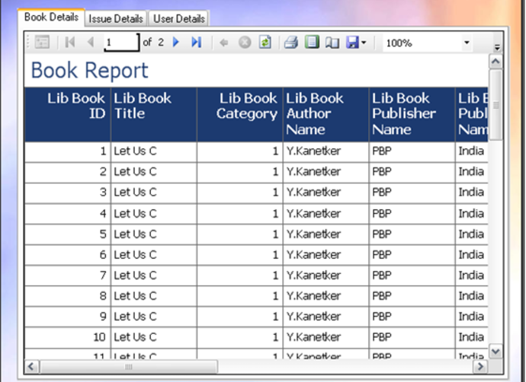

**ER DIGRAM :**

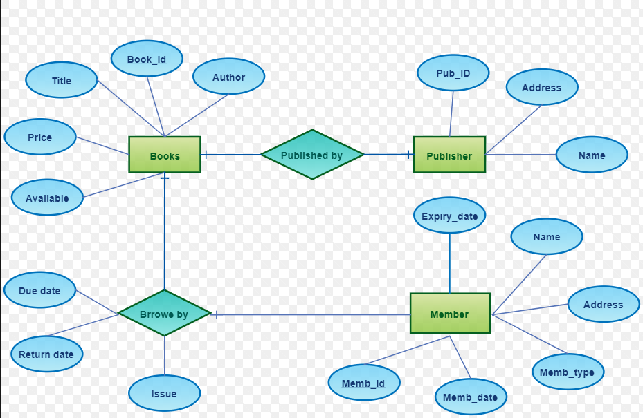

**STRUCTURE CHAT :**

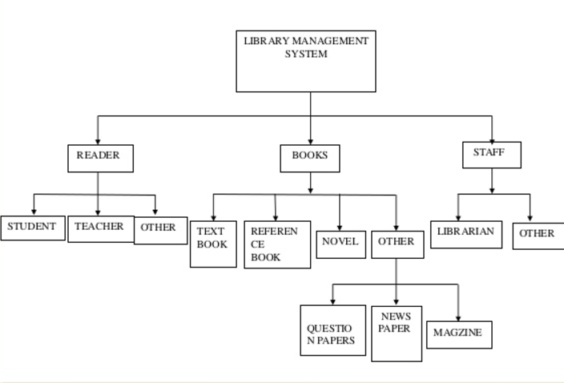

**EXPERIMENT-3**

**AIM-Development of SRS document Design Document for the selected project**

**Introduction**

The main objective of this document is to illustrate the requirements of the project Library Management system. The document gives the detailed description of the both functional and non-functional requirements proposed by the client.The purpose of this project is to provide a friendly environment to maintain the details of books and library members.The main purpose of this project is to maintain easy circulation system using computers and to provide different reports. This project describes the hardware and software interface requirements using ER diagrams and UML diagrams.

**Scope of Development Project**

Library Management System is basically updating the manual library system into an internet-based application so that the users can know the details of their accounts, availability of books and maximum limit for borrowing.

The project is specifically designed for the use of librarians and library users. The product will work as a complete user interface for library management process and library usage from ordinary users. Library Management System can be used by any existing or new library to manage its books and book borrowing, insertion and monitoring. It is especially useful for any educational institute where modifications in the content can be done easily according to requirements. The project can be easily implemented under various situations. We can add new features as and when we require, making reusability possible as there is flexibility in all the modules.

The language used for developing the project is PHP & HTML,CS,JAVASCRIPT as it is quite advantageous than other languages in terms of performance, tools available, cross platform compatibility, libraries, cost (freely available), and development process.

**Libraries And Kit Used**

* Bootstrap.
* Jquery.
* Materialize UI
* DiapoJs.
* Datepicker JS.

**Scope of Development Project**

Library Management System is basically updating the manual library system into an internet-based application so that the users can know the details of their accounts, availability of books and maximum limit for borrowing.

The project is specifically designed for the use of librarians and library users. The product will work as a complete user interface for library management process and library usage from ordinary users. Library Management System can be used by any existing or new library to manage its books and book borrowing, insertion and monitoring. It is especially useful for any educational institute where modifications in the content can be done easily according to requirements. The project can be easily implemented under various situations. We can add new features as and when we require, making reusability possible as there is flexibility in all the modules.

The language used for developing the project is PHP & HTML,CS,JAVASCRIPT as it is quite advantageous than other languages in terms of performance, tools available, cross platform compatibility, libraries, cost (freely available), and development process.

**Libraries And Kit Used**

* Bootstrap.
* Jquery.
* Materialize UI
* DiapoJs.
* Datepicker JS.

**Definitions, Acronyms and Abbreviations**

SQL-> Structured query Language

ER-> Entity Relationship

UML -> Unified Modeling Language

IDE-> Integrated Development Environment

SRS-> Software Requirement Specification

ISBN -> International Standard Book Number

IEEE ->Institute of Electrical and Electronics Engineers

**Software Configuration:-**

This software package is developed using php&html as front end. MYSQL Server as the back end to store the database.

Operating System: Any

Language: PHP

Database: MYSQL SERVER (back end)

**Hardware Configuration:-**

Processor: Pentium(R) Dual-core CPU

Hard Disk: 40GB

RAM: 256 MB or more

**Data Requirement**

The inputs consist of the query to the database and the output consists of the solutions for the query. The output also includes the user receiving the details of their accounts. In this project the inputs will be the queries as fired by the users like create an account, selecting books and putting into account. Now the output will be visible when the user requests the server to get details of their account in the form of time, date and which books are currently in the account.

**External Interface Requirement**

**GUI**

The software provides good graphical interface for the user and the administrator can operate on the system, performing the required task such as create, update, viewing the details of the book.

* It allows user to view quick reports like Book Issued/Returned in between particular time.
* It provides stock verification and search facility based on different criteria.
* The user interface must be customizable by the administrator
* All the modules provided with the software must fit into this graphical user
* The design should be simple and all the different interfaces should follow a standard template
* The user interface should be able to interact with the user management module and a part of the interface must be dedicated to the login/logout module

Login Interface:-

In case the user is not yet registered, he can enter the details and register to create his account. Once his account is created he can ‘Login’ which asks the user to type his username and password. If the user entered either his username or password incorrectly then an error message appears.

Search:-

The member or librarian can enter the type of book he is looking for and the title he is interested in,then he can search for the required book by entering the book name.

Categories View:-

Categories view shows the categories of books available and provides ability to the librarian to add/edit or delete category from the list.

Librarian’s Control Panel:-

This control panel will allow librarian to add/remove users; add, edit, or remove a resource. And manage lending options.

**System Features**

The users of the system should be provided the surety that their account is secure. This is possible by providing:-

* User authentication and validation of members using their unique member ID
* Proper monitoring by the administrator which includes updating account status, showing a popup if the member attempts to issue number of books that exceed the limit provided by the library policy, assigning fine to members who skip the date of return
* Proper accountability which includes not allowing a member to see other member’s account. Only administrator will see and manage all member accounts

**5. Other Non-functional Requirements**

**5.1 Performance Requirement**

The proposed system that we are going to develop will be used as the Chief performance system within the different campuses of the university which interacts with the university staff and students. Therefore, it is expected that the database would perform functionally all the requirements that are specified by the university.

* The performance of the system should be fast and accurate
* Library Management System shall handle expected and non-expected errors in ways that prevent loss in information and long downtime period. Thus it should have inbuilt error testing to identify invalid username/password
* The system should be able to handle large amount of data. Thus it should accommodate high number of books and users without any fault

**Safety Requirement**

The database may get crashed at any certain time due to virus or operating system failure. Therefore, it is required to take the database backup so that the database is not lost. Proper UPS/inverter facility should be there in case of power supply failure.

**Security Requirement**

* System will use secured database
* Normal users can just read information but they cannot edit or modify anything except their personal and some other information.
* System will have different types of users and every user has access constraints
* Proper user authentication should be provided
* No one should be able to hack users’ password
* There should be separate accounts for admin and members such that no member can access the database and only admin has the rights to update the database.

**Requirement attributes**

* There may be multiple admins creating the project, all of them will have the right to create changes to the system. But the members or other users cannot do changes
* The project should be open source
* The Quality of the database is maintained in such a way so that it can be very user friendly to all the users of the database
* The user be able to easily download and install the system

**User Requirement**

The users of the system are members and Librarian of the university who act as administrator to maintain the system. The members are assumed to have basic knowledge of the computers and internet browsing. The administrators of the system should have more knowledge of the internals of the system and is able to rectify the small problems that may arise due to disk crashes, power failures and other catastrophes to maintain the system. The proper user interface, user manual, online help and the guide to install and maintain the system must be sufficient to educate the users on how to use the system without any problems.

The admin provides certain facilities to the users in the form of:-

* Backup and Recovery
* Forgot Password
* Data migration i.e. whenever user registers for the first time then the data is stored in the server
* Data replication i.e. if the data is lost in one branch, it is still stored with the server
* Auto Recovery i.e. frequently auto saving the information
* Maintaining files i.e. File Organization
* The server must be maintained regularly and it has to be updated from time to time

**Other Requirements**

**Data and Category Requirement**

There are different categories of users namely teaching staff, Librarian, Admin, students etc. Depending upon the category of user the access rights are decided.It means idifferent categories of books available. According to the categories of books their relevant data should be displayed. The categories and the data related to each category should be coded in the

**EXPERIMENT-4**

**TESTING DOCUMENT**

* **TOPIC:** Big Data Analytics
* **INTRODUCTION:** To store large volume of unstructured data with the help of frameworks like hadoop, processing the data in a useful format with the help of framework such as map reduce and draw some insights out of it to convert the values into action.
* **TESTING PHASE:**

1. Testing is to be performed on the complete unstructured data that we’ll be processing for drawing out some insights out of it.
2. **Information about unstructured data**
   1. Data which is not organized into a predefined structure
   2. 80-90% of world’s data
   3. Examples: audios, videos, images, pdf’s emails, etc.
3. **Big Data Testing- The Unstructured View**

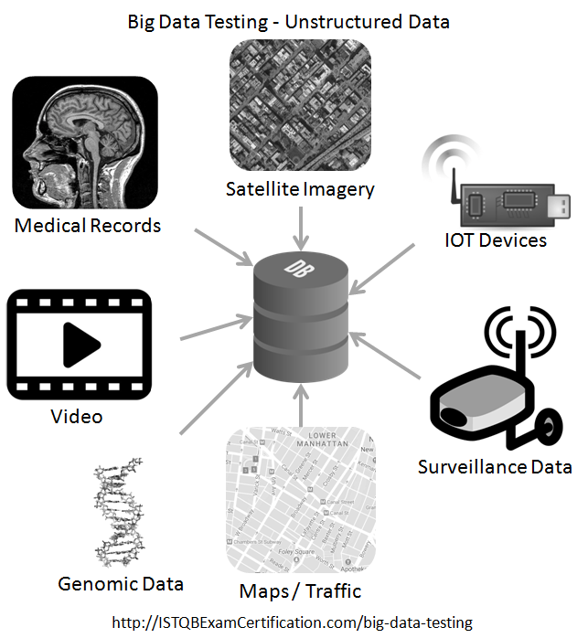

1. **Test, Strategy and steps for testing Big Data Application**
   1. DATABASE TESTING OF BIG DATA

= Before going further in our project phase we’ll be checking that which kind of database we are going to use for storage of our data depending on the functional requirement.

The functional Requirements could be :

1.Storage and querring of data

2.For cloud storage

3.For Business Intelligence, etc.

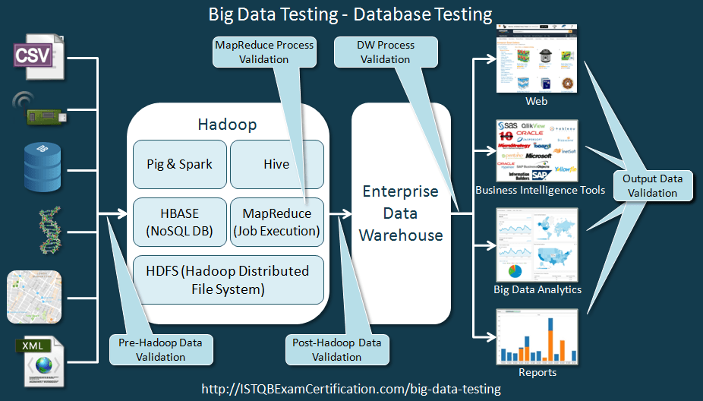

* 1. PERFORMANCE TESTING OF BIG DATA APPLICATION

= The Big Data project involves Huge amount of data processing which requires heavy computing resources and smooth data flow in the network.

So performance testing of a system measures metrics like throughput, memory utilization, CPU Utilization, time taken to complete a task, etc.

It is also recommended that some failover cases should also be run to test the fault tolerance of the system so thet if one node fails then also the processing should not stop.

The Performance tesing approach is shown in the image below:

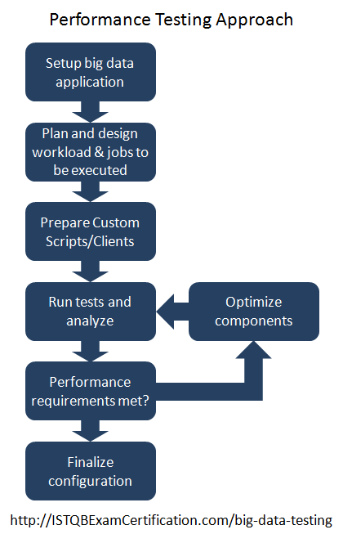

* 1. FUNCTIONAL TESTING OF BIG DATA APPLICATION:

=Functional testing of big data application is performed by testing the front end application based on user requirement. The front end can be a web based application which interfaces with HADOOP.

* 1. ROLES AND RESPONSIBIITIES OF A TESTER IN BIG DATA APPLICATION

1. The tester should be able to work with unstructured and semi-structured data.
2. The software tester should be able to work with changing schema.
3. Tester should know how to work with frameworks like HADOOP, HDFS, etc.
4. Tester of big data application requires huge amount of technical skills and and there is huge demand for those who passes these skills.

**Practical No – 5**

**AIM:** Preparation of Software Configuration Management and Risk Management related documents.

**Software Configuration Management**

1. **What is Software Configuration Management?**

Software configuration management (SCM) is a software engineering discipline consisting of standard processes and techniques often used by organizations to manage the changes introduced to its software products. SCM helps in identifying individual elements and configurations, tracking changes, and version selection, control, and baselining.

SCM is also known as software control management. SCM aims to control changes introduced to large complex software systems through reliable version selection and version control.

* 1. **Why SCM is important?**

**SCM** is important due to the following:

* Manages evolving software systems.
* Controls the costs involved in making changes to a system.
  1. **What are the benefits of Software configuration Management System?**

Following are the benefits of Software Configuration Management system:

* Reduced redundant work.
* Effective management of simultaneous updates.
* Avoids configuration-related problems.
* Facilitates team coordination.
* Helps in building management; managing tools used in builds.
* Defect tracking: It ensures that every defect has traceability back to its source.

1. **SCM Components**
   1. **Configuration Identification**

It is the process of identification of Configuration Items (CI) and developing a method to uniquely identify each individual CI. It helps answers the following questions:

* Which items are placed under configuration management?
* What are the components of the product?
* What is the structure (or configuration) of components in the product?
* What are the versions of the configuration items?
  1. **Change Control.**

Change control is function of configuration management, which ensures that all changes made to software system are consistent and made as per organizational rules and regulations.

A change in the configuration of product goes through following steps:

* Identification - A change request arrives from either internal or external source. When change request is identified formally, it is properly documented.
* Validation - Validity of the change request is checked and its handling procedure is confirmed.
* Analysis - The impact of change request is analyzed in terms of schedule, cost and required efforts. Overall impact of the prospective change on system is analyzed.
* Control - If the prospective change either impacts too many entities in the system or it is unavoidable, it is mandatory to take approval of high authorities before change is incorporated into the system. It is decided if the change is worth incorporation or not. If it is not, change request is refused formally.
* Execution - If the previous phase determines to execute the change request, this phase take appropriate actions to execute the change, does a thorough revision if necessary.
* Close request - The change is verified for correct implementation and merging with the rest of the system. This newly incorporated change in the software is documented properly and the request is formally is closed.

1. **Tools, Techniques & Methodologies**

* VSS – Visual source safe
* CVS- Concurrent version system
* Rational Clear Case
* SVN- Subversion
* Perforce
* TortoiseSVN
* IBM Rational team concert
* IBM Configuration management version management
* Razor
* Quma version control system
* SourceAnywhere

**Risk Management**

**1. Introduction**

Risk Management is the process of identifying, analyzing and responding to risk factors throughout the life of a project and in the best interests of its objectives. Proper risk management implies control of possible future events and is proactive rather than reactive.

**2. Risk Management Strategies**

As the project manager, there are four basics of risk management that you can use to manage your project's risks.

* Identify Risks
* Risk Assessment
* Risk Response Development
* Monitor and Control Risks

**2.1. Risk Identification**

Risk identification is the first stage of the risk management process. It is concerned with identifying the risks that could pose a major threat to the software engineering process, the software being developed, or the development organization. Risk identification may be a team process where a team get together to brainstorm possible risks. Alternatively, the project manager may simply use his or her experience to identify the most probable or critical risks.

**2.2. Risk Responsibility**

The responsibility for managing risk is shared amongst all the stakeholders of the project.

However, decision authority for selecting whether to proceed with mitigation strategies and implement contingency actions, especially those that have an associated cost or resource requirement rest with the Project Manager who is responsible for informing the funding agency to determine the requirement for a contract modification. The following tables details specific responsibilities for the different aspects of risk management.

* Risk Activity Responsibility
* Risk Identification: All project stakeholders
* Risk Registry: Project Manager
* Risk Assessment: All project stakeholders
* Risk Response Options Identification: All project stakeholders
* Risk Response Approval: PM with concurrence from CO/PO/COTR
* Risk Contingency Planning; Project Manager(s)
* Risk Response Management; Project Managers
* Risk Reporting; Project Manager

* 1. **Risk Assessment**

Risk assessment is the act of determining the probability that a risk will occur and the impact that event would have, should it occur. This is basically a “cause and effect” analysis. The “cause” is the event that might occur, while the “effect” is the potential impact to a project, should the event occur. Assessment of a risk involves two factors. First is the probability which is the measure of certainty that an event, or risk, will occur

**Response**

Risk response is the process of developing strategic options, and determining actions, to enhance opportunities and reduce threats to the project's objectives. A project team member is assigned to take responsibility for each risk response.

**Mitigation**

Risk mitigation involves two steps:

• Identifying the various activities, or steps, to reduce the probability and/or impact of an adverse risk.

• Creation of a Contingency Plan to deal with the risk should it occur.

Taking early steps to reduce the probability of an adverse risk occurring may be more effective and less costly than repairing the damage after a risk has occurred. However, some risk mitigation options may simply be too costly in time or money to consider. Mitigation activities should be documented in the Risk Register, and reviewed on a regular basis. They include:

• Identification of potential failure points for each risk mitigation solution.

• For each failure point, document the event that would raise a “flag” indicating that the event or factor has occurred or reached a critical condition.

• For each failure point, provide alternatives for correcting the failure

**Tracking and Processing**

As project activities are conducted and completed, risk factors and events will be monitored to determine if in fact trigger events have occurred that would indicate the risk is now a reality. Based on trigger events that have been documented during the risk analysis and mitigation processes, the project team or project managers will have the authority to enact contingency plans as deemed appropriate. Day to day risk mitigation activities will be enacted and directed by the project managers. Contingency plans that once approved and initiated will be added to the project work plan and be tracked and reported along with all of the other project activities. Risk management is an ongoing activity that will continue throughout the life of the project. This process includes continued activities of risk identification, risk assessment, planning for newly identified risks, monitoring trigger conditions and contingency plans, and risk reporting on a regular basis. Project status reporting contains a section on risk management, where new risks are presented along with any status changes of existing risks. Some risk attributes, such as probability and impact, could change during the life of a project and this should be reported as well.

**Processes to Address Immediate Unforeseen Risks**

The individual identifying the risk will immediately notify the project managers. The individual notified will assess the risk situation. If required, the project managers will identify a mitigating strategy, and assign resources as necessary. The project risk manager will document the risk factor and the mitigating strategy.

**Practical No – 6**

**AIM:** Design test cases and test suits for testing the different components of project.

**Introduction**

Library management system is a project which aims in developing a computerized system to maintain all the daily work of library .This project has many features which are generally not available in normal library management systems like facility of user login and a facility of teachers login .It also has a facility of admin login through which the admin can monitor the whole system .It also has facility of an online notice board where teachers can student can put up information about workshops or seminars being held in our colleges or nearby colleges and librarian after proper verification from the concerned institution organizing the seminar can add it to the notice board . It has also a facility where student after logging in their accounts can see list of books issued and its issue date and return date and also the students can request the librarian to add new books by filling the book request form. The librarian after logging into his account i.e. admin account can generate various reports such as student report , issue report, teacher report and book report Overall this project of ours is being developed to help the students as well as staff of library to maintain the library in the best way possible and also reduce the human efforts.

**Software Testing**

Software testing is a critical element of software quality assurance and represents the ultimate review of specification, design and coding. Testing presents an interesting of a system using various test data. Preparation of the test data plays a vital role in the system testing. After preparation the test data, the system under study is tested those test data. Errors were found and corrected by using the following testing steps and corrections are recorded for future references. Thus, series of testing is performed on the system before it is already for implementation.

The development of software systems involves a series of production activities where opportunities for injection of human errors are enormous. Errors may begin to occur at the very inception of the process where the objectives may be erroneously or imperfectly specified as well as in later design and development stages. Because of human in ability to perform and communicate with perfection, software development is followed by assurance activities.

Quality assurance is the review of software products and related documentation for completeness, correctness, reliability and maintainability. And of course it includes assurances that the system meets the specification and the requirements for its intended use and performance. The various levels of quality assurance are described in the following sub sections.

**Different types of testing**

* Black-box Testing
* White-box Testing
* Alpha Testing
* Beta Testing
* Smoke Testing
* Sanity Testing
* Regression Testing
* Sanity Testing
* A/B Testing
* Automation Testing

**The various levels of testing on the system are**:

* Unit testing
* Integrated testing
* Validation testing
* Output testing
* User acceptance testing

**Unit testing**

Unit testing focuses on verification effort on the smallest unit of software design module. Using the unit test plans. Prepared in the design phase of the system as a guide, important control paths are tested to uncover errors within the boundary of the modules. The interfaces of each of the modules under consideration are also tested. Boundary conditions were checked. All independent paths were exercised to ensure that all statements in the module are executed at least once and all error-handling paths were tested. Each unit was thoroughly tested to check if it might fall in any possible situation. This testing was carried out during the programming itself. At the end of this testing phase, each unit was found to be working satisfactorily, as regarded to the expected out from the module.

**Integration Testing**

Data can be across an interface one module can have an adverse effect on another’s sub function, when combined may not produce the desired major function; global data structures can present problems. Integration testing is a symmetric technique for constructing tests to uncover errors associated with the interface. All modules are combined in this testing step. Then the entire program was tested as a whole.

**Validation Testing**

At the culmination of integration testing, software is completely assembled as a package. Interfacing errors have been uncovered and corrected and final series of software test-validation testing begins. Validation testing can be defined in many ways, but a simple definition is that validation succeeds when the software functions in manner that is reasonably expected by the consumer. Software validation is achieved through a series of black box tests that demonstrate conformity with requirement. After validation test has been conducted, one of two conditions exists.

* The function or performance characteristics confirm to specification that are accepted.
* A validation from specification is uncovered and a deficiency created.

Deviation or errors discovered at this step in this project is corrected prior to completion of the project with the help of user by negotiating to establish a method for resolving deficiencies. Thus the proposed system under consideration has been tested by using validation testing and found to be working satisfactorily.

**Output Testing**

After performing the validation testing, the next step is output testing of the proposed system, since a system is useful if it does not produce the required output in the specific format required by them tests the output generator displayed on the system under consideration. Here the output is considered in two ways: - one is onscreen and the other is printed format. The output format on the screen is found to be correct as the format was designed in the system design phase according to the user needs. As far as hardcopies are considered it goes in terms with the user requirement. Hence output testing does not result any correction in the system.

**User Acceptance Testing**

User acceptance of the system is a key factor for success of any system. The system under consideration is tested for user acceptance by constantly keeping in touch with prospective system and user at the time of developing and making changes whenever required.

**TEST RESULT: UNIT TESTING**

**LOGIN FORM:**

|  |  |  |  |
| --- | --- | --- | --- |
| **Sr.No** | **Test Case** | **Excepted Result** | **Test Result** |
| 1 | Enter valid name and password & click on login button | Software should display main window | Successful |
| 2 | Enter invalid | Software should not display main window | successful |

**BOOK ENTRY FORM:**

|  |  |  |  |
| --- | --- | --- | --- |
| **Sr.No** | **Test Case** | **Excepted Result** | **Test Result** |
| 1 | On the click of ADD button | At first user have to fill all fields with proper data , if any Error like entering text data instead of number or entering number instead of text..is found then it gives proper message otherwise Adds Record To the Database | successful |
| 2. | On the Click of DELETE Button | This deletes the details of book by using Accession no. | Successful |
| 3. | On the Click of UPDATE Button | Modified records are Updated in database by clicking UPDATE button. | Successful |
| 4. | On the Click of SEARCH Button | Displays the Details of book for entered Accession no. Otherwise gives proper Error message. | Successful |
| 5. | On the Click of CLEAR Button | Clears all fields | Successful |
| 6. | On the Click of EXIT button | Exit the current book details form | successful |
| 7. | On the Click of NEXT button | Display the next form | successful |

**USER ACCOUNT FORM:**

|  |  |  |  |
| --- | --- | --- | --- |
| **Sr.No** | **Test Case** | **Excepted Result** | **Test Result** |
| 1 | On the click of ADD button | At first user have to fill all fields with proper data , if any Error like entering text data instead of number or entering number instead of text. Is found then it gives proper message otherwise Adds Record To the Database | successful |
| 2. | On the Click of DELETE Button | This deletes the details of student by using Register no. | Successful |
| 3. | On the Click of UPDATE Button | Modified records are Updated in database by clicking UPDATE button. | Successful |
| 4. | On the Click of SEARCH Button | Displays the Details of book for entered Register no. Otherwise gives proper Error message. | Successful |
| 5. | On the Click of CLEAR Button | Clears all fields | Successful |
| 6. | On the Click of EXIT button | Exit the current book details form | successful |
| 7. | On the Click of NEXT button | Display the next form | successful |

**BOOK ISSUE FORM:**

|  |  |  |  |
| --- | --- | --- | --- |
| **Sr.No** | **Test Case** | **Excepted Result** | **Test Result** |
| 1 | On the click of ADD button | At first user have to fill all fields with proper data ,if the accession number book is already issued then it will giving proper msg. | successful |
| 2. | On the Click of DELETE Button | This deletes the details of book by using Register no. | Successful |
| 3. | On the Click of UPDATE Button | Modified records are Updated in database by clicking UPDATE button. | Successful |
| 4. | On the Click of SEARCH Button | Displays the Details of issued book. Otherwise gives proper Error message. | Successful |
| 5. | On the Click of CLEAR Button | Clears all fields | Successful |
| 6. | On the Click of EXIT button | Exit the current book details form | successful |
| 7. | On the Click of NEXT button | Display the next form | successful |