**Experiment-7**

**Aim -** **Configuration of TCP/IP Protocols & Sharing of resources with two connected nodes**

The TCP/IP protocol and its associated routing protocols are possibly the most significant of the entire TCP/IP suite. IP is responsible for:

* IP addressing - The IP addressing conventions are part of the IP protocol. ([Chapter 5, Planning Your TCP/IP Network](https://docs.oracle.com/cd/E19455-01/806-0916/6ja85398p/index.html) describes IPv4 addressing in detail and [Chapter 14, Overview of IPv6](https://docs.oracle.com/cd/E19455-01/806-0916/6ja8539ba/index.html) describes IPv6 addressing in detail.)
* Host-to-host communications - IP determines the path a packet must take, based on the receiving host's IP address.
* Packet formatting - IP assembles packets into units known as IP datagrams. Datagrams are fully described in ["Internet Layer"](https://docs.oracle.com/cd/E19455-01/806-0916/6ja85398n/index.html#ipov-38).
* Fragmentation - If a packet is too large for transmission over the network media, IP on the sending host breaks the packet into smaller fragments. IP on the receiving host then reconstructs the fragments into the original packet.

**Step 1.** Click on start button ->control panel ->network and sharing centre.

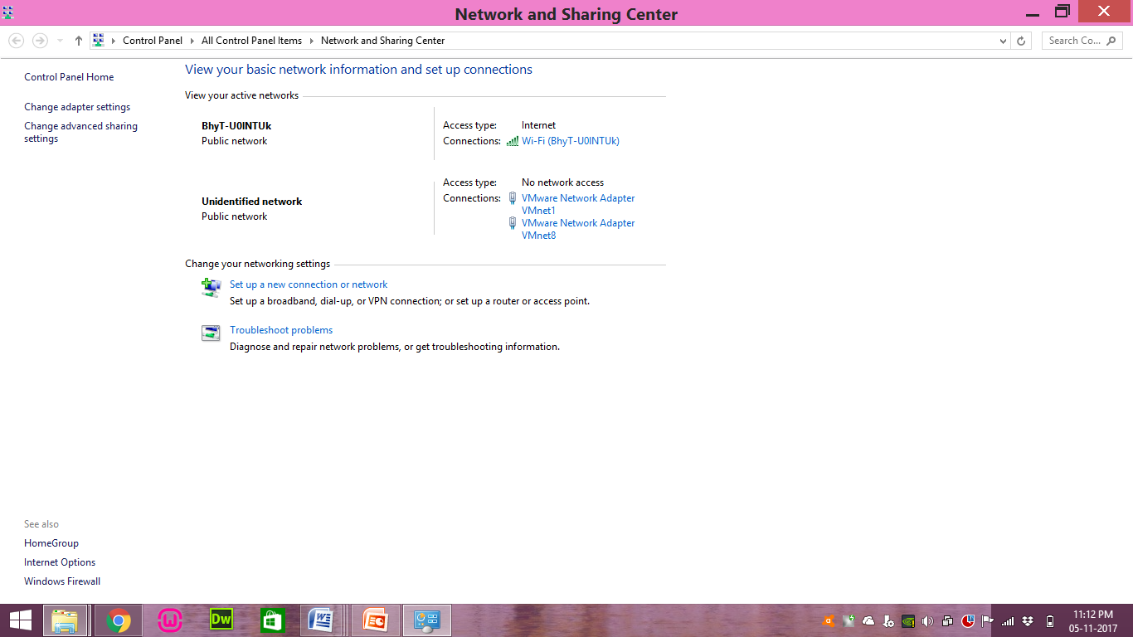

**Step -2** Click on Change Adapter settings.

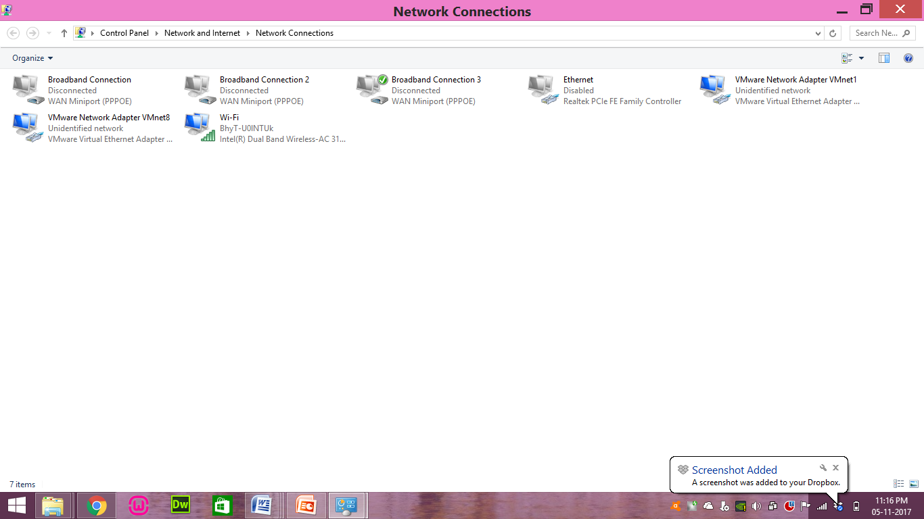

**Step-3** Right click on any network connection and select properties.

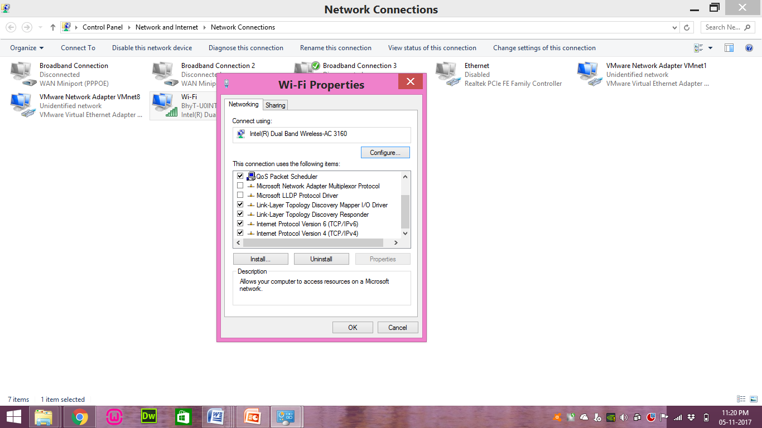

**Step -4**  Select IPV4 option and click properties and provide IP address according to requirements.

