**EXPERIMENT:-8**

**AIM:** Demonstration to Packet Tracer and Configure a Network topology.

**Packet tracer :**

Packet Tracer is a powerful network simulator that can be utilized in training for Network certifications by allowing students to create networks with an almost unlimited number of devices and to experience troubleshooting without having to buy real Cisco routers or switches. The tool is created by Cisco Systems. The purpose of Packet Tracer is to offer students a tool to learn the principles of networking as well as develop Cisco technology specific skills. However, it is not be used as a replacement for Routers or Switches.

**THEORY:-**

**TOPOLOGY**

A network topology is the arrangement of a network, including its nodes and connecting lines. There are two ways of defining network geometry: the physical topology and the logical (or signal) topology.The physical topology of a network is the actual geometric layout of workstations. There are several common physical topologies such as star, ring, bus, etc **STAR TOPOLOGY:**  In the star network topology, there is a central computer or server to which all the workstations are directly connected. Every workstation is indirectly connected to every other through the central computer.

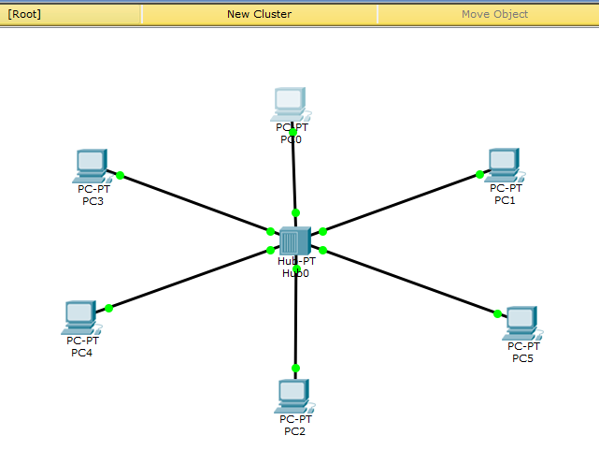

Sending message from one node to the other:

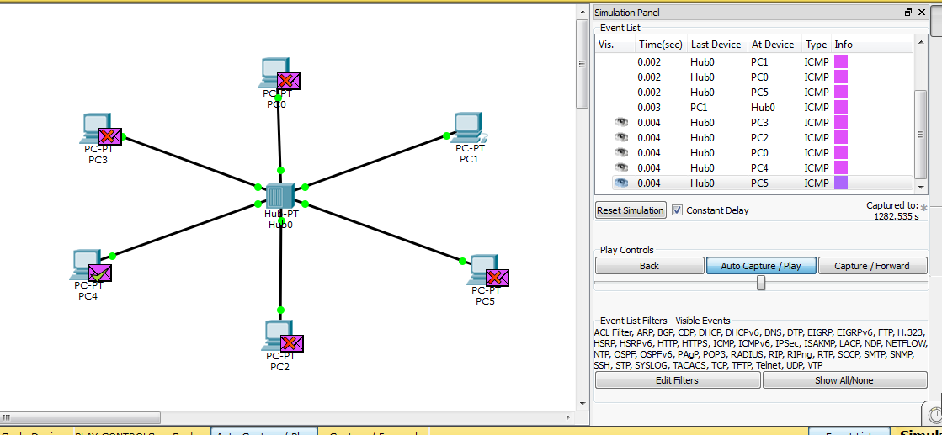

Setting the static IP address

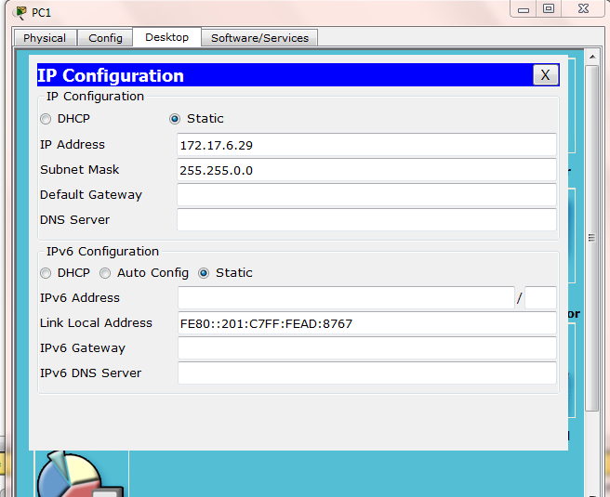

**RING TOPOLOGY**:In the [ring network](http://searchcio-midmarket.techtarget.com/definition/ring-network) topology, the workstations are connected in a closed loop configuration. Adjacent pairs of workstations are directly connected. Other pairs of workstations are indirectly connected, the data passing through one or more intermediate nodes.

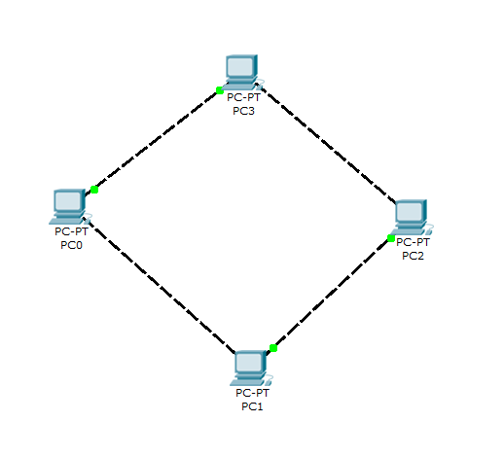

**MESH TOPOLOGY:**

The mesh network topology employs either of two schemes, called full mesh and partial mesh. In the full mesh topology, each workstation is connected directly to each of the others. In the partial mesh topology, some workstations are connected to all the others, and some are connected only to those other nodes with which they exchange the most data.

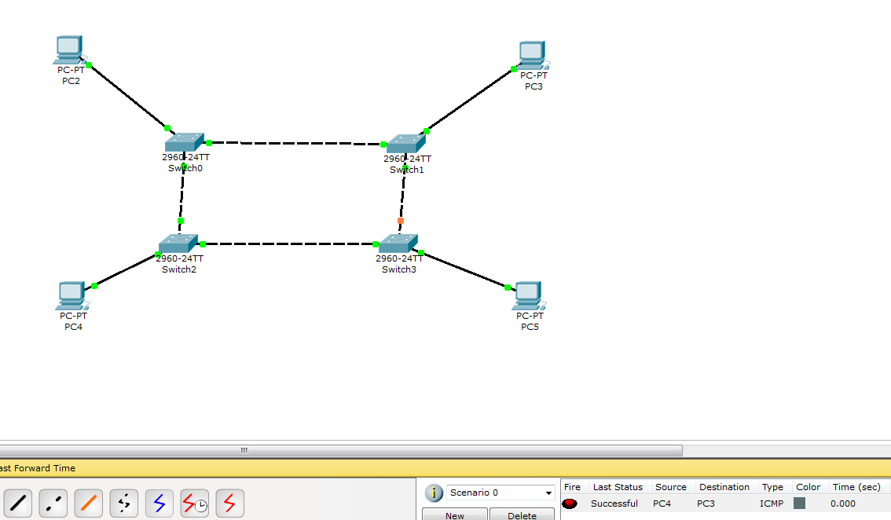

Checking the complete real simulation of how a message travels betweem different nodes starting from sender to the receiver.

