Exercise-I
Prashanth B S1 , Karthik1, Akarsha1
1Department of Information Science & Engineering, Nitte Meenakshi Institute of Technology,
Yelahanka - 560064, Bengaluru
May 14, 2022

query 1) insert atleast 15 records .
db.vishalemployee.insert({fname : "vishal",mname : "Kumar" , lname : "H K",age : 25,salary : 40000,designation : "sales manager" , role : "manager"})

db.vishalemployee.insert({fname : "sohan ",mname : "Kumar" , lname : "m",age : 28,salary : 50000,designation : "DATA analyst" , role : "manager"})

db.vishalemployee.insert({fname : "Rajesh ",mname : "c" , lname : "r",age : 38,salary : 60000,designation : "cloud architect" , role : "advisor"})

db.vishalemployee.insert({fname : "vakada",mname : "sai" , lname : "sanjeev",age : 30,salary : 50000,designation : "business analyst" , role : "advisor"})

db.vishalemployee.insert({fname : "praneeth",mname : "murthy" , lname : "vlsss",age : 35,salary : 500000,designation : "CEO" , role : "manager"})

db.vishalemployee.insert({fname : "vishal",mname : "kumar" , lname : "s",age : 29,salary : 200000,designation : "DATA SCIENTIST" , role : "senior manager"})

db.vishalemployee.insert({fname : "danush",mname : "KK" , lname : "s",age : 29,salary : 20000,designation : "full stack developer" , role : "employee"})

db.vishalemployee.insert({fname : "vinayak",mname : "p" , lname : "b",age : 29,salary : 100000,designation : "cloud engineer" , role : "manager"})

db.vishalemployee.insert({fname : "ullaas",mname : "M" , lname : "",age : 29,salary : 100000,designation : "software engineer" , role : "manager"})

db.vishalemployee.insert({fname : "ritu",mname : "kumari" , lname : "",age : 29,salary : 100000,designation : "software engineer" , role : "manager"})

db.vishalemployee.insert({fname : "sai",mname : "murthy" , lname : "H",age : 27,salary : 100000,designation : "data scientist" , role : "manager"})

db.vishalemployee.insert({fname : "sai",mname : "shetty" , lname : "j",age : 26,salary : 150000,designation : "data scientist" , role : "manager"})

db.vishalemployee.insert({fname : "kung",mname : "fu" , lname : "panda",age : 59,salary : 190000,designation : "scientist" , role : "manager"})

db.vishalemployee.insert({fname : "choota",mname : "bheem" , lname : "",age : 79,salary : 19000,designation : "attender" , role : "manager"})

db.vishalemployee.insert({fname : "ben",mname : "10" , lname : "",age : 12,salary : 1,designation : "yet to decide" , role : "yet to decide"})

db.vishalemployee.insert({fname : "rajesh",mname : "c r" , lname : "",age : 58,salary : 100000,designation : "scientiest" , role : "scientist"})

db.vishalemployee.insert({fname : "vinod",mname : "raja" , lname : "ramu",age : 35,salary : 55650,designation : "scientiest" , role : "team lead"})
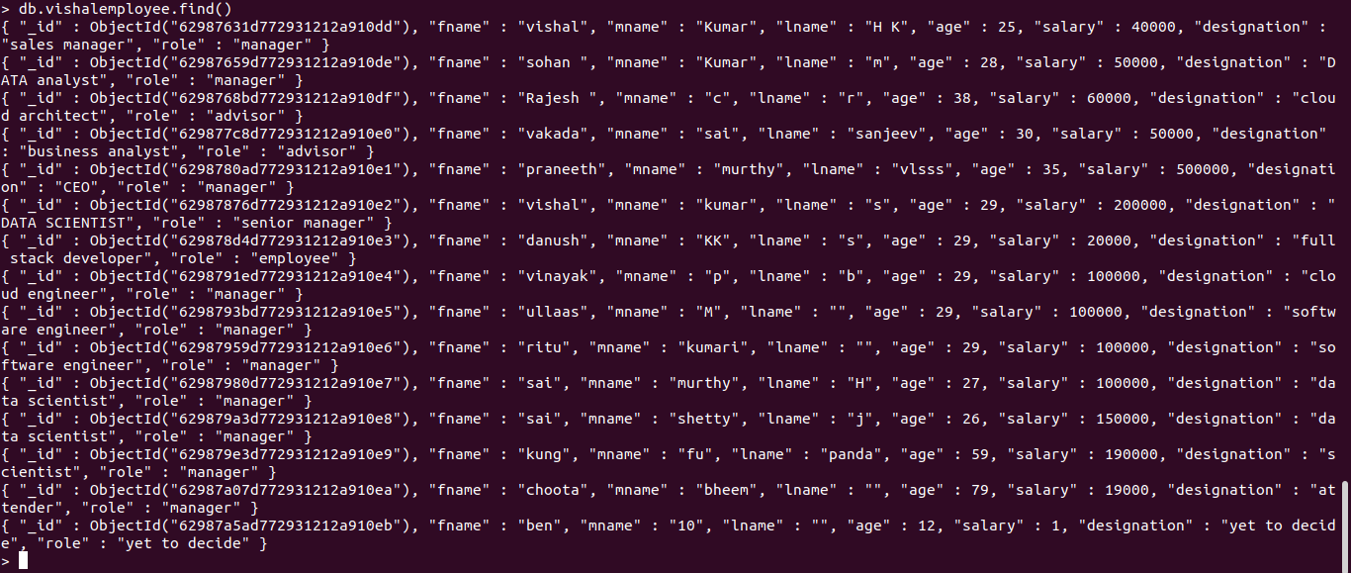
2)2. List all the records having salary in the range of 20000 – 35000(Exclusive).
db.vishalemployee.find({$and : [{salary : {$gte : 20000}} , {salary : {$gte :f35000}} ]}).pretty()

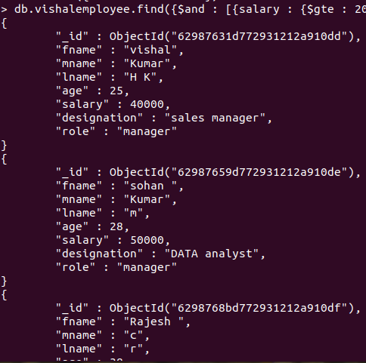

3)List all the Employee whose Middle name is "Kumar".
db.vishalemployee.find({"mname": "kumar"}).pretty()
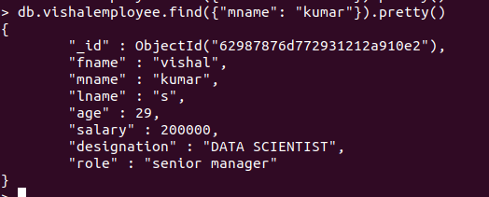
4) Count the number of Employees who has a role "Manager" in the Role field.
db.vishalemployee.count({role: "manager"})

5. Find out all the documents who have age < 35 and salary in the range of 30000-35000.
db.vishalemployee.find({ $and: [ {age: {$lte: 35}}, {salary: {$gte: 30000}}, {salary: {$lte: 35000}} ] }).pretty()

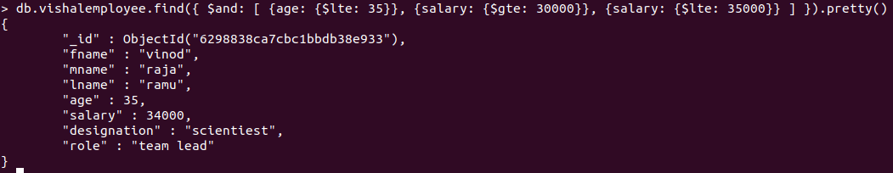
6. Delete an Employee whose "Firstname" is "Rajesh" and having the designation as "Scientist".
db.vishalemployee.remove({$and:[{fname: "rajesh"},{designation: "Scientist"}]})
7. Update all the Employees whose role is "Team Lead" with a salary of 55650 INR
db.vishalemployee.updateMany({role: "team lead"}, {$set: {salary: 55650}})
8. Group all the Employees by their age(common age should be there) and calculate the average salary obtained in the each group
db.vishalemployee.aggregate([ {$group: {_id: "$age",AVERAGE: {$avg: "$salary"}}}])
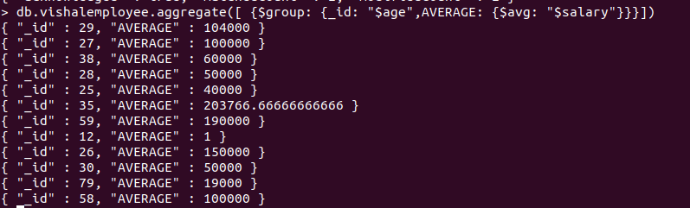
9. Apply the map-reduce to perform the above operation and obtain the results.
var mapfunction = function() { emit(this.age, this.salary)}
var reducefunction = function(key, values) {return Array.avg(values)}
db.vishalemployee.mapReduce(mapfunction, reducefunction, {'out': 'result'})
