# DATABASE in “phpmyadmin”

## DATABASE name as “mulesoft” , and “movie_id” as table name.

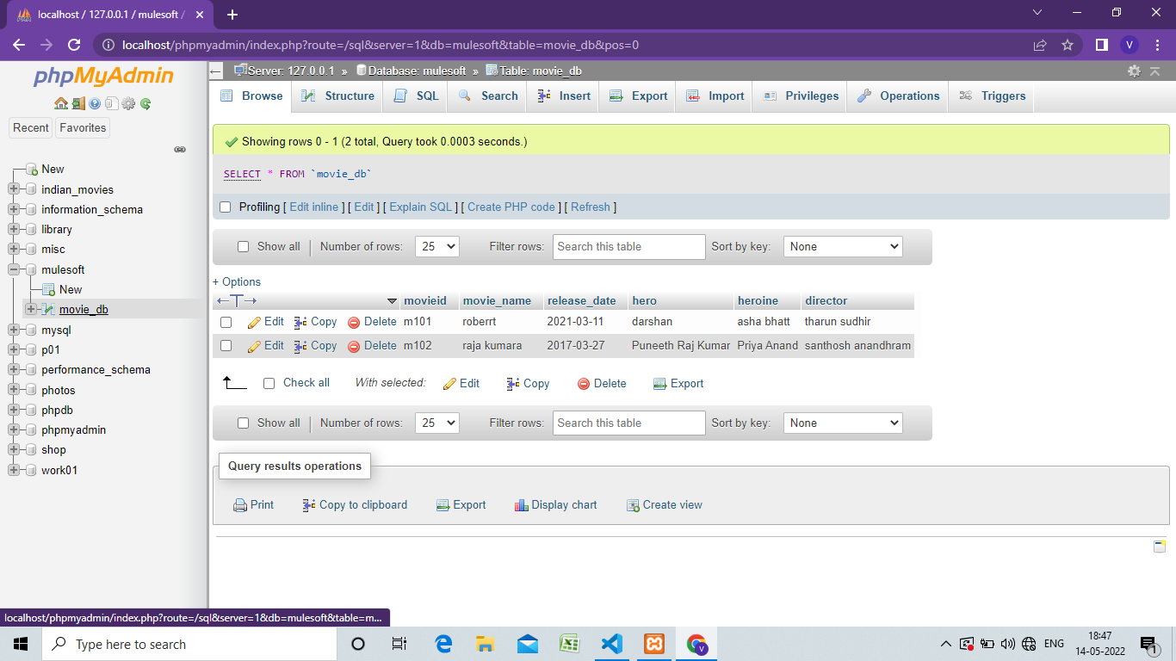

# Working of code

## Insertion of records into tables.

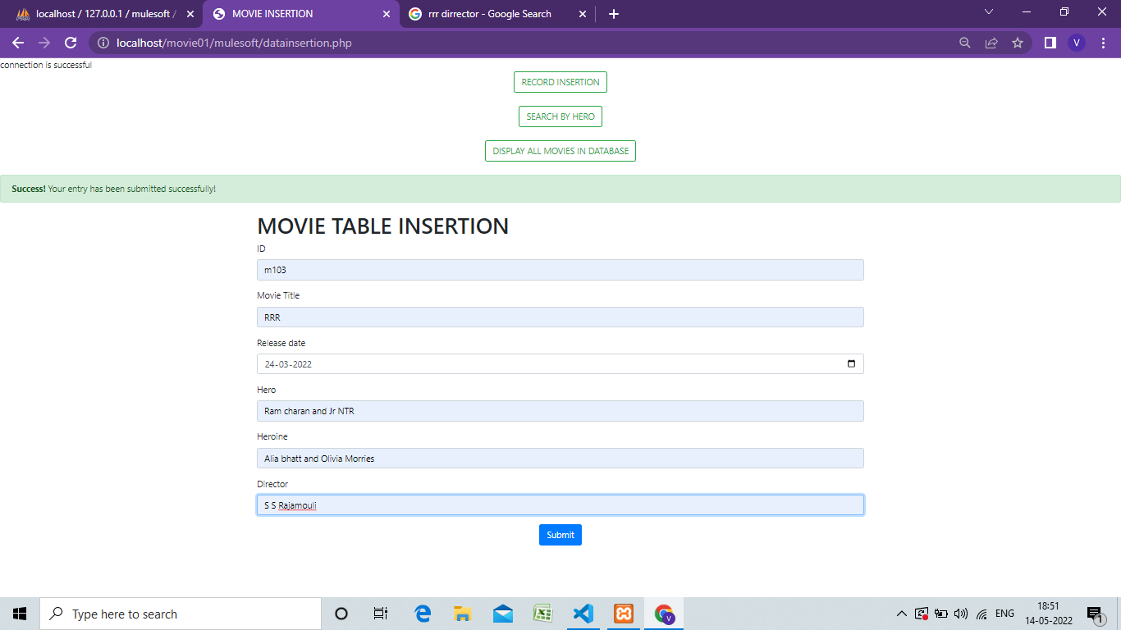

## Display all the records in the table.

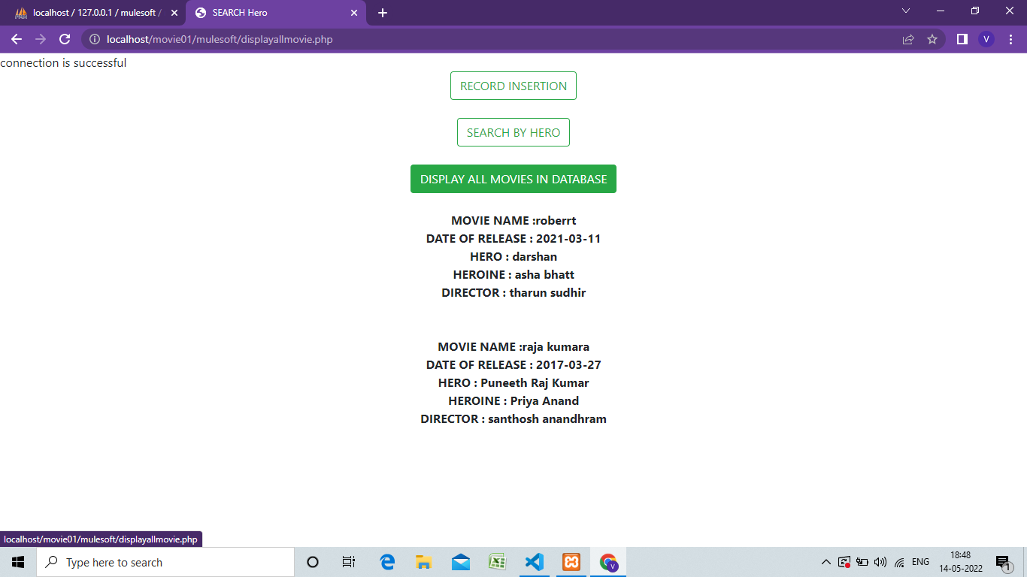

## Display the records where the hero name is same as user input .

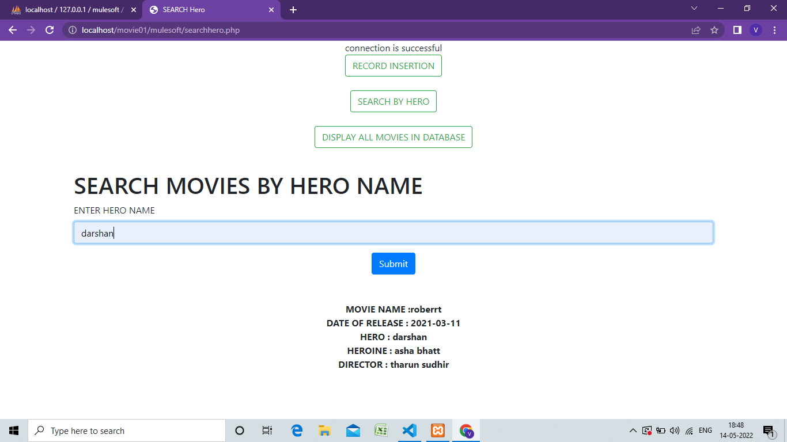

# INSTRUCTION :

* Download XAMPP .
* Create data base in phpmyadmin as mulesoft( if u want to create with another name that there is need to change the code in dbconnection.php )
* Create a table in mulesoft database with the name movie_db(if u want to create with another name then there is need of modification in searchhero.php , datainsertion.php and displayallmovie.php).
* Now database work is done and follow the remaining instruction for php code.
* Create a folder in (xampp->htdocs->new_foldername).
* In new_foldername keep all the php code.
* Open the local host and start to execute any of the code.