INTELLEXA.AI

-VISHAL KUMAR S

Sri Ramakrishana Engineering College

Problem Statement
• Extract data from a single Wikipedia page.
• Load the extracted data into a vector database (preferred) or use in-memory storage.
• Utilize a generative AI model to answer questions based on the loaded data.
• Implement the solution using Fast API.
• Create two Fast API endpoints:
- An endpoint for loading the Wikipedia data into the vector database.
- An endpoint for querying the generative AI model to generate answers from the stored data.

Objective
To design and implement a Python-based system that efficiently extracts data from a single Wikipedia page dynamically and loads it into a vector database. The system will leverage a generative AI model to answer user queries based on the loaded data. The solution will include two FastAPI endpoints to facilitate:
- Loading Wikipedia data into the vector database.
- Querying the generative AI model to provide relevant answers from the stored data.
This solution aims to demonstrate how AI models can be used for knowledge extraction and question-answering tasks with dynamic data inputs.

Modules

- Web Scraping
- Load to Vector Database
- Generative AI Model
- Creating Fast API

Web Scraping
In this process, BeautifulSoup, along with Python's requests library, is used to extract data directly from Wikipedia's web pages. This method involves sending HTTP requests to Wikipedia, retrieving the HTML of the desired page, and parsing the page to extract the relevant content.

Load to Vector Database
To load the extracted data from Wikipedia into a vector database, the extracted texts are converted into vectors (numerical representations) that is stored in a vector database for future querying. To convert these sentences into vector, sentence transformer such as sentence-transformers/all-MiniLM-L6-v2 is used for embeddings. These are then stored in MILVUS database.

Generative AI Model
After the vector database stores the Fast API representations (Fast API) of large text data, a generative AI model (Gemini 1.5-flash) is used to generate an answer to the user query. The retrieved context is combined with the user’s query to form a prompt that is passed to the generative AI model. The Gemini 1.5-flash model processes this prompt and generates a coherent, context-aware answer based on the provided information. The model’s pre-training enables it to understand the relationship between the question and the context, allowing it to generate an appropriate answer.

Fast API
The application consists of two main endpoints:
- Load Data Endpoint: This endpoint allows users to specify a Wikipedia URL from which data will be extracted, processed, and stored in a vector database.
- Query Endpoint: This endpoint accepts user questions and retrieves relevant information from the vector database to generate answers based on the previously loaded data..

Result:

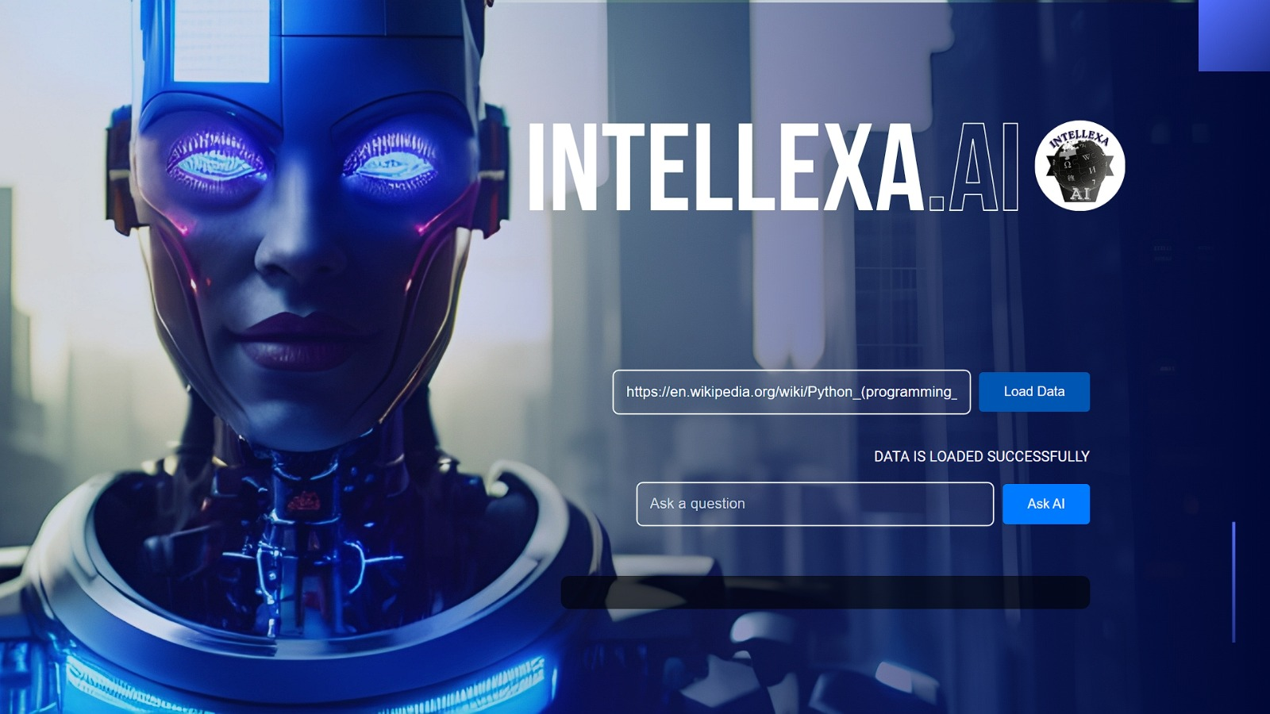

Fig 1.1 Fast API/load

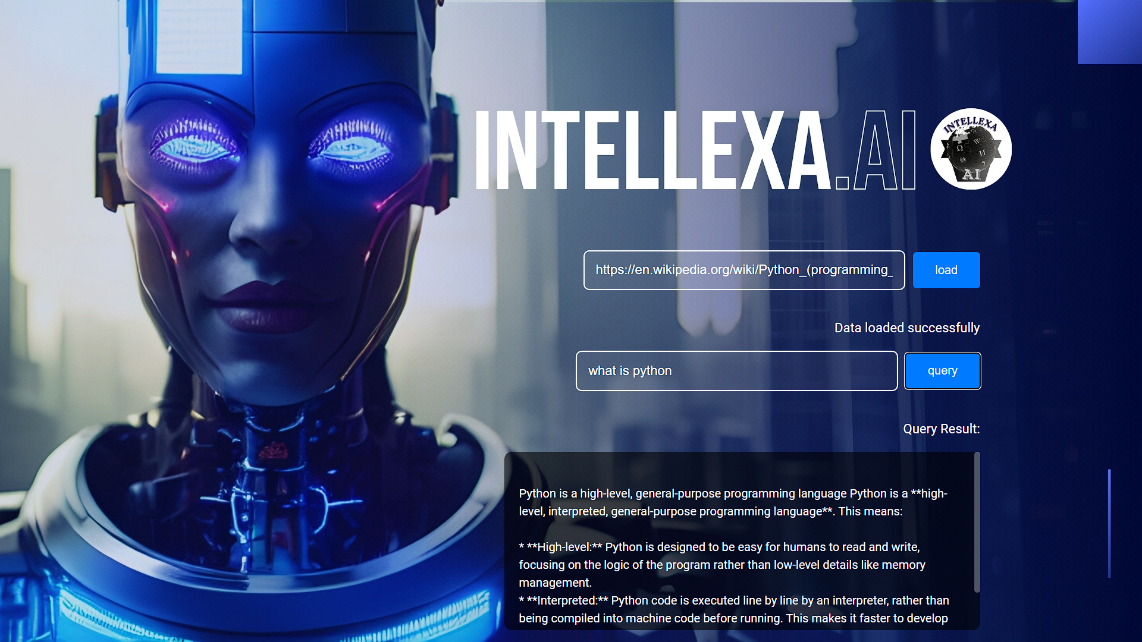

Fig 1.2 Fast API/query

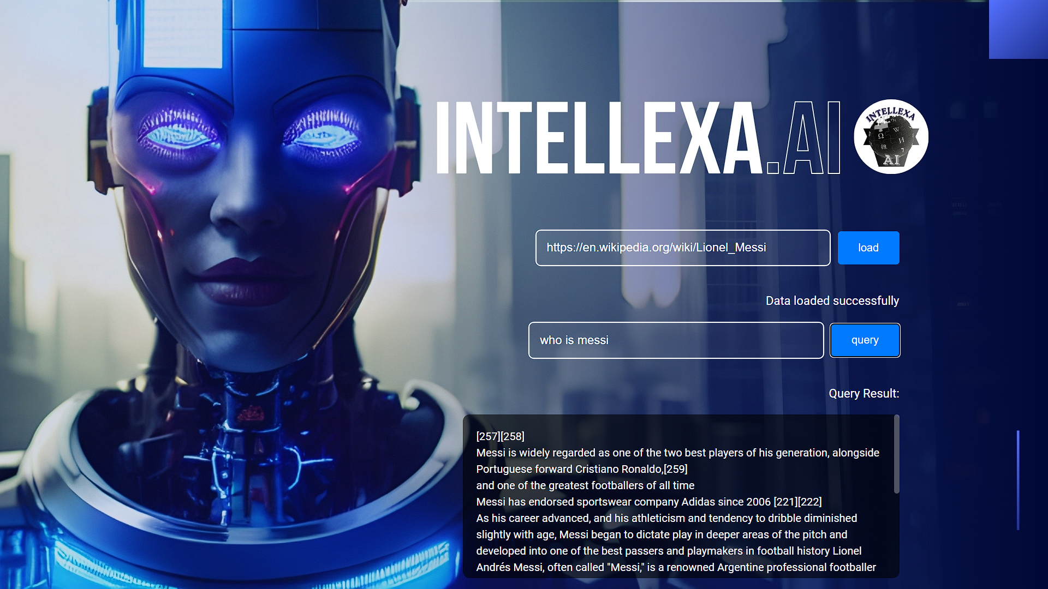

Fig 1.3 Another example

