Maven

Maven is a powerful project management tool that is based on POM (project object model). It is used for projects build, dependency and documentation.

Understanding the problem without Maven :

- Adding set of Jars in each project
- Creating right project structure
- Building and deploying the project

What it does?

Maven simplifies the above mentioned problems. It does mainly following tasks.

- It makes a project easy to build
- It provides uniform build process (maven project can be shared by all the maven projects)
- It provides project information (log document, cross referenced sources, mailing list, dependency list, unit test reports etc.)
- It is easy to migrate for new features of Maven

What is a build tool?

A build tool takes care of everything for building a process. It does following:

- Generates source code (if auto-generated code is used).
- Generates documentation from source code.
- Compiles source code.
- Packages compiled code into JAR of ZIP file.
- Installs the packaged code in local repository, server repository, or central repository.

Maven Repository

A maven repository is a directory of packaged jar file with pom.xml .Maven searches for dependencies in the repositories.

There are 3 types of maven repository:

- Local Repository
- Central Repository
- Remote Repository

Local Repository :
Maven local repository is located in your local system. It is created by the maven when you run any maven command.
By default, maven local repository is %USER_HOME%/.m2 directory. For example: C:\Users\SSS IT\.m2
Central Repository :
Maven central repository is located on the web. It has been created by the apache maven community itself.
The path of central repository is: http://repo1.maven.org/maven2/
The central repository contains a lot of common libraries that can be viewed by this url http://search.maven.org/#browse.
Remote Repository :
Maven remote repository is located on the web. Most of libraries can be missing from the central repository such as JBoss library etc, so we need to define remote repository in pom.xml file.

Dependency Management :
Dependency management is a mechanism to centralize the dependency information. In a multi-module project, you can specify in a parent project all the artifact version and it will be inherited by the child projects.
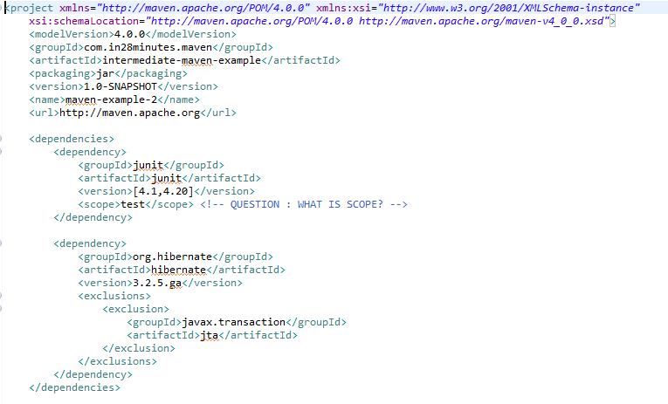

Settings.xml :
settings.xml is a file which provides all configuration for maven which internally referenced in your maven‘s project pom.xml file. When you add dependencies into pom.xml file maven internally downloads required .jar file and put it under the folder which is mentioned in settings.xml file.

What is pom.xml ?
The pom.xml file contains information of project and configuration information for the maven to build the project such as dependencies, build directory, source directory, test source directory, plugin, goals etc.
Types of POM :
Super POM:
All Maven project POM extend the Super POM, which defines a set of defaults shared by all projects. This Super POM is a part of the Maven installation.
Simplest POM:
All Maven POM s inherit defaults from the Super POM. If you are just writing a simple project that produces a JAR from some source in src/main/java, want to run your JUnit tests in src/test/java, and want to build a project site using mvn site, you don’t have to customize anything. All you would need, in this case, is the simplest possible POM shown in The Simplest POM. This POM defines a groupId, artifactId, and version: the three required coordinates for every project.
Effective POM:
The Effective POM refers the merge between the Super POM and the POM from The Simplest POM.

Plugins:
Plugins are the central feature of Maven that allow for the reuse of common build logic across multiple projects. They do this by executing an "action" (i.e. creating a WAR file or compiling unit tests) in the context of a project's description - the Project Object Model (POM).
According to Apache Maven, there are 2 types of maven plugins.
- Build plugins
- Reporting plugins

Build Plugins:
These plugins are executed at the time of build. These plugins should be declared inside the <build> element.
Reporting plugins:

These plugins are executed at the time of site generation. These plugins should be declared inside the <reporting> element.

Uber Jar:

Uber Jar is a JAR file that contains not only a Java program, but embeds its dependencies as well. This means that the JAR functions as an "all-in-one" distribution of the software, without needing any other Java code.

