**Java**

Java is a programming language and a platform. It is high level robust, object-oriented and secure programming language.

**Platform**: Any hardware or software in which a program runs, is known as a platform. Since java has a runtime environment (JRE) and API, it is called as a Platform.

**Object-Oriented**:

Java is object-oriented program language. Everything in java is an object. Object oriented means we organize our software as a combination of different types of objects that incorporates both data and behavior.

Object-oriented programming (OOPs) is a methodology that simplifies software development and maintenance by providing some rules.

**Platform Independent:**

Java is platform independent because it is different from other languages like [C](https://www.javatpoint.com/c-programming-language-tutorial), [C++](https://www.javatpoint.com/cpp-tutorial), etc. which are compiled into platform specific machines while Java is a write once, run anywhere language. A platform is the hardware or software environment in which a program runs.

There are two types of platforms software-based and hardware-based. Java provides a software-based platform.

The Java platform differs from most other platforms in the sense that it is a software-based platform that runs on the top of other hardware-based platforms. It has two components:

1. Runtime Environment
2. API(Application Programming Interface)

Java code can be run on multiple platforms, for example, Windows, Linux, Sun Solaris, Mac/OS, etc. Java code is compiled by the compiler and converted into bytecode. This bytecode is a platform-independent code because it can be run on multiple platforms, i.e., Write Once and Run Anywhere(WORA).

**Operator Overloading**: If we create two or more members having the same name but different in number or type of parameter, it is known as opeartor overloading.

JVM

JVM (Java Virtual Machine) is an abstract machine. It is called a virtual machine because it doesn't physically exist. It is a specification that provides a runtime environment in which Java bytecode can be executed. It can also run those programs which are written in other languages and compiled to Java bytecode.

JVMs are available for many hardware and software platforms. JVM, JRE, and JDK are platform dependent because the configuration of each [OS](https://www.javatpoint.com/os-tutorial) is different from each other. However, Java is platform independent.

JRE

JRE is an acronym for Java Runtime Environment. It is also written as Java RTE. The Java Runtime Environment is a set of software tools which are used for developing Java applications. It is used to provide the runtime environment. It is the implementation of JVM. It physically exists. It contains a set of libraries + other files that JVM uses at runtime.

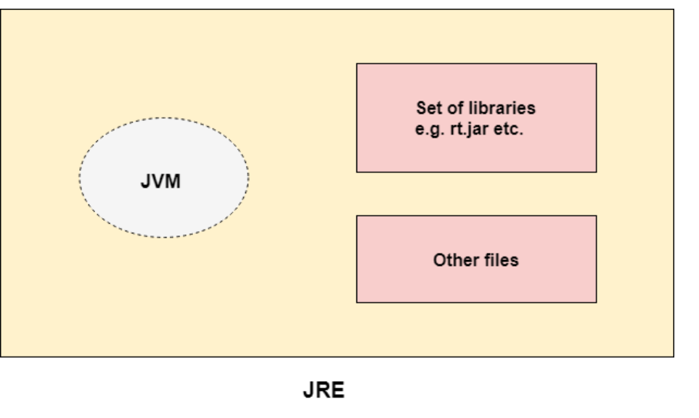

**JDK**

JDK is an acronym for Java Development Kit. The Java Development Kit (JDK) is a software development environment which is used to develop Java applications and [applets](https://www.javatpoint.com/java-applet). It physically exists. It contains JRE + development tools.

JDK is an implementation of any one of the below given Java Platforms released by Oracle Corporation:

* Standard Edition Java Platform
* Enterprise Edition Java Platform
* Micro Edition Java Platform

The JDK contains a private Java Virtual Machine (JVM) and a few other resources such as an interpreter/loader (java), a compiler (javac), an archiver (jar), a documentation generator (Javadoc), etc. to complete the development of a Java Application.

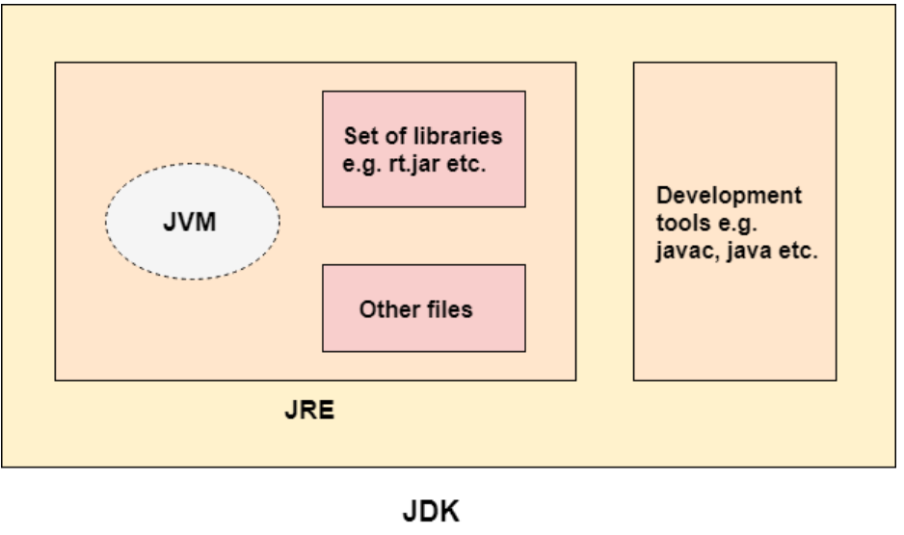

# **Java Variables**

A variable is a container which holds the value while the [Java program](https://www.javatpoint.com/simple-program-of-java) is executed. A variable is assigned with a data type.

Variable is a name of memory location. There are three types of variables in java: local, instance and static.

There are two types of [data types in Java](https://www.javatpoint.com/java-data-types): primitive and non-primitive.

## **Variable**

**Variable** is name of reserved area allocated in memory. In other words, it is a name of memory location. It is a combination of "vary + able" that means its value can be changed.

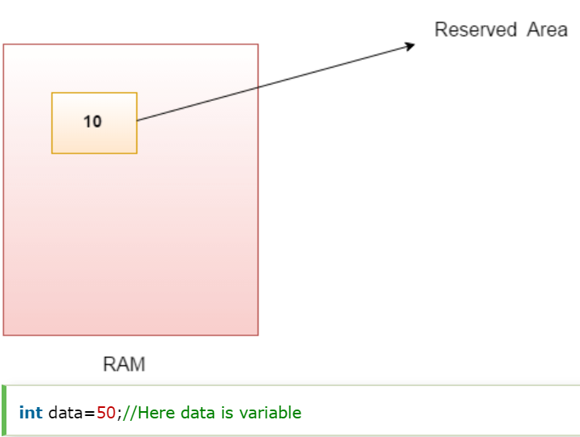

Types of Variables

There are three types of variables in [Java](https://www.javatpoint.com/java-tutorial):

* local variable
* instance variable
* static variable

#### **1) Local Variable**

A variable declared inside the body of the method is called local variable. You can use this variable only within that method and the other methods in the class aren't even aware that the variable exists.

A local variable cannot be defined with "static" keyword.

#### **2) Instance Variable**

A variable declared inside the class but outside the body of the method, is called instance variable. It is not declared as [static](https://www.javatpoint.com/static-keyword-in-java).

It is called instance variable because its value is instance specific and is not shared among instances.

#### **3) Static variable**

A variable which is declared as static is called static variable. It cannot be local. You can create a single copy of static variable and share among all the instances of the class. Memory allocation for static variable happens only once when the class is loaded in the memory.

1. **class** A{
2. **int** data=50;//instance variable
3. **static** **int** m=100;//static variable
4. **void** method(){
5. **int** n=90;//local variable
6. }
7. }//end of class

# **Data Types in Java**

Data types specify the different sizes and values that can be stored in the variable. There are two types of data types in Java:

1. **Primitive data types:** The primitive data types include boolean, char, byte, short, int, long, float and double.
2. **Non-primitive data types:** The non-primitive data types include [Classes](https://www.javatpoint.com/object-and-class-in-java), [Interfaces](https://www.javatpoint.com/interface-in-java), and [Arrays](https://www.javatpoint.com/array-in-java).

## **Java Primitive Data Types**

In Java language, primitive data types are the building blocks of data manipulation.

Java is a statically-typed programming language. It means, all [variables](https://www.javatpoint.com/java-variables) must be declared before its use. That is why we need to declare variable's type and name.

There are 8 types of primitive data types:

* boolean data type
* byte data type
* char data type
* short data type
* int data type
* long data type
* float data type
* double data type

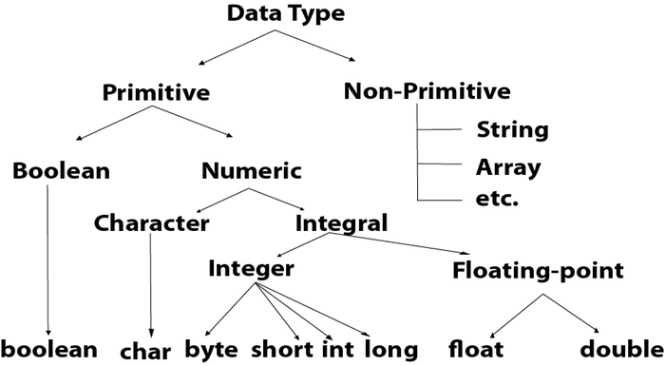

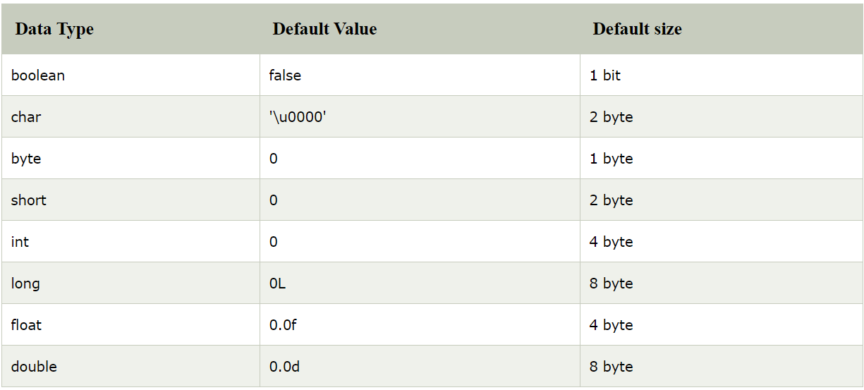

# **Operators in Java**

**Operator** in [Java](https://www.javatpoint.com/java-tutorial) is a symbol which is used to perform operations. For example: +, -, *, / etc.

There are many types of operators in Java which are given below:

* Unary Operator,
* Arithmetic Operator,
* Shift Operator,
* Relational Operator,
* Bitwise Operator,
* Logical Operator,
* Ternary Operator and
* Assignment Operator.

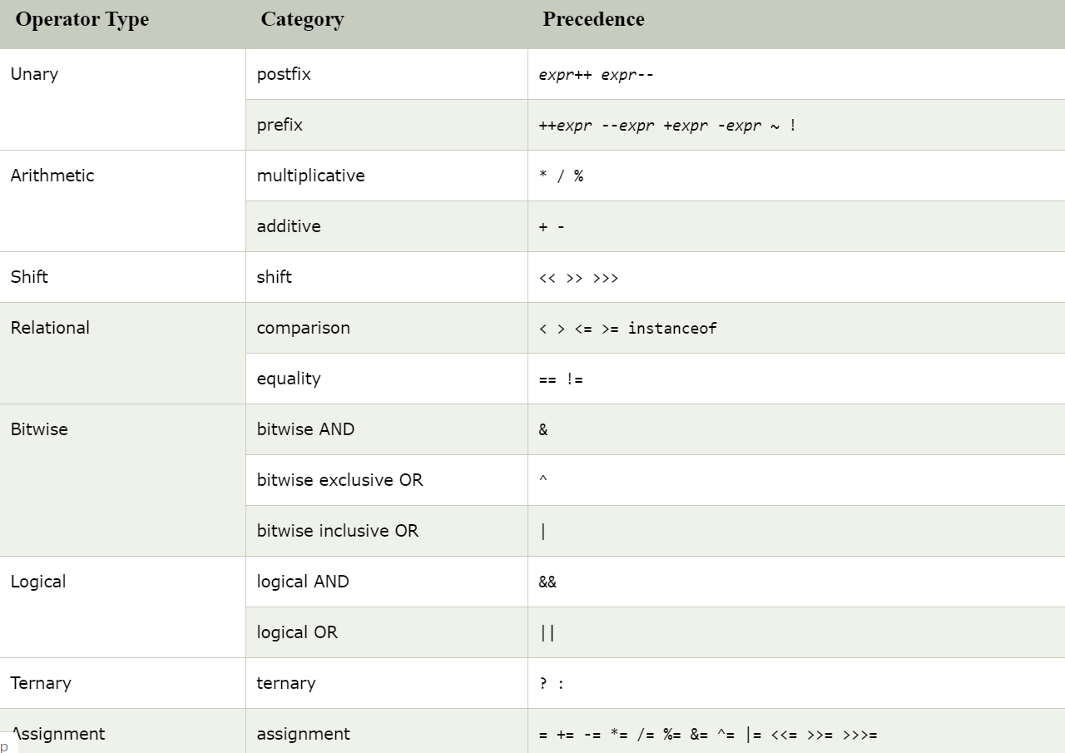

# **Java Keywords**

**Java keywords** are also known as **reserved words**. Keywords are particular words which acts as a key to a code. These are predefined words by Java so it cannot be used as a variable or object name.

## **List of Java Keywords**

A list of Java keywords or reserved words are given below:

1. [**abstract**](https://www.javatpoint.com/abstract-keyword-in-java)**:** Java abstract keyword is used to declare abstract class. Abstract class can provide the implementation of interface. It can have abstract and non-abstract methods.
2. [**boolean:**](https://www.javatpoint.com/boolean-keyword-in-java) Java boolean keyword is used to declare a variable as a boolean type. It can hold True and False values only.
3. [**break**](https://www.javatpoint.com/java-break)**:** Java break keyword is used to break loop or switch statement. It breaks the current flow of the program at specified condition.
4. [**byte**](https://www.javatpoint.com/byte-keyword-in-java)**:** Java byte keyword is used to declare a variable that can hold an 8-bit data values.
5. [**case**](https://www.javatpoint.com/case-keyword-in-java)**:** Java case keyword is used to with the switch statements to mark blocks of text.
6. [**catch**](https://www.javatpoint.com/try-catch-block)**:** Java catch keyword is used to catch the exceptions generated by try statements. It must be used after the try block only.
7. [**char**](https://www.javatpoint.com/char-keyword-in-java)**:** Java char keyword is used to declare a variable that can hold unsigned 16-bit Unicode characters
8. [**class**](https://www.javatpoint.com/class-keyword-in-java)**:** Java class keyword is used to declare a class.
9. [**continue**](https://www.javatpoint.com/java-continue)**:** Java continue keyword is used to continue the loop. It continues the current flow of the program and skips the remaining code at the specified condition.
10. [**default**](https://www.javatpoint.com/default-keyword-in-java)**:** Java default keyword is used to specify the default block of code in a switch statement.
11. [**do**](https://www.javatpoint.com/java-do-while-loop)**:** Java do keyword is used in control statement to declare a loop. It can iterate a part of the program several times.
12. [**double**](https://www.javatpoint.com/double-keyword-in-java)**:** Java double keyword is used to declare a variable that can hold a 64-bit floating-point numbers.
13. [**else**](https://www.javatpoint.com/java-if-else)**:** Java else keyword is used to indicate the alternative branches in an if statement.
14. [**enum**](https://www.javatpoint.com/enum-in-java)**:** Java enum keyword is used to define a fixed set of constants. Enum constructors are always private or default.
15. [**extends**](https://www.javatpoint.com/inheritance-in-java)**:** Java extends keyword is used to indicate that a class is derived from another class or interface.
16. [**final**](https://www.javatpoint.com/final-keyword)**:** Java final keyword is used to indicate that a variable holds a constant value. It is applied with a variable. It is used to restrict the user.
17. [**finally**](https://www.javatpoint.com/finally-block-in-exception-handling)**:** Java finally keyword indicates a block of code in a try-catch structure. This block is always executed whether exception is handled or not.
18. [**float**](https://www.javatpoint.com/float-keyword-in-java)**:** Java float keyword is used to declare a variable that can hold a 32-bit floating-point number.
19. [**for**](https://www.javatpoint.com/java-for-loop)**:** Java for keyword is used to start a for loop. It is used to execute a set of instructions/functions repeatedly when some conditions become true. If the number of iteration is fixed, it is recommended to use for loop.
20. [**if**](https://www.javatpoint.com/java-if-else)**:** Java if keyword tests the condition. It executes the if block if condition is true.
21. [**implements**](https://www.javatpoint.com/interface-in-java)**:** Java implements keyword is used to implement an interface.
22. [**import**](https://www.javatpoint.com/package)**:** Java import keyword makes classes and interfaces available and accessible to the current source code.
23. [**instanceof**](https://www.javatpoint.com/downcasting-with-instanceof-operator)**:** Java instanceof keyword is used to test whether the object is an instance of the specified class or implements an interface.
24. [**int**](https://www.javatpoint.com/int-keyword-in-java)**:** Java int keyword is used to declare a variable that can hold a 32-bit signed integer.
25. [**interface**](https://www.javatpoint.com/interface-in-java)**:** Java interface keyword is used to declare an interface. It can have only abstract methods.
26. [**long**](https://www.javatpoint.com/long-keyword-in-java)**:** Java long keyword is used to declare a variable that can hold a 64-bit integer.
27. **native:** Java native keyword is used to specify that a method is implemented in native code using JNI (Java Native Interface).
28. [**new**](https://www.javatpoint.com/new-keyword-in-java)**:** Java new keyword is used to create new objects.
29. [**null**](https://www.javatpoint.com/null-keyword-in-java)**:** Java null keyword is used to indicate that a reference does not refer to anything. It removes the garbage value.
30. [**package**](https://www.javatpoint.com/package)**:** Java package keyword is used to declare a Java package that includes the classes.
31. [**private**](https://www.javatpoint.com/private-keyword-in-java)**:** Java private keyword is an access modifier. It is used to indicate that a method or variable may be accessed only in the class in which it is declared.
32. [**protected**](https://www.javatpoint.com/protected-keyword-in-java)**:** Java protected keyword is an access modifier. It can be accessible within package and outside the package but through inheritance only. It can't be applied on the class.
33. [**public**](https://www.javatpoint.com/public-keyword-in-java)**:** Java public keyword is an access modifier. It is used to indicate that an item is accessible anywhere. It has the widest scope among all other modifiers.
34. [**return**](https://www.javatpoint.com/return-keyword-in-java)**:** Java return keyword is used to return from a method when its execution is complete.
35. [**short**](https://www.javatpoint.com/short-keyword-in-java)**:** Java short keyword is used to declare a variable that can hold a 16-bit integer.
36. [**static**](https://www.javatpoint.com/static-keyword-in-java)**:** Java static keyword is used to indicate that a variable or method is a class method. The static keyword in Java is used for memory management mainly.
37. [**strictfp**](https://www.javatpoint.com/strictfp-keyword)**:** Java strictfp is used to restrict the floating-point calculations to ensure portability.
38. [**super**](https://www.javatpoint.com/super-keyword)**:** Java super keyword is a reference variable that is used to refer parent class object. It can be used to invoke immediate parent class method.
39. [**switch**](https://www.javatpoint.com/java-switch)**:** The Java switch keyword contains a switch statement that executes code based on test value. The switch statement tests the equality of a variable against multiple values.
40. [**synchronized**](https://www.javatpoint.com/synchronization-in-java)**:** Java synchronized keyword is used to specify the critical sections or methods in multithreaded code.
41. [**this**](https://www.javatpoint.com/this-keyword)**:** Java this keyword can be used to refer the current object in a method or constructor.
42. [**throw**](https://www.javatpoint.com/throw-keyword)**:** The Java throw keyword is used to explicitly throw an exception. The throw keyword is mainly used to throw custom exception. It is followed by an instance.
43. [**throws**](https://www.javatpoint.com/throws-keyword-and-difference-between-throw-and-throws)**:** The Java throws keyword is used to declare an exception. Checked exception can be propagated with throws.
44. [**transient**](https://www.javatpoint.com/transient-keyword)**:** Java transient keyword is used in serialization. If you define any data member as transient, it will not be serialized.
45. [**try**](https://www.javatpoint.com/try-catch-block)**:** Java try keyword is used to start a block of code that will be tested for exceptions. The try block must be followed by either catch or finally block.
46. **void:** Java void keyword is used to specify that a method does not have a return value.
47. [**volatile**](https://www.javatpoint.com/volatile-keyword-in-java)**:** Java volatile keyword is used to indicate that a variable may change asynchronously.
48. [**while**](https://www.javatpoint.com/java-while-loop)**:** Java while keyword is used to start a while loop. This loop iterates a part of the program several times. If the number of iteration is not fixed, it is recommended to use while loop.

# **Java Switch Statement**

The Java switch statement executes one statement from multiple conditions. It is like [if-else-if](https://www.javatpoint.com/java-if-else) ladder statement. The switch statement works with byte, short, int, long, enum types, String and some wrapper types like Byte, Short, Int, and Long. Since Java 7, you can use [strings](https://www.javatpoint.com/java-string) in the switch statement.

In other words, the switch statement tests the equality of a variable against multiple values.

#### **Points to Remember**

* There can be one or N number of case values for a switch expression.
* The case value must be of switch expression type only. The case value must be literal or constant. It doesn't allow [variables](https://www.javatpoint.com/java-variables).
* The case values must be unique. In case of duplicate value, it renders compile-time error.
* The Java switch expression must be of byte, short, int, long (with its Wrapper type), *[enums](https://www.javatpoint.com/java-switch)* and string.
* Each case statement can have a break statement which is optional. When control reaches to the [break statement](https://www.javatpoint.com/java-break), it jumps the control after the switch expression. If a break statement is not found, it executes the next case.
* The case value can have a default label which is optional.

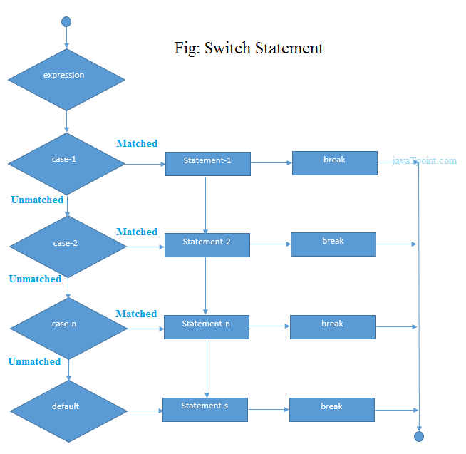

**Example:**

1. **public** **class** SwitchExample {
2. **public** **static** **void** main(String[] args) {
3. //Declaring a variable for switch expression
4. **int** number=20;
5. //Switch expression
6. **switch**(number){
7. //Case statements
8. **case** 10: System.out.println("10");
9. **break**;
10. **case** 20: System.out.println("20");
11. **break**;
12. **case** 30: System.out.println("30");
13. **break**;
14. //Default case statement
15. **default**:System.out.println("Not in 10, 20 or 30");
16. }
17. }
18. }

# **Loops in Java**

In programming languages, loops are used to execute a set of instructions/functions repeatedly when some conditions become true. There are three types of loops in Java.

* for loop
* [while loop](https://www.javatpoint.com/java-while-loop)
* [do-while loop](https://www.javatpoint.com/java-do-while-loop)

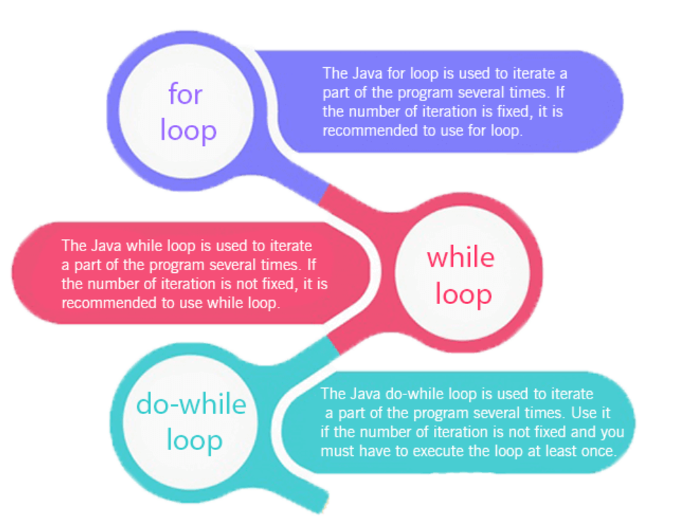

# **Java For Loop**

The Java for loop is used to iterate a part of the program several times. If the number of iteration is fixed, it is recommended to use for loop.

There are three types of for loops in java.

* Simple For Loop
* [For-each](https://www.javatpoint.com/for-each-loop) or Enhanced For Loop
* Labeled For Loop

## **Java Simple For Loop**

A simple for loop is the same as [C](https://www.javatpoint.com/c-programming-language-tutorial)/[C++](https://www.javatpoint.com/cpp-tutorial). We can initialize the [variable](https://www.javatpoint.com/java-variables), check condition and increment/decrement value. It consists of four parts:

1. **Initialization**: It is the initial condition which is executed once when the loop starts. Here, we can initialize the variable, or we can use an already initialized variable. It is an optional condition.
2. **Condition**: It is the second condition which is executed each time to test the condition of the loop. It continues execution until the condition is false. It must return boolean value either true or false. It is an optional condition.
3. **Statement**: The statement of the loop is executed each time until the second condition is false.
4. **Increment/Decrement**: It increments or decrements the variable value. It is an optional condition.

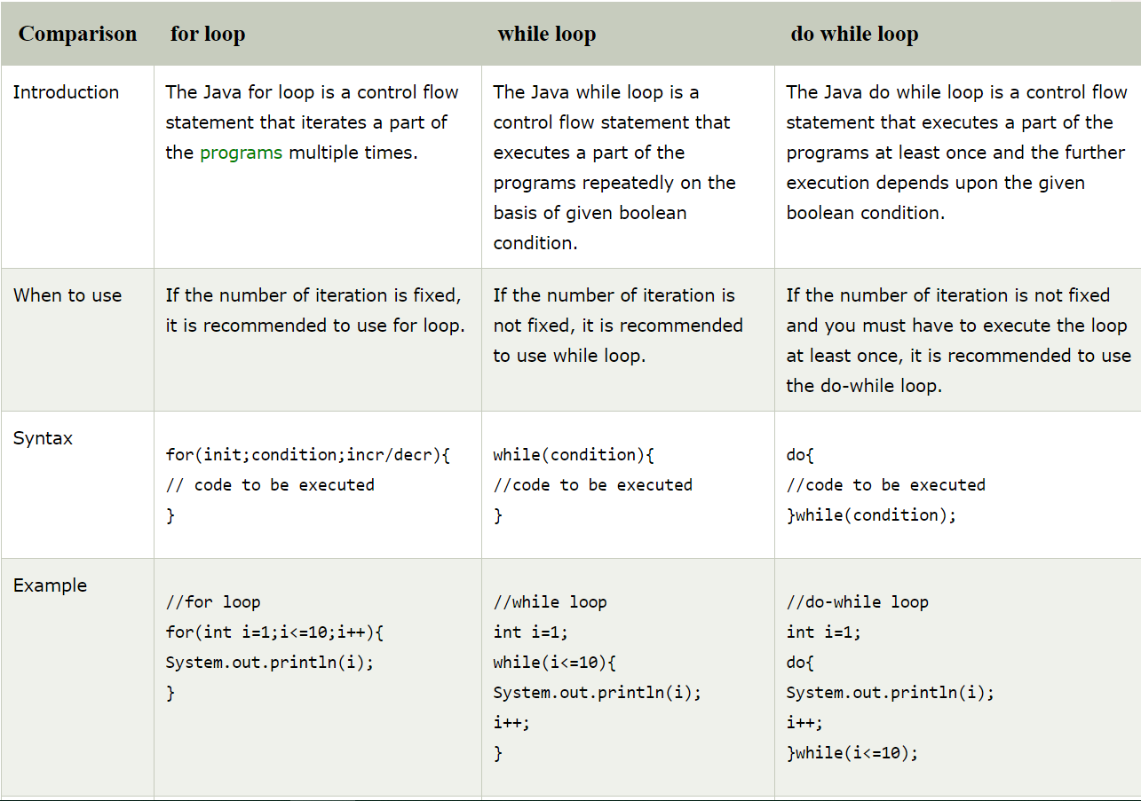

# **Java While Loop**

The [Java](https://www.javatpoint.com/java-tutorial) while loop is used to iterate a part of the [program](https://www.javatpoint.com/programs-list) several times. If the number of iteration is not fixed, it is recommended to use while [loop](https://www.javatpoint.com/java-for-loop).

Syntax:

1. **while**(condition){
2. //code to be executed
3. }

# **Java do-while Loop**

The Java do-while loop is used to iterate a part of the program several times. If the number of iteration is not fixed and you must have to execute the loop at least once, it is recommended to use do-while loop.

The Java do-while loop is executed at least once because condition is checked after loop body.

Syntax:

1. **do**{
2. //code to be executed
3. }**while**(condition)

# **Java Break Statement**

When a break statement is encountered inside a loop, the loop is immediately terminated and the program control resumes at the next statement following the loop.

The Java break statement is used to break loop or [switch](https://www.javatpoint.com/java-switch) statement. It breaks the current flow of the program at specified condition. In case of inner loop, it breaks only inner loop.

# **Java Continue Statement**

The continue statement is used in loop control structure when you need to jump to the next iteration of the loop immediately. It can be used with for loop or while loop.

The Java continue statement is used to continue the loop. It continues the current flow of the program and skips the remaining code at the specified condition. In case of an inner loop, it continues the inner loop only.

# **Java OOPs Concepts**

**Object** means a real-world entity such as a pen, chair, table, computer, watch, etc. **Object-Oriented Programming** is a methodology or paradigm to design a program using classes and objects. It simplifies software development and maintenance by providing some concepts:

* [Object](https://www.javatpoint.com/object-and-class-in-java)
* Class
* [Inheritance](https://www.javatpoint.com/inheritance-in-java)
* [Polymorphism](https://www.javatpoint.com/runtime-polymorphism-in-java)
* [Abstraction](https://www.javatpoint.com/abstract-class-in-java)
* [Encapsulation](https://www.javatpoint.com/encapsulation)

Apart from these concepts, there are some other terms which are used in Object-Oriented design:

* Coupling
* Cohesion
* Association
* Aggregation
* Composition

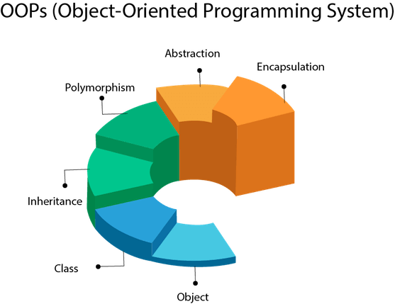

**Object:**

Any entity that has state and behavior is known as an object. An Object can be defined as an instance of a class. An object contains an address and takes up some space in memory.

## **Class**

Collection of objects is called class. It is a logical entity.

A class can also be defined as a blueprint from which you can create an individual object. Class doesn't consume any space.

### Inheritance

When one object acquires all the properties and behaviors of a parent object, it is known as inheritance. It provides code reusability. It is used to achieve runtime polymorphism.

### Polymorphism

If *one task is performed in different ways*, it is known as polymorphism. For example: to convince the customer differently, to draw something, for example, shape, triangle, rectangle, etc.

In Java, we use method overloading and method overriding to achieve polymorphism.

**Types of Polymorphism**

Overloading is **compile time polymorphism** where more than one methods share the same name with different parameters or signature and different return type. Overriding is run **time polymorphism** having same method with same parameters or signature, but associated in a class & its subclass.

#### **Abstraction**

Hiding internal details and showing functionality is known as abstraction. For example phone call, we don't know the internal processing.

In Java, we use abstract class and interface to achieve abstraction.

### Encapsulation

Binding (or wrapping) code and data together into a single unit are known as encapsulation. For example, a capsule, it is wrapped with different medicines.

A java class is the example of encapsulation. Java bean is the fully encapsulated class because all the data members are private here.

# **Objects and Classes in Java**

An entity that has state and behavior is known as an object e.g., chair, bike, marker, pen, table, car, etc. It can be physical or logical (tangible and intangible). The example of an intangible object is the banking system.

An object has three characteristics:

* **State:** represents the data (value) of an object.
* **Behavior:** represents the behavior (functionality) of an object such as deposit, withdraw, etc.
* **Identity:** An object identity is typically implemented via a unique ID. The value of the ID is not visible to the external user. However, it is used internally by the JVM to identify each object uniquely.

**An object is an instance of a class.** A class is a template or blueprint from which objects are created. So, an object is the instance(result) of a class.

**Object Definitions:**

* An object is *a real-world entity*.
* An object is *a runtime entity*.
* The object is *an entity which has state and behavior*.
* The object is *an instance of a class*.

## **What is a class in Java**

A class is a group of objects which have common properties. It is a template or blueprint from which objects are created. It is a logical entity. It can't be physical.

A class in Java can contain:

* **Fields**
* **Methods**
* **Constructors**
* **Blocks**
* **Nested class and interface**

### Instance variable in Java

A variable which is created inside the class but outside the method is known as an instance variable. Instance variable doesn't get memory at compile time. It gets memory at runtime when an object or instance is created. That is why it is known as an instance variable.

### Method in Java

In Java, a method is like a function which is used to expose the behavior of an object.

#### **Advantage of Method**

* Code Reusability
* Code Optimization

# **Constructors in Java**

In [Java](https://www.javatpoint.com/java-tutorial), a constructor is a block of codes similar to the method. It is called when an instance of the [class](https://www.javatpoint.com/object-and-class-in-java) is created. At the time of calling constructor, memory for the object is allocated in the memory.

It is a special type of method which is used to initialize the object.

Every time an object is created using the new() keyword, at least one constructor is called.

It calls a default constructor if there is no constructor available in the class. In such case, Java compiler provides a default constructor by default.

There are two types of constructors in Java: no-arg constructor, and parameterized constructor.

**Note:** It is called constructor because it constructs the values at the time of object creation. It is not necessary to write a constructor for a class. It is because java compiler creates a default constructor if your class doesn't have any.

Rules for creating Java constructor

There are two rules defined for the constructor.

1. Constructor name must be the same as its class name
2. A Constructor must have no explicit return type
3. A Java constructor cannot be abstract, static, final, and synchronized

#### **Note: We can use**[**access modifiers**](https://www.javatpoint.com/access-modifiers)**while declaring a constructor. It controls the object creation. In other words, we can have private, protected, public or default constructor in Java**

### Q) What is the purpose of a default constructor?

The default constructor is used to provide the default values to the object like 0, null, etc., depending on the type.

# **Java static keyword**

The **static keyword** in [Java](https://www.javatpoint.com/java-tutorial) is used for memory management mainly. We can apply static keyword with [variables](https://www.javatpoint.com/java-variables), methods, blocks and [nested classes](https://www.javatpoint.com/java-inner-class). The static keyword belongs to the class than an instance of the class.

The static can be:

1. Variable (also known as a class variable)
2. Method (also known as a class method)
3. Block
4. Nested class

## **1) Java static variable**

If you declare any variable as static, it is known as a static variable.

* The static variable can be used to refer to the common property of all objects (which is not unique for each object), for example, the company name of employees, college name of students, etc.
* The static variable gets memory only once in the class area at the time of class loading.

## **2) Java static method**

If you apply static keyword with any method, it is known as static method.

* A static method belongs to the class rather than the object of a class.
* A static method can be invoked without the need for creating an instance of a class.
* A static method can access static data member and can change the value of it.

Restrictions for the static method

There are two main restrictions for the static method. They are:

1. The static method can not use non static data member or call non-static method directly.
2. this and super cannot be used in static context.

### Q) Why is the Java main method static?

Ans) It is because the object is not required to call a static method. If it were a non-static method, [JVM](https://www.javatpoint.com/jvm-java-virtual-machine) creates an object first then call main() method that will lead the problem of extra memory allocation.

## **Java static block**

* Is used to initialize the static data member.
* It is executed before the main method at the time of classloading.

# **this keyword in java**

There can be a lot of usage of **java this keyword**. In java, this is a **reference variable** that refers to the current object.

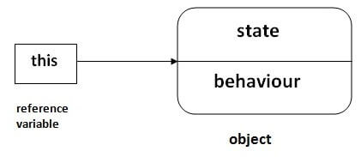

## **Usage of java this keyword**

Here is given the 6 usage of java this keyword.

1. this can be used to refer current class instance variable.
2. this can be used to invoke current class method (implicitly)
3. this() can be used to invoke current class constructor.
4. this can be passed as an argument in the method call.
5. this can be passed as argument in the constructor call.
6. this can be used to return the current class instance from the method.

### this: to refer current class instance variable

The this keyword can be used to refer current class instance variable. If there is ambiguity between the instance variables and parameters, this keyword resolves the problem of ambiguity.

### this: to invoke current class method

You may invoke the method of the current class by using the this keyword. If you don't use the this keyword, compiler automatically adds this keyword while invoking the method

### this() : to invoke current class constructor

The this() constructor call can be used to invoke the current class constructor. It is used to reuse the constructor. In other words, it is used for constructor chaining.

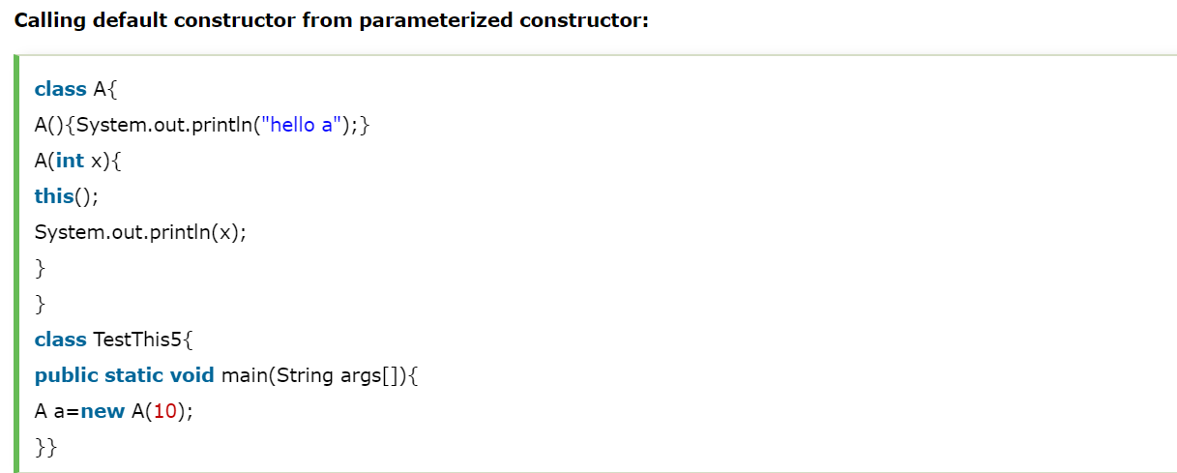

OUTPUT :

hello a

10

# **Inheritance in Java**

**Inheritance in Java** is a mechanism in which one object acquires all the properties and behaviors of a parent object. It is an important part of [OOPs](https://www.javatpoint.com/java-oops-concepts) (Object Oriented programming system).

The idea behind inheritance in Java is that you can create new [classes](https://www.javatpoint.com/object-and-class-in-java) that are built upon existing classes. When you inherit from an existing class, you can reuse methods and fields of the parent class. Moreover, you can add new methods and fields in your current class also.

Inheritance represents the **IS-A relationship** which is also known as a parent-child relationship.

### Terms used in Inheritance

* **Class:** A class is a group of objects which have common properties. It is a template or blueprint from which objects are created.
* **Sub Class/Child Class:** Subclass is a class which inherits the other class. It is also called a derived class, extended class, or child class.
* **Super Class/Parent Class:** Superclass is the class from where a subclass inherits the features. It is also called a base class or a parent class.
* **Reusability:** As the name specifies, reusability is a mechanism which facilitates you to reuse the fields and methods of the existing class when you create a new class.

The **extends keyword** indicates that you are making a new class that derives from an existing class. The meaning of "extends" is to increase the functionality.

In the terminology of Java, a class which is inherited is called a parent or superclass, and the new class is called child .

## **Types of inheritance in java**

On the basis of class, there can be three types of inheritance in java: single, multilevel and hierarchical.

In java programming, multiple and hybrid inheritance is supported through interface only. We will learn about interfaces later.

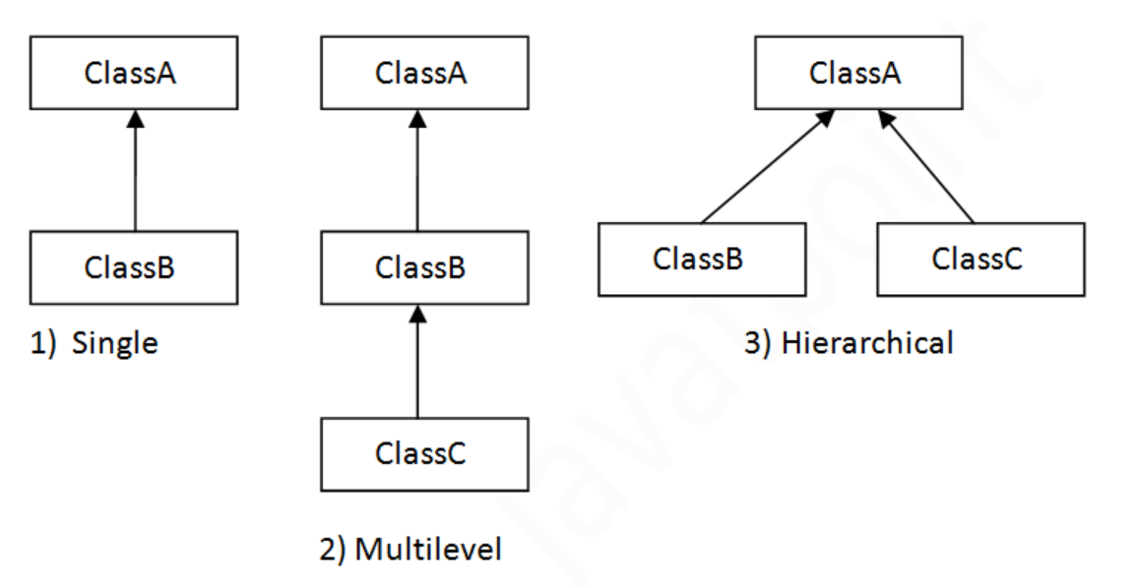

#### **Note: Multiple inheritance is not supported in Java through class.**

When one class inherits multiple classes, it is known as multiple inheritance.

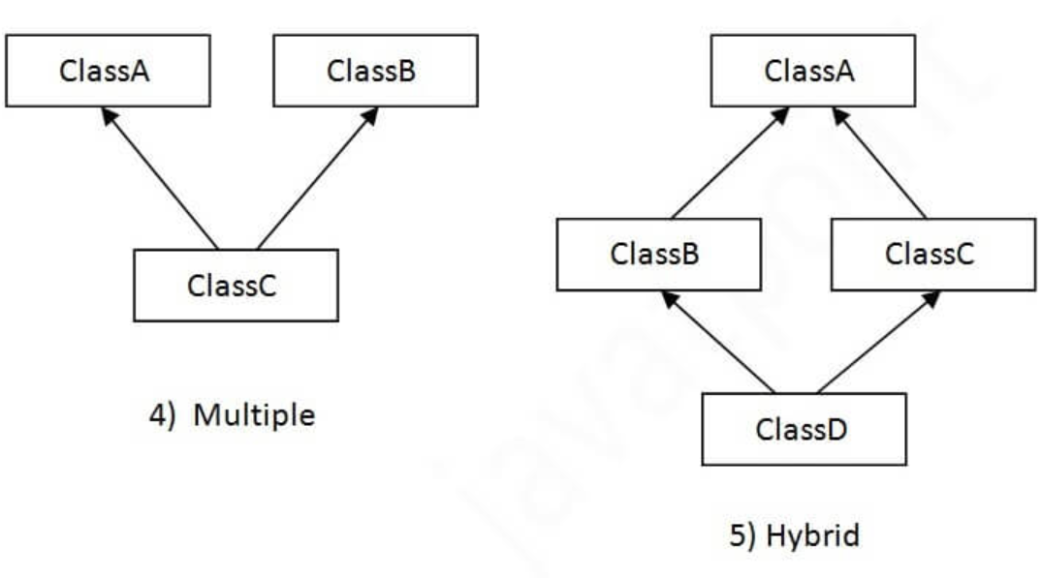

## **Q) Why multiple inheritance is not supported in java?**

To reduce the complexity and simplify the language, multiple inheritance is not supported in java.

Consider a scenario where A, B, and C are three classes. The C class inherits A and B classes. If A and B classes have the same method and you call it from child class object, there will be ambiguity to call the method of A or B class.

Since compile-time errors are better than runtime errors, Java renders compile-time error if you inherit 2 classes. So whether you have same method or different, there will be compile time error.

# **Method Overloading in Java**

If a [class](https://www.javatpoint.com/object-and-class-in-java) has multiple methods having same name but different in parameters, it is known as **Method Overloading**.

If we have to perform only one operation, having same name of the methods increases the readability of the [program](https://www.javatpoint.com/java-programs).

Suppose you have to perform addition of the given numbers but there can be any number of arguments, if you write the method such as a(int,int) for two parameters, and b(int,int,int) for three parameters then it may be difficult for you as well as other programmers to understand the behavior of the method because its name differs.

## **Advantage of method overloading**

Method overloading increases the readability of the program.

### Different ways to overload the method

There are two ways to overload the method in java

1. By changing number of arguments
2. By changing the data type

# **Method Overriding in Java**

If subclass (child class) has the same method as declared in the parent class, it is known as **method overriding in Java**.

In other words, If a subclass provides the specific implementation of the method that has been declared by one of its parent class, it is known as method overriding.

### Usage of Java Method Overriding

* Method overriding is used to provide the specific implementation of a method which is already provided by its superclass.
* Method overriding is used for runtime polymorphism

#### **Rules for Java Method Overriding**

1. The method must have the same name as in the parent class
2. The method must have the same parameter as in the parent class.
3. There must be an IS-A relationship (inheritance)

# **Super Keyword in Java**

The **super** keyword in Java is a reference variable which is used to refer immediate parent class object.

Whenever you create the instance of subclass, an instance of parent class is created implicitly which is referred by super reference variable.

## **Usage of Java super Keyword**

1. super can be used to refer immediate parent class instance variable.
2. super can be used to invoke immediate parent class method.
3. super() can be used to invoke immediate parent class constructor.

# **Final Keyword In Java**

The **final keyword** in java is used to restrict the user. The java final keyword can be used in many context. Final can be:

1. variable (Stop value change)
2. method (Stop Method Overloading)
3. class (Stop Inheritance)

### The final keyword can be applied with the variables, a final variable that have no value it is called blank final variable or uninitialized final variable. It can be initialized in the constructor only. The blank final variable can be static also which will be initialized in the static block only. We will have detailed learning of these. Let's first learn the basics of final keyword.

### static blank final variable

### A static final variable that is not initialized at the time of declaration is known as static blank final variable. It can be initialized only in static block.

### Abstraction in Java

**Abstraction** is a process of hiding the implementation details and showing only functionality to the user.

Another way, it shows only essential things to the user and hides the internal details, for example, sending SMS where you type the text and send the message. You don't know the internal processing about the message delivery.

Abstraction lets you focus on what the [object](https://www.javatpoint.com/object-and-class-in-java) does instead of how it does it.

### Ways to achieve Abstraction

There are two ways to achieve abstraction in java

1. Abstract class (0 to 100%)
2. Interface (100%)

### Abstract class in Java

A class which is declared as abstract is known as an **abstract class**. It can have abstract and non-abstract methods. It needs to be extended and its method implemented. It cannot be instantiated.

#### **Points to Remember**

* An abstract class must be declared with an abstract keyword.
* It can have abstract and non-abstract methods.
* It cannot be instantiated.
* It can have [constructors](https://www.javatpoint.com/java-constructor) and static methods also.
* It can have final methods which will force the subclass not to change the body of the method.

### Rules for Java Abstract class

# **Interface in Java**

An **interface in Java** is a blueprint of a class. It has static constants and abstract methods.

The interface in Java is a mechanism to achieve [*abstraction*](https://www.javatpoint.com/abstract-class-in-java). There can be only abstract methods in the Java interface, not method body. It is used to achieve abstraction and multiple [inheritance in Java](https://www.javatpoint.com/inheritance-in-java).

In other words, you can say that interfaces can have abstract methods and variables. It cannot have a method body.

Java Interface also **represents the IS-A relationship**.

It cannot be instantiated just like the abstract class.

Since Java 8, we can have **default and static methods** in an interface.

Since Java 9, we can have **private methods** in an interface.

## **Why use Java interface?**

There are mainly three reasons to use interface. They are given below.

* It is used to achieve abstraction.
* By interface, we can support the functionality of multiple inheritance.
* It can be used to achieve loose coupling.

## **How to declare an interface?**

An interface is declared by using the interface keyword. It provides total abstraction; means all the methods in an interface are declared with the empty body, and all the fields are public, static and final by default. A class that implements an interface must implement all the methods declared in the interface.

#### **The Java compiler adds public and abstract keywords before the interface method. Moreover, it adds public, static and final keywords before data members.**

# **Access Modifiers in Java**

There are two types of modifiers in Java: **access modifiers** and **non-access modifiers**.

The access modifiers in Java specifies the accessibility or scope of a field, method, constructor, or class. We can change the access level of fields, constructors, methods, and class by applying the access modifier on it.

There are four types of Java access modifiers:

1. **Private**: The access level of a private modifier is only within the **class**. It cannot be accessed from outside the class.
2. **Default**: The access level of a default modifier is only within the **package**. It cannot be accessed from outside the package. If you do not specify any access level, it will be the default.
3. **Protected**: The access level of a protected modifier is within the **package** and outside the package through **child class**. If you do not make the child class, it cannot be accessed from outside the package.
4. **Public**: The access level of a public modifier is **everywhere**. It can be accessed from within the class, outside the class, within the package and outside the package.

# **Java String**

In [Java](https://www.javatpoint.com/java-tutorial), string is basically an object that represents sequence of char values. An [array](https://www.javatpoint.com/array-in-java) of characters works same as Java string. For example:

1. **char**[] ch={'j','a','v','a','t','p','o','i','n','t'};
2. String s=**new** String(ch);

Is same as

String s = “javatpoint”;

**Java String** class provides a lot of methods to perform operations on strings such as compare(), concat(), equals(), split(), length(), replace(), compareTo(), intern(), substring() etc.

The java.lang.String class implements Serializable, Comparable and CharSequence [interfaces](https://www.javatpoint.com/interface-in-java).

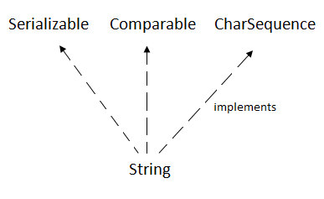

## **CharSequence Interface**

The CharSequence interface is used to represent the sequence of characters. String, [StringBuffer](https://www.javatpoint.com/StringBuffer-class) and [StringBuilder](https://www.javatpoint.com/StringBuilder-class) classes implement it. It means, we can create strings in java by using these three classes.

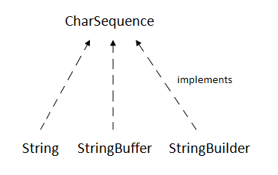

The Java String is immutable which means it cannot be changed. Whenever we change any string, a new instance is created. For mutable strings, you can use StringBuffer and StringBuilder classes.

We will discuss immutable string later. Let's first understand what is String in Java and how to create the String object.

### What is String in java

Generally, String is a sequence of characters. But in Java, string is an object that represents a sequence of characters. The java.lang.String class is used to create a string object.

### How to create a string object?

There are two ways to create String object:

1. By string literal
2. By new keyword

### 1) String Literal

Java String literal is created by using double quotes. For Example:

String s="welcome";

Each time you create a string literal, the JVM checks the "string constant pool" first. If the string already exists in the pool, a reference to the pooled instance is returned. If the string doesn't exist in the pool, a new string instance is created and placed in the pool. For example:

1. String s1="Welcome";
2. String s2="Welcome";//It doesn't create a new instance

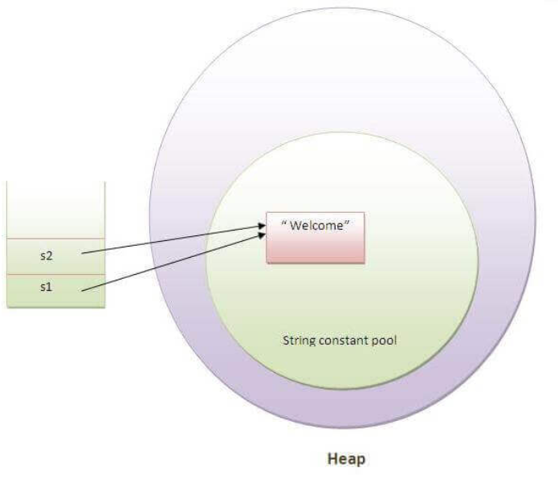

In the above example, only one object will be created. Firstly, JVM will not find any string object with the value "Welcome" in string constant pool, that is why it will create a new object. After that it will find the string with the value "Welcome" in the pool, it will not create a new object but will return the reference to the same instance.

#### **Note: String objects are stored in a special memory area known as the "string constant pool".**

Why Java uses the concept of String literal?

To make Java more memory efficient (because no new objects are created if it exists already in the string constant pool).

### 2) By new keyword

1. String s=**new** String("Welcome");//creates two objects and one reference variable

In such case, [JVM](https://www.javatpoint.com/jvm-java-virtual-machine) will create a new string object in normal (non-pool) heap memory, and the literal "Welcome" will be placed in the string constant pool. The variable s will refer to the object in a heap (non-pool).

# **Immutable String in Java**

In java, **string objects are immutable**. Immutable simply means unmodifiable or unchangeable.

Once string object is created its data or state can't be changed but a new string object is created.

Let's try to understand the immutability concept by the example given below:

1. **class** Testimmutablestring{
2. **public** **static** **void** main(String args[]){
3. String s="Sachin";
4. s.concat(" Tendulkar");//concat() method appends the string at the end
5. System.out.println(s);//will print Sachin because strings are immutable objects
6. }
7. }

[**Test it Now**](http://www.javatpoint.com/opr/test.jsp?filename=Testimmutablestring)

Output:Sachin

Now it can be understood by the diagram given below. Here Sachin is not changed but a new object is created with sachintendulkar. That is why string is known as immutable.

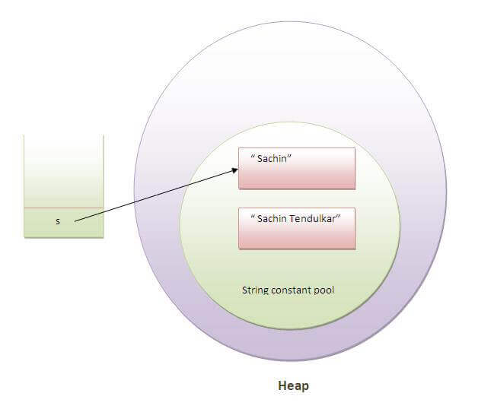

As you can see in the above figure that two objects are created but s reference variable still refers to "Sachin" not to "Sachin Tendulkar".

But if we explicitely assign it to the reference variable, it will refer to "Sachin Tendulkar" object.For example:

1. **class** Testimmutablestring1{
2. **public** **static** **void** main(String args[]){
3. String s="Sachin";
4. s=s.concat(" Tendulkar");
5. System.out.println(s);
6. }
7. }

[**Test it Now**](http://www.javatpoint.com/opr/test.jsp?filename=Testimmutablestring1)

Output:Sachin Tendulkar

In such case, s points to the "Sachin Tendulkar". Please notice that still sachin object is not modified.

### Why string objects are immutable in java?

|  |  |  |  |  |  |  |  |  |  |  |  |  |
| --- | --- | --- | --- | --- | --- | --- | --- | --- | --- | --- | --- | --- |
| Because java uses the concept of string literal. Suppose there are 5 reference variables,  all referes to one object "sachin".If one reference variable changes the value of the object,  it will be affected to all the reference variables. That is why string objects are immutable in java. **Java StringBuffer class** Java StringBuffer class is used to create mutable (modifiable) string. The StringBuffer class in java is same as String class except it is mutable i.e. it can be changed. **Note: Java StringBuffer class is thread-safe i.e. multiple threads cannot access it simultaneously. So it is safe and will result in an order.****Java StringBuilder class** Java StringBuilder class is used to create mutable (modifiable) string. The Java StringBuilder class is same as StringBuffer class except that it is non-synchronized. It is available since JDK 1.5. **Exception Handling in Java** The **Exception Handling in Java** is one of the powerful mechanism to handle the runtime errors so that normal flow of the application can be maintained.  In this page, we will learn about Java exceptions, its type and the difference between checked and unchecked exceptions. **What is Exception in Java** **Dictionary Meaning:** Exception is an abnormal condition.  In Java, an exception is an event that disrupts the normal flow of the program. It is an object which is thrown at runtime. **What is Exception Handling** Exception Handling is a mechanism to handle runtime errors such as ClassNotFoundException, IOException, SQLException, RemoteException, etc. Advantage of Exception Handling The core advantage of exception handling is **to maintain the normal flow of the application**. An exception normally disrupts the normal flow of the application that is why we use exception handling. **Hierarchy of Java Exception classes** The java.lang.Throwable class is the root class of Java Exception hierarchy which is inherited by two subclasses: Exception and Error. A hierarchy of Java Exception classes are given below:  hierarchy of exception handling Types of Java Exceptions There are mainly two types of exceptions: checked and unchecked. Here, an error is considered as the unchecked exception. According to Oracle, there are three types of exceptions:   1. Checked Exception 2. Unchecked Exception 3. Error  **Difference between Checked and Unchecked Exceptions**1) Checked Exception The classes which directly inherit Throwable class except RuntimeException and Error are known as checked exceptions e.g. IOException, SQLException etc. Checked exceptions are checked at compile-time. 2) Unchecked Exception The classes which inherit RuntimeException are known as unchecked exceptions e.g. ArithmeticException, NullPointerException, ArrayIndexOutOfBoundsException etc. Unchecked exceptions are not checked at compile-time, but they are checked at runtime. 3) Error Error is irrecoverable e.g. OutOfMemoryError, VirtualMachineError, AssertionError etc.  There are 5 keywords which are used in handling exceptions in Java.   |  |  | | --- | --- | | **Keyword** | **Description** | | try | The "try" keyword is used to specify a block where we should place exception code. The try block must be followed by either catch or finally. It means, we can't use try block alone. | | catch | The "catch" block is used to handle the exception. It must be preceded by try block which means we can't use catch block alone. It can be followed by finally block later. | | finally | The "finally" block is used to execute the important code of the program. It is executed whether an exception is handled or not. | | throw | The "throw" keyword is used to throw an exception. | | throws | The "throws" keyword is used to declare exceptions. It doesn't throw an exception. It specifies that there may occur an exception in the method. It is always used with method signature. | |
|  |