Next.js

What is NEXT.JS ?
Next.js is a React framework for Production.
Next.js is a React framework that enables developers to build fast, scalable, and SEO-friendly web applications. It provides server-side rendering (SSR), static site generation (SSG), and client-side rendering (CSR), allowing for better performance and flexibility. Next.js simplifies routing, API handling, and optimizations like automatic image optimization, code splitting, and incremental static regeneration (ISR). It is widely used for building modern web applications, including e-commerce sites, dashboards, and blogs.
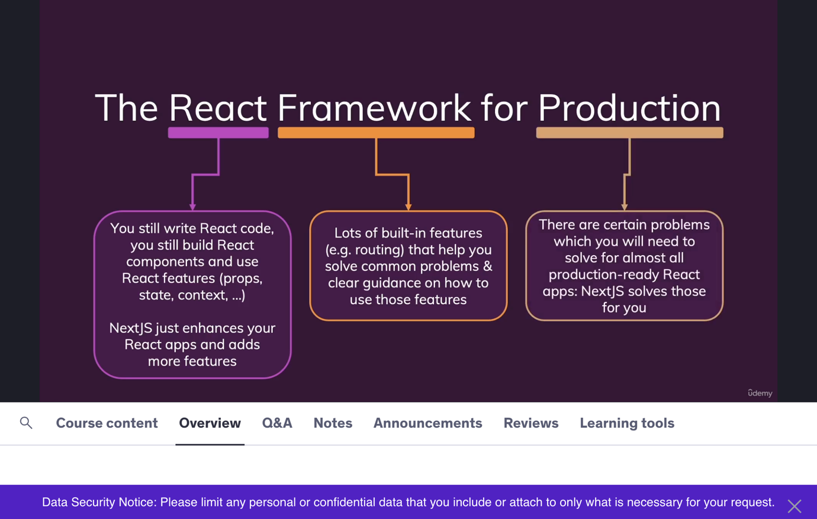
What is difference between React and Next js ?
React is a client side javascript library, all that rendering happens on the client, so its in the browsers of the users, its. not happening on server.
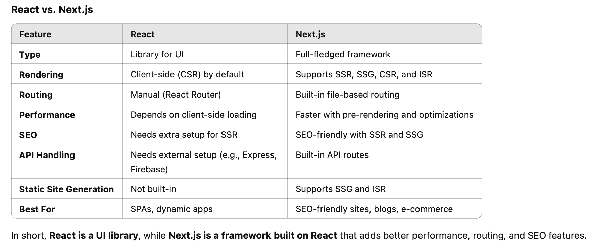

What is server-side pre-rendering of pages ?
In React (CSR - Client-Side Rendering), the initial HTML page is mostly empty, and content is loaded dynamically using JavaScript. Since search engines prefer pre-rendered content, this can be a problem for SEO, as some crawlers may not execute JavaScript properly, leading to incomplete indexing.
Pre-rendering in Next.js means generating the HTML for a page in advance
In Next.js, the content is pre-rendered on the server using Server-Side Rendering (SSR) or Static Site Generation (SSG). This means search engines receive a fully rendered HTML page, improving SEO and page load speed.
So yes, React alone has SEO limitations, but Next.js solves this by pre-rendering HTML before sending it to the client.

Why in Next.js we don’t have index.html in public folder ?
The reason for this is that NextJS has this built in pre-rendering. And whilst it gives you a single page application, that single page is dynamically pre-rendered when a request reaches the server so that you do return an initial page with content.
To be precise, Next.js allows us to determine WHEN a page should be pre-rendered. But we’re going to learn that step by step.

What is the contents should present inside index.html ?

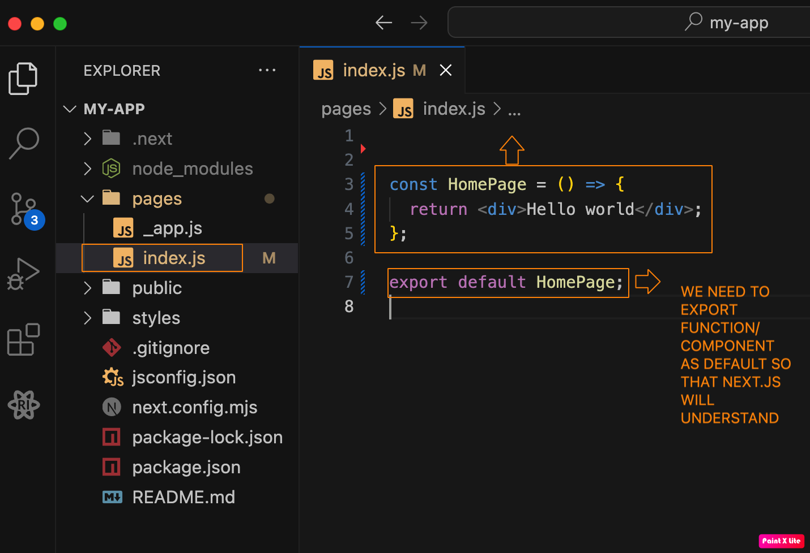

Note: We can ignore “import React from ‘React’; ” import statement in next.js

How Page Name based routing works ?

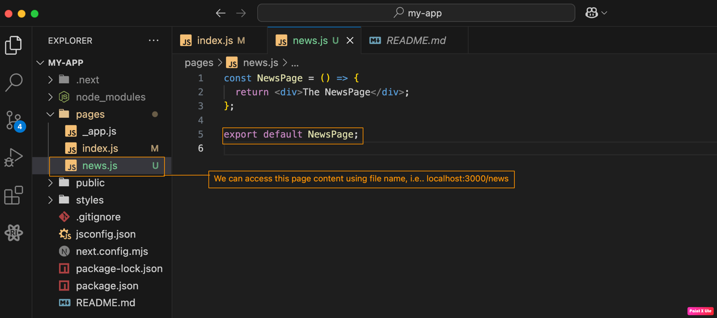

What is Nested pages and how it works ?
We can take news.js file to news folder and rename it as index.js, this works same as default index.js.

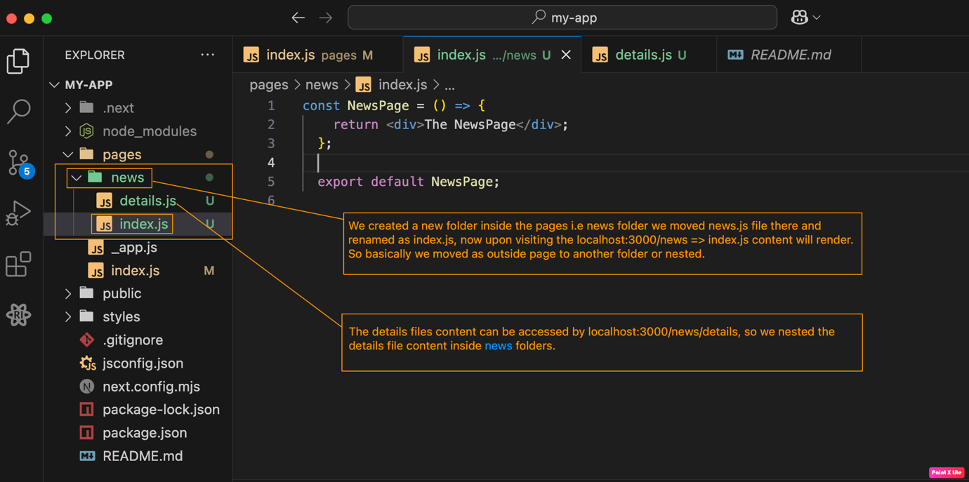

How to Extract Dynamic route data?

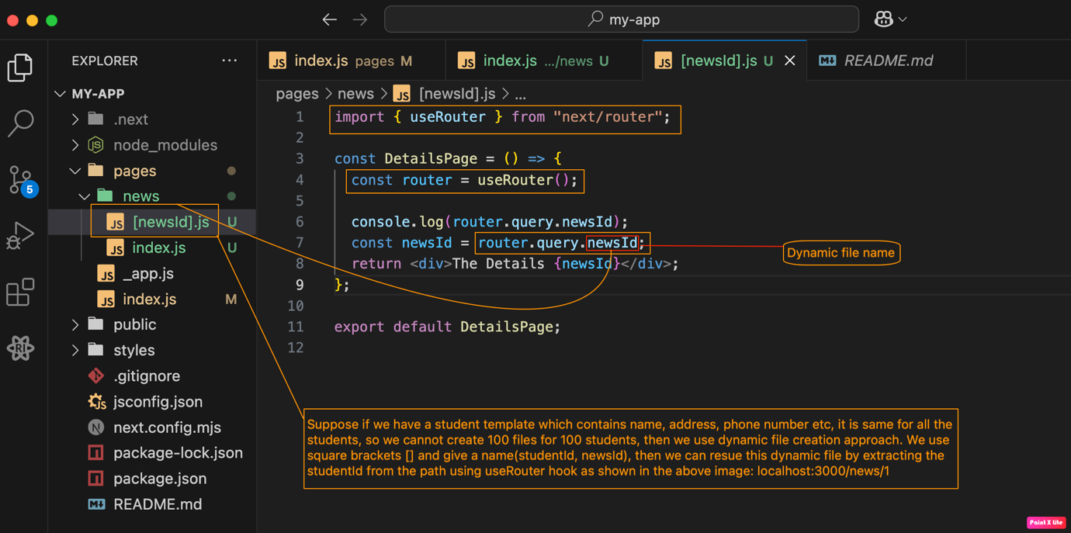

How to link between pages in Next.js ?

We use Link component from ‘next/link’ to navigate to other pages.Link component takes a href prop of page url.

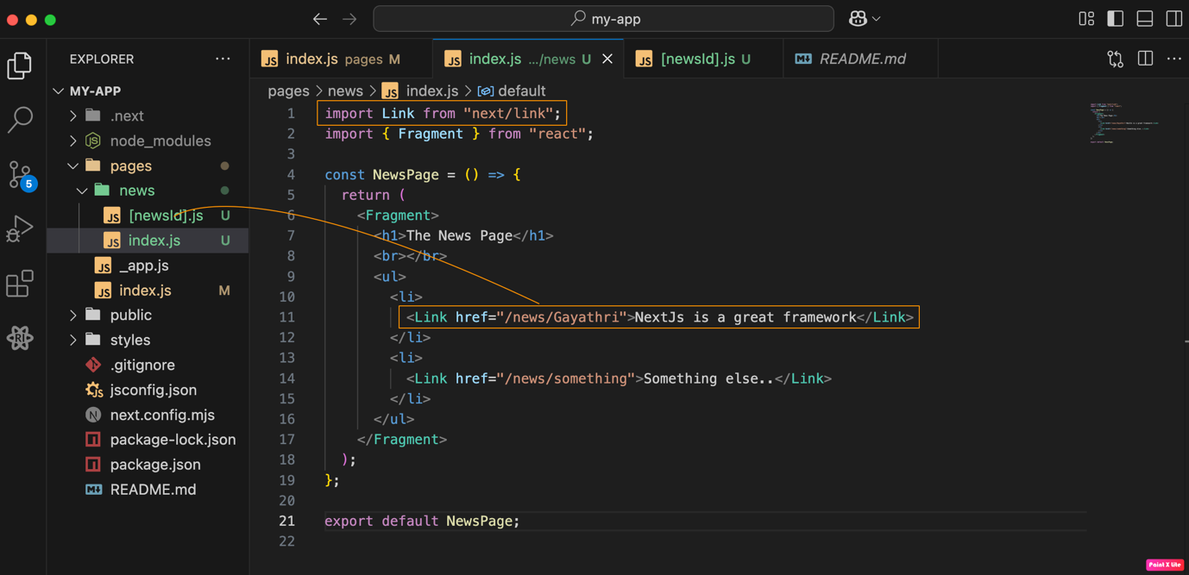

What is the use of “_app.js” File ?
It is a root file for our next.js application, so it is the best place to add wrap all our pages inside a Header component like components.

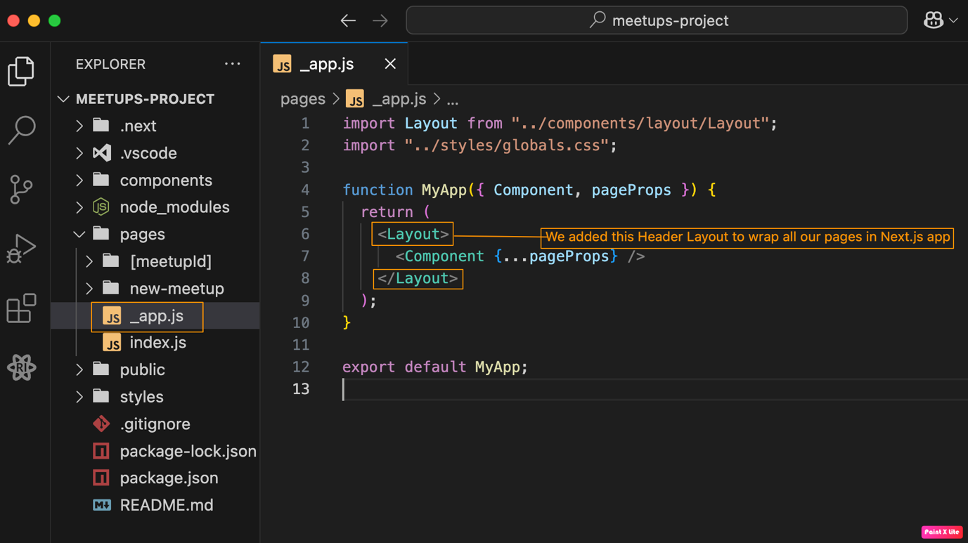

How can we move to a page programmatically in next.js ?
We can use useRouter hook from ‘next/router’ and we can use push method to navigate.
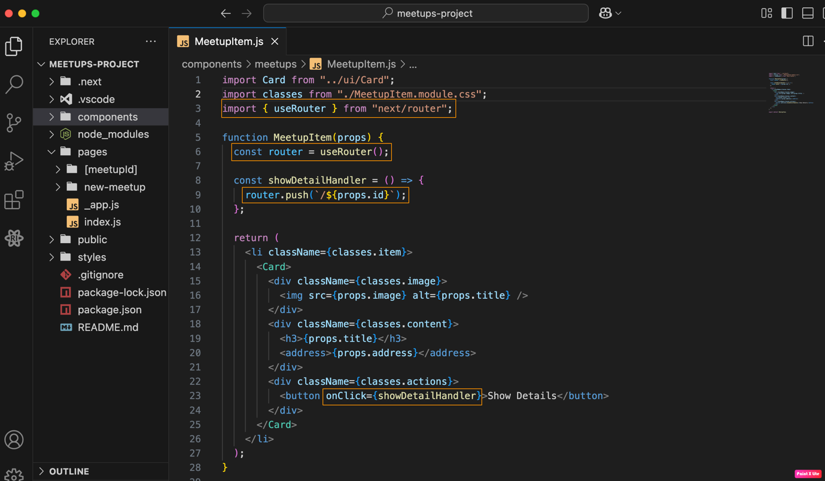

How Nextjs Page Pre-Rendering Actually works?
When we load a page, which has a HTTP request, initially a first render happens, this second render happens when the data is fetched from the datasource.
In second render, the HTML page we fetched from the server and they are missing because they are only rendered in the second component execution cycle. But the pre-rendered HTML page generated by NextJS automatically does not wait for this second cycle. It always takes the result of the first render cycle and return stat as the pre-rendered HTML code. And there, this data is missing.
Because of these two render cycles, we have a problem with search engine optimization.
This means any data that loads after the first render won’t be included in the initial HTML, potentially causing missing content issues if not handled properly.

Next.js and Pre-Rendering: Understanding Its Behavior
Next.js has a built-in page pre-rendering feature, but it comes with a potential drawback. The pre-rendered page is essentially a snapshot taken after the first component render cycle, which may lack crucial data.
When a user visits a route, Next.js serves the pre-rendered page, but some data might be missing. While this approach is generally good for SEO, it’s not always perfect. After the HTML page is received, React takes over through a process called hydration, converting the page into a single-page application (SPA). At this point, functions like useEffect may execute, fetching and updating the data dynamically in the browser, not on the server. This means the initial HTML does not contain the updated data, potentially affecting SEO and user experience.
To ensure that the pre-rendered HTML already contains the necessary data, we need to fine-tune this pre-rendering process. Next.js provides two approaches to control how pages are rendered:
1. Static Generation (SSG) – Generates pages at build time.
2. Server-Side Rendering (SSR) – Generates pages dynamically on each request.

What is Static Site Generation (SSG) in Next.js?
SSG (Static Site Generation) is a pre-rendering method in Next.js where pages are generated at build time and served as static HTML. This makes the website fast, SEO-friendly, and highly scalable, as the pre-generated pages do not require server-side processing on each request
How to Implement SSG in Next.js?
To use SSG in Next.js, you need to export a special function called getStaticProps inside a page component. This function fetches data at build time and passes it as props to the page.
Note: With this we are about to start the backend code in the getStaticProps function, will be executed in server side only, the client i.e in the browser user cant see this code. Therefore we can say Next.js is a fullstack framework.

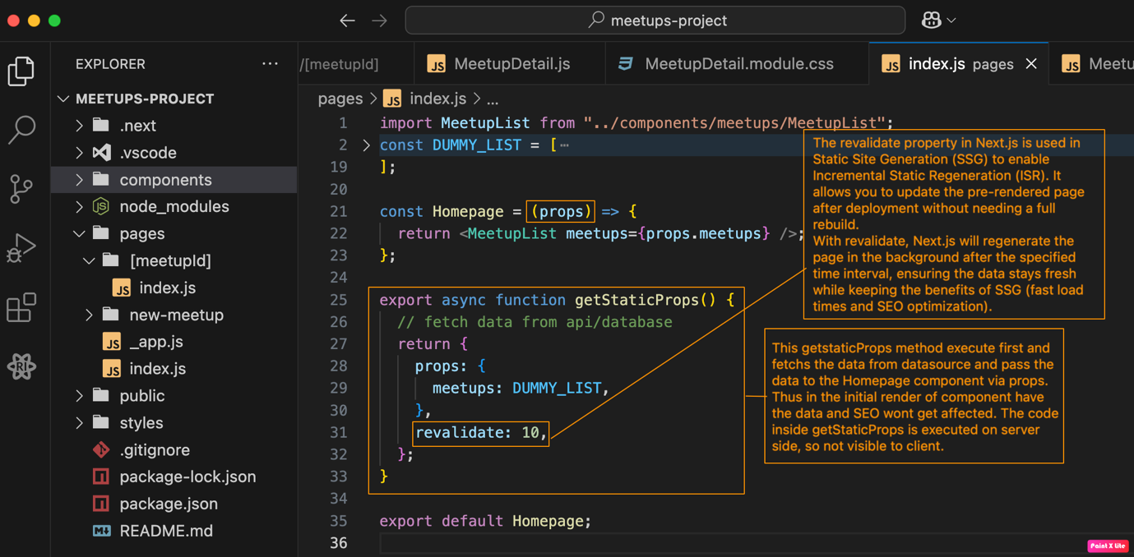
What is getServerSideProps and when to use it ?
It works same like getStaticProps, except it executes every incoming request. It also recevies a context object which contain request parameters and response parameters.
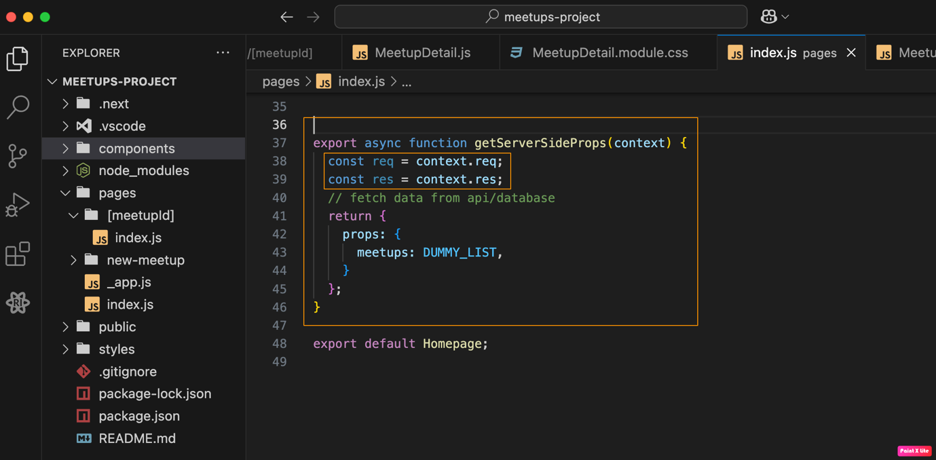

Why Use getStaticPaths in Dynamic Pages in Next.js?
In Next.js, when using Static Site Generation (SSG) for dynamic routes (e.g., /blog/[id]), Next.js doesn’t know in advance which pages to pre-generate.
getStaticPaths helps by defining which dynamic routes should be pre-rendered at build time, ensuring fast performance and SEO optimization while handling dynamic content.
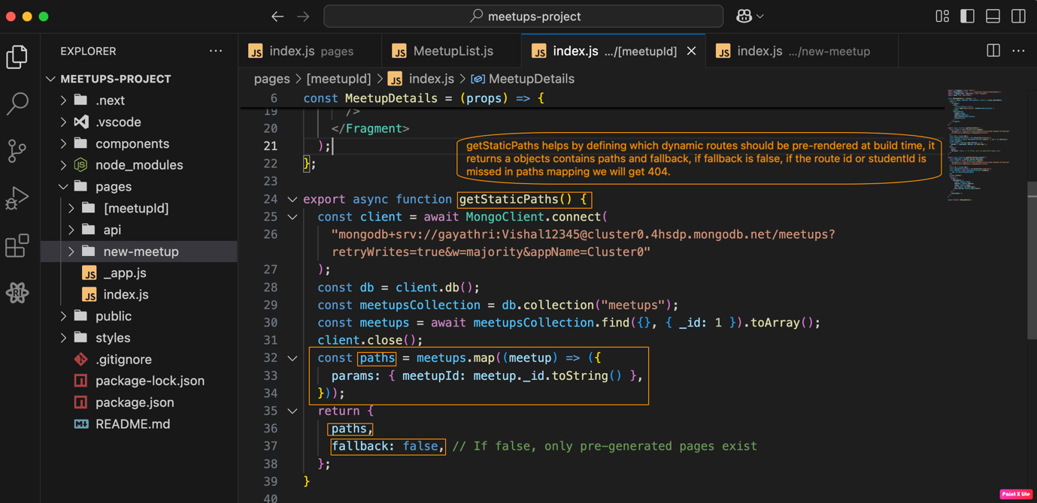
How to enable a backend or write api’s in the next.js application ?
Create a new folder inside of pages folder which name “api” and start creating the files. Example we are creating a file with name “new-meetup.js”. Now when we want to add a new meetup we need to send the details of that meetup to an API. We send the details to the file we created inside the “api/new-meetup.js”.
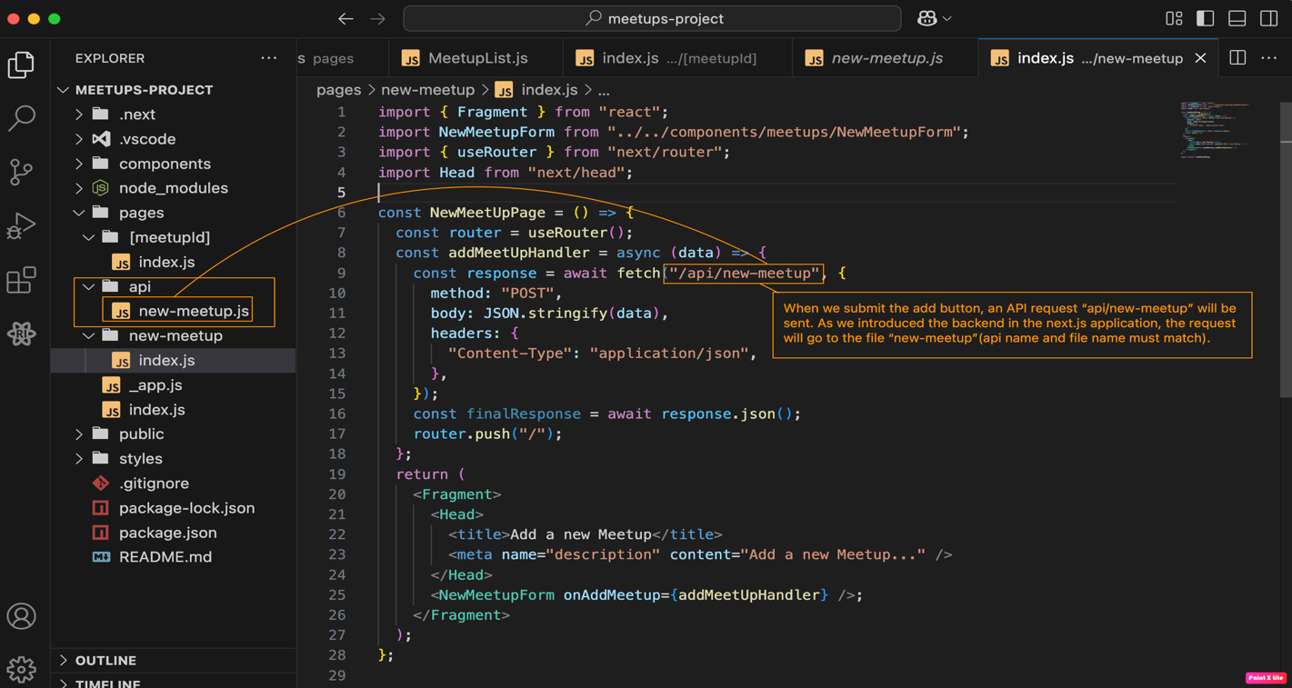
How to make a connect to the backend and store the details in database?
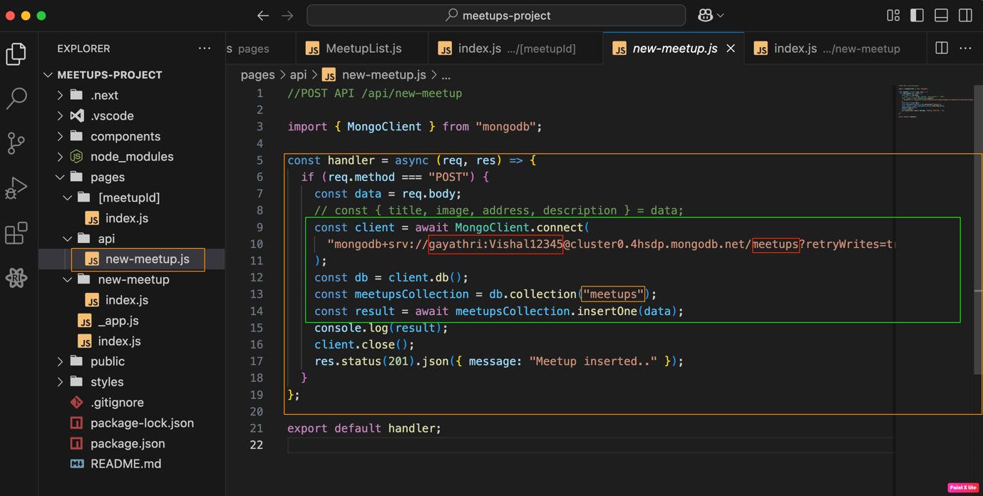
How to Read all the details from the database/collection meetups?
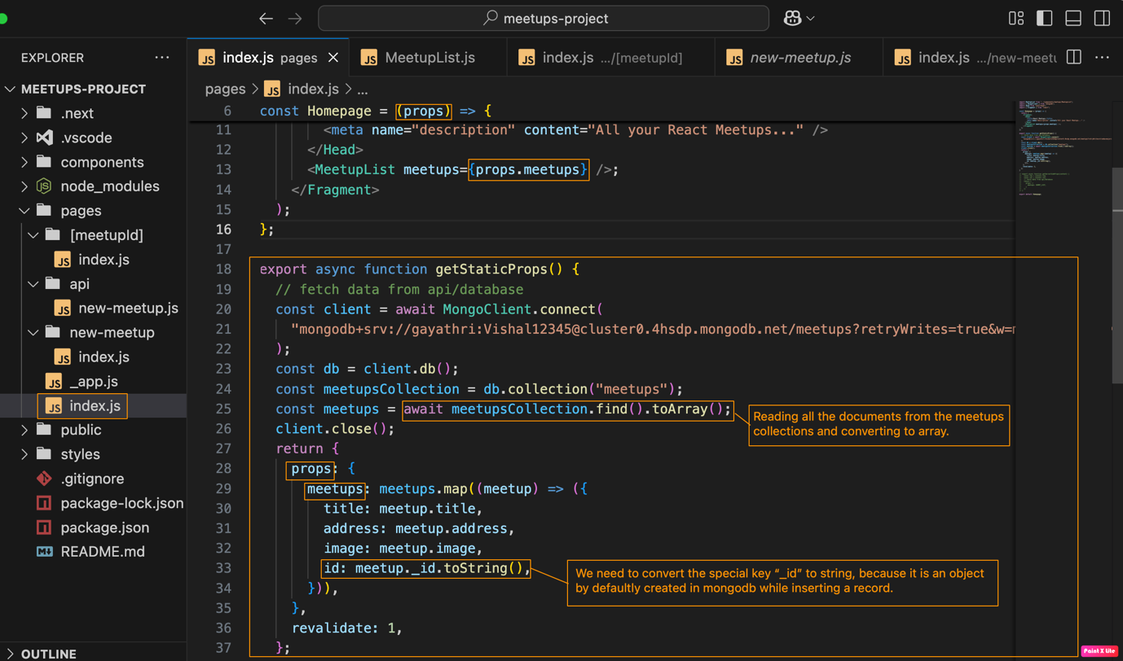

How to fetch a single dynamic record from the database in next.js ?
