REMIX

What is Remix ?
The Remix React Framework is a new full-stack web framework that lets you code the front and back together in an innovative way, combining React syntax with TypeScript (or JavaScript, if you're a heathen) for building components — and defining route handlers for the back end.

What is Routes in remix?
if you have a file(notes) under routes folder, we can access that component in browser using localhost:3000/notes, so all files under routes folder are considered as routes.

How to import CSS files in root level in remix application?
import {
Links,
LiveReload,
Meta,
Outlet,
Scripts,
ScrollRestoration,
} from "@remix-run/react";
import styles from "./styles/main.css";
export const meta = () => ({
charset: "utf-8",
title: "New Remix App",
viewport: "width=device-width,initial-scale=1",
});

export default function App() {
return (
<html lang="en">
<head>
<Meta />
<Links />
</head>
<body>
<Outlet />
<ScrollRestoration />
<Scripts />
<LiveReload />
</body>
</html>
);
}

export function links() {
return [{ rel: "stylesheet", href: styles }];
}

In the above file we can see the links function, there we need to declare our stylesheet and import the sheet and give it to href attribute. AS we can see <Links/> component which Is from remix will add all the links() function and that function will be injected to <Links/>.

In the above file we also see the <Outlet/> component to which all our other components like index.js, notes.js will be injected to the <Outlet/>.

How to inject a CSS file to a specific file in remix?
We imported the “homeStyles” and passed that to links(), which remix will understand.
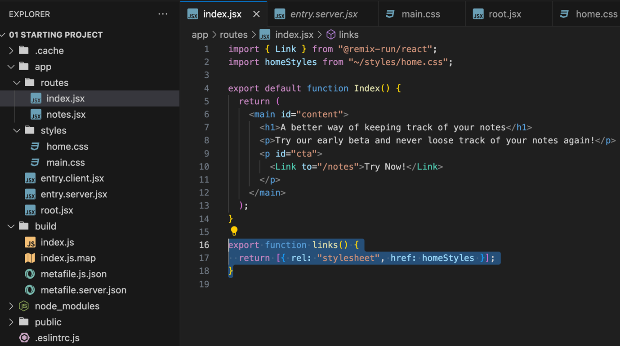

Difference between Remix and Next.js ?

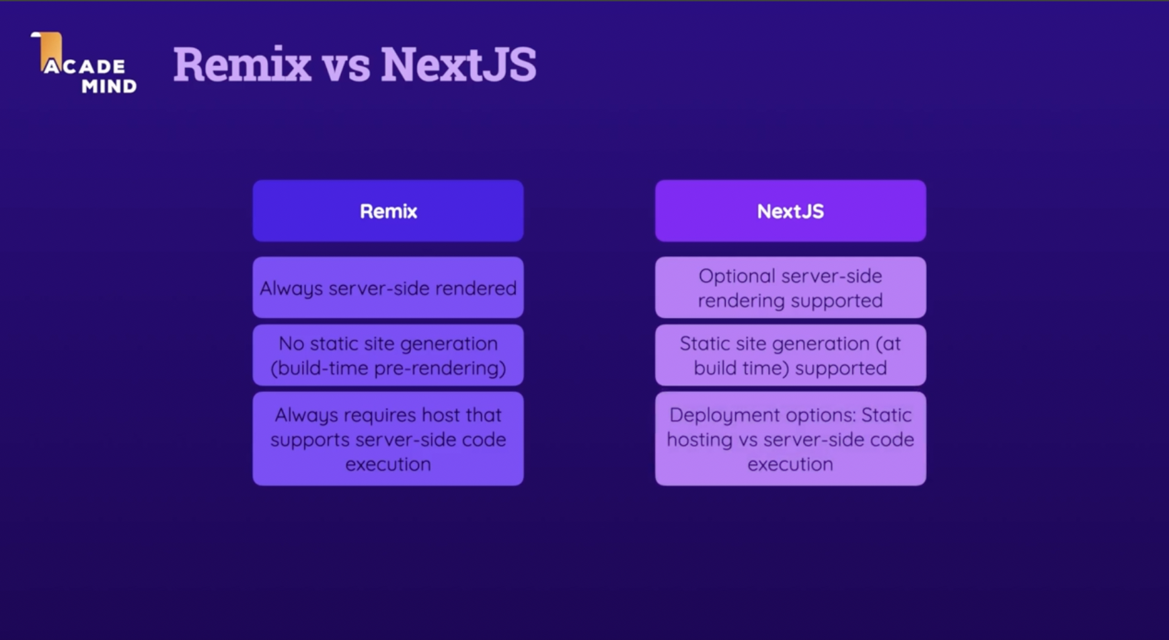
Surfacing styles:
Any component present outside the routes folder, remix wont look links() method inside the component. So we have to apply the styles for that component by surfacing the styles of that component to the parent component which is present inside the route component.

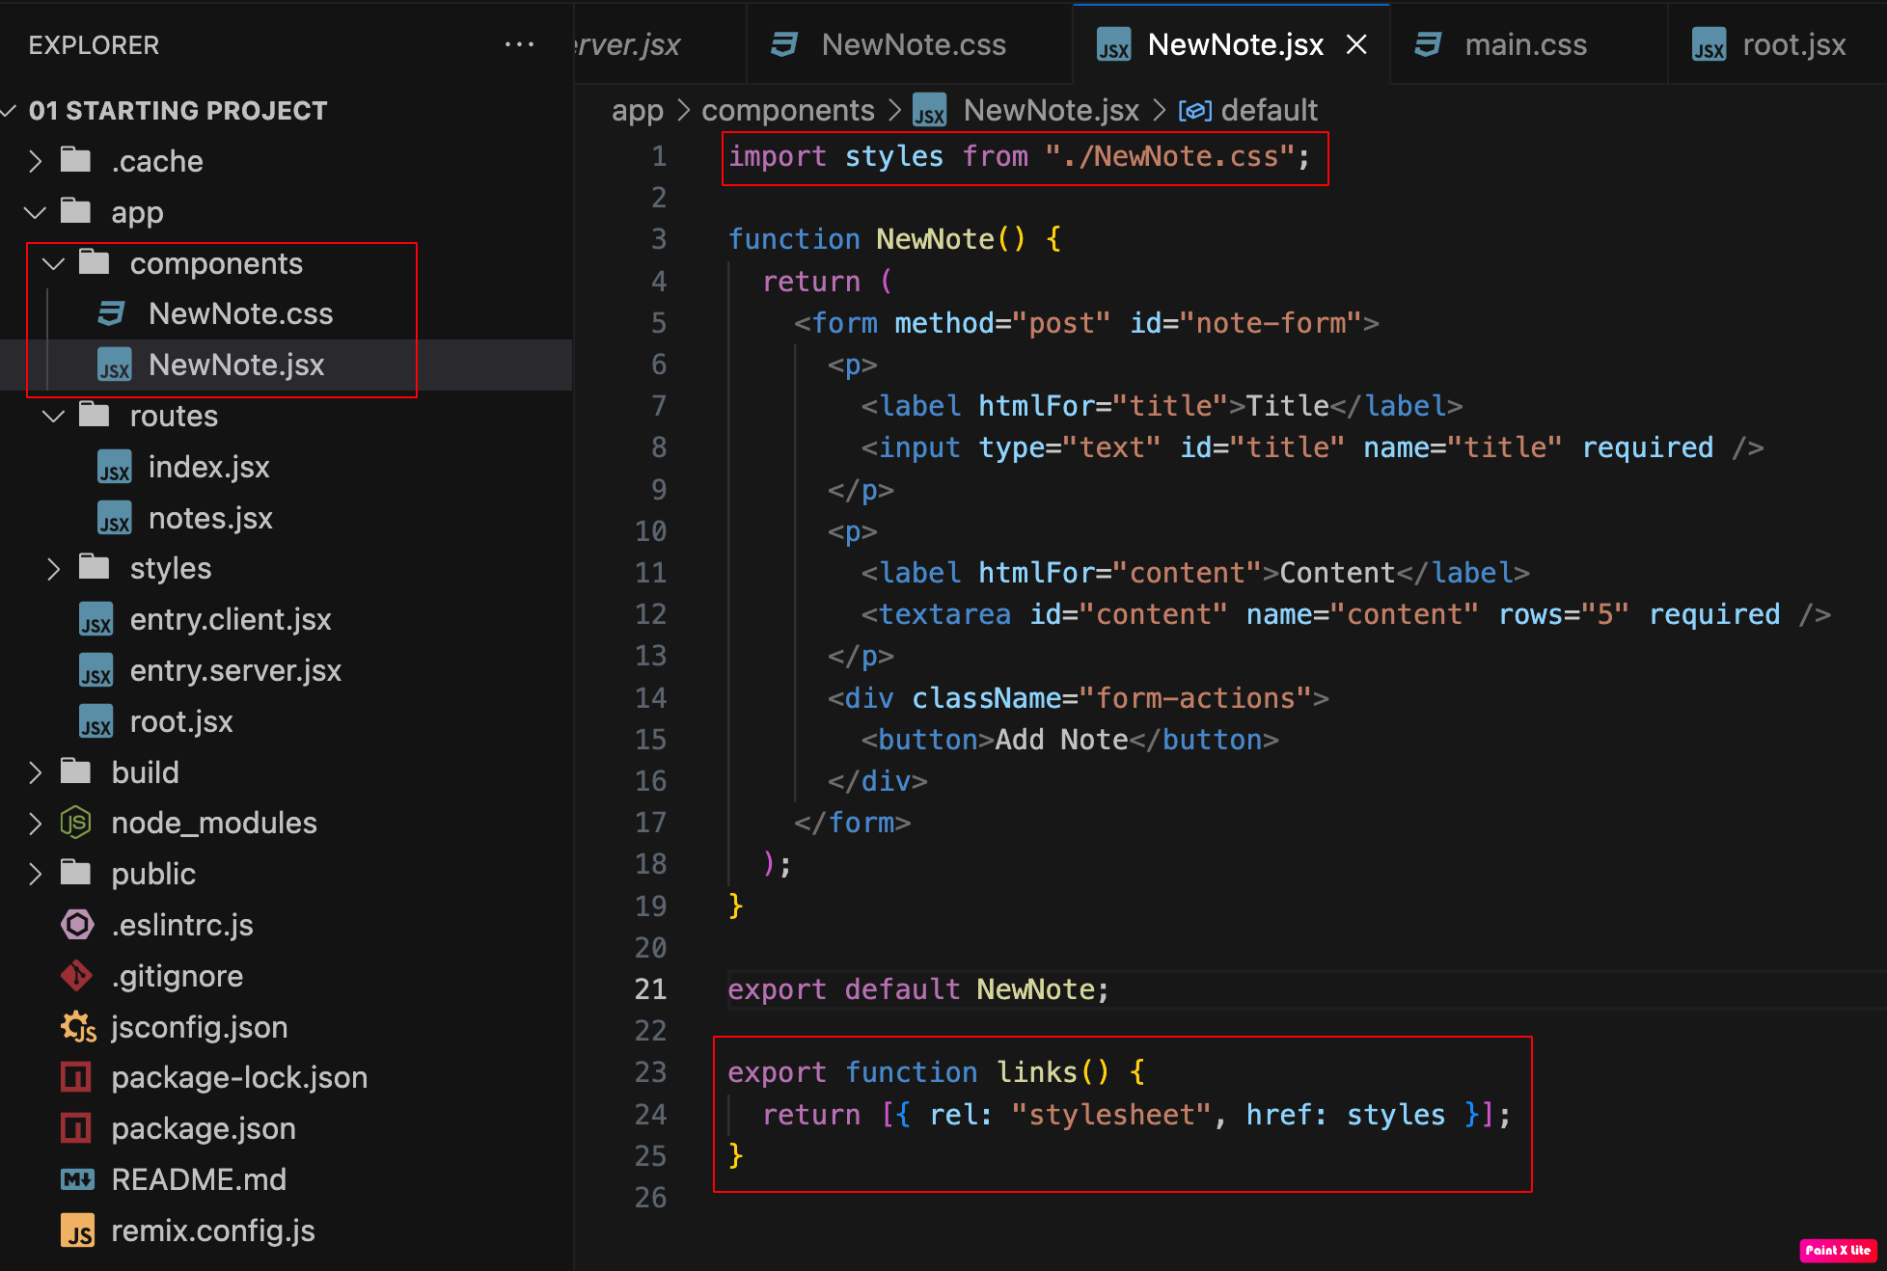

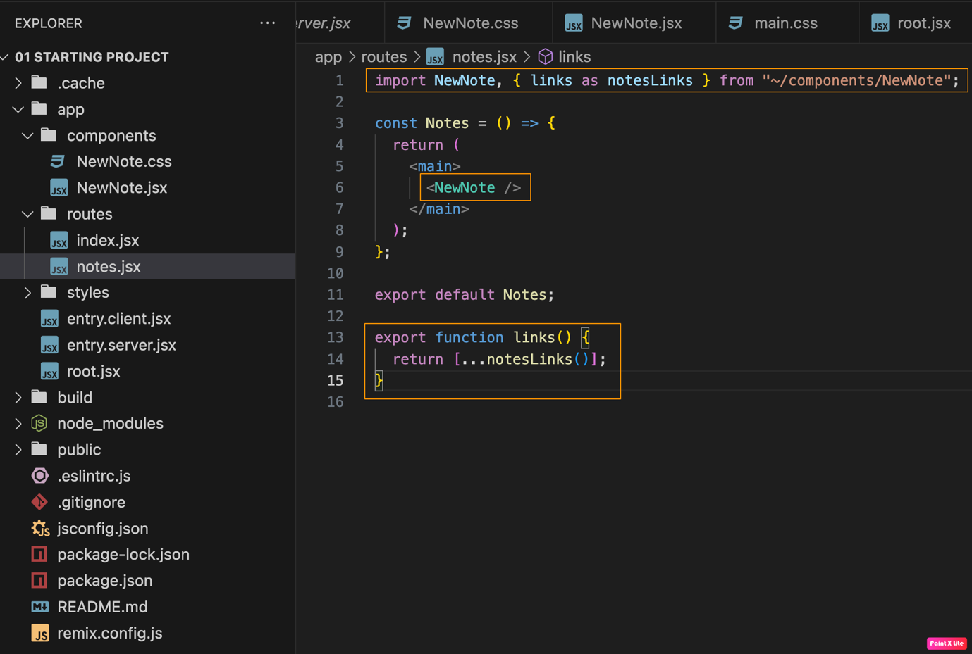
MainNavigation adding in the root file:

As we need a main Navigation bar to be added for every route/page, we add it in the root page.

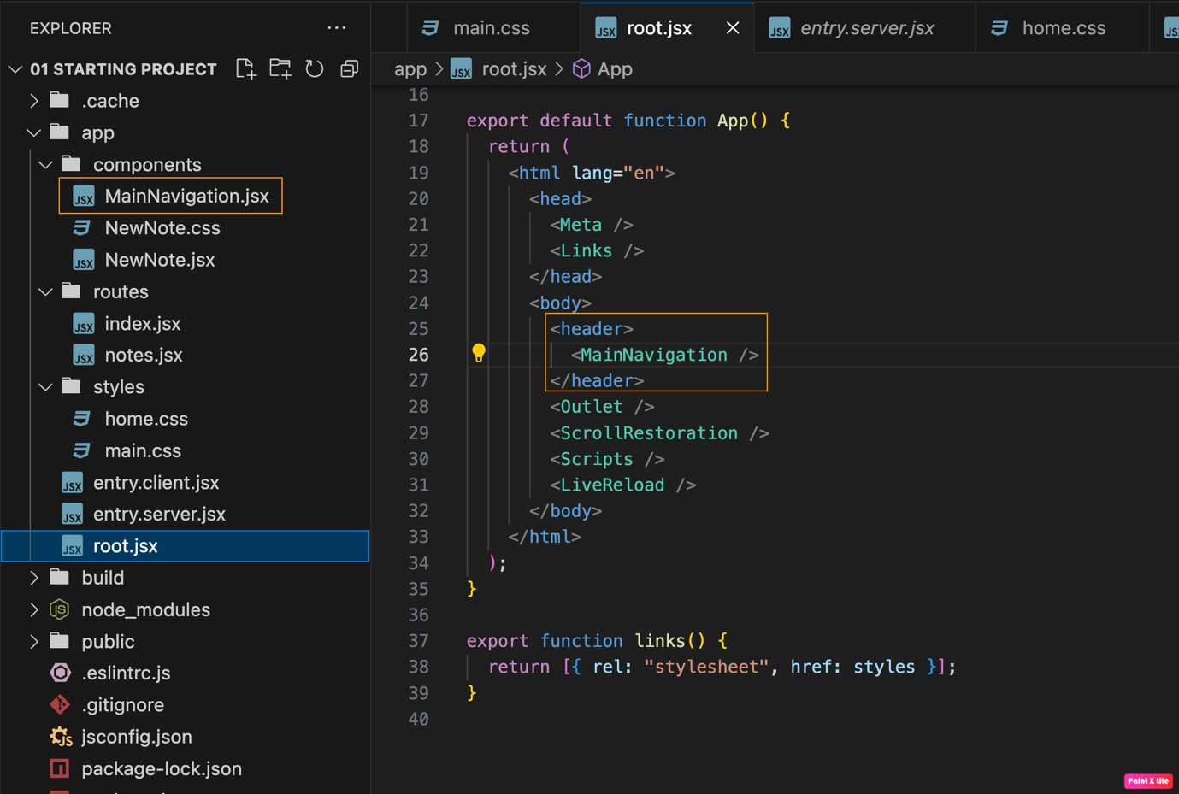

Understanding how submit handling works in REMIX:
Like React, we don’t use submit handlers methods to process the form once user submit the form. In HTML, when user submits a form, it will make a “POST” call and the call will go to the path which is specified inside the action attribute
“<form method=`POST` action=`/notes` >”, BUT as we declared the form inside the “/notes” route, we don’t need to explicitly mention “action=`/notes`” again.
Simply put when user submits the form, we catch that data inside the “/notes” component inside the action method which connects to the backend. This action method inside the component will be hidden and it wont visible to the client when application loads. When user loads the page “/notes”, by default a GET request will be triggered which get the JSX from the component, when user submits a form it triggers a POST request which will go to action method which is predefined in the REMIX.
When we want to load data from the backend to the our react component, we use another predefined method in REMIX called “loader” which executes when our component renders.
When ever a action method is triggered remix understood that data changed so it triggers loader method as well.
useLoaderData() is used to get the data that is returned from the loader method.

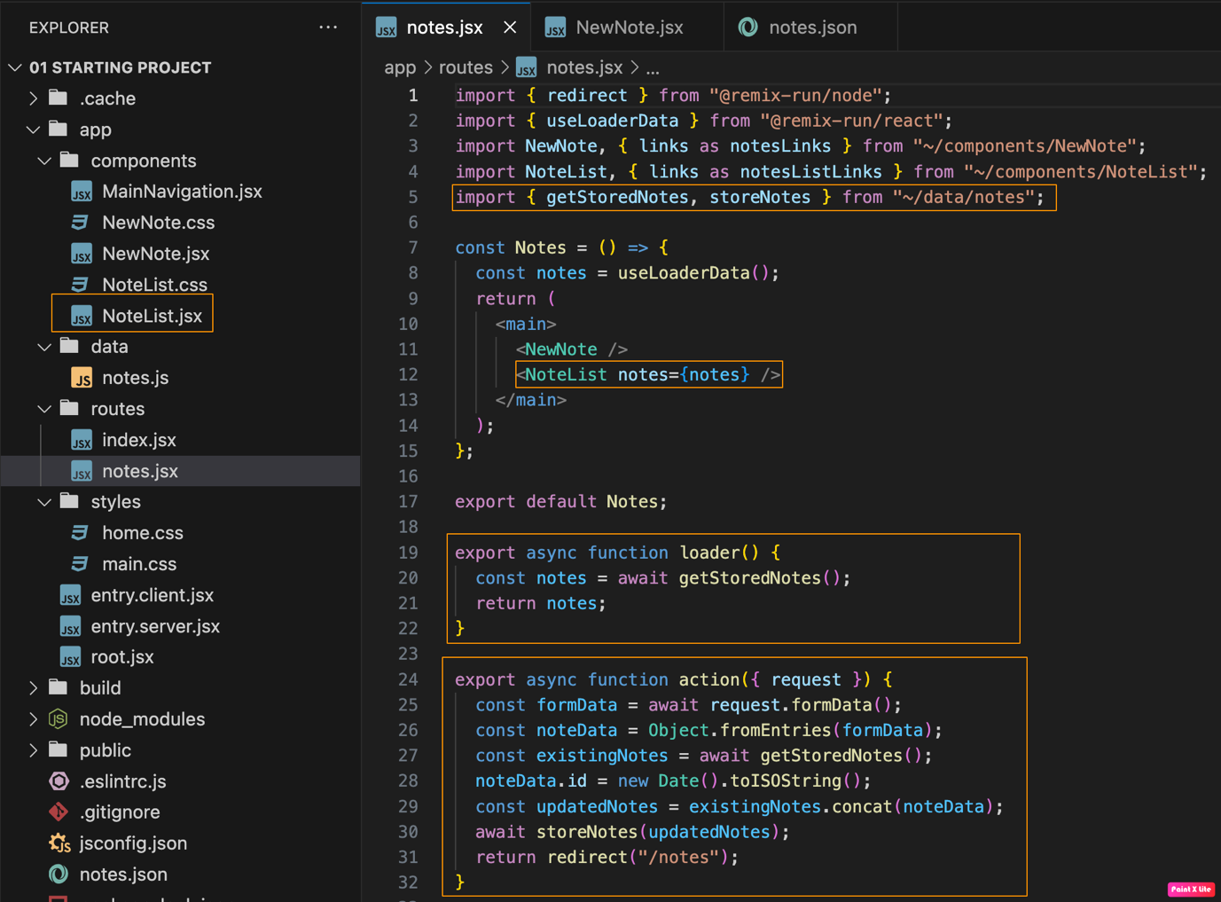

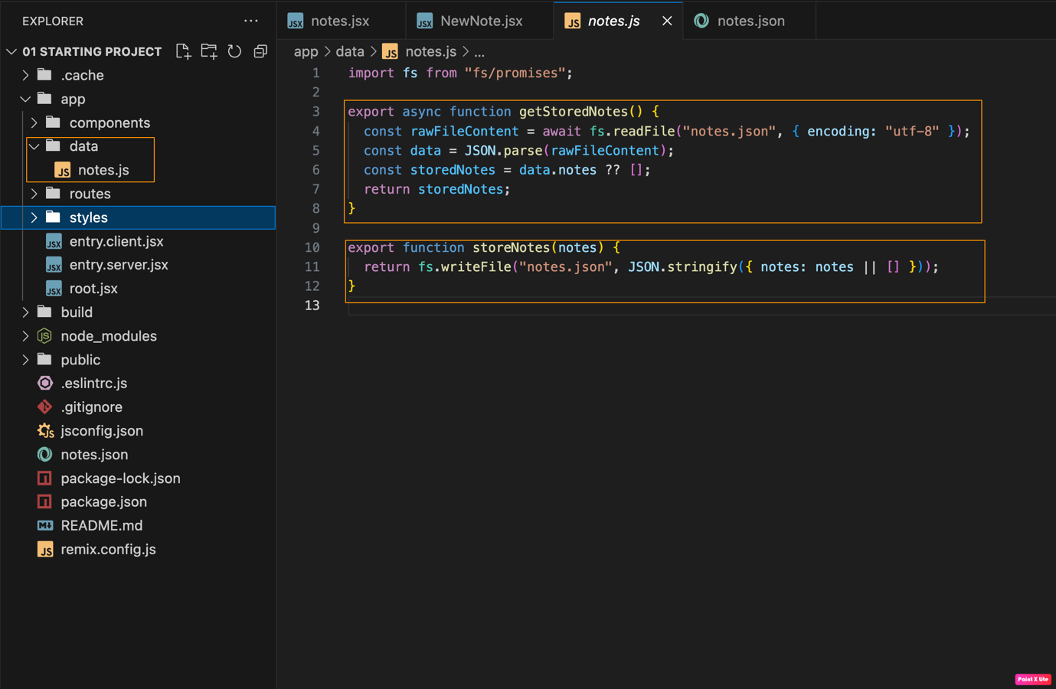

Navigation hook:

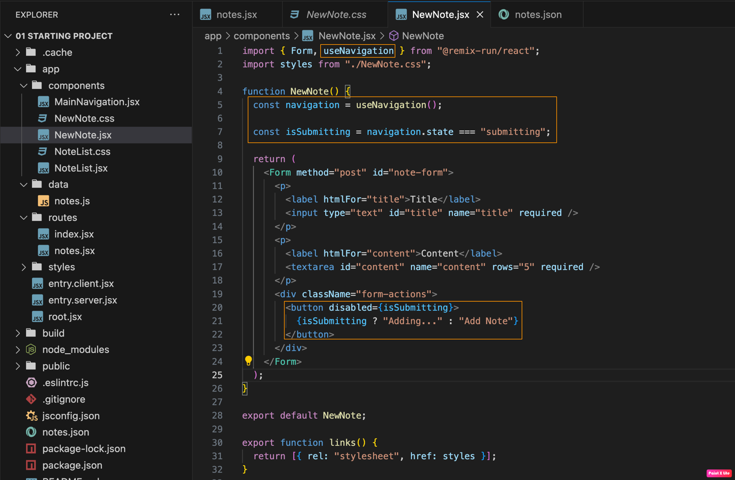

We cant use useNavigation hook with normal HTML form tag, because if we use normal form tag, the page will refresh. We should Form Component from REMIX.

useActionData hook:
We can validation on the data in the action method and if data is not passing the validations we can return the error message as a object. We can catch the error message using the useActionData hook. We can use the useActionData and useLoaderHook in anywhere in the application, they will get the data which is most recently emitted by the methods.

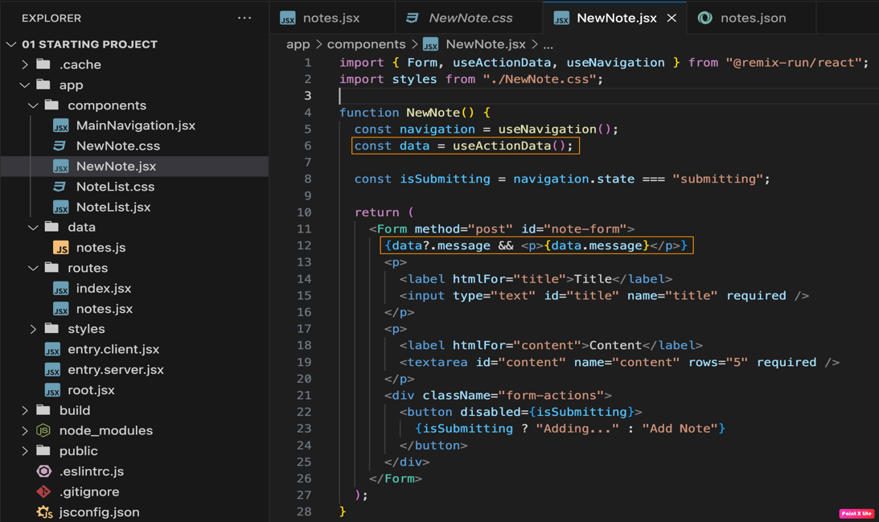

ErrorBoundary

We use this ErrorBoundary to catch the errors occurs in our application. To catch the errors globally we can add the below logic to the root.jsx file.

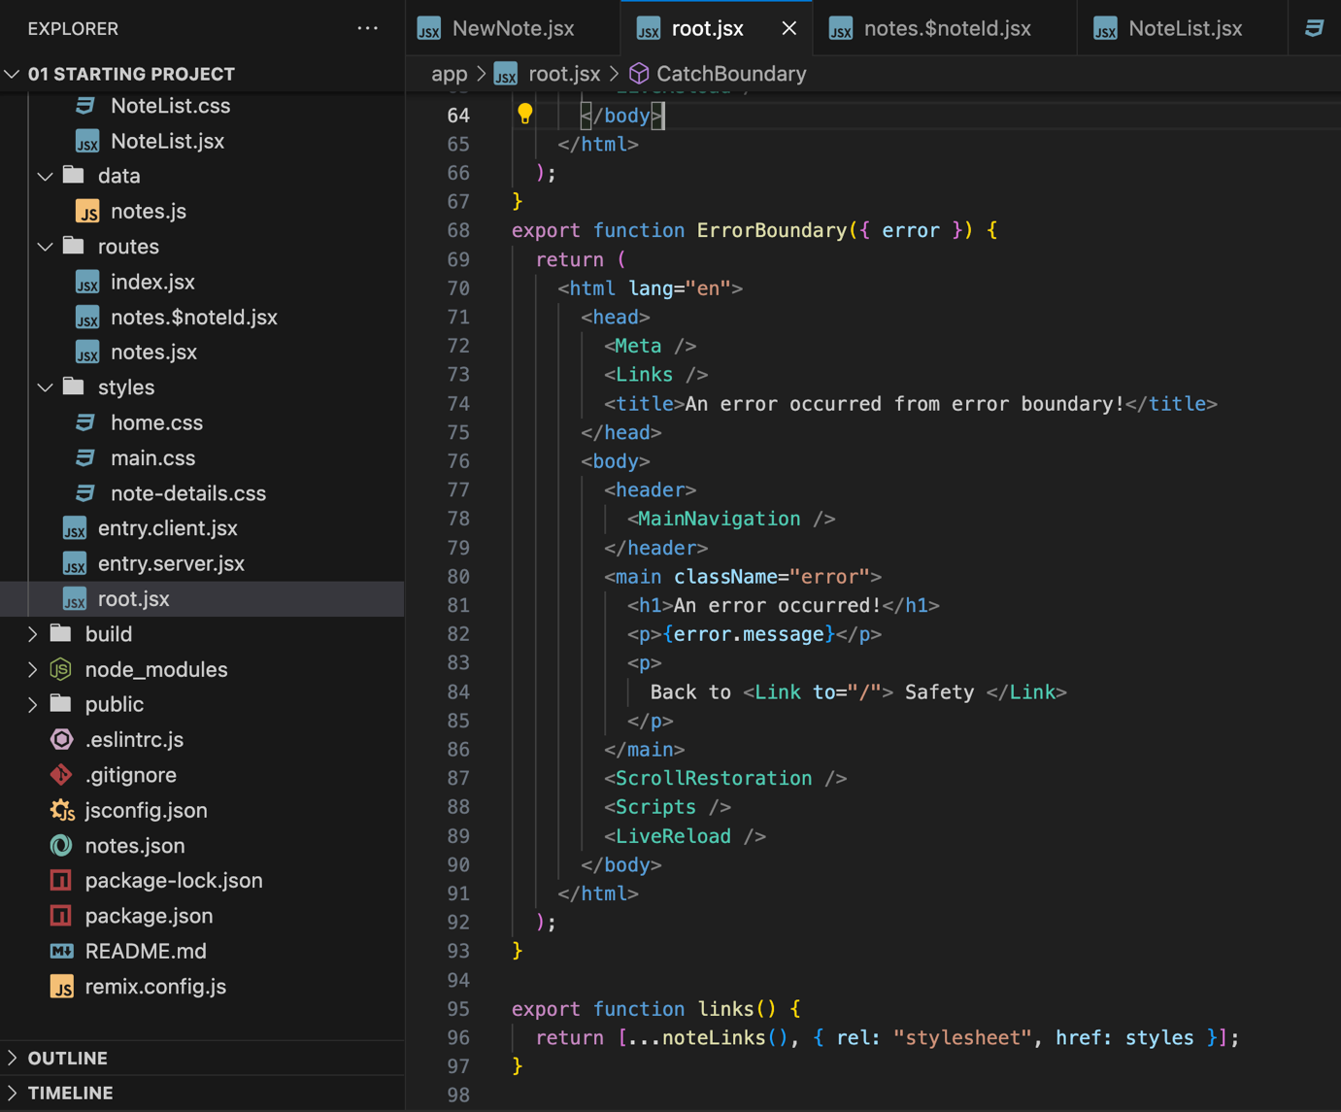

CatchBoundary

We use the catch boundary when we are throwing any error response manually from the code. This CatchBoundary can be placed in root level or the component level.

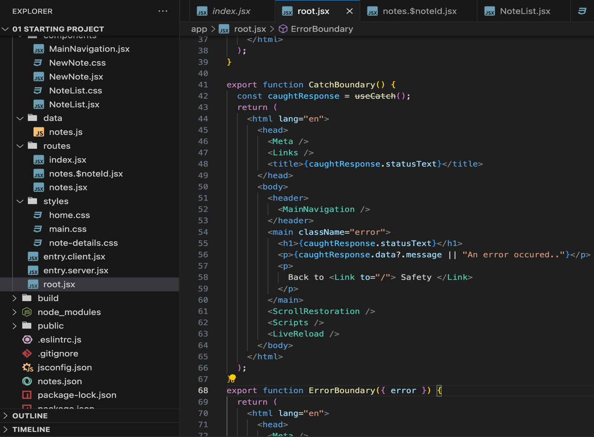

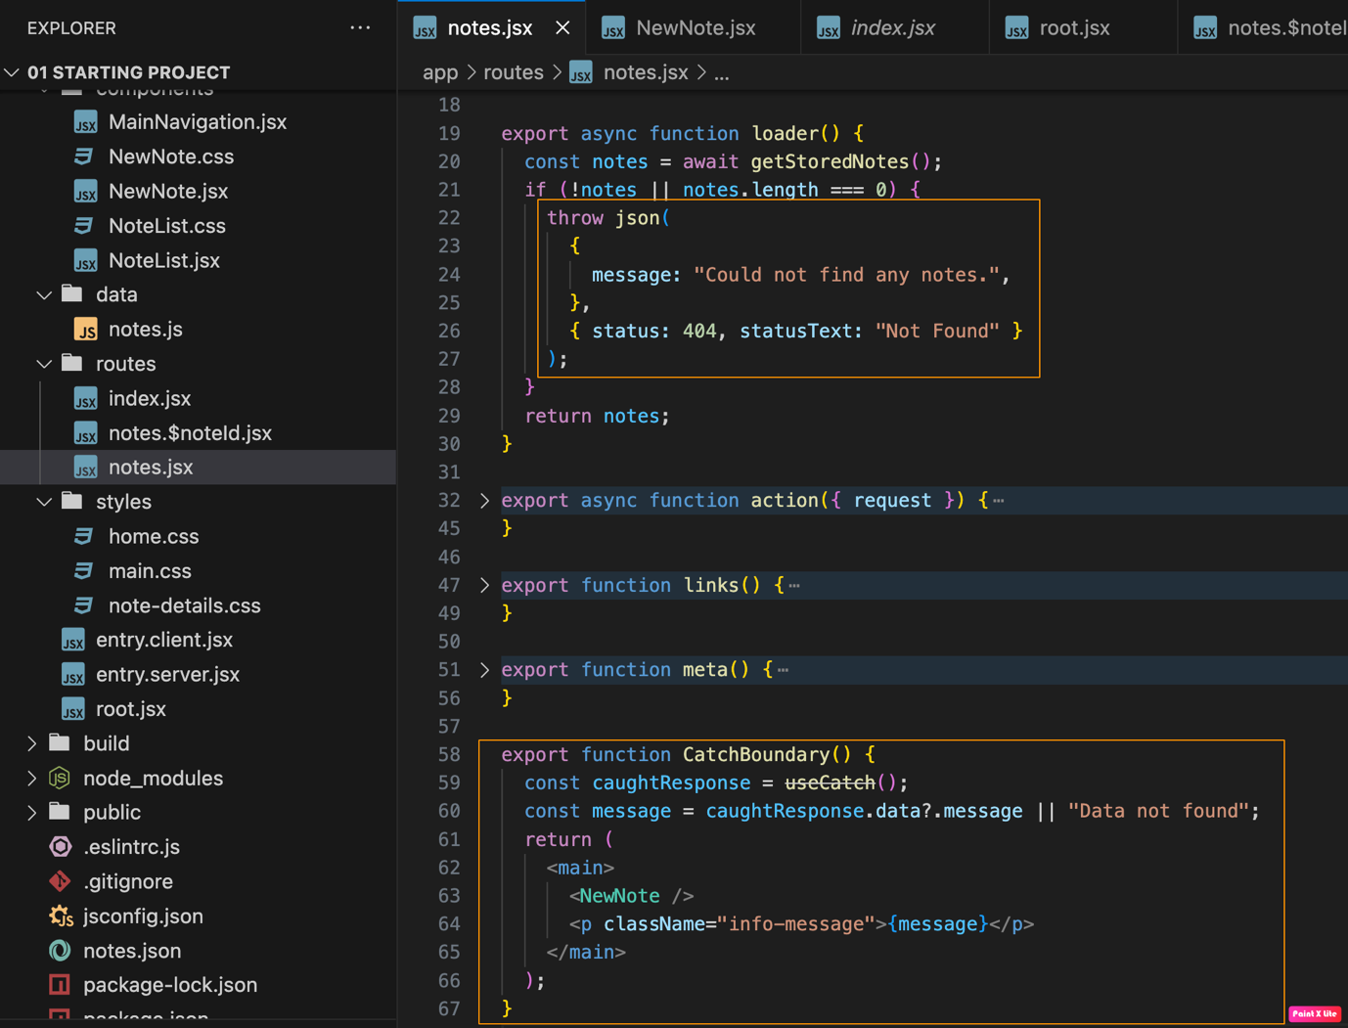
Adding Dynamic Routes & Dot-delimited Routes

If we want to show the details of a particular note based on ID, we follow “/note/{id}”, to achieve this case in REMIX we can use Dot-delimited Routes. Create a component with name “notes.$noteId”, notes => main route and “$noteId” => sub route.

We are adding a link to the Notelist, when ever a user clicks on the note card, noteid will be appended to the current url.

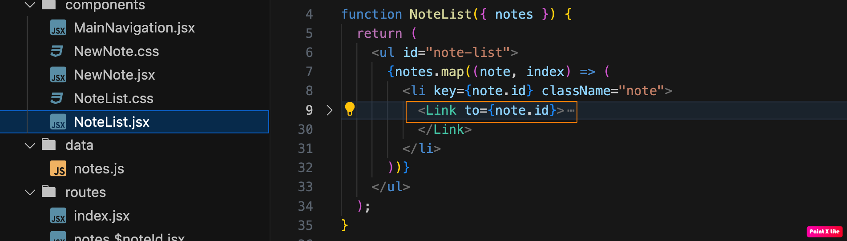

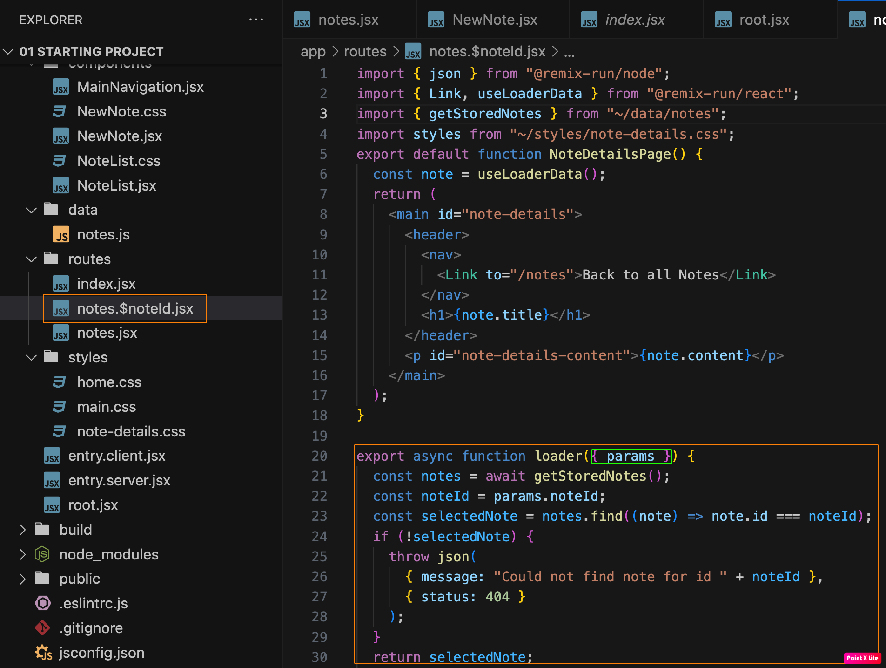

Nested Routes
As we learned when we are dealing with the nested layouts, we can use dot notation like notes.add or notes.$id. But the best approach is create a folder with the main route name and put the other routes as files inside it. In the below example we have main route “/expense” and nested routes as “/expense/raw”, “/expense/add”, “/expense/analytics” etc. We will create a index.js file in “routes/expenses/index.js” which acts as main route for “/expense”.

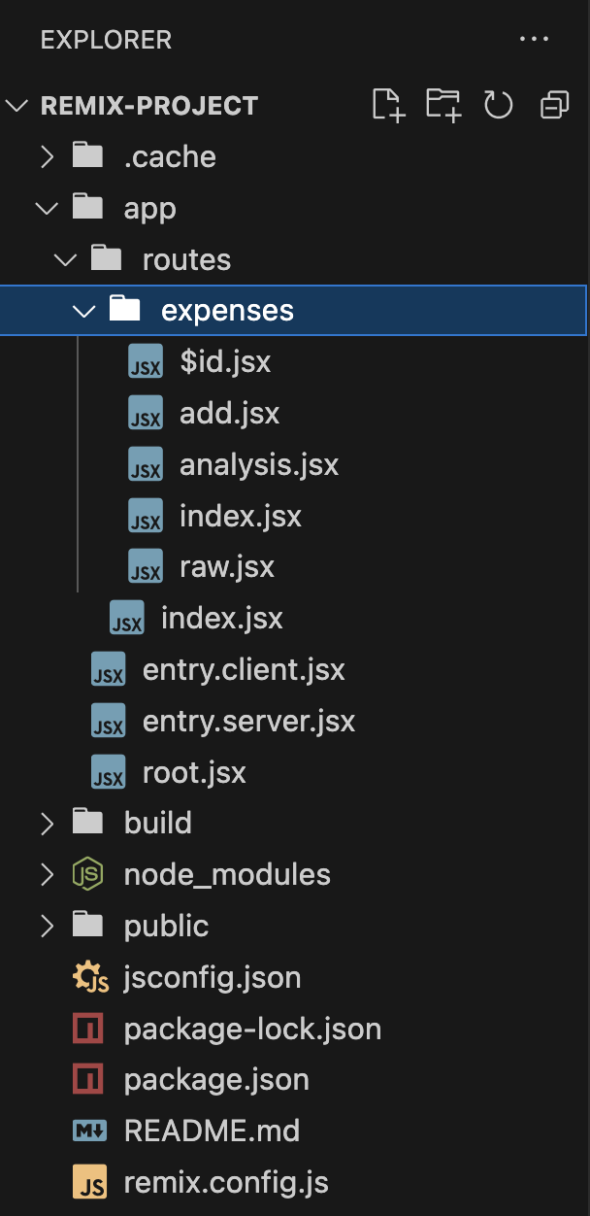

Layout
As we know, in the root file we have a <Outlet/> which act as a component in which all our other components will be injected and rendered.
We can use the same concept for “expenses” folder as well, where we need a particular header and footer for only child components of expenses then we can create a expense lauout component. In my case I need a layout component of expenses so I deleted the index.js file in the expenses folder. And also I don’t want the layout to my raw component “/expenses/raw”, so I can delete that component in the expenses folder and I can go with the dot notation outside the expenses folder.

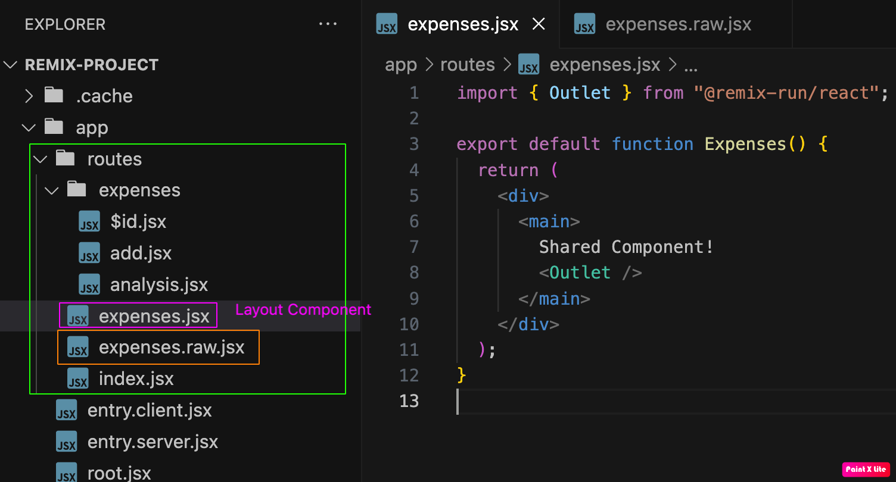

Absolute and Relative Path

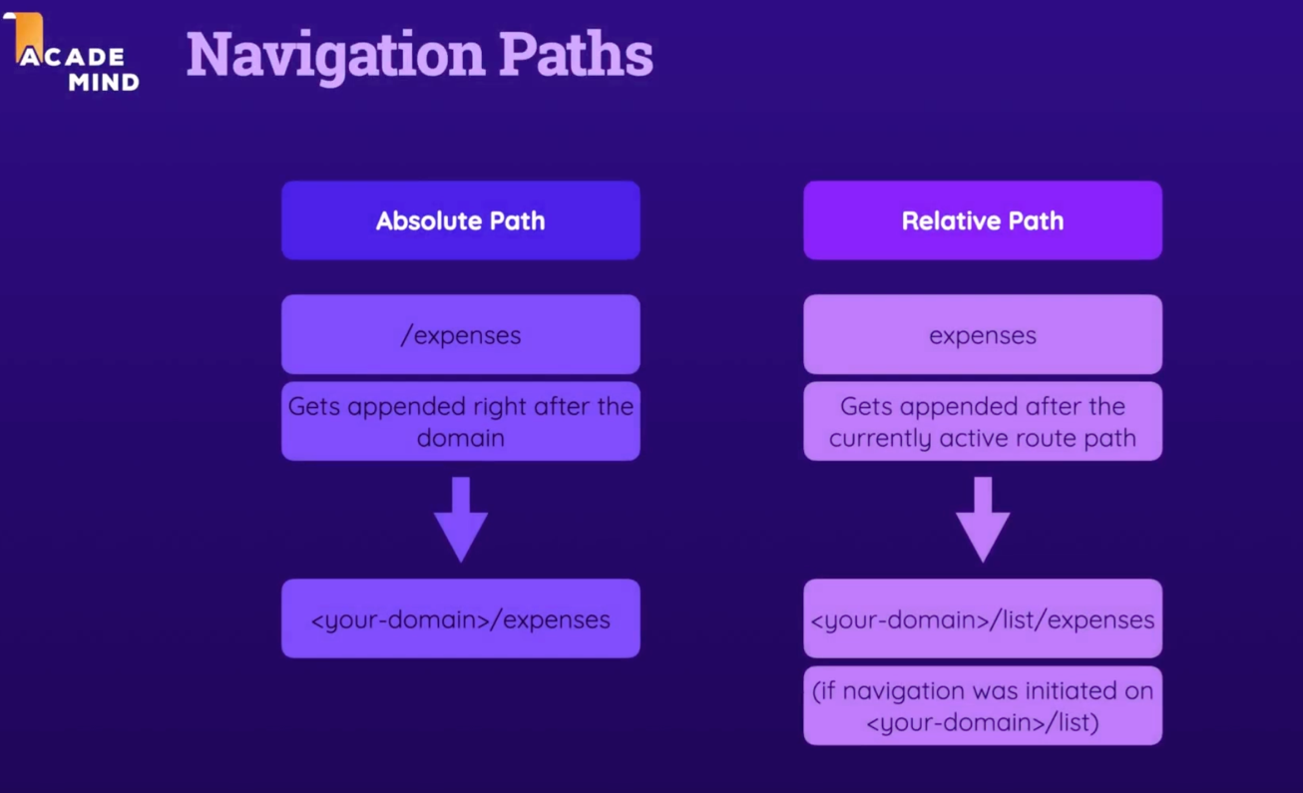
Link
We have to use Link Component when we want to navigate between the components.
If we want to go step back from current route, we can achieve this <Link to=”..” >
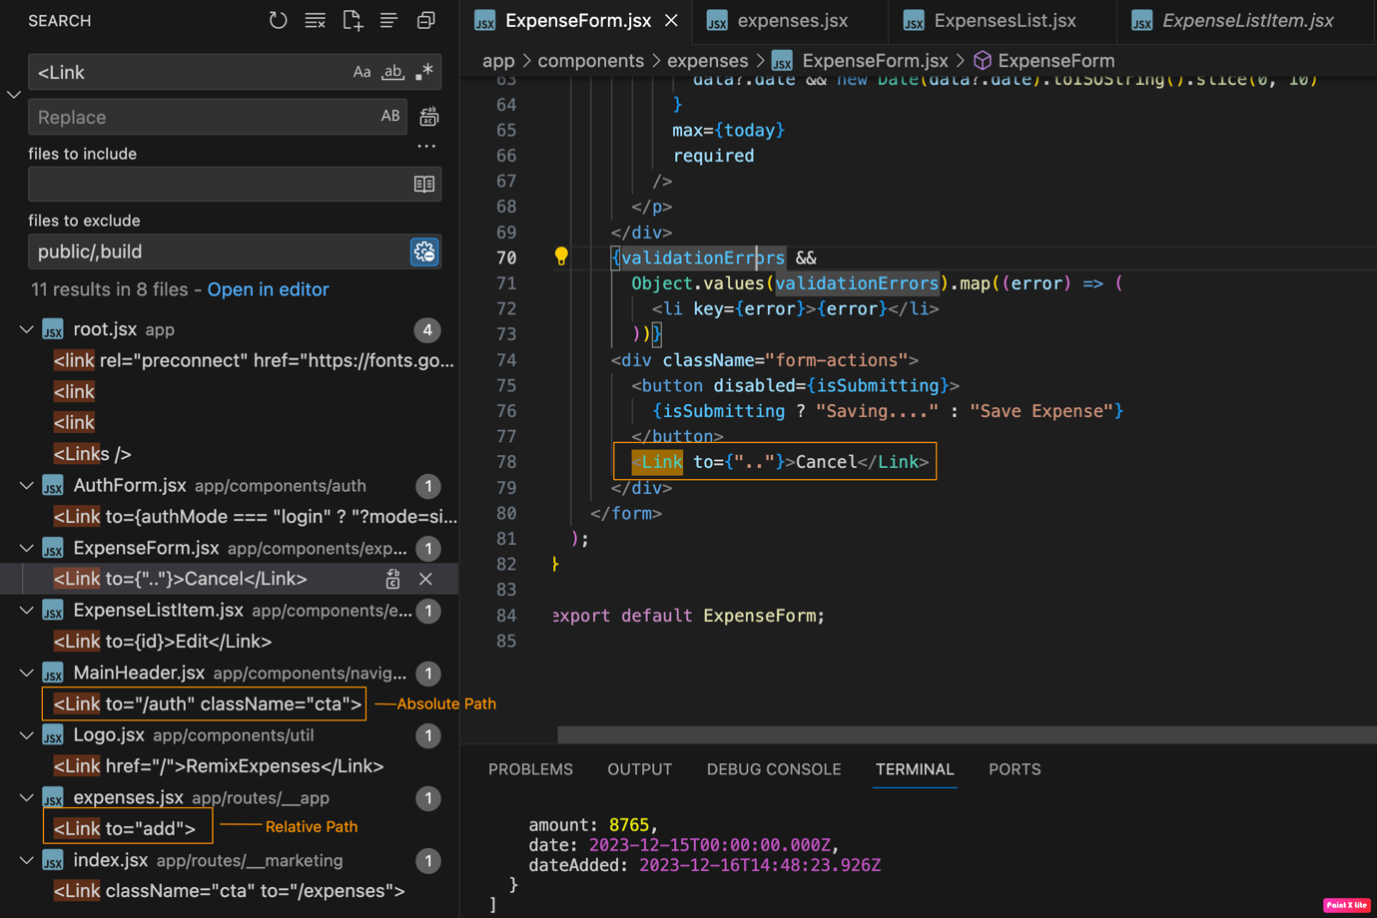

Navigating programetically
We can use useNavigate hook to navigate programatically in front-end.
We can use redirect to navigate programatically in backend.
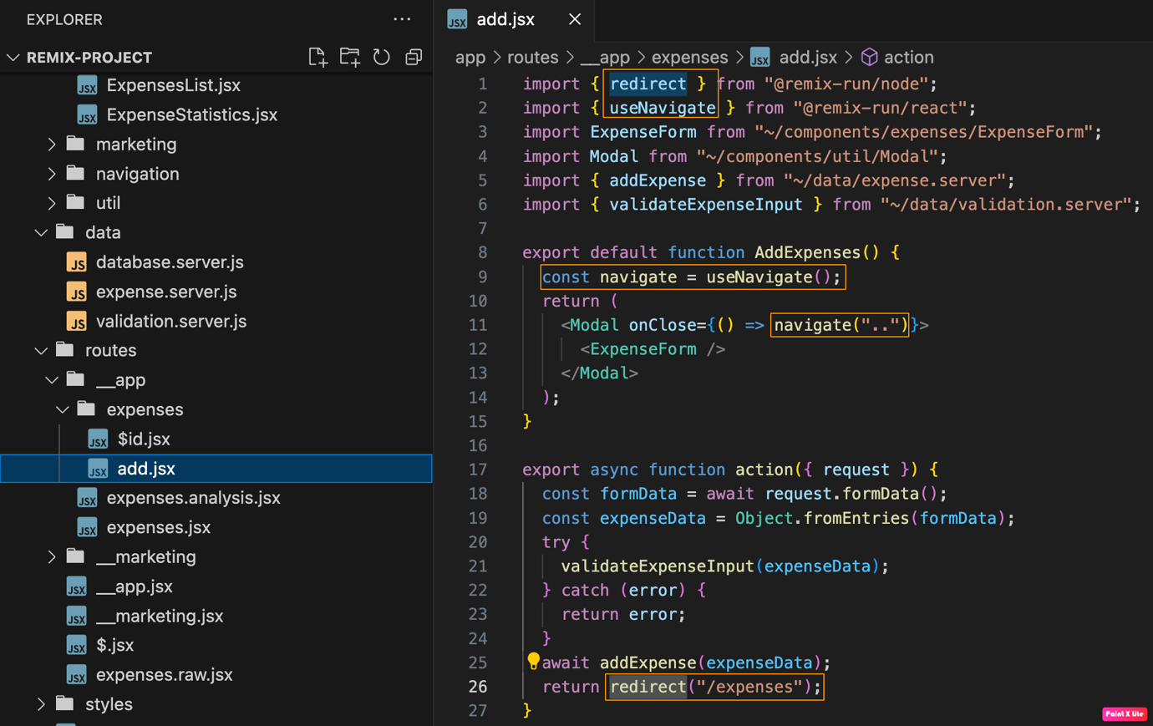
PathLess Layout Route
PathLess Layout route is a layout route we can add to add an extra layer/level of nesting without adding a new path to the URL. We need to create a folder “__app” which wont be included in the URL, and we have to create a “__app.jsx” file which will act as layout file for __app folder. Now we can move all the expense.jsx, expense.analysis.jsx, expense/ folder inside of the __app folder. Now if we add the styles (links() method) inside of the “__app.jsx” it will be availble to expense.analysis.jsx as well.

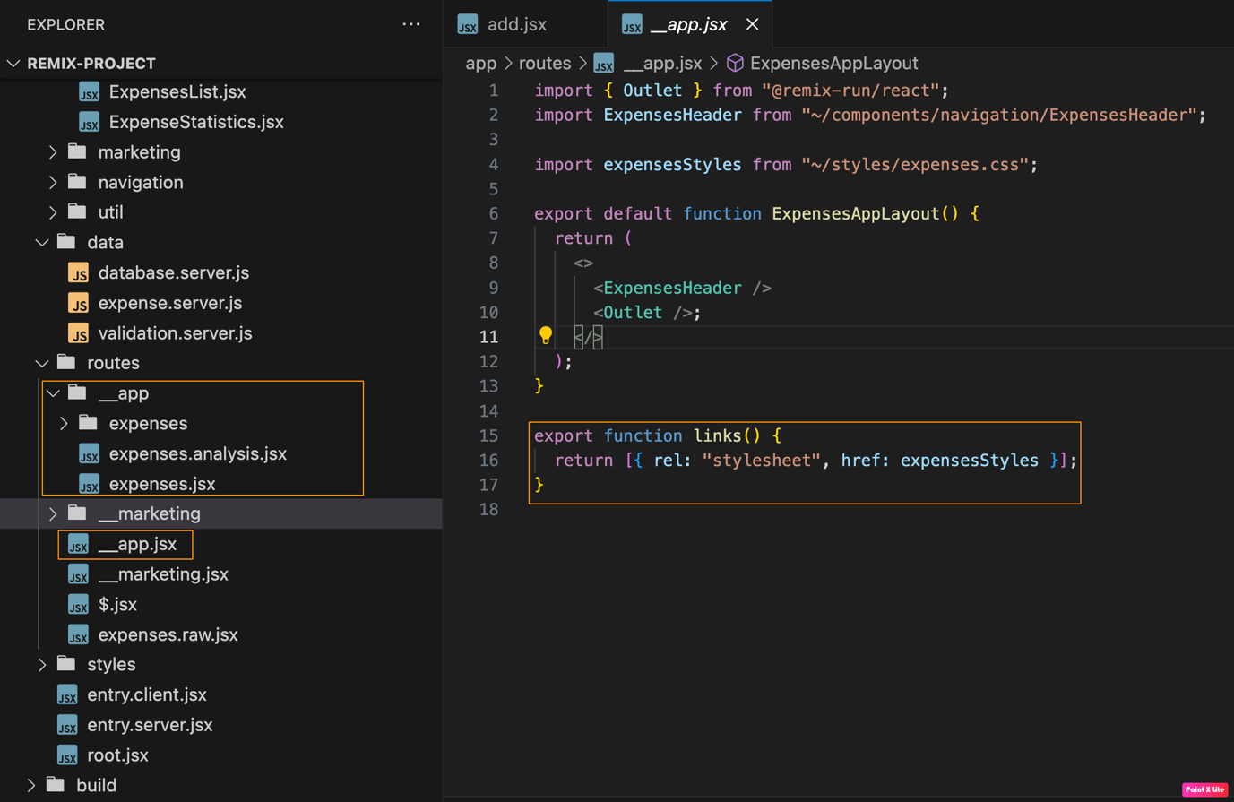

Resource Route:
It is a Route which give raw data.

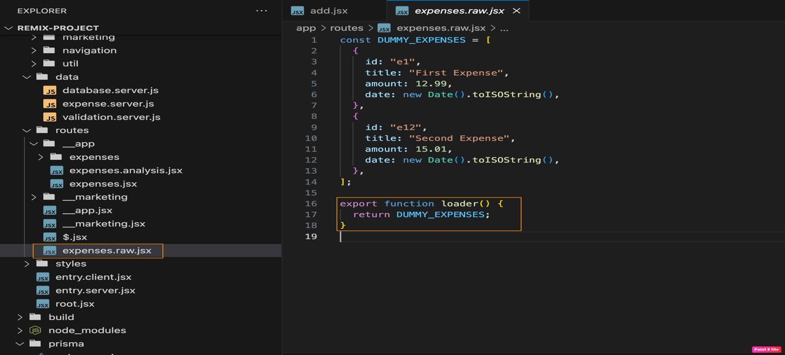

Splat Routes
When a old route name to depricated or changed to a new route, this Splat Route concept is helpful.

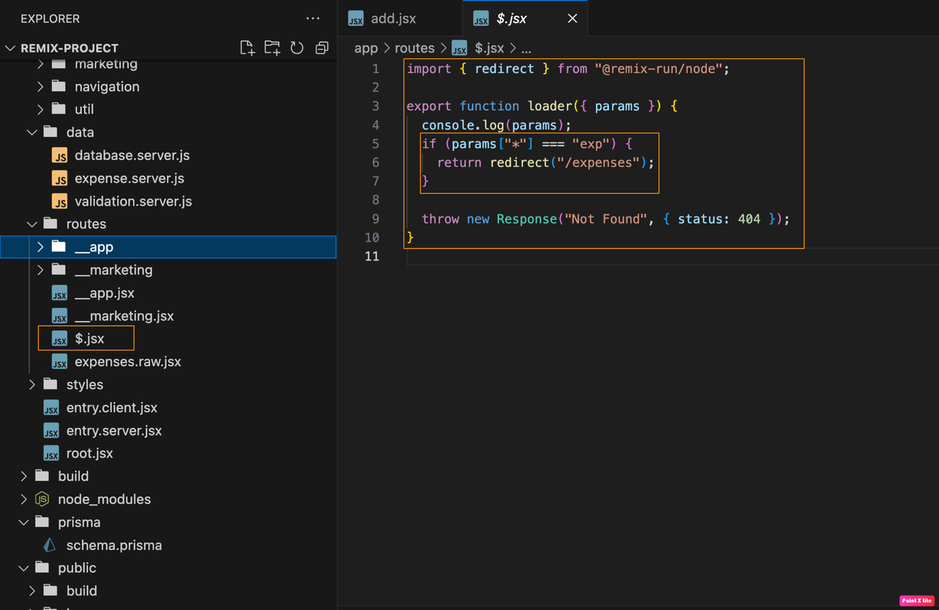

ALL ROUTES

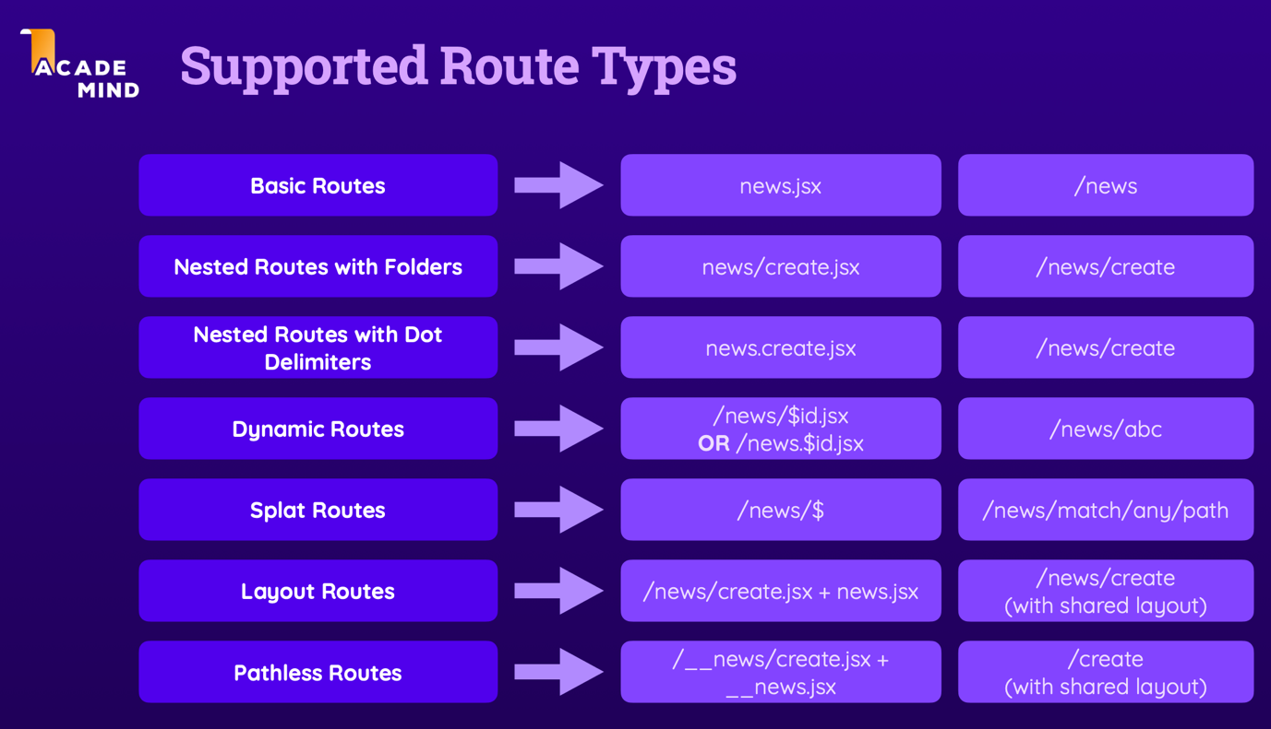

useSearchParams
To read the search parameters from the URL, we use the useSearchParams hook from react.

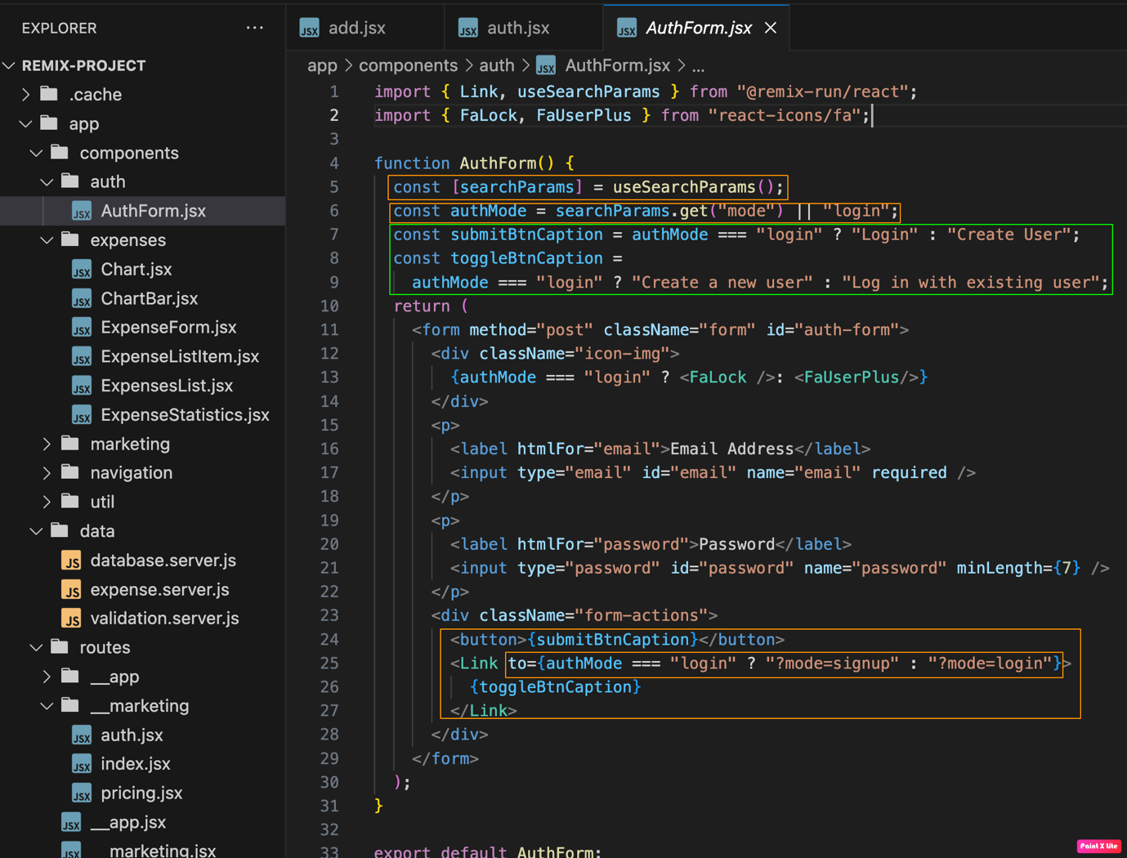

MONGO DB / PRISMA

PRISMA
We use prisma as a tool connect to mongodb. It is more like spring data jpa which contains basic crud operations. So with prisim we can interact with mongodb easily.
Install prisma as a dependency.

npm install prisma --save-dev
npx prisma init --datasource-provider mongodb
npx prisma generate -> it knows about our data and gives us the auto completion
npx prisma db push -> To update the db changes to database cluster.

By Executing the above commands we will get .env file and schema.prisma file. In the .env file put the DATABASE URL (ATLAS FREE CLUSTER CONNECTION URL)

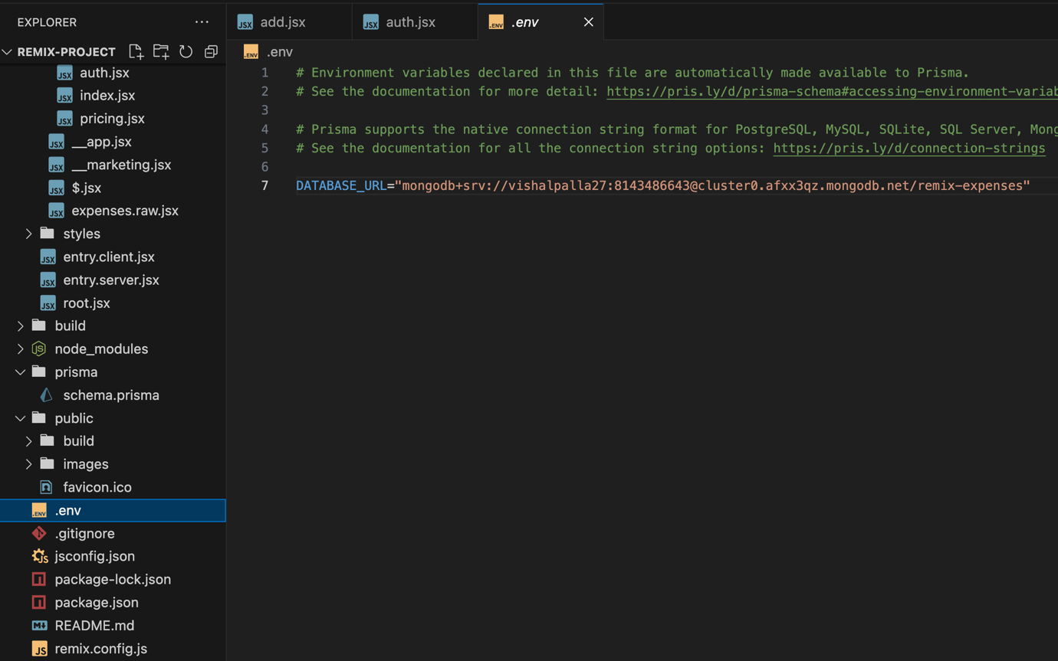

Model
We will create Model for Expense object, this model is the structute of object in mongodb, Same like Entity class in spring boot.

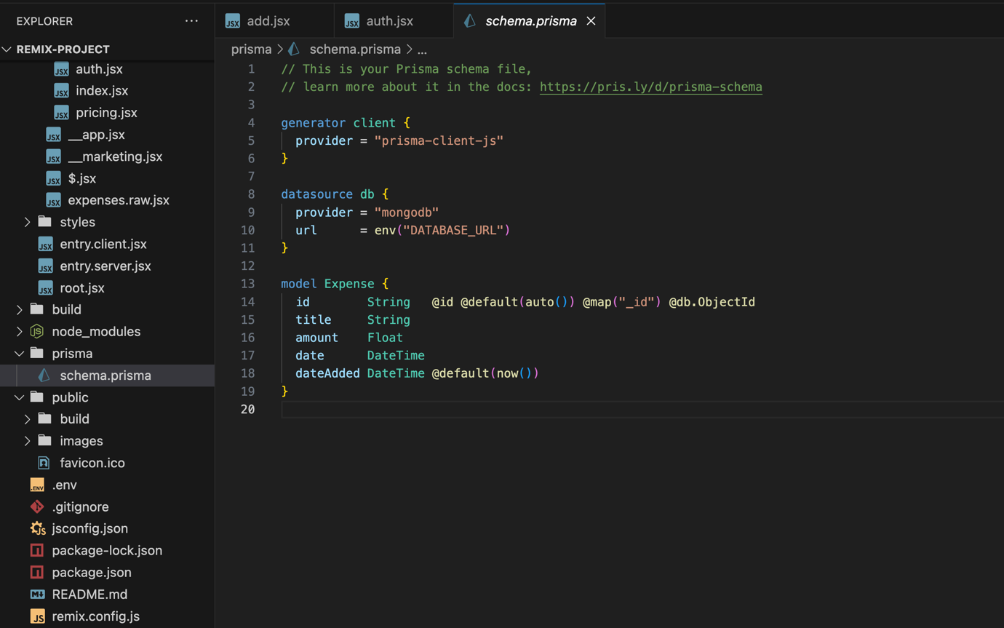

FormSubmition and Sending/Adding data in MONGODB
once Form is submitted in ExpenseForm component, action() method will be triggered with input request data, we are sending that data to the “addExpense()” method in expense.server.js file to store in mongodb.

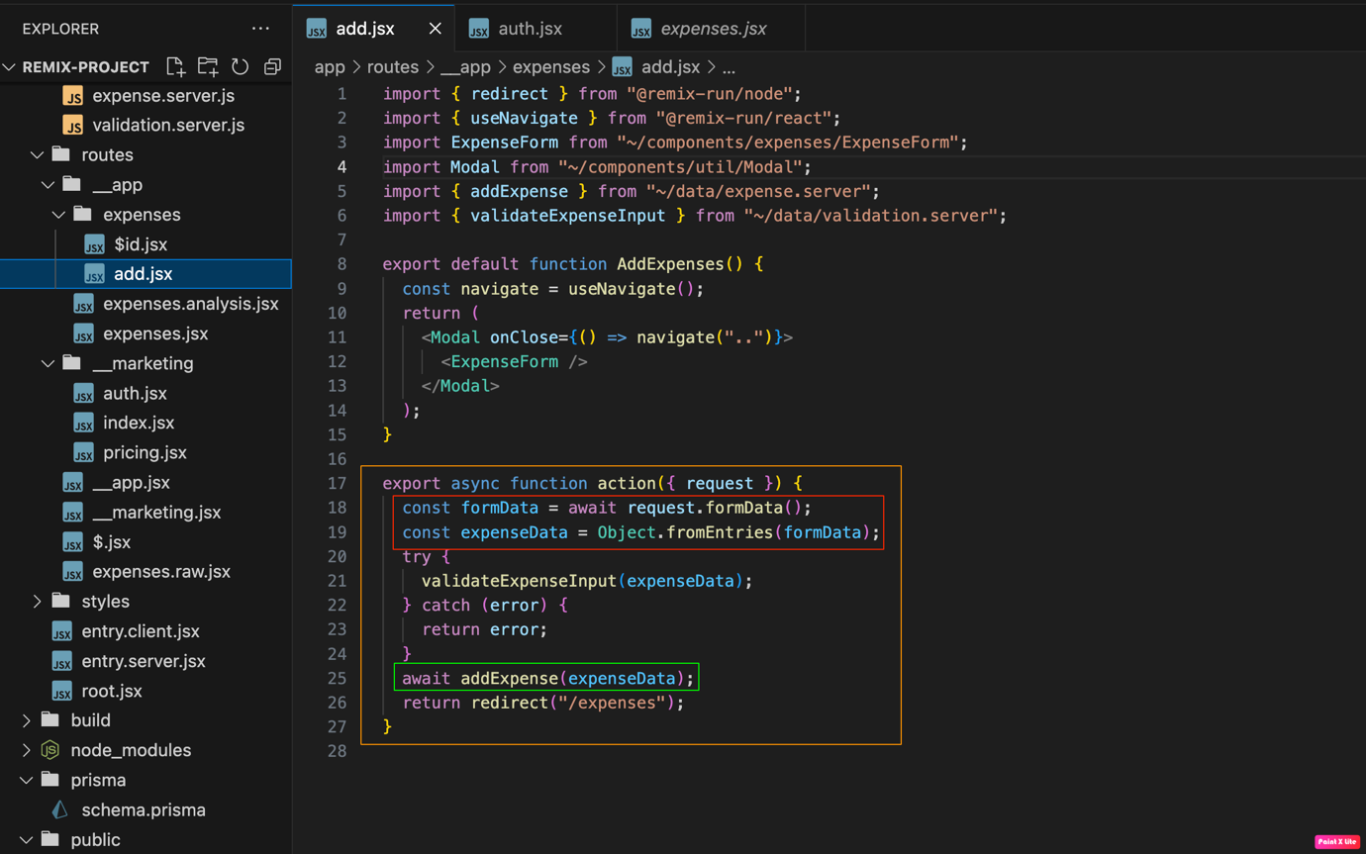

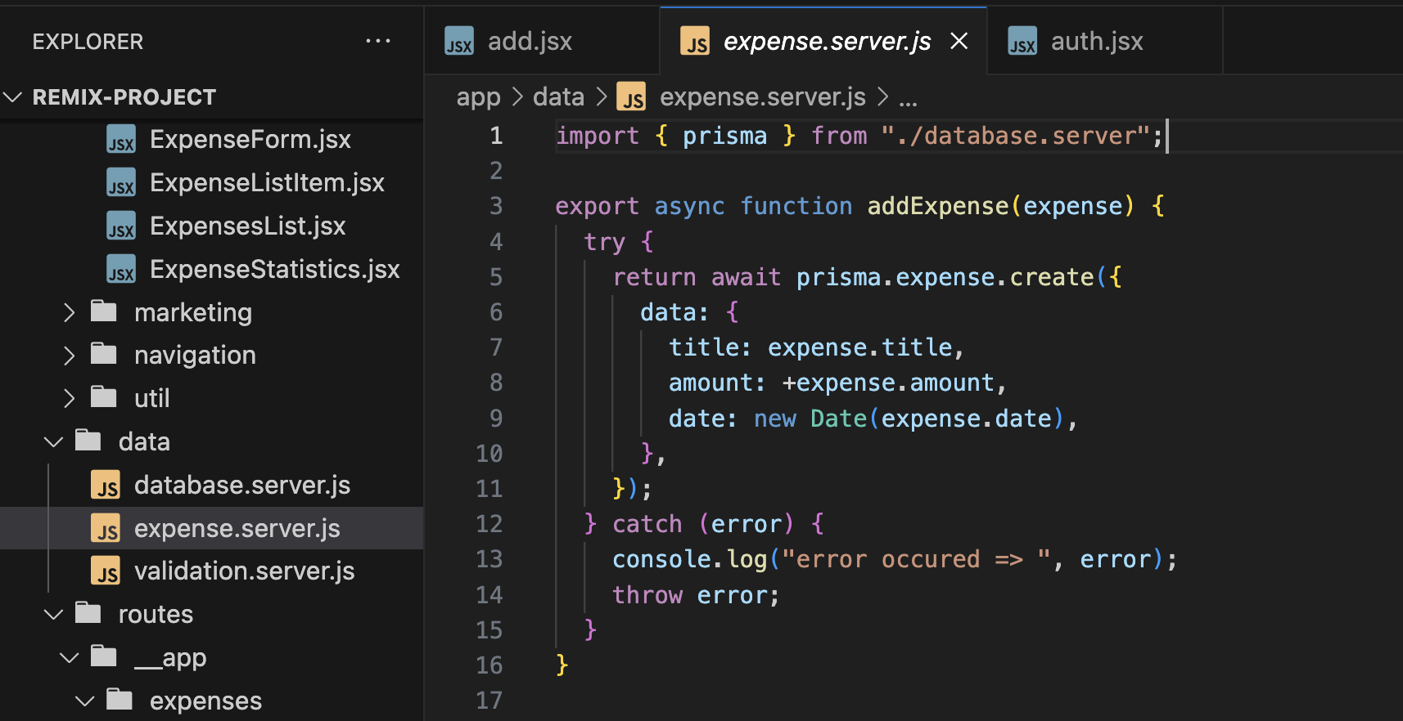

Validating the Input form data

We are validating the data in action() method and throwing the error, if input data is invalid, we are retriving the data using useActionData hook in ExpenseForm component and showing the error messages on the screen.

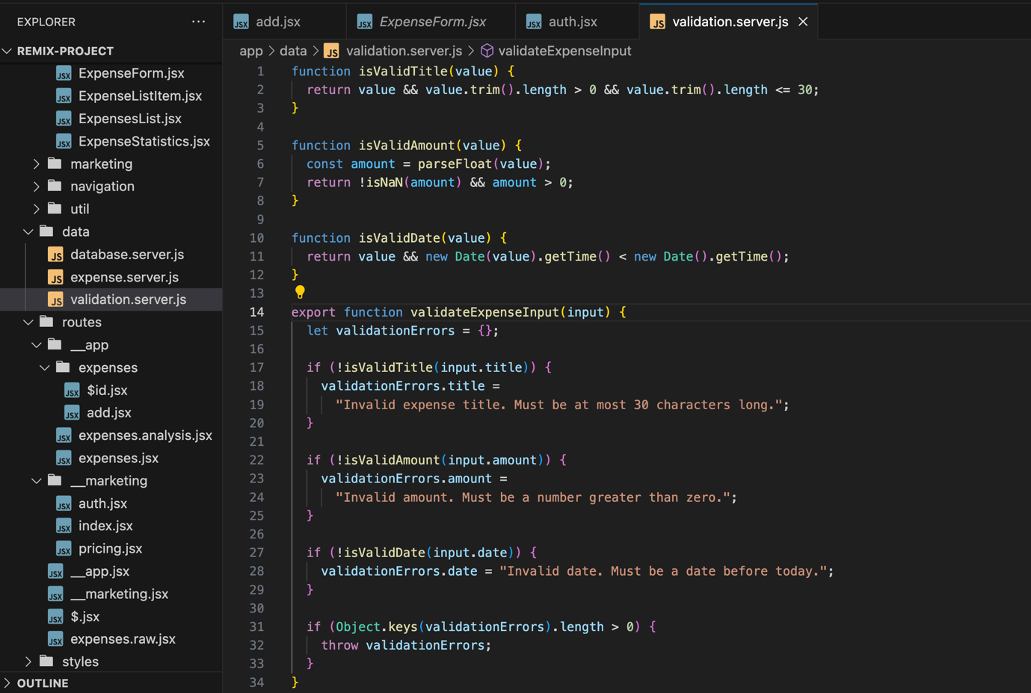

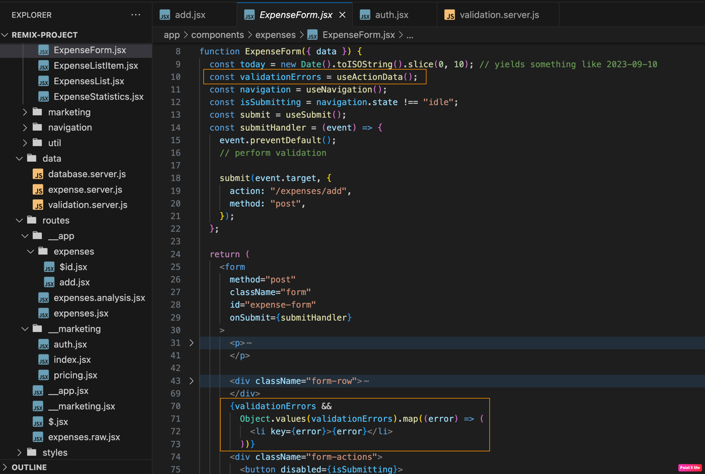

Submitting the forms programtically
We might have some custom validations on submitting the data, for we can programetically submit the data.

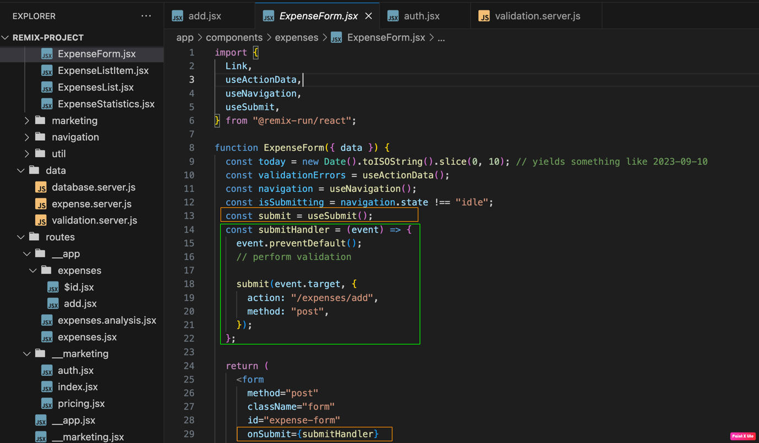

Usage of FORM Component

We should use FORM Component instead of form html tag, form html refreshes the page, but FORM tag don’t refresh the page and works same like form tag.

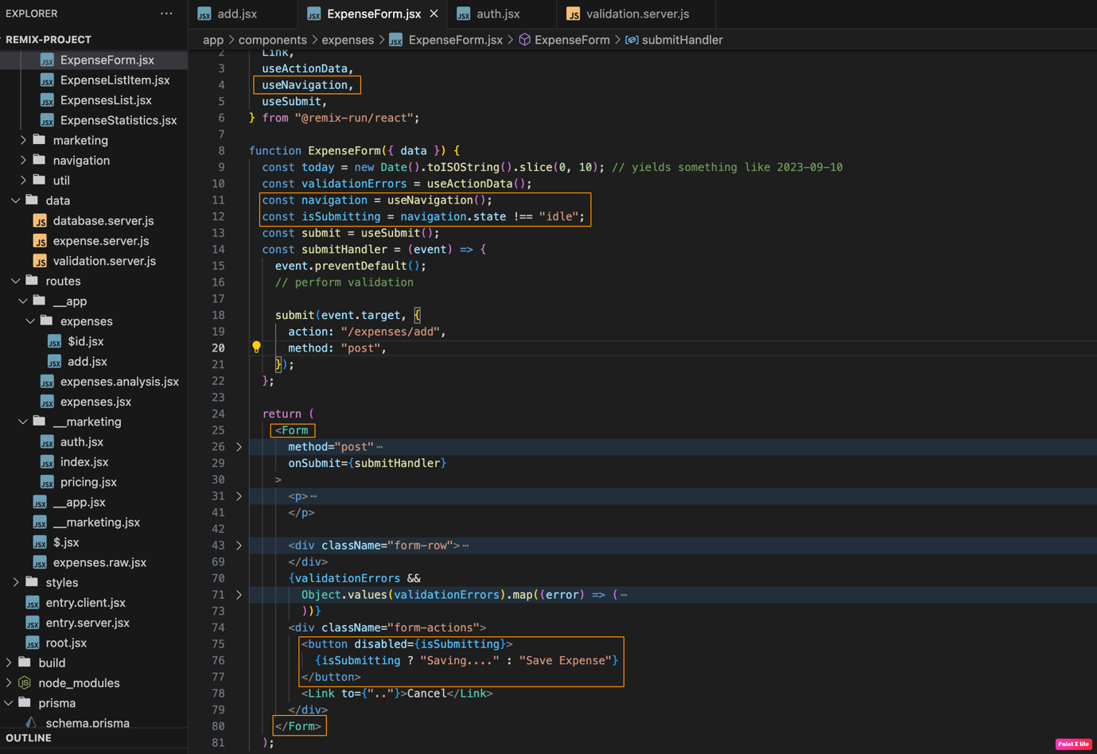

Loaders – A closer look

Consider there is expense route and expense/id route, id route is placed inside of the expense folder.
Now if we have loader() method inside of expense route component, useLoaderData hook return the data in only expense component. If we try to use useLoaderData hook inside of the expense/id, id route component page we will get undefined.
So if we are in the id page, loader() method of that component returns any data, that data only will receive for useLoaderData() in id page component.

useMatches
If data is already loaded in the /expenses route and if we want to use that data in the child route i.e expenses/{id}, then we can use the useMatches hook.

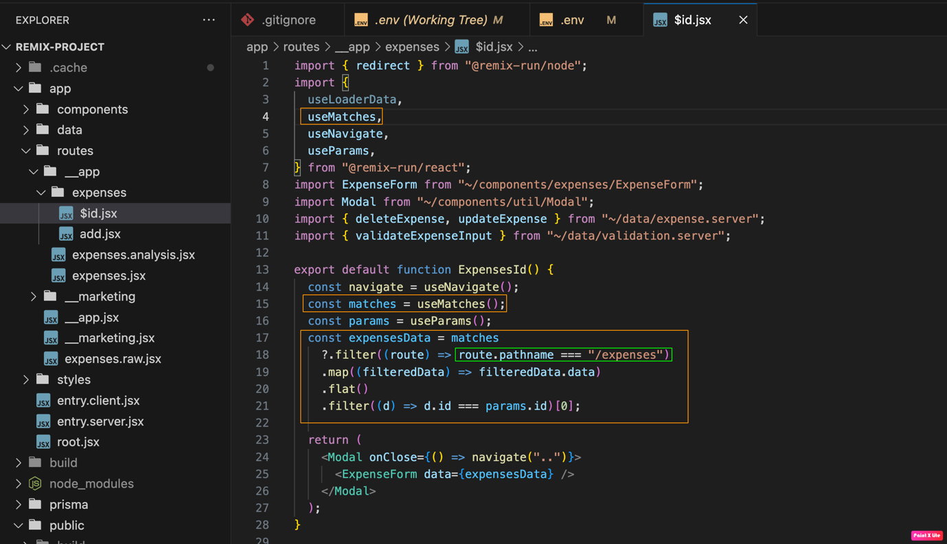

Deleting the data using One Action – Multiple forms

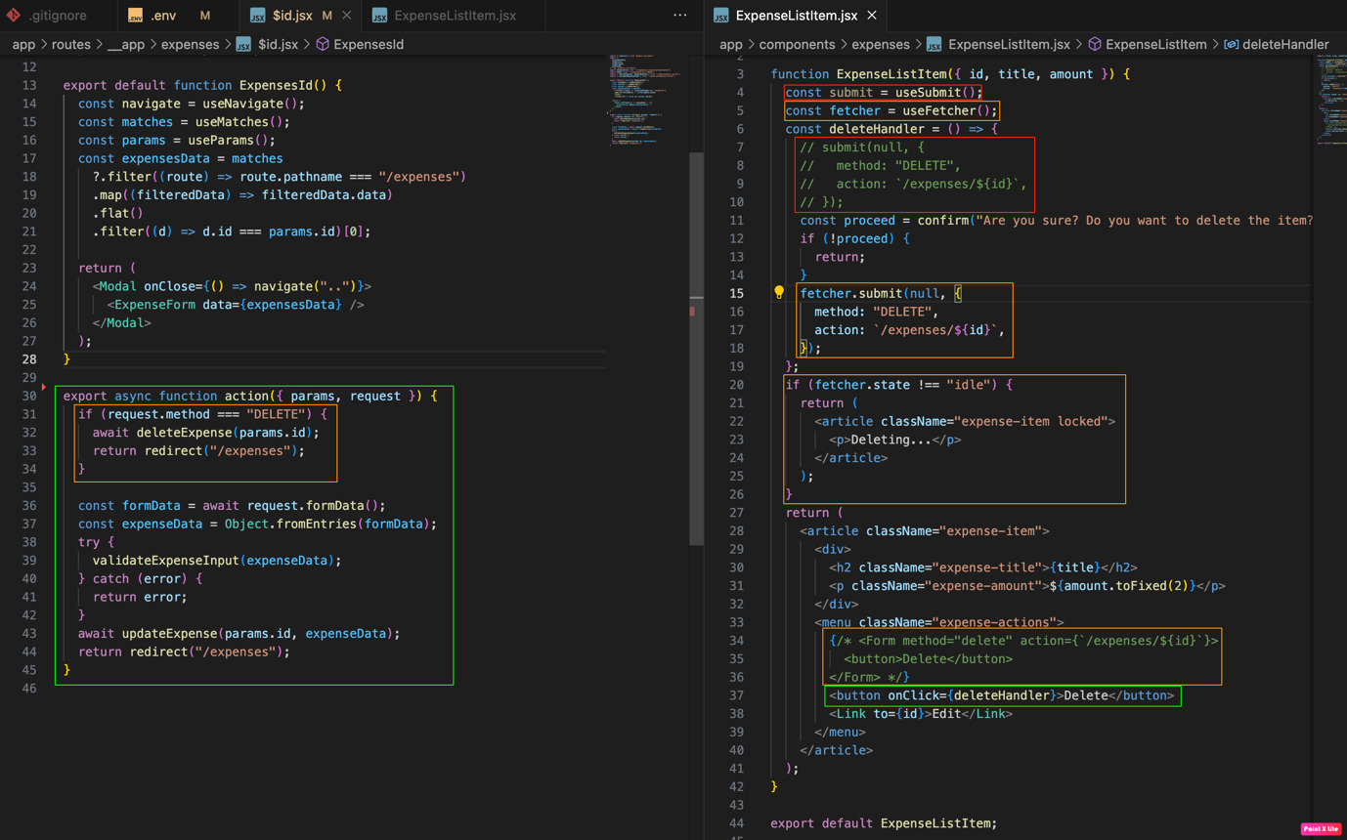

As you can see in above image, the right side in ExpenseListItem.jsx we have delete button, upon clicking the button we have to delete the expense, and that can be done using many ways.
- Using <Form /> Component delete method.
- Using useSubmit() hook.
- Using useFetch() hook.
Using above 3 ways we are sending a action to “/expense/{id}” component and we are conditional calling the database in the action() method.

Url Search Parameters Reading in Backend
In the left side component we can see how we are reading the url search params in the backend and right side we can see how we are reading in front-end.

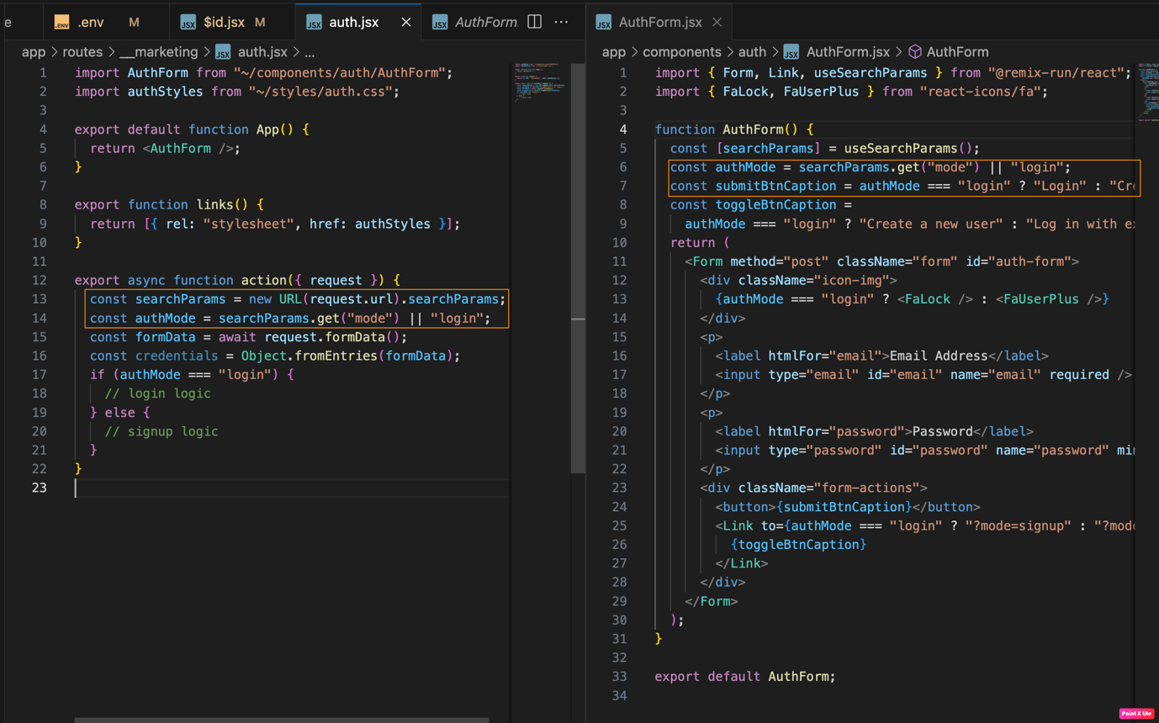

Reading Params in action() method
When a form is submitted, we will catch that form in the action() method, we will get params as input to the method, so from params we can get the data of path varibles like ids.
