JENKINS-SONARQUBE-AWS-ECR-EKS-SECRET-MANAGER-SPRINGBOOT-END-TO-END-CI-CD-PIPELINE

Install Jenkins in an EC2 Server

Follow this link https://www.jenkins.io/doc/tutorials/tutorial-for-installing-jenkins-on-AWS/ or simply type jenkins download in EC2 Linux in google.

In the EC2 Server install git, so Jenkins can clone the repos in Jenkins server.
Execute command “sudo yum install git -y”

Install maven: Jenkins require maven, so install maven, copy the download link of apache maven and execute the command “wget <download link address of apache maven>” inside /opt/
Rename the name of apache-maven-3.8.4 to maven for simplicity use command “mv”

Now we need install plugins for maven, git & github. At the time of installing we will get git & github plugin.

Git & Guthub Plugins screenshots iam attaching for reference.

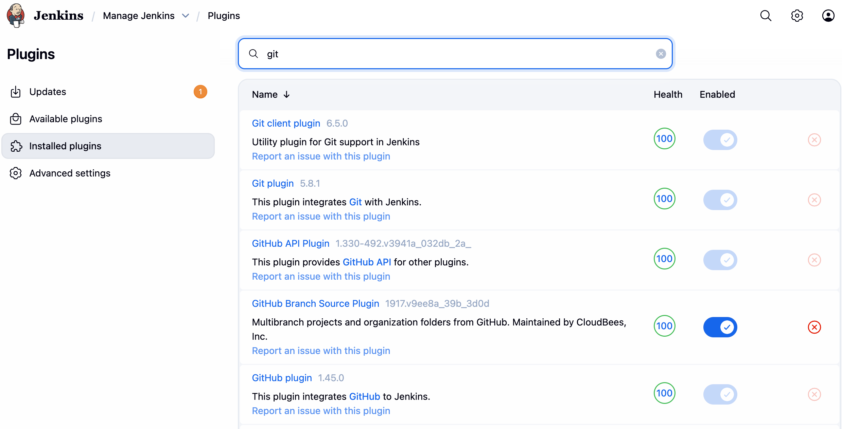

So we need to install maven plugin..
Go to available plugins and search for Maven Integration plugin and install it.

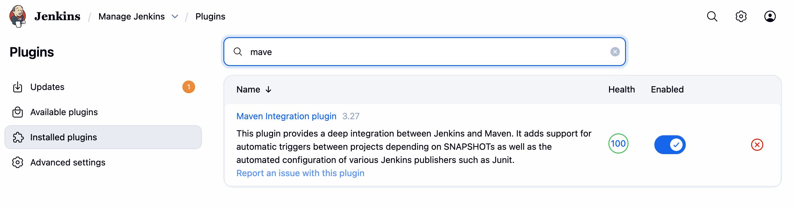
Also install plugin Pipeline: Stage view”

After installing the maven & Java we need to set Environment variables correct, so that jenkins can pick up the installed JDK & MAVEN. Go to root “cd ~”, and execute ll -a, you will see hidden folders, open .bash_profile “vi .bash_profile” and add below variables.

M2_HOME=/opt/maven
M2=/opt/maven/bin
JAVA_HOME=/usr/lib/jvm/java-21-amazon-corretto.x86_64
PATH=$PATH:$HOME/bin:$JAVA_HOME:$M2_HOME:$M2
export PATH

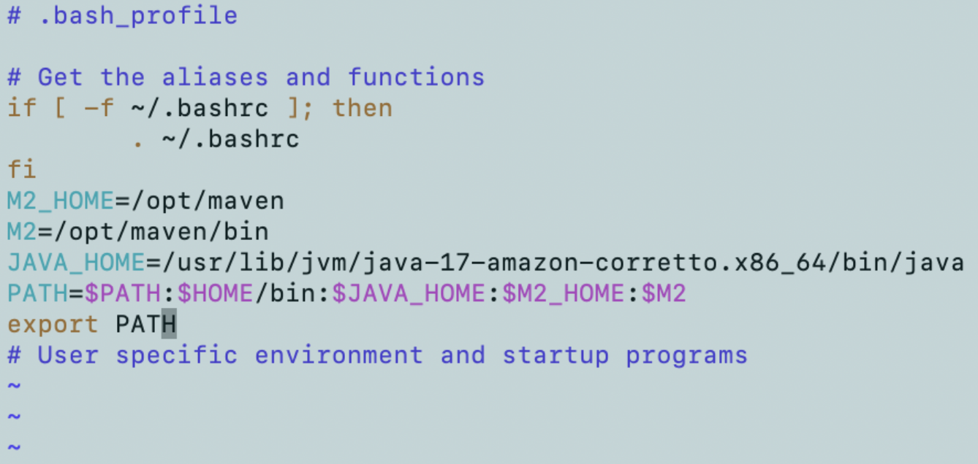

We need to reload the file “.bash_profile”, “source .bash_profile” so that newly added ENV variables will be reflected. To check, execute command “echo $PATH”
VERY IMPORTANT

When we are stopping & re-starting the jenkins server, jenkins UI will load very slowly, too overcome this issue, follow the below steps
1.Login as root.
2.Go to location “cd /var/lib/jenkins”: “vi /var/lib/jenkins/jenkins.model.JenkinsLocationConfiguration.xml”
3.Open this file “vi jenkins.model.JenkinsLocationConfiguration.xml”
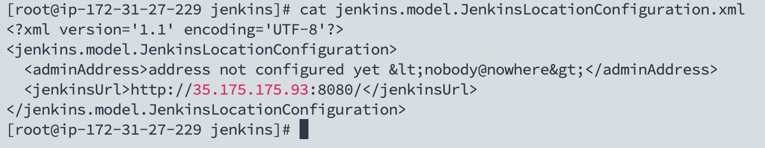
4.Update the Ipv4 address url, in the file “jenkins.model.JenkinsLocationConfiguration.xml”, save and quit.
5.Restart the jenkins “service jenkins restart”

Automating the processing of updating ipv4 public address:
Save this script with name “setup-jenkins-ipv4-auto-update.sh” in the ec2 instance, and execute the below commands only one time after installing jenkins, next after every start & restart the ipv4 address will update automatically.
sudo chmod +x setup-jenkins-ipv4-auto-update.sh
sudo ./setup-jenkins-ipv4-auto-update.sh

Registring or add credentials of another server/node/slave in the jenkins

I Created an EC2 Instance of t3xlarge with 30GB EBS volume for BuildSlave node.

Go to Manage jenkins.
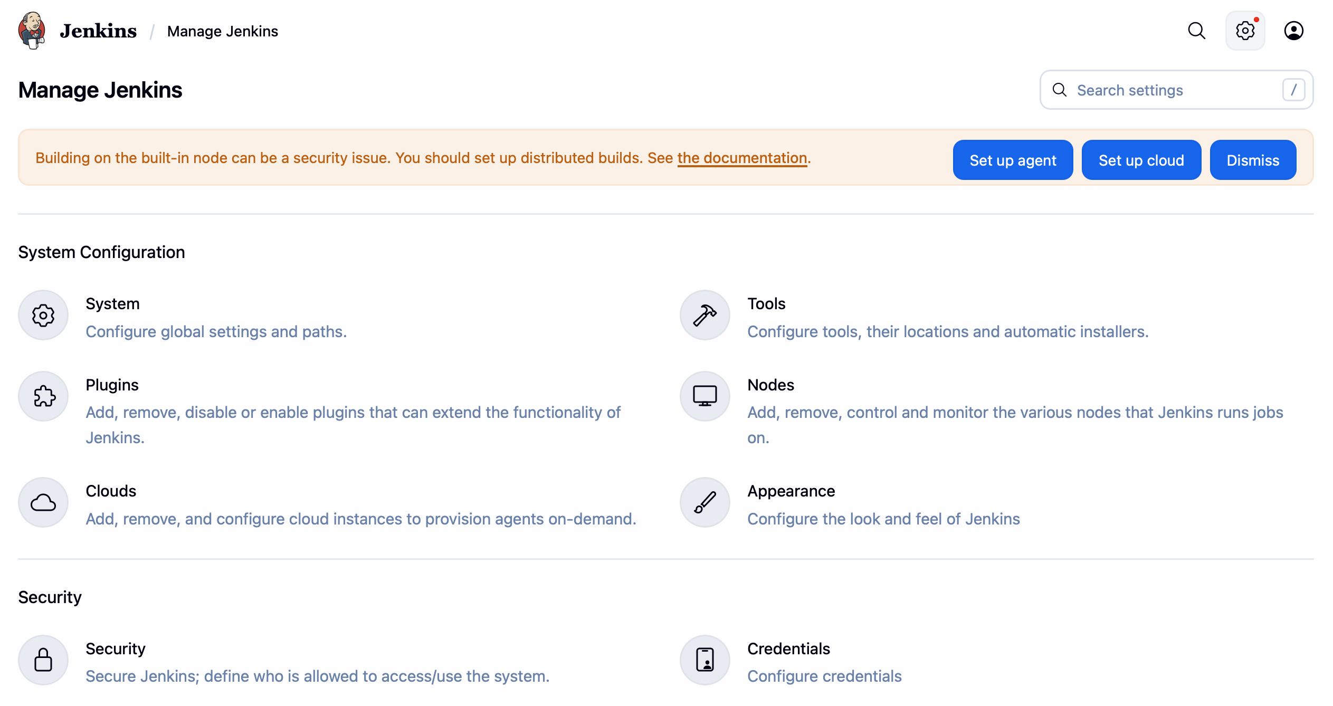

Go to the Credentials
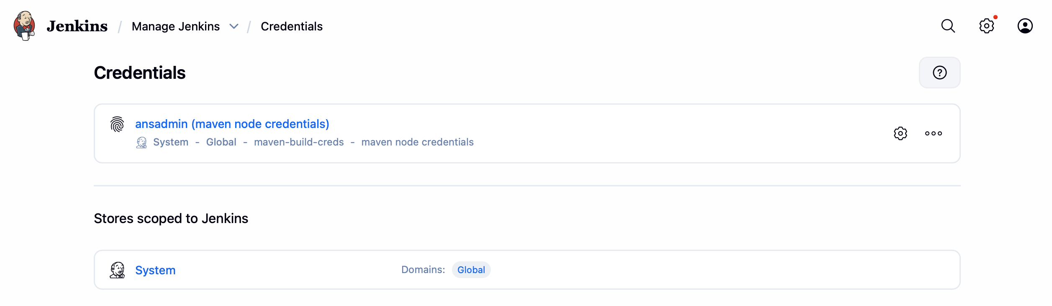

Go to the System: to add the credentials

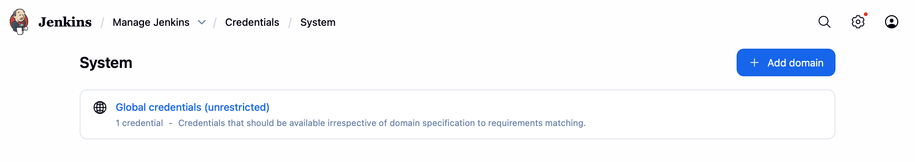

Go to the Global credentials

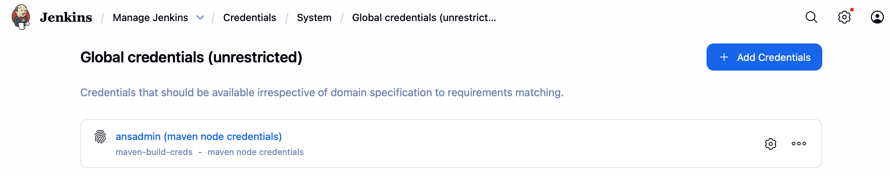

Click on Add Credentials & follow as per the below screenshot



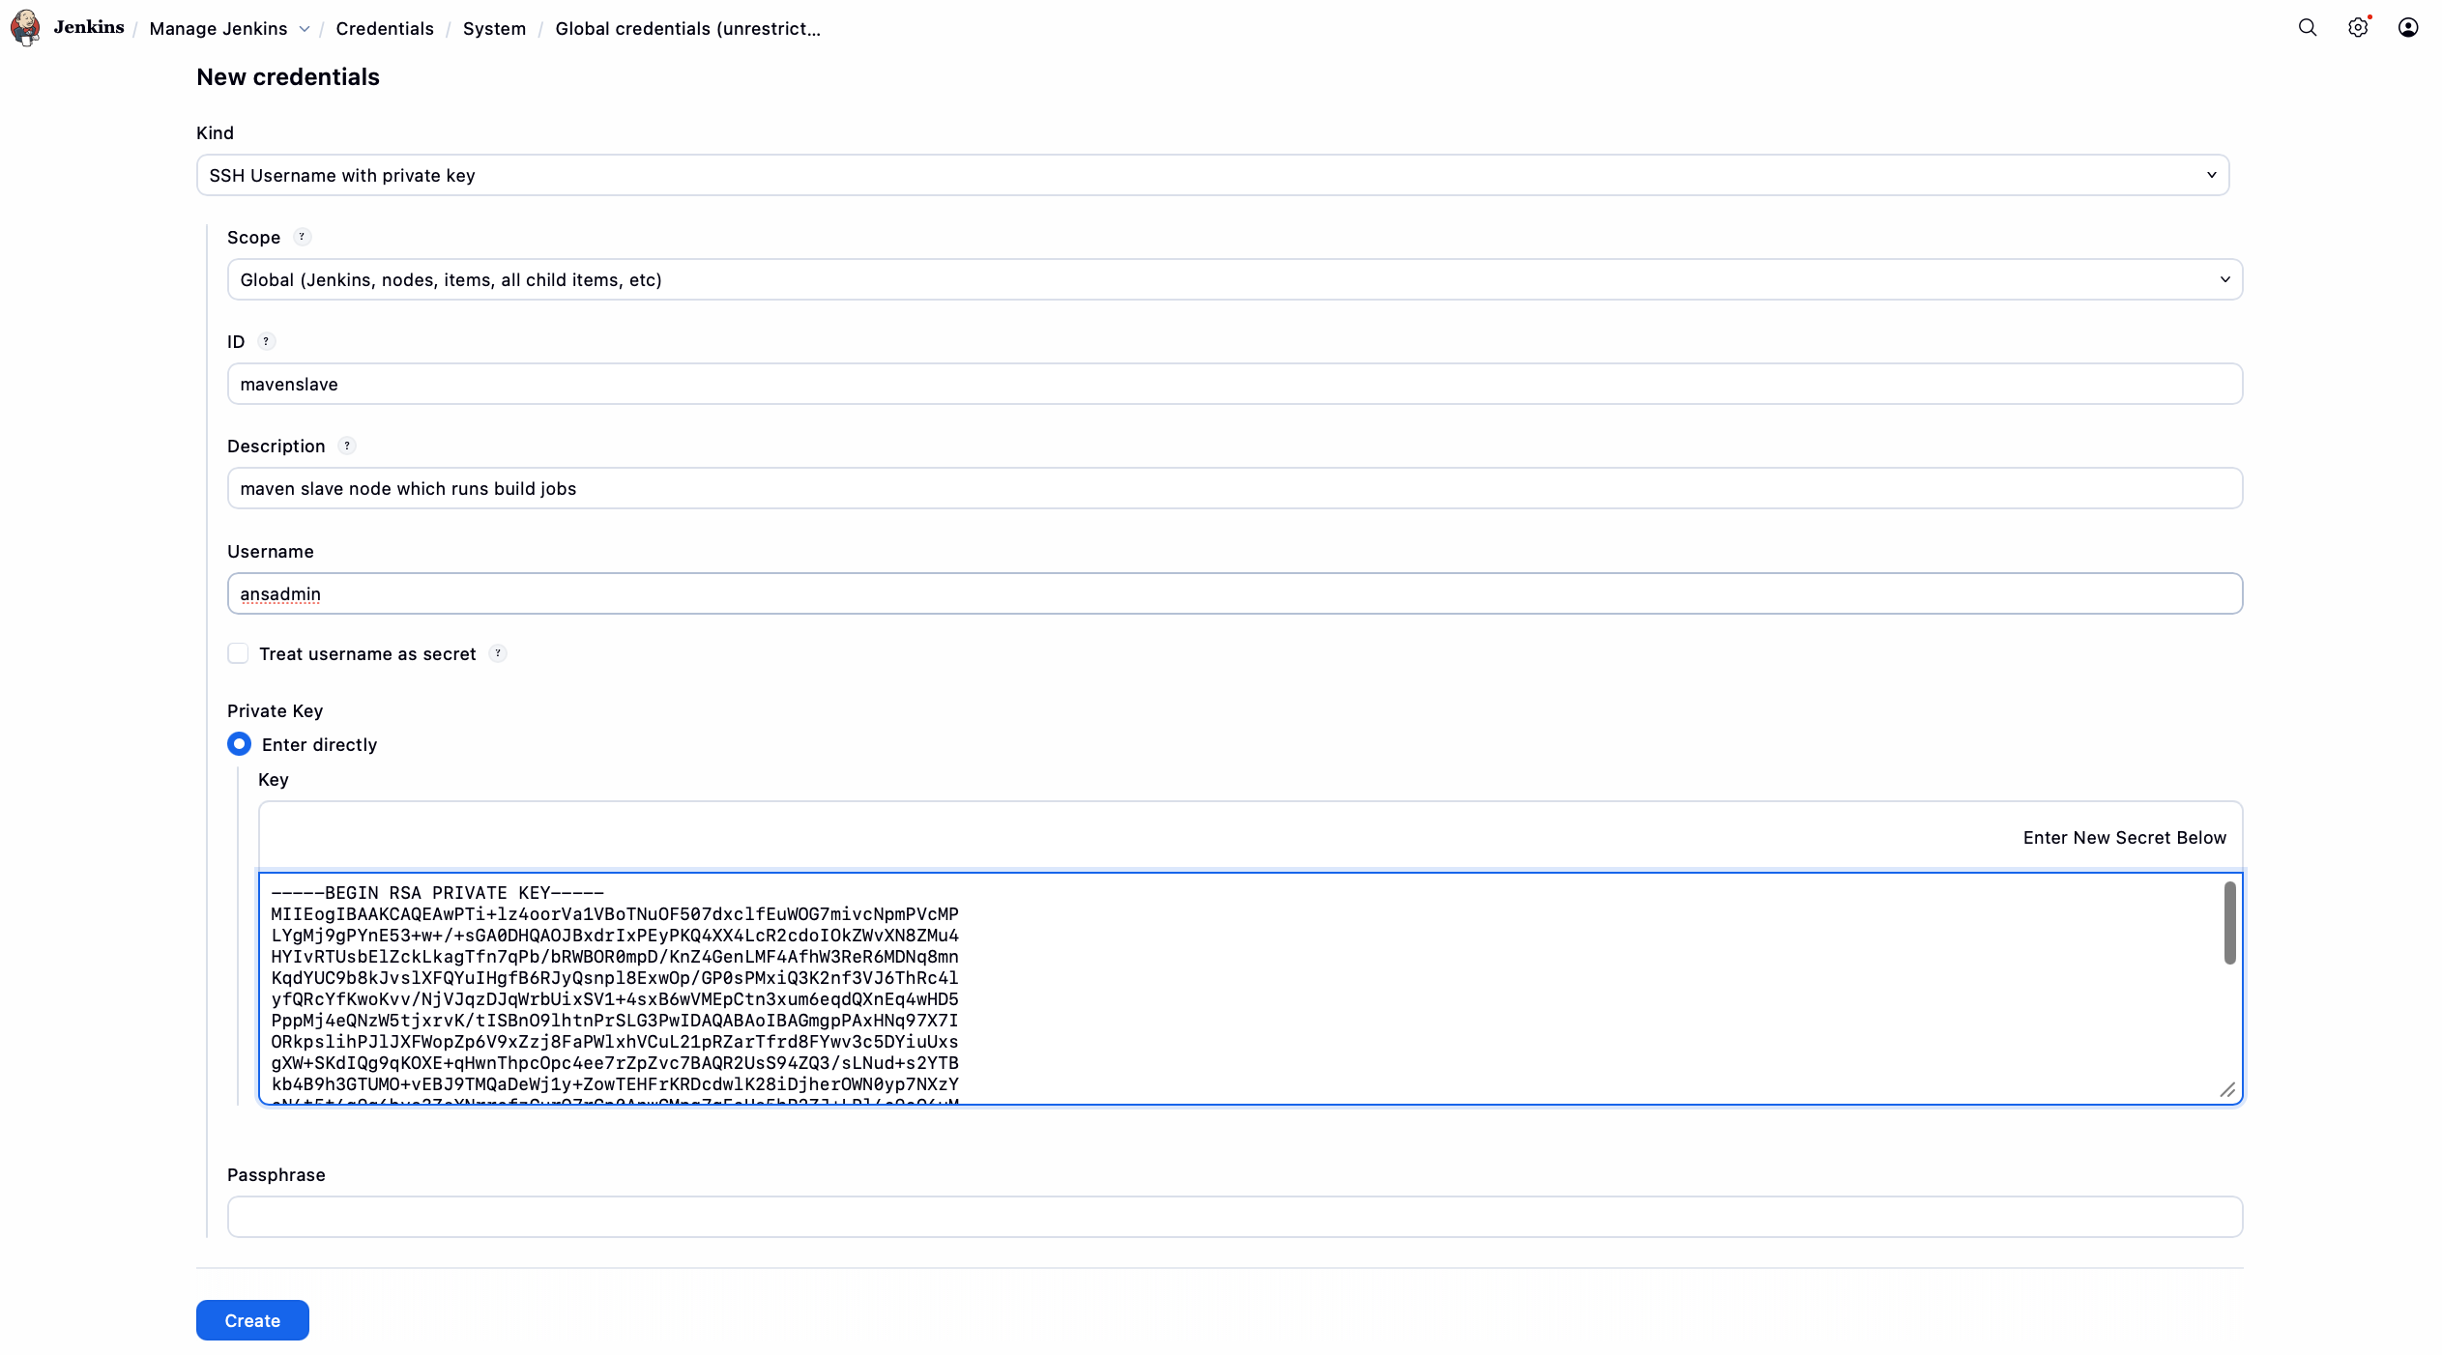

How to add a server as node in the Jenkins

First go to the maven slave node and create the disk based temp directory: We need to do this step otherwise JENKINS will mark this slave node as “Disk space is below threshold of 1 GB. ….left on /tmp”..

On small EC2 instances, Jenkins agents fail disk checks because /tmp is tmpfs. The permanent fix is to configure the agent JVM to use a disk-based temp directory using -Djava.io.tmpdir, which eliminates false disk-space errors and stabilizes builds.

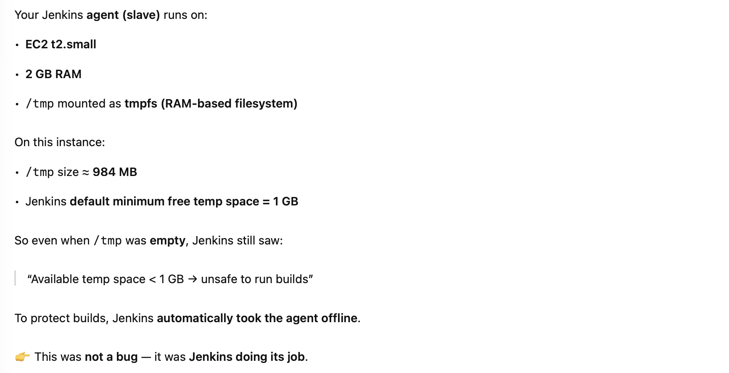

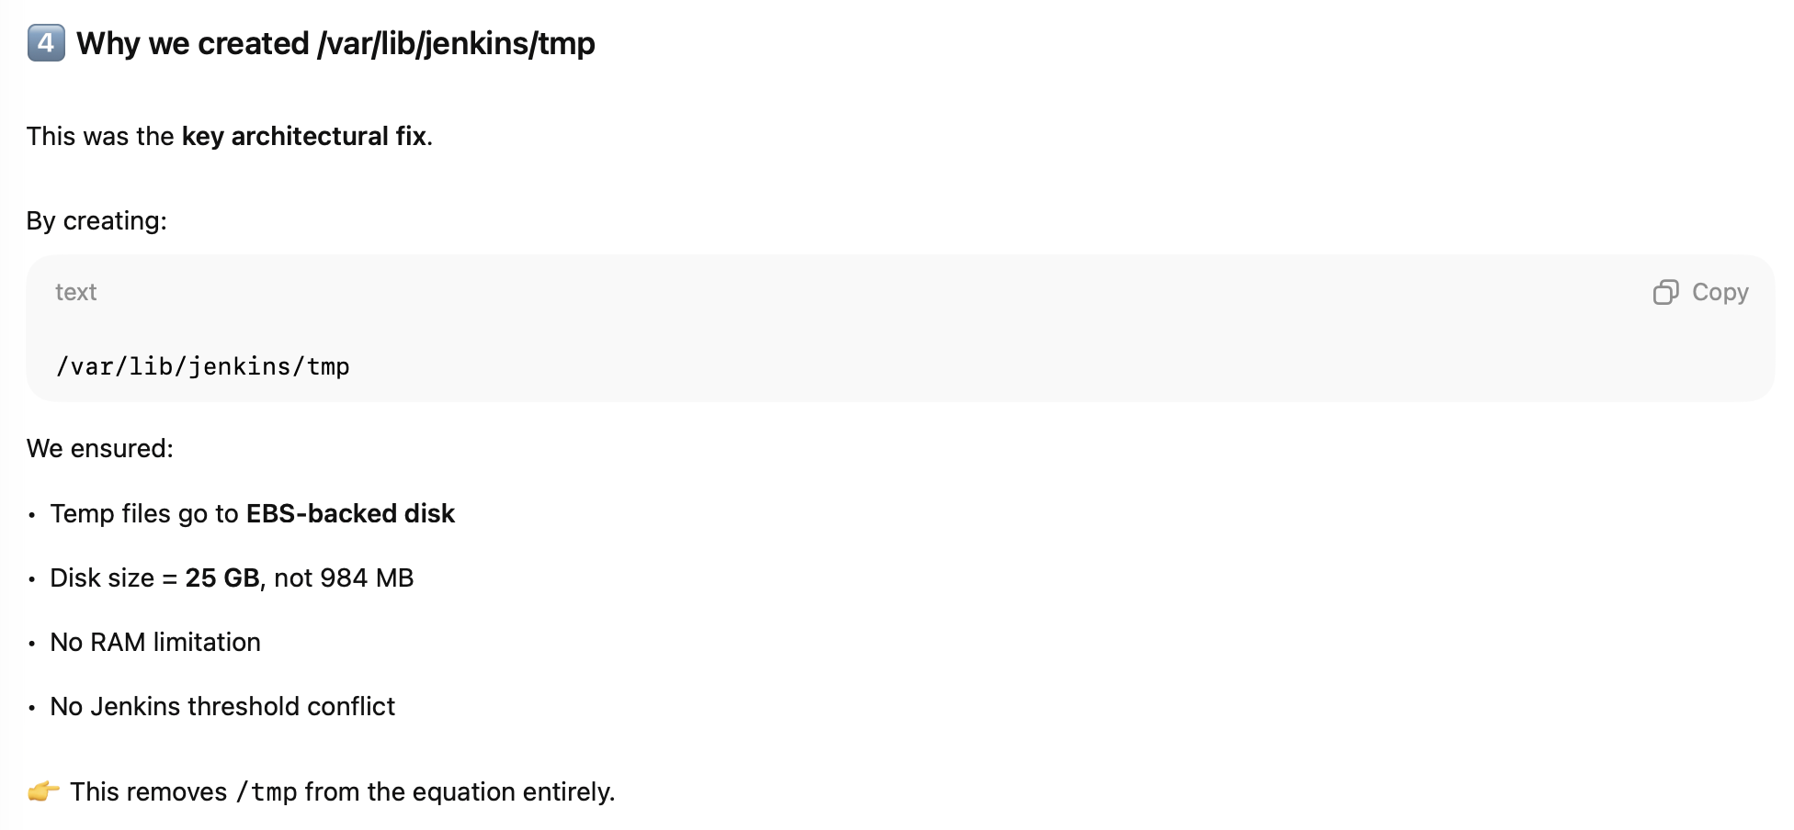

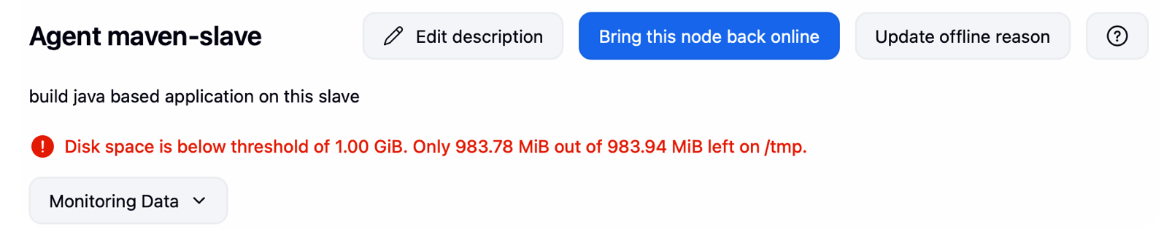

sudo mkdir -p /var/lib/jenkins/tmp
sudo chown ec2-user:ec2-user /var/lib/jenkins/tmp
sudo chmod 755 /var/lib/jenkins/tmp

Go to manage Jenkins > Nodes

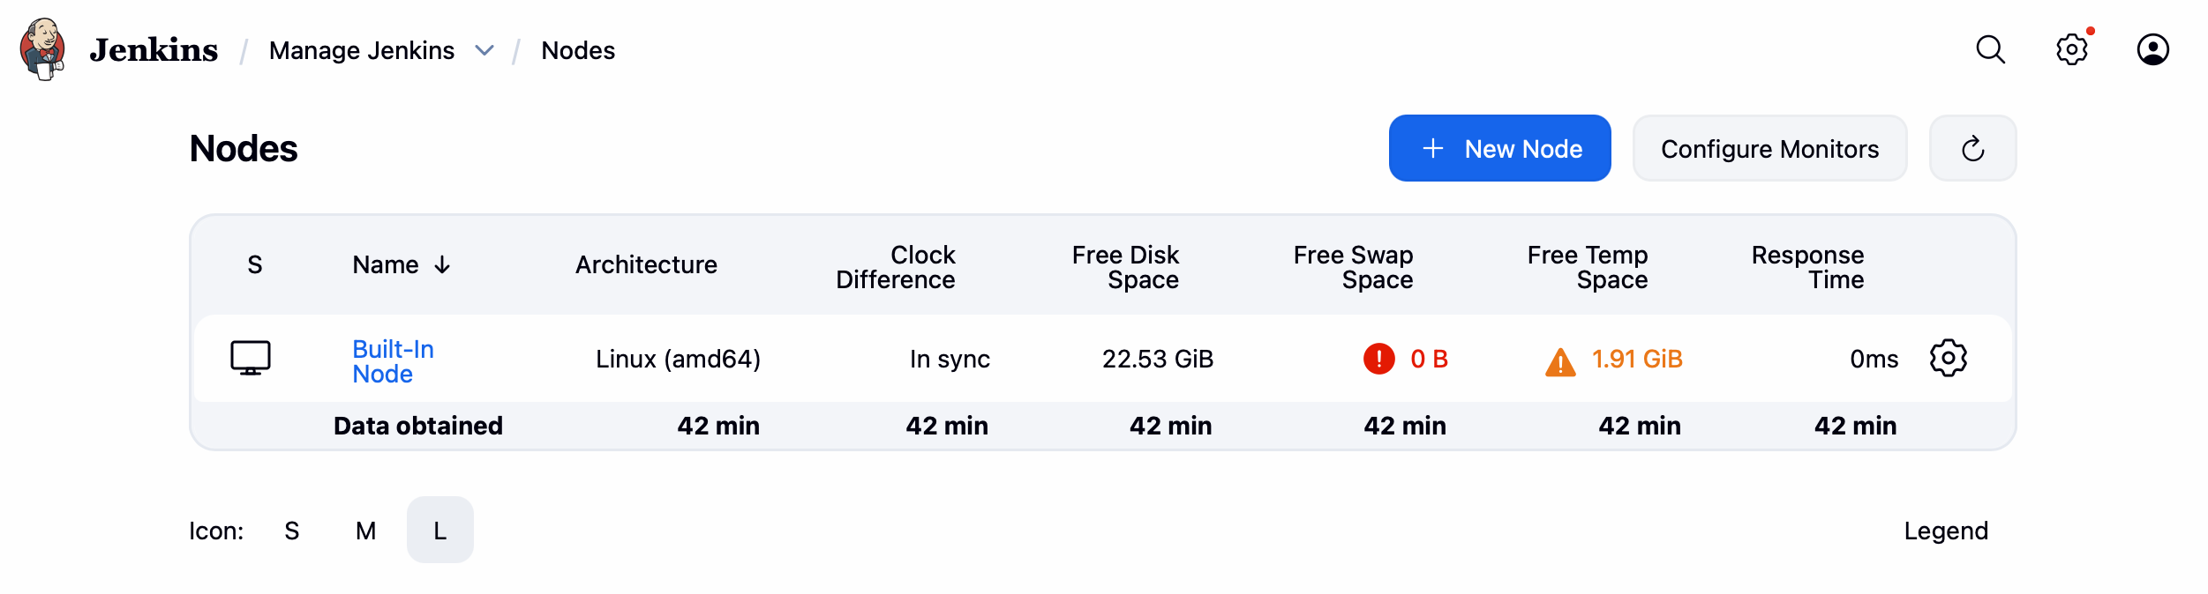

Click on New Node to start the node addition > click Create

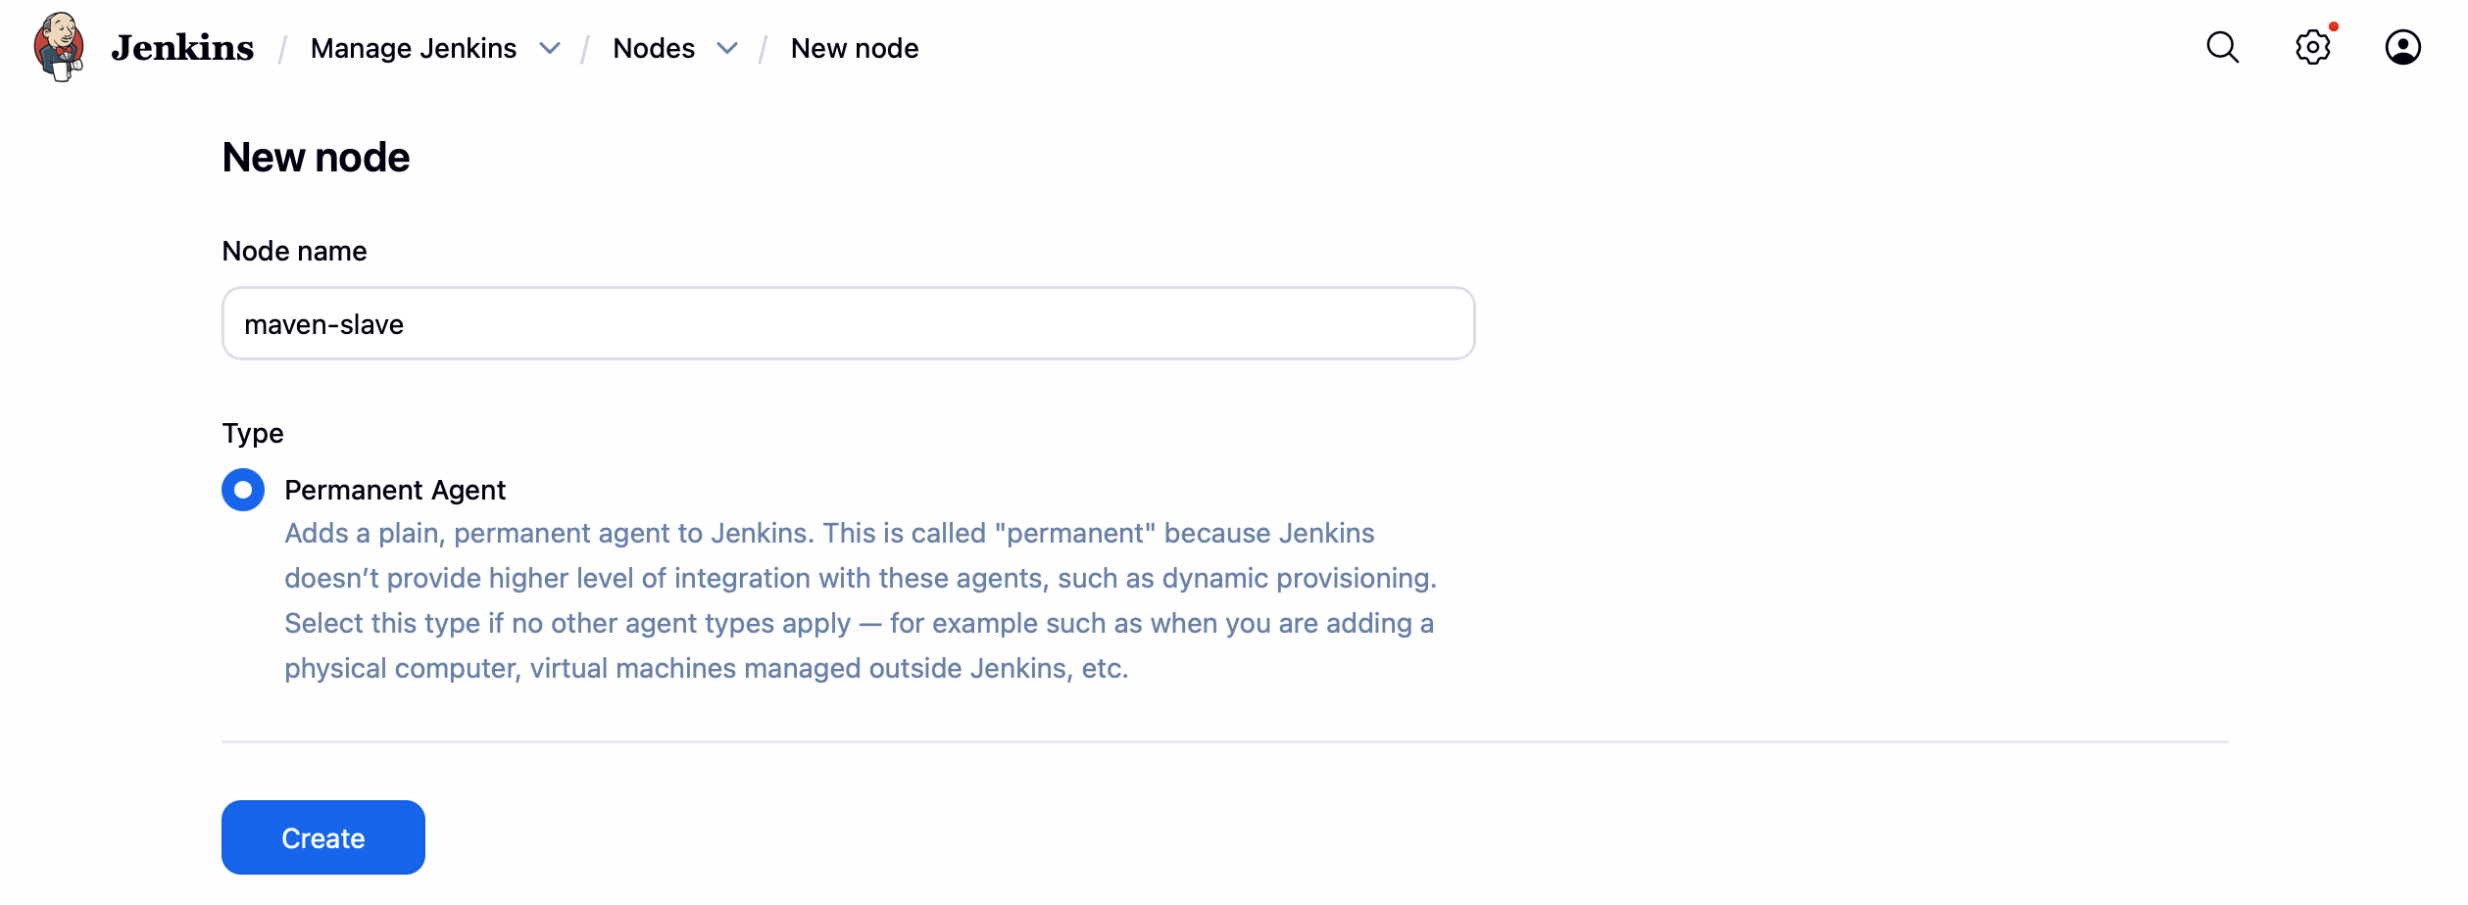

IMPORTANT:
1.As we are building the jar in the maven-slave, we need to install below softwares.
- Java
- mvn, git, docker
2.Configure there paths in .bash_profile

Start adding the info as per the below screenshot.

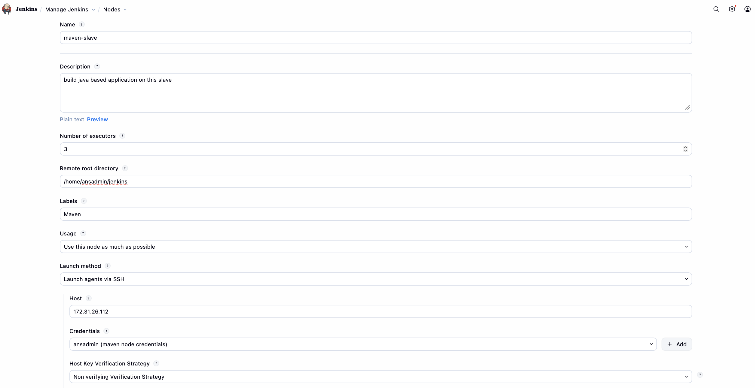
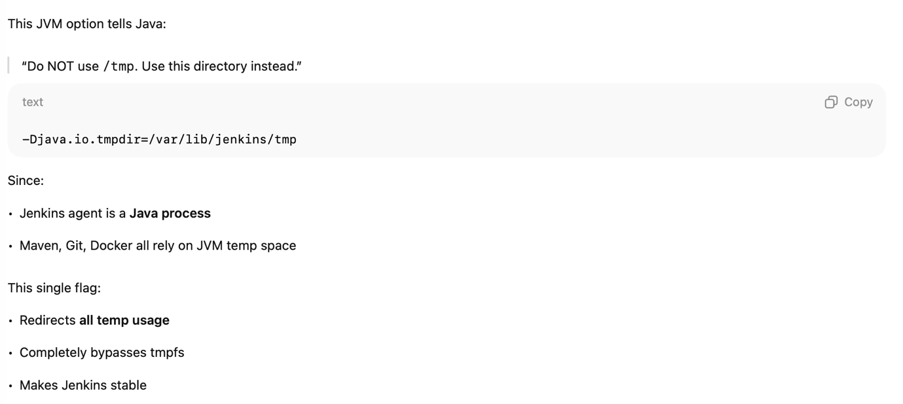
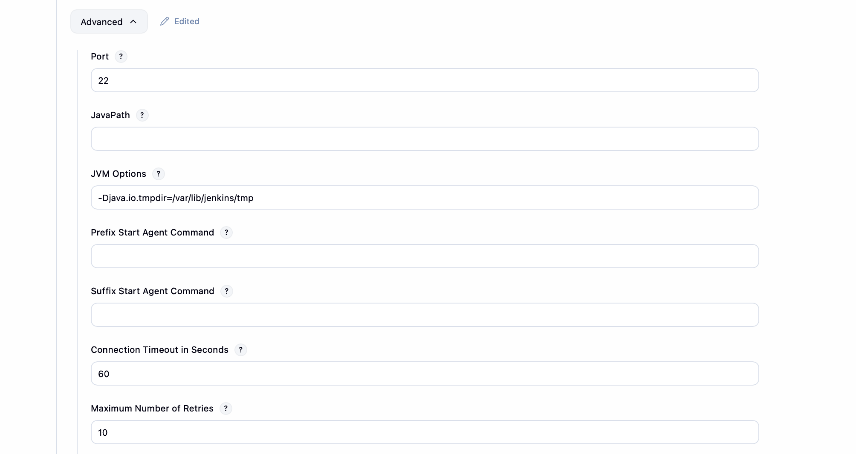
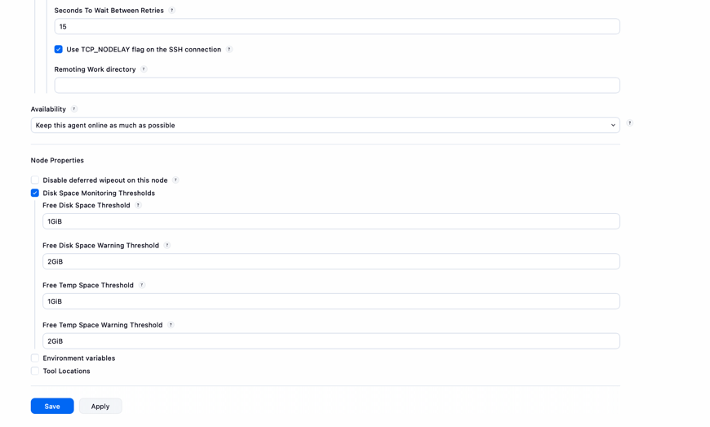

Single Pipeline job with a Branch Dropdown

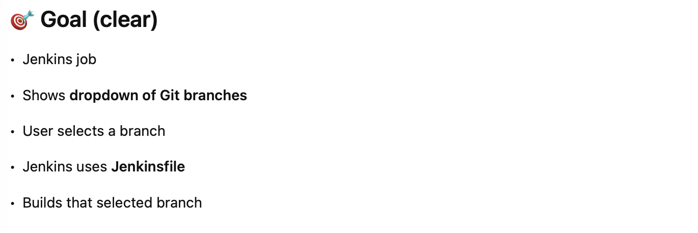

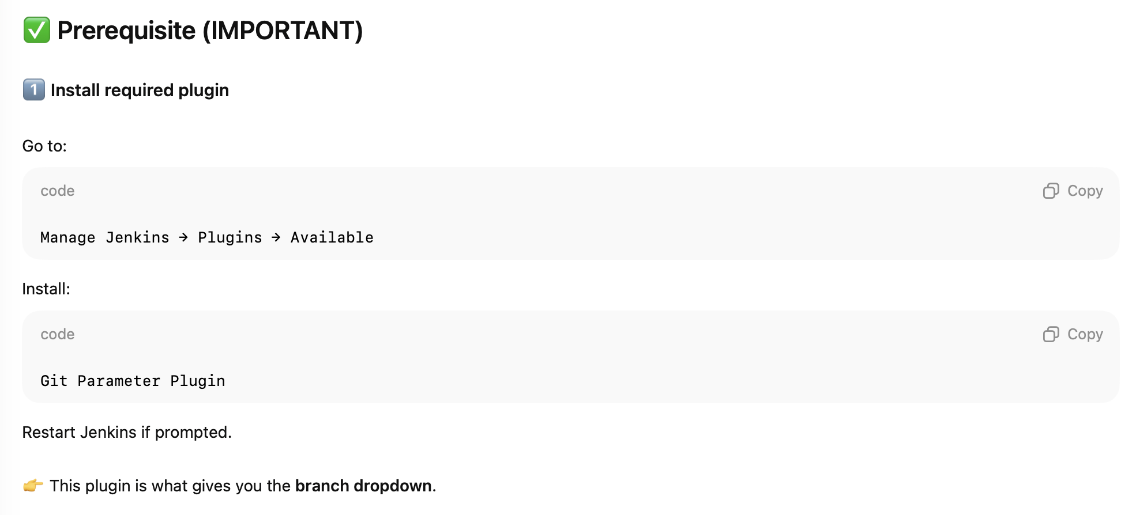

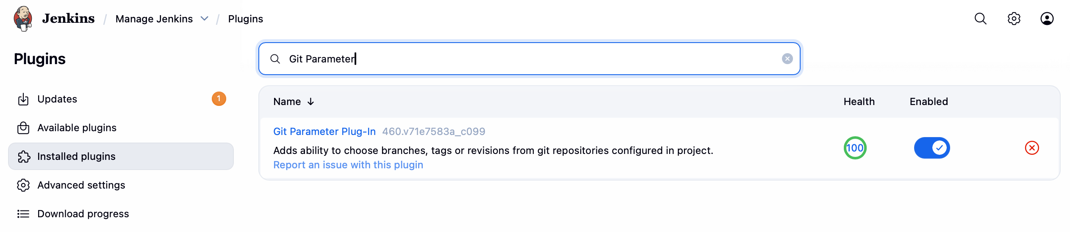

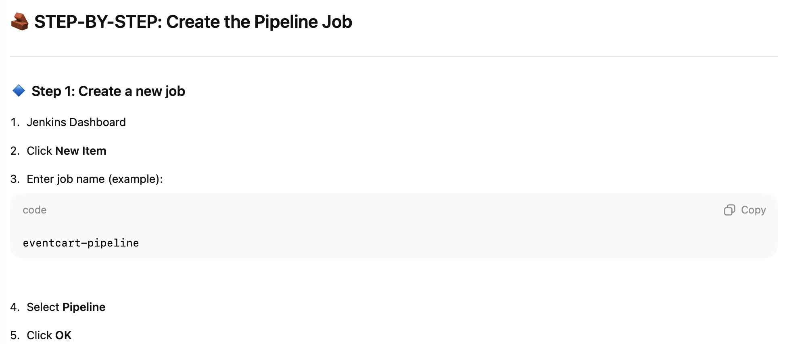

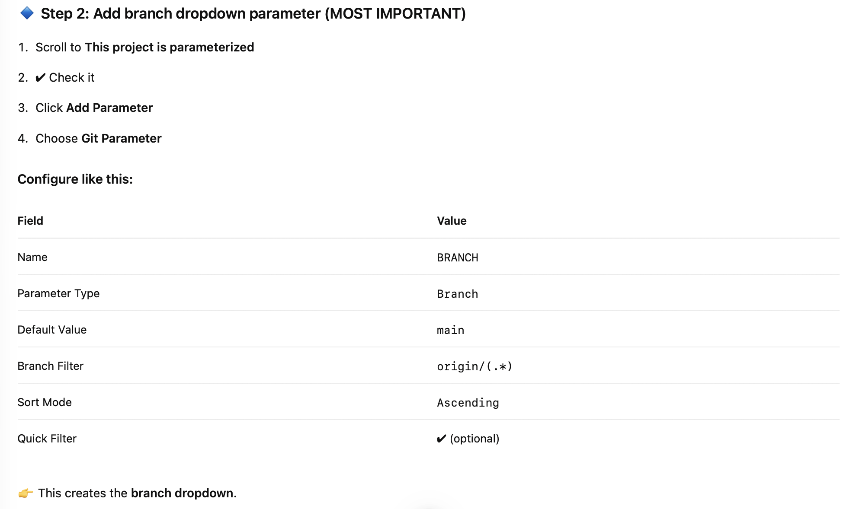

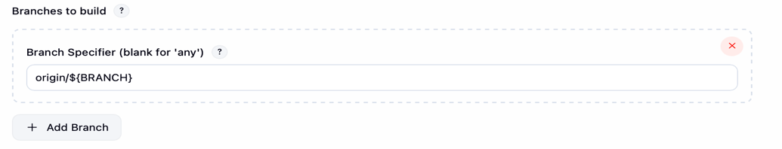
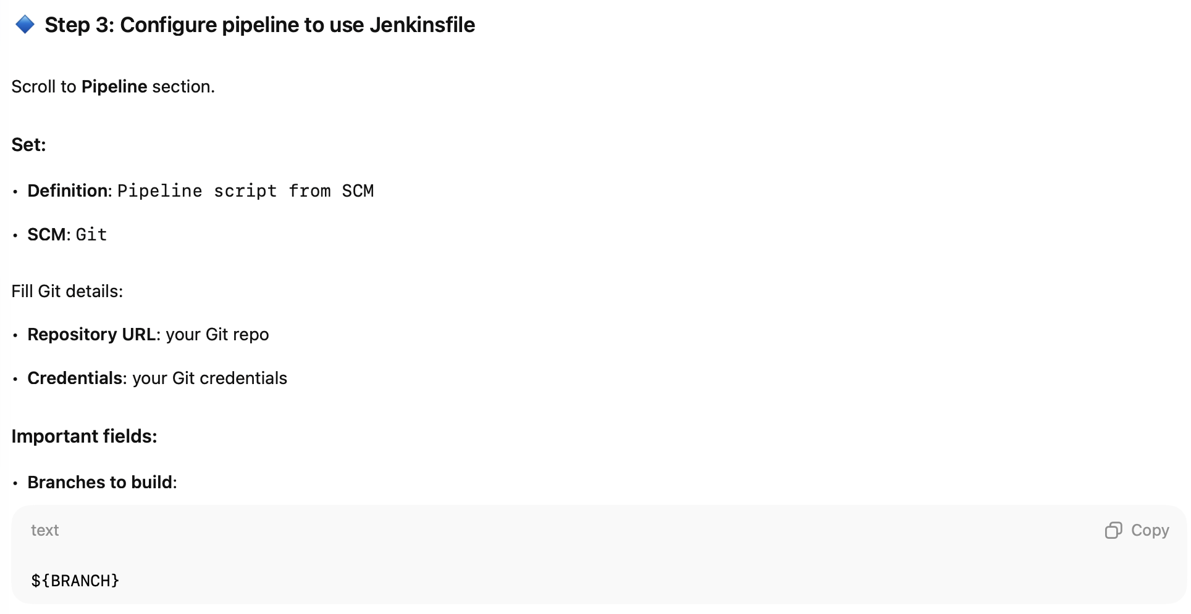
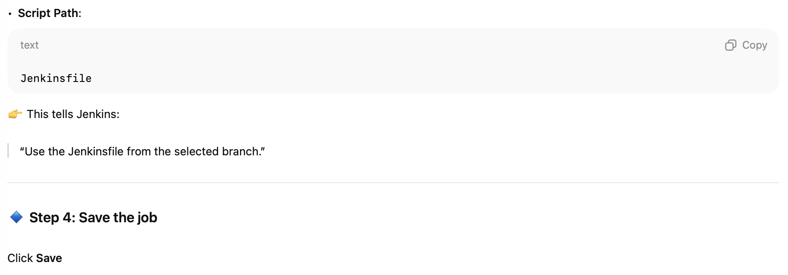

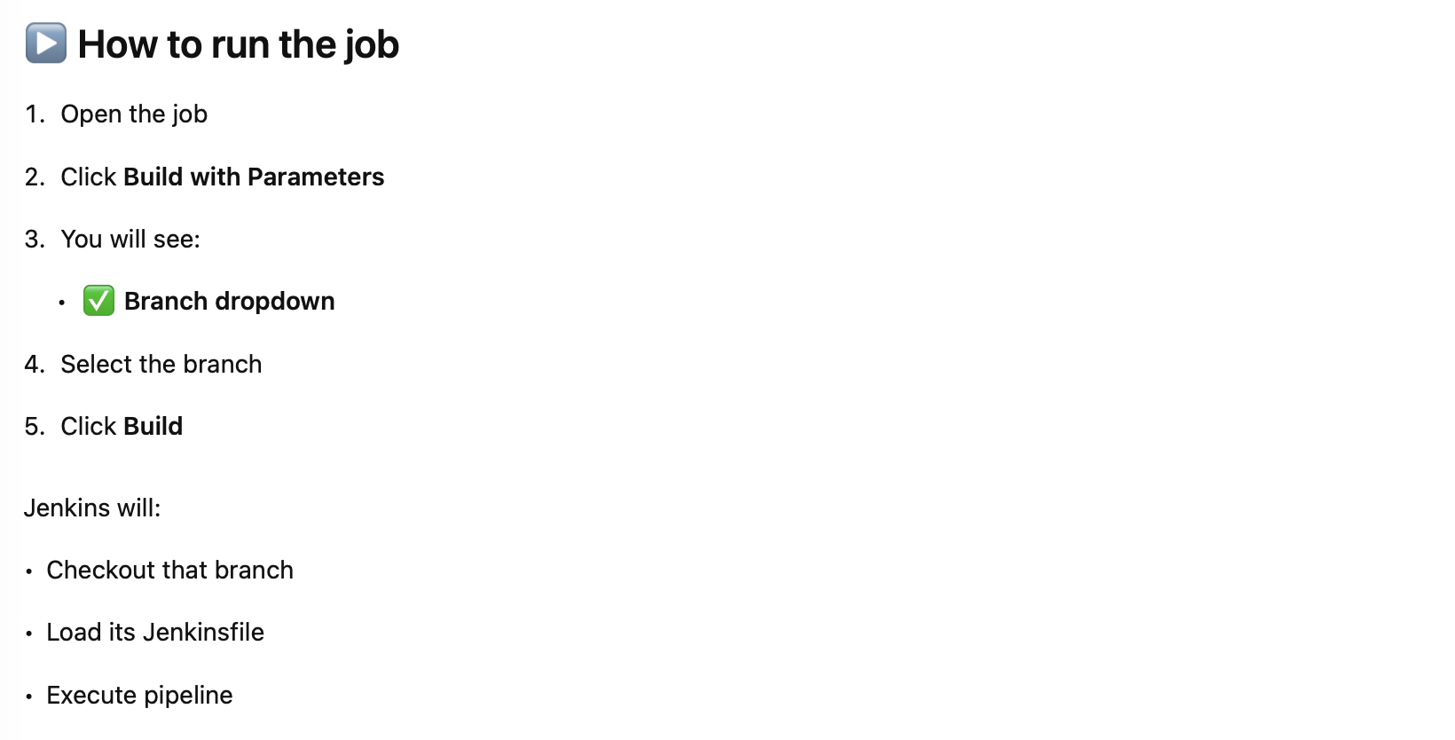

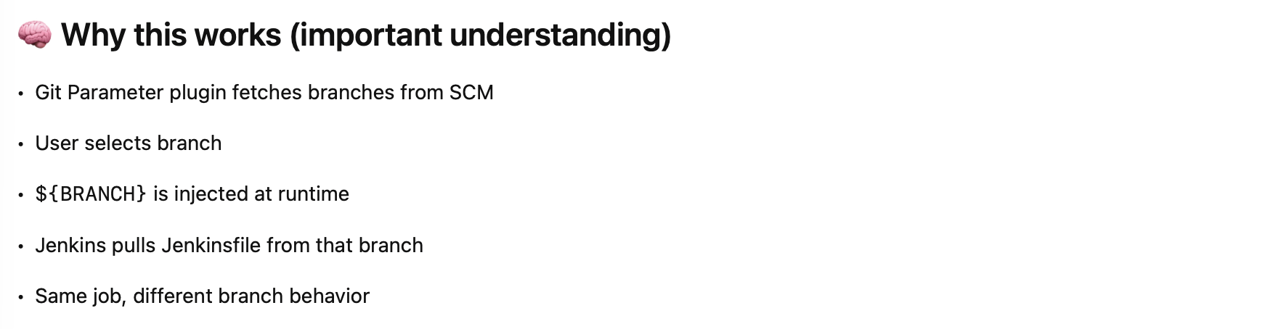

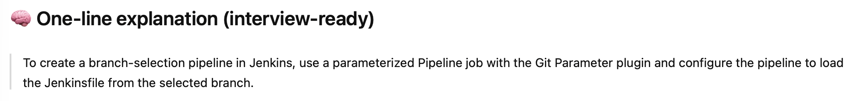

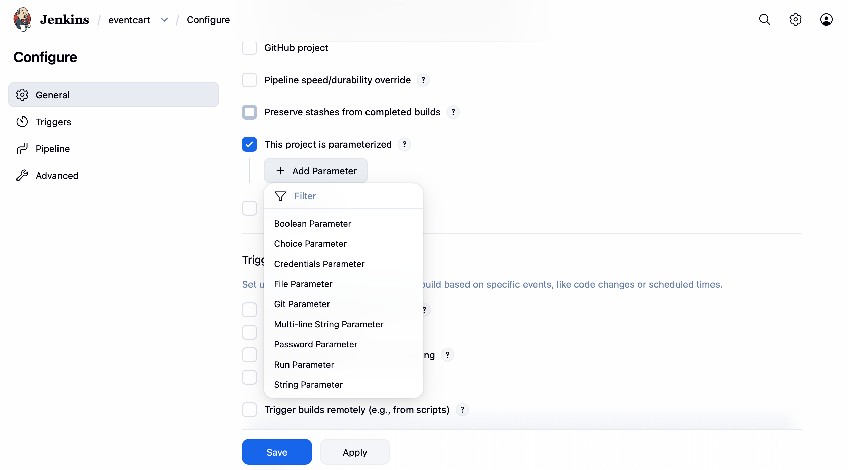

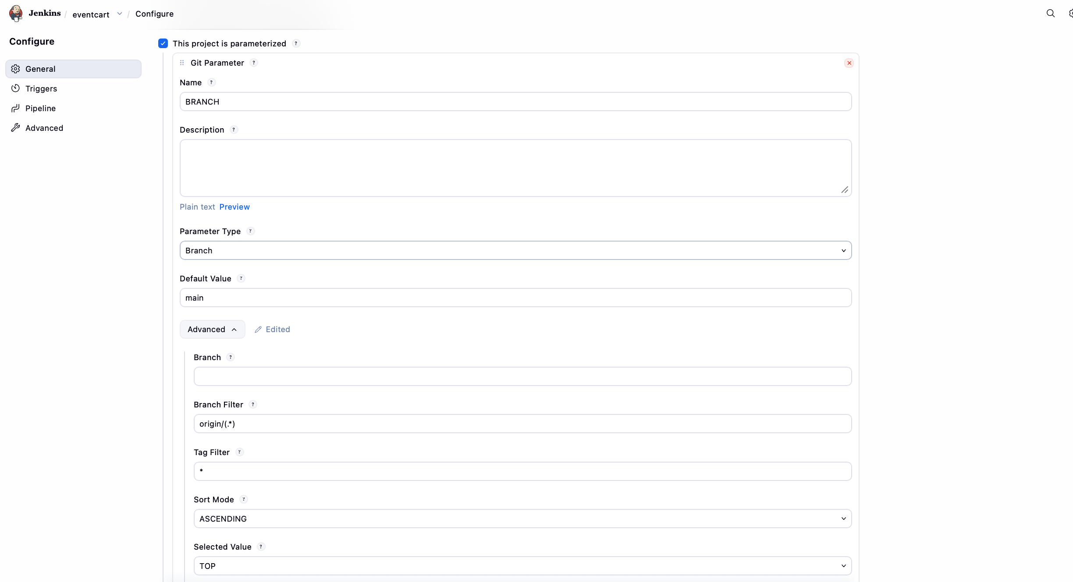
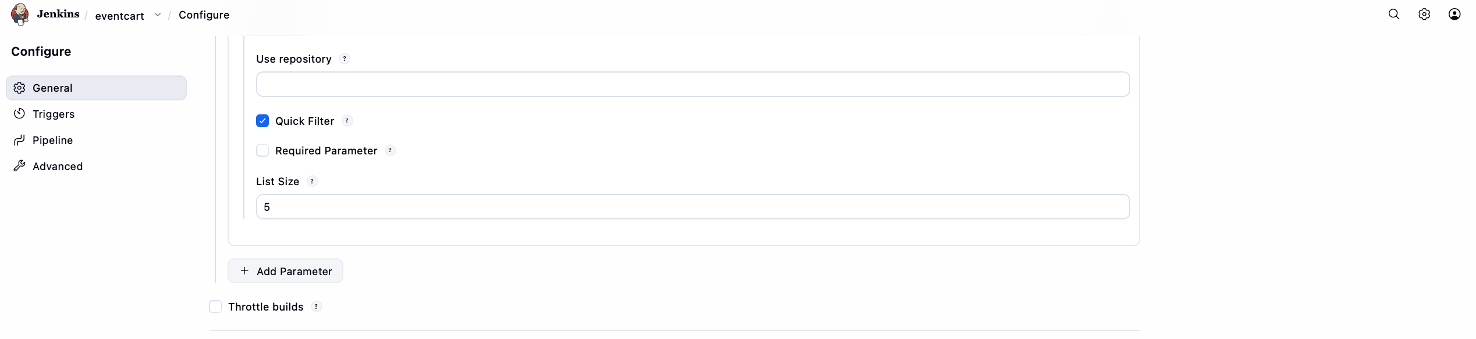

How to add Github-Credentials in Jenkins

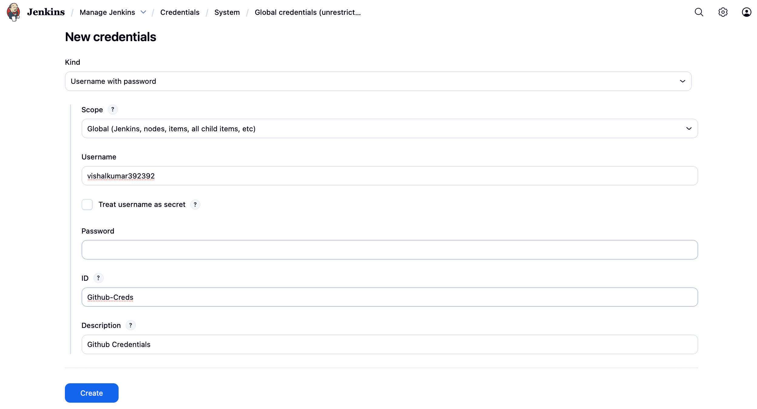

How to read Jenkinsfile in a pipeline:
- Create a new build which is pipeline.
- Go to the Pipeline section.
- In the Definition section, select value from dropdown “Pipeline script from SCM”
- Under SCM, select GIT, add the repo url, select the creds, branch.
- Under Script path mention “Jenkinsfile”
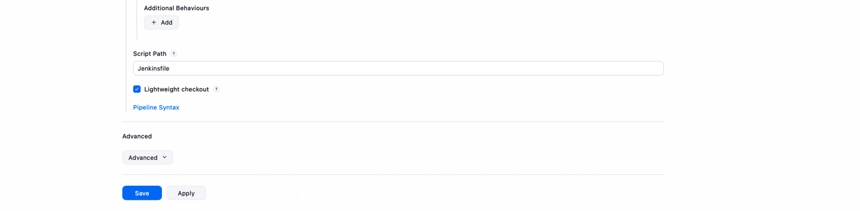
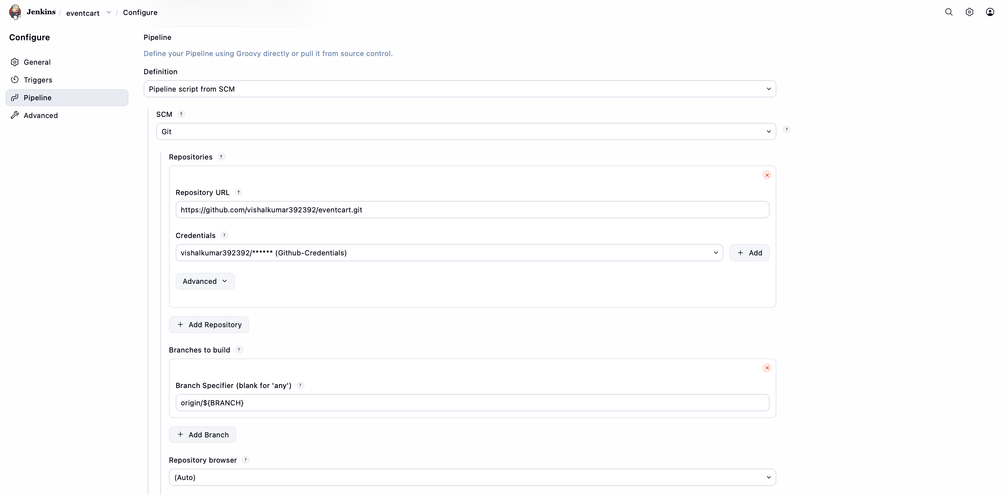

AWS ECR to store Docker Images
Create an repository with name “eventcart” in the AWS ECR.

- Install docker on our maven slave

sudo yum install -y docker
docker --version
sudo systemctl start docker
sudo systemctl enable docker
sudo systemctl status docker

- Add ec2-user to docker group

sudo usermod -aG docker ec2-user
newgrp docker

Very Important
sudo chmod 777 /var/run/docker.sock

- Create an IAM Role with “AwsAdminAccess” to the maven-slave .
- Update/add this stage in the Jenkins file

Sonarqube Installation on EC2 server
Launch an ec2 instance and paste this script in ec2-user-data to install sonarqube and complete the setup at the time of installation.

Create a securty token in sonarqube.

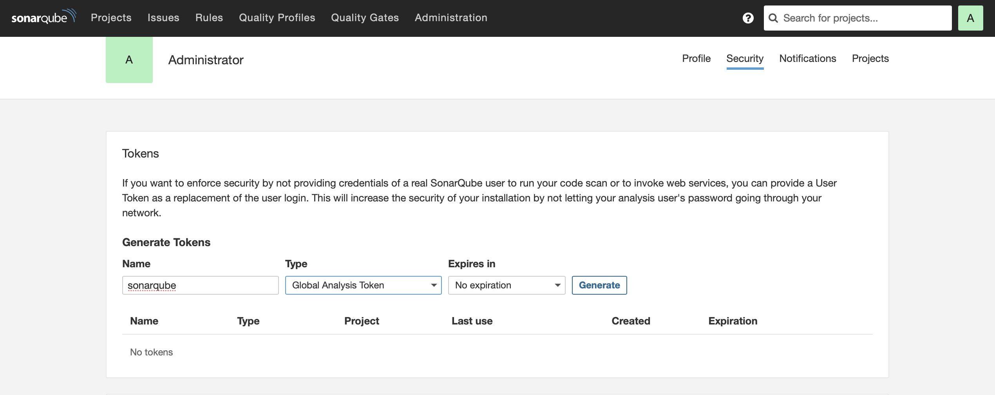

Download SonarQube Scanner Plugin on Jenkins

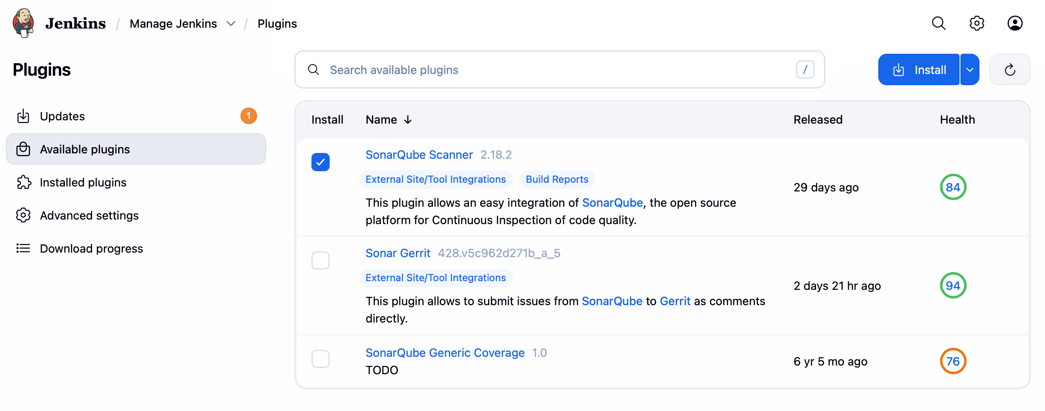

Configuring SonarQube Credentials in Jenkins

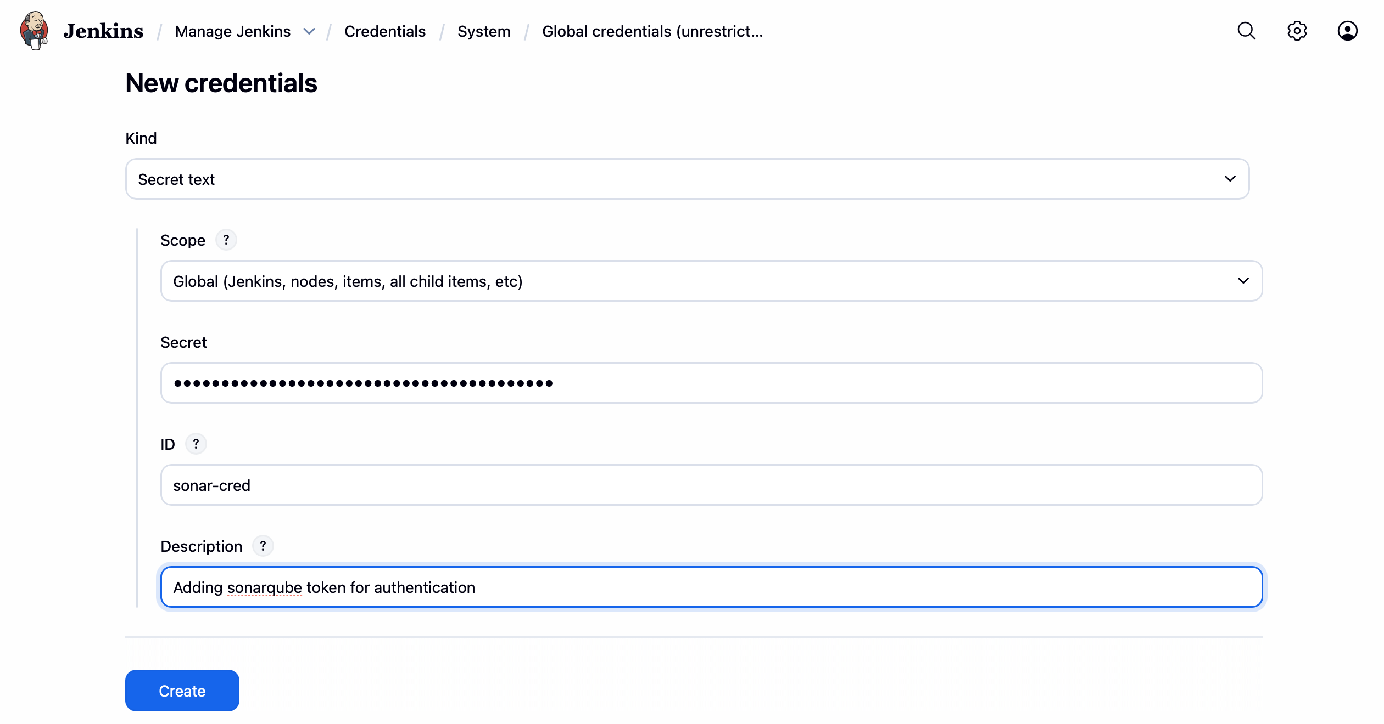

Add SonarQube scanner to jenkins

Go to Manage Jenkins/Tools, there go to the SonarQube Scanner installations section.

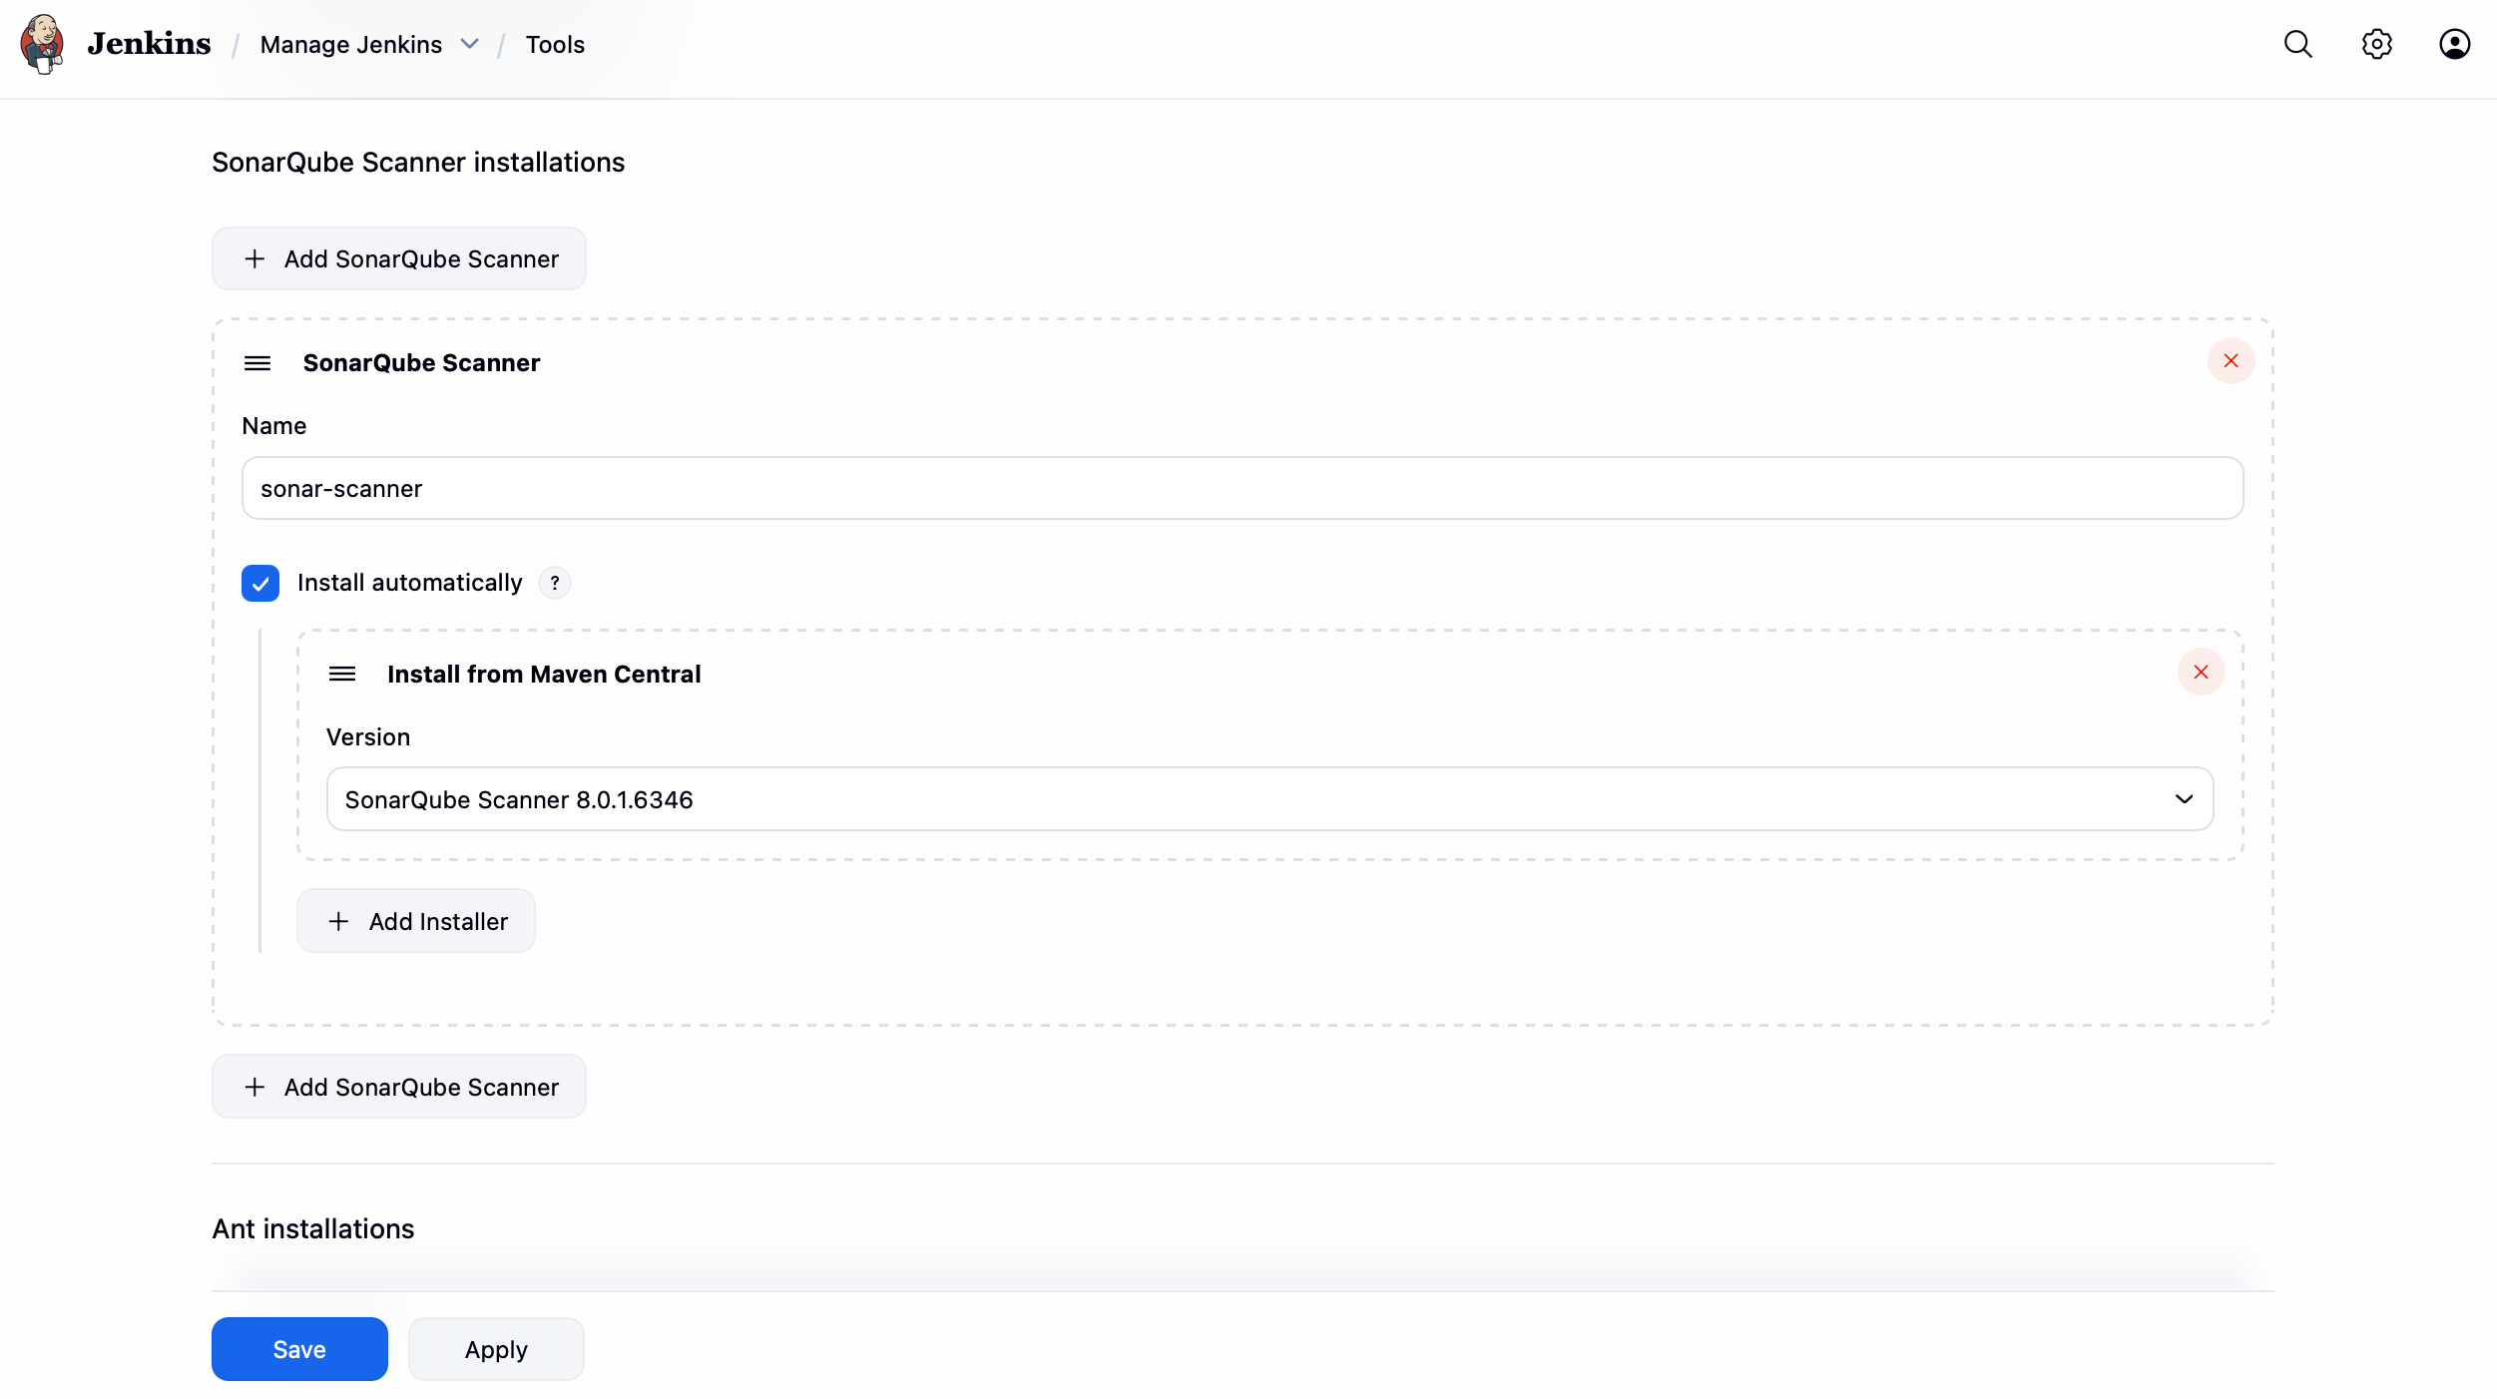

Configure SonarQube server

As we installed sonarqube scanner plugin, in the system/configure page we can see the SonarQube servers section.

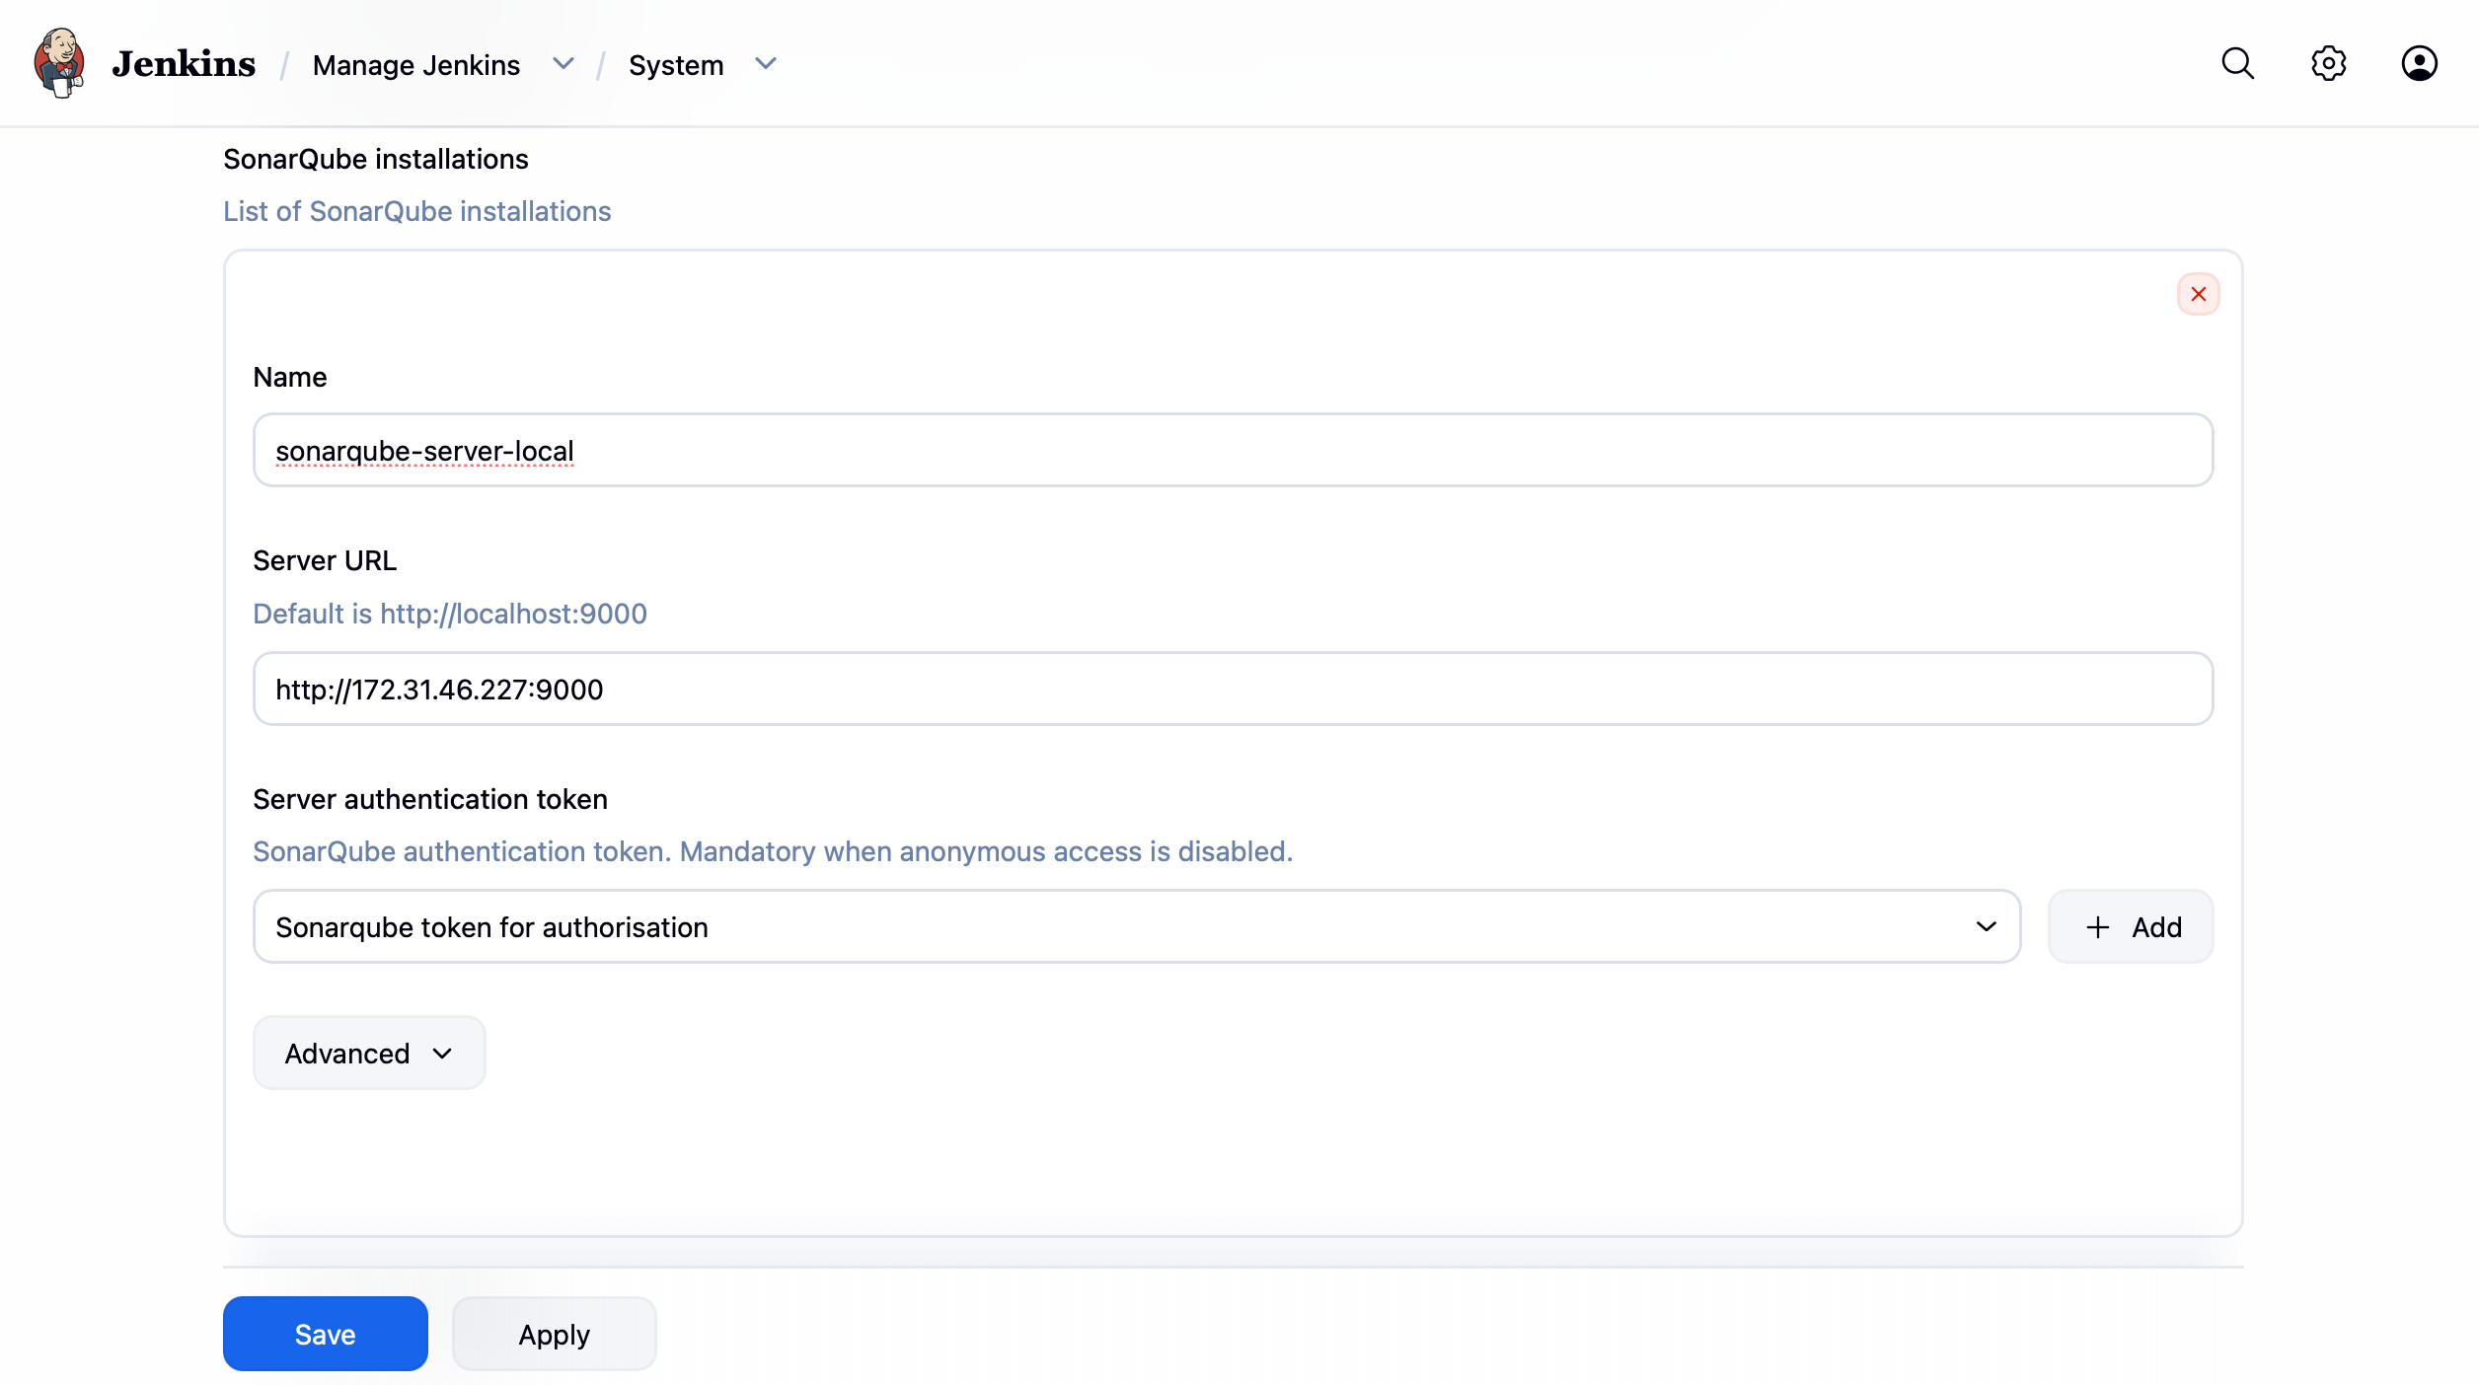

Run the Build job once, that will create the project in the sonarqube, build will fail because we havent configured the webhook in the sonarqube. So stop the build and go to the project and create the sonarqube webhook under the project.
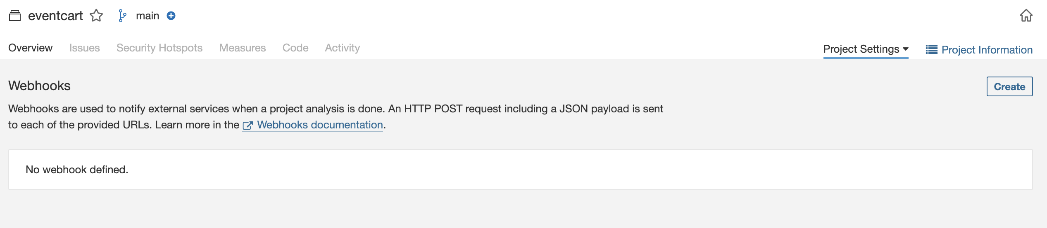
http://<JENKINS_PUBLIC_IP>:8080/sonarqube-webhook/

AWS SECRET MANAGER

Create a secret with name “aws-dev”

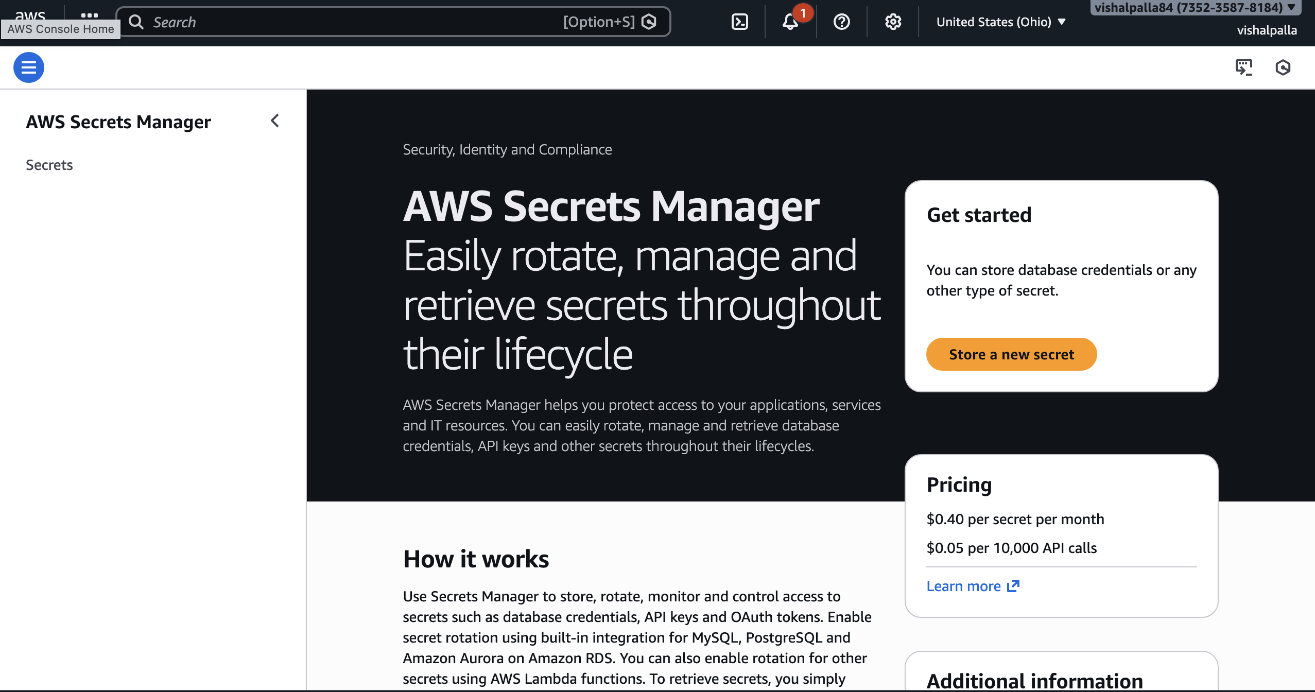

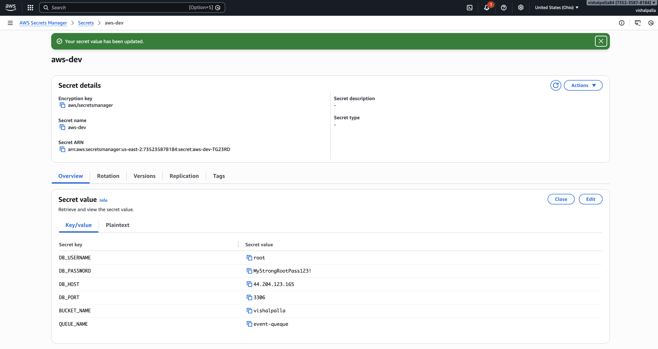

EKS CLUSTER SETUP USING EKSCTL
To create an Amazon EKS cluster in AWS, there are multiple available approaches. In our setup, we are choosing the eksctl tool because it simplifies cluster creation and management. We install eksctl on a bootstrap server, along with kubectl, and use this server as the control point to provision and manage the EKS cluster.
✅ START FROM BEGINNING — UPDATED EKS SETUP USING eksctl
1️. Pre-requisites (MANDATORY)
Verify AWS CLI

aws –version

If not installed / outdated:

curl "https://awscli.amazonaws.com/awscli-exe-linux-x86_64.zip" -o awscliv2.zip
unzip awscliv2.zip

sudo ./aws/install

Configure AWS credentials

aws configure

aws sts get-caller-identity

2️. Install kubectl (UPDATED & OFFICIAL)

curl -LO https://dl.k8s.io/release/$(curl -L -s https://dl.k8s.io/release/stable.txt)/bin/linux/amd64/kubectl

chmod +x kubectl

sudo mv kubectl /usr/local/bin/

kubectl version --client

3️. Install eksctl (UNCHANGED but verified)

curl --silent --location \
"https://github.com/weaveworks/eksctl/releases/latest/download/eksctl_$(uname -s)_amd64.tar.gz" \
| tar xz -C /tmp

sudo mv /tmp/eksctl /usr/local/bin

Verify:
eksctl version

4️. IAM Requirement (VERY IMPORTANT)
Your IAM user or EC2 role must have permissions for:
• EKS
• EC2
• IAM
• CloudFormation
Minimum policy (recommended for learning):
• AdministratorAccess

Verify identity again:

aws sts get-caller-identity

CREATING THE EKS CLUSTER USING “EKSCTL” Tool

- Create a cluster

eksctl create cluster \
--name eventcart-eks-01 \
--region us-east-2 \
--version 1.29 \
--nodegroup-name eventcart-ng \
--node-type t3.medium \
--nodes 2 \
--nodes-min 2 \
--nodes-max 2 \
--managed \
--with-oidc

- Create a namespaces

kubectl create namespace dev
kubectl create namespace uat
kubectl create namespace prod
kubectl get ns

- Create an IAM Policy name “eks-secrets-manager-policy”
It will give read permissions to our secret in AWS Secret Manager
{
"Statement": [
{
"Action": [
"secretsmanager:GetSecretValue",
"secretsmanager:DescribeSecret"
],
"Effect": "Allow",
"Resource": "arn:aws:secretsmanager:us-east-2:735235878184:secret:aws-dev*"
}
],
"Version": "2012-10-17"
}

- Create an IAM Role for each namespace
Below I am Creating the IAM Role for only “dev” namespace

eksctl create iamserviceaccount \
--cluster eventcart-eks-01 \
--region us-east-2 \
--name eventcart-sa \
--namespace dev \
--attach-policy-arn arn:aws:iam::735235878184:policy/eks-secrets-manager-policy-2 \
--approve

Verify:
kubectl get sa eventcart-sa -n dev -o yaml | grep eks.amazonaws.com

- Install CSI Driver

helm repo add secrets-store-csi-driver \
https://kubernetes-sigs.github.io/secrets-store-csi-driver/charts

helm repo update

helm install csi-secrets-store \
secrets-store-csi-driver/secrets-store-csi-driver \
--namespace kube-system \
--set syncSecret.enabled=true \
--set enableSecretRotation=true

- Install AWS Provider
kubectl apply -f \
https://raw.githubusercontent.com/aws/secrets-store-csi-driver-provider-aws/main/deployment/aws-provider-installer.yaml

Verify:
kubectl get pods -n kube-system | grep secrets-store
kubectl get crd | grep secretprovider

Update kubeconfig for your EKS cluster

aws eks update-kubeconfig \
--region us-east-1 \
--name eventcart-eks-01

Verify cluster admin access
kubectl get nodes

Open aws-auth ConfigMap for editing
kubectl edit configmap aws-auth -n kube-system

Add build-slave IAM role under mapRoles
- rolearn: arn:aws:iam::735235878184:role/eksctl
username: eksctl
groups:
- system:masters

(Optional but recommended) Verify mapping
kubectl get configmap aws-auth -n kube-system -o yaml

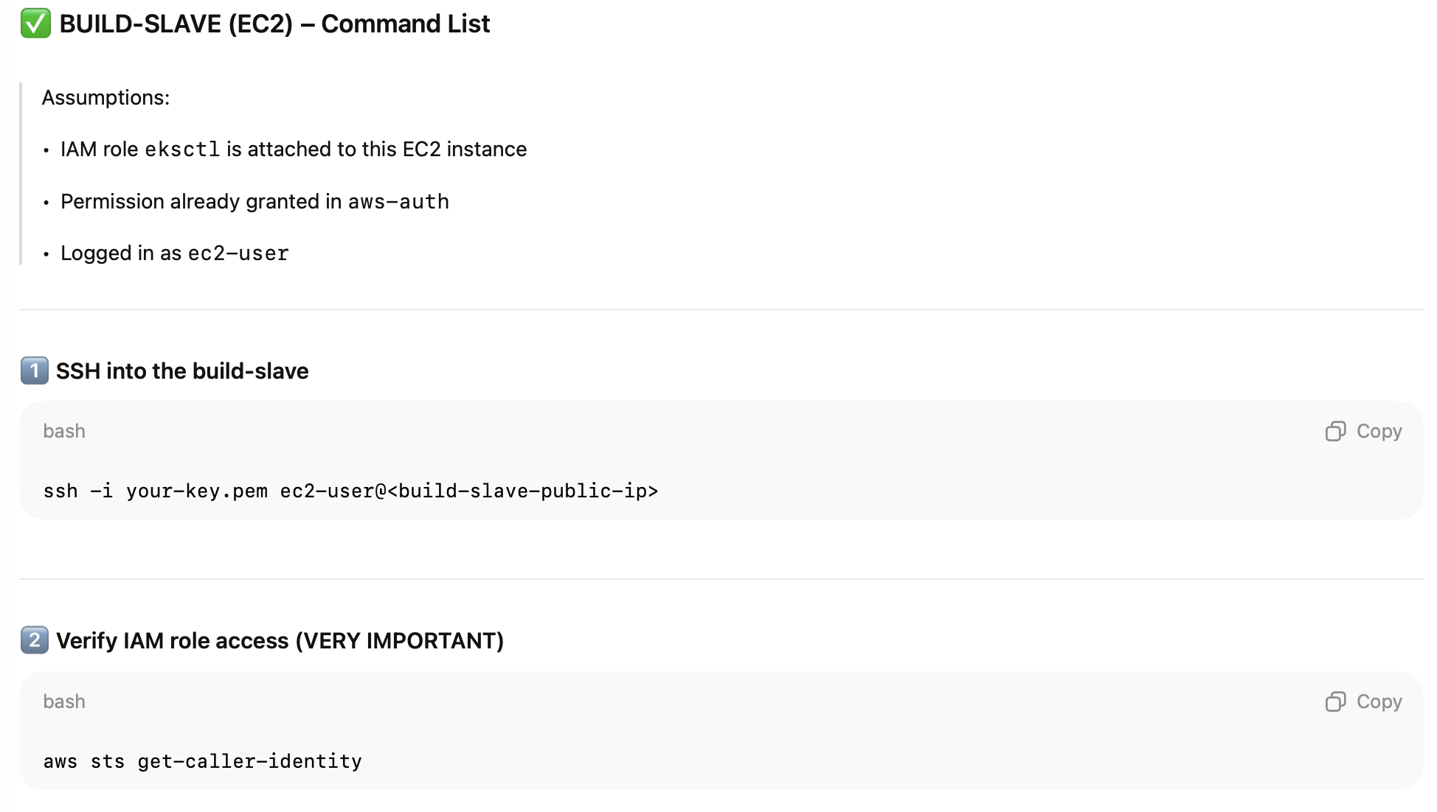

3️ Install kubectl
curl -o kubectl https://s3.us-west-2.amazonaws.com/amazon-eks/1.29.0/2024-01-04/bin/linux/amd64/kubectl
chmod +x kubectl
sudo mv kubectl /usr/local/bin/
kubectl version –client

4️ Create kubeconfig for ec2-user
aws eks update-kubeconfig \
--region us-east-1 \
--name eventcart-eks-01
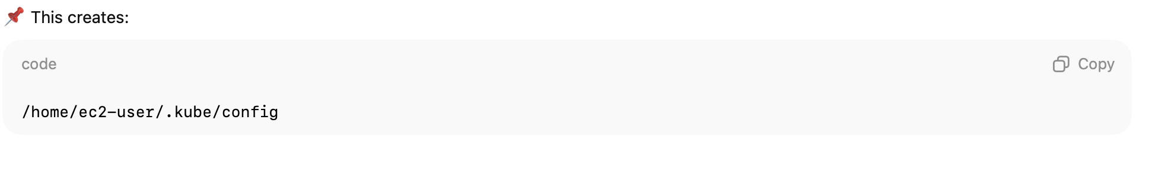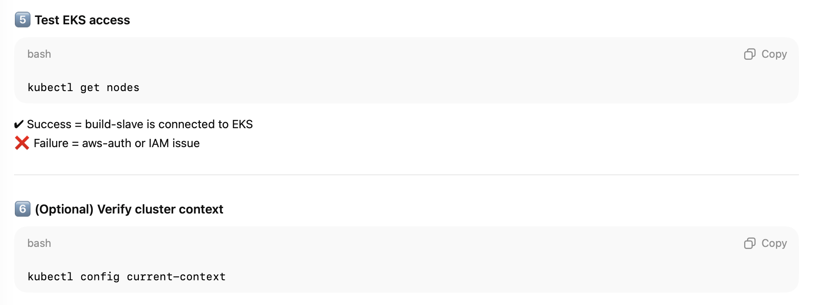
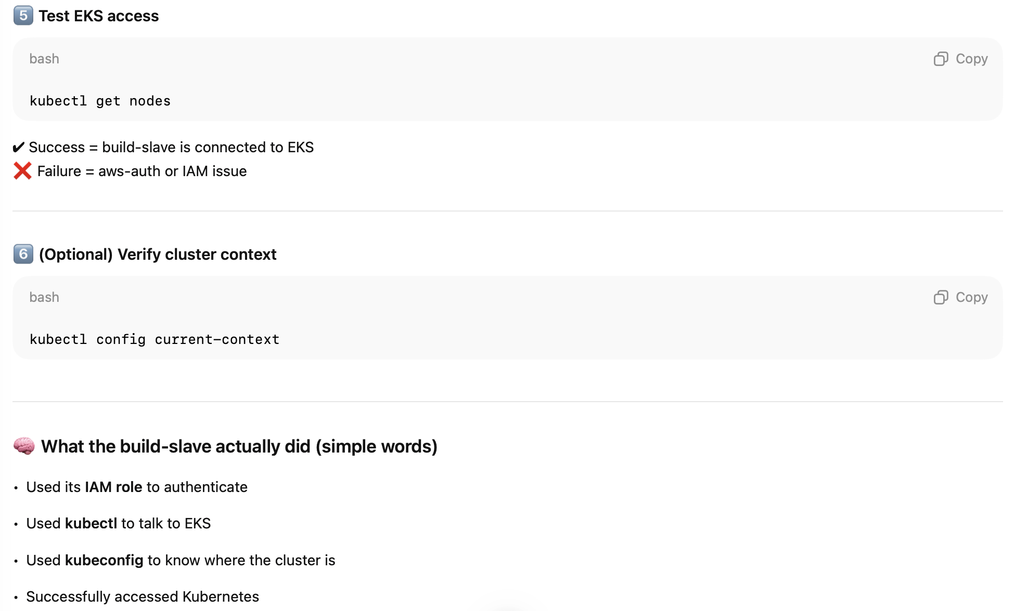

- Deleting the cluster

kubectl delete namespace dev
kubectl delete namespace uat
kubectl delete namespace prod

eksctl delete cluster --name eventcart-eks-01 --region us-east-2

