- Power of a Number
Aim
Implement methods to compute ( x^n ) using recursion (optimized and simple recursive versions).

Algorithm: POWER(x, n)
- If ( n = 0 ), return 1
- If ( n < 0 ), return ( 1 / POWER(x, -n) )
- Compute ( y = POWER(x, n/2) )
- If ( n ) is even, return ( y \times y )
- Else return ( x \times y \times y )

Algorithm: SIMPLE-POWER(x, n)
- If ( n = 0 ), return 1
- Else return ( x \times SIMPLE\text{-}POWER(x, n-1) )

Time Complexity (TC)
- Optimized: ( O(log n) )
- Simple: ( O(n) )

Space Complexity (SC)
- Optimized: ( O(\log n) )
- Simple: ( O(n) )

Code
long long power(long long x, int n) {
if (n==0) return 1;
long long half = power(x, n / 2);
if (n % 2 == 0) {
return half * half;}
else {
return x * half * half;}
}

Use Cases
- Graphics computations
- Simulations of various models

Graph
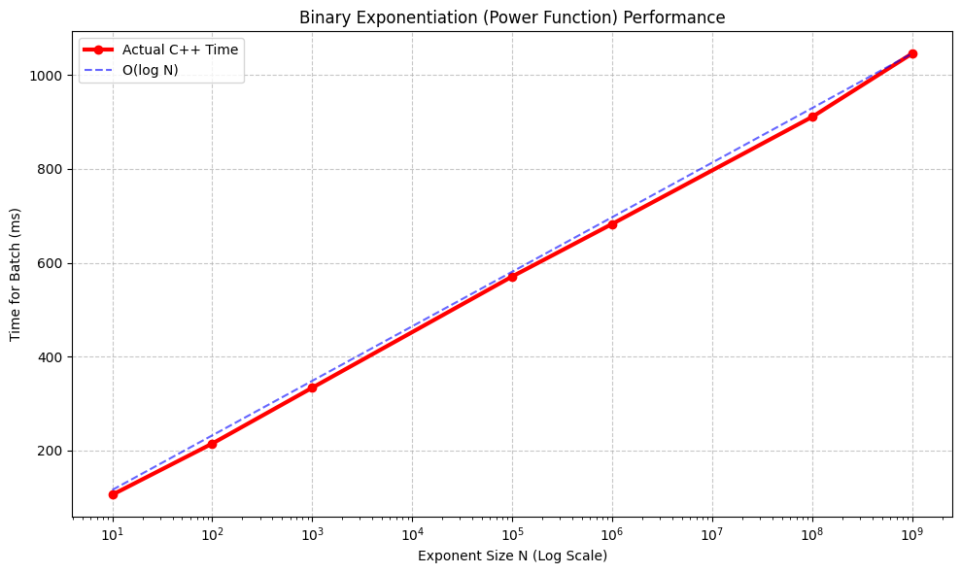

- Tower of Hanoi
Aim
Print the sequence of moves to transfer n disks from source to destination using an auxiliary rod.

Algorithm: TOH(n, src, dest, aux)
- If ( n \leq 0 ), return
- If ( n = 1 ),
Print "Move disk 1 from src to dest"
Return
- Call ( TOH(n-1, src, aux, dest) )
- Print "Move disk n from src to dest"
- Call ( TOH(n-1, aux, dest, src) )

Time Complexity (TC)
- ( O(2^n) )

Space Complexity (SC)
- ( O(n) ) (recursion stack)

Code
void hanoi(int n, char from, char to, char aux_rod) {
if (n == 0) {
return;}
hanoi(n-1,from,aux_rod,to);
hanoi(n-1,aux_rod,to,from);}

Use Cases
- Understanding recursion deeply.
- Used in divide-and-conquer.
- Puzzle solving.

Graph
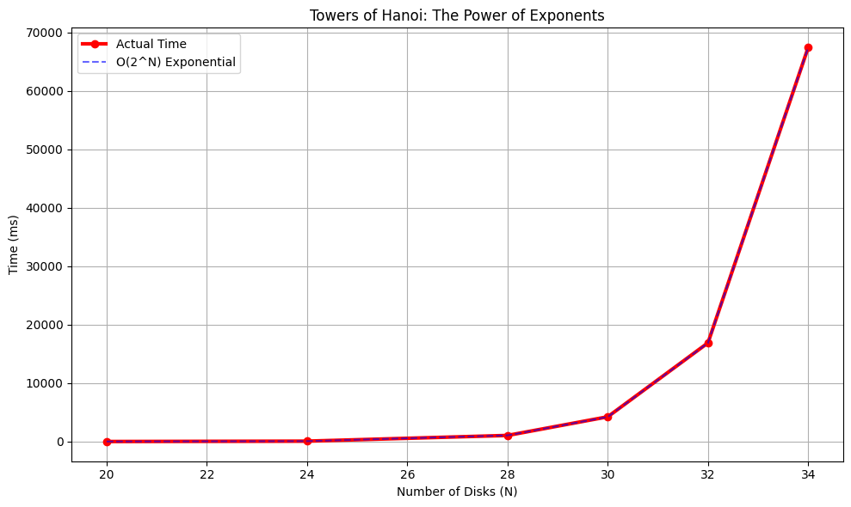

- Permutations of a String
Aim
Generate all permutations of a string using recursion and backtracking.

Algorithm: PERM(s, i)
- If ( i = n ),
Output the current permutation of string ( s )
Return
- For ( j = i ) to ( n-1 ):
Swap ( s[i] ) and ( s[j] )
Call ( PERM(s, i+1) )
Swap back ( s[i] ) and ( s[j] )

Time Complexity (TC)
- ( O(n!) )

Space Complexity (SC)
- ( O(n) ) (recursion depth)

Code
void permute(string &s, int l, int r) {
if (l == r) {
perm_count++;
return;}
for (int i = l; i <= r; i++){
char temp = s[l];
s[l] = s[i];
s[i] = temp;
permute(s, l + 1, r);
temp = s[l];
s[l] = s[i];
s[i] = temp;}}

Use Cases
- Anagram generation
- Combinatorial problems

Graph
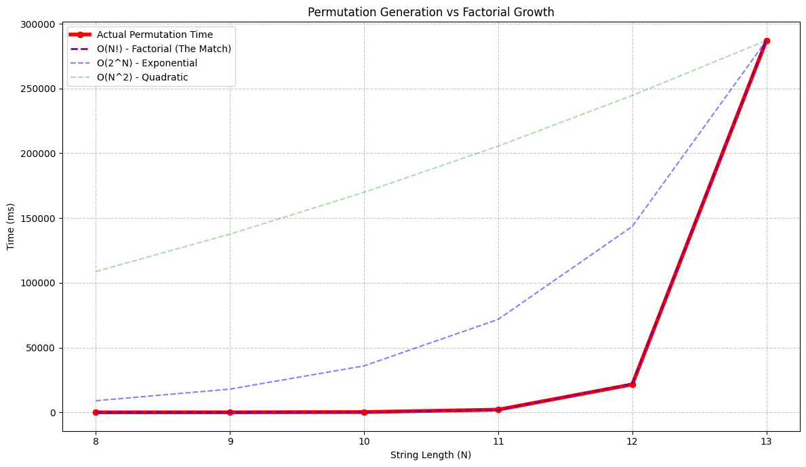

- Velocity Reduction
Aim
Count the number of steps required for a velocity ( v ) to drop below 1 when reduced by a fixed percentage at each step.

Algorithm: TIPS(v, t)
- If ( v < 1 ), return ( t )
- Set ( v = v \times (1 - r) ) where ( r ) is reduction rate
- Return ( TIPS(v, t+1) )

Time Complexity (TC)
- O(k), where ( k ) is number of reductions

Space Complexity (SC)
- O(k)

Code
int speed(float v,int i) {
if(v<1) return i;
return speed(v-v*.40-v*0.01-v*.015,i+1);}

Use Cases
- Decay simulations
- Physics-based modeling

- Horner's Rule
Aim
Represent and evaluate a polynomial using Horner's Rule via recursion.

Algorithm: HR(i, arr)
- If ( i = n-1 ), return ( arr[i] )
- Return ( arr[i] + x \times HR(i+1, arr) )

Time Complexity (TC)
- ( O(n) )

Space Complexity (SC)
- ( O(n) )

Code
string horners_rule(int i,const vector<int>& array) {
if (i==array.size()-1){
return to_string(array[i]);}
else {
return to_string(array[i])+"+x("+horners_rule(i+1,array)+")";}}

Use Cases
- Polynomial evaluation
- Compiler optimizations
- Numerical computations

- Finding Duplicate in a Consecutive Array
Aim
Find the duplicate element in an array containing consecutive integers.

Algorithm: FIND-DUP(nums)
- For ( i = 0 ) to ( n-1 ):
- If ( nums[i] \neq i ), return ( nums[i] )
- Return -1

Time Complexity (TC)
- ( O(n) )

Space Complexity (SC)
- ( O(1) )

Code
int dup2(vector<int>& arr) {
int duplicate_value=-1;
int k=arr.size()/2;
for (int i=0;i<k;i++) {
int t=arr[k-i];
for (int j=0;j<k-i;j++) {
if(t==arr[j]) {
duplicate_value=t;
break;}
}}
return duplicate_value;}

Use Cases
- Data validation
- Detecting anomalies in sequences

- Selection Sort
Aim
Sort an array using recursive selection sort.

Algorithm: SS(arr, i)
- If ( i \geq n ), return
- Find index of minimum element in ( arr[i \dots n-1] )
- Swap ( arr[i] ) with minimum element
- Call ( SS(arr, i+1) )

Time Complexity (TC)
- ( O(n^2) )

Space Complexity (SC)
- ( O(n) )

Code
void selectionSort(int* arr, int n) {
for (int i=0;i<n-1;i++){
int min_index=i;
for (int j=i+1;j<n;j++) {
if (arr[j]<arr[min_index]) {
min_index=j;}}
if (min_index!=i) {
swap(arr[i],arr[min_index]);}}}

Use Cases
- Learning sorting fundamentals
- Small datasets where simplicity matters

Graph:
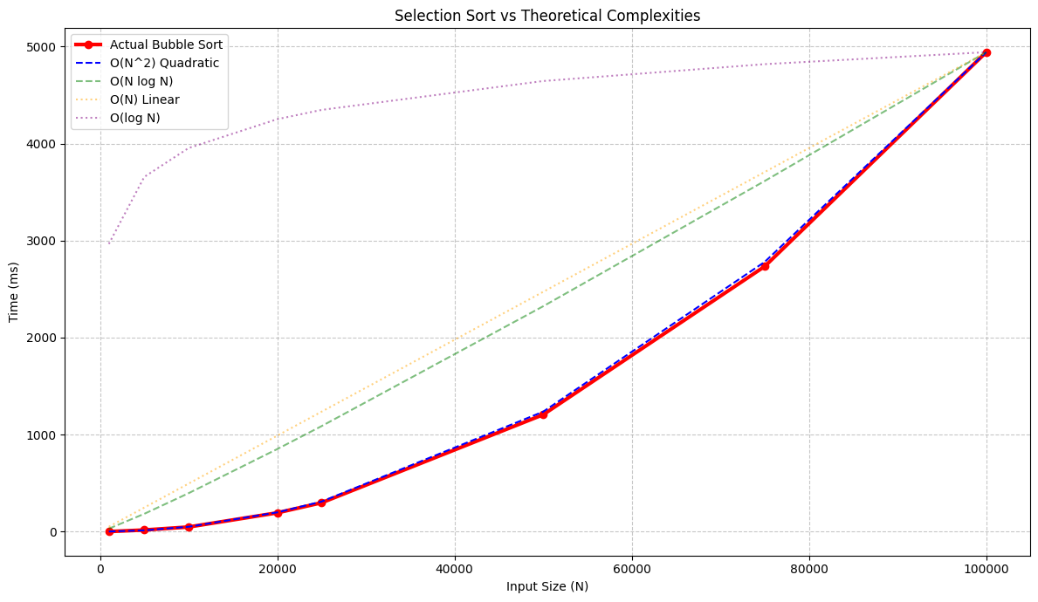

- Bubble Sort
Aim
Sort an array using recursive bubble sort and measure execution time.
Algorithm: BB(arr, n)
- If ( n = 1 ), return
- For ( i = 0 ) to ( n-2 ):
- If ( arr[i] > arr[i+1] ), swap them
- Call ( BB(arr, n-1) )

Time Complexity (TC)
- Best: ( O(n) )
- Average/Worst: ( O(n^2) )

Space Complexity (SC)
- ( O(n) )

Code
void bubbleSort(int* arr, int n) {
for (int i = 0; i < n - 1; i++) {
for (int j = 0; j < n - i - 1; j++) {
if (arr[j] > arr[j + 1]) {
int temp = arr[j];
arr[j] = arr[j+1];
arr[j+1] = temp;}}}
}

Use Cases
- Teaching sorting basics
- Understanding algorithm complexity

Graphs
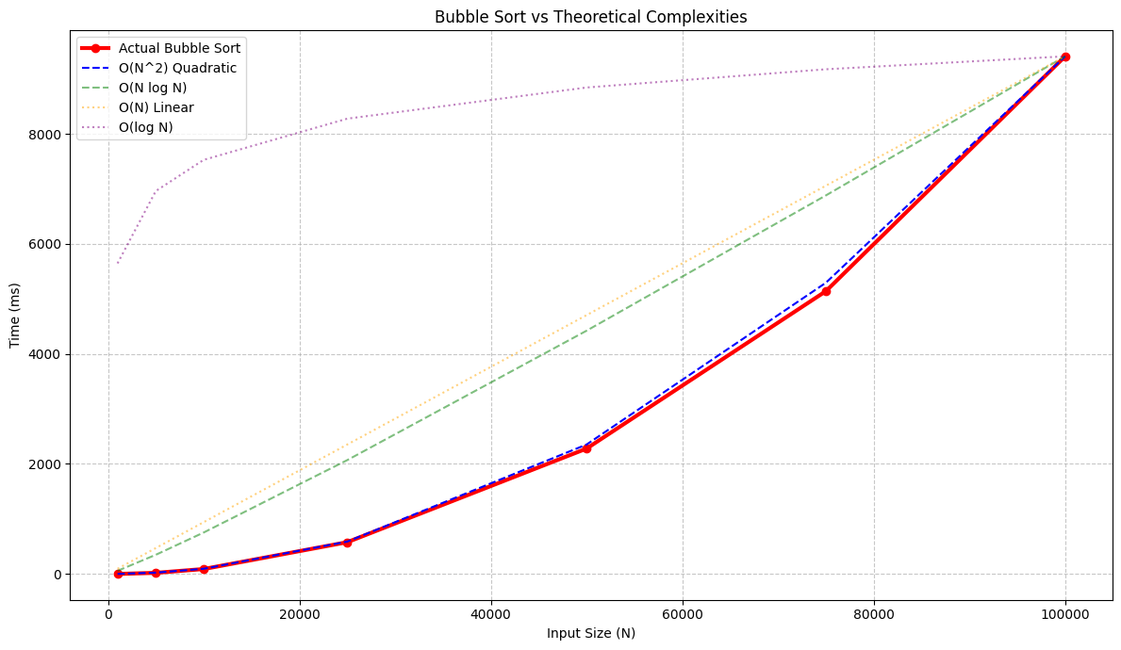

- Linear Search
Aim
Find a target element in an array using recursive linear search.

Algorithm: LS(arr, target, i)
- If ( i \geq n ), return -1
- If ( arr[i] = target ), return ( i )
- Return ( LS(arr, target, i+1) )

Time Complexity (TC)
- Best: ( O(1) )
- Average/Worst: ( O(n) )

Space Complexity (SC)
- ( O(n) )

Code
int linear(int a[], int n, int i, int tar) {
if (i == n) return -1;
if (a[i] == tar) return i;
return linear(a, n, i + 1, tar);
}

Use Cases
- Small datasets
- Basic searching problems

- Binary Search
Aim
Search for a target in a sorted array using recursive binary search and measure execution time.

Algorithm: BS(arr, t, s, e)
- If ( s > e ), return -1
- Compute ( m = \lfloor (s+e)/2 \rfloor )
- If ( arr[m] = t ), return ( m )
- If ( arr[m] > t ), return ( BS(arr, t, s, m-1) )
- Else return ( BS(arr, t, m+1, e) )

Time Complexity (TC)
- Best: O(1)
- Average/Worst: O(\log n)

Space Complexity (SC)
- O(\log n)

Code
public static int BS(int[] arr, int t, int s, int e) {
if (s > e) return -1;
int m = s + (e - s) / 2;
if (arr[m] == t) return m;
if (arr[m] > t) return BS(arr, t, s, m - 1);
return BS(arr, t, m + 1, e);
}

Use Cases
- Efficient searching in sorted data
- Databases and lookup systems

Graphs
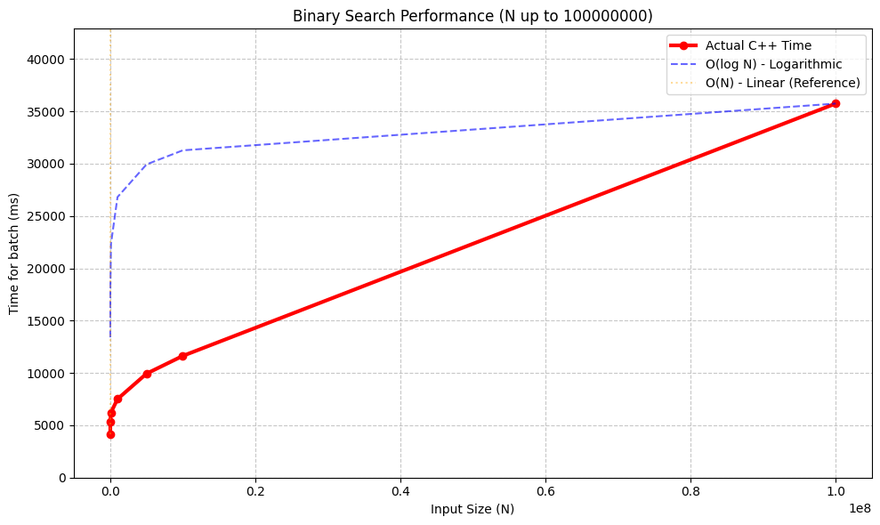

- Insertion Sort
Aim
Sort an array using insertion sort and measure performance.

Algorithm: IS(arr)
- For ( i = 1 ) to ( n-1 ):
  - Set ( key = arr[i] )
  - Set ( j = i-1 )
  - While ( j \geq 0 ) and ( arr[j] > key ):
Shift ( arr[j] ) to ( arr[j+1] )
Decrement ( j )
  - Insert ( key ) at position ( j+1 )

Time Complexity (TC)
- Best: ( O(n) )
- Average/Worst: ( O(n^2) )

Space Complexity (SC)
- ( O(1) )

Code
void insertionSort(int* arr, int n) {
for (int i=1;i<n;i++) {
int key=arr[i];
int j=i-1;
while(j>=0&&arr[j]>key) {
arr[j+1]=arr[j];
j=j-1;}
arr[j+1]=key;}}

Use Cases
- Small datasets
- Nearly sorted arrays
- Online/incremental sorting

Graphs
- Best case insertion sort
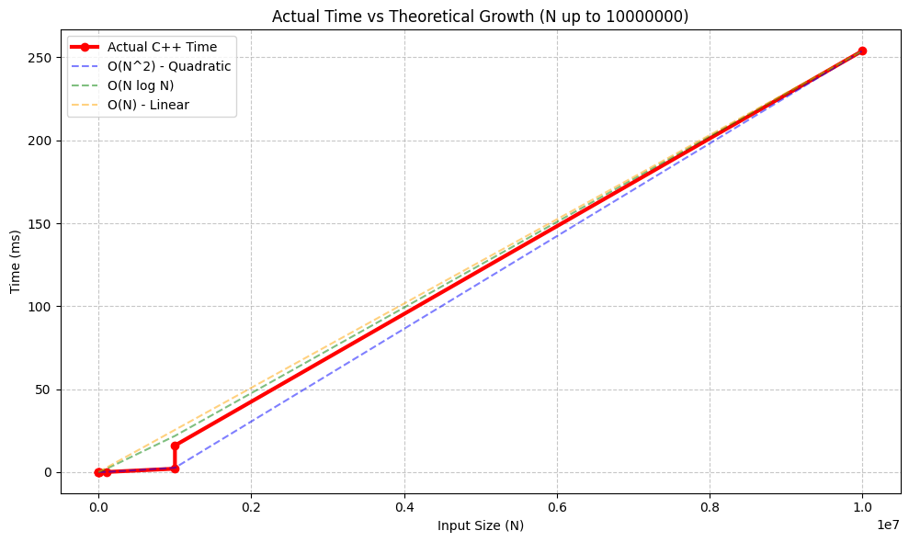
- average insertion sort case
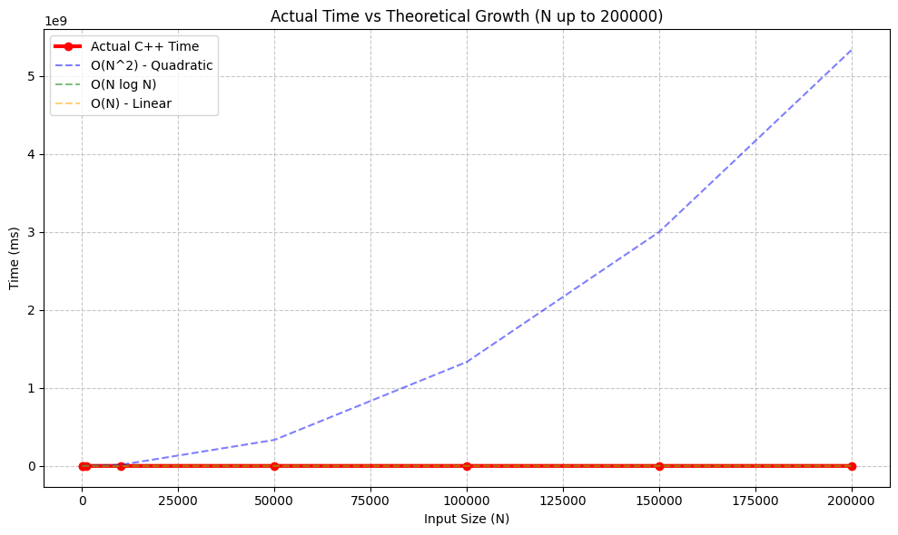
- worst insertion sort case
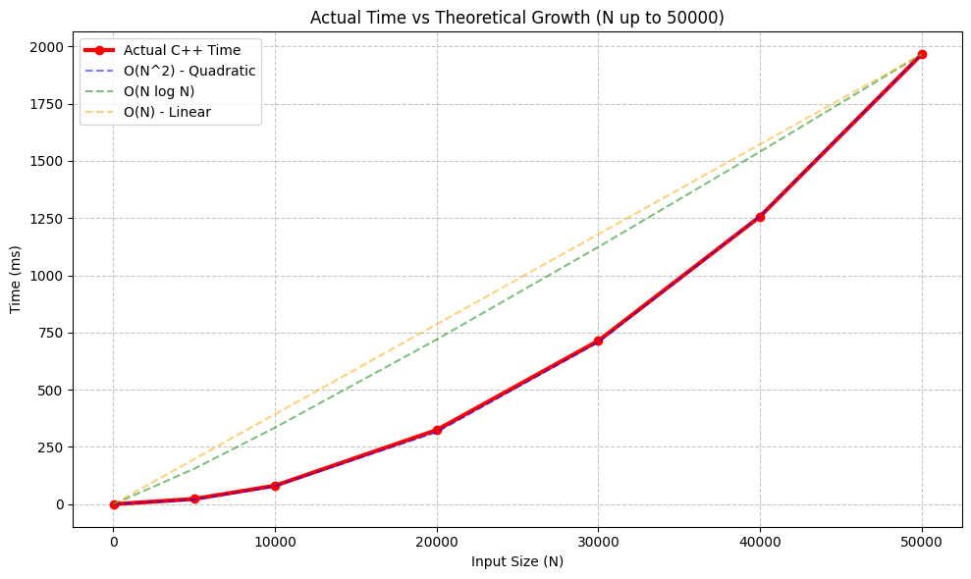

- Merge Sort
Aim
Sort an array using merge sort and analyze performance for different input sizes.

Algorithm: MS(arr, s, e)
- If ( s \geq e ), return
- Compute ( m = \lfloor (s+e)/2 \rfloor )
- Call ( MS(arr, s, m) )
- Call ( MS(arr, m+1, e) )
- Merge the two sorted halves

Time Complexity (TC)
- O(n \log n) (all cases)

Space Complexity (SC)
- O(n)

Code
void merge(vector<int>& arr, int low, int mid, int high){
vector<int> temp;
int left = low, right = mid + 1;
while (left <= mid && right <= high) {
if (arr[left] <= arr[right])
temp.push_back(arr[left++]);
else
temp.push_back(arr[right++]);}

while (left <= mid)
temp.push_back(arr[left++]);
while (right <= high)
temp.push_back(arr[right++]);
for (int i = low; i <= high; i++)
arr[i] = temp[i - low];
}

Use Cases
- Large datasets
- Stable sorting requirements

Graphs 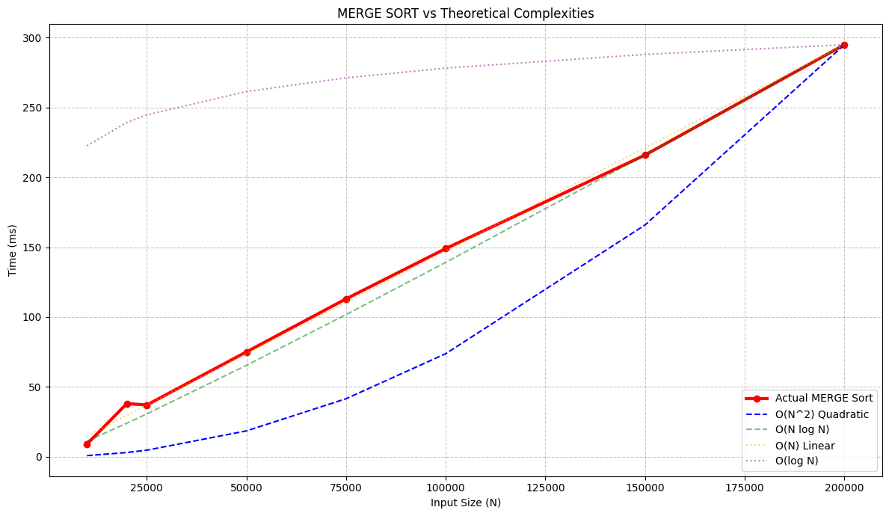

- Quick Sort
Aim
Sort using quick sort and observe performance characteristics.

Algorithm: QS(arr, s, e)
- If ( s \geq e ), return
- Choose pivot element
- Partition array such that:
  - Elements < pivot on left
  - Elements > pivot on right
- Recursively apply on left and right partitions

Time Complexity (TC)
- Best/Average: ( O(n \log n) )
- Worst: ( O(n^2) )

Space Complexity (SC)
- Average: ( O(\log n) )
- Worst: ( O(n) )

Code
int partion(vector<int>& arr, int low,int high){
int pivot=arr[high];
int i=low -1;
for( int j= low ; j< high ; j++){
if(arr[j]<=pivot){
i++;
swap(arr[i],arr[j]);}}
swap(arr[i+1],arr[high]);
return i+1;}
void quicksort(vector<int>& arr, int low, int high) {
if(low<high){
int pivotindex=partion(arr,low,high);
quicksort(arr , low , pivotindex - 1);
quicksort(arr , pivotindex + 1 , high);}}

Use Cases
- General-purpose in-memory sorting
- High-performance applications

Graphs
- Worst case
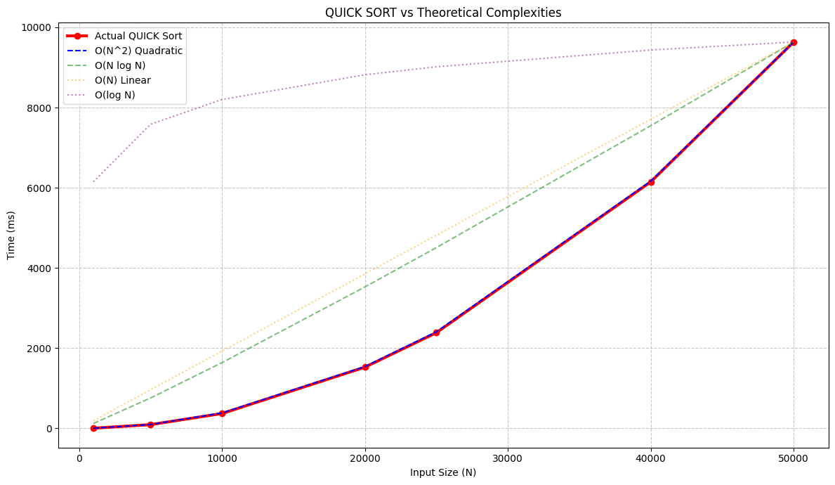
- average case
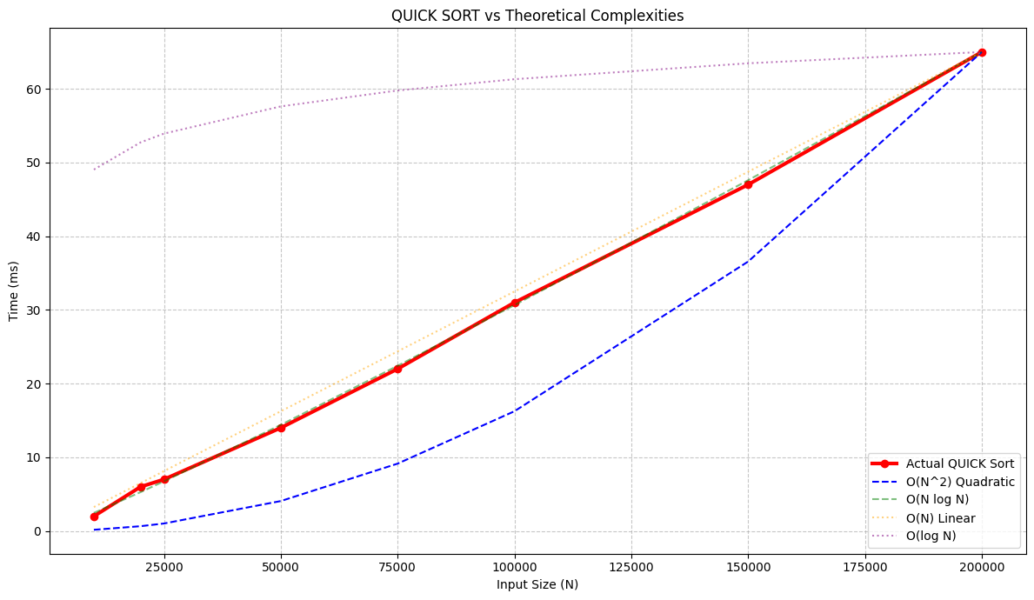
- best case
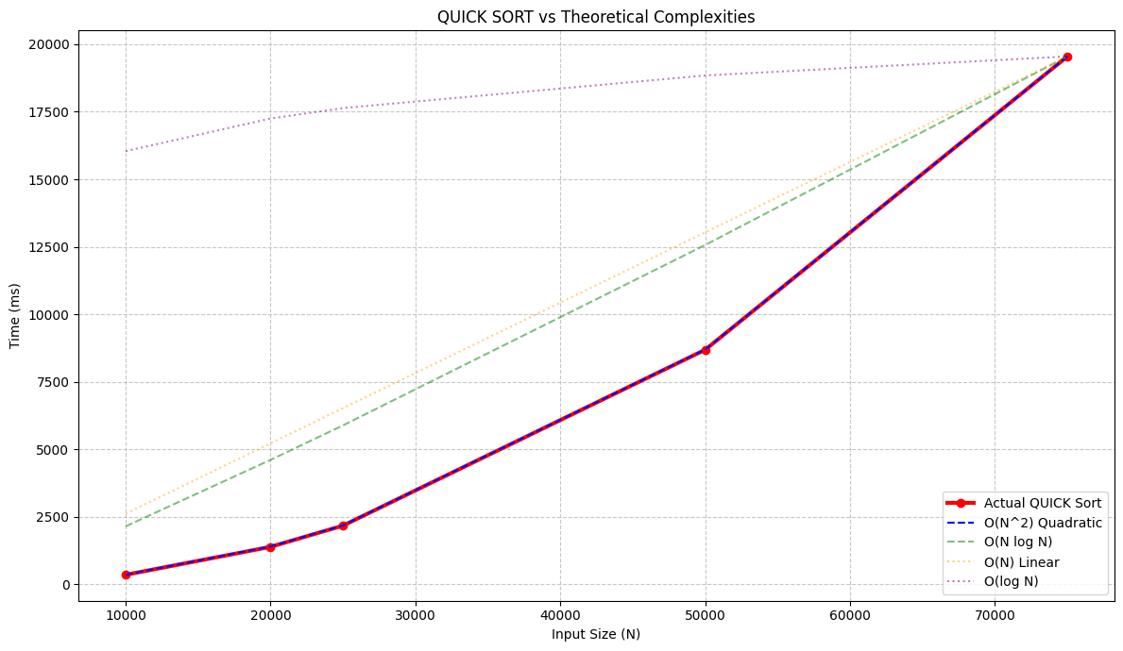

- MIN-MAX PROBLEM
Aim
Compute the min and max in an given array using the divide and conquer

Algorithm: MIN_MAX(arr, low, high)
- If low == high
→ Return (arr[low], arr[low])
- If high == low + 1
→ Compare both elements
→ Return (min, max)
- Find mid:
mid = (low + high) / 2
- Recursively find:
  - Left result = MIN_MAX(arr, low, mid)
  - Right result = MIN_MAX(arr, mid+1, high)
- Combine results:
  - Final Min = min(left.min, right.min)
  - Final Max = max(left.max, right.max)
- Return (Final Min, Final Max)

Time Complexity (TC)
- O(n )

Space Complexity (SC)
- O(log n)

Code
pair<int,int> MIN_MAX(int* arr, int low, int high) {
if(low==high){
return {arr[low], arr[low]};}
if(high==low + 1){
if (arr[low] < arr[high])
return {arr[low], arr[high]};
else
return {arr[high], arr[low]};}

int mid = (low + high)/2;
pair<int,int> left = MIN_MAX(arr, low, mid);
pair<int,int> right = MIN_MAX(arr, mid+1, high);
int fMin = min(left.first, right.first);
int fMax = max(left.second, right.second);
return {fMin,fMax};}

- Convex Hull
Aim
Compute the convex hull of a set of planar points using monotone chain (or Graham scan style).

Algorithm: CONVEX-HULL(points)
- Sort points by x-coordinate, then by y-coordinate
- Build lower hull:
  - For each point, remove last point while it makes a non-left turn
- Build upper hull similarly in reverse order
- Concatenate lower and upper hulls

Time Complexity (TC)
- O(n \log n)

Space Complexity (SC)
- O(n)

Code
struct Point {int x,y;};
int cross(Point O,Point A,Point B) {
return (A.x-O.x)*(B.y-O.y)-(A.y-O.y)*(B.x-O.x);}
int main() {
vector<Point> pts={
{0,3},{2,2},{1,1},{2,1},{3,0},{0,0},{3,3}};
int n=pts.size();
sort(pts.begin(),pts.end(),[](Point a,Point b) {
if(a.x==b.x) return a.y<b.y;
return a.x<b.x;});
vector<Point> hull;
for(int i=0;i<n;i++) {
while(hull.size()>=2&&cross(hull[hull.size()-2],hull[hull.size()-1],pts[i])<=0) {
hull.pop_back();}
hull.push_back(pts[i]);}
int lowerSize=hull.size();
for(int i=n-2;i>=0;i--) {
while(hull.size()>lowerSize&&cross(hull[hull.size()-2],hull[hull.size()-1],pts[i])<=0) {
hull.pop_back();}
hull.push_back(pts[i]);}
hull.pop_back();
cout<<"Convex Hull Points\n";
for(auto p:hull) {
cout<<"("<<p.x<<","<<p.y<<")\n";}
return 0;}

Graphs
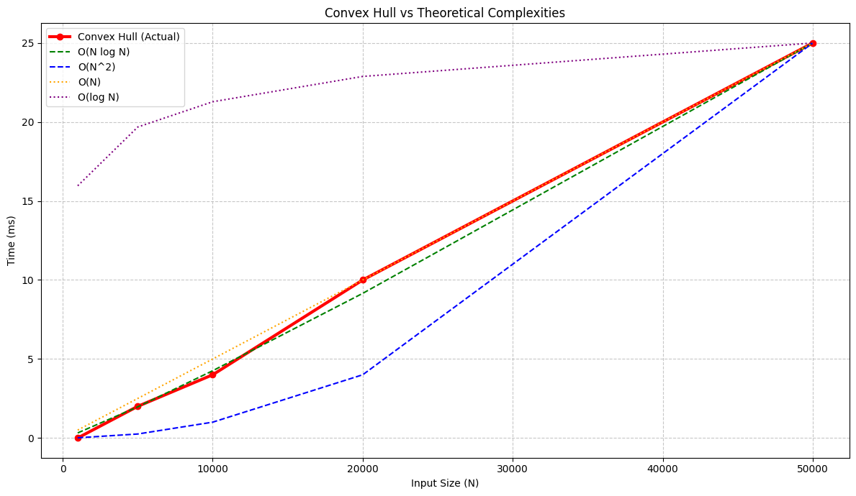

- Fractional Knapsack
Aim
Maximize value in a knapsack allowing fractional items using a greedy approach.

Algorithm: KNAPSACK(W, wt, val)
- Compute value/weight ratio for each item
- Sort items in decreasing order of ratio
- For each item:
  - Take as much as possible (fully or fractionally)
  - Reduce remaining capacity ( W )
- Return total value

Time Complexity (TC)
- ( O(n \log n) )

Space Complexity (SC)
- ( O(1) )

Code
struct Item {
int value, weight;};
bool cmp(Item a,Item b) {
double r1=(double)a.value/a.weight;
double r2=(double)b.value/b.weight;
return r1>r2;}
int main() {
Item arr[] ={
{60,10},
{100,20},
{120,30},
{120,40},
{150,50}};
int n = sizeof(arr)/sizeof(arr[0]);
int W = 50;
sort(arr, arr + n, cmp);
double totalvalue = 0.0;
cout << "Items taken:\n";
for(int i = 0; i < n; i++){
if(W >= arr[i].weight){
W -= arr[i].weight;
totalvalue += arr[i].value;
cout << "Full item (v=" << arr[i].value
<< ", w=" << arr[i].weight << ")\n";}
else {
double fraction = (double)W / arr[i].weight;
totalvalue += arr[i].value * fraction;
cout << "Fraction " << fraction
<< " of item (v=" << arr[i].value
<< ", w=" << arr[i].weight << ")\n";
break;}}
cout << "Maximum value: " << totalvalue << endl;
return 0;
}

Graphs
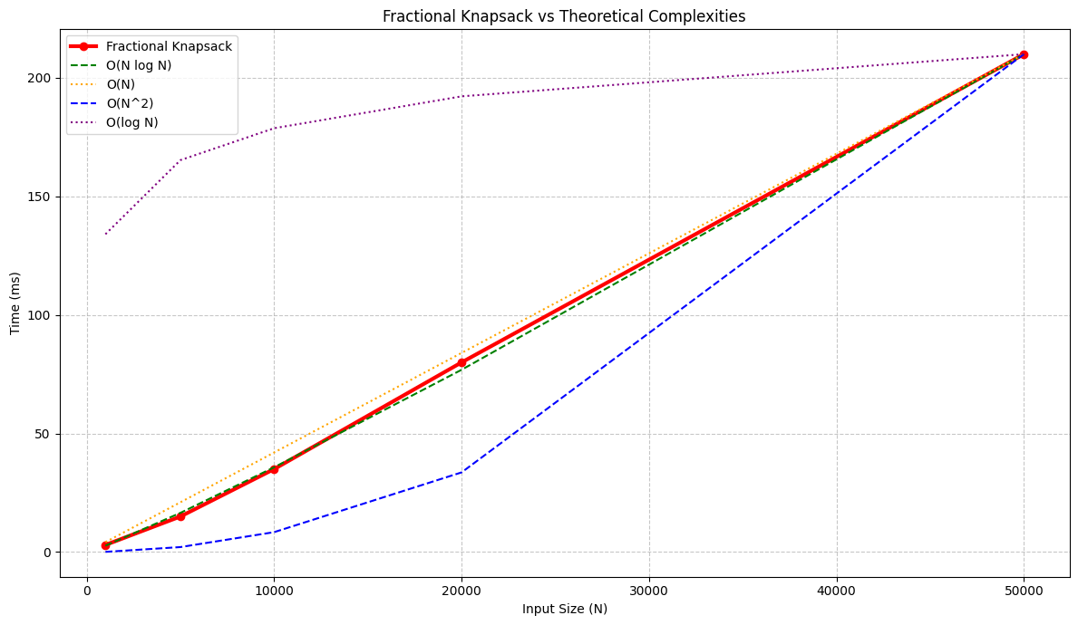

- Matrix Multiplication (Naive Method)
Aim
To multiply two square matrices of size n × n using the standard (naive) algorithm and measure the execution time.

Algorithm: matrix(A, B, C)
- Initialize matrix C with zeros
- For each row i from 0 → n-1
- For each column j from 0 → n-1
- Compute:
C[i][j] = Σ (A[i][k] * B[k][j]) for k = 0 → n-1
- Store result in matrix C

Time Complexity (TC)
- O(n³)

Space Complexity (SC)
- O(n²)

Code:
void multiplyMatrices(vector<vector<int>>& A,vector<vector<int>>& B,vector<vector<int>>& C) {
for(int i = 0;i < SIZE; i++) {
for(int j = 0;j < SIZE; j++) {
C[i][j] = 0;
for (int k = 0; k < SIZE; k++) {
C[i][j] += A[i][k] * B[k][j];}}}}
void generateMatrix(vector<vector<int>>& M) {
for (int i = 0; i < SIZE; i++)
for (int j = 0; j < SIZE; j++)
M[i][j] = rand() % 10; }
int main() {
srand(time(0));
cout<<"Matrix Size: 100x100"<<endl;
vector<vector<int>> A(SIZE, vector<int>(SIZE));
vector<vector<int>> B(SIZE, vector<int>(SIZE));
vector<vector<int>> C(SIZE, vector<int>(SIZE));
generateMatrix(A);
generateMatrix(B);
clock_t start=clock();
multiplyMatrices(A, B, C);
clock_t end=clock();
double time_ms=1000.0*(end-start)/CLOCKS_PER_SEC;
cout<<time_ms<<endl;
return 0;
}

Graph:
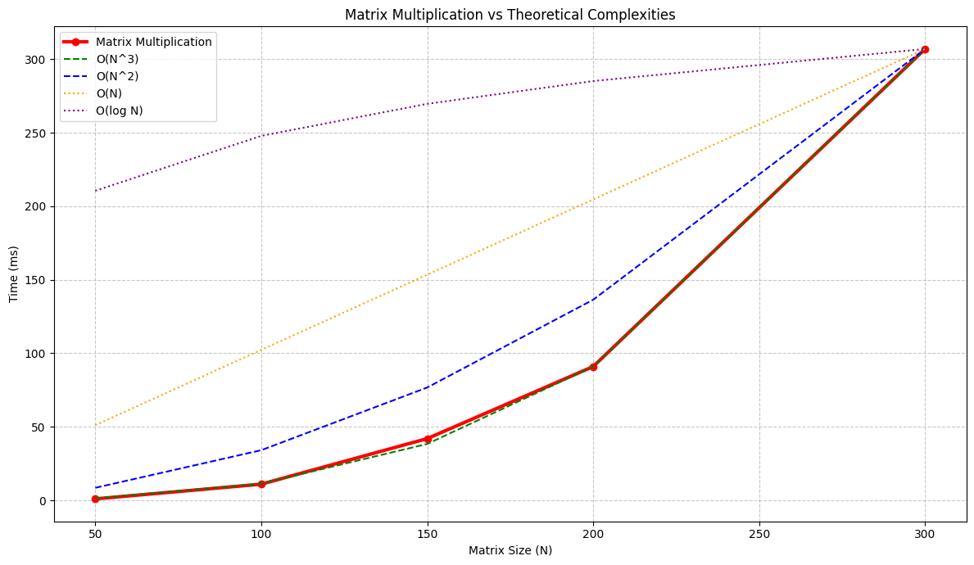

- Stresson (Dynamic Programming)
Aim
To determine the minimum number of scalar multiplications required to multiply a chain of matrices using Dynamic Programming.

Algorithm: MATRIX_CHAIN_ORDER(p, n)
- Let m[i][j] store minimum cost
- Initialize:
  - m[i][i] = 0 (single matrix → no cost)
- For chain length len = 2 → n-1
- For each i:
  - Compute j = i + len - 1
  - Set m[i][j] = ∞
- Try all possible splits k = i → j-1
  - Compute cost:
m[i][k] + m[k+1][j] + p[i-1]*p[k]*p[j]
  - Take minimum
- Final answer = m[1][n-1]

Time Complexity (TC)
- O(n³)

Space Complexity (SC)
- O(n²)

Code:
#include <iostream>
#include <climits>
using namespace std;
#define N 5
int main() {
int p[N] = {10, 30, 5, 60, 20};
int m[N][N];
for(int i = 1; i < N; i++)
m[i][i] = 0;
for(int len = 2; len < N; len++) {
for(int i = 1; i < N - len + 1; i++) {
int j = i + len - 1;
m[i][j] = INT_MAX;
for(int k = i; k < j; k++) {
int cost = m[i][k] + m[k+1][j]
+ p[i-1]*p[k]*p[j];
if(cost < m[i][j])
m[i][j] = cost;}}}
cout<<"Minimum multiplication cost "<<m[1][N-1]<<endl;
return 0;
}

Graph:
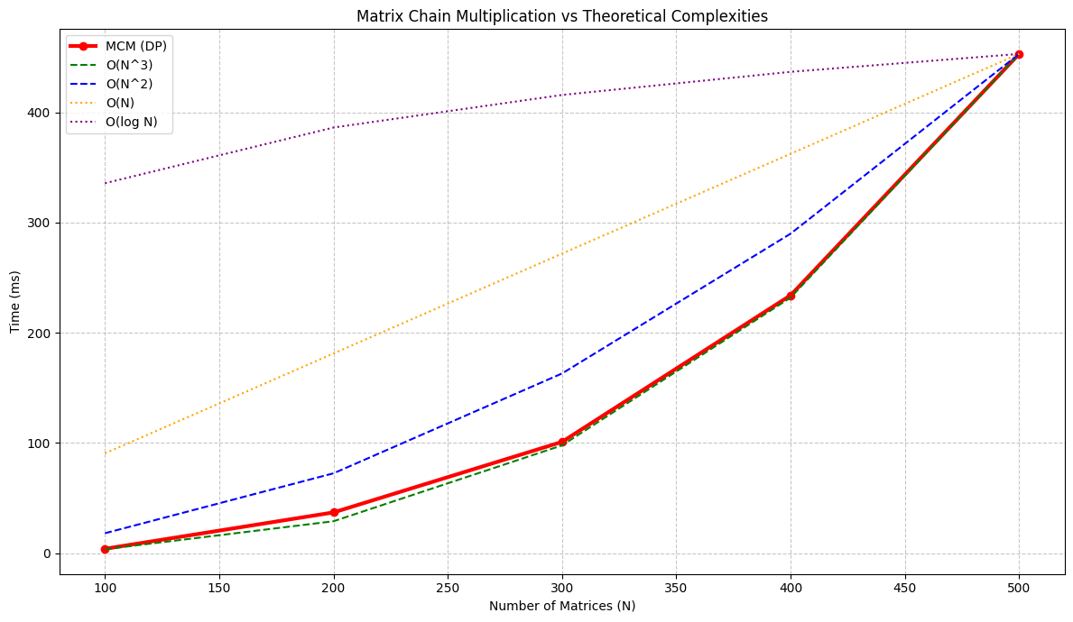

- Activity Selection Problem (Greedy Method)
Aim
To select the maximum number of non-overlapping activities from a given set using a greedy approach.

Algorithm: ACTIVITY_SELECTION(arr, n)
- Sort activities based on increasing finish time
- Select the first activity
- Initialize lastFinish = finish time of first activity
- For each remaining activity:
  - If start >= lastFinish
    - Select the activity
    - Update lastFinish
- Print selected activities

Time Complexity (TC)
- Sorting → O(n log n)
- Selection loop → O(n)
👉 Overall: O(n log n)

Space Complexity (SC)
- O(1)

Code:
#include <iostream>
#include <algorithm>
using namespace std;
struct act{
int start,finish;};
bool cmp(act a,act b) {
return a.finish<b.finish;}
int main() {
act arr[] = {
{1,3}, {2,4}, {0,6}, {5,7},
{8,9}, {5,9}};
int n = sizeof(arr)/sizeof(arr[0]);
sort(arr, arr + n, cmp);
cout << "Selected activities:\n";
int lastFinish = arr[0].finish;
cout << "(" << arr[0].start << "," << arr[0].finish << ")\n";
for(int i = 1; i < n; i++) {
if(arr[i].start >= lastFinish) {
cout << "(" << arr[i].start << "," << arr[i].finish << ")\n";
lastFinish = arr[i].finish;}}
return 0;
}

- Dijkstra's Shortest Path
Aim
Compute shortest paths from a single source in a weighted graph with non-negative weights.

Algorithm: DIJKSTRA(graph, src)
- Initialize distance array with infinity, set ( dist[src] = 0 )
- Use a priority queue to select node with minimum distance
- For each adjacent vertex:
  - Update distance if a shorter path is found
- Repeat until all vertices are processed

Time Complexity (TC)
- ( O((V + E) \log V) )

Space Complexity (SC)
- ( O(V) )

Code
#include <iostream>
#include <climits>
using namespace std;
#define V 5
int main() {
int graph[V][V] = {
{0, 10, 0, 5, 0},
{0, 0, 1, 2, 0},
{0, 0, 0, 0, 4},
{0, 3, 9, 0, 2},
{7, 0, 6, 0, 0}};
int dist[V];
bool visited[V];
for(int i = 0; i < V; i++) {
dist[i] = INT_MAX;
visited[i] = false;}
dist[0] = 0;
for(int j = 0; j < V-1; j++) {
int u = -1, minval = INT_MAX;
for(int i = 0; i < V; i++) {
if(!visited[i]&&dist[i]<minval){
minval=dist[i];
u=i;}}
visited[u]=true;
for(int v = 0; v < V; v++) {
if(graph[u][v]&&!visited[v]&&dist[u]!=INT_MAX&&dist[u]+graph[u][v]<dist[v]) {
dist[v]=dist[u] + graph[u][v];}}}
cout<<"Shortest distances from source (0):\n";
for(int i = 0; i < V; i++){
cout<<"0 -> "<<i<<" = "<<dist[i]<<endl;}
return 0;
}

Graphs:
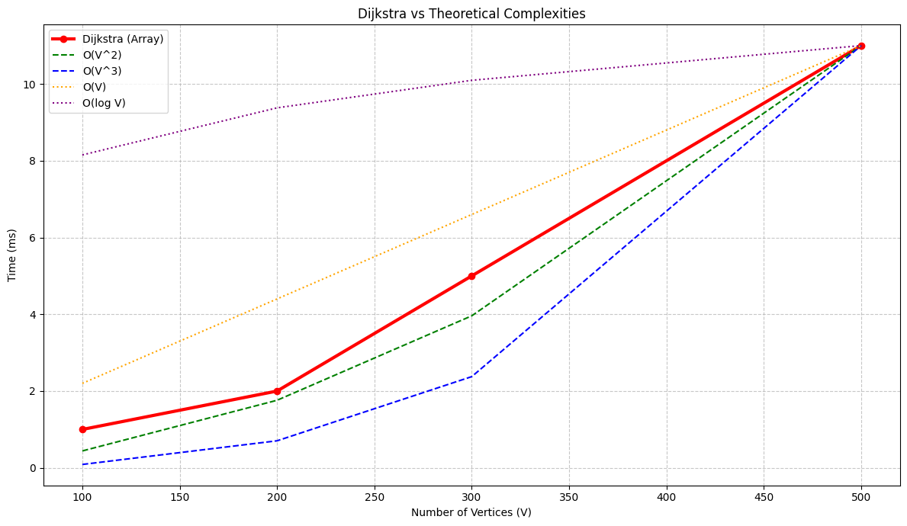

- Prim's Algorithm for MST
Aim
Construct a Minimum Spanning Tree using Prim's greedy approach.

Algorithm: PRIMS(graph)
- Initialize all vertices as not included in MST
- Start from any vertex (e.g., 0)
- Select minimum weight edge connecting MST to a new vertex
- Add selected vertex to MST
- Repeat until all vertices are included

Time Complexity (TC)
- ( O(V^2) ) (matrix)
- ( O(E \log V) ) (with heap)

Space Complexity (SC)
- ( O(V) )

Code
#include <iostream>
#include <climits>
using namespace std;
#define N 5
int main() {
int graph[N][N] = {
{0, 2, 0, 6, 0},
{2, 0, 3, 8, 5},
{0, 3, 0, 0, 7},
{6, 8, 0, 0, 9},
{0, 5, 7, 9, 0}};

int key[N]; // minimum edge weight
int parent[N]; // store MST
bool inMST[N]; // visited set

for(int i = 0; i < N; i++) {
key[i] = INT_MAX;
inMST[i] = false;}
key[0] = 0;
parent[0] = -1;
for(int c = 0; c < N-1; c++) {
int u = -1, minVal = INT_MAX;
for(int i = 0; i < N; i++){
if(!inMST[i] && key[i] < minVal) {
minVal = key[i];
u = i;}}
inMST[u] = true;
for(int v = 0; v < N; v++) {
if(graph[u][v] && !inMST[v] && graph[u][v] < key[v]) {
key[v] = graph[u][v];
parent[v] = u;}}}
int total = 0;
cout<<"Edges in MST:\n";
for(int i = 1; i < N; i++) {
cout<<parent[i]<<" - "<<i<<" weight "<<graph[parent[i]][i]<<endl;
total += graph[parent[i]][i];
}
cout << "Total cost: " << total << endl;
return 0;
}

Graph:
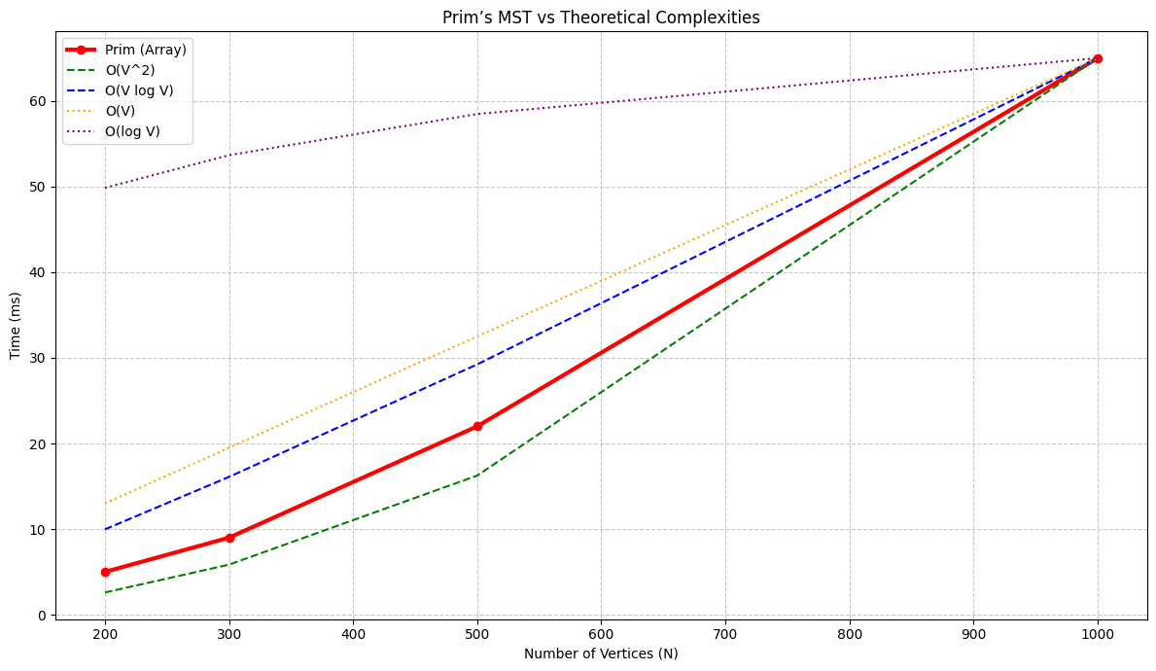

- Kruskal's Algorithm for MST
Aim
Construct a Minimum Spanning Tree by sorting edges and avoiding cycles using union-find.

Algorithm: KRUSKAL(edges, V)
- Sort all edges by weight
- Initialize disjoint sets for all vertices
- For each edge:
  - If it connects two different sets, include it in MST
  - Union the sets
- Repeat until MST has ( V-1 ) edges

Time Complexity (TC)
- ( O(E \log E) )

Space Complexity (SC)
- ( O(V + E) )

Code
#include <iostream>
#include <algorithm>
using namespace std;
#define V 5
#define E 7
struct Edge {
int u, v, w;};
int parent[V];
int find(int x) {
if(parent[x] != x)
parent[x] = find(parent[x]);
return parent[x];}
void unite(int x, int y) {
int px = find(x);
int py = find(y);
parent[px] = py;}
bool cmp(Edge a, Edge b) {
return a.w < b.w;}
int main() {
Edge edges[E] = {
{0,1,2},{0,3,6},{1,2,3},{1,3,8},{1,4,5}, {2,4,7},{3,4,9}};
sort(edges, edges + E, cmp);
for(int i = 0; i < V; i++)
parent[i] = i;
int total = 0;
cout << "Edges in MST:\n";
for(int i = 0; i < E; i++) {
int u = edges[i].u;
int v = edges[i].v;
if(find(u) != find(v)){
cout<<u<<" - "<<v<<"weight "<<edges[i].w<<endl;
total += edges[i].w;
unite(u, v);}}
cout<<"Total cost "<<total<<endl;
return 0;
}

Graphs
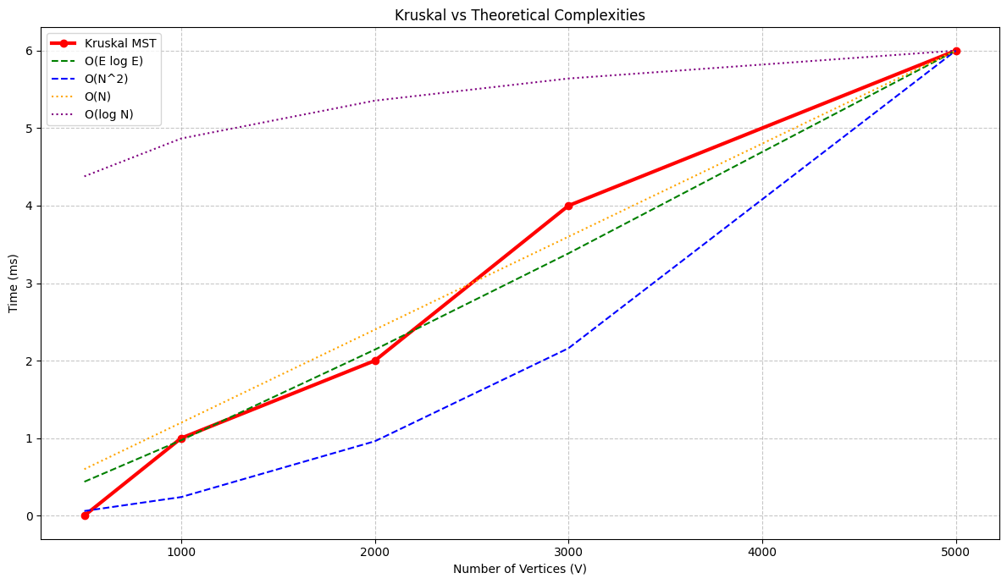

- Shortest path using Dijkstra’s Algorithm
Aim
To find the shortest path from a source vertex to all other vertices in a weighted graph with non-negative edge weights.

Algorithm: DIJKSTRA(graph, source)
- Initialize:
  - dist[i] = ∞ for all vertices
  - dist[source] = 0
  - visited[i] = false
  - parent[i] = -1
- Repeat V-1 times:
  - Select vertex u with minimum distance not visited
  - Mark u as visited
- For each adjacent vertex v:
  - If not visited and edge exists:
if dist[u] + weight(u,v) < dist[v]
update dist[v]
parent[v] = u
- Print distances and paths

Time Complexity (TC)
- O(v^2)

Space Complexity (SC)
- O(V)

Code:
#include <iostream>
#include <climits>
using namespace std;
#define V 5
void printPath(int parent[], int j) {
if(j==-1)
return;
printPath(parent, parent[j]);
cout<<j<<" ";}
int main() {
int graph[V][V] = {
{0, 10, 0, 5, 0},
{0, 0, 1, 2, 0},
{0, 0, 0, 0, 4},
{0, 3, 9, 0, 2},
{7, 0, 6, 0, 0}};
int dist[V];
bool visited[V];
int parent[V];
for(int i = 0; i < V; i++) {
dist[i] = INT_MAX;
visited[i] = false;
parent[i] = -1;}
dist[0] = 0;
for(int j = 0; j < V-1; j++) {
int u = -1, minval = INT_MAX;
for(int i = 0; i < V; i++) {
if(!visited[i]&&dist[i]<minval){
minval=dist[i];
u=i;}}
visited[u]=true;
for(int v = 0; v < V; v++) {
if(graph[u][v]&&!visited[v]&&dist[u]!=INT_MAX&&dist[u]+graph[u][v]<dist[v]) {
dist[v]=dist[u] + graph[u][v];
parent[v] = u;}}}
cout<<"Shortest distances from source (0):\n";
for(int i=0;i<V;i++) {
cout<<"0 ->"<<i<<" = "<<dist[i]<<" | Path ";
printPath(parent, i);
cout << endl;}
return 0;
}

- Cycle Detection in Directed Graph (DFS)
Aim
To detect whether a directed graph contains a cycle using Depth First Search (DFS).

Algorithm: IS_CYCLIC(V, edges)
- Create adjacency list from edges
- Initialize:
  - vis[i] = 0
  - path[i] = 0
- For each node:
  - If not visited → call DFS
- In DFS:
  - Mark node visited and in path
  - For each neighbor:
    - If not visited → recurse
    - If already in path → cycle found
- Backtrack:
  - Remove node from path

Time Complexity (TC)
- O(V + E)

Space Complexity (SC)
- O(V)

Code:
#include <bits/stdc++.h>
#include <vector>
#include <queue>
#include <iostream>
#include <algorithm>
using namespace std;
bool dfs( int node , vector<vector<int>>& adj , int vis[] , int path[] ){
vis[node] = 1;
path[node]= 1;
for ( auto it : adj[node]){
if( !vis[it] )
{
if ( dfs( it , adj , vis , path) == true)
return true ;
}
else if ( path[it] )
return true ;
}
path[node]=0;
return false; }
bool isCyclic(int V, vector<vector<int>> &edges) {
vector<vector<int>> adj(V);
for (auto &e : edges) {
int u = e[0];
int v = e[1];
adj[u].push_back(v); }
int path[V];
int vis[V];
for (int i =0 ; i < V ; i++ ){
path[i]= 0;
vis[i] = 0;}
for ( int i =0 ; i< V ; i++){
if ( !vis[i] ) {
if ( dfs ( i , adj , vis , path) == true)
return true ;
}
}
return false ;
}
int main(){
int V = 4;
vector<vector<int>> edges = {{0, 1}, {1, 2}, {2, 0}, {1, 3}};
if (isCyclic(V, edges)) {
cout << "Graph contains a cycle." << endl;
} else {
cout << "Graph does not contain a cycle." << endl;
}
return 0;
}

- Multistage Graph (Backward Approach)
Aim
Find shortest path in a multistage graph using backward approach.

Algorithm: MULTISTAGE(graph, N)
- Set:
  - cost[N-1] = 0 (destination)
- For i = N-2 → 0:
  - Initialize cost[i] = ∞
- For each j > i:
  - If edge exists:
    - Compute:
graph[i][j] + cost[j]
    - Take minimum
    - Store j in path[i]
- Final answer = cost[0]

Time Complexity (TC)
- O(V^2)

Space Complexity (SC)
- O(V)

Code
#include <iostream>
#include <climits>
using namespace std;
#define N 8 // number of nodes
int main() {
int path[N] = {-1};
int graph[N][N] = {
{0,1,2,5,0,0,0,0},
{0,0,0,0,4,11,0,0},
{0,0,0,0,9,5,16,0},
{0,0,0,0,0,0,2,0},
{0,0,0,0,0,0,0,18},
{0,0,0,0,0,0,0,13},
{0,0,0,0,0,0,0,2},
{0,0,0,0,0,0,0,0}};
int cost[N];

cost[N-1] = 0;
for(int i = N-2; i >= 0; i--) {
cost[i] = INT_MAX;
for(int j = i+1; j < N; j++) {
if(graph[i][j] != 0) {
if(graph[i][j]+cost[j]<cost[i]) {
cost[i] = graph[i][j]+cost[j];
path[i] = j;
}}}}
cout<<"Minimum cost "<<cost[0]<<endl;
for( int j = 0 ; j< N ; j++ ){
cout<<j<<" -> "<<path[j]<<endl;
}
return 0;
}

Use Cases
- Shortest path in staged graphs
- Network optimization
- DAG-based DP problems

- Multistage Graph (Forward Approach)
Aim
Find shortest path in a multistage graph using forward dynamic programming.

Algorithm
- If i == destination → return 0
- If cost[i] already computed → return it
- Try all k > i:
  - If edge exists:
    - Compute:
graph[i][k] + solve(k)
- Store minimum in cost[i]
- Track next node in path[i]

Time Complexity (TC)
- O(V^2)

Space Complexity (SC)
- O(V)

Code
#include <iostream>
#include <climits>
using namespace std;
#define N 8
int solve(int graph[N][N], int i, int j, int cost[N], int path[N]) {
if(i == j)
return 0;
if(cost[i] != -1)
return cost[i];
cost[i] = INT_MAX;
for(int k = i+1; k <= j; k++) {
if(graph[i][k] != 0) {
int curr = graph[i][k] + solve(graph, k, j, cost, path);
if(curr < cost[i]) {
cost[i] = curr;
path[i] = k;}}}
return cost[i];}
int main() {
int path[N], cost[N];
for(int i = 0; i < N; i++) {
path[i] = -1;
cost[i] = -1;}
int graph[N][N] = {
{0,1,2,5,0,0,0,0 },
{0,0,0,0,4,11,0,0},
{0,0,0,0,9,5,16,0},
{0,0,0,0,0,0,2,0 },
{0,0,0,0,0,0,0,18},
{0,0,0,0,0,0,0,13},
{0,0,0,0,0,0,0,2 },
{0,0,0,0,0,0,0,0 } };
solve(graph, 0, N-1, cost, path);
cout << "Minimum cost: " << cost[0] << endl;
cout << "Path: ";
int i = 0;
while(i != -1) {
cout << i << " ";
i = path[i]; }
return 0;}

Use Cases
- Dynamic programming on DAGs
- Decision optimization problems
- Multistage shortest path

- Matrix Chain Multiplication
Aim
Find the optimal parenthesization of matrices to minimize scalar multiplications.

Algorithm: MATRIX-CHAIN(p)
- Let ( n = length(p) - 1 )
- Initialize ( m[i][i] = 0 )
- For chain length ( L = 2 ) to ( n ):
  - For ( i = 1 ) to ( n-L+1 ):
    - Set ( j = i + L - 1 )
    - Set ( m[i][j] = \infty )
    - For ( k = i ) to ( j-1 ):
      - Compute cost
      - Update minimum value

Time Complexity (TC)
- O(n^3)

Space Complexity (SC)
- O(n^2)

Code
int mul(vector<int>& arr, int i , int j , vector<vector<int>> &dp ){
if( i + 1 == j ){
return 0;}

if( dp[i][j] != -1 )
return dp[i][j];

int res = INT_MAX;
for( int k = i + 1 ; k < j ; k++ ){
int curr = mul( arr, i , k , dp ) + mul( arr, k , j , dp ) + arr[i] * arr[k] * arr[j];
res = min( curr , res );
}
return dp[i][j] = res;}

Use Cases
- Optimizing matrix operations in scientific computing
- Compiler optimization (expression evaluation order)
- Graphics transformations

Graphs
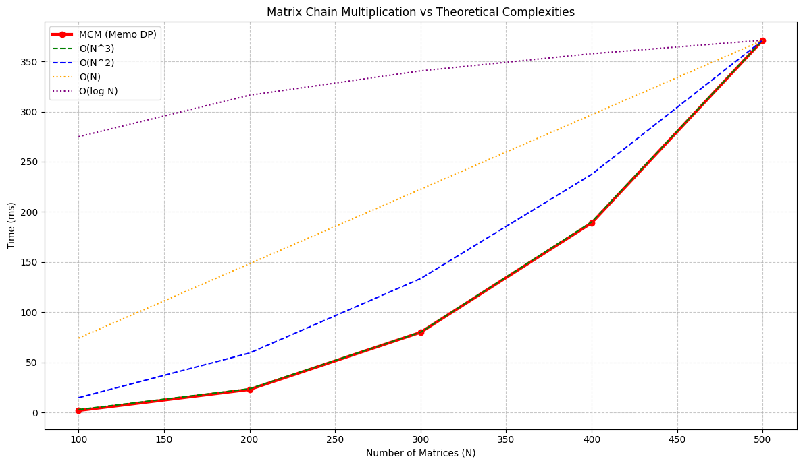

- All Pairs Shortest Path
Aim
Compute shortest paths between all pairs of vertices.

Algorithm: solve(dist)
- For each vertex ( k ):
- For each pair ( (i, j) ):
  - Update ( dist[i][j] = \min(dist[i][j], dist[i][k] + dist[k][j]) )

Time Complexity (TC)
- O(V^3)

Space Complexity (SC)
- O(V^2)

Code
#include <bits/stdc++.h>
using namespace std;
void floydWarshall(vector<vector<int>>& dist, int V) {
const int INF = 1e9;
// Convert -1 to INT_MAX
for (int i = 0; i < V; i++) {
for (int j = 0; j < V; j++) {
if (dist[i][j] == -1 && i != j)
dist[i][j] = INF; }
}
// Floyd-Warshall logic
for (int k = 0; k < V; k++) {
for (int i = 0; i < V; i++) {
for (int j = 0; j < V; j++) {
if (dist[i][k] != INF && dist[k][j] != INF) {
dist[i][j] = min(dist[i][j],
dist[i][k] + dist[k][j]);
}
}
}
}
// Print result of the code
cout << "All-pairs shortest distances:\n";
for (int i = 0; i < V; i++) {
for (int j = 0; j < V; j++) {
if (dist[i][j] >= INF) cout << "INF ";
else cout << dist[i][j] << " "; }
cout << "\n";
}}
int main() {
int V = 4;
vector<vector<int>> graph = {
{0, 5, -1, 10},
{-1, 0, 3, -1},
{-1, -1, 0, 1},
{-1, -1, -1, 0} }
floydWarshall(graph, V);
return 0;}
Use Cases
- Network routing protocols
- Shortest path in dense graphs
- Transitive closure (reachability problems)

Graphs
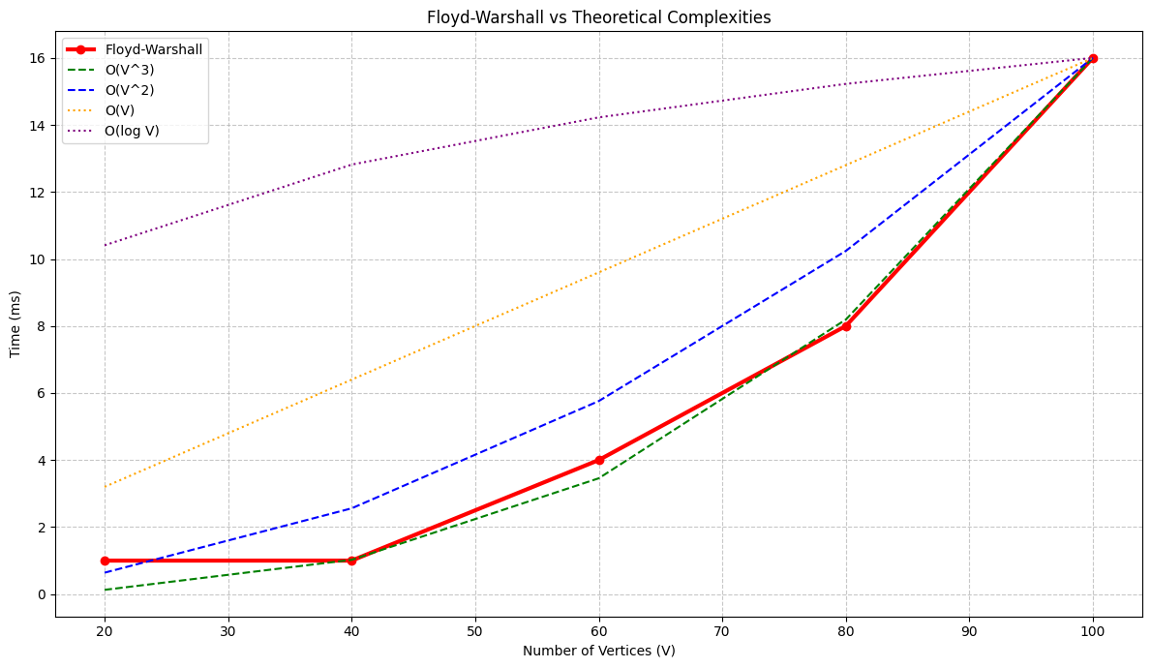

- Longest Common Subsequence
Aim
Find the longest common subsequence between two strings using dynamic programming.

Algorithm: LCS(X, Y)
- Let ( m = length(X), n = length(Y) )
- Create table ( c[m+1][n+1] )
- Fill table:
  - If characters match → diagonal + 1
  - Else → max of top or left
- Use a direction table to reconstruct LCS
- Backtrack to print the subsequence

Time Complexity (TC)
- O(m \cdot n)

Space Complexity (SC)
- O(m \cdot n)

Code:
int solve( int i , int j , string &s1 , string &s2 , vector<vector<int>> & dp ){
if( i < 0 || j < 0 )
return 0
if( dp[i][j] != -1 ){
return dp[i][j];
if( s1[i] == s2[j] )
return dp[i][j] = 1 + solve(i-1, j-1, s1, s2, dp);
return dp[i][j] = max(solve(i - 1 ,j ,s1 ,s2 ,dp ),solve(i ,j - 1 ,s1 ,s2 ,dp ));
}

Use Cases
- DNA sequence alignment
- Text comparison (diff tools)
- Version control systems
- Plagiarism detection

- 0/1 Knapsack (Dynamic Programming)
Aim
Maximize total value in a knapsack without exceeding capacity, where each item can be taken at most once.

Algorithm: KNAPSACK(weights, values, capacity)
- Let ( n = number\ of\ items )
- Create DP table ( dp[n+1][capacity+1] )
- For each item ( i ) and weight ( w ):
  - If item can be included:
[ dp[i][w] = \max(dp[i-1][w],\ dp[i-1][w - weight[i]] + value[i]) ]
  - Else: [ dp[i][w] = dp[i-1][w] ]
- Return ( dp[n][capacity] )

Time Complexity (TC)
- ( O(n \cdot W) )

Space Complexity (SC)
- ( O(n \cdot W) )

Code (Important Function)
int solve( int ind , int w , vector<int> &val , vector<int>& wt , vector<vector<int>> &dp ){
if( ind == 0 ){
if( wt[0] <= w )
return val[0];
else
return 0;}
if( dp[ind][w] != -1)
return dp[ind][w];
int not_take = solve( ind - 1 , w , val , wt , dp );
int take = 0;
if( wt[ind] <= w ){
take = val[ind] + solve( ind - 1 , w - wt[ind] , val , wt , dp );
}
return dp[ind][w] = max( take , not_take );
}
Use Cases
- Resource allocation problems
- Budget optimization
- Cargo loading and logistics
- Investment decision making
Graphs
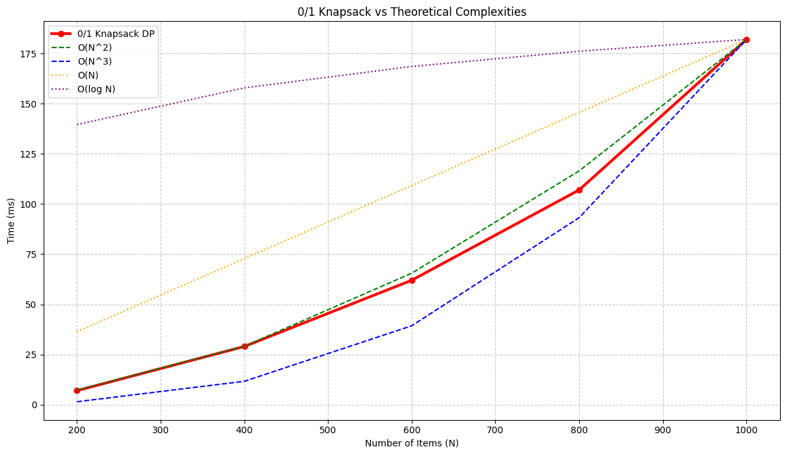

- Traveling Salesman Problem (Dynamic Programming)
Aim
Solve TSP efficiently using Dynamic Programming (Bitmasking).

Algorithm: TSP-DP(n, cost)
- Use bitmask to represent visited cities
- Initialize DP table
- Iterate over all subsets of cities
- Update minimum cost for each subset
- Return minimum cost including return to source

Time Complexity (TC)
- ( O(n^2 \cdot 2^n) )

Space Complexity (SC)
- ( O(n \cdot 2^n) )

Code
using namespace std;
int solve( int i , int next , vector<vector<int>> &cost , vector<vector<int>> &dp) {
if( next == 0 )
return cost[i][0];
if( dp[i][next] != -1 )
return dp[i][next];

int ans = INT_MAX;

for( int j = 0 ; j < cost.size() ; j++ ){
if (next & (1 << j)){
ans = min(ans , cost[i][j] + solve( j , next^(1<<j) , cost , dp));
}
}
return dp[i][next] = ans;
}
int main(){
vector<vector<int>> cost = {
{0, 10, 15, 20},
{5, 0, 9, 10},
{6, 13, 0, 12},
{8, 8, 9, 0}
};
vector<vector<int>> dp( cost.size() , vector<int>(1<<cost.size() , -1));
cout<<solve( 0 , ((1 << cost.size()) - 1) ^ 1 , cost , dp )<<endl;
return 0;
}

Use Cases
- Logistics and route planning
- Circuit design
- Optimization problems with constraints

- Graph coloring
Aim
Assign colors to vertices such that no two adjacent vertices share the same color.

Algorithm: GRAPH-COLORING(graph, m)
- Assign colors one by one to vertices
- Check if current color assignment is safe
- If safe, recurse for next vertex
- If all vertices are colored, solution found

Time Complexity (TC)
- Exponential in worst case

Space Complexity (SC)
- ( O(n) )

Code
static boolean isSafe(int v, int c, int[][] graph, int[] color, int n) {
for (int i = 0; i < n; i++)
if (graph[v][i] == 1 && color[i] == c)
return false;
return true;
}
static void solve(int v, int[][] graph, int[] color, int n, int m) {
if (v == n) {
for (int i = 0; i < n; i++) System.out.print(color[i] + " ");
System.out.println();
return;
}

for (int c = 1; c <= m; c++) {
if (isSafe(v, c, graph, color, n)) {
color[v] = c;
solve(v + 1, graph, color, n, m);
color[v] = 0;
}
}
}

Use Cases
- Register allocation in compilers
- Scheduling problems
- Frequency/channel assignment

- Hamiltonian Cycle
Aim
Find a Hamiltonian cycle in a graph using backtracking.

Algorithm: HAMILTONIAN(graph)
- Start from a vertex
- Recursively add vertices to path
- Check if all vertices are visited exactly once
- Verify if last vertex connects to first

Time Complexity (TC)
- ( O(n!) )

Space Complexity (SC)
- ( O(n) )

Code
#include <bits/stdc++.h>
using namespace std;
bool isSafe(int v, vector<vector<int>>& graph,
vector<int>& path, vector<bool>& visited, int pos) {

// must be adjacent to previous vertex
if (graph[path[pos - 1]][v] == 0)
return false;

// must not be visited already
if (visited[v])
return false;

return true;
}
bool solve(vector<vector<int>>& graph,
vector<int>& path, vector<bool>& visited,
int pos, int V) {

// all vertices included
if (pos == V) {
// check if last connects to first
return graph[path[pos - 1]][path[0]] == 1;
}

for (int v = 1; v < V; v++) {
if (isSafe(v, graph, path, visited, pos)) {

path[pos] = v;
visited[v] = true;

if (solve(graph, path, visited, pos + 1, V))
return true;

// backtrack
visited[v] = false;
path[pos] = -1;
}
}

return false;
}

int main() {

vector<vector<int>> graph = {
{0,1,0,1,0},
{1,0,1,1,1},
{0,1,0,0,1},
{1,1,0,0,1},
{0,1,1,1,0}
};
int V = graph.size();
vector<int> path(V, -1);
vector<bool> visited(V, false);
path[0] = 0;
visited[0] = true;
if (solve(graph, path, visited, 1, V)) {
cout << "Hamiltonian Cycle: ";
for (int v : path) cout << v << " ";
cout << path[0] << endl;
} else {
cout << "No Hamiltonian Cycle\n";
}

return 0;

- N-Queens Problem
Aim
Place N queens on an ( N \times N ) chessboard such that no two queens attack each other.

Algorithm (Backtracking)
Algorithm: N-QUEENS(k, x, n)
- If ( k = n ), a solution is found
- For each column ( i = 0 ) to ( n-1 ):
  - Check if placing queen at ( (k, i) ) is safe
  - If safe:
    - Place queen
    - Recurse for next row

Time Complexity (TC)
- ( O(n!) )

Space Complexity (SC)
- ( O(n) )

Code
public static void solve(int k, int[] x, int n) {
if (k == n) {
solutions++;
return; }
for (int i = 0; i < n; i++) {
if (isSafe(k, i, x)) {
x[k] = i;
solve(k + 1, x, n);
}
}
}
static boolean isSafe(int k, int i, int[] x) {
for (int j = 0; j < k; j++) {
if (x[j] == i || Math.abs(x[j] - i) == Math.abs(j - k)) {
return false;
}
}
return true;}

Use Cases
- Constraint satisfaction problems
- Puzzle solving
- Backtracking optimization techniques

- Sum of Subsets
Aim
Find all subsets of a given set whose sum equals a target value.

Algorithm: SUM-OF-SUBSETS(s, k, r, w, x, n, W)
- If ( k < n ):
- Include current element ( w[k] ):
  - If ( s + w[k] = W ), output solution
  - Else recurse if promising
- Exclude current element:
  - Recurse if remaining elements can still reach ( W )

Time Complexity (TC)
- Exponential (worst case)

Space Complexity (SC)
- ( O(n) )

Code
public static void sumOfSubsets(int s, int k, int r, int[] w, int[] x, int n, int W) {
if (k < n) {
x[k] = 1;

if (s + w[k] == W) {
System.out.println("Found subset");
}
else if (k + 1 < n && s + w[k] + w[k+1] <= W) {
sumOfSubsets(s + w[k], k + 1, r - w[k], w, x, n, W);
}

if (k + 1 < n && s + r - w[k] >= W && s + w[k+1] <= W) {
x[k] = 0;
sumOfSubsets(s, k + 1, r - w[k], w, x, n, W);
}
}
}

Use Cases
- Subset selection problems
- Resource allocation
- Combinatorial optimization

