1.Draw a labeled diagram of a typical home Wi-Fi setup showing a modem, router, switch, access point, and at least two devices (like a laptop and smartphone) connected to the network.
----
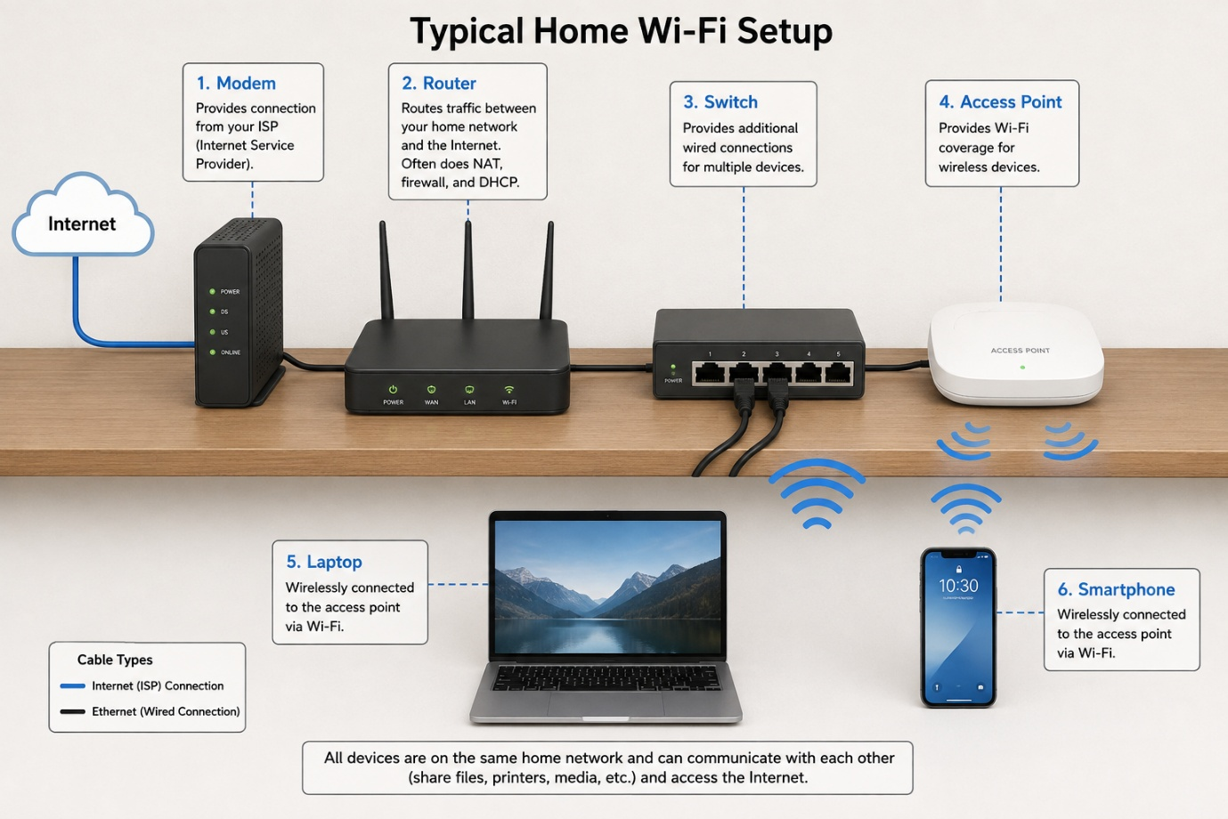

2.List the main function of each networking hardware device: modem, router, switch, access point, and network cable. For each, give a real-life example of where you might see or use it (for example, 'router: at home to share internet').
---Main Functions of Networking Hardware Devices
- Modem
Main function: Connects your home network to the Internet Service Provider (ISP) and converts the ISP signal into a form your network can use.
Real-life example: Used at home to receive the Internet connection from your ISP.
- Router
Main function: Connects different networks and directs data between your home network and the Internet. It can also provide Wi-Fi and assign IP addresses.
Real-life example: Used at home to share one Internet connection with laptops, phones, and smart TVs.
- Switch
Main function: Connects multiple wired devices in the same local network and sends data to the correct device.
Real-life example: Used in an office to connect many desktop computers, printers, and servers using Ethernet cables.
- Access Point (AP)
Main function: Provides Wi-Fi access to wireless devices and connects them to the wired network.
Real-life example: Used in a school or office to provide Wi-Fi coverage in different rooms.
- Network Cable
Main function: Carries data between networking devices and computers through a wired connection.
Real-life example: An Ethernet cable used to connect a PC to a router or switch.

3.Take photos or find images online (with source links) of at least three types of network cables (such as Ethernet, coaxial, fiber optic) and write one line describing where each is commonly used.
---
1. Ethernet Cable (Cat5e/Cat6)
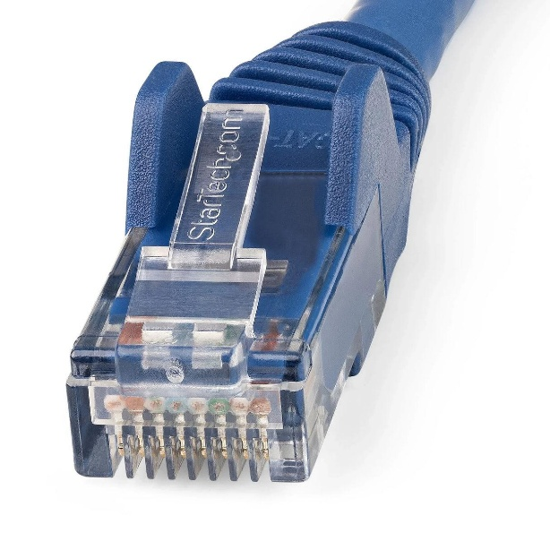
Common use: Used to connect computers, routers, switches, printers, and other devices in a home or office LAN.
2. Coaxial Cable
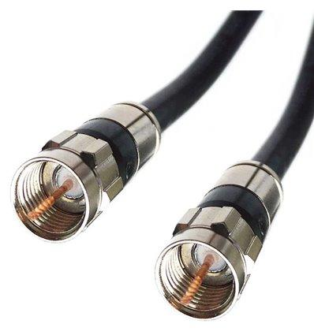
Common use: Commonly used for cable TV, cable Internet, satellite TV, and some CCTV systems.

3. Fiber Optic Cable
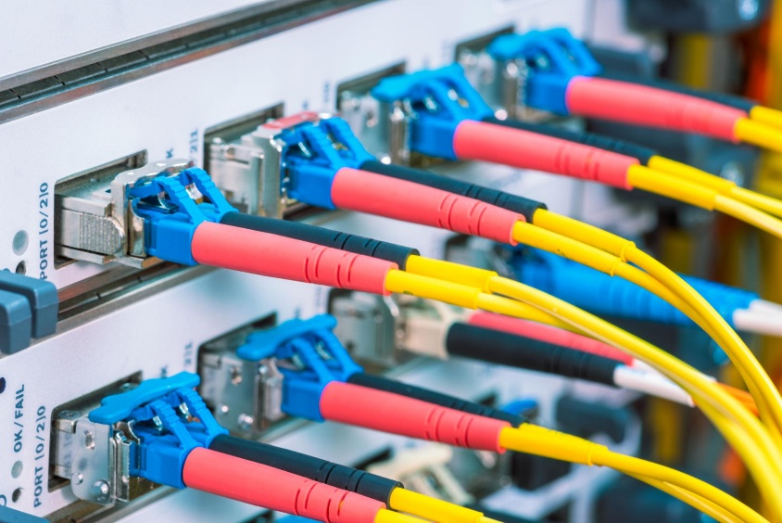
Common use: Used for high-speed Internet, telecommunications, data centers, and long-distance network connections because it transmits data using light.

4.Create a comparison table listing at least four differences between a router and a switch, including their main use, typical location, and how they handle data.
---
Difference | Router | Switch
Main use | Connects your network to the Internet. | Connects many devices inside the same network.
Where used | Usually at home or office. | Usually in offices, schools, and server rooms.
What it does | Decides where data should go between networks. | Sends data to the correct device in the same network.
Uses | Mainly uses IP addresses to find the destination. | Mainly uses MAC addresses to find the device.
Example | Home router connects your phone and laptop to the Internet. | Office switch connects many computers together.
Simple example | Router = connects networks | Switch = connects devices

