1.List 3 key differences between Ethernet cables and fiber optic cables, and give one real-world example where each type would be used (for example, home WiFi router, data center, college campus backbone).
---
- Signal: Ethernet cables use electrical signals through copper wires, while fiber optic cables use light signals through glass or plastic fiber.
- Speed and Distance: Ethernet cables are generally used for shorter distances, while fiber optic cables can provide high-speed communication over much longer distances.
- Cost and Installation: Ethernet cables are cheaper and easier to install, while fiber optic cables are more expensive and require specialized equipment and handling.
Real-world examples:
Ethernet cable: Connecting a home Wi-Fi router to a PC or gaming console.
Fiber optic cable: Connecting servers and switches in a data center.
Fiber optic cable: Connecting different buildings in a college campus backbone.

2.Draw and label a diagram showing the internal wiring of a straight-through Ethernet cable (use T568B wiring standard), indicating the color of each wire and its pin number.
---
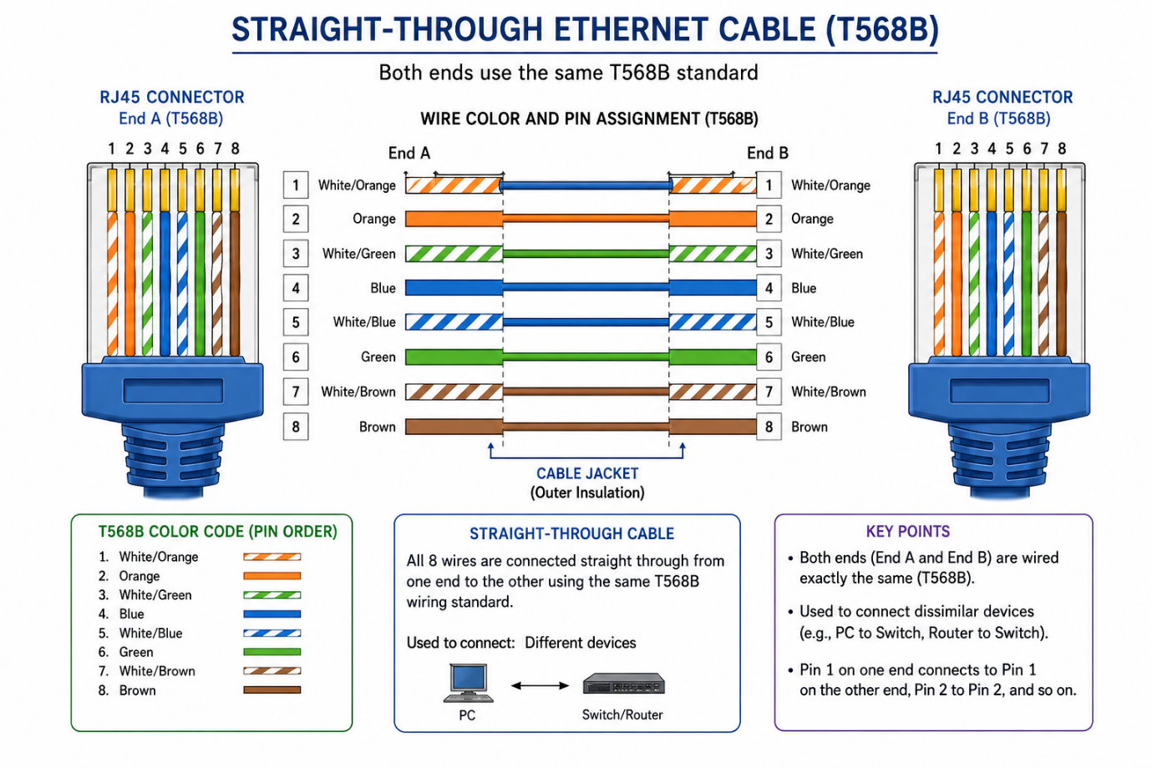

3.Watch a YouTube video demonstrating how to use an RJ45 crimper, then write a step-by-step guide (in your own words) on how to attach an RJ45 connector to a CAT6 cable.
---
1.Cut the cable – Cut the CAT6 cable to the required length.
2. Remove the outer cover – Use the cable stripper to carefully remove about
2–3 cm of the outer jacket.
3. Separate the wires – Untwist and separate the 8 small wires inside the cable.
4. Arrange the wires – Arrange the wires in the T568B order:
- White/Orange
- Orange
- White/Green
- Blue
- White/Blue
- Green
- White/Brown
- Brown
5. Straighten the wires – Make all 8 wires straight and place them next to each other in the correct order.
6. Cut the wires evenly – Trim the ends so all 8 wires are the same length.
7. Insert into RJ45 connector – Push the wires into the RJ45 plug. Make sure each wire reaches the end of its channel.
8. Check the order – Look through the transparent connector and confirm that the wires are still in the correct T568B order.
9. Crimp the connector – Put the RJ45 plug into the crimping tool and squeeze the handles firmly.
10. Test the cable – Use an Ethernet cable tester to check whether all 8 wires are connected correctly.
4.Imagine you are setting up a gaming café with 10 PCs for LAN gaming. Decide which cable type (Ethernet or fiber optics) and which tool (RJ45 crimper or fiber cleaver) you would use, and explain your choices in 3-4 sentences.<br><br><em><strong>Hint:</strong> Consider speed, distance, and budget for your answer.</em>
---
For a gaming café with 10 PCs, I would use CAT6 Ethernet cables because they provide enough speed for LAN gaming and are suitable for normal café distances. Ethernet cables are also cheaper and easier to install than fiber optic cables. I would use an RJ45 crimper to attach RJ45 connectors to the CAT6 cables. Fiber optic cable and a fiber cleaver would be more suitable for long-distance or high-speed backbone connections.

