1.Log in to your home Wi-Fi router's admin panel using its default IP address (usually 192.168.0.1 or 192.168.1.1) and take a screenshot of the login page.<br><br><em><strong>Hint:</strong> If you don't know your router's IP, open Command Prompt and run 'ipconfig' — look for 'Default Gateway'.</em>
----
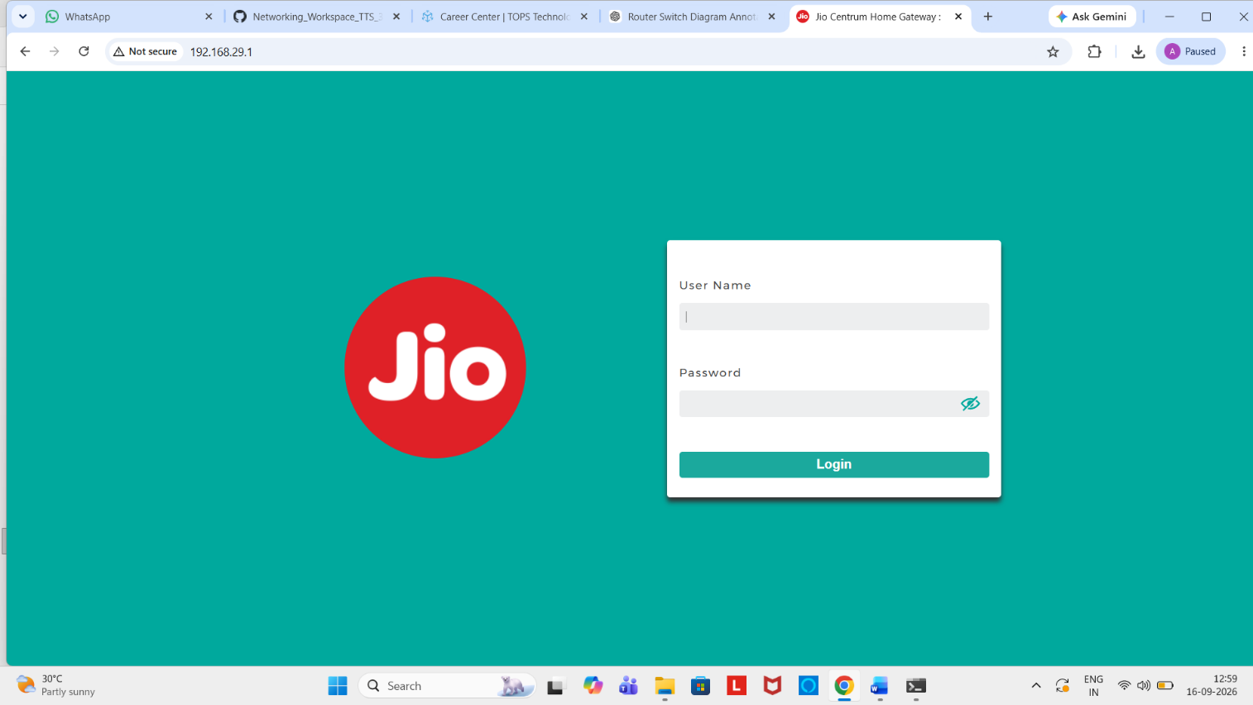

2.Find and note down the current IP address, subnet mask, and default gateway assigned to your laptop or mobile device when connected to your Wi-Fi network.
---
IPv4 Address : 192.168.29.8
Subnet Mask : 255.255.255.0
Default Gateway : 192.168.29.1

4.In your router's admin panel, locate the section where you can view or change the DHCP range. Write down the current range, and explain in 2-3 lines what would happen if two devices are assigned the same IP address in this range.
---
