1.Draw a labelled diagram of a typical home WiFi router and a network switch, clearly marking at least 3 different ports (such as WAN, LAN, Console) and the location of status LEDs.
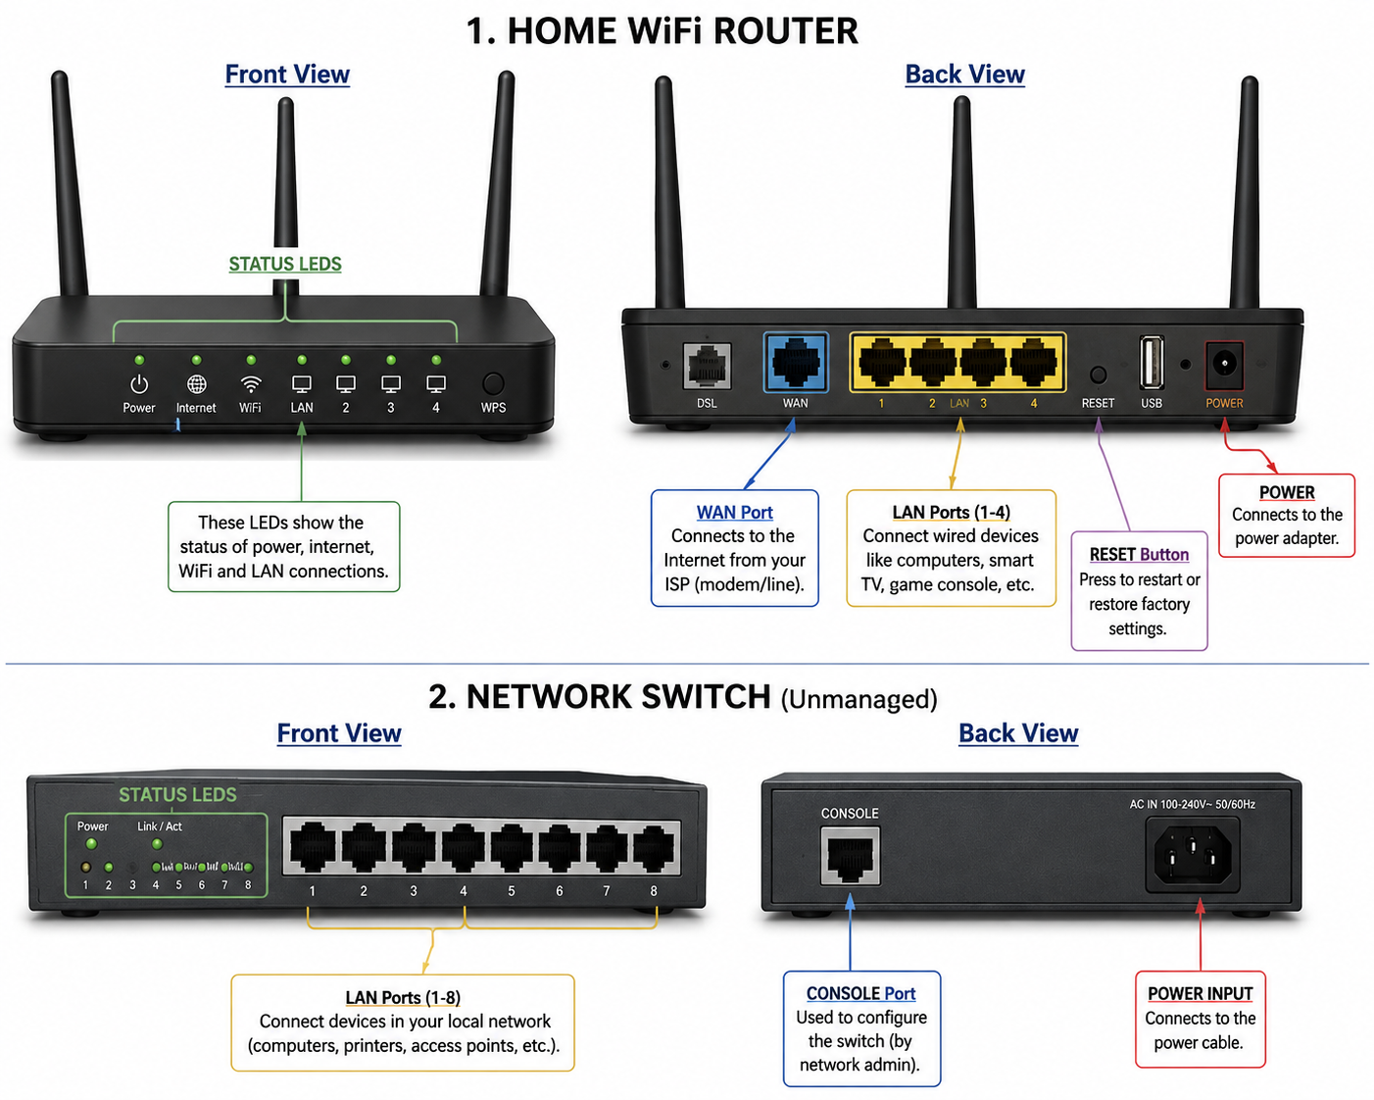

2.List 3 key differences between routers and switches in terms of their main functions and how they handle network traffic.<br><br><em><strong>Hint:</strong> Think about how each device deals with IP addresses, MAC addresses, and the types of networks they connect.</em>
---
Router vs Switch – 3 Key Differences
- Main Function:
A router connects different networks, such as a home network to the Internet.
A switch connects multiple devices within the same network.
- Address Used:
A router mainly uses IP addresses to decide where data should go.
A switch mainly uses MAC addresses to send data to the correct device.
- Network Traffic:
A router sends data between different networks.
A switch sends data between devices within the same local network (LAN).

3.Take a real or virtual image of a router and a switch (from your home, lab, or Google Images), and identify the following on each: Power port, at least 2 Ethernet ports, and any LED indicators. Annotate the image or describe their position and purpose.
---
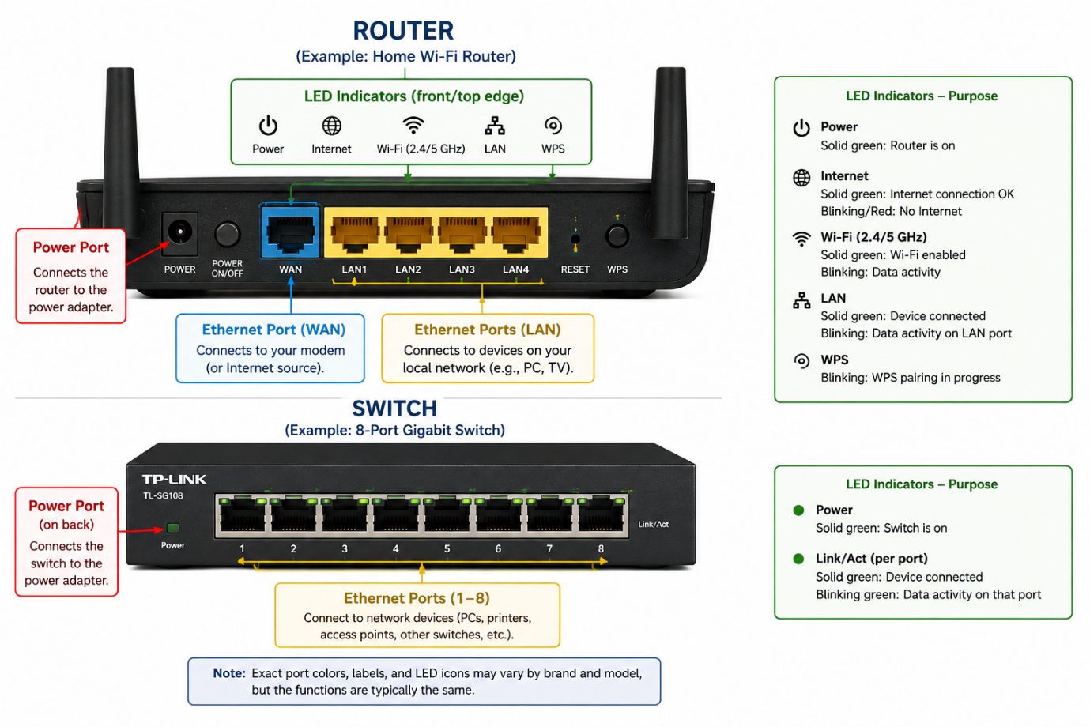

4.Imagine you are setting up a small gaming café network for IPL streaming and multiplayer matches. Write a short scenario explaining which device (router or switch) you would connect first to the ISP line, and how you would connect 8 gaming PCs to the network. Justify your choices.
----

I am setting up a small gaming café for IPL streaming and multiplayer gaming. I would first connect the ISP Internet line to the router's WAN/Internet port. The router provides Internet access, assigns IP addresses to the computers, and manages the network.
Next, I would connect one LAN/Ethernet port of the router to an Ethernet port on a network switch. Then I would connect the 8 gaming PCs to 8 different Ethernet ports on the switch.
Connection:
ISP → Router → Switch → 8 Gaming PCs
I would use a switch because it provides multiple Ethernet ports and allows all 8 PCs to communicate efficiently on the local network. The router is needed to connect the café network to the Internet, while the switch is used to connect the 8 gaming PCs together.

