**Task 1:**

* This Amazon Prime dataset consists of 8807 instances and 12 attributes and it has 6 missing value columns.
* And highest missing values in director attributes and lowest missing values in duration.

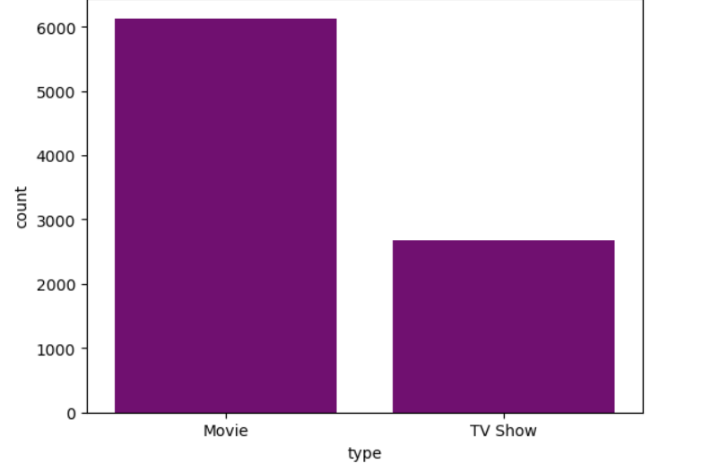

Fig : 1

* In amazon prime Movie has published more than TV shows (Fig: 1) , the Movie and Tv shows are more release on 2018.

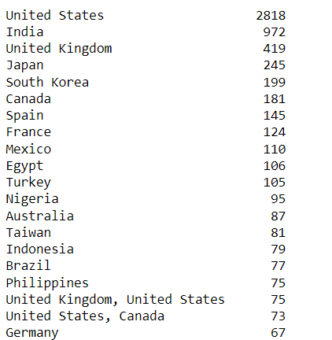

Fig:2

* United States has more movies and shows are released in prime, more than 500 country has released on 1 movies and shows.
* Dramas, International Movies has released more on prime it has 362 and less shows are TV Action & Adventure, TV Comedies.
* In the dataset ‘Rajiv Chilaka’ has direct the 19 movies and shows.
* And highest duration 1season it has 1793 shows.
* Over all my analytics in the dataset, it is all about the amazon prime services, it has a more show on dramas, and international movies, more shows and movies released in the country on United states.

**Task 2:**

* The given dataset is a Video Games Sales analysis in this dataset contains 13 attributes and 1907 instances and it has 1519 unique Games and 22 Platforms
* And it has a 29 missing values in year and 2values in publisher.
* ‘Nintendo’ has the highest publisher in global.
* The top most genre is Sports.
* In 2007 to 2009 the top genre is sports, Action, Misc
* ‘Wii Sports’ has the top sales in global.
* In the year 2008 has the highest video games sales in global.