Project Report
Agile Dashboard Implementation: Regional Sales & Profit Analysis using Power BI

1. Project Overview
The project titled “Agile Dashboard Implementation: Regional Sales & Profit Analysis using Power BI” was initiated through a detailed Project Charter (attached separately as Annexure A).
The charter outlined the project’s objectives, scope, key stakeholders, deliverables, and success criteria, serving as the foundation for this analytical and visualization-based initiative.
The project aimed to design an interactive dashboard that enables stakeholders to monitor sales, profit, and performance trends across regions, categories, and customer segments — empowering faster, data-driven decision-making.

2. Data Preparation & Cleaning
Dataset Used:
The dataset selected for analysis was the Global Superstore Dataset (sourced from Kaggle).
It contains transactional sales data across multiple regions and time periods, with details such as Order Date, Ship Date, Region, Category, Sub-Category, Segment, Sales, Quantity, Discount, and Profit.
Data Cleaning Steps:
- Removed duplicate and null records using Power Query in Power BI.
- Standardized date formats and validated regional and categorical fields.
- Created calculated columns:
  - Year = YEAR(Order Date)
  - Month = MONTH(Order Date)
  - Month-Year = FORMAT(Order Date, "MMM yyyy")
- Created DAX measures:
  - Total Sales = SUM(Sales)
  - Total Profit = SUM(Profit)
  - Profit Margin = DIVIDE(SUM(Profit), SUM(Sales))
- Verified data relationships between Region, Segment, and Category to ensure consistency across visuals.
Outcome:
The dataset was cleaned, transformed, and validated to ensure accuracy and readiness for visualization in Power BI.

3. Agile Task Tracking (Execution Monitoring)
The project followed an Agile approach to manage dashboard development efficiently.
Tasks were organized and tracked using Trello, enabling real-time visibility of progress and ensuring iterative completion of deliverables.
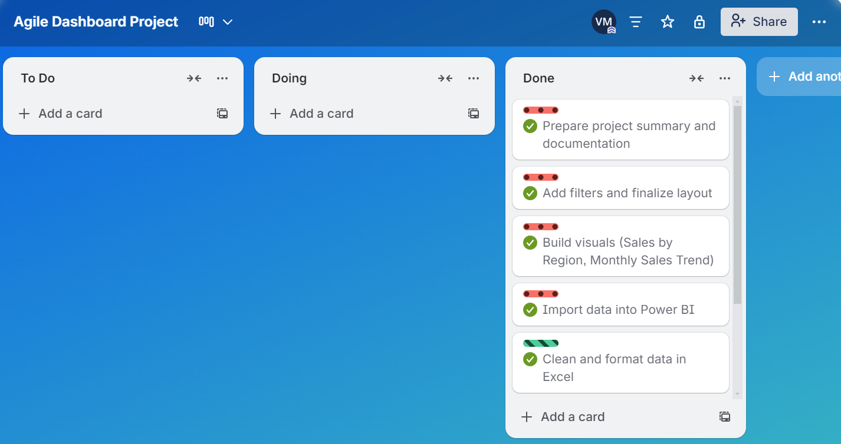
The board included three workflow stages — To Do, Doing, and Done — representing Agile sprint-style task management.

This approach helped maintain clear progress tracking and timely delivery of each stage — from data cleaning to visualization and report preparation.

Dashboard Development (Execution Phase)
The dashboard was developed using Microsoft Power BI following an Agile methodology, enabling iterative testing and enhancement through short sprints.
Core Visuals Created:
- KPI Cards: Total Sales, Total Profit, Profit Margin %, Total Quantity Sold
- Line Chart: Monthly Sales Trend
- Bar Chart: Top 10 Products by Sales
- Column Chart: Profit by Category
- Map Visual: Regional Sales Distribution
- Interactive Filters (Slicers): Region, Category, Year, Segment
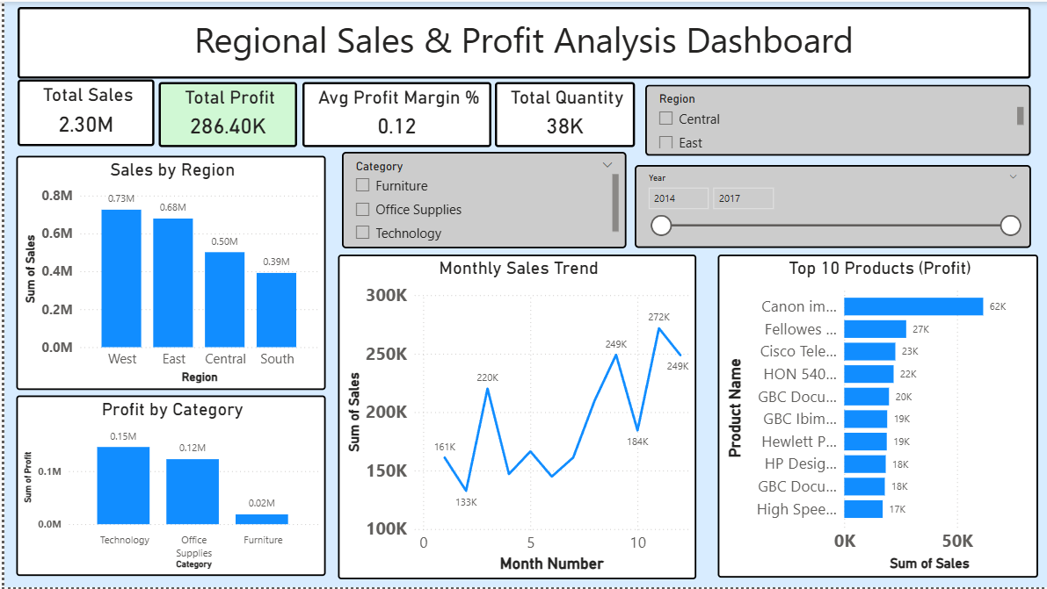
Design Approach:
A minimalist, user-friendly layout was adopted to make insights easily accessible.
All visuals were interconnected to allow real-time filtering, ensuring the dashboard remained dynamic and responsive.
Dashboard Purpose:
To help decision-makers identify performance gaps, monitor profitability, and evaluate business trends with just a few clicks.
4. Insights & Analysis (Monitoring Phase)
1. Regional Performance
- The West region leads in total sales (~₹0.73M), followed by the East (~₹0.68M).
- Central and South regions show lower sales volumes, presenting an opportunity to expand market share.
- Despite high sales, the West exhibits slightly weaker profit margins — possibly due to discount-heavy sales strategies.
2. Category Profitability
- Technology generates the highest profit (~₹0.15M), followed by Office Supplies (~₹0.12M).
- Furniture, while having large sales volumes, yields lower profitability, likely due to high transportation and warehousing costs.
3. Product-Level Insights
- The Canon imageCLASS Printer Series stands out as the top profit contributor (~₹62K).
- A majority of profits come from fewer top-performing SKUs, indicating a high dependence on select products.
4. Monthly Sales Trend
- Sales rise steadily throughout the year, with strong spikes during November and December, highlighting seasonal consumer demand.
- This pattern suggests opportunities for targeted promotions and stock optimization during Q4.
5. KPI Summary
KPI | Value
Total Sales | ₹2.30M
Total Profit | ₹286.4K
Average Profit Margin | 12%
Total Quantity Sold | 38K units
6. Interactive Filters
Dynamic slicers for Region, Category, Year, and Segment enable management to drill down into performance data for deeper insights, making the dashboard a practical analytical tool for continuous monitoring.

5. Conclusion & Reflection (Closure Phase)
Conclusion
The Power BI dashboard effectively transforms raw Superstore data into actionable intelligence.
It supports management in identifying regional sales patterns, evaluating category-level profitability, and tracking seasonal demand trends.
By combining analytics and visualization, this project demonstrates how business dashboards can directly enhance performance management and decision-making efficiency.
Reflection
This project strengthened my practical understanding of the Agile Project Lifecycle in data analytics — from defining the charter to developing and deploying the dashboard.
It enhanced my technical expertise in Power BI, DAX, and visualization design, as well as my ability to extract and communicate insights that drive business value.
These skills are directly applicable to project management and business analytics roles.

6. Tools & Technologies Used
- Microsoft Power BI
- Microsoft Excel
- DAX (Data Analysis Expressions)
- Agile SDLC
- Data Visualization Best Practices

7. References
- Kaggle – Global Superstore Dataset
- Microsoft Power BI Documentation
- TutorialsPoint – Agile Project Management Framework

Annexure A: Project Charter Document
