**UCS 1712 – GRAPHICS AND MULTIMEDIA LAB**

**ASSIGNMENT – 11**

**VISHAL N**

**185001198**

**28.10.2021 CSEC**

**1. IMAGE EDITING AND MANIPULATION:**

Before editing:

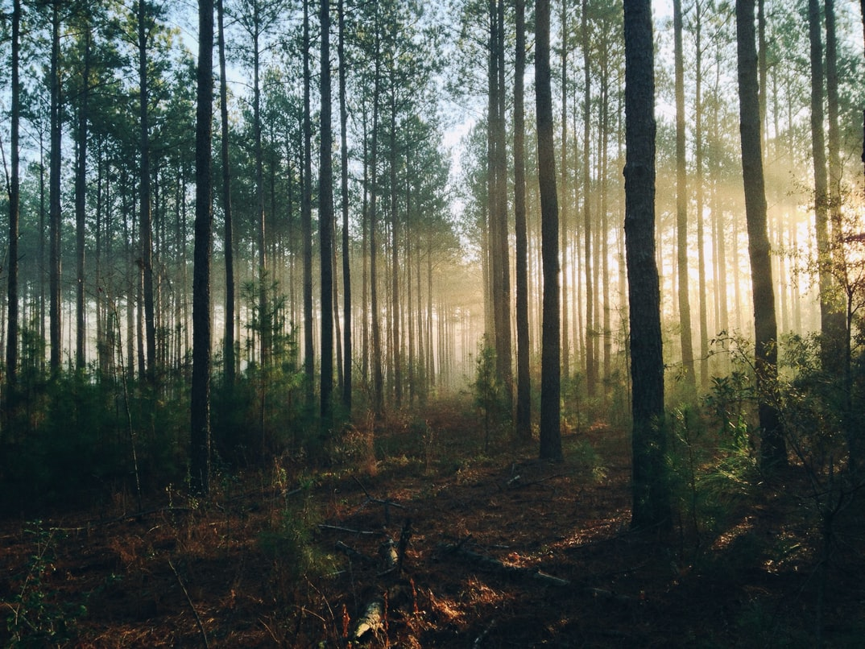

After editing:

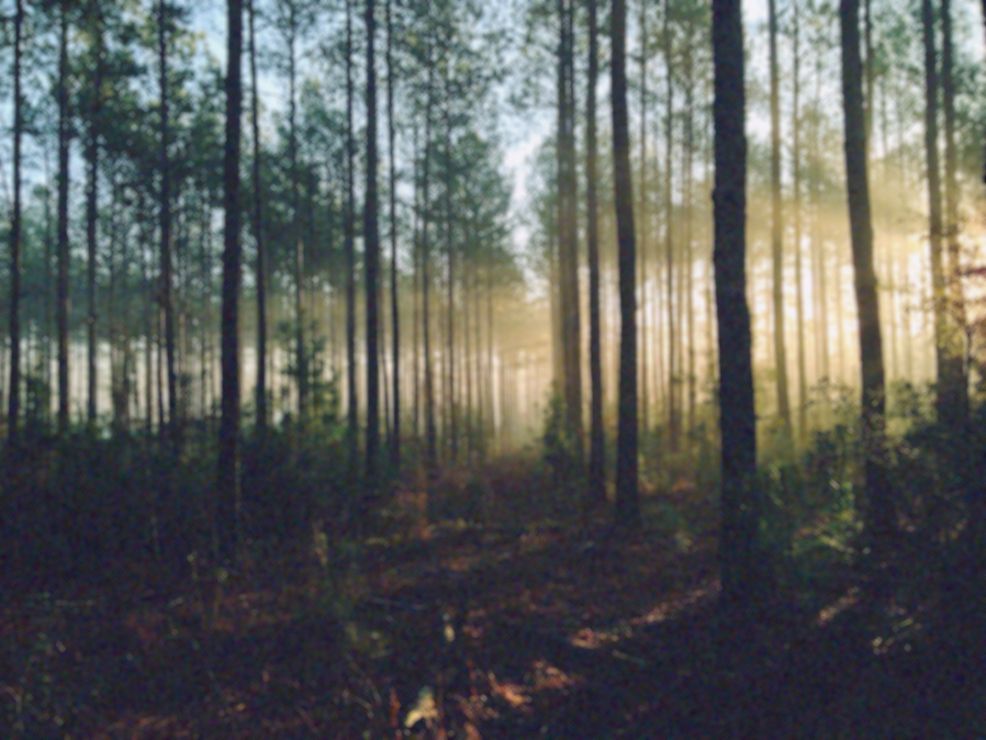

**2. GIF ANIMATED IMAGE:**



