**Credit Rating Model Validation Report of SIDBI**

**RAM-LSME Rating Model**

**22nd June 2023**



**Confidentiality Clause**

This report is submitted by CARE Risk Solutions Pvt. Ltd. (CARE Risk Solutions) to Small Industries Development Bank of India (SIDBI) for “Validation of Rating Models RAM LSME” on the condition that SIDBI will not divulge the contents of the report to any third party without the express written consent of CARE Risk Solutions.

**Disclaimer**

This Report is prepared by CARE Risk Solutions Pvt Ltd. (CARE Risk), a wholly

owned subsidiary of CARE Ratings (CARE). CARE Risk has taken due care and

caution in preparing this Report. The Report is prepared on the basis of information/documents received from SIDBI and that available in the public domain but its adequacy or accuracy or completeness is not guaranteed. CARE Risk also had to make certain assumptions in the absence of complete information. CARE Risk operates separately from CARE and does not have access to information obtained by CARE, which may have in its regular operations obtained information of a confidential nature. The views of CARE Risk expressed herein cannot be compared with the results or outlook developed on the same Company by the Ratings Division of CARE or any other Credit Rating Agencies. CARE Risk is not responsible for any errors or omissions in the financial analysis/inferences/views or for the results obtained from the use of this Report. CARE Risk especially states that CARE has no financial liability whatsoever to the recipients /users / transmitters/distributors of this Report. This Report is for the information of the intended recipients only and no part of this Report may be published/ reproduced in any form or manner without prior written permission of CARE Risk. The views expressed herein do not constitute the opinion of CARE Risk to buy or invest in any of the parties included in the analysis in any manner whatsoever.

**Acknowledgement**

We are thankful to the Risk Management Team of SIDBI for the co-operation and support extended during the course of execution of this assignment.

Table of Contents

**I. Executive Summary 5**

A. Key findings and assessment 6

B. Summary of statistical tests performed 8

C. Summary of qualitative aspects assessed 10

D. Our key recommendations 11

**II. Model Validation : Detailed Report 12**

1. **Scope and approach for validation** 13

1.1 Mandate 13

1.2 Approach,Methodology & Constraints 13

1.3 Default data 15

1.4 Model applicability 15

2. **Observations and findings Phase-1 & Phase-2** 16

2.1 Assessment of model discriminatory power 16

2.2 Assessment of model calibration 21

2.3 Assessment of model concentration 24

2.4 Assessment of model credit rating migration 25

2.5 Assessment of model factor validation 26

2.6 Qualitative analysis of factor significance 29

2.7 Qualitative Stability Analysis 36

2.8 Policy and governance analysis 36

3 **Recommendations** 37

**III. Annexure 40**

A. RAM LSME Existing Vs Proposed Parameter Recommendations 41

B. CAP Curve & Accuracy Ratio 52

C. ROC Curve 52

D. Kolmorogov Smirnov Curve 53

E. Calibration Curve 53

F. Pluto Tasche PD Curve 54

G. Concentration : HHI Index 54

H. Rating GradesTransition Matrix 55

I. Parmater Recalibration (excel attached)

1. **Model Validation-Executive Summary**



We present here the summary of **RAM LSME** model validation report in brief.Our approach to model validation included both **Qualitative and Quantitative validation**.

The qualitative aspect reviewed are model design, model governance, model documentation, data quality and other qualitative aspects. Accordingly, model development documents, model policy, model governance documents and other relevant documents were requested from the Bank. Based on the documentation made available, the qualitative assessment was carried out for **RAM LSME** model.

For performing quantitative validation, borrower and default data set were requested and received from Bank. The data was cleansed to remove aberrations and discrepancies. The final data set was reviewed to ascertain the adequacy for conducting statistical tests. Based on the final default data, the quantitative validation is being done for **RAM-LSME Model.**

Small Industries Development Bank of India, herein referred to as “SIDBI” or “the Bank” serves as the principal financial institution for the promotion, financing, and development of the Micro, Small and Medium Enterprises (MSME) sector in India. Based on our observation on **RAM LSME** model validation process, recommendations have been provided to further improvise the model performance and align it to industry good practices.

**Summary of default data considered for RAM – LSME rating model validation:**

|  |  |  |  |
| --- | --- | --- | --- |
| **Model** | **Default Data considered for Validation** | | |
| Assessment Years | NPA accounts | Total accounts |
| **RAM - LSME Rating Model** | 2017-2022 | 24 | 1018 |

Executive summary of assessments performed, key findings and our recommendations are captured below in tabular format in subsequent part of this report.

**A. Key findings and assessment**

| **Quantitative Assessment** | | | |
| --- | --- | --- | --- |
| **Dimensions** | **Parameters Assessed** | **Key Findings** | **Assessment** |
| **Discriminatory**  **Power** | 1. Cumulative accuracy Profile (CAP) 2. Receiver Operating Characteristics (ROC) | LSME model with accuracy = 54%, AUROC =77% & KS score = 59% indicates an overall satisfactory discriminatory power. | The accuracy ratio, ROC and KS scores of RAM LSME indicates that model is performing marginally high in comparison with the neutral model having no discriminatory power. |
| **Calibration** | 1. Calibration Curve 2. Pluto Tasche PD 3. Kendall’s Tau | The rank order of observed default rate is not increasing monotonically from safe to risk grades, However it as expected considering the nature of the LSME model. | LSME model is observed to having a satisfactory calibration as reflected in calibration curve, derived Pluto Tasche PD and through Kendall’s Tau method. |
| **Concentration** | 1. HHI | Concentration of borrowers is observed in S4 and S5 and HHI index is marginally high. | Concentration in the S4 and S5 grades establishes the need to improve the granularity of model and the bank is advised to implement the suggestive measures as mentioned in the **recommendations** |
| **Stability** | 1. Migration analysis | Migration analysis shows that transition rate of majority of the re-rated accounts remains constant for a three-year time horizon. However, it is observed that there is a dip in S6 grade for maintaining the stability. | The average proportion of accounts whose ratings remains constant ranges largely between 75% to 83% across the grades also model shows a positive drift between the transition of upgraded and downgraded accounts. The overall stability of the model was found to be satisfactory. |
| **Factor validation** | 1. Information Value | High predictive power is observed in Financial risk and Business risk parameters. | Discriminatory power of few risk parameters may be improvised by incorporating more objectivity in risk attributes as mentioned in Annexure- A & I. |
| **Qualitative Assessment** | | | |
| **Dimensions** | **Parameters Assessed** | **Key Findings** | **Assessment** |
| **Governance and policy framework** | Governance and policy – design and compliance | Annual model validation exercise undertaken as per the policy of the bank. | Model validation exercise is governed by model validation policy memorandum approved SIDBI B. No.49/2021-22 and policy is implemented in FY-22 |
| **Design and documentation** | 1.Model development documentation  2.Model selection criteria | The bank has documentation around risk entity manual, definition of rating grades, selection of rating model, external PD mapping | RAM LSME model is procured from CRISIL in 2004, Bank needs to revisit/update the documents as per the prevailing practices. |
| **Data quality and assurance** | Data quality and assurance | 1. Weights needs to be aligned for few parameters. 2. Equal assignment of weights are observed in few cases. | 1. As per the extent guidelines of the bank, all borrowers are needs to be rated annually and same needs to be followed. 2. Bank needs to re-align the totaling of weights and scoring scale |

**B. Summary of Statistical Tests Performed / Parameters Assessed:**

|  |  |  |  |
| --- | --- | --- | --- |
| **Dimensions** | **Statistical Tests Performed / Parameters Assessed** | **RAM - LSME Rating Model**  **Statistical Value** | **Remarks** |
| **Discriminatory power** | 1. Cumulative accuracy profile(accuracy ratio) | 54% | The CAP curve of LSME model is marginally performing above the neutral model. |
| 1. Receiver operating characteristic curve(AUC) | 77% | The AUC value of LSME is performing above the neutral model and it shows that model is having significant discriminatory power. |
| 1. Kolmogorov Smirnov(KS) | 59% | LSME, KS score indicates the distance between cumulative proportion of default and non-default across the grades is satisfactory and model is having a reasonable predictive power. |
| 1. Pietra Index(PI) | 21% | At 95% confidence interval pre-specified threshold value of PI is 21% which is slightly less than the original PI. It indicates model is having a reasonable predictive power. |
| **Calibration** | 1. Calibration curve | There is a visible upward trend in overall default rate across the grades except in S3 & S4 due to low default count. | LSME model’s observed default rate is not increasing monotonically in few grades, however considering the low default portfolio we can ignore the same. |
| 1. Pluto Tasche PD | There is a visible upward trend in overall default rate across the grades except in S3 & S4 due to low default count. | The estimated Pluto Tasche PD of LSME model’s is not increasing monotonically from safe to higher risk grades. The curve is stagnant from S2 to S5. However, considering the low default portfolio, we can ignore the same. |
| 1. Kendall’s Tau | 0.88 | It is observed that there is positive correlation is existing between model’s observed PD and the external PD. |
| **Concentration** | 1. HHI Index | 21% | The average HHI Index of the model indicates that the model concentration is marginally high (21% as against 20% expected). Considering the sample size and the portfolio, it is expected to have slight concentration in HHI index. |
| **Stability** | 1. Migration analysis | Rating drift is positive | Average proportion of accounts whose ratings is not been changed on a three-year horizon is largely ranging from 75% to 83%. It is observed that 34% of the accounts are likely to see a change in their rating grade in a three-year duration. |
| **Factor Validation** | 1. Information Value | The information of value of 31 Parameters in the LSME are in the range of 0.3 to 0.5. It shows a high predictive power. | The Factors deciding the default and non-default status of accounts majorly from contributing Financial risk and Business risk |

**C. Summary of qualitative aspects assessed**

|  |  |  |
| --- | --- | --- |
| **Sr No** | **Dimensions** | **Assessment** |
| 1 | Model Design | 1. Following key aspects need further revisit:  * Approach for factor selection and weight assessment. * Model assumptions & limitations.  1. While going forward the bank is advised to develop bank’s own PD model with substantial database to align with IRB guidelines. |
| 2 | Governance and documentation | * IRB approaches require model validation to be performed at least once annually, although bank has done as per the board-approved policy. * Borrowers not rated annually in some cases. |
| 3 | Data quality and sufficiency | * Concerns around weights assigned and applied. |

**D. Key Recommendations:**

|  |  |  |  |
| --- | --- | --- | --- |
| **Sr No** | **Area** | **Objective** | **What needs to be done?** |
| 1 | Refine risk factors / sub factors and weights to improve the discriminatory power of the factors | Increase the discriminatory power of the  factors | 1.Refine risk factors and their weights for RAM-LSME models  2.Refine Business risk factor and industry risk  3. Introduce objectivity in scoring parameters recommendations mentioned in **Annexure A & I.** |
| 2 | Rating Parameter recommendation | Improvising the objectivity of the selected individual parameters | The objectivity of the  rating system could be further  enhanced by exploring the parameter recommendations mentioned in **Annexure A & I.** |
| 3 | Governance | Improve adherence to policy framework | Strengthen the mechanism for annual rating of borrowers as per model validation policy. |

1. **Model Validation-RAM LSME Detailed Report**

Detailed Report

1. Scope and Approach for Validation

**1.1** **Mandate:**

We have been given the mandate to carry out the model validation of credit rating model RAM LSME. Our approach to model validation included both quantitative and qualitative validation. We are presenting our report in two phases based on the nature of validation.

Phase I: Report pertains to validating model on **Quantitative** parameters.

Phase II: Report pertains to validating model on **Qualitative** parameters.

Here presenting our model validation report on **RAM - LSME Rating Model.**

## **1.2 Approach, Methodology and Constraints:**

Based on the data received from the bank, we have drilled down data into different cycles based on the rating year for the analysis. Further identified the default and non-default status of those accounts in the subsequent years for actual default percentage calculation in each rating bucket. Each rated companies are considered as an independent event for the discrimination, calibration and concentration test. In the case of the rating stability test, we have considered the model rating assigned at the beginning of the relevant rating period and rating assigned at the end of the rating period.

**Constraints:**

LSME data set is a low default portfolio having a total defaults accounts of 24 rated accounts across the 5 years. Hence all statistical tests not applicable in this scenario.

**1.2.1 Information and Data**

The following model development documents were shared by SIDBI for validation purpose:

1.SIDBI Definition of Ratings Grade

2.Large SME Risk Entity Manual

3.Client data rating, scoring and NPA status (2017 to 2022)

4.Master circular-selection of rating model

5.CRISIL external PD mapping scores to SIDBI rating grades

**1.2.2 Activities undertaken:**

1. Review of documents received.

2. Review of rating governance and process

3. Quantitative and Qualitative validation of model performance including discriminatory power, calibration, stability, factor predictive power.

4. Key recommendations

**1.2.3 Assessments performed:**

Our approach to model validation included both quantitative and qualitative assessment

**1.2.3.1 Quantitative Assessment:**

Quantitative assessment has been carried out to assess the discriminatory power, calibration, stability, predictive power of the RAM-LSME model

Under quantitative assessment following statistical tests were carried out:

1. Cumulative Accuracy Profile curve & Accuracy Ratio
2. Receiver Operating Characteristic (ROC) Curve & Area Under Curve (AUC)
3. Kolmogorov Smirnov
4. Pietra Index
5. Herfindahl Hirschman Index (HHI)
6. Calibration Curve
7. Pluto Tasche
8. Kendall’s Tau
9. Credit rating transition matrix
10. Information Value

**1.2.3.2 Qualitative Assessment:**

Qualitative assessment has been carried out for the RAM LSME rating model to assess the following aspects:

1. Model design
   1. Model selection criteria
   2. Description of the rating method/model type/model architecture used
   3. Initial validation
2. Governance and Documentation
   1. Default definition
   2. Ongoing validation policy
   3. Independence
3. Data quality
   1. Volume of data available i.e. comprehensiveness and adequacy of data
   2. Data quality

## **1.3 Default Data:**

The final default data considered for validation is as follows

|  |  |  |  |
| --- | --- | --- | --- |
| Model | Default Data considered for Validation | | |
| Assessment Years | NPA accounts | Total accounts |
| RAM - LSME Rating Model | 2017-2022 | 24 | 1018 |

## **1.4 RAM LSME Model applicability:**

LSME Rating Model is applicable for rating large SME clients conforming to the following criteria

* Existing limited company
* Average annual turnover of 25 crores and above based on the previous three year audited results.
* The management of the company is broad based with well laid down organizational structure. Also, the company is adequately staffed with key professional personnel in place

**1.5 RAM LSME Risk Gradation**

|  |  |  |  |
| --- | --- | --- | --- |
| **Common Scale** | **Grade** | **From Score (weighted)** | **To Score**  **(weighted)** |
| **S2** | LSME 1 | 7.80 | 10 |
| **S3** | LSME 2 | 7.36 | 7.80 |
| **S4** | LSME 3 | 6.85 | 7.36 |
| **S5** | LSME 4 | 6.33 | 6.85 |
| **S6** | LSME 5 | 5.95 | 6.33 |
| **S7** | LSME 6 | 5.82 | 5.95 |
| **S8** | LSME 7 | 5.43 | 5.82 |
| **S9** | LSME 8 | 4.43 | 5.43 |
| **S10** | LSME 9 | 3.50 | 4.43 |
| **S11** | LSME 10 | 0.00 | 3.50 |

1. Observation and Findings:

**Phase -1 Quantitative Validation**

**2.1 Assessment of LSME Model Discriminatory Power**

|  |  |  |
| --- | --- | --- |
| **LSME Model Discrimination Test Results (Average o**f all Years) | | |
| **Sr. No** | **Parameters** | **Score** |
| 1 | Accuracy Ratio (CAP) | 54% |
| 2 | ROC/AUC | 77% |
| 3 | Kolmogorov Smirnoff Test Score | 59% |
| 4 | Pietra Index | 21% |

**Discriminatory power of a Rating Model**

The discriminatory power of a rating system denotes their *ex ante* capability to identify borrowers who are in danger of defaulting. Thus, a rating system with maximum discriminatory power would be able to precisely identify in advance all borrowers who subsequently default. If a rating system is said to have a high discriminatory power means that better a grade, the smaller the proportion of defaulters and greater the proportion of non-defaulters.

**2.1.1 CAP Curve/Accuracy Ratio of LSME Model**

The ability of a rating model to differentiate between good and bad debtors is the chief purpose behind quantitative model validation of the credit-scoring model. Cumulative Accuracy Profile (CAP) can successfully show the discriminatory power of scoring function. The Cumulative Accuracy Profile is also known as the Gini curve, Power curve or Lorenz curve. The cap curve provides a graphical illustration of the discriminatory power of a rating process. The CAP curve is determined by plotting the cumulative percentage of all borrowers on the horizontal axis and the cumulative percentage of all defaulters in the vertical axis. Accuracy ratio is used to quantify the observations from the CAP curve. It is defined as the area between the current model and random model to the area between perfect model and random model.

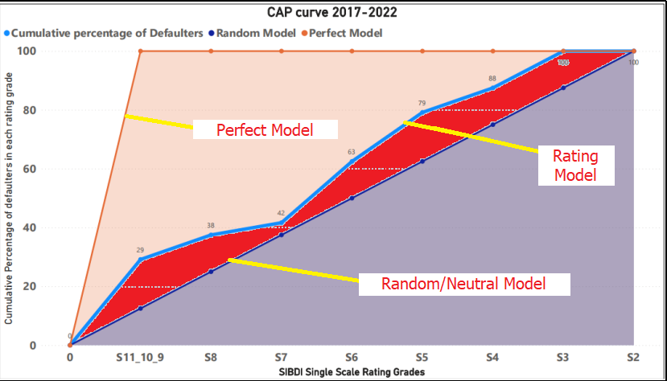

**Inferences**

A perfect rating model is expected to assign lowest score to all defaulters. In that case the curve will go vertically up and then stay at one. The diagonal line in the CAP curve corresponds to a neutral model which cannot identify between default and non-default cases. Here in the LSME model we can see the cap curve is very close to the neutral model and it is crossing the reference neutral model. The average accuracy ratio of LSME model is 54% which indicate that model is significant and only marginally performing better than the random model. However, since the observed accuracy is not very high, it is suggested that any further drop in accuracy observed during the next validation cycle, should require model to be re-calibrated

**Trend of accuracy Ratio across years**

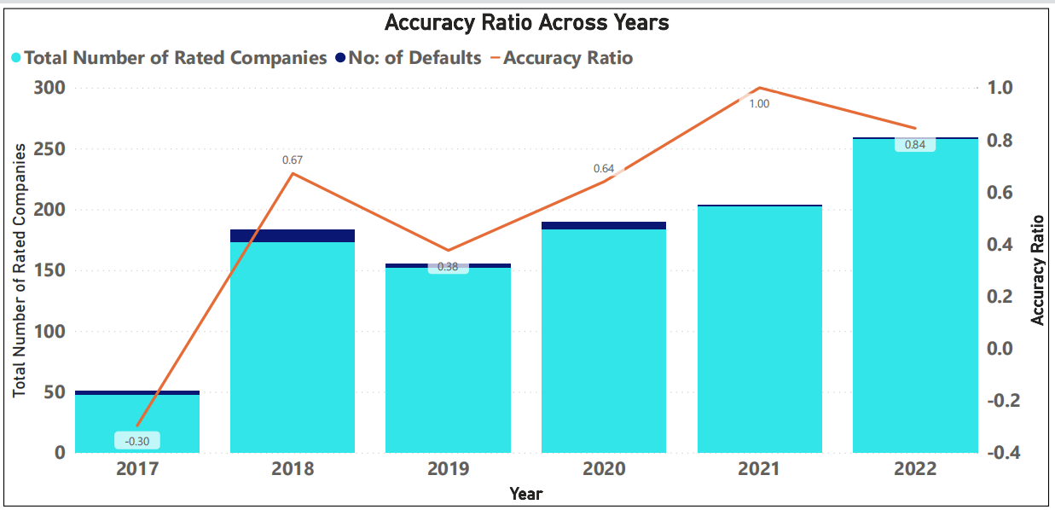

**2.1.2 Area Under Curve (AUC) /Receiver Operating Characteristic (ROC)**

Area Under Curve (AUC) /Receiver Operating Characteristic (ROC) can be interpreted as the average ability of the rating model to accurately classify non-default accounts and default accounts. For constructing the ROC curve, initially all the obligor in the validation sample are ordered in the increasing order of credit scores. In this case the rating grades needs to be ordered from S11 to S2. As one traverses from S11 to S2, the cumulative proportion of defaulters and non-defaulters are computed after counting every obligor in the rating grade. Then a line graph is plotted against the cumulative proportion of defaulters against cumulative proportion of non-defaulters across the rating grades. It represents the discrimination between the two populations. A higher area denotes higher discrimination. The AUC ratio is always between zero and 100 %. The closer the AUC to 100%, the more accurate the rating system

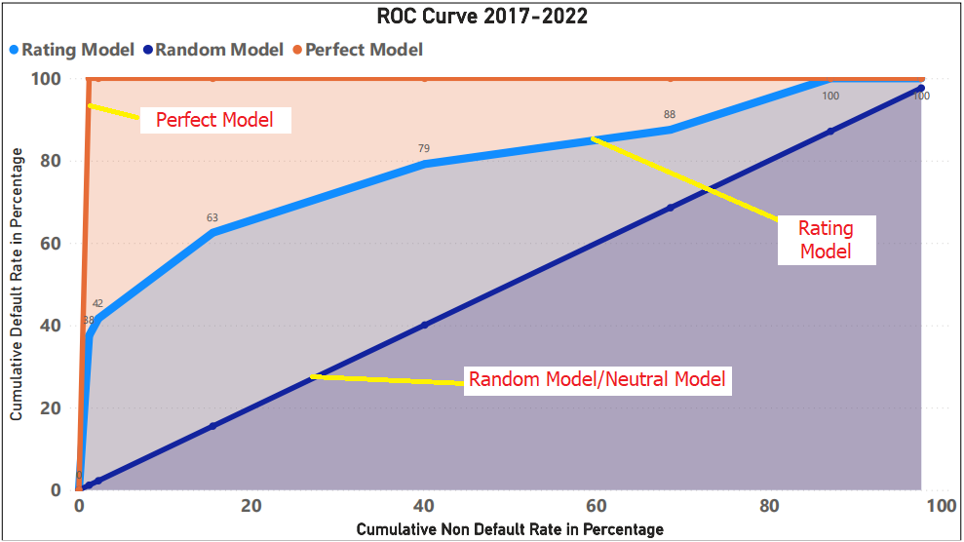

**Inferences**

To quantify the discriminatory power, the Area under the ROC curve is computed. For a perfect model area under the curve would be 100% and a score of 50% corresponds to a random model (neutral model) which cannot differentiate between defaulters and non-defaulters. The AUC score of LSME model is 77% indicates that LSME model is significant.

**Trend of ROC curve across years**

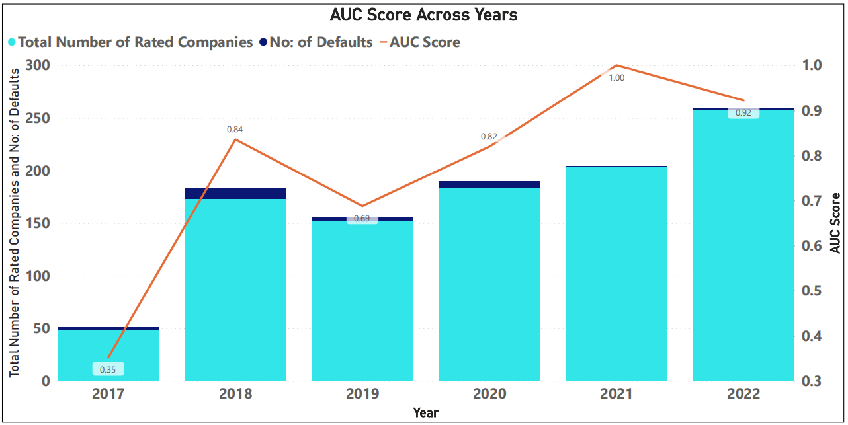

**2.1.3 & 2.1.4 KS statistic & Pietra Index**

The Kolmogorov-Smirnov (KS) test statistic is the maximum difference between the cumulative proportions of good and bad. A zero value for the KS statistic means that the two credit-score distributions are the same and indicates that the credit score fails to differentiate between defaulters and non-defaulters. A value equal to 100% indicates that the credit score perfectly differentiates defaulters from non-defaulters.

Pietra index is defined as the maximal distance of the ROC curve and the diagonal in the unit square of the ROC plot. Pietra Index is compared with a pre-specified threshold D based on the confidence level. If Pietra Index is greater than D, then the model has a good discriminatory power with a given confidence level and if Pietra index is less than D, then the model is not discriminating between good and bad customers with a given confidence level.

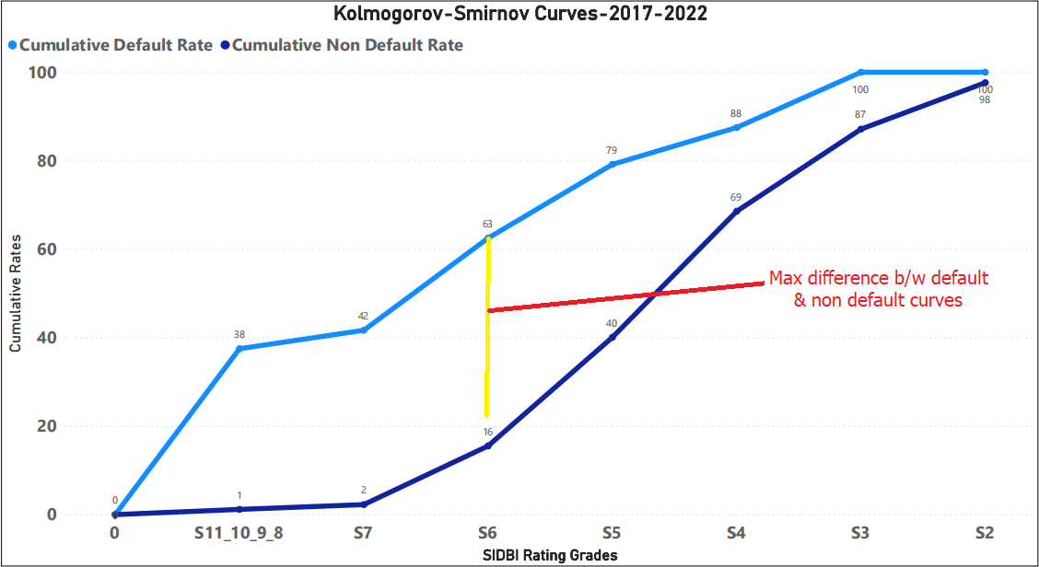

**Inferences**

The model Kolmogorov-Smirnov statistic score is 59% indicates that distance between cumulative proportion of non-default and default curve is satisfactory (ie greater than 50%) it suggests model is having a reasonable predictive power to differentiate between defaulters and non-defaulters

The model Pietra Index value is 20%. The large value of Pietra Index indicates high discriminatory power of the model. In addition, Pietra Index can assess based on the confidence interval. At 95% confidence interval, pre-specified D value is 21%, which is slight less than the original Pietra index value. Hence, we can say that model is having a reasonable predictive power.

**Trend of Kolmogorov-Smirnov across years**

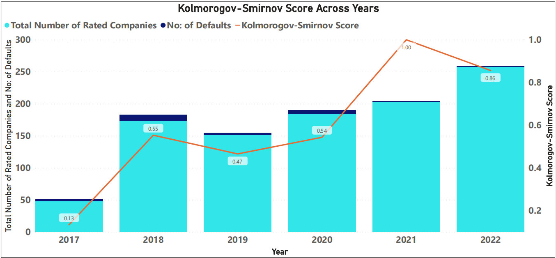

**2.2 Assessment of Model Calibration**

|  |  |  |
| --- | --- | --- |
| **LSME Model Calibration Test Results (Average of all Years)** | | |
| **Sr. No** | **Parameters** | **Score/Interpretation** |
| 1 | Calibration curve based on observed default rate | This is no constant visible upward trend from S2 to S11 |
| 2. | Pluto Tasche PD calibration  Check | This is no constant visible upward trend from S2 to S11 |
| 3. | Kendall’s Tau | The Kendall’s Tau score of 0.88 indicates that model’s derived Pluto Tasche PD and external probability of default is positively correlated. |

**2.2.1 Calibration Curve Test**

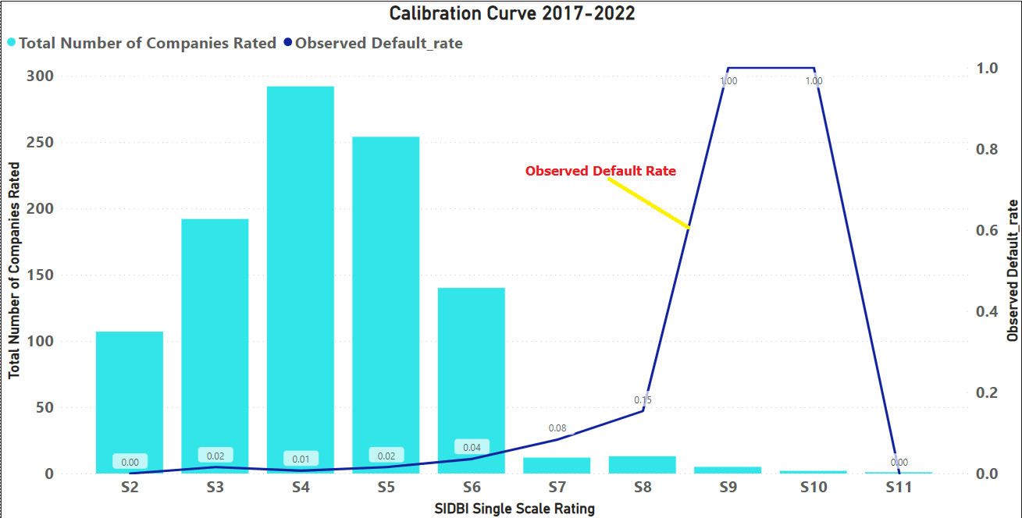

**Inferences**

Calibration curve test is graphical tool to check the movement of observed default rates and population in each rating bucket. Ideally, the creditworthiness of the borrower’s decreases from the rating bucket S2 to S11 and the default rate should increase from S2 to S11. If the default rates in the rating bucket S2 to S11 is increasing monotonically, we can conclude that calibration power of model is good. LSME model’s observed default rate is not increasing monotonically in few grades, however considering the low default portfolio we can ignore the same.

**2.2.2 Pluto Tasche calibration check for Low default portfolio’s**

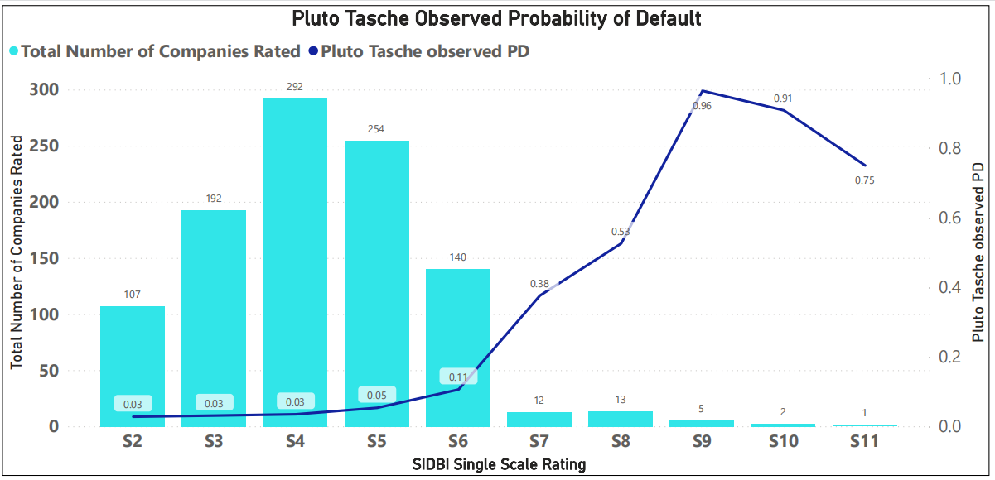

It is the method to estimate the probability of default in low default portfolio. In LSME model there are only 24 defaults occurred as per the last five-year data. Because of this reason, the observed default is not a correct metric to define the probability of default. Pluto-Tasche (PT) methodology helps to addresses the problem of estimating the PD for zero or low default portfolio using a conservative approach. Table below shows the estimated Probability of default via Pluto-Tasche methodology in each rating grades.

|  |  |  |
| --- | --- | --- |
| **Ratings** | **No: of Defaults in each rating grade** | **Pluto Tasche observed PD** |
| S2 | **107** | 2.76% |
| S3 | **192** | 3.08% |
| S4 | **292** | 3.46% |
| S5 | **254** | 5.32% |
| S6 | **140** | 10.58% |
| S7 | **12** | 37.58% |
| S8 | **13** | 52.8% |
| S9 | **5** | 96.47% |
| S10 | **2** | 90.86% |
| S11 | **1** |  |

**Inferences**

Ideally, the creditworthiness of the borrower’s decreases from the rating bucket S2 to S11 & the default rate should increase from S2 to S11. If the default rates in the rating bucket S2 to S11 is increasing monotonically, we can conclude that calibration power of model is good. Though in RAM LSME, we can observe a slight upward trend in Pluto Tasche probability of default in each grades however the PD is not increasing monotonically.

**2.2.3 Kendall’s Tau**

Kendall's tau-b is a non-parametric measure of association based on the number of concordances and discordance in paired observations. It is also called rank order statistics. It indicates the linear correlation between two variables. Here considered the derived probability of default from Pluto Tashe methodology and external probability default.

**Inferences**

Kendall's tau values range between -1 and +1, with a positive correlation indicating that the ranks of both variables increase together. A negative association indicates that as the rank of one variable increases, the rank of the other variable decreases.

Model’s Kendall’s Tau score is 0.88, which indicates model’s derived probability default and external probability of default is positively correlated.

**2.3 Assessment of Model Concentration**

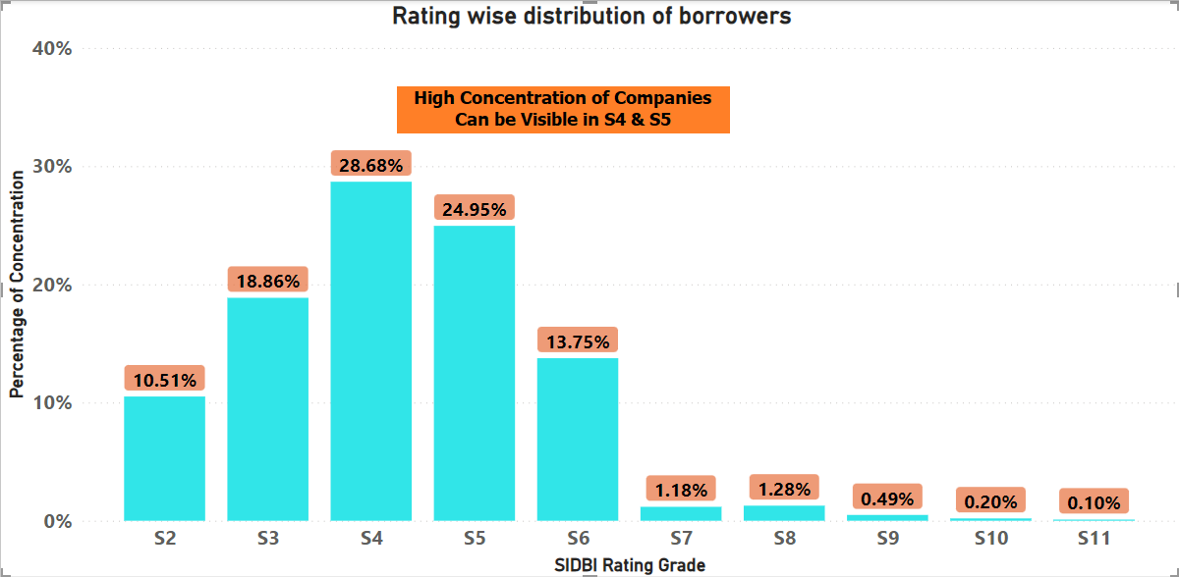

|  |  |  |  |
| --- | --- | --- | --- |
| **Rating Grade** | **Rating Instances** | **Percentage Concentration** | **Percentage Squared** |
| **S2** | 107 | 11% | 1% |
| **S3** | 192 | 19% | 4% |
| **S4** | 292 | 29% | 8% |
| **S5** | 254 | 25% | 6% |
| **S6** | 140 | 14% | 2% |
| **S7** | 12 | 1% | 0% |
| **S8** | 13 | 1% | 0% |
| **S9** | 5 | 0% | 0% |
| **S10** | 2 | 0% | 0% |
| **S11** | 1 | 0% | 0% |
| **Herfindahl-Hirshman Index (HHI)** | | | **21%** |

|  |  |
| --- | --- |
| **Legend** | |
| **HHI** | **Interpretation** |
| **Less than 10%** | No concentration |
| **10% to 20%** | Moderate Concentration |
| **Greater than 20%** | High Concentration |

|  |  |  |
| --- | --- | --- |
| **LSME Model Concentration Test Results (Average of all Years)** | | |
| **Sr. No** | **Parameters** | **Score/Interpretation** |
| 1 | Herfindahl Hirschman Index (HHI) | 21% |

Number of borrowers in each rating bucket is also an important aspect to check and monitor. Usually there are a smaller number of borrowers in the lower and upper rating grades and more customers in the middle rating grades. However, if there is a huge concentration (say, more than 50%) in any rating grade, it is a matter of concern. In such cases, re-calibration of Rating Grades needs to be done.

**2.3.1 Herfindahl Hirschman Index (HHI)**

The Herfindahl Hirschman Index (HHI) as a measure of loan portfolio indicates the concentration of companies/accounts across different risk grades. It ranges from 0% to 100%, with 0% indicating perfectly diversified portfolio - with same number of companies/accounts in each rating grade.  In practice, values of the HHI in excess of 20% may indicate a need for further action.

**Inferences**

The average HHI Index of the model indicates that the model concentration is slightly high (21% as against 20% expected). Considering the sample size and the portfolio, it is expected to have slight concentration in HHI index. Further, in view of the recommendations suggested, the concentration is expected to reduce. The bank is recommended to carry out review of HHI concentration after a year of implementation of the revised model in production with at least 200 cases being rated in the new revised model.

**2.4 Assessment of Credit Migration**

|  |  |  |
| --- | --- | --- |
| **LSME Model Credit Migration Test Results (Average of all Years)** | | |
| **Sr. No** | **Parameters** | **Score/Interpretation** |
| 1 | Rating grades transition matrix | Rating drift is positive |

Credit migration is measured through a transition matrix. A transition matrix is used to calculate the relative frequency of customer migrations over the rating grades. The transition matrix shows the frequency with which customers migrate from one status 1 to observation period (where K is the number of rating grades for non-defaulted exposures). The objective of this validation exercise is to verify the stability of transition frequencies in the matrix.

**2.4.1 Rating grades transition matrix**

The data pertains to a period of 6 years and here estimated the transition matrix of rating grades based on a three-year horizon. The companies re-rated intervals taken are 2017-2019, 2019-2021, 2020-2022.

*Note: S1 & S12 is not a rating grade for LSME model*

Here assessing stability of the model rating assigned at the beginning of the relevant rating period and rating assigned at the end of the rating period. 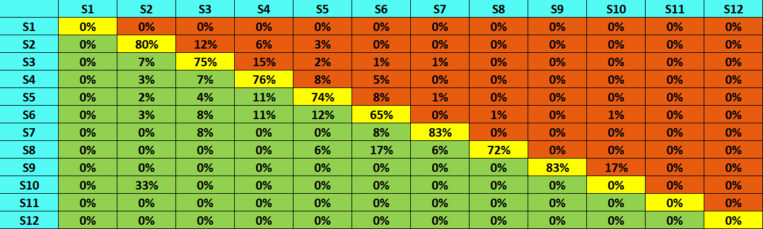

**Inferences**

* Average share of accounts with no migration: 76%
* Average share of accounts upgraded: 21%
* Average share of accounts downgraded: 13%
* Average rating activity: 34%
* Rating drift: Positive

Average proportion of accounts whose ratings do not change on three years, ranges largely between 75% to 83%. As per the industry study, change in rating transitions increase consistently with lowering in grades i.e., highest grades have few transitions and lower grades shows high amounts of transitions. We can observe a similar corresponding pattern in case of rating grade transitions in LSME portfolio as well. This is encouraging. In addition, the overall, the average rating activity is 34%. In other words, over a three-year horizon, 34% of accounts are likely to see a change in their rating grade. However, the drift of rating activity between upgraded and downgraded is positive. The changes in their grades dominating due to improvement in their credit quality rather than change due to the deterioration of credit quality. This can perhaps be attributed to portfolio quality, or in other words good performance of accounts. But it is hard to interpret if this is result of better selection by the rating model and lending decisions, or a product of economic & monetary cycles.

**2.5 Assessment of factor validation**

Factor level validation attempts to identify and explain the underlying pattern of correlation within the model parameters. It helps to understand the key parameters deciding the default and non-defaults events based on the historical loan data set.

**2.5.1 Information Value**

Information value is the characteristic of model factors, which implies the ability of the parameters to discriminate between defaults and non-default accounts. Those parameters having information value less than 0.02 is considered as no predictive power and value greater than 0.3 is having good predictive power in determining good and bad accounts.

For our study we have taken those accounts rated having assessment type company without projects. The majority of default is occurred in this category. We estimated the information value of those parameters in the LSME model

**Inference**

The table below shows top 30 parameters having high discriminatory power as per the criteria selected and nature of risk category associated. These parameters having information value is greater than 0.3, which indicates a high predictive power.

|  |  |  |
| --- | --- | --- |
| **Information Value** | | |
| **Risk Name** | **Risk Category** | **Information Value** |
| Interest Coverage - Past | Financial Risk | 2.50 |
| Payment Track Record with Banks/Lenders | Management Risk | 1.54 |
| Assessment of immediate buyer | Business Risk | 1.12 |
| Ability to raise equity from Own Sources | Financial Risk | 1.11 |
| Capacity utilization | Business Risk | 1.05 |
| Debt Service Coverage Ratio | Financial Risk | 0.94 |
| Financial Flexibility | Financial Risk | 0.92 |
| Raw Material Cost Management | Business Risk | 0.85 |
| Quality of Information Submitted | Management Risk | 0.80 |
| Proximity to Customers | Business Risk | 0.73 |
| Length of operating cycle | Industry Risk | 0.73 |
| Marketing and Selling arrangement | Business Risk | 0.72 |
| Cash Profits/Total Debt | Financial Risk | 0.60 |
| Preparedness against Environment risk | Business Risk | 0.60 |
| Ability to raise debt from Banks/Financial Institutions | Financial Risk | 0.57 |
| Report regarding legal proceedings | Management Risk | 0.54 |
| Supplier base and concentration | Business Risk | 0.53 |
| Demand supply scenario | Industry Risk | 0.51 |
| Inventory and Receivables | Financial Risk | 0.48 |
| Perceived Service Quality | Business Risk | 0.46 |
| Attrition Rate | Business Risk | 0.45 |
| Management Succession Plan | Management Risk | 0.43 |
| Environmental Issues | Industry Risk | 0.43 |
| Group support: Financial interaction with group companies | Management Risk | 0.42 |
| Industry Prospects | Industry Risk | 0.37 |
| Net Profit Margin-Projected | Financial Risk | 0.36 |
| Impact of Government policies | Industry Risk | 0.36 |
| Total Outside Liabilities | Financial Risk | 0.35 |
| Competition | Industry Risk | 0.34 |
| Return on Capital Employed | Financial Risk | 0.34 |

**2.5.2 Information Value and Risk Category**

|  |  |
| --- | --- |
| **Highest Information value Risk Categories(Top 30)** | **Count** |
| Financial Risk | 10 |
| Business Risk | 9 |
| Industry Risk | 6 |
| Management Risk | 5 |

It is observed that out of the top 30 parameters in LSME model: Financial risk components having highest weights in discriminating good and bad customers, followed by business risk, industry risk and management risk.

Generally, the key differentiating factor of LSME is the management risk score; the observed model information value of management risk parameters indicates that, there are further scope to strengthen the risk parameter. The Bank is recommended to add the new parameters mentioned in **Annexure A & I**

**Phase -2 Qualitative Validation**

## **2.6 Qualitative analysis of factor significance**

### **2.6.1 Low discriminatory power of some factors observed signify scope for improvement:**

The RAM – LSME Ratings Model are largely built around 4 risk factors viz. Industry, Finance, Business and Management covering brownfield project, Company with project and Company without project. The below mentioned information value (related to Industry Risk & Business Risk) prove to have very low contribution to overall discriminatory power for the model which is reflected in the information value of the factors.

|  |  |  |  |
| --- | --- | --- | --- |
| **Risk Factors** | **Sub-Parameters** | **High** | **Minimal** |
| **Industry Risk** | Demand supply scenario | 97%  (Score 6 & 8) | 3%  (Score 2,4 & 10) |
| Competition | 92%  (Score 6 & 8) | 8%  (Score 0, 2,4 & 10) |
| Impact of Government policies | 96%  (Score 6 & 8) | 4%  (Score 2,4 & 10) |
| Impact of change in technology | 98%  (Score 6 & 8) | 2%  (Score 2,4 & 10) |
| Industry Prospects | 92%  (Score 6 & 8) | 8%  (Score 0, 2,4 & 10) |

|  |  |  |  |
| --- | --- | --- | --- |
| **Risk Factors** | **Sub-Parameters** | **High** | **Minimal** |
| **Business Risk –**  **Market Positions** | Position of entity in its target market | 94%  (Score 6 & 8) | 6%  (Score 4 & 10) |
| Proximity to Customers | 96%  (Score 6 & 8) | 4%  (Score 0, 2,4 & 10) |
| Assessment of immediate buyer | 95%  (Score 6 & 8) | 4%  (Score 2, 4 & 10) |
| Perceived Service Quality | 98%  (Score 6 & 8) | 2%  (Score 2, 4 & 10) |
| Customer Concentration Risk | 92%  (Score 6 & 8) | 8%  (Score 0, 2,4 & 10) |

|  |  |  |  |
| --- | --- | --- | --- |
| **Risk Factors** | **Sub-Parameters** | **High** | **Minimal** |
| **Business Risk – Operating Efficiency** | Availability of skilled manpower | 93%  (Score 6 & 8) | 7%  (Score 2 & 10) |
| Capacity utilization | 94%  (Score 6 & 8) | 6%  (Score 2,4 & 10) |
| Flexibility in manufacturing | 91%  (Score 6 & 8) | 9%  (Score 2,4 & 10) |
| Availability of key raw material | 94%  (Score 6 & 8) | 6%  (Score 4 & 10) |
| Availability of power and other utilities | 88%  (Score 8) | 12%  (Score 4, 6 & 10) |
| Raw Material Cost Management | 95%  (Score 6 & 8) | 6%  (Score 0,2,4 & 10) |
| Processes and controls | 92%  (Score 6 & 8) | 8%  (Score 0,2,4 & 10) |
| Ability to attract Quality Resources | 93%  (Score 6 & 8) | 7%  (Score 4 & 10) |
| Employee Turnover | 97%  (Score 6 & 8) | 3%  (Score 0,2,4 & 10) |

### **2.6.2 Distribution Analysis - Default vs Good:**

|  |  |  |  |  |  |
| --- | --- | --- | --- | --- | --- |
| **Average Factor Score** | **Business** | **Finance** | **Management** | **Industry** | **Overall** |
| Default | 6.77 | 4.98 | 6.85 | 5.96 | 6.14 |
| Non Default | 7.41 | 6.68 | 8.28 | 6.61 | 7.25 |
| Difference | 0.64 | 1.70 | 1.43 | 0.65 | 1.10 |

*\*For distribution analysis we have considered those obligor having assessment type without project only*

Based on the above table the score distribution between default and non-default cases is very low in case of Business and Industry factors.

### **2.6.3 Instances of equal assignments of weights:**

In RAM – LSME Ratings Model, project post implementation risk, finance scores are the weighted average scores of multiple risk factors, but each individual factor is equally weighted. This smoothness out idiosyncrasies in a company’s financial health. Bank is advised to realign the weights as mentioned in Annexure-I

|  |  |
| --- | --- |
| **Parameters** | **Weights** |
| Internal Rate of Return (Post Tax) | 14.29% |
| Cash Break even (% to sales of the optimum year of sales) | 14.29% |
| Average Debt Service Coverage Ratio | 14.29% |
| Capital Structure (Post project Debt – Equity Ratio) | 14.29% |
| Promoters Contribution (as a % of Project Size) | 14.29% |
| % of Promoters Contribution by way of Equity | 14.29% |
| Sensitivity of age DSCR to 10% drop in sales (Projected) | 14.29% |

Some of the other scenarios with equal distribution of weights in RAM LSME project post implementation risk are as follows: (The table is not comprehensive and is intended to act as an indicator of the need to reassess the weights proportionate to their information value). Bank is advised to realign the weights as mentioned in Annexure-I

|  |  |  |  |
| --- | --- | --- | --- |
| **Model** | **Factor** | **Parameters with equal weight** | **Weights** |
| **RAM – LSME Ratings Model** | Industry Risk | * Demand supply scenario * Competition | 19.05%  each |
| Industry Risk | * Environmental Issues * Impact of change in technology * Length of operating cycle | 14.29 % each |
| Business Risk  (Market Position) | * Proximity to customers * Assessment of immediate buyer * Nature of economy of export country * Perceived Service Quality * Geographical Reach of the entity | 10%  Each |
| Business Risk  (Operating Efficiency) | * Availability of skilled manpower * Availability of power and other utilities * Trend in unit price of raw materials * Ability to attract Quality Resources * Employee Turnover | 10%  Each |

### **2.6.4 Instances of ambiguity in scoring scale:**

Another aspect observed is the ambiguity in scoring options. For example, in RAM - LSME Ratings Model, Capacity Utilization under Business Risk (Overall Efficiency), Optimum utilization of installed capacity will reflect the cost effectiveness & efficiency of the entity. The scoring options are as follows:

|  |  |
| --- | --- |
| **Scores** | **Attributes** |
| 10 | Full utilization of existing capacities on a consistent basis |
| 8 | Very close to maximum capacity utilization |
| 6 | Above average levels of capacity utilization. Full capacity  levels unachievable on account of operational  bottlenecks |
| 4 | Moderate levels of capacity utilization |
| 2 | Below average capacity Utilization |
| 0 | Largely un utilized capacities |

In the above example, scores 10, 8 and 6 can be assigned and justified by different analysts to the same borrower because of the ambiguity in options. So, we suggest to have a scale of capacity utilization for justifications for selecting the attributes.

### **2.6.5 Discrepancies in totaling of weights:**

Under the management risk project ratings in the page 6 of SIDBI risk entity manual, carries 20% of weights, which is again distributed for sub risk factors. The sum total of the below mentioned modules may be aligned to 100%. Bank is advised to realign the weights in risk entity manual as mentioned in Annexure-I

|  |  |
| --- | --- |
| **Risk Parameters** | **Score Weightage** |
| Years of experience in the same line of business – Project | 15% |
| Constitution of Borrower-Project | 10% |
| Credentials, background and experience of the promoters-PR | 15% |
| Management Succession Plans – Project | 10% |
| Payment Track Record with Banks/Lenders – Project | 20% |
| Group support: Financial interaction with group cos – Project | 10% |
| Quality of Information submitted – Project | 10% |
| Report regarding legal proceedings | 10% |

Some of the other Parent risk parameters given below mentioned with totaling not equal to 100% and may be aligned to 100%. Bank is advised to realign the weights as mentioned in Annexure-I

|  |  |
| --- | --- |
| **Parent Name** | **Total Score** |
| **Industry Risk Overall(Company)** | 100.01% |
| **Industry Risk Project** | 100.01% |
| **Financial Risk Project** | 100.03% |
| **Business Risk Market Position** | 99.98% |

### **2.6.6 In consistence Considerations of risk factors:**

Project Implementation Risk (Project) carries two child rating parameters Construction Risk – PIR and Funding Risk – PIR. The Funding Risk is having two sub parameters as “Tie up of Funds” and “Financial Flexibility” carrying equal weights.

In ideal situation, funding risk sub parameters should have equal say considering that both have equal weights. While reviewing it has been observed that in few instances the value of “Tie-up of fund” is not capturing and only the “financial flexibility” value contributing towards the funding risk, which needs to be aligned as per the Large SME risk entity manual. The table below shows examples of such instances.

|  |  |  |  |  |
| --- | --- | --- | --- | --- |
| **Borrower Name** | **Tie-up of funds - Project** | **Financial Flexibility- Pro** | **Funding Risk** | **Ideal Risk Should be** |
| Abro technologies pvt ltd | 10 | 6 | 6 | 8 |
| Accrete electromech pvt | 8 | 6 | 6 | 7 |
| Accurate steel forgings | 10 | 8 | 8 | 9 |
| Accurate steel forgings | 8 | 6 | 6 | 7 |
| Advanced anmol metcomp | 8 | 6 | 6 | 7 |
| Allena auto industries | 8 | 10 | 10 | 9 |
| Ample auto tech pvt ltd | 6 | 8 | 8 | 7 |
| Arce polymers pvt ltd | 10 | 8 | 8 | 9 |
| Balaji aluminium extrusions | 4 | 6 | 6 | 5 |

### **2.6.7 Instances of outlier risk factors used:**

1. Inventory and Receivables to Sales – Past

|  |  |
| --- | --- |
| **Receivables Turnover** | **Scores** |
| Above 210 days | 0 |
| 180 days to 210 days | 2 |
| 150 days to 180 days | 4 |
| 120 days to 150 days | 6 |
| 90 days to 150 days | 8 |
| Less than 90 days | 10 |

The Receivables with less than 90 Days and 90 days to 150 days are carrying weights of 10 and 8 respectively. In the Banking parlance, the same is default category. Bank need to re-align the bucket to benchmark with industry best practice. Bank is advised to modify the value statements as mentioned in Annexure-I

1. Inventory and Receivables to Sales – Past

Further, the definition is for Inventory and Receivables to Sales whereas the same is used as a collection period, so the definition is to be re-aligned.

1. Current Ratio:

The scoring for Current Ratio is as below in the existing rating manual:

|  |  |  |  |
| --- | --- | --- | --- |
| **PAST** | | **FUTURE** | |
| **Current Ratio Past** | **Score** | **Current Ratio Future** | **Score** |
| Less than 0.7 | 0 | Less than 0.9 | 0 |
| >=0.7 and <0.9 | 2 | >=0.9 and <1.0 | 2 |
| >=0.9 and <1.1 | 4 | >=1.0 and <1.2 | 4 |
| >=1.1 and <1.2 | 6 | >=1.2 and <1.24 | 6 |
| >=1.2 and <1.3 | 8 | >=1.4 and <1.5 | 8 |
| >=1.3 | 10 | >=1.5 | 10 |

It can be observed that Current Ratio carries scoring even with achievement of 1.00, which means that short-term fund has been utilized for long-term purposes and there is deficiency of promoter’s margin. Bank is advised to realign the current ratio scores as mentioned in Annexure-I

### **2.6.8 Impact of regulatory changes**

Over the years, there have been multiple regulations but the same needs to be updated in the factors. For example, the change in definition of MSME has been effected since 2020 which needs to be realigned in for applicability of RAM LSME model.

**2.7 Qualitative Stability Analysis:**

The Bank is having most of the Ratings centered to S4, S5 and S6 with S8 being the investment grade.

Ideally, the stability in Investment grades should be around 75%. On calculating a three-year average of transition matrix, the percentage of ratings carried forward for RAM – LSME Ratings Model is as below:

|  |  |  |  |  |  |  |  |  |  |  |  |  |
| --- | --- | --- | --- | --- | --- | --- | --- | --- | --- | --- | --- | --- |
|  | **S1** | **S2** | **S3** | **S4** | **S5** | **S6** | **S7** | **S8** | **S9** | **S10** | **S11** | **S12** |
| **S1** | NA | NA | NA | NA | NA | NA | NA | NA | NA | NA | NA | NA |
| **S2** | 0% | 80% | 12% | 6% | 3% | 0% | 0% | 0% | 0% | 0% | 0% | 0% |
| **S3** | 0% | 7% | 75% | 15% | 2% | 1% | 1% | 0% | 0% | 0% | 0% | 0% |
| **S4** | 0% | 3% | 7% | 76% | 8% | 5% | 0% | 0% | 0% | 0% | 0% | 0% |
| **S5** | 0% | 2% | 4% | 11% | 74% | 8% | 1% | 0% | 0% | 0% | 0% | 0% |
| **S6** | 0% | 3% | 8% | 11% | 12% | 65% | 0% | 1% | 0% | 1% | 0% | 0% |
| **S7** | 0% | 0% | 8% | 0% | 0% | 8% | 83% | 0% | 0% | 0% | 0% | 0% |
| **S8** | 0% | 0% | 0% | 0% | 6% | 17% | 6% | 72% | 0% | 0% | 0% | 0% |
| **S9** | 0% | 0% | 0% | 0% | 0% | 0% | 0% | 0% | 83% | 17% | 0% | 0% |
| **S10** | 0% | 33% | 0% | 0% | 0% | 0% | 0% | 0% | 0% | 0% | 0% | 0% |
| **S11** | 0% | 0% | 0% | 0% | 0% | 0% | 0% | 0% | 0% | 0% | 0% | 0% |
| **S12** | NA | NA | NA | NA | NA | NA | NA | NA | NA | NA | NA | NA |

*Note: S1 & S12 is not a rating grade for LSME model*

This above signifies scope for improvement in the long term predictive ability.

## **2.8 Policy and governance analysis:**

### **2.8.1 Annual review of rating grades not undertaken comprehensively in some cases**

### While the policy and prudent banking practices require the rating to be reviewed at least once every year, however we have observed that even in few instances borrowers are not rated annually due to non-submission of financial information. The bank is advised to do an aggressive follow up the customer for the annual re-rating to ensure the bank policy guide line referring “RMV - Master Circular October 2022 Rating and Validation Process”. Also for implementing the IRB approach, bank has to build the database of historical data for PD modelling and annual re-rating of borrowers is necessary for this development.

1. **Recommendations**

## **Refine risk factors/sub-factors and weights to improve the discriminatory power of factors**

Our recommendations on risk parameters are detailed in **Annexure A & I.** The need for refining the risk factors has been observed to achieve the following key objectives:

1. Increase the discriminatory power of the factors
2. Improve the significance of factors in borrower performance i.e. the factor should add to the ability of model to discriminate over and above the existing factors in place.

The bank may consider following key actionable:

### **3.1.1 Refine risk factors and their weights**

The results of factor analysis raise the need for refining risk factors and their weights for RAM – LSME Ratings Model. At minimum, Industry Risk and Business Risk factor needs to be re-calibrated to increase its information value in significance. Bank is advised to realign the weights as mentioned in Annexure-I

### **3.1.2 Introduce objectivity in scoring parameters as proposed in Annexure A & I.**

Review the scoring options across models and consider introducing objectivity wherever applicable.

Some examples are:

Capacity Utilization under Business Risk (Overall Efficiency):

|  |  |
| --- | --- |
| **Capacity Utilization** | **Score** |
| Utilization more than 90% | 10 |
| Utilization between 75% to 90% | 8 |
| Utilization between 60% to 75% | 6 |
| Utilization between 50% to 60% | 4 |
| Utilization between 40% to 50% | 2 |
| Utilization less than 40% | 0 |

While introducing objectivity, care must be taken to improve reproducibility of ratings i.e. if two credit officers are assessing the same borrowers, the difference in scores should be minimized.

## **3.2 Align governance and policy to leading practices**

A need for better alignment has arisen to achieve the following key objectives:

1. Align with leading practice and IRB requirements

2. Improve adherence to policy framework

The bank may consider following key actionable:

### **3.2.1 Strengthen the mechanism for annual rating of borrowers**

All the borrowers need to be rated at least once on an annual basis. The current challenge around cooperation from borrower can be circumvented by introducing covenants in the loan agreement itself.

### **3.2.2 Document the missing aspects of models development documentation**

If the bank undertakes re-development of models, then documentation can be undertaken in line with IRB requirements. If not, bank can document the predicted probability of defaults (basis historical data) based on relevant scenario and the rationale behind changes made in vendor model (basis the discussion held or expert judgment) and any other aspect introduced later.

## **3.3 Training and development**

Bank may consider providing sensitization training of credit officers and back-office to address issues around pending rating, multiple ratings, missing ratings etc.

**3.4 Enlarging the scope of applicability of the model**

**3.4.1 Increasing the threshold for selection of the Model:**

Currently the existing RAM - LSME Model is used to rate borrowers with last three years average turnover of Rs 25 Crore and more. With the introduction of the new revised definition of the MSME by GOI wherein the Turnover of Small Enterprises has been increased up to Rs 50 Crore, accordingly bank need to re-consider the existing threshold of the applicability of the Model to be in sync with the revised guidelines of GOI.

**3.5 Inferences on Discriminatory tests conducted**

Out of the discriminatory test conducted, the overall scores suggest that model is marginally performing above the neutral model. But in the case of the accuracy ratio test, observed score is 54%, which indicate that model is significant but only slightly performing better than the neutral model. Since the observed accuracy is not very high, it is suggested that any further drop in accuracy observed during the next validation cycle, should require model to be re-calibrated.

**3.6 Challenges on Back testing of the Revised Model**

Since the historic data for the new parameter added is not available with us, hence the back testing on the revised model is not possible. The bank is recommended to carry out review of HHI concentration after a year of implementation of the revised model in production with at least 200 cases being rated in the new revised model.

1. **Model Validation - Annexure ’s**

Annexure

1. **Annexure- A: RAM LSME Existing Vs Proposed Parameter Recommendations**

|  |  |  |  |
| --- | --- | --- | --- |
| **RAM-LSME MODEL** | | | |
|  | **Existing Risk Parameters** | **Proposed Risk Parameters** | **Rationale** |
|  |  |  |  |
| **A.** | **Industry Risk** | **Industry Risk** |  |
| **1.** | **Competition** | **Competition** | Since there is no measurement policy for command over the price, it is recommended to link over yearly GP margin which can be measurable. |
| The borrower has a very high command over margin. Borrower can get his requested price from >80% of buyers. | The borrower has a very high command over margin. Gross Profit Margin is over 30% |
| The borrower has high command over margin. Borrower can get his requested price from >60% of buyers. | The borrower has high command over margin. Gross Profit Margin is over 25-30% |
| The borrower has some command over margin. Borrower can get his requested price from >50% of buyers. | The borrower has some command over margin. Gross Profit Margin is over 20 - 25% |
| The borrower has a low command over margin. Borrower can get his requested price from >30% of buyers. | The borrower has a low command over margin. Gross Profit Margin is over 15-20% |
| The borrower has very low command over margin. Borrower can get his requested price from >20% of buyers. | The borrower has very low command over margin. Gross Profit Margin is over 10-15% |
| The borrower has no command over margin. | The borrower has no command over margin. |
| **2.** | **Impact of Government policies** | **Impact of Government policies(Scoring has to be carried based on the industry score available in SIDBI intranet)** | To neutralize the impact of Govt. regulations by more discrimination statement |
| Policies are highly favorable and likely to continue in the foreseeable future. | Positive |
| Moderately favorable policies (such as protective import tariffs/incentives), positively impacting profitability | Neutral |
| Policies are not significantly favorable/ unfavorable for the industry. Profitability is not influenced by existing/foreseen regulatory measures. | Negative |
| Negative influence due to the current government policies. | NA |
| Government policy has a significantly negative influence, in the form of high excise burden, inverted import duty structure, un-viable price regulation, etc. | NA |
| Government policy towards industry is extremely unfavorable, e.g. Order for closure of all units in a polluting industry by a specified date. | NA |
| **3.** | **Environmental Issues** | **Environmental Issues** | The Bank is advised to add an environmental parameter based on the industry's categorization on the pollution load which would make it more objective and it also give a fair picture of the industries. |
| Extremely environment friendly / Least susceptible to environmental issues | Non-polluting – White |
| Very Low polluting/ Very low susceptibility to environmental issues | Polluting – Green |
| Marginally polluting / Marginally susceptible to environmental issues | Polluting – Orange |
| Moderately polluting / Moderately susceptible to environmental issues | Red |
| Highly polluting / Highly susceptible to environmental issues | NA |
| Very Highly polluting / Very Highly susceptible to environmental issues | NA |
| **4.** | **Impact of change in technology** | **Impact of change in technology** | The subjectivity associated with the value statement of the parameter has to be reduced and more objectivity can be brought in quantifying the technology upgradation and modification in the industry. |
| Least impact | Least impact. The technology upgradation/ modification in the industry generally takes greater than 10 years. |
| Marginal impact | Moderate impact. The technology upgradation/ modification in the industry generally takes greater than 7 years. |
| Moderate impact | High impact. The technology upgradation/ modification in the industry generally takes within 5 years. |
| High impact |  |
| Very High Impact |  |
| Extremely High Impact |  |
| **5.** | **Industry Prospects** | **Industry Prospects** | The subjectivity associated with the value statement of the parameter has to be reduced and more objectivity can be brought in by incorporating the industry trend in past two years and the prospect response on the same. |
| Positive | Industry has shown positive trend in the average past two years and the prospect is expected to remain positive. |
| Marginally Positive | Industry has shown neutral/ negative trend in the average past two years however the prospect is expected improve to positive. |
| Neutral | Industry shown negative trend in the average past two years however the prospect is expected improve to neutral. |
| Marginally Negative | Industry shown negative trend in the average past two years and is expected to continue the same. |
| Negative |  |
| Industry prospects not available |  |
| **6.** | **Length of Operating cycle** | **Length of Operating cycle** | The Borrowers under this Lending scheme are accepted for Drawing Power of 90 Days, so as such recommending to segregate between 90 Days and beyond 90 Days. |
| Up to 1 month | Up to 1 month |
| More than 1 month and up to 2 months | More than 1 month and up to 2 months |
| More than 2 months and up to 3 months | More than 2 months and up to 3 months |
| More than 3 months and up to 4 months | More than 3 months |
| More than 4 months and up to 6 months | NA |
| More than 6 months | NA |
| **B.** | **Business Risk** | **Business Risk** |  |
| **1.** | **Market Position** | **Market Position** |  |
| **1.1** | **Position of entity in its target market** | **Position of entity in its target market** | The subjectivity associated with the value statement of the parameter has to be reduced and more objectivity can be brought in by removing the redundant value statement and realigning the statements. |
| Monopolistic presence in the market. Entity has long term (3-5year)contracts/arrangements with customers | Monopolistic presence in the market. Entity has long term (3-5year)contracts/arrangements with customers |
| Strong presence in the market with very few competitors. Has key customers(contracts/arrangements) for next year | Strong presence in the market with very few competitors. Has key customers(contracts/arrangements) for next year |
| Presence in the market with significant competitors. Good perceived quality of products of the company. | Lots of competition for the entity. Good perceived quality of products of the company. |
| Lots of competition for the entity. Good perceived quality of products of the company. | Highly competitive market. There is a threat of substitutes. |
| Highly competitive market. No established relationship with customers. There is a threat of substitutes. | Very weak player or unsatisfactory perception of product/ service quality. Non-recurring customer base/ No established relationship with customers. |
| Very weak player or new company. No/bad perception of product quality. Non-recurring customer base. There is a threat of substitutes. |  |
| **1.2** | **Assessment of immediate buyer** | **Assessment of immediate buyer** | The subjectivity associated with the value statement of the parameter has been reduced and more objectivity has been brought in by realigning and quantifying the statements. Further, parameter weight has been increased considering the fact that more sales to entities of repute brings stability and consistency in revenue. |
| Excellent | The entity is catering to more than 70% to national / international repute companies / OEMs. |
| Very Good | The entity is catering to more than 50% to national / international repute companies / OEMs. |
| Good | The entity is catering to more than 30% to national / international repute companies / OEMs. |
| Satisfactory | The entity is catering only for captive consumption to within group / associates concerns. |
| Fair |  |
| Poor |  |
| **1.3** | **Customer Concentration Risk** | **Customer Concentration for TOP 3 customers during Trailing Twelve Months** | The subjectivity associated with the value statement of the parameter has been reduced and more objectivity has been brought in by realigning and quantifying the statements. Further weight of the parameter has been increased considering the fact that with greater customer base, entity has greater potential of growth. |
| Very large number of customers /catering to retail customers | Manufacturing - Top 3 customers accounting for <40% of sales Service Sector - B2C/ Retail customer concentration accounting for >=80% of sales |
| Large number of customers | Manufacturing - Top 3 customers accounting for >=40% & <60% of sales Service Sector - B2C/ Retail customer concentration accounting for >=60% & <80% of sales |
| Relatively large number of customers | Manufacturing - Top 3 customers accounting for >=60% & <80% of sales Service Sector - B2C/ Retail customer concentration accounting for >=40% & <60% of sales |
| Relatively small number of customers | Manufacturing - Single customer accounting for >=50% of sales OR Top 3 customers accounting for >=80% of sales Service Sector - B2C/ Retail customer concentration accounting for <40% of sales |
| Very few customers |  |
| Single customer |  |
| **1.4** | **Management of foreign exchange and fund repatriation risks** | **Management of foreign exchange and fund repatriation risks** | The subjectivity associated with the value statement of the parameter has to be reduced and more objectivity can be brought in by quantifying the foreign currency and the natural hedge availability of the borrower. |
| Extremely High | Extremely High, revenue sharing in foreign currency is more than 60% and Natural hedge available/ Other hedging strategies are in place. |
| High | High revenue sharing in foreign currency is more than 50%. and Natural hedge available/ Other hedging strategies are in place. |
| Above Average | Above Average revenue sharing in foreign currency is more than 40%. and Natural hedge available/ Other hedging strategies are in place. |
| Average | Average revenue sharing in foreign currency is in between 30% to 40%.and Natural hedge available/ Other hedging strategies are in place. |
| Low | Average revenue sharing in foreign currency is in between 20% to 30%. and Natural hedge available/ Other hedging strategies are in place. |
| Extremely low | Average revenue sharing in foreign currency is in below 20%. and Natural hedge available/ Other hedging strategies are in place. |
| **2.** | **Operating Efficiency** | **Operating Efficiency** |  |
| **2.1** | **Preparedness against environment risk** | **Preparedness against environment risk** | The subjectivity associated with the value statement of the parameter has to be reduced and more objectivity can be brought in by modifying the value statements and aligning with the "Environmental Issues" parameter in Industry Risk |
|  | Part of non-polluting industry/ Part of polluting Industry but has taken extreme measures against it and meets all standards set by environmental norms | Part of non-polluting Industry |
|  | Adequate measures taken against environmental problems. | Adequate measures taken against environmental problems/ Key approvals are in place and valid. Additional measure in terms of wastage treatment are also in place. |
|  | Key measures taken against environmental problems. | Key measures taken against environmental problems and key approvals for compliances are in place and valid as on date. |
|  | Entity facing environmental problems and has taken some measures against it but not fool proof. | Entity facing environmental problems and has taken some measures that are not fully addressing. |
|  | The entity in particular and the cluster of industries in general facing environmental problems | The entity in particular and the cluster of industries in general facing environmental problems. |
|  | No measures adopted against environmental problems. Frequent agitations from environmentalists/ Closure threats by relevant authorities. | No measures adopted against environmental problems. Frequent agitations from environmentalists/ Closure threats by relevant authorities. |
|  | NA | Approvals expired/ yet to be obtained |  |
| **2.2** | **Capacity utilization** | **Capacity utilization** | The subjectivity associated with the value statement of the parameter has to be reduced and more objectivity can be brought in by quantifying the capacity utilization, to bring out measurable input as a criteria |
| Full utilization of existing capacities on a consistent basis. | Utilization more than 90% |
| Very close to maximum capacity utilization | Utilization between 75% to 90% |
| Above average levels of capacity utilization. Full capacity levels unachievable on account of operational bottlenecks. | Utilization between 60% to 75% |
| Moderate levels of capacity utilization | Utilization between 50% to 60% |
| Below average capacity Utilization | Utilization between 40% to 50% |
| Largely un-utilized capacities | Utilization less than 40% |
| **2.3** | **Supplier Base and concentration** | **Supplier Concentration for Top 5 suppliers during Trailing Twelve Months** | The subjectivity associated with the value statement of the parameter has to be reduced and more objectivity can be brought in quantifying the raw material suppliers. Further, weight has been increased as the diversified of supplier base results in better cost management and availability of raw material. |
| Relationship of more than 10 years and diversified supplier base with less than 25% material supplied by single supplier | Top 5 raw material suppliers accounting for < 60% of its purchases |
| Relationship of 8-10 years and diversified supplier base with 25 to 30% material procured from single supplier | Top 5 raw material suppliers accounting for >=60% & <70% of its purchases |
| Relationship of 6-8 years and 30 to 40% material procured from single supplier | Top 5 raw material suppliers accounting for >=70% & <80% of its purchases |
| Relationship of 5-6 years and 40 to 50% material procured from single supplier | Single supplier/Top 5 raw material suppliers accounting for >=80% of its purchases |
| Relationship of less than 5 years and more than 50% material procured from single supplier |  |
| No past relationship with the supplier |  |
| **2.4** | **Availability of key raw material** | **Availability of key raw material** | The subjectivity associated with the value statement of the parameter has to be reduced and more objectivity can be brought in modifying the value statement and by quantifying in terms of job work. Further increased the rationale considering its importance. |
| Ensured by long-term tie-ups./ Easily available./ Alternate sources available | Ensured by long-term tie-ups./ Easily available./ Alternate sources available |
| Highly reliable sources. / Few alternate sources exist. | Highly reliable sources. / Few alternate sources exist. |
| Reliable supply sources. | Reliable supply sources. |
| Moderately reliable supply | Moderately reliable supply |
| Inadequate reliability in supply | Inadequate reliability in supply |
| Highly seasonal and erratic supply | Highly seasonal and erratic supply |
| **2.5** | **Trend in unit price of raw materials/Raw Material Cost Management** | **Trend in unit price of raw materials/Raw Material Cost Management** | The subjectivity associated with the value statement of the parameter has to be reduced and more objectivity can be brought in by incorporating cost of raw material/cost of production thus we can quantify the average variation in the unit price. |
| Very good | Average variation in last 2 years<10% |
| Good | Average variation in last 2 years<15% |
| Satisfactory | Average variation in last 2 years<20% |
| Average | Average variation in last 2 years>25% |
| Below Average | NA |
| Not Satisfactory | NA |
| **2.6** | **Processes and controls** | **Processes and controls** | The subjectivity associated with the value statement of the parameter has to be reduced and more objectivity can be brought in modifying the value statement to ensure that processes and controls by the valid certification achieved. Further weight has been reduced. |
| Extremely comprehensive processes and controls in place | Extremely comprehensive processes and controls in place. The entity is having valid quality certifications such as ISO, TUV etc. |
| The controls and processes are highly organized | The controls and processes are highly organised with quality certifications. |
| Adequate controls and processes | Adequate controls and processes, entity has applied for quality certifications |
| The processes and controls are required to be redefined | The processes and controls are required to be redefined |
| Inadequate controls and processes | Inadequate controls and processes |
| No controls and processes in place | No controls and processes in place |
| **C.** | **Financial Risk** | **Financial Risk** |  |
| 1. | **Past Financial** | **Past Financial** |  |
| 1.1 | **Current Ratio - Past** | **Current Ratio - Past** | A current ratio of less than 1.00 may seem alarming and as such recommending not to score Current Ratio less than 1.00 |
| Less than 0.7 |  |
| >=0.7 and <0.9 | Below 1.00 |
| >=0.9 and <1.1 | >=1.00 and <1.1 |
| >=1.1 and <1.2 | >=1.1 and <1.25 |
| >=1.2 and <1.3 | >=1.25 and <1.3 |
| >=1.3 | >=1.3 |
| 1.2 | **Inventory and Receivables to Sales – Past** | **Inventory and Receivables to Sales – Past** | To discriminate the rating parameters within Drawing Power Limit |
| **Receivables Turnover** | **Receivables Turnover** |
| Above 210 days |  |
| 180 days to 210 days | Less than 120 Days |
| 150 days to 180 days | 90 days to 120 days |
| 120 days to 150 days | 60 days to 90 days |
| 90 days to 150 days | 30 days to 60 days |
| Less than 90 days | Less than 30 days |
| 2. | **Future Financial** | **Future Financial** |  |
| 2.1 | **Inventory and Receivables to Sales** | **Inventory and Receivables to Sales – Future** | To discriminate the rating parameters within Drawing Power Limit |
| **Receivables Turnover** | **Receivables Turnover** |
| Above 210 days |  |
| 180 days to 210 days | Less than 120 Days |
| 150 days to 180 days | 90 days to 120 days |
| 120 days to 150 days | 60 days to 90 days |
| 90 days to 150 days | 30 days to 60 days |
| Less than 90 days | Less than 30 days |
| 2.2 | **Current Ratio - Future** | **Current Ratio - Future** | A current ratio of less than 1.00 may seem alarming and as such recommending not to score Current Ratio less than 1.00 |
| Less than 0.9 |  |
| >=0.9 and <1.0 | Below 1.00 |
| >=1.0 and <1.2 | >=1.00 and <1.1 |
| >=1.2 and <1.24 | >=1.1 and <1.25 |
| >=1.4 and <1.5 | >=1.25 and <1.3 |
| >=1.5 | >=1.3 |
| **D.** | **Management Risk** | **Management Risk** |  |
| 1. | **Quality of Information submitted** | **Submission of Audited Balance Sheet / Book debts / MSOD** | The subjectivity associated with the value statement of the parameter has to be reduced and more objectivity can be brought in by the type of audit report issued. |
|  | Extremely good | Unqualified audit report |
|  | Good | Qualified audit report |
|  | Above average | Disclaimer audit report |
|  | Average | Adverse audit report |
|  | Poor |  |
|  | Very poor |  |
| **E.** | **Project Factors** | **Project Factors** |  |
| **1.** | **Credentials of Machinery Supplier** | **Due diligence -More than 50% of the machines cost to total cost of machines/MFA under the project** | The Bank is recommended to modify the parameter value statements so as to decrease the subjectivity associated with the parameter definition |
|  | Established and reputed supplier | SIDBI OEM tie-up/ Mira Inform Rating-A++,A+,A / D&B Risk Indicator Rank -1-2 |
|  | Very good experience & reputed in the supply of designed machinery | Mira Inform -B / D&B Risk Indicator Rank -3 |
|  | Relatively less experienced & reputed as compared to the ones in the higher grades | Fabricators/Other service providers whose credentials are not as per any standards Mira Inform Rating - C,D,NB,NT D&B Risk Indicator Rank -4, - (Insufficient information to assign risk indicator) Second hand machinery, Due diligence done by branch official visit |
|  |  |  |  |

1. **Proposed new parameters in Management Risk**

|  |  |  |  |
| --- | --- | --- | --- |
| **D.** | **Management Risk** | | |
|  | **New Parameters** | **Scores** | **Rationale** |
| 1 | **CIBIL Trans Union Score** |  |  |
| >720 | 10 | Currently CIBIL Trans union Score is acting as a deflator under Management Risk. We are proposing to add CIBIL Score as a Value input instead of deflator under Management Risk, and so proposing this as an additional value input. |
| >670 & <=720 | 8 |
| >600 & <=670 | 4 |
| <=600 | 0 |
| No Credit History or Credit Background or Credit History of less than 6 months | 6 |
| 2 | **Jocata Rating Grade of entity** |  |  |
|  | JAAA to JAA | 10 | Jocata GRID provides a ratings based on near to real time view of early warning triggers and compliance which will help to assess the compliance culture. Proposing to consider the same to have a view on Customers through another lens. |
|  | JA to JBBB | 7 |
|  | JBB and lower /Rating not available | 4 |
| 3 | **FIT rank of entity** |  |  |
|  | FIT rank 1-2 | 10 | FIT Rank will provide a ranking for MSME’s by collaborating the details available with GST filings, Bank Statements, and Income Tax returns (ITR) information and it help to assess profiles with sharper risk differentiation. |
|  | FIT rank 3-4 | 8 |
|  | FIT rank 5-6 | 4 |
|  | FIT rank >6/Not Available | 0 |
| 4 | CMR of the entity/Average CMR of the associates |  |  |
|  | CMR 1-2 | 10 | It is recommended to include CMR score of the borrower/borrower group entity for MSME segment which gives specific score to the borrower firm for informed lending decision. It help to assign a grade to the borrower based on the credit profile, credit behavior and firmographics. |
|  | CMR 3-5 | 8 |
|  | CMR 6/not available | 6 |
|  | CMR > 8 | 0 |

1. **Proposed to Remove the Parameters**

|  |  |  |
| --- | --- | --- |
| **A** | **Business Risk** | |
| **1.** | **Market Position** | |
| 1.1 | Proximity to Market/Customers | This parameter is to be deleted as it appears to be redundant in presence of the parameter geographic reach of the entity |

**Annexure- B**

**RAM LSME - Cumulative accuracy profile curve and accuracy ratio(CAP)**



**Annexure- C**

**Receiver Operating Characteristic Curve(ROC) & Area Under Curve(AUC)**



**Annexure- D**

**Kolmogorov Smirnov Curves**



**Annexure- E**

**Calibration Curve**



**Annexure- F**

**Pluto Tasche Observed Probability of Default**

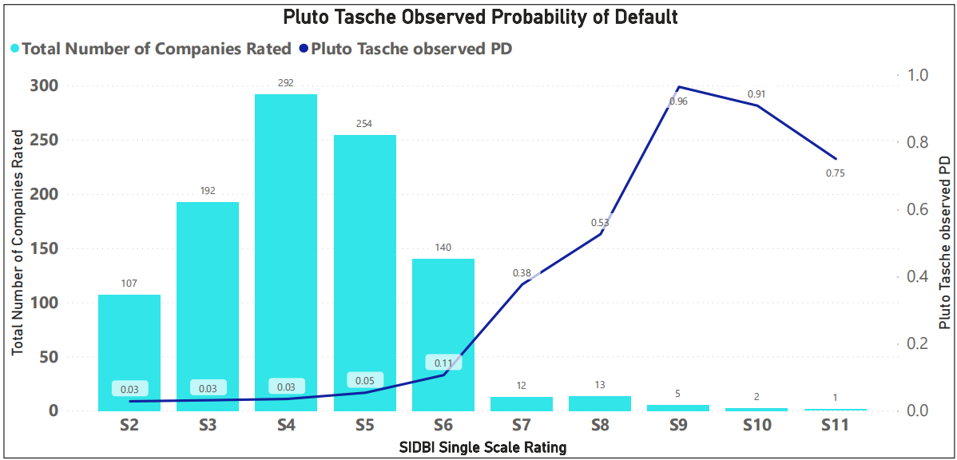

**Annexure- G**

**Concentration Test-Herfindahl Hirschman Index(HHI)**



**Annexure- H**

**Rating Grades Transition Matrix**

**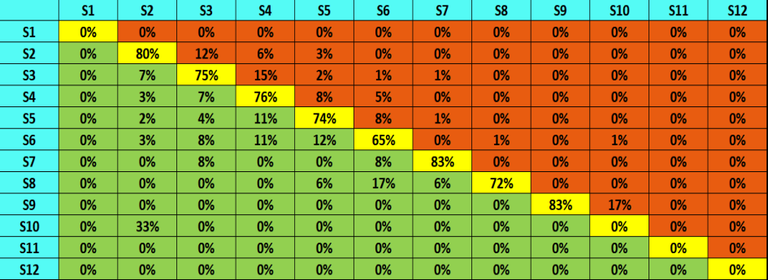***Note : S1 & S12 is not a rating grade for LSME model*