Quantum Computing and Business Readiness: A Human-Centered Framework for Risk-Aware Strategic Adoption of Quantum Technologies
A Conceptual and Critical Literature-Based Research Article

Abstract
Quantum computing has moved from laboratory demonstration toward early commercial experimentation, yet most organizations remain uncertain about whether, when, and how to prepare for it. Existing research examines quantum hardware progress, quantum algorithms, industry applications, and post-quantum security largely in isolation, leaving managers without an integrated account of what business readiness for quantum computing actually requires. This article addresses that problem through a conceptual, critical literature-based analysis. Drawing on research in quantum computation, information systems, strategic management, decision intelligence, and cybersecurity, the article develops the Quantum Business Readiness (QBR) Framework: a seven-layer conceptual architecture connecting technology and market intelligence, use-case and value analytics, quantum and hybrid computation, knowledge and translation capability, quantum-safe risk management, strategic decision intelligence, and human governance, closed by a continuous learning loop. The central theoretical insight is that quantum readiness is not a hardware acquisition problem but an organizational decision-intelligence problem: value emerges only when quantum and quantum-inspired computation is embedded in explainable, risk-aware, and human-governed decision processes. The article derives six research propositions, illustrates the framework across portfolio management, finance, autonomous-system mission planning, and enterprise cybersecurity, and outlines an empirical research agenda. Contributions include an integrated readiness theory, a testable proposition set, and practical guidance for staged, security-conscious quantum adoption. No new empirical results are reported.
Keywords: Quantum computing; business readiness; strategic decision intelligence; quantum-inspired optimization; post-quantum cryptography; hybrid quantum-classical computing; human-AI collaboration; technology adoption; organizational resilience

1. Introduction
Organizational decision-making has been reshaped over two decades by the accumulation of large heterogeneous datasets and by the progression from descriptive reporting toward predictive and prescriptive analytics. Contemporary decision environments increasingly embed artificial intelligence directly into operational infrastructure: edge-cloud collaborative platforms now support AI-enabled project portfolio management with integrated cyber-threat detection [1], quantum-enhanced techniques are being explored for autonomous-system localization in GPS-denied environments [2], and quantum-inspired, knowledge-guided decision support has been proposed for risk-aware mission planning in contested settings [3]. These developments signal that the computational substrate of strategic decision-making is itself changing, and that quantum computation, in both literal and inspired forms, is entering the decision-support conversation.
Quantum computing exploits superposition and entanglement to address certain classes of problems, particularly combinatorial optimization, simulation of quantum systems, and specific linear-algebraic workloads, in ways that differ fundamentally from classical computation. The field currently operates in what Preskill terms the noisy intermediate-scale quantum (NISQ) era, in which devices are powerful enough to be scientifically interesting but too error-prone for most fault-tolerant applications [4]. Landmark demonstrations such as Google's programmable superconducting processor established computational capabilities beyond classical simulation for contrived tasks [5], yet commercially meaningful advantage remains largely prospective. Business-oriented analyses nevertheless identify concrete near-term opportunity spaces, including quantum-safe encryption, materials and drug discovery, and quantum-inspired algorithms that run on classical hardware [6]. Bova, Goldfarb, and Melko further argue that firms should orient toward quantum economic advantage, situations in which quantum approaches deliver commercially relevant solutions faster or differently than classical alternatives, rather than waiting for formal quantum advantage [7].
For most organizations, however, the managerial question is not whether quantum computing is scientifically promising but whether the organization is ready to engage with it: ready to identify quantum-amenable problems, to experiment through cloud-based access, to develop or acquire scarce talent, to protect data against quantum-era cryptographic threats, and to make staged investment decisions under deep technological uncertainty. Information systems scholarship has begun to frame quantum computing as an organizational and market phenomenon rather than a purely physical one [8], and readiness-oriented work has proposed quantum technology readiness levels and ecosystem models for assessing maturity [9]. Yet analytics capability alone does not automatically create better decisions; capability must be converted into decision quality through explainable reasoning, risk assessment, and human judgment. This conversion problem, well documented for classical AI, is amplified for quantum computing, where outputs are probabilistic, expertise is scarce, hardware roadmaps are uncertain, and the same technology that promises optimization gains also threatens existing cryptographic infrastructure.
The research gap this article addresses is the absence of an integrated conceptual framework explaining how organizations can move from monitoring quantum technology, through analytics-based use-case screening and hybrid experimentation, to transparent, risk-aware, and human-governed strategic decisions about quantum adoption. The article pursues one central question: how can quantum computing capability be systematically integrated with organizational analytics, risk management, and human judgment to support explainable, risk-aware, resilient, and human-centered strategic decision-making about quantum adoption? Three supporting research questions structure the analysis. RQ1 asks how data analytics and technology intelligence create the information foundation required to identify quantum-amenable strategic problems. RQ2 asks how quantum, quantum-inspired, and hybrid quantum-classical computation can improve decision quality under uncertainty and risk in the near term. RQ3 asks what role human judgment, governance, cybersecurity, and organizational context should play when quantum-derived intelligence is converted into strategic action.
The article makes five contributions. First, it synthesizes fragmented literatures spanning quantum computation, information systems, strategy, decision intelligence, and security into a single business-readiness perspective. Second, it introduces the Quantum Business Readiness (QBR) Framework, a seven-layer conceptual architecture with an explicit feedback loop, as the article's central original contribution. Third, it articulates four specific sub-gaps that explain why quantum capability does not automatically translate into business value. Fourth, it derives six theoretically grounded propositions to guide empirical research. Fifth, it demonstrates the framework's cross-domain applicability, from portfolio management and finance to autonomous systems and quantum-safe cybersecurity, and translates the analysis into managerial guidance for staged, risk-aware adoption.

2. Theoretical Background

2.1 Data Analytics and Organizational Information
The value chain of organizational analytics converts raw data into information through curation and contextualization, information into insight through descriptive and diagnostic analysis, insight into foresight through predictive modeling, and foresight into recommended action through prescriptive optimization. Research on analytics and AI capability shows that this conversion depends less on tooling than on complementary organizational resources: data quality, technical skills, managerial skills, and an organizational culture that permits evidence to influence decisions [10]. This capability perspective matters for quantum readiness in two ways. First, quantum computing enters the pipeline at the computational stage, accelerating or restructuring optimization and simulation, and therefore inherits every upstream weakness in data and information management. Second, the same complementarity logic implies that access to quantum hardware without absorptive organizational capability will produce little value, just as big-data infrastructure without analytics capability produced little value in the previous technology cycle [10].

2.2 Strategic Decision Intelligence
Decision intelligence reframes analytics around decisions rather than data: it begins with the decision to be made, models the causal chain from action to outcome, and only then asks what data, prediction, and optimization are required. Pratt, Bisson, and Warin formalize this orientation in the Decision Intelligence/Data Science integration framework, arguing that advanced technology creates strategic value only when embedded in explicitly modeled decision processes with human decision-makers in the loop [11]. Decision intelligence therefore differs from traditional analytics, which optimizes information supply, and from conventional decision support systems, which assist predefined choices, by treating the decision itself as the designed artifact. This article adopts decision intelligence as the organizing logic for quantum readiness: the question is never whether quantum computation is impressive, but whether a specific organizational decision, portfolio selection, routing, molecular screening, or cryptographic migration, would be made better, faster, or more robustly with quantum or quantum-inspired components. Table 1 positions quantum-enhanced strategic decision intelligence against prior decision-support paradigms.
Dimension | Traditional Analytics | Business Intelligence | AI Decision Support | Quantum-Enhanced Strategic Decision Intelligence
Primary focus | Historical description of data | Monitoring and reporting on performance | Prediction and recommendation | Decision design under complexity, uncertainty, and risk
Computational core | Statistics, OLAP queries | Dashboards, KPIs, data warehousing | Machine learning, optimization heuristics | Hybrid classical-quantum and quantum-inspired optimization and simulation
Time orientation | Past | Past and present | Future (forecast) | Future (scenarios, options, staged commitments)
Human role | Interpreter of reports | Consumer of dashboards | Supervisor of model outputs | Governing judge of explained, risk-assessed alternatives
Typical limitation | No foresight | Correlation without causation | Opacity; brittleness under distribution shift | Hardware immaturity; scarce expertise; uncertain timelines
Maturity | Mature | Mature | Rapidly diffusing | Emergent and pre-paradigmatic
Table 1. Comparison of traditional analytics, business intelligence, AI decision support, and quantum-enhanced strategic decision intelligence.

2.3 Quantum Computing in Strategic Decision-Making
Quantum computing research relevant to business decisions spans four strands. First, hardware and systems research characterizes device capabilities and constraints in the NISQ era [4], [5], with systematic reviews taxonomizing hardware modalities, software stacks, and application domains [12]. Second, quantum machine learning explores whether quantum devices can accelerate or enrich learning tasks, with Biamonte and colleagues mapping both the promise and the substantial caveats around data loading and error rates [13]. Third, quantum simulation research argues that chemistry and materials problems are the most natural fit for quantum hardware because the systems being modeled are themselves quantum mechanical [14]. Fourth, and most immediately actionable, quantum-inspired computation transfers algorithmic ideas such as annealing schedules, amplitude-amplification heuristics, and tensor-network methods onto classical hardware, delivering some structural benefits today without quantum devices [3], [6]. For strategy, the salient point is that these strands mature on different clocks: quantum-inspired methods are deployable now, simulation and optimization advantage is plausible mid-term, and broad fault-tolerant application remains long-term [4], [7].

2.4 Human-AI Collaboration
Strategic decisions are rarely candidates for full automation. Raisch and Krakowski characterize the automation-augmentation paradox: organizations gain most when AI augments managerial judgment, yet competitive and efficiency pressures continually push toward automation that erodes the very judgment augmentation requires [15]. Quantum-supported decision processes intensify this tension. Quantum outputs are intrinsically probabilistic, often sampled from distributions rather than returned as single answers, and the reasoning embodied in a quantum circuit is even less inspectable to managers than a gradient-boosted model. Human contextual judgment is therefore not a residual to be engineered away but a structural component of any credible quantum decision pipeline: humans frame the problem, set constraint and risk tolerances, interpret sampled solutions against unmodeled context, and own accountability for action. The QBR Framework consequently places human governance as its final layer rather than as an afterthought.

2.5 Explainable and Responsible Computation
The explainable AI literature establishes that transparency, interpretability, and accountability are preconditions for trust and adoption of algorithmic recommendations in consequential settings [16]. Explainability for quantum-supported decisions must operate at the decision level rather than the mechanism level: managers do not need to understand entanglement, but they do need to know which constraints bound a recommended portfolio, which risk terms penalized a candidate route, and how sensitive the recommendation is to assumptions. Knowledge-guided formulations that inject explicit, symbolic domain rules into optimization, as demonstrated for quantum-inspired UAV mission planning [3], illustrate a promising pattern: because the rules are declared rather than learned, the resulting recommendations inherit a natural justification structure. Responsible adoption also requires honesty about capability claims, an acute concern in a field where commercial narratives frequently outrun demonstrated results [7], [8].

2.6 Risk, Cybersecurity, and Organizational Resilience
Quantum computing is unique among emerging decision technologies in that it is simultaneously an opportunity and a named threat. Mosca's widely cited risk formulation asks whether the time to migrate cryptographic infrastructure plus the required data-secrecy lifetime exceeds the time until cryptographically relevant quantum computers arrive; when it does, organizations are already late [17]. Bernstein and Lange survey the post-quantum cryptographic families, lattice-, hash-, code-, and multivariate-based schemes, that must replace factoring- and discrete-log-based systems vulnerable to Shor-style attacks [18]. The managerially critical harvest-now-decrypt-later pattern means adversaries can exfiltrate encrypted data today for decryption once hardware matures, making quantum risk a present-tense governance issue regardless of application timelines [17]. Readiness therefore has a defensive core, crypto-agility, inventorying of cryptographic assets, and staged migration to standardized post-quantum schemes, that applies to every organization, including those that never intend to run a quantum workload.

3. Critical Literature Synthesis
Rather than summarizing studies individually, this section synthesizes the literature into eight themes that connect quantum computation to strategic decision-making, identifying agreements, tensions, limitations, and open questions in each. Table 2 consolidates representative sources.

Theme 1: Data Analytics as the Foundation of Organizational Intelligence
Capability research converges on the finding that analytics creates value only through organizational complementarities rather than through technology possession [10], and decision-intelligence work extends this by insisting that analytic outputs be architected around explicit decisions [11]. The literatures agree that infrastructure without capability disappoints; they differ on remedy, with capability scholars emphasizing resource development and decision-intelligence scholars emphasizing process redesign. What remains unresolved is how these prescriptions transfer to a technology as immature as quantum computing, where the capability to be developed barely exists in labor markets [9]. The implication carried into the QBR Framework is that quantum readiness must be built on an already functioning analytics-to-decision pipeline; quantum computation amplifies decision architecture, it does not substitute for one.

Theme 2: Quantum Capability, Computation, and Optimization
Technical assessments agree on the classes of problems where quantum approaches are structurally promising, combinatorial optimization, quantum simulation, and certain sampling and linear-algebra tasks [4], [12], [13], and business analyses agree that these classes map onto commercially significant verticals [6]. They disagree sharply on timing. Preskill cautions that NISQ devices may deliver scientific rather than commercial value for some time [4]; supremacy-style demonstrations concern contrived tasks distant from business workloads [5]; and Bova and colleagues argue that economic advantage can nonetheless emerge before formal quantum advantage through speed, cost, or solution-diversity effects [7]. The unresolved question, when does economically material advantage arrive for which problem class, cannot be settled conceptually, which is precisely why the framework developed here treats adoption as staged decision-making under uncertainty rather than as a forecastable rollout.

Theme 3: Knowledge-Guided Computation and Context-Aware Decisions
A recurring finding across decision-support research is that purely data-driven optimization ignores domain rules that practitioners consider non-negotiable. Knowledge-guided formulations address this by encoding rules, no-fly zones, regulatory constraints, sequencing requirements, directly into the objective or constraint structure, as in quantum-inspired mission planning that penalizes rule violations symbolically [3]. This approach agrees with explainability research that declared knowledge improves justification [16], but it carries limitations the literature acknowledges only partially: rule bases are expensive to maintain, may encode outdated practice, and can conflict with learned patterns. How to arbitrate between symbolic knowledge and statistical evidence inside quantum-supported optimization remains open, and the QBR Framework assigns that arbitration explicitly to its knowledge and human-governance layers.

Theme 4: Edge-Cloud and Distributed Decision Intelligence
Because quantum hardware is accessed almost exclusively through cloud services [8], [12], quantum-supported decisions inherit the architecture of distributed intelligence: local, latency-sensitive processing at the edge, heavy computation in the cloud, and orchestration between them. Edge-cloud collaborative systems for AI-enabled portfolio management with embedded cyber-threat detection demonstrate this division of labor in an enterprise decision context [1], and quantum-enhanced localization for drone swarms extends it to settings where cloud connectivity itself is contested [2]. The agreement across these strands is that distribution improves responsiveness and resilience; the tension is that distribution multiplies attack surface and complicates accountability for decisions assembled from many nodes. Literature on securing such pipelines end-to-end, particularly when a quantum cloud service sits inside the loop, is thin, marking a clear research need.

Theme 5: Explainability, Transparency, and Trust
The XAI literature establishes a broadly accepted taxonomy of transparency needs and post-hoc explanation methods, and links explanation to trust and accountability [16]. Applied decision-support research concurs that explainability drives managerial adoption, while noting that explanations can also manufacture unwarranted trust. For quantum-supported decisions the field is nearly silent: sampling-based outputs, hardware noise, and hybrid pipelines have no established explanation conventions. What the synthesis supports is a pragmatic position, explain the decision model, constraints, penalties, scenario assumptions, sensitivity, rather than the physics, a position consistent with knowledge-guided designs [3], [16]. Standards for communicating probabilistic quantum outputs to executives remain entirely unresolved.

Theme 6: Cybersecurity, Quantum Risk, and Resilient Decisions
Security research is unusually unified on the quantum threat: public-key infrastructure based on factoring and discrete logarithms will eventually fail against quantum attack, post-quantum families exist and are being standardized, and migration must begin well before capable hardware exists because of secrecy lifetimes and harvest-now-decrypt-later exposure [17], [18]. Enterprise practice, however, lags this consensus, and the literature offers limited guidance on prioritizing migration across sprawling cryptographic estates under budget constraints. Integrating threat analytics into operational decision systems, as in edge-cloud portfolio platforms with built-in cyber-threat detection [1], points toward the needed pattern: security as a live input to strategic decisions rather than a parallel compliance track. How to quantify quantum-era cyber risk for board-level decision-making is an open measurement problem.

Theme 7: Human-AI Collaboration and Strategic Judgment
Management research agrees that consequential, ambiguous decisions benefit from human-machine complementarity rather than substitution [15], and decision-intelligence frameworks institutionalize the human in the loop [11]. The disagreement concerns durability: whether augmentation is a stable equilibrium or a transitional stage that automation pressure erodes [15]. Quantum contexts sharpen the stakes because expertise asymmetry is extreme; very few managers can independently challenge a quantum specialist's claim. This creates governance exposure the literature has not addressed: organizations must make judgment calls about a technology they cannot internally evaluate, which elevates translation capability, boundary-spanning roles that connect quantum specialists and decision-makers, from convenience to control mechanism [9].

Theme 8: Quantum-Inspired and Advanced Optimization for Complex Decision Search
A pragmatically important stream shows that algorithmic ideas from quantum computation, annealed probabilistic search, amplitude-inspired selection, tensor-network compression, can improve classical solvers for complex decision search today [3], [6]. Finance provides the densest evidence base: overviews and state-of-the-art surveys across portfolio optimization, risk analysis, and derivative pricing agree on structural promise while documenting that demonstrated end-to-end advantage on production-scale problems remains absent [19], [20], [21]. The strength of this stream is that it decouples near-term value from hardware maturity; its limitation is attribution, since quantum-inspired gains are sometimes indistinguishable from well-tuned classical metaheuristics. For readiness strategy, quantum-inspired deployment functions as a low-regret learning investment that builds formulation skill transferable to future hardware [6], [7].
Ref. | Analytics / Quantum Technology | Decision Context | Key Contribution | Limitation | Relevance to QBR
[1] | Edge-cloud AI; cyber-threat detection | Project portfolio management | Demonstrates AI-enabled PPM with embedded security monitoring in a distributed architecture | Single-system scope; generalization untested | Layers 1, 5, 6: distributed intelligence with security in the loop
[2] | Quantum-enhanced localization | Drone swarms, GPS-denied environments | Applies quantum-enhanced techniques to swarm localization without satellite navigation | Early-stage; constrained scenarios | Layer 3: quantum methods under operational constraint
[3] | Quantum-inspired, knowledge-guided optimization | Risk-aware UAV mission planning | Injects symbolic domain rules into annealed route search for interpretable planning | Conceptual/simulation orientation; no field validation | Layers 3-4: knowledge-guided, explainable quantum-inspired search
[6] | Quantum applications survey | Cross-industry commercial use | Identifies near-term opportunity in quantum-safe encryption, discovery, and quantum-inspired algorithms | Pre-advantage snapshot; fast-moving field | Layer 2: use-case screening logic
[7] | Economic modeling | Firm strategy and competition | Distinguishes quantum economic advantage from formal quantum advantage | Stylized duopoly model | Layer 6: investment timing rationale
[8] | IS fundamentals of QC | Organizations and markets | Frames quantum computing as an information-systems phenomenon with research agenda | Introductory scope | Layers 1, 7: organizational framing
[9] | Readiness levels and ecosystem model | Quantum ecosystem development | Formulates quantum technology readiness levels and workforce ecosystem needs | Ecosystem-level, not firm-level | Layers 1, 4: readiness measurement and talent
[10] | AI capability construct | Firm performance | Shows AI value depends on complementary organizational resources | Pre-quantum context | Layer 4: absorptive capacity logic
[11] | Decision Intelligence / Data Science integration | Strategic decision-making | Architects technology around explicitly modeled decisions with humans in loop | Conceptual framework | Layer 6: decision-first design
[13] | Quantum machine learning | Learning tasks | Maps QML potential and caveats (data loading, noise) | Theoretical; hardware-limited | Layer 3: capability boundaries
[15] | Automation-augmentation theory | Management and AI | Identifies paradox between augmenting and automating managerial judgment | Not quantum-specific | Layer 7: human governance rationale
[17] | Quantum threat timeline (Mosca inequality) | Cryptographic risk | Formalizes urgency of migration relative to secrecy lifetimes | Parameter uncertainty | Layer 5: quantum-safe resilience
[21] | Quantum finance survey | Portfolio, risk, pricing | Consolidates state of quantum methods in finance with sober advantage assessment | Domain-specific | Layers 2-3: densest application evidence
Table 2. Literature synthesis mapped to the QBR Framework.

4. Research Gap
Across the eight themes, a consistent structural pattern emerges: research streams on quantum hardware and algorithms [4], [5], [12], [13], business applications and economics [6], [7], organizational capability and decision intelligence [10], [11], human-machine collaboration [15], explainability [16], and quantum-era security [17], [18] have each matured within their own boundaries while remaining weakly connected to one another. The central gap is therefore integrative: there is no established framework explaining how organizations transform heterogeneous technology and market signals into analytically screened quantum use cases, exercise those use cases through hybrid and quantum-inspired computation, and convert the resulting intelligence into transparent, risk-aware, and human-governed strategic decisions about adoption, investment, and protection. Four specific sub-gaps compose this central gap.
First, a technology-to-value gap: technical literature specifies what quantum devices can compute [4], [12], and business literature speculates about vertical value [6], but the mechanism connecting computational capability to realized decision value inside a specific firm is under-theorized. Second, a prediction-to-action gap: economic analysis clarifies why timing matters [7], yet organizations lack decision architectures for acting under irreducible roadmap uncertainty, when to pilot, when to scale, and when to wait. Third, a capability-to-judgment gap: readiness models measure ecosystem and technology maturity [9] but say little about the translation and governance capabilities that let non-specialist executives responsibly judge quantum claims [15]. Fourth, a performance-to-trust-and-resilience gap: application research optimizes for computational performance [13], [19], [20], [21] while security research warns of quantum threat [17], [18], and almost no work treats opportunity pursuit and threat mitigation as a single, jointly governed decision problem. The QBR Framework developed next is constructed to close these four sub-gaps by design.

5. The Quantum Business Readiness (QBR) Framework
The article's central contribution is the Quantum Business Readiness Framework: a seven-layer conceptual architecture that organizes how an organization senses, evaluates, exercises, secures, decides upon, and governs quantum computing capability, closed by a feedback loop that converts outcomes into learning. Figure 1 situates the framework in the broader evolution from data to action; Figure 2 presents the framework itself; Table 3 details each layer's inputs, functions, outputs, and decision value. The layers are conceptually sequential but operationally concurrent: mature organizations run all seven continuously.
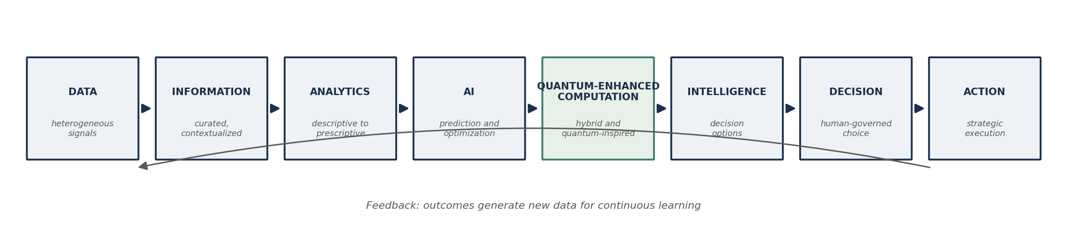
Figure 1. Evolution from data analytics to quantum-enhanced strategic decision intelligence.

Layer 1: Technology and Market Intelligence
Readiness begins with disciplined sensing. Because quantum progress is rapid, uneven, and heavily narrated by a fast-moving commercial landscape of hardware firms, software startups, and cloud platforms [8], [22], organizations require systematic monitoring of hardware roadmaps, error-correction milestones, cloud-service offerings, standardization activity in post-quantum cryptography, competitor initiatives, and regulatory signals. Readiness-level instruments provide a vocabulary for calibrating maturity claims [9]. The layer's function is epistemic hygiene: separating demonstrated capability [5] from projected capability [4], so that downstream analysis operates on defensible premises. Its output is a continuously refreshed technology and threat picture with explicit confidence gradings.

Layer 2: Use-Case and Value Analytics
The second layer applies the organization's existing analytics discipline to the quantum question itself. Descriptive and diagnostic analysis inventories the firm's computational pain points; predictive analysis estimates how those pain points scale; prescriptive screening ranks candidate problems by quantum amenability, combinatorial structure, simulation content, optimization criticality, against feasibility on current and near-term platforms [6], [12]. The decision-intelligence principle governs the layer: begin from decisions the business must make better, not from the technology outward [11]. Outputs are a scored use-case portfolio and explicit no-go rationales, which are as valuable as go decisions in preventing hype-driven investment [7].

Layer 3: Quantum and Hybrid Computation
The third layer is the exercise layer, where selected use cases meet actual computation: cloud-accessed gate-based processors, annealers, quantum-inspired algorithms on classical hardware, and hybrid quantum-classical pipelines in which classical preprocessing, quantum subroutines, and classical postprocessing interleave [12], [13]. In the NISQ era, most business-relevant learning occurs through quantum-inspired and hybrid modes [3], [4], [6]; finance illustrates both the breadth of formulations available and the current absence of production-scale advantage [19], [20], [21]. The layer's decision value is twofold: it generates problem-formulation skill, QUBO and constraint encodings, penalty design, that transfers across hardware generations, and it produces realistic performance evidence that disciplines Layer 2 scoring.

Layer 4: Knowledge, Talent, and Translation
Computation becomes organizational capability only through people. This layer develops quantum literacy across managerial ranks, deep specialism where the use-case portfolio justifies it, and, critically, translation roles that bridge specialists and executives, the boundary-spanning capability that ecosystem studies identify as the binding constraint on adoption [9]. The layer also curates domain knowledge, rules, constraints, and contextual facts, so it can be injected into formulations [3], and owns decision-level explainability: rendering probabilistic, sampled outputs into constraint-referenced, sensitivity-annotated justifications that satisfy transparency norms [16]. Absorptive-capacity logic from AI research applies directly: complementary human capital determines whether identical technology access yields differential value [10].

Layer 5: Risk and Quantum-Safe Resilience
The fifth layer integrates threat into the same architecture that pursues opportunity. Its defensive agenda, cryptographic inventory, crypto-agility engineering, prioritized migration to standardized post-quantum schemes, is driven by the Mosca timing logic and harvest-now-decrypt-later exposure [17], [18]. Its analytical agenda embeds security signals into operational decision systems, as demonstrated by edge-cloud platforms that fuse cyber-threat detection with portfolio management [1], and extends risk assessment to vendor concentration, cloud dependency, talent flight, and roadmap slippage. The layer's output is a risk-adjusted view of every quantum initiative and a migration program that proceeds regardless of whether the organization ever runs a quantum workload.

Layer 6: Strategic Decision Intelligence
The sixth layer converts screened use cases, computational evidence, and risk assessments into investment-grade alternatives: pilot, scale, partner, wait, or divest. Because roadmaps are uncertain, the layer reasons in scenarios and staged commitments, treating early investments as options that purchase learning and position rather than as forecast-dependent bets [7], [11]. A simple conceptual formalization guides screening. For initiative i, the scenario-weighted expected strategic value is
E[V_{i}] = Σ_{s} π_{s} [ p_{i,s} · ΔV_{i,s} − C_{i,s} + L_{i,s} ] (1)
where πs is the probability of technology scenario s, pi,s the probability that the initiative achieves decision-relevant advantage in that scenario, ΔVi,s the incremental decision value if it does, Ci,s the adoption and integration cost, and Li,s the learning-and-option value realized even without advantage. Equation (1) is a reasoning device, not an estimation claim: its role is to force explicit, revisable assumptions, and to make visible that Li,s frequently dominates the near-term case for quantum-inspired pilots [6], [7]. The layer's outputs are prioritized recommendations with documented trade-offs, ready for human governance.

Layer 7: Human Governance and Action
The final layer is deliberately human. Executives validate recommendations against unmodeled context, ethical review examines externalities, governance assigns accountability, and a named decision-maker commits the organization to action [11], [15]. The layer institutionalizes augmentation over automation: quantum-derived intelligence proposes, humans dispose, with the translation capability of Layer 4 ensuring the disposal is informed rather than deferential [15], [16]. Every decision, including decisions to wait, is recorded with its rationale, creating the traceability that responsible-computation norms require [16].

The Feedback Loop: Continuous Readiness Learning
Decision outcomes, pilot results, migration milestones, abandoned initiatives, feed back as new data and capability signals; models, use-case scores, risk parameters, and knowledge bases are updated; and the organization's readiness posture is re-graded. The loop converts readiness from a static audit into a learning system, mirroring the outcome-to-data cycles that decision-intelligence and capability research identify as the engine of durable advantage [10], [11]. Figure 2 depicts the complete architecture.
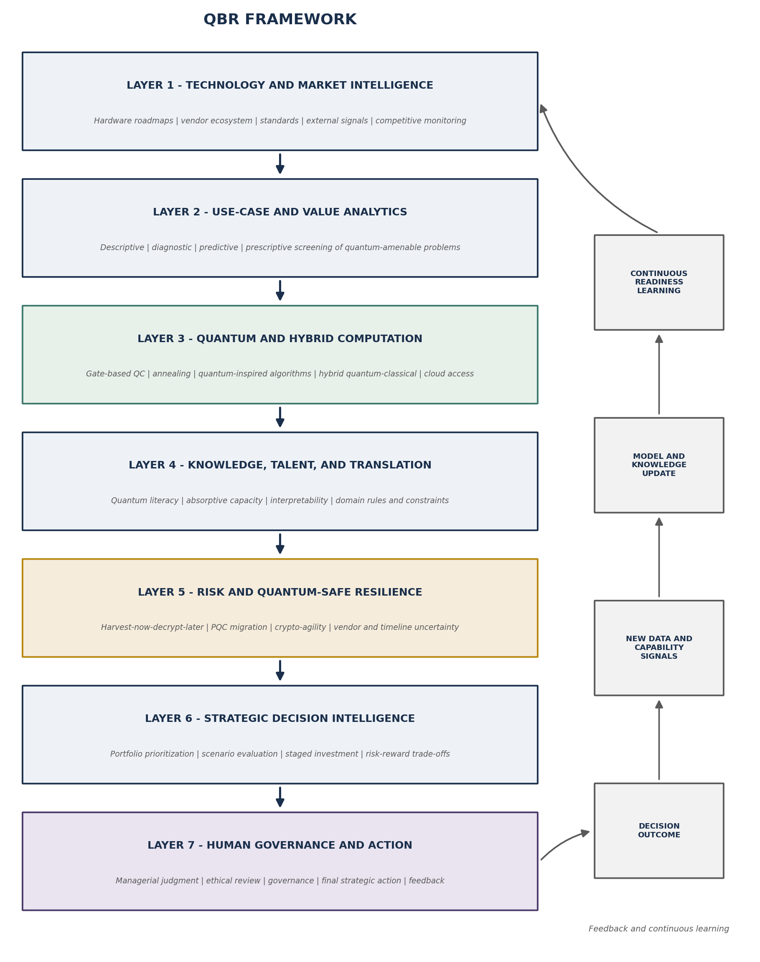
Figure 2. The Quantum Business Readiness (QBR) Framework: seven layers with continuous feedback.
QBR Layer | Primary Inputs | Analytical Functions | Outputs | Decision Value
1. Technology and market intelligence | Roadmaps, vendor data, standards activity, competitor signals | Monitoring, maturity calibration, claim verification | Confidence-graded technology and threat picture | Defensible premises; hype resistance
2. Use-case and value analytics | Business pain points, process data, Layer 1 picture | Descriptive-to-prescriptive screening of quantum amenability | Scored use-case portfolio; no-go rationales | Investment focus; avoided waste
3. Quantum and hybrid computation | Selected use cases, cloud QC access, classical HPC | Quantum, quantum-inspired, and hybrid experimentation | Performance evidence; reusable formulations | Realism; transferable skill
4. Knowledge, talent, and translation | Specialists, domain rules, XAI methods | Literacy building, knowledge encoding, decision-level explanation | Translation capability; justified recommendations | Trust; informed governance
5. Risk and quantum-safe resilience | Crypto inventory, threat intelligence, PQC standards | Mosca-style timing analysis, migration prioritization, risk adjustment | Migration program; risk-adjusted initiative view | Resilience; present-tense protection
6. Strategic decision intelligence | Layers 1-5 outputs, scenarios | Option-based valuation, portfolio prioritization, trade-off analysis | Ranked alternatives with documented trade-offs | Timing discipline under uncertainty
7. Human governance and action | Layer 6 recommendations, context, values | Validation, ethical review, accountable commitment | Governed strategic action; recorded rationale | Accountability; legitimacy
Table 3. QBR Framework layers: inputs, functions, outputs, and decision value.

6. Cross-Domain Illustration
The framework's claim to generality is best examined by walking it through technically dissimilar domains. No new empirical results are asserted; the purpose is to show that the same readiness logic organizes each setting.

6.1 Project and Technology Portfolio Management
Portfolio selection is a canonical combinatorial problem and an early candidate for quantum-inspired optimization. Edge-cloud collaborative platforms that pair AI-enabled portfolio management with cyber-threat detection [1] instantiate Layers 3 and 5 simultaneously: distributed computation serves responsiveness while security telemetry conditions the same decisions. QBR adds the surrounding discipline, use-case scoring before adoption (Layer 2), translated explanation of recommended portfolios (Layer 4), and staged human sign-off (Layer 7).

6.2 Financial Services
Finance hosts the most developed quantum application literature, spanning portfolio optimization, risk simulation, and pricing [19], [20], [21], and simultaneously faces the sharpest quantum-safe exposure because transaction confidentiality has long secrecy lifetimes [17]. QBR frames the sector's task as jointly governing both faces: Layer 2 screens which desks' problems are genuinely quantum-amenable, Layer 3 accumulates hybrid-pipeline evidence, and Layer 5 sequences cryptographic migration ahead of threat timelines [18].

6.3 UAV and Autonomous Mission Planning
Risk-aware mission planning in contested environments must balance threat exposure, communication degradation, and hard operational rules. Quantum-inspired, knowledge-guided route selection that penalizes rule violations within an annealed search [3] exemplifies Layers 3 and 4 fused: optimization power with declared, explainable constraints. Layer 7 retains the mission commander's judgment over sampled route alternatives, and the feedback loop folds mission outcomes into updated rules and risk terms.

6.4 GPS-Denied Autonomous Systems
Where satellite navigation is denied, swarms require alternative localization and uncertainty-aware coordination. Quantum-enhanced localization approaches [2] operate at the hardest edge of Layer 3, computation under severe connectivity and latency constraint, and stress Layer 5, since the communication fabric itself is adversarial. The readiness lesson generalizes: the more contested the environment, the more decision value depends on Layers 4 and 7, because automation confidence degrades exactly when human judgment is least replaceable [15].

6.5 Enterprise Cybersecurity and Quantum-Safe Migration
For most organizations, the first mandatory quantum program is defensive. Layer 1 tracks standardization and threat estimates; Layer 2 inventories cryptographic dependence; Layer 5 runs Mosca-style timing analysis and prioritizes migration [17], [18]; Layer 6 treats migration sequencing as a resource-allocation decision; and Layer 7 assigns board-level accountability. That the same seven layers organize an optimization opportunity in finance and a defensive migration in security is the framework's core demonstration: strategic decision intelligence principles are domain-invariant even when the underlying technology roles differ. Figure 3 depicts the human-in-the-loop decision cycle common to all five settings.
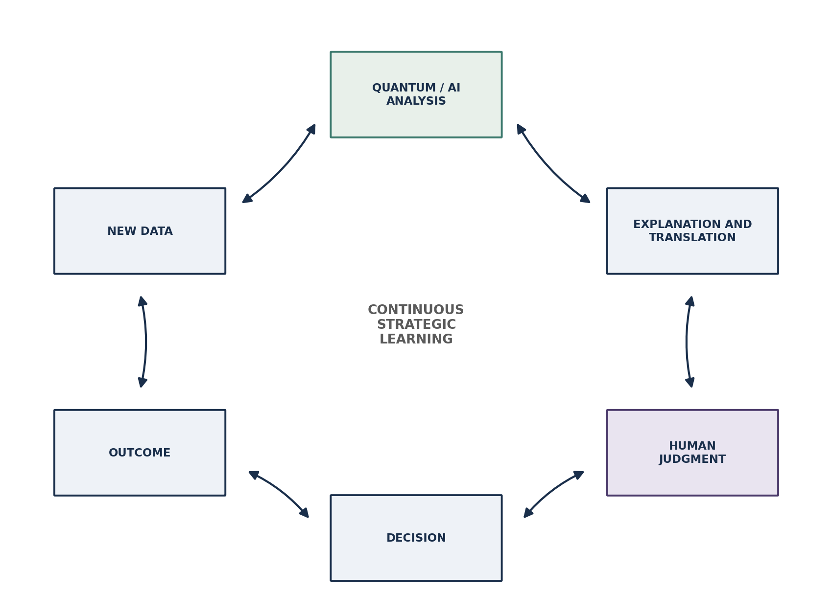
Figure 3. The human-quantum-AI strategic decision loop underlying all QBR application domains.

7. Research Propositions
Six theoretically grounded propositions summarize the framework's causal claims. They are offered for empirical testing, not asserted as demonstrated by this article.
P1. Organizations with stronger data-analytics and decision-intelligence capability will identify quantum-amenable strategic problems more accurately than organizations that approach quantum computing technology-first [10], [11].
P2. Engagement with quantum-inspired and hybrid quantum-classical computation strengthens the relationship between quantum technology access and realized decision value in the pre-fault-tolerant era, primarily through formulation skill and learning effects [3], [4], [6], [7].
P3. Decision-level explainability of quantum-derived recommendations positively influences managerial trust in, and adoption of, those recommendations [16].
P4. Knowledge-guided formulations improve the contextual fit of quantum-supported decisions in domains governed by explicit rules and constraints [3].
P5. Early crypto-agility and post-quantum migration planning strengthen organizational resilience, and this effect operates independently of whether the organization pursues quantum applications [17], [18].
P6. Human-machine complementarity, quantum-derived intelligence governed by informed human judgment, produces more context-sensitive strategic adoption decisions than either expert intuition or automated recommendation alone [11], [15].

8. Managerial and Practical Implications
For chief executives, the framework reframes the quantum question from a technology bet into a readiness posture: the relevant commitment is to sensing, screening, and staged learning, not to hardware. For CIOs and analytics leaders, the priority ordering is concrete, harden the classical analytics-to-decision pipeline first, then add quantum-inspired experimentation where combinatorial pain is genuine [6], [11]. For cybersecurity managers, Layer 5 is not optional and not future-tense: cryptographic inventory and migration sequencing should begin immediately under harvest-now-decrypt-later logic [17], [18]. For portfolio and technology strategists, Equation (1) supplies a discussion discipline, forcing scenario probabilities, advantage likelihoods, and learning value into the open where they can be challenged [7]. For leaders of autonomous-system programs, the contested-environment cases [2], [3] show that explainable constraints and preserved human authority are operational requirements, not compliance decoration. The unifying managerial message is a progression: more data is worthless without better analytics; better analytics is inert without better intelligence; and better intelligence matters only when it produces better, governed decisions.

9. Research Implications
The framework opens research avenues at each layer and at their junctions. Decision-intelligence research can extend decision-first design to technologies whose capabilities are themselves uncertain [11]. Explainability research should develop explanation conventions for probabilistic, sampled quantum outputs [16]. Information systems scholarship can test readiness constructs at the firm level, complementing ecosystem-level readiness instruments [8], [9]. Security research needs board-usable quantification of quantum-era cyber risk and migration-prioritization methods [17], [18]. Human-computer collaboration research can examine how extreme expertise asymmetry reshapes augmentation dynamics [15]. Application research in finance, logistics, and autonomous systems should pursue attribution discipline, distinguishing quantum-inspired gains from tuned classical baselines [3], [19], [20], [21]. Finally, connections to adjacent agendas, generative AI for formulation assistance, digital twins as testbeds for quantum-supported decisions, and edge-cloud orchestration of hybrid pipelines [1], [2], remain almost entirely unexplored.

10. Limitations
This article is conceptual: it develops and justifies a framework from literature synthesis and introduces no new dataset, experiment, or measurement, and the QBR Framework accordingly requires empirical validation before prescriptive confidence is warranted. The synthesis privileges peer-reviewed sources in a field where significant activity occurs in industrial gray literature, and the technology it describes is moving quickly enough that specific capability characterizations [4], [5] may date faster than the framework's logic. Domain differences, regulatory intensity in finance, safety criticality in autonomous systems, mean layer weightings will vary by sector, and governance prescriptions assume organizational forms typical of larger enterprises. The cross-domain illustrations are conceptual applications, not case evidence, and should not be generalized as demonstrated practice.

11. Future Research
Three empirical programs follow naturally. First, measurement and survey research should operationalize the seven layers as a firm-level readiness instrument, building on ecosystem-level readiness work [9], and test the propositions across industries. Second, case and longitudinal research should trace organizations through complete readiness cycles, pilot decisions, migration programs, abandonment decisions, to observe the feedback loop in operation and to examine P2 and P6 in situ. Third, experimental and simulation research should test decision-level explainability formats for quantum outputs with managerial subjects (P3), compare knowledge-guided against unconstrained formulations on matched problems (P4), and develop decision-quality metrics that capture learning value alongside outcome value, the Li,s term of Equation (1). Cross-industry validation, AI-governance integration, and human-quantum teaming experiments would round out the agenda.

12. Conclusion
The value of data analytics has never resided in the quantity of data produced; it resides in the quality of the decisions it enables. Quantum computing does not change that principle, it raises its stakes. This article has argued that business readiness for quantum computing is an organizational decision-intelligence achievement rather than a procurement event, and has offered the QBR Framework as an integrated account of what that achievement requires: disciplined technology sensing, analytics-driven use-case screening, hands-on hybrid and quantum-inspired computation, translation and knowledge capability, quantum-safe risk management, option-based strategic decision-making, and accountable human governance, bound together by continuous learning. The future of quantum-era strategic decision intelligence will belong to organizations that integrate data, analytics, computation, knowledge, explainability, risk awareness, cyber resilience, and human judgment as one system. Those elements are individually available today; the framework's contribution, theoretical and practical, is to specify how they compose, so that when quantum capability matures, on whatever timeline it chooses, prepared organizations will already know which decisions it should improve and how to govern it when it does.

References
[1] S. K. Thota, P. R. Raval, K. Onapakala, J. S. Taur, A. Jain, and S. Balamuralitharan, "An Edge-Cloud Collaborative System for AI-Enabled Project Portfolio Management with Cyber Threat Detection," 2025 IEEE 1st International Conference on Smart Innovations in Systems, Infrastructure, Mechanical, Power, AI and Computing Technologies (SISIMPACT), Bhopal, India, 2025, pp. 752-757, doi: 10.1109/SISIMPACT67725.2025.11439722.
[2] S. K. Thota, "Quantum-Enhanced Drone Swarm Localization in GPS-Denied Environment," 2026 IEEE International Conference on Emerging Computing and Intelligent Technologies (ICoECIT), Hyderabad, India, 2026, pp. 1-6, doi: 10.1109/ICoECIT68303.2026.11497954.
[3] S. K. Thota, "Quantum-inspired knowledge-guided decision support for risk-aware UAV mission planning in contested environments," Knowledge-Based Systems, vol. 351, Part C, Art. no. 116815, 2026, doi: 10.1016/j.knosys.2026.116815.
[4] J. Preskill, "Quantum Computing in the NISQ era and beyond," Quantum, vol. 2, p. 79, 2018, doi: 10.22331/q-2018-08-06-79.
[5] F. Arute et al., "Quantum supremacy using a programmable superconducting processor," Nature, vol. 574, no. 7779, pp. 505-510, 2019, doi: 10.1038/s41586-019-1666-5.
[6] F. Bova, A. Goldfarb, and R. G. Melko, "Commercial applications of quantum computing," EPJ Quantum Technology, vol. 8, Art. no. 2, 2021, doi: 10.1140/epjqt/s40507-021-00091-1.
[7] F. Bova, A. Goldfarb, and R. G. Melko, "Quantum Economic Advantage," Management Science, vol. 69, no. 2, pp. 1116-1126, 2023, doi: 10.1287/mnsc.2022.4578.
[8] R. Rietsche, C. Dremel, S. Bosch, L. Steinacker, M. Meckel, and J.-M. Leimeister, "Quantum computing," Electronic Markets, vol. 32, no. 4, pp. 2525-2536, 2022, doi: 10.1007/s12525-022-00570-y.
[9] A. Purohit, M. Kaur, Z. C. Seskir, M. T. Posner, and A. Venegas-Gomez, "Building a quantum-ready ecosystem," IET Quantum Communication, vol. 5, no. 1, pp. 1-18, 2024, doi: 10.1049/qtc2.12072.
[10] P. Mikalef and M. Gupta, "Artificial intelligence capability: Conceptualization, measurement calibration, and empirical study on its impact on organizational creativity and firm performance," Information & Management, vol. 58, no. 3, Art. no. 103434, 2021, doi: 10.1016/j.im.2021.103434.
[11] L. Pratt, C. Bisson, and T. Warin, "Bringing advanced technology to strategic decision-making: The Decision Intelligence/Data Science (DI/DS) Integration framework," Futures, vol. 152, Art. no. 103217, 2023, doi: 10.1016/j.futures.2023.103217.
[12] S. S. Gill et al., "Quantum computing: A taxonomy, systematic review and future directions," Software: Practice and Experience, vol. 52, no. 1, pp. 66-114, 2022, doi: 10.1002/spe.3039.
[13] J. Biamonte, P. Wittek, N. Pancotti, P. Rebentrost, N. Wiebe, and S. Lloyd, "Quantum machine learning," Nature, vol. 549, no. 7671, pp. 195-202, 2017, doi: 10.1038/nature23474.
[14] Y. Cao et al., "Quantum Chemistry in the Age of Quantum Computing," Chemical Reviews, vol. 119, no. 19, pp. 10856-10915, 2019, doi: 10.1021/acs.chemrev.8b00803.
[15] S. Raisch and S. Krakowski, "Artificial Intelligence and Management: The Automation-Augmentation Paradox," Academy of Management Review, vol. 46, no. 1, pp. 192-210, 2021, doi: 10.5465/amr.2018.0072.
[16] A. Barredo Arrieta et al., "Explainable Artificial Intelligence (XAI): Concepts, taxonomies, opportunities and challenges toward responsible AI," Information Fusion, vol. 58, pp. 82-115, 2020, doi: 10.1016/j.inffus.2019.12.012.
[17] M. Mosca, "Cybersecurity in an Era with Quantum Computers: Will We Be Ready?" IEEE Security & Privacy, vol. 16, no. 5, pp. 38-41, 2018, doi: 10.1109/MSP.2018.3761723.
[18] D. J. Bernstein and T. Lange, "Post-quantum cryptography," Nature, vol. 549, no. 7671, pp. 188-194, 2017, doi: 10.1038/nature23461.
[19] R. Orus, S. Mugel, and E. Lizaso, "Quantum computing for finance: Overview and prospects," Reviews in Physics, vol. 4, Art. no. 100028, 2019, doi: 10.1016/j.revip.2019.100028.
[20] D. J. Egger et al., "Quantum Computing for Finance: State-of-the-Art and Future Prospects," IEEE Transactions on Quantum Engineering, vol. 1, Art. no. 3101724, 2020, doi: 10.1109/TQE.2020.3030314.
[21] D. Herman et al., "Quantum computing for finance," Nature Reviews Physics, vol. 5, pp. 450-465, 2023, doi: 10.1038/s42254-023-00603-1.
[22] E. R. MacQuarrie, C. Simon, S. Simmons, and E. Maine, "The emerging commercial landscape of quantum computing," Nature Reviews Physics, vol. 2, pp. 596-598, 2020, doi: 10.1038/s42254-020-00247-5.

